UNITED STATES
SECURITIES AND EXCHANGE COMMISSION
Washington, D.C. 20549

FORM 10-K
(Mark One)
☒ |  |  | ANNUAL REPORT PURSUANT TO SECTION 13 OR 15(d) OF THE SECURITIES EXCHANGE ACT OF 1934
For the fiscal year ended December 31, 2024
OR
☐ |  |  | TRANSITION REPORT PURSUANT TO SECTION 13 OR 15(d) OF THE SECURITIES EXCHANGE ACT OF 1934
For the transition period from _________________________ to

Commission file number: 001-36246
Civeo Corporation
____________

(Exact name of registrant as specified in its charter)
 |  |  | British Columbia, Canada |  |  | 98-1253716
 |  |  | (State or other jurisdiction of |  |  | (I.R.S. Employer
 |  |  | incorporation or organization) |  |  | Identification No.)
 |  |  | Three Allen Center, 333 Clay Street, Suite 4400,
 |  |  | Houston, Texas |  |  | 77002
 |  |  | (Address of principal executive offices) |  |  | (Zip Code)
713 510-2400
(Registrant’s telephone number, including area code)

Securities registered pursuant to Section 12(b) of the Act:
Title of Each Class |  |  | Trading Symbol(s) |  |  | Name of Exchange on Which Registered
Common Shares, no par value |  |  | CVEO |  |  | New York Stock Exchange
Securities registered pursuant to Section 12(g) of the Act:
None
Indicate by check mark if the registrant is a well-known seasoned issuer, as defined in Rule 405 of the Securities Act.
Yes |  |  | ☐ |  |  | No |  |  | ☒

Indicate by check mark if the registrant is not required to file reports pursuant to Section 13 or Section 15(d) of the Act.
Yes |  |  | ☐ |  |  | No |  |  | ☒

Indicate by check mark whether the registrant (1) has filed all reports required to be filed by Section 13 or 15(d) of the Securities Exchange Act of 1934 during the preceding 12 months (or for such shorter period that the registrant was required to file such reports), and (2) has been subject to such filing requirements for the past 90 days.
Yes |  |  | ☒ |  |  | No |  |  | ☐

Indicate by check mark whether the registrant has submitted electronically every Interactive Data File required to be submitted pursuant to Rule 405 of Regulation S-T (§232.405 of this chapter) during the preceding 12 months (or for such shorter period that the registrant was required to submit such files).
Yes |  |  | ☒ |  |  | No |  |  | ☐

Indicate by check mark whether the registrant is a large accelerated filer, an accelerated filer, a non-accelerated filer, a smaller reporting company or an emerging growth company. See the definitions of "accelerated filer," "large accelerated filer," "smaller reporting company” and “emerging growth company” in Rule 12b-2 of the Exchange Act.
(Check one):

Large Accelerated Filer |  |  | ☐ |  |  | Accelerated Filer |  |  | ☒ |  |  | Emerging Growth Company |  |  | ☐
Non-Accelerated Filer |  |  | ☐ |  |  | Smaller Reporting Company |  |  | ☐
If an emerging growth company, indicate by check mark if the registrant has elected not to use the extended transition period for complying with any new or revised financial accounting standards provided pursuant to Section 13(a) of the Exchange Act. ☐

Indicate by check mark whether the registrant has filed a report on and attestation to its management’s assessment of the effectiveness of its internal control over financial reporting under Section 404(b) of the Sarbanes-Oxley Act (15 U.S.C. 7262(b)) by the registered public accounting firm that prepared or issued its audit report. ☒

If securities are registered pursuant to Section 12(b) of the Act, indicate by check mark whether the financial statements of the registrant included in the filing reflect the correction of an error to previously issued financial statements. ☐

Indicate by check mark whether any of those error corrections are restatements that required a recovery analysis of incentive-based compensation received by any of the registrant’s executive officers during the relevant recovery period pursuant to §240.10D-1(b). ☐

Indicate by check mark whether the registrant is a shell company (as defined in Rule 12b-2 of the Exchange Act).
Yes |  |  | ☐ |  |  | No |  |  | ☒

The aggregate market value of common shares held by non-affiliates computed by reference to the price at which the common equity was last sold, or the average bid and asked price of such common equity, as of the last business day of the registrant’s most recently completed second fiscal quarter, June 30, 2024, was $342,546,231.

The Registrant had 13,653,647 common shares outstanding as of February 21, 2025.

DOCUMENTS INCORPORATED BY REFERENCE

Portions of the registrant's Definitive Proxy Statement for the 2025 Annual General Meeting of Shareholders, which the registrant intends to file with the Securities and Exchange Commission not later than 120 days after the end of the fiscal year covered by this Annual Report on Form 10-K, are incorporated by reference into Part III of this Annual Report on Form 10-K.

CIVEO CORPORATION

INDEX

 |  |  |  |  |  | Page No.
PART I
Cautionary Statement Regarding Forward-Looking Statements |  |  |  |  |  | 1
Item 1. |  |  | Business |  |  | 3
Item 1A. |  |  | Risk Factors |  |  | 22
Item 1B. |  |  | Unresolved Staff Comments |  |  | 37
Item 1C. |  |  | Cybersecurity |  |  | 37
Item 2. |  |  | Properties |  |  | 38
Item 3. |  |  | Legal Proceedings |  |  | 39
Item 4. |  |  | Mine Safety Disclosures |  |  | 40
PART II
Item 5. |  |  | Market for Registrant’s Common Equity, Related Shareholder Matters and Issuer Purchases of Equity Securities |  |  | 41
Item 6. |  |  | Reserved |  |  | 43
Item 7. |  |  | Management’s Discussion and Analysis of Financial Condition and Results of Operations |  |  | 44
Item 7A. |  |  | Quantitative and Qualitative Disclosures About Market Risk |  |  | 58
Item 8. |  |  | Financial Statements and Supplementary Data |  |  | 58
Item 9. |  |  | Changes in and Disagreements with Accountants on Accounting and Financial Disclosure |  |  | 58
Item 9A. |  |  | Controls and Procedures |  |  | 58
Item 9B. |  |  | Other Information |  |  | 59
Item 9C. |  |  | Disclosure Regarding Foreign Jurisdictions that Prevent Inspections |  |  | 59
PART III
Item 10. |  |  | Directors, Executive Officers and Corporate Governance |  |  | 60
Item 11. |  |  | Executive Compensation |  |  | 60
Item 12. |  |  | Security Ownership of Certain Beneficial Owners and Management and Related Shareholder Matters |  |  | 60
Item 13. |  |  | Certain Relationships and Related Transactions, and Director Independence |  |  | 60
Item 14. |  |  | Principal Accounting Fees and Services |  |  | 60
PART IV
Item 15. |  |  | Exhibits, Financial Statement Schedules |  |  | 61
Item 16. |  |  | Form 10-K Summary |  |  | 64
SIGNATURES |  |  |  |  |  | 65
INDEX TO CONSOLIDATED FINANCIAL STATEMENTS |  |  |  |  |  | 66

i

PART I

This annual report on Form 10-K (annual report) contains certain “forward-looking statements" within the meaning of Section 27A of the Securities Act of 1933 (the Securities Act) and Section 21E of the Securities Exchange Act of 1934 (the Exchange Act). Actual results could differ materially from those projected in the forward-looking statements as a result of a number of important factors. For a discussion of known material factors that could affect our results, refer to "Cautionary Statement Regarding Forward-Looking Statements" below and “Part I, Item 1. Business,” “Part I, Item 1A. Risk Factors,” “Part II, Item 7. Management's Discussion and Analysis of Financial Condition and Results of Operations” and “Part II, Item 7A. Quantitative and Qualitative Disclosures about Market Risk” of this annual report.

In addition, in certain places in this annual report, we refer to reports published by third parties that purport to describe trends or developments in the energy industry. We do so for the convenience of our shareholders and in an effort to provide information available in the market that will assist our investors in a better understanding of the market environment in which we operate. However, we specifically disclaim any responsibility for the accuracy and completeness of such information and undertake no obligation to update such information.

Cautionary Statement Regarding Forward-Looking Statements

We include the following cautionary statement to take advantage of the "safe harbor" provisions of the Private Securities Litigation Reform Act of 1995 for any "forward-looking statement" made by us or on our behalf. All statements other than statements of historical facts included in this annual report are forward-looking statements. The forward-looking statements can be identified by the use of forward-looking terminology including “may,” “expect,” “anticipate,” “estimate,” “continue,” “believe” or other similar words. Such statements may include statements regarding our future financial position, budgets, capital expenditures, projected costs, plans and objectives of management for future operations and possible future strategic transactions. Where any such forward-looking statement includes a statement of the assumptions or bases underlying such forward-looking statement, we caution that, while we believe such assumptions or bases to be reasonable and make them in good faith, assumed facts or bases almost always vary from actual results. The differences between assumed facts or bases and actual results can be material, depending upon the circumstances. The factors identified in this cautionary statement are important factors (but not necessarily all of the important factors) that could cause actual results to differ materially from those expressed in any forward-looking statement made by us, or on our behalf.

In any forward-looking statement where we, or our management, express an expectation or belief as to future results, such expectation or belief is expressed in good faith and believed to have a reasonable basis. However, there can be no assurance that the statement of expectation or belief will result or be achieved or accomplished. Taking this into account, the following are identified as important factors that could cause actual results to differ materially from those expressed in any forward-looking statement made by, or on behalf of, us:

•the ability to consummate our pending acquisition of four villages in Australia’s Bowen Basin and successfully integrate such assets into our existing operations;

•the level of supply and demand for metallurgical (met) coal, oil, natural gas, iron ore and other minerals;

•the level of activity, spending and natural resource development in Australia and Canada;

•the level of demand, particularly from China and India, for coal and other natural resources from Australia;

•the availability of attractive natural resource projects and assets, which may be affected by governmental actions, including changes in royalty or tax regimes, or environmental activists which may restrict drilling or development;

•fluctuations or sharp declines in the current and future prices of coal, oil, natural gas, iron ore and other minerals;

•failure by our customers to reach positive final investment decisions on, or otherwise not complete, projects with respect to which we have been awarded contracts to provide related hospitality services, which may cause those customers to terminate or postpone the contracts;

•fluctuations in currency exchange rates;

1

•general global economic conditions, such as the pace of global economic growth, a general slowdown in the global economy, supply chain disruptions, labor shortages, inflationary pressures and geopolitical events such as the ongoing Russia/Ukraine and Middle East conflicts;

•changes in tax laws, tax treaties or tax regulations or the interpretation or enforcement thereof, including taxing authorities not agreeing with our assessment of the effects of such laws, treaties and regulations;

•changes to government and environmental regulations, including climate change legislation and clean energy policies;

•global weather conditions, natural disasters, including wildfires, global health concerns and security threats, including cybersecurity incidents;

•our ability to hire and retain skilled personnel;

•the availability and cost of capital, including instability in the banking sector and the ability to access the debt and equity markets;

•our capital structure and our ability to return cash to shareholders through dividends or common share repurchases;

•our ability to integrate acquisitions;

•the development of new projects, including whether such projects will continue in the future; and

•other factors identified in Item 1A. - "Risk Factors" of this annual report.

Such risks and uncertainties are beyond our ability to control, and in many cases, we cannot predict the risks and uncertainties that could cause our actual results to differ materially from those indicated by the forward-looking statements.

All subsequent written and oral forward-looking statements attributable to us or to persons acting on our behalf are expressly qualified in their entirety by reference to these risks and uncertainties. You should not place undue reliance on forward-looking statements. Each forward-looking statement speaks only as of the date of the particular statement, and we do not undertake any obligation to publicly update or revise any forward-looking statements except as required by law.

2

ITEM 1. Business

Available Information

We maintain a website with the address of www.civeo.com. We are not including the information contained on our website as a part of, or incorporating it by reference into, this annual report. We file or furnish annual, quarterly and current reports, proxy statements and other documents with the Securities and Exchange Commission (the SEC). We make available free of charge through our website our Annual Report on Form 10-K, quarterly reports on Form 10-Q and current reports on Form 8-K, and amendments to these reports, as soon as reasonably practicable after we electronically file such material with, or furnish such material to, the SEC. Also, the SEC maintains a website that contains reports, proxy and information statements, and other information regarding issuers that file electronically with the SEC, including us, and our filings are available on the Internet at www.sec.gov and free of charge upon written request to our corporate secretary at the address shown on the cover page of this annual report.

Our Company

We provide hospitality services to remote workforces in Australia and Canada, including catering and food service, lodging, housekeeping and maintenance at accommodation facilities that we or our customers own. We provide services that support the day-to-day operations of these facilities, such as laundry, facility management and maintenance, water and wastewater treatment, power generation, communication systems, security and logistics. We also manage development activities for workforce accommodation facilities, including site selection, permitting, engineering and design and manufacturing and site construction management, along with providing hospitality services once the facility is constructed.

We primarily operate in some of the world’s most active met coal, oil, liquefied natural gas (LNG) and iron ore producing regions, where, in many cases, traditional hospitality accommodations and related infrastructure services often are not accessible, sufficient or cost effective. Our customers include mining companies, major and independent oil companies, engineering companies and oilfield and mining service companies. Our extensive suite of services enables us to meet the unique needs of each of our customers, while providing comfortable accommodations for their employees. Our customers can outsource their hospitality accommodations needs to a single supplier, maintaining employee welfare and satisfaction while focusing their investment on their core resource production efforts.

Our Company is built on the foundation of the following core values: Safety, Respect, Care, Excellence, Integrity and Collaboration. We put the safety of our employees and guests above all. We act with respect in all that we do. We care about our people, guests, customers, environment and communities. We deliver service excellence with passion and pride. We strive to operate with integrity, earning trust and delivering on our promises. We collaborate to share perspectives and to achieve shared success. We firmly believe that living and integrating these values into our operations is a strategic advantage that drives innovation, builds resilience and creates lasting value for our stakeholders.

Our hospitality services span the lifecycle of customer projects, from the initial exploration and resource delineation to long-term production. Initially, as customers assess the resource potential and determine how they will develop it, they typically need our hospitality services for a limited number of employees for an uncertain duration of time. Our fleet of mobile assets in Canada is well-suited to support this initial exploratory stage as customers evaluate their development and construction plans. As development of the resource begins, we can serve their needs through either: (i) our integrated services model in customer-owned facilities, (ii) our scalable lodge or village model or (iii) our fleet of mobile assets, particularly for shorter term projects such as pipeline construction and seasonal drilling programs. As projects grow and headcount needs increase, we are able to meet our customers growing needs at our accommodation facilities or with our hospitality services. By providing infrastructure support and hospitality services early in the project lifecycle, we are well positioned to continue to service our customers throughout the production phase, which typically lasts decades.

We own and operate 25 lodges and villages with approximately 26,000 rooms. We operate approximately 19,000 rooms across 22 locations where the accommodations assets are owned by our customers. Additionally, in Canada, we also offer a fleet of mobile assets which serve shorter term projects, such as pipeline construction. We have long-standing relationships with many of our customers, many of whom are, or are affiliates of, large, investment-grade energy and mining companies.
3

For the years ended December 31, 2024, 2023 and 2022, we generated $682.1 million, $700.8 million and $697.1 million in revenues and $1.3 million, $39.5 million and $17.0 million in operating income, respectively. The majority of our operations, assets and income are derived from the hospitality services provided at lodges and villages we own that have historically been contracted by our customers under multi-year, take-or-pay or exclusivity contracts. The hospitality services we provide at these facilities generated 60% of our revenue for the year ended December 31, 2024. Important performance metrics include revenue related to our major properties, average daily rates and aggregate billed rooms. The following summarizes these key statistics for the periods presented in this annual report.
 |  |  | Year Ended December 31,
 |  |  | 2024 |  |  |  |  |  | 2023 |  |  |  |  |  | 2022
 |  |  | (In thousands, except for room counts and average daily rate)
Accommodation and Other Services Revenue (1)
Canada |  |  | $ | 214,774 |  |  |  |  | $ | 266,926 |  |  |  |  | $ | 279,455
Australia |  |  | 196,684 |  |  |  |  |  | 177,834 |  |  |  |  |  | 152,714
Other |  |  | 10,079 |  |  |  |  |  | 11,205 |  |  |  |  |  | 3,058
Total Accommodation and Other Services Revenue |  |  | $ | 421,537 |  |  |  |  | $ | 455,965 |  |  |  |  | $ | 435,227
Mobile Facility Rental Revenue (2)
Canada |  |  | $ | 1,523 |  |  |  |  | $ | 61,899 |  |  |  |  | $ | 96,400
Other |  |  | — |  |  |  |  |  | — |  |  |  |  |  | 18,367
Total Mobile Facility Rental Revenue |  |  | $ | 1,523 |  |  |  |  | $ | 61,899 |  |  |  |  | $ | 114,767
Food Service and Other Services Revenue (3)
Canada |  |  | $ | 28,790 |  |  |  |  | $ | 23,970 |  |  |  |  | $ | 20,142
Australia |  |  | 230,272 |  |  |  |  |  | 158,929 |  |  |  |  |  | 125,538
Other |  |  | — |  |  |  |  |  | 42 |  |  |  |  |  | 90
Total Food Service and Other Services Revenue |  |  | $ | 259,062 |  |  |  |  | $ | 182,941 |  |  |  |  | $ | 145,770
Manufacturing Revenue (4)
Other |  |  | $ | — |  |  |  |  | $ | — |  |  |  |  | $ | 1,288
Total Manufacturing Revenue |  |  | $ | — |  |  |  |  | $ | — |  |  |  |  | $ | 1,288
Total Revenue |  |  | $ | 682,122 |  |  |  |  | $ | 700,805 |  |  |  |  | $ | 697,052
Average Daily Rates for Lodges and Villages (5)
Canada |  |  | $ | 97 |  |  |  |  | $ | 97 |  |  |  |  | $ | 100
Australia |  |  | $ | 78 |  |  |  |  | $ | 75 |  |  |  |  | $ | 75
Total Billed Rooms for Lodges and Villages (6)
Canada |  |  | 2,205,700 |  |  |  |  |  | 2,710,784 |  |  |  |  |  | 2,759,521
Australia |  |  | 2,524,108 |  |  |  |  |  | 2,371,763 |  |  |  |  |  | 2,024,068
Average Exchange Rate
Canadian dollar to U. S. dollar |  |  | $ | 0.73 |  |  |  |  | $ | 0.74 |  |  |  |  | $ | 0.77
Australian dollar to U. S. dollar |  |  | $ | 0.66 |  |  |  |  | $ | 0.66 |  |  |  |  | $ | 0.69

(1)Includes revenues related to lodge and village rooms and hospitality services for Civeo owned rooms for the periods presented.
(2)Includes revenues related to mobile assets for the periods presented.
(3)Includes revenues related to food service, laundry and water and wastewater treatment services and facilities management for the periods presented.
(4)Includes revenues related to modular construction and manufacturing services for the periods presented. Civeo's remaining manufacturing operations in Louisiana were sold in the fourth quarter of 2022.
(5)Average daily rate is based on billed rooms and accommodation and other services revenue for Civeo owned rooms during the periods presented.
(6)Billed rooms represents total billed days for Civeo owned rooms for the periods presented.
4

Our History

Our history is one of identifying customer and market needs and developing economic solutions. Our historical experience in Canada began in small, mobile camps and evolved into owning and managing large scale remote accommodations. In Australia, our operations originated with a similar build-own-operate model as we operate in our Canadian lodges. Since then and with the addition of an acquisition, we have evolved our service delivery to include operating customer-owned locations with the same hospitality services that we provide at our owned villages.

Our Canadian operations, founded in 1977, began by providing modular rental housing to energy customers, primarily supporting drilling rig crews in the Western Canadian Sedimentary Basin. Over the next decade, we acquired a food service operation, enabling us to provide a more comprehensive accommodation solution. Through our experience with Syncrude’s Mildred Lake Village, a 2,100 bed facility that we operated and managed for them for nearly 20 years, we recognized the need for a premium, and more permanent, solution for workforce accommodations and hospitality services in the Canadian oil sands region. Pursuing this strategy, we opened PTI Lodge in 1998, one of the first independent lodging facilities in the region.

In 2018, we acquired Noralta Lodge Ltd., which provided remote hospitality services in Alberta, Canada through eleven lodges comprising over 5,700 owned rooms and 7,900 total rooms. Over time, we have developed into Canada’s largest third-party provider of accommodations and hospitality services in the Canadian oil sands region.

During 2015, we entered the Canadian LNG market with the construction of our Sitka Lodge. LNG Canada (LNGC), a joint venture among Shell Canada Energy, an affiliate of Shell plc (40 percent), and affiliates of PETRONAS, through its wholly-owned entity, North Montney LNG Limited Partnership (25 percent), PetroChina (15 percent), Mitsubishi Corporation (15 percent) and Korea Gas Corporation (5 percent), is currently constructing a liquefaction and export facility in Kitimat, British Columbia (Kitimat LNG Facility). Construction activity of Phase 1 of the Kitimat LNG Facility is nearing completion, with commercial operations expected to begin in mid-2025. The Coastal GasLink Pipeline was completed in 2024 and entered commercial operations. The majority of our contracted commitments associated with the Coastal GasLink Pipeline were completed in the fourth quarter of 2023. As such, we expect continued lower occupancy at our Sitka Lodge in the near-term until subsequent phases of the LNGC project are approved and commence, or additional construction activity in the region drive increased occupancy demand.

With the acquisition of our Australian business in December 2010, we began providing hospitality services to support the Australian natural resources industry through our villages located in Queensland, New South Wales and Western Australia. Like Canada, our Australian business has a long-history of taking care of customers in remote regions, beginning with our initial Moranbah Village in 1996, and has grown to become Australia’s largest independent provider of hospitality services for people working in remote locations. Our Australian business was the first to introduce resort-style accommodations to the mining sector, adding landscaping, outdoor kitchens, pools, fitness centers and, in some cases, taverns.

In 2019, we acquired Action Industrial Catering, a provider of catering and managed services (which we refer to as our integrated services business) to the mining industry in Western Australia. This acquisition enhanced our service offering, expanded our geographic footprint, added exposure to new commodities in Australia and underlined our focus on pursuing growth opportunities that fit within our core competencies and strategic direction.

Our Customers

We provide our hospitality services to customers in the natural resources industry. Our scalable facilities provide long-term and temporary workforce accommodations where, in many cases, traditional hospitality accommodations and related infrastructure services often are not accessible, sufficient or cost effective.

Through our wide range of hospitality services offerings, we are able to identify, solve and implement solutions and services that enhance the guest experience and reduce the customer’s total cost of housing a workforce in a remote operating location. In addition to catering and food service, lodging, housekeeping and maintenance at accommodation facilities that we or our customers own, our hospitality services have evolved to include fitness centers, water and wastewater treatment, laundry service and many other enhancements.

Our customers either own their accommodations assets or outsource them. Customers may choose to own their accommodations assets because (i) their natural resource project is the only source of demand for rooms in the region; (ii) they believe in the long-term nature of their resource project; and/or (iii) they desire to maintain control over the supply of rooms for their project. Where customers have chosen to own their accommodations assets, customers usually subcontract the management
5

of the facility and the provision of the hospitality services to a third-party provider, such as Civeo through our integrated services model in customer-owned facilities.

Historically, Australian mining companies and Canadian oil sands developers built and owned the accommodations necessary to house their personnel in these remote regions because local labor and third-party owned rooms were not available. Over the past 20 years, and increasingly over the past 10 years, some customers have moved away from the insourcing business model for a portion of their accommodation needs as they recognize that owning accommodations and providing the related hospitality services are non-core investments for their business.

The accommodations outsourcing model is effective in regions in which multiple customers have on-going or prospective projects where third-party owned and operated accommodations assets can service multiple customers. This allows those customers to share some of the costs associated with their peak accommodations needs, including infrastructure (power, water, sewer and information technology) and central dining and recreation facilities. The Queensland Bowen Basin region and the Canadian oil sands region are two geographic areas that fit this market dynamic.
Initial demand for our hospitality services has historically been driven by our customers’ capital spending programs related to the construction and development of natural resource projects and associated infrastructure. Long-term demand for our services has been driven by natural resource production, maintenance, operation and expansion of those facilities. In general, industry capital spending programs are based on the outlook for commodity prices, production costs, economic growth, perceived political risk, global commodity supply/demand, estimates of resource production and the expectations of our customers' shareholders. As a result, demand for our hospitality services is largely sensitive to expected commodity prices, principally related to met coal, oil, LNG and iron ore, and the resultant impact of these commodity price expectations on our customers’ spending. Other factors that can affect our business and financial results include the general global economic environment, including inflationary pressures, supply chain disruptions and labor shortages, instability affecting the global banking system and financial markets, availability of capital to the natural resource industry and regulatory changes in Canada, Australia and other markets, including governmental measures introduced to fight climate change.

We believe that our existing industry divides accommodations into two primary types: (i) lodges and villages and (ii) mobile assets. Civeo is principally focused on hospitality services at lodges and villages that are either owned by Civeo or customer-owned. Lodges and villages typically contain a larger number of rooms and require more time and capital to develop. These facilities typically have dining areas, meeting rooms, recreational facilities, pubs and taverns and landscaped grounds where weather permits. Lodges and villages are generally supported by multi-year, take-or-pay or exclusivity contracts. These facilities are designed to serve the long-term needs of customers in developing and producing their natural resource developments. Mobile assets are designed to follow customers’ activities and can be deployed rapidly to scale. They are often used to support conventional and in-situ drilling crews, as well as pipeline and seismic crews, and are contracted on a project-by-project or short-term basis. Oftentimes, customers will initially require mobile assets as they evaluate or initially develop a field or mine. Mobile asset projects can be dedicated and committed to a single customer or project or can serve multiple customers.

Our Competitors

The accommodation facilities market supporting the natural resource industry is segmented into competitors that serve components of the overall value chain, but very few offer the entire suite of hospitality services to customers. We estimate that customer-owned rooms represent over 50% of the market. Engineering firms such as Bechtel and Fluor often design accommodations facilities. Many public and private firms, such as ATCO Structures & Logistics Ltd. (ATCO), Alta-Fab Structures Ltd. and Northgate Industries Ltd., build modular accommodations for sale. Dexterra Group Inc. (Dexterra), Black Diamond Group Limited (Black Diamond), ATCO, Royal Camp Services Ltd. and Target Hospitality Corp. primarily own and lease units to customers and, in some cases, provide facility management services, usually on a shorter-term basis with a more limited number of rooms, similar to our mobile assets business. Facility service companies, such as Aramark Corporation (Aramark), Sodexo Inc. (Sodexo), Compass Group PLC (Compass Group) and Cater Care Australia Pty. Ltd. (Cater Care), typically do not invest in and own the accommodations assets but will provide hospitality services at third-party or customer-owned facilities.

Australia

Overview

During the year ended December 31, 2024, we generated 63% of our revenue from our Australian operations. As of December 31, 2024, we owned 8,950 rooms across eight villages, of which 7,488 rooms service the Bowen Basin of central Queensland, one of the premier met coal basins in the world. We are Australia’s largest provider of hospitality services for people
6

working in the Bowen Basin. We provide hospitality services on a day rate basis to mining and related service companies (including construction contractors), typically under short- and medium-term contracts (from several months to six years) with minimum nightly room commitments. In addition, we provide integrated services to the mining industry in Western Australia and South Australia. On February 18, 2025, we entered into a definitive asset purchase agreement with a private seller to acquire four villages with 1,340 rooms in Australia’s Bowen Basin and the associated long-term customer contracts (the “Proposed Acquisition”). Under the terms of the agreement, Civeo would acquire the assets and customer contracts for total cash consideration of A$105 million, or approximately US$67 million, funded with cash on hand and borrowings from its existing revolving credit facility. The Proposed Acquisition is anticipated to close in the second quarter of 2025, subject to regulatory approvals and customary conditions.

Australian Market

As the largest contributor to exports and a major contributor to the country’s gross domestic product and government revenue, the Australian natural resources industry plays a vital role in the Australian economy. Australia has broad natural resources, including met and thermal coal, iron ore, conventional and coal seam gas, base metals, copper, lithium and precious metals such as gold. Australia is the largest exporter of met coal and iron ore in the world, in addition to being in close proximity to the largest steel producing countries in the world, primarily in Southeast Asia and India. The growth of Australian natural resource commodity exports over the last decade has been largely driven by strong Asian demand for met coal, iron ore and LNG. Australia’s resources are primarily located in remote regions of the country that lack infrastructure and resident labor forces to produce these resources, as the majority of Australia’s population is located on the east coast of the country. As a result, much of the natural resources labor force works on a rotational basis, which often requires a commute from a major city or the coast to a living arrangement near the resource projects. Consequently, there is substantial need for workforce accommodations and hospitality services to support resource production in the country. Workforce accommodations have historically been built and owned by the resource developer/owner, with third parties providing the hospitality and facility management services, typical of an insourcing business model.

Since 1996, our Australian business has sought to change the insourcing business model through its hospitality services offering, allowing customers to outsource their accommodations needs and focus their investments on resource production operations. Our Australian villages are strategically located in proximity to long-lived, low-cost mines operated by multiple investment-grade, international mining companies.

Our customers are typically developing and producing met coal, iron ore and other minerals which have resource lives that are measured in decades. As such, their spending levels tend to react similarly to commodity prices as the spending levels of our Canadian customers. Spending on producing assets is less sensitive to commodity price decreases in the short and medium term, assuming the projects remain cash flow positive. However, new construction projects and expansionary projects are typically canceled or deferred during periods of lower met coal and iron ore prices. New project construction activity typically requires larger workforces than day-to-day operations, where proximity and availability of customer-owned rooms influences the demand for our rooms and services. Demand for rooms at our Australian villages is primarily driven by production, maintenance and operational activities.

Our Australian operations primarily serve the Bowen Basin of Queensland and the Pilbara region in Western Australia. During the year ended December 31, 2024, our five villages in the Bowen Basin generated 40% of our Australian revenue, or 25% of our consolidated revenue. The Bowen Basin contains one of the largest coal deposits in Australia and is renowned for its premium met coal. In addition, we provide village operation and mine site cleaning services at 11 customer locations in the Pilbara region, which is renowned for high grade iron ore production. Our villages and customer-owned locations are focused on the mines in the central portion of the Pilbara and Bowen Basins and are well positioned for the active mines in the region.

Beyond met coal and iron ore markets served in the Pilbara and Bowen Basins, we serve several other markets with three additional villages and ten customer-owned villages. At the end of 2024, we had two villages with over 1,000 combined rooms in the Gunnedah Basin, a thermal and met coal region in New South Wales. In Western Australia, we serve workforces related to LNG facilities operations on the Northwest Shelf through our Karratha village. In addition, we provide hospitality services in Western Australia and South Australia at ten customer-owned villages which support workforces related to nickel, copper, zinc, silver and gold production in the Goldfields-Esperance region, lithium production in the Pilbara region and copper, silver and gold in Western Australia and South Australia.

7

Australian Village Locations
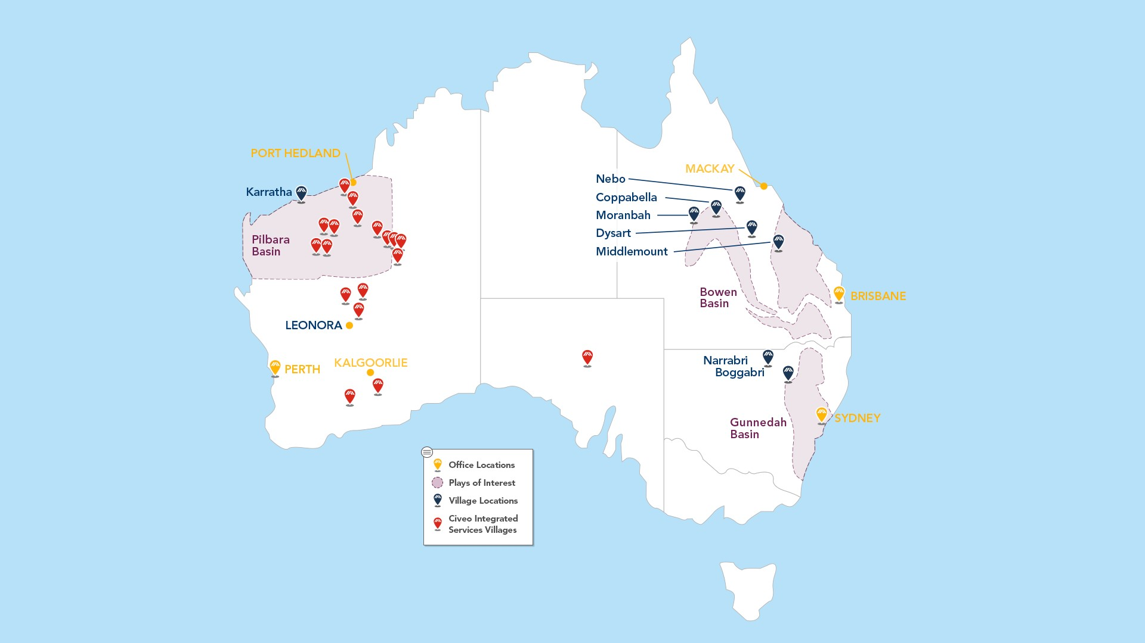

Owned Rooms in our Australian Villages
 |  |  |  |  |  |  |  |  |  |  |  |  |  |  |  |  |  | As of December 31,
Villages |  |  |  |  |  | Resource  Basin |  |  |  |  |  | Commodity |  |  |  |  |  | 2024 |  |  |  |  |  | 2023 |  |  |  |  |  | 2022
Coppabella |  |  |  |  |  | Bowen |  |  |  |  |  | met coal |  |  |  |  |  | 3,144 |  |  |  |  |  | 3,144 |  |  |  |  |  | 3,048
Dysart |  |  |  |  |  | Bowen |  |  |  |  |  | met coal |  |  |  |  |  | 1,798 |  |  |  |  |  | 1,798 |  |  |  |  |  | 1,798
Moranbah |  |  |  |  |  | Bowen |  |  |  |  |  | met coal |  |  |  |  |  | 1,240 |  |  |  |  |  | 1,240 |  |  |  |  |  | 1,240
Middlemount |  |  |  |  |  | Bowen |  |  |  |  |  | met coal |  |  |  |  |  | 816 |  |  |  |  |  | 816 |  |  |  |  |  | 816
Boggabri |  |  |  |  |  | Gunnedah |  |  |  |  |  | met/thermal coal |  |  |  |  |  | 662 |  |  |  |  |  | 622 |  |  |  |  |  | 622
Narrabri |  |  |  |  |  | Gunnedah |  |  |  |  |  | met/thermal coal |  |  |  |  |  | 502 |  |  |  |  |  | 502 |  |  |  |  |  | 502
Nebo |  |  |  |  |  | Bowen |  |  |  |  |  | met coal |  |  |  |  |  | 490 |  |  |  |  |  | 490 |  |  |  |  |  | 490
Karratha |  |  |  |  |  | Pilbara |  |  |  |  |  | LNG, iron ore |  |  |  |  |  | 298 |  |  |  |  |  | 298 |  |  |  |  |  | 298
Total Rooms |  |  |  |  |  |  |  |  |  |  |  |  |  |  |  |  |  | 8,950 |  |  |  |  |  | 8,910 |  |  |  |  |  | 8,814

Our Australian segment includes eight company-owned villages with 8,950 rooms as of December 31, 2024, which are strategically located near long-lived, low-cost mines operated by large mining companies. Our Australian business provides hospitality services to mining and related service companies under short- and medium-term contracts. Our growth plan for this part of our business continues to include enhanced occupancy and expansion of these properties where we believe there is durable long-term demand, as well as to provide hospitality services at customer-owned assets.

Our Coppabella, Dysart, Moranbah, Middlemount and Nebo villages are located in the Bowen Basin. Coppabella, at over 3,100 rooms, is our largest village and provides rooms and related hospitality services to a variety of customers. Each of these villages supports both operational workforce needs and contractor needs with resort style amenities, including swimming pools, gyms, a walking track and a tavern.

Our Narrabri and Boggabri villages in New South Wales provide rooms and related hospitality services to met and thermal coal mines and coal seam gas in the Gunnedah Basin. Our Karratha village, in Western Australia, services workforces related to LNG facilities operations on the Northwest Shelf.

8

Australian Hospitality Services at Third-Party Owned Facilities

We also provide hospitality services at customer-owned villages to the mining industry in Western Australia and South Australia. Historically, this has been focused on natural resource production-related village facilities that are primarily owned by iron ore production companies. We provide village hospitality services at 21 customer-owned locations, which represent over 17,000 rooms, primarily in the Pilbara region of Western Australia, one of the premier iron ore bodies in the world, and in the Goldfields-Esperance region of Western Australia. The facilities we manage range anywhere from 200 to over 1,900 rooms. We work together with our customers to customize our service offerings depending on our customer’s needs. Hospitality services can be performed on an end-to-end basis with catering and food service, housekeeping and site maintenance or just portions of the services offered such as food service only. Mine site office cleaning services are also provided at some of our customer-owned locations.

Canada

Overview

During the year ended December 31, 2024, we generated approximately 36% of our revenue from our Canadian operations. We are western Canada’s largest provider of hospitality services for people working in remote locations. We provide our services through our lodges and mobile assets and at customer-owned locations. Our hospitality services support workforces in the Canadian LNG and oil sands markets and in a variety of oil and natural gas drilling, mining, pipeline and related natural resource applications.

Canadian Market

Demand for our hospitality services in the Canadian market is largely driven by customer capital spending, which is greatly influenced by current and future commodity prices.

In the Canadian oil sands region, demand is primarily influenced by the longer-term outlook for oil prices rather than current energy prices, given the multi-year production life of oil sands projects and the capital investment associated with development of such large-scale projects. Demand for our Canadian lodges is secondarily impacted by oil takeaway capacity which influences the net price our customers receive for their oil production.

Spending on the construction and development of new projects generally decreases as the outlook for oil prices decreases. However, spending on current operations and maintenance has historically reacted less quickly and less severely to changes in oil prices, as customers consider their cash operating costs, rather than overall full-cycle returns. Customers have recently focused on lowering their cash operating costs while maintaining similar levels of production, leading to lower overall customer spending and reduced personnel on site and therefore lower demand for remote accommodations, like we provide. Construction and expansion projects already underway have also been less sensitive to commodity price decreases, as customers generally focus on completion and incremental costs. Natural gas prices also influence oil sands activity as an input cost: as natural gas prices fluctuate, a significant component of our customers’ operating costs fluctuate as well.

Another factor that influences demand for our hospitality services in the Canadian oil sands region is the type of customer project we are supporting. Generally, Canadian customers require larger workforces during construction and expansionary periods, and therefore have higher demand for our rooms and services. Operational and maintenance headcounts are typically a fraction, 20% to 25%, of the headcounts experienced during construction.

In addition, proximity to customer activity and availability of customer-owned and competitor-owned rooms influences the demand for our rooms in the Canadian oil sands region. Typically, customers prefer to first utilize their own rooms on location, and if such customer-owned rooms are insufficient, customers prefer to avoid busing their workforces to housing more than 45 kilometers away.

The Athabasca oil sands are located in northern Alberta, an area that is very remote, with a limited local labor supply. Of Canada’s approximately 41 million residents, approximately half of the population lives in ten cities, while approximately 12% of the population lives in Alberta and less than 1% of the population lives within 100 kilometers of the oil sands activity. The local municipalities, of which the town of Fort McMurray is the largest, have limited infrastructure to respond to workforce accommodation demands and are a significant driving distance from many of the oil sands projects. Civeo lodges are strategically placed near customer mining and production facilities to enhance their productivity and safety of their workforce.

9

With respect to LNG and related pipeline activity in Canada, a number of multinational energy companies believe there is a potential to export LNG from Canada to meet the increasing global LNG demand, particularly in Asia. Currently, Western Canada does not have any operational LNG export facilities. Phase 1 of the Kitimat LNG Facility is nearing completion, with commercial operations expected to begin in mid-2025. The population of Kitimat and the surrounding area is approximately 9,000 people, whereas the LNGC project had almost 7,500 workers at its peak to construct the Kitimat LNG Facility. See "Canada-Canadian British Columbia Lodge" for more information.

LNG investment and activity in Western Canada, and related demand for hospitality services, is influenced by the global prices for LNG, which are largely tied to global oil prices, global supply/demand dynamics for LNG and Western Canadian wellhead prices for natural gas. Utilization of our existing Canadian capacity and any future expansions will largely depend on continued LNG and oil sands spending related to existing production, maintenance activities and potential future expansion of existing projects.

Canadian Oil Sands Lodges

During the year ended December 31, 2024, activity in the Athabasca oil sands region generated approximately 82% of our Canadian revenue, or 30% of our consolidated revenue. The oil sands region continues to represent one of the world’s largest reserves for heavy oil. Our Wapasu Creek, Athabasca, Beaver River, Fort McMurray Village, Grey Wolf, Hudson, and Borealis lodges are focused on the northern region of the Athabasca oil sands, where customers primarily utilize surface mining to extract bitumen. Oil sands mining operations are characterized by large capital requirements, large reserves, larger personnel requirements, long-term reserve lives, very low exploration or reserve risk and relatively lower cash operating costs per barrel of bitumen produced. Our Conklin, Anzac, Red Earth and Wabasca lodges are focused in the southern portion of the region where we primarily serve in-situ operations and pipeline expansion and maintenance activity. In-situ methods are used on reserves that are too deep for traditional mining methods. In-situ technology typically injects steam or solvents into the deep oil sands in place to separate the bitumen from the sand and pumps it to the surface where it undergoes the same upgrading treatment as the mined bitumen. Reserves requiring in-situ techniques of extraction represent 80% of the established recoverable reserves in Alberta. In comparison to surface mining operations, in-situ operations generally require lower initial capital investment, fewer personnel but produce lower volumes of bitumen per development, with higher ongoing operating expense per barrel of bitumen produced.

Our oil sands lodges primarily support personnel for ongoing operations associated with surface mining and in-situ oil sands projects, as well as maintenance, turnaround and expansionary personnel, generally under short- and medium-term contracts. Most of our oil sands lodges are located on land with leases obtained from the province of Alberta, with initial terms of ten years, or subleased from the resource developer. Our leases have expiration dates that range from 2025 to 2030 with the exception of one lease that expires in 2049. In recent years, we have successfully renewed or extended all expiring land leases which we have requested to renew or extend. We did not renew an expiring land lease associated with our McClelland Lake Lodge in Alberta, Canada, which expired in June 2023, in order to support our customer’s intent to mine the land where the lodge was located. Two of our oil sands properties are located on land which we own.

In order to operate a lodge in Canada, we are required to obtain a development permit from the regional municipality in which the lodge is located. The development permits are granted for a term of five years. Our development permits have expiration dates that range from 2025 to 2028. In recent years, we have successfully renewed or extended all expiring development permits. See “Item 1A. Risk Factors - Risks Related to Our Operations - The majority of our major Canadian lodges are located on land subject to leases. If we are unable to renew a lease or obtain permits necessary to operate on such leased land, we could be materially and adversely affected.” of this annual report for further discussion.

We provide a range of hospitality services at our lodges, including reservation management, food service, housekeeping and facilities management. Our lodge guests receive amenities similar to an economy, full-service, urban hotel with our service offering a room and three meals a day.

We provide our hospitality services at the lodges we own on a day rate or monthly rental basis, and our customers typically commit for short to long-term contracts (from several months up to several years). Most customers make a minimum nightly or monthly room commitment or an aggregate total room night commitment for the term of the contract, and the multi-year contracts typically provide for inflationary escalations in rates for increased food, labor and utilities costs.

10

Canadian British Columbia Lodge

Phase 1 of the Kitimat LNG Facility is nearing completion, with commercial operations expected to begin in mid-2025. The Coastal GasLink Pipeline was completed in 2024 and entered commercial operations. As such, we expect continued lower occupancy at our Sitka Lodge in the near-term until subsequent phases of the LNGC project are approved and commence, or additional construction activity in the region drives increased occupancy demand.

Canadian Lodge Locations
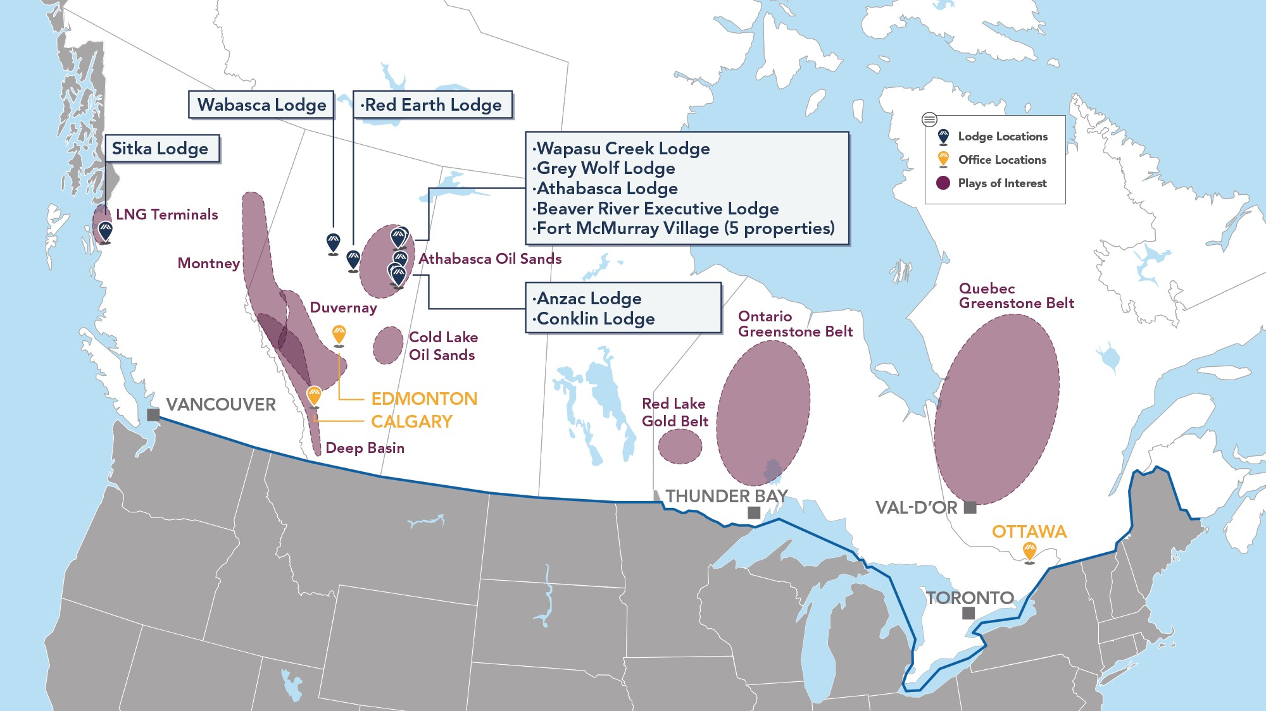

Rooms in our Canadian Lodges
 |  |  |  |  |  |  |  |  |  |  |  |  |  |  |  |  |  | As of December 31,
Lodges |  |  |  |  |  | Region |  |  |  |  |  | Extraction  Technique |  |  |  |  |  | 2024 |  |  |  |  |  | 2023 |  |  |  |  |  | 2022
Wapasu Creek |  |  |  |  |  | N. Athabasca |  |  |  |  |  | mining/in-situ |  |  |  |  |  | 5,174 |  |  |  |  |  | 5,174 |  |  |  |  |  | 5,174
Athabasca (1) |  |  |  |  |  | N. Athabasca |  |  |  |  |  | mining |  |  |  |  |  | 2,005 |  |  |  |  |  | 2,005 |  |  |  |  |  | 2,005
McClelland Lake (2) |  |  |  |  |  | N. Athabasca |  |  |  |  |  | mining |  |  |  |  |  | — |  |  |  |  |  | — |  |  |  |  |  | 1,997
Beaver River |  |  |  |  |  | N. Athabasca |  |  |  |  |  | mining |  |  |  |  |  | 1,094 |  |  |  |  |  | 1,094 |  |  |  |  |  | 1,094
Fort McMurray Village:
Buffalo (1) |  |  |  |  |  | N. Athabasca |  |  |  |  |  | mining |  |  |  |  |  | 256 |  |  |  |  |  | — |  |  |  |  |  | —
Black Bear |  |  |  |  |  | N. Athabasca |  |  |  |  |  | mining |  |  |  |  |  | 531 |  |  |  |  |  | 531 |  |  |  |  |  | 531
Bighorn |  |  |  |  |  | N. Athabasca |  |  |  |  |  | mining |  |  |  |  |  | 763 |  |  |  |  |  | 763 |  |  |  |  |  | 763
Lynx |  |  |  |  |  | N. Athabasca |  |  |  |  |  | mining |  |  |  |  |  | 855 |  |  |  |  |  | 855 |  |  |  |  |  | 855
Wolverine |  |  |  |  |  | N. Athabasca |  |  |  |  |  | mining |  |  |  |  |  | 855 |  |  |  |  |  | 855 |  |  |  |  |  | 855
Borealis (1) |  |  |  |  |  | N. Athabasca |  |  |  |  |  | mining |  |  |  |  |  | 1,504 |  |  |  |  |  | 1,504 |  |  |  |  |  | 1,504
Grey Wolf |  |  |  |  |  | N. Athabasca |  |  |  |  |  | mining |  |  |  |  |  | 946 |  |  |  |  |  | 946 |  |  |  |  |  | 946
Hudson (1) |  |  |  |  |  | N. Athabasca |  |  |  |  |  | mining |  |  |  |  |  | 624 |  |  |  |  |  | 624 |  |  |  |  |  | 624
Wabasca (1) |  |  |  |  |  | S. Athabasca |  |  |  |  |  | mining |  |  |  |  |  | 288 |  |  |  |  |  | 288 |  |  |  |  |  | 288
Red Earth (1) |  |  |  |  |  | S. Athabasca |  |  |  |  |  | mining |  |  |  |  |  | 216 |  |  |  |  |  | 216 |  |  |  |  |  | 216
Conklin (1) |  |  |  |  |  | S. Athabasca |  |  |  |  |  | mining/in-situ |  |  |  |  |  | 610 |  |  |  |  |  | 610 |  |  |  |  |  | 610
Anzac (1) |  |  |  |  |  | S. Athabasca |  |  |  |  |  | in-situ |  |  |  |  |  | 526 |  |  |  |  |  | 526 |  |  |  |  |  | 526
Subtotal – Oil Sands |  |  |  |  |  |  |  |  |  |  |  |  |  |  |  |  |  | 16,247 |  |  |  |  |  | 15,991 |  |  |  |  |  | 17,988
Sitka Lodge |  |  |  |  |  | Kitimat, BC |  |  |  |  |  | LNG |  |  |  |  |  | 961 |  |  |  |  |  | 961 |  |  |  |  |  | 961
Total Rooms |  |  |  |  |  |  |  |  |  |  |  |  |  |  |  |  |  | 17,208 |  |  |  |  |  | 16,952 |  |  |  |  |  | 18,949

11

(1)Currently closed as of December 31, 2024, due to lodge loading strategy, seasonal activity fluctuations or low activity level in the region. All closed lodges are periodically assessed for impairment at an asset group level, in accordance with U.S. generally accepted accounting principles. See Note 4 - Impairment Charges to the notes to the consolidated financial statements in Item 8 of this annual report for further discussion.
(2)The land lease associated with the assets expired in June 2023 and was not renewed and the assets were demobilized and completely removed from the existing site in the first quarter of 2024.

Canadian Hospitality Services at Third-Party Owned Facilities

We also provide hospitality services at customer-owned facilities. Historically, this has been focused around natural resource production-related housing facilities that are owned by oil production companies. The facilities we manage typically range anywhere from 500 to 1,500 rooms. We customize our service offerings depending on our customer’s needs. Hospitality services can be performed on an end-to-end basis with food service, housekeeping, maintenance and utility services included or in segments such as food service only. Our focus on hospitality service contracts has allowed us to successfully pursue food service only opportunities. Due to our experience servicing customer-owned facilities, this business easily fits into our overall strategy.

Canadian Mobile Assets
Our mobile assets consist of modular, skid-mounted accommodations and central facilities that can be configured to serve a multitude of short- to medium-term accommodation needs. Dormitory, kitchen and ancillary assets can be rapidly mobilized and demobilized and are scalable to support 200 to 800 people in a single location. In addition to asset rental, we provide hospitality services such as food service and housekeeping, as well as other camp management services. Our mobile assets service the traditional oil and gas sector in Alberta and British Columbia and in-situ oil sands drilling and development operations in Alberta, as well as pipeline construction crews throughout Western Canada. These assets have also been used in the past in disaster relief efforts, the 2010 Vancouver Winter Olympic Games and a variety of other non-energy related projects.

Our mobile assets are rented on a per unit basis based on the number of days that a customer utilizes the asset, and, in some cases, involve standby rental arrangements. In cases where we provide food service or ancillary services, the contract can provide for per unit pricing or cost-plus pricing. Customers are also typically responsible for mobilization and demobilization costs. Our focus on hospitality service contracts has allowed us to successfully pursue food service only opportunities. Due to our experience servicing customer-owned facilities, this business easily fits into our overall strategy.

United States

In the first quarter of 2023, we sold our accommodation assets in Louisiana, and in the second quarter of 2024, we sold the land at our Louisiana location. Our remaining U.S. business, which supported completion activity in the Bakken, was closed in the fourth quarter of 2024 due to low activity levels.

Community Engagement

In Australia, our community relations program aims to build and maintain a positive social license to operate by consulting and engaging with local regional communities from project inception, through development, construction and operations. This is a major advantage for our business model, as it facilitates consistent communication, engenders trust and builds relationships to last throughout the resource lifecycle. There is an emphasis on developing partnerships that create a long-term sustainable outcome to address specific community needs. To that end, we partner with local municipalities to improve and expand municipal infrastructure. These improvements provide necessary infrastructure, allowing the local communities an opportunity to expand and improve. We also provide support to local community groups through sponsorship and in-kind contributions to local events and initiatives. In addition, all of our food suppliers are Australian companies and, where possible, are based locally. Through our membership with Supply Nation, a non-profit organization committed to supplier diversity and Indigenous business development, we directed approximately A$15.3 million in 2024, up 24% from A$12.3 million in 2023, into Indigenous-owned and operated companies, and we are always looking for more opportunities to partner with these businesses.

In addition, we have three unincorporated joint venture partnerships with Indigenous landowners in Western Australia. Under these agreements, we strive to develop the business capacity, project management skills and expertise of the Indigenous joint venture members, providing local employment opportunities and training. One of the four unincorporated joint venture partnerships entitles Indigenous landowners to a profit distribution calculated in accordance with the unincorporated joint venture deeds. Additionally, two of the three remaining agreements incentivize the joint venture members via milestone payments for business objectives achieved.

12

With a focus on long-term Indigenous community participation, our Canadian operations continue to work closely with a number of First Nations to develop mutually beneficial partnerships focused on revenue sharing, capacity building, employment and community investment and support. For over a decade, our Canadian operations supported Buffalo Metis Catering, a partnership with three Metis communities in the Regional Municipality of Wood Buffalo. Through this partnership, food and housekeeping services were delivered to three of our lodges. Beyond these services, this partnership provided a business incubator environment for a number of Metis business ventures. Our Canadian operations also procure services from a number of other First Nations-owned, Metis-owned and member-owned businesses including water hauling, snow removal and security services. In 2024, we purchased more than C$31.3 million in goods and services from the Indigenous business community, representing 16% of our total Canadian local spending, compared to C$64.0 million in goods and services from the Indigenous business community, representing 27% of our total Canadian local spending in 2023.

In 2024, the Fort McMurray First Nation Economic Development Corporation awarded Civeo with the Eagle Award, for Civeo’s commitment to positively impacting and contributing to the long-term benefits of the members of the Fort McMurray First Nation. In 2021, the Fort McKay Metis community awarded Civeo with the inaugural 2020 Fort McKay Metis National President's Award. This award recognizes people or organizations who make a positive contribution to the well-being of the Metis community. In 2023 and in 2019, our Indigenous partnership initiatives earned Civeo a Gold level Partnership Accreditation in Indigenous Relations certification, by a jury comprised of Indigenous business people, which was supported by an unbiased, independent, third-party verification of our performance.

In 2018, Civeo entered into three new Indigenous partnerships in the oil sands region and two new partnerships in British Columbia and, in 2021, Civeo entered into a new partnership in British Columbia. Our partnerships in British Columbia are tied to accommodations contracts secured by Civeo for (i) the Kitimat LNG Facility, (ii) the CGL pipeline project that originates in the North Montney region of north-east British Columbia and (iii) the Trans Mountain expansion project that twins an existing pipeline between Edmonton, Alberta and Burnaby, British Columbia. In 2024, Civeo entered into an agreement with an Indigenous group in Ontario and is currently in the process of developing business opportunities. Beyond revenue sharing, these arrangements provide procurement, employment, training, and ancillary business opportunities for Indigenous owned businesses.

Customers and Competitors

Our customers primarily operate in oil sands mining and development, drilling, exploration and extraction of oil and natural gas and coal and other extractive industries. To a lesser extent, we also support other activities, including pipeline construction, forestry and humanitarian aid. Our largest customers in 2024 were Suncor Energy Inc. and Fortescue Metals Group Ltd., who each accounted for more than 10% of our 2024 revenues.

Our primary competitors in Australia for our village hospitality services are customer-owned and operated villages as well as Ausco Modular (a subsidiary of Modulaire Group), Fleetwood Corporation and smaller independent village operators. We compete against ISS, Sodexo, Compass Group, Northern Rise (as a division of Sirrom Corporation) and Cater Care for third-party facility management services.

Our primary competitors in Canada in lodge and mobile asset hospitality services include ATCO, Black Diamond, Dexterra and Clean Harbors, Inc. Some of these competitors have one or two locations similar to our oil sands lodges; however, based on our estimates, these competitors do not have the breadth or scale of our lodge operations. In Canada, we also compete against Aramark, Sodexo, Compass Group and Royal Camp Services for third-party facility management and hospitality services.

Historically, many customers have invested in their own accommodations. We estimate that our existing and potential customers own approximately 50% of the rooms available in both the Australian coal mining regions and Canadian oil sands.

Our Lodge and Village Contracts

During the year ended December 31, 2024, revenues from our lodges and villages represented over 60% of our consolidated revenues. Our contract terms generally provide for a daily rate for a reserved room and an occupied room rate that compensates us for hospitality services, including food service, housekeeping, utilities and maintenance for workers staying in the lodges and villages. In most multi-year contracts, our rates typically have annual escalation provisions to cover increases in labor, food and consumables costs over the contract term. In some contracts, customers have a contractual right to terminate, for reasons other than a breach, in exchange for a termination fee. Our customers typically contract for hospitality services under contracts with terms that range from several months to twelve years. The contracts expire throughout the year, and for many of the near-term expirations, we are in the process of negotiating extensions or new commitments. We cannot assure that we can renew existing contracts or obtain new business on the same or better terms, if at all.

13

Long-Term Take-or-Pay Contracts. Over the term of a take-or-pay contract, the customer commits to either a minimum number of rooms over a specified period or an aggregate number of room nights over the period, generally for terms greater than 12 months. During the year ended December 31, 2024, we billed approximately 2.3 million room nights under our long-term take-or-pay contracts, which included 0.5 million room nights in excess of the take-or-pay minimums. For the year ended December 31, 2025, we have commitments for 1.9 million room nights under our long-term take-or-pay contracts.

Short-Term Take-or-Pay Contracts. Customers may contract with us on a take-or-pay basis for less than 12 months, particularly for turnaround projects. Similar to long-term take-or-pay contracts, the customer commits to either a minimum number of rooms over a specified period or an aggregate number of room nights over the period. During the year ended December 31, 2024, we billed approximately 0.7 million room nights under our short-term take-or-pay contracts. For the year ended December 31, 2025, we have commitments for 0.1 million room nights under our short-term take-or-pay contracts.

Exclusivity Contracts. Over the term of an exclusivity contract, rather than receiving a minimum room commitment, we are the exclusive hospitality service provider for the customer's employees working on a specific project or projects. During the year ended December 31, 2024, we billed approximately 1.7 million room nights under our exclusivity contracts.

Casual / Walk-ins. Customers without long-term committed contracts may utilize lodge/village rooms via short-term bookings at lodge/village casual or agreed rates. During the year ended December 31, 2024, we billed approximately 0.1 million room nights to casual or walk-in customers.

Our Integrated Services Contracts

During the year ended December 31, 2024, revenues from our customer-owned locations represented 38% of our consolidated revenues. Our contract terms generally provide a rate on a per guest per day basis for hospitality services, including food service and housekeeping. Similar to our owned lodge and villages contracts, in most multi-year contracts, our rates typically have annual escalation provisions to cover increases in labor, food and consumables costs over the contract term.

Seasonality of Operations

Our operations are directly affected by seasonal weather. During the Australian rainy season between November and April, our operations in Queensland and the northern parts of Western Australia can be affected by cyclones, monsoons and resultant flooding. A portion of our Canadian operations is conducted during the winter months when the winter freeze in remote regions is required for customers’ activity to occur. The spring thaw in these frontier regions restricts operations in the second quarter and adversely affects our customers' operations and our ability to provide services. Customers’ maintenance activities in the oil sands region, such as shutdown and turnaround activity, are typically performed in the second and third quarters annually. Our Canadian operations have also been impacted by forest fires and flooding in the past five years.

Human Capital Resources

We believe that our employees are one of our greatest resources. As of December 31, 2024, we had approximately 2,000 full-time employees and approximately 600 hourly employees. On a consolidated basis, 71% of our employees are located in Australia, 28% are located in Canada and 1% are located in the U.S. We were party to collective bargaining agreements covering 480 employees located in Canada and 1,401 employees located in Australia as of December 31, 2024.

As a company, we acknowledge the significance of a diverse workforce composed of individuals from various backgrounds, experiences, and perspectives. As many of our projects in Canada and Australia operate in traditional territories, we work closely with Indigenous communities to actively explore mutually beneficial investment, employment and business opportunities. Our ability to cultivate and strengthen relationships with Indigenous communities is vital to the success of our business. In Canada, we are committed to expanding our Indigenous workforce to 10%. In 2024, we reached 5% Indigenous employment in Canada, excluding corporate staff. Approximately 6% of our total new hires in Canada were of Indigenous background during 2024.

We strive to offer competitive compensation, benefits and services that meet the needs of our employees, including short- and long-term incentive packages, various defined contribution plans, healthcare benefits, and wellness and employee assistance programs. Management monitors market compensation and benefits in order to attract, retain, and promote employees and reduce turnover and its associated costs.

Safety is a foundational pillar of Civeo’s corporate culture. We are committed to operating in a safe, secure and responsible manner for the benefit of our employees, customers and the communities we serve. Our commitment to safeguarding employees,
14

contractors, and guests is demonstrated through our employee-named Making Zero Count initiative, which emphasizes the importance of eliminating harm and focuses on the processes required to achieve exceptional performance.

At Civeo, we believe that investing in our employees is fundamental to our success. Our commitment to training and career development enables employees to grow and advance in their careers while supporting our industry-leadership position. Committed to the continuous improvement of our team, we prioritize the development of our workforce’s technical and managerial competencies, with an emphasis on safety, customer service, and leadership development. Our learning and development program encompasses a range of learning modalities, including e-learning modules, in-person training sessions, nationally certified programs and licensed training provided by external partners.

Government Regulation

Our business is significantly affected by Australian and Canadian laws and regulations at the federal, provincial, state and local levels relating to the oil, natural gas and mining industries, worker safety and environmental protection. Changes in these laws, including more stringent regulations and increased levels of enforcement of these laws and regulations, and the development of new laws and regulations could significantly affect our business and result in:

•increased difficulty securing required permits, approvals, licenses or other authorizations issued by federal, provincial and local authorities needed to carry out our operations or our customers' operations;
•increased compliance costs or additional operating restrictions associated with our operations or our customers’ operations;
•other increased costs to our business or our customers’ business;
•reduced demand for oil, natural gas, and other natural resources that our customers produce; and
•reduced demand for our services.

To the extent that these laws and regulations impose more stringent requirements or increased costs or delays upon our customers in the performance of their operations, the resulting demand for our services by those customers may be adversely affected, which impact could be significant and long-lasting. Moreover, climate change laws or regulations could increase the cost of consuming, and thereby reduce demand for, oil and natural gas, which could reduce our customers’ demand for our services. We cannot predict changes in the level of enforcement of existing laws and regulations, how these laws and regulations may be interpreted or the effect changes in these laws and regulations may have on us or our customers or on our future operations or earnings. We also are not able to predict the extent to which new laws and regulations will be adopted or whether such new laws and regulations may impose more stringent or costly restrictions on our customers or our operations.

Our operations and the operations of our customers are subject to numerous stringent and comprehensive foreign, federal, provincial, state and local environmental laws and regulations governing the release or discharge of materials into the environment or otherwise relating to environmental protection. Numerous governmental agencies issue regulations to implement and enforce these laws, for which compliance is often costly yet critical. The violation of these laws and regulations may result in the denial or revocation of permits, issuance of corrective action orders, modification or cessation of operations, assessment of administrative and civil penalties, and even criminal prosecution. Although we do not anticipate that future compliance with existing environmental laws and regulations will have a material effect on our financial condition, results of operations or cash flows over the short term, there can be no assurance that substantial costs for compliance or penalties for non-compliance with these existing requirements will not be incurred in the future by us or our customers. Moreover, it is possible that other developments, such as the adoption of stricter environmental laws, regulations and enforcement policies or more stringent enforcement of existing environmental laws and regulations, could result in additional costs or liabilities upon us or our customers that we cannot currently quantify.

Australian Environmental Regulations

Our Australian segment is regulated by statutory environmental and land use controls at the federal, state and territory and local government levels which may result in land use approval, regulation of operations and compliance risk. These controls include: land use and urban design controls; controls to protect Australia’s natural environment, iconic places and Aboriginal and Torres Strait islander native title and heritage; the regulation of hard and liquid waste, including the requirement for trade waste and/or wastewater permits or licenses; the regulation of water, noise, heat, and atmospheric gases emissions; the regulation of the production, transport and storage of dangerous and hazardous materials (including asbestos); the regulation of pollution and site contamination and requirements to notify of and clean-up environmental contamination.

15

Federal Controls

At a federal level, the Environment Protection and Biodiversity Conservation Act 1999 (EPBC Act) is Australia’s key piece of environmental legislation. The EPBC Act protects of matters of national environmental significance, for example, threatened species and communities (e.g. Koalas), migratory species, Ramsar wetlands and world heritage properties. Activities that have the potential to impact matters protected by the EPBC Act trigger referral to the federal government for assessment and approval.

In October 2020, the findings of an independent review of the EPBC Act (Independent Review) recommended significant reforms including (but not limited to) introduction of legally binding ‘National Environmental Standards’, a ‘climate change’ referral trigger, measures to harness and recognize the importance of indigenous knowledge, stronger compliance and enforcement powers, proposals for revised bilateral agreements with the States and Territories to streamline the assessment and approval process of some activities regulated by the EPBC Act and criminal penalties for offenses relating to emissions-intensive actions.

In December 2022 the federal government announced its response to the Independent Review. This response proposed various changes to the EPBC Act in line with the Independent Review, for example, the introduction of ‘National Environmental Standards’, creation of a federal Environmental Protection Agency to administer the EPBC Act and the introduction of a requirement to achieve ‘net positive’ outcomes. A comprehensive draft bill to effect these reforms was introduced before Parliament in 2024 together with a draft of the proposed National Environmental Standards. Notably, the federal government is not presently proposing to introduce the climate change referral trigger recommended by the Independent Review; however, there appears to be significant support for the trigger amongst opposition parties, and a federal election will occur in 2025.

If any of the recommended reforms take effect, our obligations under, and compliance with, the EPBC Act ought to be reviewed. However, its implications for our Australian operations are not anticipated to be significant.

Ongoing awareness of these reforms is important as the legislative and policy changes may affect our customers’ operations and have impacts on the non-renewable resources sector generally.

There is an increasing emphasis from regulators on sustainability and energy efficiency in business operations. Federal requirements are now in place for the mandatory disclosure of energy performance under building rating schemes. These schemes require the tracking of specific environmental performance factors. Carbon reporting requirements currently exist for corporations which meet a reporting threshold for greenhouse gases (GHG) or energy use or production for a reporting (financial) year under federal legislation.

From July 1, 2023, new obligations and reporting requirements took effect with respect to the ‘Safeguard Mechanism’ – Australia’s policy for reducing emissions from facilities that emit more than 100,000t CO2-e per financial year that has been in place since 2016. These reforms are intended to assist Australia meet its emissions reduction targets of 43% below 2005 levels by 2030 and affect large scale industry customers.

In 2024, the federal government introduced further legislation requiring companies that satisfy key threshold criteria based upon employee numbers and/or revenue, to make climate-related disclosures, including information about their GHG emissions, climate-related targets, offset contributions, transition plans, and information about strategies, plans and governance procedures/controls in place to monitor and manage climate-related risks and opportunities. These reforms will commence with initial reporting required in 2026 for the preceding year. Civeo meets the relevant thresholds and will be required to make these annual disclosures in Australia.

In addition to our own requirement to commence disclosure to ASIC in accordance with the new legislation, our operations represent a portion of each of our customer’s Scope 3 emissions; we will be required by our customers to provide certain emissions information in order for our customers to meet their disclosure obligations. Complexity and resourcing are identified as significant challenges as we navigate the new legislation.

State and Territory Controls

At a State and Territory level, our operations are authorized and regulated by layers of planning and environmental approvals. Queensland, New South Wales and Western Australia all have multiple acts regulating matters of the environment, conservation, vegetation management and protection of aboriginal and Torres Strait Islander use rights which are administered by each States’ independent environment protection regulator (e.g. Queensland’s Department of Environment, Science and
16

Innovation). If amendments are made to the EPBC Act to effect new bilateral agreements, the States and Territories will likely be given further power to assess and approve certain actions regulated the EPBC Act.

Under state law, some specified activities, such as sewage treatment at our sites, may require regulation by way of environmental approvals. Such approvals may also impose monitoring and reporting obligations on the holder as well as obligations to rehabilitate the subject site once the regulated activity has ceased.

We must ensure that all necessary approvals, permits and licenses are in place to authorize our operations and that the conditions of those approvals, permits and licenses are complied with until the relevant operations cease (and are cleaned-up if necessary). Where approvals are not held and/or complied with, the operation may be unlawful and subject to penalties, including stop-work orders, remediation orders and financial penalties. Our Australian operations continue to comply with our existing approvals, permits and licenses.

We have a positive obligation under state legislation to notify of an incident causing (or threatening) serious or material environmental harm. Examples of notifiable environment harm include effluent overflow, chemical leaks and chemical fires. Failure to discharge this obligation can attract significant sanctions and financial penalties.

Local Government

At a local government level, our operations are subject to, and regulated by, local laws administered by local government authorities. Local laws may cover matters such as operation of certain activities, management of vegetation and natural and anthropogenic hazards, actionable nuisance and fencing. Local laws differ between each local government area and we must understand and operate within these laws as they apply to our operations Australia wide.

Canadian Environmental Regulations

In Canada, the federal and provincial governments both have jurisdiction to regulate environmental matters. The provincial governments may also devolve jurisdiction over environmental matters to local governments. Our activities, or those of our customers, may be subject to environmental regulations imposed by these three levels of government. The following addresses updates to Canadian federal and provincial environmental regulations in 2024 that may affect us or our customers.

Proposed Oil Sands Mining Effluent Regulations

Oil sands mines use hot water to separate bitumen from sand. Oil sands operators then store this process-affected water in large tailings ponds. In the tailings ponds, the fine suspended particles separate out and fall to the bottom. The process-affected water is then reused. Currently, oil sands mining operators are unable to discharge treated process-affected water and must maintain such water in on-site storage facilities. Oil sands operators have indicated a need to discharge that process-affected water as a result of storage constraints and reclamation obligations. Regulations are being proposed to allow treated process-affected water to be released back into the Athabasca River system.

In May 2024, the Government of Canada released a preliminary report outlining proposed solutions and public concerns. Industry representatives expressed concern that the proposed regulations would cause delays because of regulatory uncertainty and put capital decisions at risk. Industry representatives called for regulation by 2025 to reduce uncertainty but no definitive plans have been announced by the Government of Canada. Planning for and meeting these proposed regulations may result in additional costs or liabilities for our customers’ operations.

Proposed Emissions Cap

In November 2024, Canada announced the latest version of the proposed Oil and Gas Sector Greenhouse Gas Emissions Cap Regulations (the Proposed Emissions Cap). The Proposed Emissions Cap aims to use a cap-and-trade system to reduce emissions by 35% below 2019 levels by 2030. If the Proposed Emissions Cap is approved, it will be phased in beginning in 2026. As currently proposed, the cap-and-trade system would apply to liquified natural gas producers as well as producers in the conventional oil, offshore, oil sands and natural gas production and processing subsectors. Producers would be required to reduce their emissions or purchase "allowances" from other facilities that have reduced their emissions. These requirements, if implemented, may result in additional costs or liabilities for our customers’ operations.

The Government of Alberta and the oil and gas industry oppose the Proposed Emissions Cap and argue that it serves as a de facto production cap. The Proposed Emissions Cap is currently undergoing a feedback period and the final and binding
17

regulations are not expected to be released until late 2025. If the Proposed Emissions Cap becomes law, the Canadian oil and gas industry may be significantly harmed.

Air Quality Management

The Government of Canada (Canada), the Government of Alberta (Alberta), and the Government of British Columbia (British Columbia) each have frameworks for air quality management that may affect us and our customers.

At the federal level, the Reduction in the Release of Volatile Organic Compounds Regulations (Petroleum Sector) were published in 2020 and have not been amended since January 2023. Certain leak detection and repair provisions of the regulations took effect beginning in 2021 and the regulations set additional monitoring and requirements for operators in 2022 and 2023. These regulations require the implementation of comprehensive leak detection and repair (LDAR) programs as well as design and operating standards that prevent leaks at Canadian petroleum refineries, upgraders and certain petrochemical facilities and may affect our customers’ operations.

In addition to federal requirements, emissions from facilities in Alberta are subject to provincial regulation. The Alberta Energy Regulator (AER), which is responsible for regulating upstream oil and gas activity in Alberta and oversees compliance with Directive 060: Upstream Petroleum Industry Flaring, Incinerating, and Venting (Directive 60). Directive 60 was last updated in April 2020 and applies to all upstream petroleum industry wells, facilities and pipelines as well as all oil sands schemes and operations with the exception of oil sands mining. Directive 60 requires operators to eliminate or reduce flaring associated with a wide variety of energy development activities and operations. In December 2018, the AER finalized amendments to Directive 60 and Directive 017: Measurement Requirements for Oil and Gas Operations (Directive 17) as part of its role in implementing commitments from the Alberta government to reduce methane emissions from upstream oil and gas operations by 45% by 2025. Alberta achieved this goal in 2022, three years ahead of schedule. These requirements, among other things, set limits on methane emissions from various facilities and require annual reporting of such emissions to the AER. The methane reduction requirements in Directive 60 took effect in 2020, additional vent gas limits took effect on January 1, 2022 and further, more stringent vent gas limits took effect on January 1, 2023. Meeting these regulatory requirements may result in additional costs or liabilities for our customers’ operations.

Similarly, emissions from facilities in British Columbia are also subject to provincial regulation. The British Columbia Energy Regulator (BCER) is responsible for regulating oil and gas activity in British Columbia. BCER oversees compliance with the Drilling and Production Regulation, which is one of British Columbia's primary regulatory instruments governing all aspects of oil and natural gas drilling and production. Effective January 1, 2020, that regulation was amended to require operators to eliminate or reduce natural gas leaking or venting associated with a wide variety of equipment and activities in energy development. Under this regulation, requirements are imposed for facilities detecting leaks and inspecting seals as well as restrictions or prohibitions on the types of equipment used for energy development. Some of these requirements took effect in 2022 and further requirements took effect on January 1, 2023. In addition, the BCER completed consultation in 2023 on proposed amendments to the Drilling and Production Regulation to maintain equivalency with federal requirements. Regulations designed to achieve a 45% reduction in methane emissions relative to 2014 levels by 2025 are now in place. The BCER is currently conducting a regulatory review and engagement on the development of new regulations designed to achieve a 75% reduction in methane emissions from the oil and gas sector by 2030 relative to 2014 levels. Meeting these regulatory requirements may result in additional costs or liabilities for our customers’ operations.

Environmental Assessment of Major Projects

The Impact Assessment Act (IAA) came into force in August 2019. The IAA and its subordinate legislation apply to the development of many large projects, including oil sands mining and in situ projects, met mining projects, pipelines, and other large developments. One of the stated objectives of the IAA was to shorten review times for projects. However, concerns about lengthy reviews that require substantial information from project proponents remain even after the implementation of the IAA. Our customers operate in the aforementioned industries and could be considering future projects that would be subject to the IAA. To the extent our customers are required to comply with this legislation, it is possible that the uncertainty regarding cost and timelines for navigating the planning, assessment, and decision-making processes may negatively impact our customers' decisions on whether to proceed with those projects.

The Government of Alberta, supported by the governments of Ontario and Saskatchewan, challenged the constitutionality of the IAA. In October 2023, the Supreme Court of Canada ruled that a large portion of the IAA was unconstitutional because it infringed upon areas of provincial jurisdiction. In June 2024, the federal government significantly amended the IAA. Changes included narrowing the scope of federal responsibility, increasing cooperation between federal and provincial governments and providing an interim plan to smooth the transition from the old IAA to the amended IAA. However, despite the amendments,
18

there remains significant uncertainty about the future impact of Canada's federal environmental assessment legislation on our customers.

Climate Change Regulation

Scientific studies have suggested that emissions of GHG, including carbon dioxide and methane, may be contributing to warming of the Earth’s atmosphere and other climatic changes. In December 2015, 196 countries, including Canada, Australia and the U.S., adopted the Paris Agreement at the 2015 United Nations Climate Change Conference. The stated goal of the Paris Agreement is to hold “the increase in the global average temperature to well below 2°C above pre-industrial levels” and pursue efforts “to limit the temperature increase to 1.5°C above pre-industrial levels.” To reach these goals, the Paris Agreement requires parties to submit Nationally Determined Contributions (NDCs) which set out their emission reduction targets. NDCs are updated every five years with increasingly ambitious targets.

In March 2016, the government of Canada and the U.S. jointly announced their intention to take action to reduce methane emissions from the oil and gas sector in an effort to meet their respective NDCs pursuant to the Paris Agreement. For its part, Canada announced its intention to reduce methane emissions from the oil and gas sector by 40-45 percent below 2012 levels by 2025. Canada is on track to meet this target. In 2018, Canada introduced the Regulations Respecting Reduction in the Release of Methane and Certain Volatile Organic Compounds (Upstream Oil and Gas Sector) (Federal Methane Regulations) to implement its methane commitment. The Federal Methane Regulations impose various quantity-based limits on the venting of natural gas (or in the case of well completions involving hydraulic fracturing, a ban on such venting) and include associated conservation, measurement, inspection and corrective action requirements. Certain requirements of the Federal Methane Regulations came into effect January 1, 2020, and other emissions limits are now in place for certain equipment installed on or after January 1, 2023.

In March 2022, the federal government began consultation on a proposed strategy to expand coverage and increase stringency of methane reduction obligations on the oil and gas sector specifically, and was expected to issue draft regulations in 2023. In December 2023, the federal government published proposed amendments to the Federal Methane Regulations for public comment. The proposed amendments are intended to reduce methane emissions in Canada's upstream oil and gas sector by at least 75% below 2012 levels by 2030. To achieve that objective, the proposed amendments would prohibit venting natural gas to the environment, subject to limited exceptions. They would also impose requirements on hydrocarbon combustion systems and measures to reduce fugitive methane emissions. As of December 2024, the proposed amendments have not been enacted. The proposed amendments may result in additional costs or liabilities for our customers’ operations.

In 2018, the federal government enacted the Greenhouse Gas Pollution Pricing Act (GGPPA), which came into force on January 1, 2019. This regime has two parts: an output-based pricing system for large industry and a regulatory fuel charge. This system serves as a "backstop" and applies in provinces and territories that request it and in those that do not have their own emissions pricing systems in place that meet the federal standards. This ensures that there is a uniform price on emissions across the country. As of December 2024, the backstop price is $80 per tonne of CO2e. The current government plan is to continue increasing that price by $15 each year until it reaches $170/tonne of CO2e in 2030.

On November 19, 2020, the federal government introduced the Canadian Net-Zero Emissions Accountability Act in Parliament. That Act was passed by Parliament and received Royal Assent on June 29, 2021 and binds the Government of Canada to a process intended to help Canada achieve net-zero emissions by 2050. It also establishes rolling five-year emissions-reduction targets and requires the government to develop plans to reach each target. The federal government is required to support those efforts by creating a Net-Zero Advisory Body and by publishing annual reports that describe how departments and Crown corporations are considering the financial risks and opportunities of climate change in their decision-making. The current 2030 Emissions Reduction Plan is an ambitious target to reduce emissions by 40% below 2005 levels by 2030.

In addition, the federal government amended the Canadian Environmental Protection Act, 1999 (CEPA) in 2023. In particular, the preamble to CEPA now recognizes that every individual in Canada has a right to a healthy environment. The Government of Canada must now take into consideration this right, including the principles of environmental justice, when making decisions under CEPA, including its regulation of GHG emissions in Canada. In October 2024, Canada unveiled a draft framework to protect the right to a healthy environment through further modernization of the CEPA. As of December 2024, the draft framework still has not been finalized and there remains significant uncertainty regarding how these proposed changes to the CEPA will be implemented and the potential of the proposed changes to affect our customers' operations.

In Alberta, GHGs are regulated pursuant to the Emissions Management and Climate Resilience Act and the Technology Innovation and Emissions Reduction Regulation (TIER Regulation). In December 2019, the TIER Regulation was deemed equivalent to the backstop prescribed by the federal GGPPA, meaning that facilities within Alberta subject to the TIER Regulation are not subject to the full costs of complying with the GGPPA. The TIER Regulation generally applies to Alberta-based facilities that emit over 100,000 tonnes of CO2e per year. Under the TIER Regulation, emissions from each facility are
19

compared to either an industry-wide benchmark or a facility-specific benchmark which effectively permits facilities to emit GHGs up to a certain amount without being subject to the provincial carbon price. Those benchmarks “tighten” resulting in more onerous compliance costs, every year. Facilities with emissions that exceed the industry-wide benchmark or facility-specific benchmark, as applicable, must rely on one or more of the compliance options established by the TIER Regulation, such as purchase credits or offsets for each tonne of CO2e in excess of their limits. The Alberta government issues an order every year setting the price to acquire credits, which effectively dictates compliance costs. In January 2023, the Alberta government published amendments to the TIER Regulation, including increases to the carbon price and increases to annual benchmark tightening rates. These changes were implemented in order to ensure that the TIER Regulation maintains equivalency with the framework established by GGPPA. Increases to the cost of TIER Regulation credits and annual benchmark tightening rates may result in additional costs or liabilities for our customers’ operations. In addition, similar increases in stringency of provincial GHG regulatory frameworks within British Columbia and Saskatchewan may result in additional costs or liabilities for our customers’ operations.

The Canadian Species at Risk Act (SARA) is intended to prevent wildlife species in Canada from disappearing and to provide for the recovery of wildlife species that no longer exist in the wild in Canada, or that are endangered or threatened as a result of human activity, and to manage species of special concern to prevent them from becoming endangered or threatened. Alberta’s Wildlife Act is similar legislation designed to protect wildlife in Alberta. The designation of previously unprotected species as threatened or endangered in areas of Canada where our customers’ oil and natural gas exploration and production operations are conducted could cause them to incur increased costs arising from species protection measures or could result in limitations on their exploration and production activities, which could have an adverse impact on demand for our services.

Woodland caribou habitat covers large portions of several Canadian provinces including British Columbia, Alberta, and Saskatchewan. Many of our customers have existing or proposed developments in or near woodland caribou habitat. Conservation measures imposed by the federal or provincial governments could affect the business of our customers with operations near caribou habitat. In October 2020, Alberta and Canada signed the Agreement for the Conservation and Recovery of the Woodland Caribou in Alberta (Caribou Agreement) pursuant to the SARA. The Caribou Agreement has not led to any concrete provincial regulations or restrictions that affect oil and gas development in Alberta. However, certain local governments have created caribou range plans (also known as sub-regional plans) that may limit oil and gas developments by limiting the creation of right-of-ways (e.g., pipelines, electricity transmission lines, seismic lines, etc.) that break up caribou habitat and provide predators like wolves with easier access to caribou herds. For example, the Cold Lake sub-regional plan states that all new development in caribou ranges “must be issued with a no-surface-disturbance restriction.” Wildlife protection legislation may create challenges to development that may negatively impact our customers’ operations.

Abandonment and Remediation of Oil and Gas Infrastructure

As the lifecycle regulator for energy resource activities, the AER oversees closure requirements, including the abandonment and reclamation of wells, well sites, facilities, facility sites and pipelines.

Beginning in 2020, the Government of Alberta (Alberta) began implementing legislative and regulatory changes to the framework used to manage liability from oil and gas facilities within the province. In particular, in July 2020, Alberta released a new Liability Management Framework (AB LMF) which includes a series of mechanisms and requirements to improve and expedite reclamation efforts and to require industry to better manage clean-up of wells, pipelines and facilities.

Alberta followed the announcement of the AB LMF with amendments to the Oil and Gas Conservation Rules and the Pipeline Rules in late 2020. Those changes gave the AER additional authority to manage closure-related activity for oil and gas facilities within the province.

The AER implements and administers these policies through directives. In April 2021, the AER made changes to Directive 067: Eligibility Requirements for Acquiring and Holding Energy Licenses and Approvals (Directive 67) to ensure the AER closely scrutinizes those parties seeking eligibility to hold AER licenses by evaluating whether they pose an "unreasonable risk" based on a variety of factors.

In December 2021, the AER published Directive 088: Licensee Life-Cycle Management (Directive 88) to support implementing the AB LMF. Directive 88 establishes the AER's authority to conduct a holistic licensee assessment to inform regulatory decisions about a given licensee. Directive 88 also establishes the Licensee Management Program which enables the AER to proactively monitor licensees to identify those at risk of not meeting their regulatory obligations and to use appropriate regulatory tools to address that risk. Finally, Directive 88 establishes the Inventory Reduction Program and allows the AER to set licensee-specific and industry-wide closure targets.

These and any other changes to the AER's approach to manages closure requirements for energy resource activities may result in additional costs or liabilities for our customers’ operations.
20

In British Columbia the British Columbia Energy Regulator's (BCER) Comprehensive Liability Management Plan addresses liability management, improves the rate of inactive site restoration and addresses orphan sites. The BCER uses a Liability Management Rating program to evaluate each company’s ability to pay for site restoration. The BCER addresses dormant sites through the Dormancy and Shutdown Regulation, which ensures producers responsibly bring their energy resource activities to regulatory closure within a reasonable time frame. If or when applicable to operations, any changes to the BCER’s approach to managing dormancy and closure requirements for energy resource activities may result in additional costs or liabilities for our customers’ operations.

21

ITEM 1A. Risk Factors

We are subject to various risks and hazards due to the nature of the business activities we conduct. The risks summarized and discussed below, any of which could materially and adversely affect our business, financial condition, cash flows and results of operations and the price of our shares, are not the only risks we face. We may experience additional risks and uncertainties not currently known to us or, as a result of developments occurring in the future, conditions that we currently deem to be immaterial may also materially and adversely affect our business, financial condition, cash flows and results of operations.

Risks in this section are grouped by category. Many risks affect more than one category and the risks are not in order of significance or probability of occurrence because they have been grouped by categories.

Summary of Risk Factors:

Set forth below is a summary of the risks more fully described in this Part I, Item 1A. “Risk Factors” of this Annual Report on Form 10-K. This summary should be read in connection with the Risk Factors more fully described below and should not be relied upon as an exhaustive summary of the material risks facing our business.

•Risks Related to Our Customers
◦Certain of our customers’ spending may be directly, and our business may be indirectly, affected by (i) volatile or low met coal, oil, natural gas or iron ore prices; (ii) elevated or increasing production costs; or (iii) unsuccessful exploration results.
◦Our customers and their operations are exposed to a number of unique operating risks and challenges.
◦We depend on several significant customers.
◦Our failure to retain our current customers, renew our existing customer contracts and obtain new customer contracts, or the termination of existing contracts, could adversely affect our business.
◦Adverse events in areas where we operate could negatively impact our business, and our geographic concentration could limit the number of customers seeking our services.
◦We may be adversely affected if customers reduce their accommodations outsourcing.
•Risks Related to Our Operations
◦We operate in a highly competitive industry, and if we fail to compete effectively, our business will suffer.
◦Our operations may suffer due to over-capacity of certain types of accommodations assets in certain regions.
◦Increased operating costs and limited cost recovery through pricing or contract terms may constrain our ability to make a profit.
◦Employee and customer labor problems could adversely affect us.
◦Failure to develop or maintain positive relationships with the Indigenous people in the areas where we operate could adversely affect our business.
◦Development of permanent infrastructure in the areas where we locate our assets could negatively impact our business.
◦A failure to maintain food safety or comply with government regulations related to food and beverages or serving alcoholic beverages may subject us to liability.
◦The majority of our major Canadian lodges are located on land subject to leases.
◦We are susceptible to seasonal earnings volatility due to seasonal weather patterns in our regions of operations.
◦We may be subject to risks associated with the transportation, installation and demobilization of mobile accommodations.
◦Our business could be negatively impacted by security threats, including cybersecurity threats and other disruptions.
◦Our business could be disrupted by any failure of our information technology systems.
◦Loss of key members of our management could adversely affect our business.
◦The effects of public health crises, pandemics and epidemics may materially affect how we and our customers are operating our and their businesses.

•Financial/Accounting Risks
◦Currency exchange rate fluctuations could adversely affect our U.S. dollar reported results of operations and financial position.
◦We may not have adequate insurance for potential liabilities and insurance may not cover certain liabilities.
22

◦The cyclical nature of our business and a severe prolonged downturn has, and could in the future, negatively affect the value of our long-lived assets and our goodwill.
◦Our inability to control the inherent risks of identifying, acquiring and integrating businesses that we may acquire could adversely affect our operations.
◦Our indebtedness could restrict our operations and make us more vulnerable to adverse economic conditions.

•Legal and Regulatory Risks
◦We do business in Canada and Australia, whose political and regulatory environments and compliance regimes differ from those in the U.S.
◦We are subject to extensive and costly environmental laws and regulations.
◦We may be exposed to certain regulatory and financial risks related to climate change and other environmental, social and governance (ESG) related matters.

•Risks Related to Our Common Shares
◦The market price and trading volume of our common shares may be volatile.
◦The payment of dividends and repurchases of our common shares are each within the discretion of our Board of Directors, and there is no guarantee that we will pay any dividends or repurchase common shares in the future or at levels anticipated by our shareholders.
◦We are governed by the corporate laws in British Columbia, Canada.
◦Provisions contained in our articles and applicable Canadian and British Columbia laws could discourage a take-over attempt.
◦The enforcement of civil liabilities against Civeo may be more difficult.

•Risks Related to Our Structure
◦We are subject to various Canadian, Australian and other taxes.
◦We remain subject to changes in tax law (in various jurisdictions) and other factors that could impact our effective tax rate.
◦Future potential changes to U.S. tax laws could result in Civeo being treated as a U.S. corporation for U.S. federal income tax purposes.

Risk Factors:

Risks Related to Our Customers

Certain of our customers’ spending may be directly, and our business may be indirectly, affected by (i) volatile or low met coal, oil, natural gas or iron ore prices; (ii) elevated or increasing production costs; or (iii) unsuccessful exploration results.

Demand for our services is sensitive to the level of exploration, development and production activity of, and the corresponding capital spending by, natural resources companies. Our business typically supports customer projects that are capital intensive and require several years to generate first production, with production lasting for decades. The economic analyses conducted by our customers in Australian mining, Canadian oil sands and global LNG investment areas have historically assumed a relatively conservative longer-term price outlook for production from such projects to determine economic viability. The willingness of natural resources companies to explore, develop and produce depends largely upon the availability of attractive resource prospects and the prevailing view of future commodity prices, and expenditures by our natural resources customers generally lag changes in commodity prices by at least three to six months.

Prices for met coal, oil, LNG, iron ore and other natural resources are subject to large fluctuations in response to changes in global supply of and demand for these commodities. Other factors beyond our control that affect commodity prices include:

•worldwide economic activity including growth in and demand for coal, oil and other natural resources, particularly from developing countries, such as China and India;
•the level of activity, spending and natural resource developments in Australia and Canada;
•the level of global oil and gas exploration and production and the impact of government regulation or Organization of the Petroleum Exporting Countries Plus (OPEC+) policies that impact production levels and oil prices;
•the availability of transportation infrastructure and refining capacity for oil, natural gas, LNG and coal;
•global weather conditions, natural disasters and global health concerns;
•geopolitical events such as the ongoing Russia/Ukraine and Middle East conflicts;
23

•the impact on global demand for fossil fuels due to international efforts to address climate change;
•rapid technological change and the timing and extent of energy resource development, including hydraulic fracturing of horizontally drilled wells in shale discoveries and LNG;
•development, commercialization, availability and economics of alternative fuels; and
•government, tax and environmental regulation, including climate change legislation and clean energy policies.

As of February 21, 2025, the West Texas Intermediate (WTI) price was $70.58 and the Western Canadian Select (WCS) price was $57.24, resulting in a discount (WCS Differential) at which WCS trades relative to WTI of $13.34. Should the price of WTI decline or the WCS discount to WTI widen further, our oil sands customers may delay or eliminate additional investments, reduce their spending in the oil sands region or curtail or shut-down existing operations. Further, the Trump Administration has announced and is in the process of implementing several new tariffs, including a 10% tariff on energy resources imported to the United States from Canada. Implementation of tariffs could have adverse impact on our Canadian customers profit margins, which may in turn reduce their spending on our accommodations and services.

Our customers and their operations are exposed to a number of unique operating risks and challenges which could also adversely affect us.

We could be materially adversely affected by disruptions to our customers’ operations. The price of and demand for natural resources produced by our customers may impact their desire and/or ability to continue producing existing projects or start new projects. Customers may also experience unexpected problems, higher costs or delays in commencing, developing or producing a project. Additionally, the willingness of natural resources companies to explore, develop and produce may be impacted by pressures to limit increases in capital spending generally and on met coal and hydrocarbons in particular, as well as by cost overruns on past and current projects, which could adversely impact demand for our services. Operating risks and challenges our customers face, which may ultimately affect their need for the accommodations and services we provide, include:

•commodity price volatility;
•unforeseen and adverse geological, geotechnical, seismic and mining conditions;
•lack of availability or failure of the required infrastructure, including sourcing sufficient water or power, necessary to maintain or to expand their operations;
•the breakdown or shortage of equipment and labor necessary to maintain their operations;
•capital project cost overruns and cost inflation;
•risks associated with the natural resources industry being subject to laws and regulations, including those governing air and GHG emissions, as well as various regulatory approvals, including a government agency failing to grant an approval or failing to renew an existing approval, or the approval or renewal not being provided by the government agency in a timely manner or the government agency granting or renewing an approval subject to materially onerous conditions;
•risks to land titles, mining titles and use thereof as a result of native title claims;
•claims by persons living in close proximity to mining projects, which may have an impact on the consents granted;
•interruptions to the operations of our customers caused by governmental action, industrial accidents, disputes or public health emergencies; and
•reduce operating costs to increase profitability.

We depend on several significant customers.

We depend on several significant customers, including customers that operate in the natural resources industry. The loss of any one of our largest customers in any of our business segments or a sustained decrease in demand by any of such customers could result in a substantial loss of revenues and could have a material adverse effect on our results of operations. In addition, the concentration of customers in the natural resources industry may impact our overall exposure to credit risk, either positively or negatively, in that customers may be similarly affected by changes in economic and industry conditions. With low and/or volatile oil and gas prices, some of our customers may face liquidity issues, which could impair their ability to pay or otherwise perform on their obligations. Furthermore, some of our customers may be highly leveraged and subject to their own operating and regulatory risks, which increases the risk that they may default on their obligations to us. For a more detailed explanation of our customers, see “Business” in Item 1 of this annual report.

24

Failure to retain our current customers, renew our existing customer contracts and obtain new customer contracts, or the termination of existing contracts, could adversely affect our business.

Our success depends on our ability to retain our current customers, renew or replace our existing customer contracts and obtain new business. Our ability to do so generally depends on a variety of factors, including overall customer expenditure levels and the quality, price and responsiveness of our services, as well as our ability to market these services effectively and differentiate ourselves from our competitors. We cannot assure that we will be able to obtain new business, renew existing customer contracts at the same or higher levels of pricing, or at all, or that our current customers will not turn to competitors, cease operations, elect to (i) utilize their own, on-site accommodations or (ii) terminate contracts with us.

Our business is contract intensive, and we are party to many contracts with customers. Due to the volatile nature of commodity prices, our customers may not renew contracts on terms favorable to us or, in some cases, at all, and we may have difficulty obtaining new business. Several contracts have clauses that allow termination upon the payment of a termination fee. As a result, our customers may choose to terminate their contracts. The likelihood that a customer may seek to terminate a contract is increased during periods of market volatility like those we are currently experiencing. Additionally, our exclusivity contracts do not include minimum room commitments, so we receive payment only if the customer utilizes our services. Finally, while we periodically review our compliance with contract terms and provisions, if customers were to dispute our contract determinations, the resolution of such disputes in a manner adverse to our interests, including customers withholding payments or modification of payment terms, could negatively affect sales and operating results.

Customer contract cancellations, reduced customer utilization, the failure to renew a significant number of our existing contracts or the failure to obtain new business would have a material adverse effect on our business and results of operations.

Due to the significant geographic concentration of our business, adverse events in areas where we operate could negatively impact our business, and our geographic concentration could limit the number of customers seeking our services.

Because of the concentration of our business in three relatively small geographic areas, the oil sands region of Alberta, Canada, the coal producing, Bowen Basin region of Queensland, Australia and the iron ore producing, Pilbara region of Western Australia, we have increased exposure in these areas to political, regulatory, environmental, labor, climate or natural disasters such as forest fires or flooding, events or developments that could disproportionately impact our operations and financial results. For example, in 2011 and 2017, cyclones and resulting flooding threatened our villages in Queensland, Australia. Similarly, in 2011 and 2016, forest fires in northern Alberta impacted areas near our Canadian oil sands lodges. Moreover, global climate change may result in significant natural disasters occurring more frequently or with greater intensity, such as drought, wildfires, storms, sea-level rise, and flooding. Many of the areas in which we operate are very remote with limited local supplies, including availability of water, electricity or natural gas necessary to operate our business, and any significant adverse events such as those discussed above could impact our ability to obtain good or services and personnel.

In addition, a limited number of potential customers operate in the areas in which our business is located, and occupancy at each of our lodges may be constrained by the radius which potential customers are willing to transport their workers. Our geographic concentration could limit the number of customers seeking our services, and as to any single lodge or village, we may have few potential customers. Therefore, we are subject to volatility in occupancy in any location based on the capital spending plans of a limited number of customers, based on their changing decisions as to whether to outsource or use their own company-owned accommodations and whether other potential customers move into that lodge’s radius.

We may be adversely affected if customers reduce their accommodations outsourcing.

Our business and growth strategies depend in large part on customers outsourcing some or all of the services that we provide. Many natural resources companies in our core markets own their own accommodations facilities, while others outsource all or part of their accommodations requirements. Customers have largely built their own accommodations in the past but will outsource for additional capacity or if they perceive that outsourcing may provide quality services at a lower overall cost or allow them to accelerate the timing of their projects. We cannot be certain that these customer preferences will continue or that customers that have previously outsourced accommodations will not decide to perform these functions themselves or only outsource accommodations during the development or construction phases of their projects. In addition, labor unions representing customer employees and contractors have, in the past, opposed outsourcing accommodations to the extent that the unions believe that third-party accommodations negatively impact union membership and recruiting. The reversal or reduction in customer outsourcing of accommodations could negatively impact our financial results and growth prospects.

25

Risks Related to Our Operations

We operate in a highly competitive industry, and if we fail to compete effectively, our business will suffer.

The workforce accommodations and hospitality industry in which we operate is highly competitive. To be successful, we must provide hospitality services that meet the specific needs of our customers at competitive prices. The principal competitive factors in the markets in which we operate are service quality, availability, price, location, technical knowledge and experience and safety performance. We compete with international and regional competitors, several of which are significantly larger than us. These competitors offer similar services in the geographic regions in which we operate. Many natural resources companies in our core markets own their own accommodations facilities and outsource their service requirements, while others outsource all or part of their accommodations requirements. As a result of competition, we may be unable to continue to provide our present services, to provide such services at historical operating margins or to acquire additional business opportunities, which could have a material adverse effect on our business, financial condition, results of operations and cash flows. Reduced levels of activity in the workforce accommodation industry can intensify competition and result in lower revenue to us.

Our operations may suffer due to over-capacity of certain types of accommodations assets in certain regions.

The demand for and/or pricing of rooms and accommodation services is subject to the overall availability of rooms in a region. If demand for our assets were to decrease, or to the extent that we and our competitors have capacity in excess of current demand, we may encounter decreased pricing for, or utilization of, our assets and services, which could adversely impact our operations and profits. For example, we experienced a decrease in customer demand in 2020 for accommodations in the Canadian oil sands and our U.S. business as a result of the economic disruption caused by COVID-19, and experienced a corresponding decrease in our occupancy and profitability. Volatility in commodity price levels, any future global health crises, inflationary pressures, actions taken by OPEC+ to adjust production levels, geopolitical events such as the ongoing Russia/Ukraine and Middle East conflicts, and regulatory implications on such prices, among other factors, could cause our Canadian oil sands and pipeline customers to reduce production, delay expansionary and maintenance spending and defer additional investments in their oil sands assets, which would cause a decrease in customer demand for our accommodations.

Increased operating costs and limited cost recovery through pricing or contract terms may constrain our ability to make a profit.

Our profitability can be adversely affected to the extent we are faced with cost increases for food, wages and other labor related expenses, insurance, fuel and utilities, especially to the extent we are unable to recover such increased costs through increases in the prices for our services, due to one or more of general economic conditions, competitive conditions or contractual provisions in our customer contracts. For example, substantial increases in the cost of fuel and utilities have historically resulted in cost increases in our lodges and villages.

Over the past few years, we experienced, and may continue to experience, increases in our food costs from time to time due to increasing fuel prices, rising global food demand, other general inflationary pressures and rising supply chain issues affecting supply of goods. In addition, food prices can fluctuate as a result of foreign exchange rates and temporary changes in supply, including as a result of incidences of wildfires or severe weather such as droughts, heavy rains and late freezes, or other climate effects. Climate and natural disaster events, such as forest fires or flooding, have the ability to impact local crop production, limiting supply and therefore having an upward pressure on food prices. For example, large swathes of farmland across the Australian states of New South Wales, Queensland and Victoria in 2022 were inundated with flood waters, damaging wheat and other crops including fruit and vegetables.

A shortage of skilled labor could also result in higher wages due to more expensive temporary hire labor resources that would increase our labor costs, which could negatively affect our profitability. For example, within the past few years we have been impacted by increased staff costs as a result of hospitality labor shortages in Australia due to low levels of immigration into Australia and, specifically, an acute shortage of skilled labor. The reduced levels of immigration and shortage of skilled labor subsequently led to an increased reliance on more expensive temporary labor hire resources and negatively affected our profitability. Additionally, an increased proportion of temporary labor hire resources has the effect of driving up costs due to a lack of efficiency. The nature of temporary labor hire resource positions are short term, with key skills unable to be retained in our lodges and villages due to higher staff turnover.

While our multi-year contracts often provide for annual escalation in our room rates for food, labor and utility inflation, we may be unable to fully recover costs, or the recovery may be delayed, and such increases would negatively impact our profitability on contracts that do not contain such inflation protections.

26

Further, the U.S. and other countries from time to time may impose tariffs that affect the goods or raw materials we or our customers use or the products our customers provide. Any new tariffs impacting us or our customers could result in a cost increase in operating our lodges and villages or impact the demand for the services that we provide.

Employee and customer labor problems could adversely affect us.

Our business is labor intensive requiring a significant number of employees to perform housekeeping, janitorial and food service functions at our locations or locations that we manage. As our operations grow or our occupancy increases, we require additional staff to take care of our guests at a standard we deem appropriate and to operate safely. If we are unable to hire a sufficient labor force, we could be required to increase wages or use temporary labor at a higher cost and reduced efficiency. In recent years, we experienced, and expect to continue to experience, a shortage of labor for certain functions, inflationary pressures on wages, and an increasingly competitive labor market. The extent and duration of the effect of these labor market challenges are subject to numerous factors, including geopolitical events such as the ongoing Russia/Ukraine and Middle East conflicts, availability of qualified persons in the markets where we and our contracted service providers operate, inflation and unemployment levels within these markets and our reputation within the labor market. Inefficient operations or further increased labor costs resulting from these labor market challenges could negatively impact our profitability and could damage our reputation with our customers.
Additionally, as of December 31, 2024, we were party to collective bargaining agreements covering 480 employees in Canada and 1,401 employees in Australia. Efforts have been made from time to time to unionize other portions of our workforce. In addition, our facilities serving oil sands development work in Northern Alberta, Canada and mining operations in Australia house both union and non-union customer employees. We have not experienced strikes, work stoppages or other slowdowns in the past, but we cannot guarantee that we will not experience such events in the future. A prolonged strike, work stoppage or other slowdown by our employees or by the employees of our customers could cause us to experience a disruption of our operations or adversely impact our reputation, which could adversely affect our business and results of operations. Additional unionization efforts and new collective bargaining agreements also could materially increase our costs or limit our flexibility. Collective bargaining agreements in our Canadian operations have individual expiration dates, but in no case extend beyond 2028. Enterprise bargaining agreements in our Australian operations cover certain employees working at our villages in Queensland, New South Wales and Western Australia, as well as certain employees working at our integrated services sites in Western Australia. These agreements either have individual expiration dates or continue until either party seeks to have such agreement cancelled, but in no case extend beyond 2024.

Failure to develop or maintain positive relationships with the Indigenous people in the areas where we operate could adversely affect our business.

A component of our business strategy is based on developing and maintaining positive relationships with the Indigenous people and communities in the areas where we operate. These relationships are important to our operations and our customers who desire to work on traditional Indigenous lands. The inability to develop and maintain relationships and to be in compliance with local requirements could have an adverse effect on our business and results of operations.

Development of permanent infrastructure in the areas where we locate our assets could negatively impact our business.

We specialize in providing hospitality services for workforces in remote areas which often lack the infrastructure typically available in nearby towns and cities. If permanent towns, cities and municipal infrastructure develop, grow or otherwise become available in the regions of Australia where we operate, the oil sands region of northern Alberta, Canada or the west coast of British Columbia, then demand for our hospitality services could decrease as customer employees move to the region and choose to utilize permanent housing and food service.

A failure to maintain food safety or comply with government regulations related to food and beverages or serving alcoholic beverages may subject us to liability.

Claims of illness or injury relating to food quality or food handling are common in the food service industry, and a number of these claims may exist at any given time. Because food safety issues could be experienced at the source or by food suppliers or distributors, food safety could, in part, be out of our control. Regardless of the source or cause, any report of food-borne illness or other food safety issues such as food tampering or contamination at one of our locations could adversely impact our reputation, hindering our ability to renew contracts on favorable terms or to obtain new business, and have a negative impact on our revenue. Future food product recalls and health concerns associated with food contamination may also increase our raw materials costs and, from time to time, disrupt our business.
27

A variety of regulations at various governmental levels relating to the handling, preparation and serving of food (including, in some cases, requirements relating to the temperature of food), cleanliness of food production facilities and hygiene of food-handling personnel are enforced primarily at the local public health department level. We can give no assurances that we are in full compliance with all applicable laws and regulations at all times or that we will be able to comply with any future laws and regulations. Furthermore, legislation and regulatory attention to food safety is very high. Additional or amended regulations in this area may significantly increase the cost of compliance or expose us to liabilities.

We serve alcoholic beverages at some of our facilities and must comply with applicable licensing laws, as well as local service laws. These laws generally prohibit serving alcoholic beverages to certain persons such as a patron who is intoxicated or a minor. If we violate these laws, we may be liable to the patron and/or to third parties for the acts of the patron. We cannot guarantee that certain patrons will not be served or that liability for their acts will not be imposed on us. There can be no assurance that additional regulation in this area would not limit our activities in the future or significantly increase the cost of regulatory compliance. We must also obtain and comply with the terms of licenses in order to sell alcoholic beverages in the jurisdictions in which we serve alcoholic beverages. If we are unable to maintain food safety or comply with government regulations related to food, beverages or alcoholic beverages, the effect could be materially adverse to our business and results of operations.

The majority of our major Canadian lodges are located on land subject to leases. If we are unable to renew a lease or obtain permits necessary to operate on such leased land, we could be materially and adversely affected.

The majority of our major Canadian lodges are located on land subject to provincial leases. Accordingly, while we own the accommodations assets, we only own a leasehold in those properties. If we are found to be in breach of a lease, we could lose the right to use the property. In addition, our leases generally have an initial term of ten years and unless extended will expire between 2025 and 2030 with the exception of one lease that expires in 2049. Unless we can extend the terms of these leases before their expiration, as to which no assurance can be given, we will lose our right to operate our facilities located on these properties upon expiration of the leases. In that event, we would be required to remove our accommodations assets and remediate the site at our own cost, which could be material. For example, we did not renew an expiring land lease associated with our McClelland Lake Lodge in Alberta, Canada, which expired in June 2023, in order to support our customer’s intent to mine the land where the lodge was located. Our assets associated with our McClelland Lake Lodge were demobilized, for which we recognized $15.4 million in demobilization costs, and completely removed from the existing site in the first quarter of 2024. In addition, we completed the sale of the McClelland Lake Lodge assets in January 2024.

As of December 31, 2024, we had asset retirement obligation liabilities on our balance sheet of $14.1 million. Consistent with U.S. generally accepted accounting principles, these liabilities are the estimated present value of the amount of required asset removal and site remediation costs related to the retirement of assets. Should the remediation requirement be accelerated, our near term cash obligation could be significantly larger than the liability currently on our balance sheet and could negatively impact our cash flows and liquidity.

Also, in certain areas in which we operate, we are required to seek permits from local government agencies in order to build a new lodge or operate an existing lodge on leased land. We can provide no assurances that we will be able to renew our leases or permits upon expiration on similar terms, or at all. If we are unable to renew our leases or permits on similar terms, it may have an adverse effect on our business and results of operations.

We are susceptible to seasonal earnings volatility due to seasonal weather patterns in our regions of operations.

Our operations are directly affected by seasonal differences in weather in the areas in which we operate. During the Australian rainy season, generally between the months of November and April, our operations in Queensland and the northern parts of Western Australia can be affected by cyclones, monsoons and resultant flooding. A portion of our Canadian operations is conducted during the winter months when the winter freeze in remote regions is required for exploration and production activity to occur. The spring thaw in these frontier regions restricts operations in the spring months and, as a result, adversely affects our operations and our ability to provide services in the second quarter. Additionally, the areas in which we operate are susceptible to wildfires. Finally, global climate change may result in certain of these adverse weather conditions occurring more frequently or with greater intensity. If any of these conditions occur, our operations could be interrupted and our earnings may be adversely impacted.
28

We may be subject to risks associated with the transportation, installation and demobilization of mobile accommodations.

We currently have several contracts to transport and install modular, skid-mounted accommodations and central facilities that can be quickly configured to serve a multitude of short- to medium-term accommodation needs. In connection with the transportation and installation of these facilities, we may be exposed to various risks, including:

•delays in necessary approvals to install the facilities or objections to our activities or those of our customers aired by aboriginal or community interests, environment and/or neighborhood groups which may cause delays in the granting of such approvals and/or the overall progress of a project;
•challenges during installation, including problems, defects, inclement weather conditions, land contamination, cultural heritage claims, difficult site access or industrial relations issues; and
•risks related to the quality of our materials and workmanship, including warranties and defect liability obligations.

Our business could be negatively impacted by security threats, including cybersecurity threats and other disruptions.

We face various security threats, including cybersecurity threats to our data and systems and those of third-party service providers, threats to the safety of our employees, threats to the security of our facilities and infrastructure or third-party facilities and infrastructure and threats from terrorist acts. Although we utilize various procedures and controls to monitor these threats and mitigate our exposure to such threats, including cybersecurity insurance, there can be no assurance that these procedures and controls will be sufficient in preventing security threats from materializing, including attempts to gain unauthorized access to sensitive information or to render data or systems unusable or hold them for ransom. If any of these events were to materialize, they could lead to losses of sensitive information, critical infrastructure, personnel or capabilities essential to our operations and could have a material adverse effect on our reputation, competitive position, financial position, results of operations or cash flows.

Cybersecurity threats in particular develop and evolve rapidly, including from emerging technologies, such as advanced forms of artificial intelligence. Due to evolving cybersecurity threats, it has and will continue to be difficult to prevent, detect, mitigate, and remediate cybersecurity incidents. Such threats include, but are not limited to, malicious software, attempts to gain unauthorized access to data, ransomware attacks and other electronic security breaches that could lead to disruptions in critical systems, unauthorized release of or denial of access to confidential or otherwise protected information and corruption of data. We have experienced, and expect to continue to confront, efforts by hackers and other third parties to gain unauthorized access or deny access to, or otherwise disrupt, our information systems and networks. While we have not experienced a material cybersecurity incident in the last three years, a material cybersecurity incident could result in increased costs to prevent, respond to or mitigate cybersecurity incidents, damage to our brand or reputation, or otherwise result in a material adverse effect on our business, financial condition, results of operations or liquidity. Moreover, a delay in or failure to detect a cybersecurity incident, or the full extent of an incident, could exacerbate the effects of the incident.

In addition, we are subject to evolving laws and regulations governing data protection and the unauthorized disclosure of confidential information, which are evolving and can vary significantly by jurisdiction. Such laws and regulations may pose increasingly complex compliance challenges and elevate our compliance costs. Any failure by us to comply with these laws and regulations, including as a result of a cybersecurity or data protection incident, could result in a loss of sensitive information, litigation, regulatory action and potential liability. Further, we may incur additional costs or operational impacts related to the prevention, response or remediation of a cybersecurity or data protection incident, and such costs may not fully be covered by insurance coverage or indemnified by other means.

Our business could be disrupted by any failure of our information systems.

We depend on our information systems to actively manage our accommodation services, including with respect to administrative functions, financial and operational data, ordering and point of sale processing, to enhance our ability to optimize facility utilization, occupancy, costs of goods sold and average daily rate. The failure of our information systems to perform as anticipated could damage our reputation with our customers, disrupt our business or result in, among other things, decreased revenue and increased costs. Any such failure could harm our business, results of operations and financial condition. In addition, the delay or failure to implement information system upgrades and new systems effectively could disrupt our business, distract management’s focus and attention from business operations and growth initiatives, and increase our implementation and operating costs, any of which could materially adversely affect our operations and operating results. Furthermore, these technologies may require refinements and upgrades, which may require significant investment by us. As various systems and technologies become outdated or new technology is required, we may not be able to replace or introduce them as quickly as
29

needed or in a cost- effective and timely manner. As a result, we may not achieve the benefits we may have been anticipating from any new technology or system.

Loss of key members of our management could adversely affect our business.

We depend on the continued employment and performance of key members of our management. If any of our key managers resign or become unable to continue in their present roles and are not adequately replaced, our business operations could be materially adversely affected. We do not maintain “key man” life insurance for any of our officers.

The effects of public health crises, pandemics and epidemics may materially affect how we and our customers are operating our and their businesses.

Public health crises, pandemics and epidemics, such as the COVID-19 pandemic, have adversely impacted, and may in the future adversely impact, worldwide economic activity, including the operations of natural resources companies in Australia, Canada and the U.S. and the worldwide demand for natural resources. Other effects of such public health crises, pandemics and epidemics include significant volatility and disruption of the global financial markets; volatility of commodity prices and related uncertainties around OPEC+ production; disruption of operations resulting from decreased customer demand and labor shortages; supply chain disruptions or equipment shortages; reduced capital spending by oil and gas companies; and employee impacts and labor shortages from illness, travel restrictions, including border closures, and other community response measures.

The extent to which our business operations and financial results may be affected by such public health crises, pandemics and epidemics depends on various factors beyond our control, such as the duration, severity and sustained geographic impact of the outbreak; the impact and effectiveness of governmental actions to contain and treat such outbreaks, including government policies and restrictions; the availability of effective vaccines and other treatments; vaccine hesitancy, vaccine mandates, and voluntary or mandatory quarantines; and the global response surrounding such uncertainties.

Financial/Accounting Risks

Currency exchange rate fluctuations could adversely affect our U.S. dollar reported results of operations and financial position.

Our reporting currency is the U.S. dollar, and we are exposed to currency exchange risk primarily between the U.S. dollar and the Australian and Canadian dollars. For the year ended December 31, 2024, 99% of our revenues originated from subsidiaries outside of the U.S. and were denominated in either the Australian dollar or the Canadian dollar. As a result, a material decrease in the value of these currencies relative to the U.S. dollar has had, and may have in the future, a negative impact on our reported revenues, net income, financial condition and cash flows. Any currency controls implemented by local monetary authorities in countries where we currently operate could also adversely affect our business, financial condition and results of operations. We may attempt to limit the risks of currency fluctuation where possible by entering into financial instruments to protect against foreign currency exposure, but, to date, we have not entered into any foreign currency financial instruments. Our efforts to limit exchange risks may be unsuccessful, thereby exposing us to foreign currency fluctuations that could cause our results of operations, financial condition and cash flows to deteriorate.

30

We may not have adequate insurance for potential liabilities and insurance may not cover certain liabilities.

Our operations are subject to many hazards. In the ordinary course of business, we become the subject of various claims, lawsuits and administrative proceedings seeking damages or other remedies concerning our commercial operations, products, employees and other matters, including occasional claims by individuals alleging exposure to hazardous materials as a result of our products or operations. Some of these claims relate to the activities of businesses that we have acquired, even though these activities may have occurred prior to our acquisition of such businesses. We maintain insurance to cover many of our potential losses, including cyber risk insurance, and we are subject to various self-retentions and deductibles under our insurance policies. It is possible, however, that a judgment could be rendered against us in cases in which we could be uninsured and beyond the amounts that we currently have reserved or anticipate incurring for such matters. Even a partially uninsured or underinsured claim, if successful and of significant size, could have a material adverse effect on our results of operations or consolidated financial position. In addition, we are insured under certain insurance policies of Oil States International, Inc. (Oil States) for occurrences prior to the completion of our spin-off from Oil States in May 2014 (the Spin-Off). The specifications and insured limits under those policies, however, may be insufficient for such claims. We also face other risks related to our insurance coverage, including (i) we may not be able to continue to obtain insurance on commercially reasonable terms; (ii) the counterparties to our insurance contracts may pose credit risks; (iii) we may incur losses from interruption of our business that exceed our insurance coverage; and (iv) we may not be able to procure insurance for certain risks due to various factors including insurance market constraints.

The cyclical nature of our business and a severe prolonged downturn has, and could in the future, negatively affect the value of our long-lived assets and our goodwill.

We recorded impairments of our long-lived assets of $11.6 million, $1.4 million and $5.7 million in 2024, 2023 and 2022, respectively. As of December 31, 2024, goodwill at our Australian reporting unit represented 2% of total assets, or $7.0 million.

Factors that may cause us to recognize further impairment losses on our long-lived assets or on the goodwill at our Australian reporting unit include, among other things, extended periods of limited or no activity by our customers at our lodges or villages, increased or unanticipated competition, and downward forecast revisions or restructuring plans or if certain of our customers do not reach positive final investment decisions on projects with respect to which we have been awarded contracts to provide related accommodation, which may cause those customers to terminate the contracts.

Our inability to control the inherent risks of identifying, acquiring and integrating businesses that we may acquire, including any related increases in debt or issuances of equity securities, could adversely affect our operations.

Acquisitions have been, and our management believes acquisitions will continue to be, a key element of our growth strategy. We may not be able to identify and acquire acceptable acquisition candidates on favorable terms in the future. We may be required to incur substantial indebtedness to finance future acquisitions and also may issue equity securities in connection with such acquisitions. Such additional debt service requirements could impose a significant burden on our results of operations and financial condition. The issuance of additional equity securities could result in significant dilution to shareholders. In addition, overpayment of an acquisition could cause potential impairments which could affect our results of operations.

We expect to gain certain business, financial and strategic advantages as a result of business combinations or asset acquisitions we undertake, including synergies and operating efficiencies. Our forward-looking statements assume that we will successfully integrate our acquisitions and realize these intended benefits. For example, on February 18, 2025, we entered into a definitive purchase agreement with a private seller to acquire four villages with 1,340 rooms in Australia’s Bowen Basin and the associated long-term customer contracts. The Proposed Acquisition is anticipated to close in the second quarter of 2025, subject to the receipt of required regulatory approvals and the satisfaction of other closing conditions. The success of the Proposed Acquisition and any other acquisitions we make depends, in large part, (i) on the risk that any such acquisition may not be completed in a timely manner or at all, which may adversely affect our business and the price of our common shares, and (ii) our ability to realize the anticipated benefits, including operating synergies from integrating these assets, which were previously operated independently, and retaining key employees, vendors and customers associated with the acquired assets. An inability to successfully integrate the acquired assets or businesses and to realize expected strategic advantages as a result of any acquisition, including the Proposed Acquisition, would negatively affect the anticipated benefits of such acquisition.

Additionally, an acquisition may bring us into businesses we have not previously conducted or geographies in which we have not previously operated and expose us to additional business risks that are different from those we have previously experienced. Our future success depends, in part, upon our ability to manage this expanded business, which will pose substantial challenges for our management, including challenges related to the management and monitoring of new operations
31

and associated increased costs and complexity. If we fail to manage any of these risks successfully, our business could be harmed. Our capitalization and results of operations may change significantly following an acquisition, and our shareholders may not have the opportunity to evaluate the economic, financial and other relevant information that we will consider in evaluating future acquisitions.

Our indebtedness could restrict our operations and make us more vulnerable to adverse economic conditions.

As of December 31, 2024, we had approximately $43.3 million outstanding under the revolving portion of our Syndicated Facility Agreement (as then amended to date, the Credit Agreement), $1.1 million of outstanding letters of credit and an additional $197.0 million in remaining capacity to borrow under the revolving portion of the Credit Agreement. If market or other economic conditions remain depressed or further deteriorate, our borrowing capacity may be reduced.

Our Credit Agreement contains, and any future indebtedness we incur may contain, a number of restrictive covenants that impose significant operating and financial restrictions on us and may limit our ability to, among other things, borrow funds, dispose of assets, pay dividends and make certain investments. In addition, these covenants also may limit our ability to obtain future financings, make needed capital expenditures, withstand a continued downturn in our business or a downturn in the economy in general or otherwise conduct necessary corporate activities. Our ability to comply with these covenants may be affected by events beyond our control. Declines in commodity prices, or a prolonged period of commodity prices at depressed levels, could eventually result in our failing to meet one or more of the financial covenants under the Credit Agreement, which could require us to refinance or amend such obligations resulting in the payment of consent fees or higher interest rates, or require us to raise additional capital at an inopportune time or on terms not favorable to us.

A failure to comply with these covenants, ratios or tests could also result in an event of default. A default under the Credit Agreement, if not cured or waived, could result in acceleration of all indebtedness outstanding thereunder. The accelerated debt would become immediately due and payable. If that should occur, we may be unable to pay all such debt or to borrow sufficient funds to refinance it. Even if new financing were then available, it may not be on terms that are acceptable to us. In addition, in the event of an event of default under the Credit Agreement, the lenders could foreclose on the collateral securing the credit facility and require repayment of all borrowings outstanding. If the amounts outstanding under the credit facility or any of our other indebtedness were to be accelerated, our assets may not be sufficient to repay in full the money owed to the lenders or to our other debt holders. Moreover, any new indebtedness we incur may impose financial restrictions and other covenants on us that may be more restrictive than our existing debt agreements.

Our ability to service our debt, including repaying outstanding borrowings under our Credit Agreement at maturity, will depend upon, among other things, our future financial and operating performance, which will be affected by prevailing economic conditions and financial, business, regulatory and other factors, some of which are beyond our control. If our business does not generate sufficient cash flows from operations to enable us to meet our obligations under our indebtedness, we will be forced to take actions such as reducing or delaying business activities, including dividend payments and share repurchases, acquisitions, investments and/or capital expenditures, selling assets, restructuring or refinancing our indebtedness or seeking additional equity capital. We may not be able to effect any of these remedies on satisfactory terms or at all, which could have a material adverse effect on our business, financial condition, results of operations and cash flows.

Legal and Regulatory Risks

We do business in Australia and Canada, whose political and regulatory environments and compliance regimes differ from those in the U.S.

A significant portion of our revenue is attributable to operations in Australia and Canada. These activities accounted for 99% of our consolidated revenue in the year ended December 31, 2024. Risks associated with our operations in Australia and Canada include, but are not limited to, (i) different taxing regimes; (ii) changing political conditions at the federal, provincial or state level; (iii) changing international and U.S. monetary policies; and (iv) regional economic downturns.

The regulatory regimes in these countries are substantially different than those in the U.S. and may be unfamiliar to U.S. investors. Violations of non-U.S. laws could result in monetary and criminal penalties against us or our subsidiaries and could damage our reputation and, therefore, our ability to do business.

We are subject to extensive and costly environmental laws and regulations that may require us to take actions that will adversely affect our results of operations.

32

All of our operations are significantly affected by stringent and complex foreign, federal, provincial, state and local laws and regulations governing the discharge of substances into the environment or otherwise relating to environmental protection. We could be exposed to liabilities for cleanup costs, natural resource damages and other damages as a result of our conduct that was lawful at the time it occurred or the conduct of, or conditions caused by, prior operators or other third-parties. There is inherent risk of environmental costs and liabilities in our business as a result of historical industry operations and waste disposal practices, which include air emissions and waste water discharges as well as our handling of petroleum hydrocarbons related to our operations. Certain environmental statutes impose joint and several strict liability for these costs. For example, an accidental release by us in the performance of services at one of our or our customers’ sites could subject us to substantial liabilities arising from environmental cleanup, restoration costs and natural resource damages, claims made by neighboring landowners and other third parties for personal injury and property damage and fines or penalties for related violations of environmental laws or regulations. We may not be able to recover some or any of these costs from insurance.

Environmental laws and regulations are subject to change in the future, possibly resulting in more stringent requirements. The implementation of new laws and regulations could result in materially increased costs, stricter standards and enforcement, increased reporting obligations, larger fines and liability and increased capital expenditures and operating costs, particularly for our customers, and could have an adverse effect on our business or demand for our services. See Item 1. “Business - Government Regulation” of this annual report for a more detailed description of our risks associated with environmental laws and regulations. It should also be noted that scientists have concluded that increasing concentrations of GHG in the earth’s atmosphere may produce climate changes that have significant physical effects, such as increased frequency and severity of storms, droughts, and floods and other climatic events.

Any failure by us to comply with applicable environmental laws and regulations may result in governmental authorities taking actions against our business that could adversely impact our business and results of operations, including the issuance of administrative, civil and criminal penalties; denial or revocation of permits or other authorizations; reduction or cessation of operations; and performance of site investigatory, remedial or other corrective actions.

We may be exposed to certain regulatory and financial risks related to climate change and other ESG-related matters.

Climate change and other ESG-related matters are receiving increasing attention from the media, scientists and legislators alike, which has resulted in legislative, regulatory and other initiatives, including international agreements, to reduce GHG emissions, such as carbon dioxide and methane, and proposed regulations to increase climate change reporting obligations. Significant focus is being made on companies that are active producers of fossil fuels, or companies which serve such producers.

Efforts have been made and continue to be made in the international community toward the adoption of international treaties or protocols that would address global climate change issues and impose reductions of hydrocarbon-based fuels. There are a number of legislative and regulatory proposals to address GHG emissions, including increased fuel efficiency standards, carbon taxes or cap and trade systems, restrictive permitting and incentives for renewable energy, which are in various phases of discussion or implementation. Moreover, such legislation, regulations and proposals are subject to frequent change by regulatory authorities. The outcome of Australian, Canadian and U.S. federal, regional, provincial and state actions to address global climate change could result in a variety of regulatory programs including potential new regulations, additional charges to fund energy efficiency activities or other regulatory actions. These actions could both (i) directly impact us due to increased costs associated with our operations and (ii) indirectly impact us due to increased costs of and/or reduced demand for our customers' operations and resulting reduced demand for our services.

Any adoption of these or similar proposals by Australian, Canadian or U.S. federal, regional, provincial, state or local governments mandating a substantial reduction in GHG emissions could have far-reaching and significant impacts on the energy industry, including negatively impacting the price of oil relative to other energy sources, reducing demand for hydrocarbons and other minerals or limiting drilling or mining in the areas in which we operate. Although it is not possible at this time to predict how legislation or new regulations that may be adopted to address GHG emissions would impact our business, any such future laws and regulations could result in increased compliance costs or additional operating restrictions and could have a material adverse effect on our business or demand for our services.

In addition, there have also been efforts in recent years to influence the investment community, including investment advisors and certain sovereign wealth, pension and endowment funds promoting divestment of fossil fuel equities and pressuring lenders to limit funding to companies engaged in the extraction of fossil fuel reserves. Such environmental activism and initiatives aimed at limiting climate change and reducing air pollution could interfere with our business activities, operations and ability to access capital and assess acquisitions. Furthermore, many members of the investment community, as well as political advocacy groups, are increasing their focus on ESG practices and disclosures by public companies, and concerns over climate change have resulted in, and are expected to continue to result in, the adoption of regulatory requirements
33

relating to climate-related disclosures. As a result, we may continue to face increasing pressure regarding and focus on our ESG disclosures and practices, and mandatory reporting obligations could increase our compliance burden and costs. We publish an annual ESG Report, which outlines our progress and ongoing efforts to advance our ESG initiatives. Our disclosures on these matters rely on management’s expectations as of the date the statements are first made, as well as standards for measuring progress that are still in development, and may change or fail to be realized. These expectations and standards may continue to evolve. If our ESG disclosures and practices do not meet regulatory, investor or other stakeholder expectations and standards, which continue to evolve, it could have a material adverse effect on our business or demand for our services. At the same time, some stakeholders and regulators have increasingly expressed or pursued opposing views, legislation, and investment expectations with respect to ESG, including criticizing companies for their ESG disclosures and practices and enacting or proposing “anti-ESG” legislation or policies. By publishing our annual ESG Report, our business may also face increased scrutiny related to ESG activities and be unable to satisfy all stakeholders. Additionally, members of the investment community may screen our ESG disclosures and performance before investing in our common shares.

See Item 1. “Business - Government Regulation” of this annual report for a more detailed description of our climate-change related risks.

Risks Related to Our Common Shares

The market price and trading volume of our common shares may be volatile.

The market price of our common shares has historically experienced and may continue to experience volatility. For example, during 2024, the market price of our common shares ranged from a low of $21.15 per share to a high of $28.92 per share. The market price of our common shares may be influenced by many factors, some of which are beyond our control, including those described above and the following:

•changes in financial estimates by analysts and our inability to meet those financial estimates;
•strategic actions by us or our competitors;
•announcements by us or our competitors of significant contracts, acquisitions, joint marketing relationships, joint ventures or capital commitments;
•variations in our quarterly operating results and those of our competitors;
•general economic and stock market conditions;
•risks related to our business and our industry, including those discussed above;
•changes in conditions or trends in our industry, markets or customers;
•geopolitical events or terrorist acts, including cybersecurity threats;
•trading volume of our common shares;
•the majority of our common shares being held by a few shareholders;
•our policy on share repurchases and dividend payments;
•future sales of our common shares or other securities by us, members of our management team or our existing shareholders; and
•investor perceptions of the investment opportunity associated with our industry or common shares relative to other investment alternatives.

These factors may materially reduce the market price of our common shares, regardless of our operating performance. In addition, our average daily trading volume on the New York Stock Exchange has historically been low, which may result in greater price volatility.

In addition, in recent years the stock market has experienced substantial price and volume fluctuations. This volatility has had a significant effect on the market prices of securities issued by many companies for reasons potentially unrelated to their operating performance. For example, our share price may experience substantial volatility due to uncertainty regarding commodity prices. These market fluctuations, regardless of the cause, may materially and adversely affect our share price, regardless of our operating results. Price volatility may cause the average price at which we repurchase our common shares (see Note 16 – Share Repurchase Programs and Dividends for a discussion of repurchases of our common shares) in a given period to exceed the share price at a given point in time. In addition, stock market volatility may impact our ability to access the capital markets in the future on acceptable terms or at all. Furthermore, the trading market for our common shares is influenced by the research and reports that industry or securities analysts publish about us or our business. If one or more of these analysts cease coverage of our company or fail to publish reports on us regularly, we could lose visibility in the financial markets, which in turn could cause our share price or trading volume to decline.

34

The payment of dividends and repurchases of our common shares are each within the discretion of our Board of Directors, and there is no guarantee that we will pay any dividends or repurchase common shares in the future or at levels anticipated by our shareholders.

The amount and timing of all future payments of dividends or repurchases of common shares pursuant to our share repurchase program, if any, are each subject to the discretion of the Board of Directors (Board) and will depend upon business conditions, results of operations, financial condition and other factors. Our Board may, without advance notice, discontinue the payment of dividends or suspend or terminate our share repurchase program. There can be no assurance that we will make dividend payments or repurchase our common shares in the future. The payment of dividends on our common shares or repurchase of shares under our share repurchase program could diminish our cash reserves, which may impact our ability to finance future growth and to pursue possible future strategic growth projects. In addition, any elimination of, or downward revision in, our dividend policy or our share repurchase program could have an adverse effect on the market price of our common shares. While the U.S. has imposed an excise tax on U.S. domestic corporations repurchasing stock, our share repurchase program is not subject to this tax. A similar 2% tax has been imposed in Canada, effective January 1, 2024, which applies to us and may impact the tax efficiency of our share repurchase program.
We are governed by the corporate laws in British Columbia, Canada which in some cases have a different effect on shareholders than the corporate laws in Delaware, U.S.

There are material differences between the Business Corporations Act (British Columbia) (BCBCA) as compared to the Delaware General Corporation Law (DGCL). Some of these material differences include the following: (i) for material corporate transactions (such as amalgamations, arrangements, the sale of all or substantially all of our undertaking, and other extraordinary corporate transactions), the BCBCA, subject to the provisions of our articles, generally requires two-thirds majority vote by shareholders, whereas DGCL generally only requires a majority vote of shareholders for similar material corporate transactions; and (ii) under the BCBCA, a holder of 5% or more of our common shares can requisition a general meeting of shareholders for the purpose of transacting any business that may be transacted at a general meeting, whereas the DGCL does not give this right. We cannot predict if investors will find our common shares less attractive because of these material differences. If some investors find our common shares less attractive as a result, there may be a less active trading market for our common shares and our share price may be more volatile.

Provisions contained in our articles and applicable Canadian and British Columbia laws could discourage a take-over attempt, which may reduce or eliminate the likelihood of a change of control transaction and, therefore, the ability of our shareholders to sell their shares for a premium.

Provisions contained in our articles provide for a classified Board (which will be phased out by the 2027 annual general meeting of shareholders), limitations on the removal of directors, limitations on shareholder proposals at meetings of shareholders and limitations on shareholder action by written consent, which could make it more difficult for a third-party to acquire control of us. Our articles, subject to the corporate law of British Columbia, also authorize our Board to issue series of preferred shares without shareholder approval. If our Board elects to issue preferred shares, it could increase the difficulty for a third-party to acquire us, which may reduce or eliminate our shareholders’ ability to sell their common shares at a premium. In addition, in Canada, we may become subject to applicable securities laws, including National Instrument 62-104 Take-Over Bids and Issuer Bids of the Canadian Securities Administrators, which provide a heightened threshold for shareholder acceptance of third-party acquisition offers and could discourage take-over attempts that could result in a premium over the market price for our common shares.

As a British Columbia company, we may be subject to additional Canadian laws and regulations. The application of additional Canadian laws and regulations could make it more difficult for third parties to acquire control of us. For example, such laws and regulations may, depending on the circumstances, result in regulatory reviews of and may require regulatory approval for any proposed take-over attempts.

Any of the foregoing could prevent or delay a change of control and may deprive or limit strategic opportunities for our shareholders to sell their common shares and/or affect the market price of our common shares.

The enforcement of civil liabilities against Civeo may be more difficult.

Civeo is a British Columbia company and a substantial portion of our assets are located outside the U.S. As a result, investors could experience more difficulty enforcing judgments obtained against us in U.S. courts than would be the case for U.S. judgments obtained against a U.S. company. In addition, some claims may be more difficult to bring against Civeo in Canadian courts than it would be to bring similar claims against a U.S. company in a U.S. court.
35

Risks Related to Our Structure

We are subject to various Canadian, Australian and other taxes.

Our effective tax rates (including our Canadian and Australian tax rate) are dependent on a variety of factors, many of which are beyond our ability to control, such as changes in the rate of economic growth in jurisdictions in which we operate, currency exchange rate fluctuations (especially between Canadian and U.S. dollars and Australian and U.S. dollars) and significant changes in trade, monetary or fiscal policies of Canada and Australia, including changes in interest rates, withholding taxes, tax treaties and federal and provincial tax rates generally. The impact of these factors, individually and in the aggregate, is difficult to predict, in part because the occurrence of any number of the events or circumstances described in such factors may be (and, in fact, often seem to be) interrelated, and the impact to us of the occurrence of any one of these events or circumstances could be compounded or, alternatively, reduced, offset or more than offset, by the occurrence of one or more of the other events or circumstances described in such factors.

Generally, Canada’s tax rules under the Income Tax Act (Canada) (the Canadian Tax Act) may allow for favorable tax treatment related to the repatriation of certain dividends from certain foreign affiliates. If it becomes necessary or desirable to repatriate earnings from our foreign subsidiaries, repatriating earnings could, in certain circumstances, give rise to the imposition of potentially significant withholding taxes by the jurisdictions in which such amounts were earned, without our receiving the benefit of any offsetting tax credits in Canada, which could adversely impact our effective tax rate and cash flows. These tax rules are complicated and could change over time. Any such changes could have a material impact on our overall tax rate.

Canada has also introduced tax rules governing “foreign affiliate dumping” in the Canadian Tax Act that can have adverse tax consequences in respect of non-Canadian business activities and investments for Canadian corporations that are controlled by a non-Canadian person or group of non-Canadian persons. These rules would have a negative impact on us to the extent that we became controlled by a non-Canadian person or group of non-Canadian persons.

We remain subject to changes in tax law (in various jurisdictions) and other factors that could impact our effective tax rate.

The tax laws of Canada, Australia and the U.S. could change in the future, and such changes could cause a material change in our effective corporate tax rate. As a result, our realized effective tax rate may be materially different from our current expectation. Our provision for income taxes will be based on certain estimates and assumptions made by management in consultation with our tax and other advisors. Our consolidated income tax rate will be affected by the amount of net income earned in Canada and our other operating jurisdictions, the availability of benefits under tax treaties, and the rates of taxes payable in respect of that income. We will enter into many transactions and arrangements in the ordinary course of business in respect of which the tax treatment is not entirely certain. We will therefore make estimates and judgments based on our knowledge and understanding of applicable tax laws and tax treaties, and the application of those tax laws and tax treaties to our business, in determining our consolidated tax provision. The final outcome of any audits by taxation authorities may differ from the estimates and assumptions we may use in determining our consolidated tax provisions and accruals. This could result in a material adverse effect on our consolidated income tax provision, financial condition and the net income for the period in which such determinations are made.

The U.S. Congress, government agencies in non-U.S. jurisdictions where we and our affiliates do business and the Organization for Economic Co-operation and Development (the “OECD”) have recently focused on issues related to the taxation of multinational corporations. For example, the OECD has proposed a two-pillar plan to reform international taxation, with proposals to ensure a fairer distribution of profits among countries and to impose a floor on tax competition through the introduction of a global minimum tax. The tax laws of countries in which we and our affiliates do business have already begun to change based on this two-pillar plan and could change further on a prospective or retroactive basis (or both), and any such changes could materially adversely affect us.

Future potential changes to U.S. tax laws could result in Civeo being treated as a U.S. corporation for U.S. federal income tax purposes.

Although we have historically been regarded as a foreign corporation for U.S. federal income tax purposes, changes to Section 7874 of the Internal Revenue Code or the U.S. Treasury regulations promulgated thereunder, or official interpretations thereof, could adversely affect Civeo’s status as a foreign corporation for U.S. federal income tax purposes. For example,
36

members of Congress from time to time have proposed changes to the Internal Revenue Code, and the U.S. Treasury has taken and may continue to take regulatory action, in connection with inversion transactions. The timing and substance of any such change in law or regulatory action is uncertain. Any such change of law or regulatory action could adversely impact the treatment of Civeo as a foreign corporation for U.S. federal income tax purposes and could adversely impact its tax position and financial position and results in a material manner. The precise scope and application of any legislative or regulatory proposals will not be clear until they are actually issued, and, accordingly, until such legislation or regulations are issued and fully understood, we cannot be certain as to their potential impact. If Civeo were to be treated as a U.S. corporation for U.S. federal income tax purposes, it could be subject to substantially greater U.S. federal income tax liability.

ITEM 1B. Unresolved Staff Comments

None.

ITEM 1C. Cybersecurity

Risk Management and Strategy

We recognize the importance of developing, implementing and maintaining robust cybersecurity measures to safeguard our information systems and protect the confidentiality, integrity and availability of our data. Civeo leverages controls modeled in the Center for Internet Security (CIS) and the National Institute of Standards and Technology Cybersecurity Framework (NIST CSF) to evaluate our cybersecurity capabilities and to inform the implementation and configuration of certain systems, processes, and technologies. Our processes for assessing, identifying, and managing material risks from cybersecurity threats have been integrated into our overall risk management system and processes. Cybersecurity events are collected, evaluated and, when appropriate, escalated to the Chief Information Security Officer (CISO) for impact analysis utilizing our cybersecurity risk management policy.

Our cybersecurity policies and procedures encompass data privacy, incident response, information security and risks from our use of third-party vendors. In order to help develop these policies and procedures, we monitor applicable privacy and cybersecurity laws, regulations and guidance in the regions where we do business, as well as proposed privacy and cybersecurity laws, regulations, guidance and emerging risks.

Cybersecurity risks are monitored and evaluated by management through an internal compliance program with oversight by internal audit. We engage various third-party cybersecurity partners, such as auditors, assessors and consultants to perform penetration testing and audits on our cybersecurity profile. With the assistance of a third-party cybersecurity consultant, we also conducted three cyber breach simulation exercises in the last five quarters, focused on incident management and communication processes. These third-party partnerships enable us to leverage specialized knowledge and insights, and are meant to ensure our cybersecurity strategies and processes remain appropriately tailored to the company’s risk profile. In order to promote a company-wide culture of cybersecurity risk management, management has also implemented programs to both test and train our employees on cybersecurity fundamentals, including both annual and ongoing information security awareness training.

Risks from cybersecurity threats, including as a result of any previous cybersecurity incidents, have not materially affected us, including our business strategy, results of operations, or financial condition, but we face certain ongoing risks from cybersecurity threats that, if realized, are reasonably likely to have such an affect. See Part I, Item 1A, “Risk Factors,” under the heading “Risks Related to Our Operations - Our business could be negatively impacted by security threats, including cybersecurity threats and other disruptions” for more information regarding the risks we face.

As discussed in Part I, Item 1A, “Risk Factors,” under the heading “Financial/Accounting Risks – We may not have adequate insurance for potential liabilities and insurance may not cover certain liabilities,” we maintain cyber risk insurance to mitigate our exposure to these threats.

Governance

While the Board maintains responsibility for risk oversight it has delegated responsibility for evaluating technology and cybersecurity risks to the Audit Committee. The Board reviews the Company's cybersecurity risk posture, strategy and execution on at least an annual basis while the Audit Committee receives cybersecurity updates quarterly.

The CISO and executive management play a pivotal role in informing the Audit Committee on cybersecurity risks. Executive management, including the CISO, meets regularly with the Audit Committee to discuss cybersecurity risks, review
37

quarterly cyber metrics and oversee progress against our annual action plans. These briefings may encompass a broad range of topics, including:

•Current cybersecurity landscape and emerging threats;
•Status of ongoing cybersecurity initiatives and strategies;
•Incident reports and learnings from any cybersecurity events; and
•Compliance with regulatory requirements and industry standards.

In addition to our scheduled meetings, the Audit Committee and executive management maintain an ongoing dialogue regarding emerging or potential cybersecurity risks, and the CISO regularly updates executive management on cybersecurity risks and incidents.

Primary responsibility for assessing, monitoring and managing our cybersecurity risks rests with the CISO who has over 18 years of experience in the field of cybersecurity, including at Civeo and previously for a Fortune 500 company. The CISO implements and oversees processes for the monitoring of our information systems, which includes the deployment of advanced security measures and regular system audits to identify potential vulnerabilities. The CISO also oversees our cybersecurity governance programs, assists with testing our compliance with applicable standards, leads our efforts to remediate known risks and leads our employee training program.

The Company deploys a Security Operations Center team who monitor and escalate cybersecurity events to the CISO. In the event of a cybersecurity incident, the Company maintains an incident response plan, which is intended to facilitate response, escalation, and mitigate the impact of the incident and includes long-term strategies for remediation and prevention of future incidents. Significant cybersecurity matters and certain strategic risk management decisions are escalated to the Audit Committee and the Board.

ITEM 2. Properties

The following presents information about our principal properties and facilities as of December 31, 2024. Except as indicated, we own all of the properties or facilities listed below. Each of the properties is encumbered by our secured credit facilities. See “Management’s Discussion and Analysis of Financial Condition and Results of Operations” in Item 7 and Note 11 – Debt to the notes to consolidated financial statements included in Item 8 of this annual report for additional information concerning our credit facilities. For a discussion about how each of our business segments utilizes its respective properties, see Item 1, “Business” of this annual report.

38

Location |  |  | Approximate  Square  Footage/Acreage |  |  |  |  |  | Description
Australia:
Coppabella, Queensland, Australia |  |  | 192 acres |  |  |  |  |  | Coppabella Village
Narrabri, New South Wales, Australia |  |  | 82 acres |  |  |  |  |  | Narrabri Village
Boggabri, New South Wales, Australia |  |  | 52 acres |  |  |  |  |  | Boggabri Village
Dysart, Queensland, Australia |  |  | 50 acres |  |  |  |  |  | Dysart Village
Middlemount, Queensland, Australia |  |  | 37 acres |  |  |  |  |  | Middlemount Village
Nebo, Queensland, Australia |  |  | 26 acres |  |  |  |  |  | Nebo Village
Moranbah, Queensland, Australia |  |  | 17 acres |  |  |  |  |  | Moranbah Village
Karratha, Western Australia, Australia |  |  | 11 acres |  |  |  |  |  | Karratha Village
Sydney, New South Wales, Australia (lease) |  |  | 11,518 sq. feet |  |  |  |  |  | Office
Perth, Western Australia, Australia (lease) |  |  | 6,921 sq. feet |  |  |  |  |  | Office
Brisbane, Queensland, Australia (lease) |  |  | 5,543 sq. feet |  |  |  |  |  | Office
Canada:
Fort McMurray, Alberta (leased land) |  |  | 240 acres |  |  |  |  |  | Wapasu Creek Lodge
Fort McMurray, Alberta (leased land) |  |  | 138 acres |  |  |  |  |  | Fort McMurray Village
Fort McMurray, Alberta (leased land) |  |  | 135 acres |  |  |  |  |  | Conklin Lodge
Fort McMurray, Alberta (leased land) |  |  | 128 acres |  |  |  |  |  | Beaver River and Athabasca Lodges
Kitimat, British Columbia |  |  | 59 acres |  |  |  |  |  | Sitka Lodge
Fort McMurray, Alberta (leased land and lodges) |  |  | 58 acres |  |  |  |  |  | Hudson and Borealis Lodges
Acheson, Alberta (lease) |  |  | 40 acres |  |  |  |  |  | Office and warehouse
Vanderhoof, British Columbia |  |  | 33 acres |  |  |  |  |  | Storage yard
Fort McMurray, Alberta (leased land) |  |  | 30 acres |  |  |  |  |  | Greywolf Lodge
Fort McMurray, Alberta (leased land) |  |  | 18 acres |  |  |  |  |  | Anzac Lodge
Edmonton, Alberta (lease) |  |  | 86,376 sq. feet |  |  |  |  |  | Office and commercial production kitchen
Calgary, Alberta (lease) |  |  | 7,000 sq. feet |  |  |  |  |  | Office
U.S.:
Houston, Texas (lease) |  |  | 8,900 sq. feet |  |  |  |  |  | Principal executive offices
Killdeer, North Dakota |  |  | 39 acres |  |  |  |  |  | Killdeer Lodge

We also own various undeveloped properties in British Columbia.

We believe that our leases are at competitive or market rates and do not anticipate any difficulty in leasing additional suitable space upon expiration of our current lease terms.

Leased land for our lodge properties in Canada refers to land leased from the Alberta government. We also lease land for our Karratha Village from the state government in Australia. Generally, these leases have an initial term of ten years and are scheduled to expire between 2025 and 2030 with the exception of one lease that expires in 2049.

ITEM 3. Legal Proceedings

We are a party to various pending or threatened claims, lawsuits and administrative proceedings seeking damages or other remedies concerning our commercial operations, products, employees and other matters, including occasional claims by individuals alleging exposure to hazardous materials as a result of our products or operations. Some of these claims relate to matters occurring prior to our acquisition of businesses, and some relate to businesses we have sold. In certain cases, we are entitled to indemnification from the sellers of businesses, and in other cases, we have indemnified the buyers of businesses from us. Although we can give no assurance about the outcome of pending legal and administrative proceedings and the effect such outcomes may have on us, we believe that any ultimate liability resulting from the outcome of such proceedings, to the extent not otherwise provided for or covered by indemnity or insurance, will not have a material adverse effect on our consolidated financial position, results of operations or liquidity.

39

ITEM 4. Mine Safety Disclosures

Not applicable.

40

PART II

ITEM 5. Market for Registrant's Common Equity, Related Shareholder Matters and Issuer Purchases of Equity Securities

Market for Our Common Shares

Our common shares trade on the New York Stock Exchange under the trading symbol “CVEO”.

Holders of Record

As of February 21, 2025, there were 21 holders of record of Civeo common shares.

Dividend Information

We intend to pay regular quarterly dividends on our common shares, with all future dividend payments subject to quarterly review and approval by our Board of Directors (Board). The declaration and amount of all potential future dividends will be at the discretion of our Board and will depend upon many factors, including our financial condition, results of operations, cash flows, prospects, industry conditions, capital requirements of our business, covenants associated with certain debt obligations, legal requirements, regulatory constraints, industry practice and other factors the Board deems relevant. In addition, our ability to pay cash dividends on common shares is limited by covenants in the Credit Agreement. Future agreements may also limit our ability to pay dividends, and we may incur incremental taxes if we are required to repatriate foreign earnings to pay such dividends. The amount per share of our dividend payments may be changed, or dividends may be suspended, without advance notice. The likelihood that dividends will be reduced or suspended is increased during periods of market weakness. There can be no assurance that we will continue to pay a dividend in the future.

Performance Graph

The share price performance shown on the graph is not necessarily indicative of future price performance. Information used in the graph was obtained from Research Data Group, Inc., a source believed to be reliable, but we are not responsible for any errors or omissions in such information.
The following performance graph and chart compare the cumulative total return to holders of our common shares with the cumulative total returns of the Standard & Poor's 500 Stock Index, Philadelphia OSX and with that of our peer group, for the period from December 31, 2019 to December 31, 2024. The graph and chart show the value, at the dates indicated, of $100 invested at December 31, 2019 and assume the reinvestment of all dividends, as applicable.

Our peer group consists of the following:

Badger Daylighting Ltd. |  |  | Nine Energy Service, Inc.
Black Diamond Group Limited |  |  | North American Construction Group
Dexterra Group Inc. |  |  | Oil States International, Inc.
Enerflex Ltd. |  |  | Precision Drilling Corporation
Forum Energy Technologies, Inc. |  |  | Select Energy Services Inc.
Matrix Service Company |  |  | Target Hospitality Corp.
McGrath RentCorp |  |  | Tetra Technologies, Inc.
Newpark Resources, Inc. |  |  | Total Energy Services Inc.
Note: The current peer group remained unchanged for 2024.

41

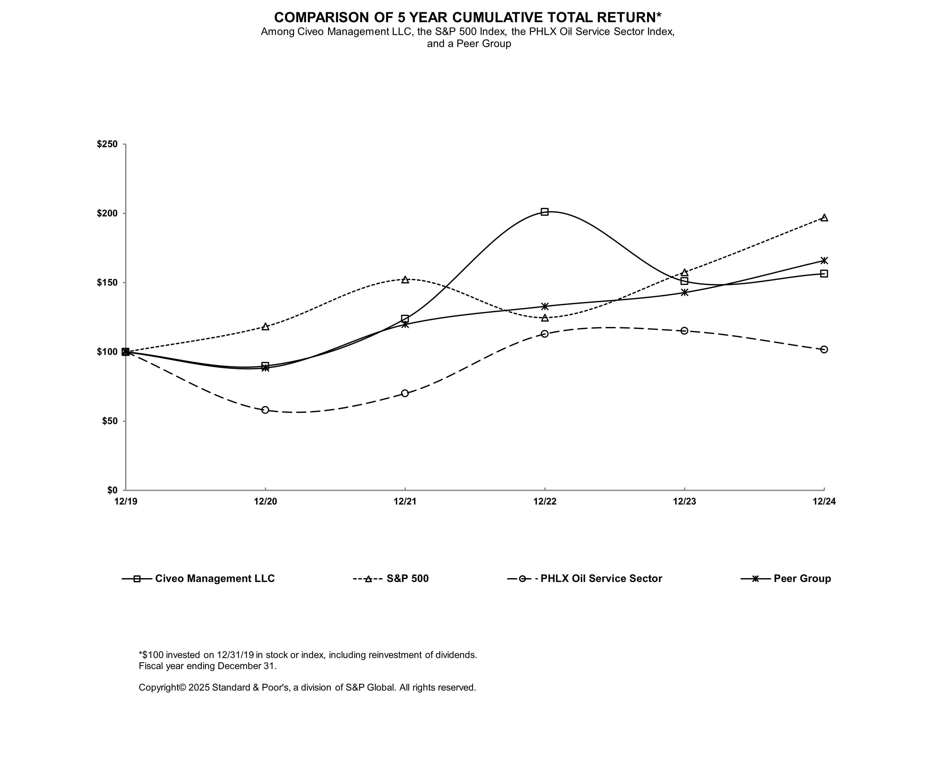
 |  |  |  |  |  | 12/31/19 |  |  |  |  |  | 12/31/20 |  |  |  |  |  | 12/31/21 |  |  |  |  |  | 12/31/22 |  |  |  |  |  | 12/31/23 |  |  |  |  |  | 12/31/24
Civeo Corporation |  |  |  |  |  | $ | 100.00 |  |  |  |  | $ | 89.79 |  |  |  |  | $ | 123.84 |  |  |  |  | $ | 200.90 |  |  |  |  | $ | 151.00 |  |  |  |  | $ | 156.43
S&P 500 |  |  |  |  |  | $ | 100.00 |  |  |  |  | $ | 118.40 |  |  |  |  | $ | 152.39 |  |  |  |  | $ | 124.79 |  |  |  |  | $ | 157.59 |  |  |  |  | $ | 197.02
PHLX Oil Service Sector |  |  |  |  |  | $ | 100.00 |  |  |  |  | $ | 57.92 |  |  |  |  | $ | 69.94 |  |  |  |  | $ | 112.94 |  |  |  |  | $ | 115.10 |  |  |  |  | $ | 101.68
Peer Group |  |  |  |  |  | $ | 100.00 |  |  |  |  | $ | 88.54 |  |  |  |  | $ | 119.90 |  |  |  |  | $ | 132.98 |  |  |  |  | $ | 142.98 |  |  |  |  | $ | 166.08

The performance graph above is furnished and not filed for purposes of the Securities Act and the Exchange Act. The performance graph is not soliciting material subject to Regulation 14A.

Unregistered Sales of Equity Securities and Use of Proceeds

None.

42

Repurchases of Registered Equity Securities by Registrant or its Affiliates in the Fourth Quarter

The following provides information about purchases of our common shares during the three months ended December 31, 2024.
 |  |  | Total Number of Shares Purchased (1) |  |  |  |  |  | Average Price Paid per Share |  |  |  |  |  | Total number of shares purchased as part of publicly announced plans or programs |  |  | Maximum number of shares that may be purchased under the plans or programs
October 1, 2024 - October 31, 2024 |  |  | 111,555 |  |  |  |  |  | $ | 27.52 |  |  |  |  | 111,555 |  |  | 249,692
November 1, 2024 - November 30, 2024 |  |  | 96,600 |  |  |  |  |  | 25.67 |  |  |  |  |  | 96,600 |  |  | 153,092
December 1, 2024 - December 31, 2024 |  |  | — |  |  |  |  |  | — |  |  |  |  |  | — |  |  | 153,092
Total |  |  | 208,155 |  |  |  |  |  | $ | 26.66 |  |  |  |  | 208,155 |  |  | 153,092

(1) In September 2024, our Board authorized the repurchase of up to 5% of our total common shares which were issued and outstanding, or 710,556 common shares (the 2024 Share Repurchase Program). Under the 2024 Share Repurchase Program, we may repurchase shares through open market repurchases, pursuant to a Rule 10b5-1 compliant plan, or in privately negotiated transactions. The 2024 Share Repurchase Program expires 12 months from the date of the first repurchase and was made pursuant to a foreign issuer bid exemption under Canadian securities law, which permits us to make repurchases in excess of 5% (subject to approval by our Board). We repurchased an aggregate of 208,155 of our common shares outstanding for approximately $5.6 million under the 2024 Share Repurchase Program during the three months ended December 31, 2024.

ITEM 6. Reserved

43

ITEM 7. Management’s Discussion and Analysis of Financial Condition and Results of Operations

“Management’s Discussion and Analysis of Financial Condition and Results of Operations” contains “forward-looking statements” within the meaning of Section 27A of the Securities Act and Section 21E of the Exchange Act that are based on management’s current expectations, estimates and projections about our business operations. Read “Cautionary Statement Regarding Forward Looking Statements.” Our actual results may differ materially from those currently anticipated and expressed in such forward-looking statements as a result of numerous factors, including the known material factors set forth in Item 1A. “Risk Factors” of this annual report. You should read the following discussion and analysis together with our consolidated financial statements and the notes to those statements in Item 8 of this annual report.

This section of this annual report generally discusses key operating and financial data as of and for the years ended 2024 and 2023 and provides year-over-year comparisons for such periods. For a similar discussion and year-over-year comparisons to our 2022 results, refer to "Management’s Discussion and Analysis of Financial Condition and Results of Operations" in Part II, Item 7 of our Annual Report on Form 10-K for the year ended December 31, 2023, filed with the Securities and Exchange Commission on February 29, 2024.

Description of the Business

We provide hospitality services to remote workforces in Australia and Canada, including catering and food service, lodging, housekeeping and maintenance at accommodation facilities that we or our customers own. We provide services that support the day-to-day operations of these facilities, such as laundry, facility management and maintenance, water and wastewater treatment, power generation, communication systems, security and logistics. We also manage development activities for workforce accommodation facilities, including site selection, permitting, engineering and design and manufacturing and site construction management, along with providing hospitality services once the facility is constructed. We primarily operate in some of the world’s most active met coal, oil, liquefied natural gas (LNG) and iron ore producing regions, and our customers include mining companies, major and independent oil companies, engineering companies and mining service companies. We operate in two principal reportable business segments – Australia and Canada.

Basis of Presentation

Unless otherwise stated or the context otherwise indicates: (i) all references in these consolidated financial statements to “Civeo,” “us,” “our” or “we” refer to Civeo Corporation and its consolidated subsidiaries; and (ii) all references in this annual report to “dollars” or “$” are to United States (U.S.) dollars.

Overview and Macroeconomic Environment

Demand for our hospitality services is driven primarily by ongoing operations of existing natural resource projects in Australia and Canada. Historically, initial demand for our hospitality services has been driven by our customers’ capital spending programs related to the construction and development of natural resource projects and associated infrastructure. Long-term demand for our services has been driven by natural resource production, maintenance, operation and expansion of those facilities. In general, industry capital spending programs are based on the outlook for commodity prices, production costs, economic growth, perceived political risk, global commodity supply/demand, reserve replacement requirements, estimates of resource production, annual maintenance requirements and the expectations of our customers' shareholders. As a result, demand for our hospitality services is sensitive to expected commodity prices, principally related to met coal, oil, iron ore and LNG, and the resultant impact of these commodity price expectations on our customers’ spending. Other factors that can affect our business and financial results include the general global economic environment, including inflationary pressures, supply chain disruptions and labor shortages, volatility affecting the banking system and financial markets, availability of capital to the natural resource industry and regulatory changes in Canada, Australia and other markets, including governmental measures introduced to mitigate climate change.

Commodity Prices

There is continued uncertainty around commodity price levels, driven by many factors, including rising fears of a recession resulting from lingering inflation and higher interest rates, an economic slowdown in China and resultant economic stimulus by the Chinese government, the impact of inflationary pressures, actions taken by Organization of the Petroleum Exporting Countries Plus (OPEC+) to adjust oil production levels, geopolitical events such as the ongoing Russia/Ukraine and Middle East conflicts, U.S. oil production levels and regulatory implications on such prices. In particular, these items could
44

cause our Canadian oil sands and pipeline customers to delay expansionary and maintenance spending and defer additional investments in their oil sands assets and in extreme cases reduce production.

Recent Commodity Prices

Recent met coal, iron ore, West Texas Intermediate (WTI) crude, and Western Canadian Select (WCS) crude pricing trends are as follows:

 |  |  |  |  |  |  |  |  |  |  |  |  |  |  |  |  |  | Average Price (1)
Quarter  ended |  |  |  |  |  | Hard  Coking Coal  (Met Coal)  (per tonne) |  |  |  |  |  | Iron  Ore  (per tonne) |  |  |  |  |  | WTI  Crude  (per bbl) |  |  |  |  |  | WCS  Crude  (per bbl)
First Quarter through February 21, 2025 |  |  |  |  |  | $ | 190.01 |  |  |  |  | $ | 97.82 |  |  |  |  | $ | 73.79 |  |  |  |  | $ | 59.71
12/31/2024 |  |  |  |  |  | 203.50 |  |  |  |  |  | 96.00 |  |  |  |  |  | 70.42 |  |  |  |  |  | 57.50
9/30/2024 |  |  |  |  |  | 210.74 |  |  |  |  |  | 94.54 |  |  |  |  |  | 75.29 |  |  |  |  |  | 59.97
6/30/2024 |  |  |  |  |  | 242.93 |  |  |  |  |  | 106.01 |  |  |  |  |  | 80.83 |  |  |  |  |  | 67.24
3/31/2024 |  |  |  |  |  | 307.68 |  |  |  |  |  | 118.54 |  |  |  |  |  | 77.01 |  |  |  |  |  | 59.48
12/31/2023 |  |  |  |  |  | 332.24 |  |  |  |  |  | 122.24 |  |  |  |  |  | 78.60 |  |  |  |  |  | 55.31
9/30/2023 |  |  |  |  |  | 260.12 |  |  |  |  |  | 111.04 |  |  |  |  |  | 82.50 |  |  |  |  |  | 66.20
6/30/2023 |  |  |  |  |  | 243.54 |  |  |  |  |  | 106.98 |  |  |  |  |  | 73.54 |  |  |  |  |  | 60.25
3/31/2023 |  |  |  |  |  | 341.08 |  |  |  |  |  | 117.08 |  |  |  |  |  | 75.96 |  |  |  |  |  | 56.61
12/31/2022 |  |  |  |  |  | 276.19 |  |  |  |  |  | 94.93 |  |  |  |  |  | 82.82 |  |  |  |  |  | 54.72
9/30/2022 |  |  |  |  |  | 252.63 |  |  |  |  |  | 99.21 |  |  |  |  |  | 91.63 |  |  |  |  |  | 70.70
6/30/2022 |  |  |  |  |  | 464.61 |  |  |  |  |  | 128.80 |  |  |  |  |  | 108.77 |  |  |  |  |  | 92.89
3/31/2022 |  |  |  |  |  | 474.83 |  |  |  |  |  | 129.46 |  |  |  |  |  | 95.17 |  |  |  |  |  | 82.04

(1)Source: Hard coking prices are from IHS Markit, iron ore prices and WCS crude prices are from Bloomberg and WTI crude prices are from U.S. Energy Information Administration.

Met Coal. In Australia, 84% of our rooms are located in the Bowen Basin of Queensland, Australia and primarily serve met coal mines in that region. Met coal pricing and production growth in the Bowen Basin region is predominantly influenced by the level of global steel production. Following negative growth from July through September 2024, production increased in the last quarter of 2024, reaching similar levels when compared to the same period in 2023. The turnaround in positive production growth in the last quarter of 2024 was driven by India’s steady steel production and a return to positive steel production growth in China. Global steel production during 2024 decreased by 0.9% compared with 2023. As of February 21, 2025, met coal spot prices were $188.50 per tonne. Steel demand is expected to increase marginally in 2025 compared to 2024 driven by continued improvements in demand from India.

Met coal prices stagnated around $200 per tonne during the last quarter of 2024, following a downward price correction in July and August 2004 as steel demand declined coupled with higher overall met coal inventories. Despite higher steel production from India and China in the last quarter of 2024, prices remained muted with high met coal inventories and steady supply in late 2024 and early 2025. In early 2025 met coal prices have dropped below $200, with prices averaging $190 in early 2025. High met coal inventories from buyers are impacting demand, however producers are maintaining strong production levels even at these lower prices.

While high met coal inventories continued to weigh on prices in late 2024 and early 2025, analysts are forecasting prices to trend higher during 2025 to average approximately $230 per tonne for the year. This will be contingent upon supply-side constraint from weather events and further anticipated Chinese stimulus support and stable demand from India.

Iron Ore. Iron ore prices fluctuated during the first quarter of 2024 and weakened through the second half of 2024, with prices range bound between $90 to $100 per tonne. Analysts expect iron ore prices to average $100 per tonne in 2025, with large producers forecasting steady supply and demand expected to remain muted.

WTI Crude. After reaching historic lows in early 2020 during the start of the COVID-19 pandemic, global oil prices increased to above $100 per barrel in the second quarter 2022. In the second half of 2022 and throughout 2023, oil prices generally declined due to (i) rising fears of a recession resulting from severe inflation and higher interest rates, (ii) resulting lower demand for oil and (iii) increasing U.S. oil production. In an effort to support the price of oil amidst demand concerns, OPEC+ countries extended their 2023 oil production cuts throughout 2024. These production cuts, coupled with the rising
45

geopolitical risks in the Middle East, resulted in rising oil prices during the first half of 2024. Oil prices decreased during the second half of 2024 due to increased market concerns over economic growth and demand. OPEC+ is expected to increase production in 2025, likely putting pressure on global oil prices.
WCS Crude. In Canada, WCS crude is the benchmark price for our oil sands customers. Pricing for WCS is driven by several factors, including the underlying price for WTI crude, the availability of transportation infrastructure (consisting of pipelines and crude by railcar), refinery blending requirements and governmental regulation. Historically, WCS has traded at a discount to WTI, creating a “WCS Differential,” due to transportation costs and capacity restrictions to move Canadian heavy oil production to refineries, primarily along the U.S. Gulf Coast. The WCS Differential has varied depending on the extent of transportation capacity availability.
Certain expansionary oil pipeline projects have the potential to both drive incremental demand for mobile assets and to improve take-away capacity for Canadian oil sands producers over the longer term, most notably the Trans Mountain Pipeline expansion, which began operating in the second quarter of 2024.
WCS prices in the fourth quarter of 2024 averaged $57.50 per barrel compared to an average of $55.31 in the fourth quarter of 2023. The WCS Differential decreased from $19.35 per barrel at the end of the fourth quarter of 2023 to $13.49 at the end of the fourth quarter of 2024. As of February 21, 2025, the WTI price was $70.58 and the WCS price was $57.24, resulting in a WCS Differential of $13.34. Further, the Trump Administration has announced and is in the process of implementing a 10% tariff on energy resources imported to the U.S. from Canada. This tariff could widen the WCS differential and reduce Canadian oil producers' production and profits.
Other
Recent Developments. On February 18, 2025, we entered into a definitive asset purchase agreement with a private seller to acquire four villages with 1,340 rooms in Australia’s Bowen Basin and the associated long-term customer contracts. Under the terms of the agreement, Civeo would acquire the assets and customer contracts for total cash consideration of A$105 million, or approximately US$67 million, funded with cash on hand and borrowings from its existing revolving credit facility. The Proposed Acquisition is anticipated to close in the second quarter of 2025, subject to regulatory approvals and customary conditions.
Inflationary Pressures. During 2023 and 2024, inflationary pressures and supply chain disruptions have been, and continue to be, experienced worldwide. Price increases resulting from inflation and supply chain concerns have, and are expected to continue to have, a negative impact on our labor and food costs, as well as consumable costs such as fuel. We are managing inflation risk with negotiated service scope changes and contractual protections.
Labor Shortages. In addition to the macro inflationary impacts on labor costs noted above, we continue to be impacted by increased staff costs as a result of hospitality labor shortages in Australia due to significantly reduced migration in and around Australia affecting labor availability, which has subsequently led to an increased reliance on more expensive temporary labor resources.

LNG. Our Sitka Lodge supports the LNG Canada (LNGC) project and related pipeline projects (specifically, the Coastal GasLink Pipeline, the pipeline constructed to transport natural gas feedstock to LNGC). LNGC, a joint venture among Shell Canada Energy, an affiliate of Shell plc (40 percent), and affiliates of PETRONAS, through its wholly-owned entity, North Montney LNG Limited Partnership (25 percent), PetroChina (15 percent), Mitsubishi Corporation (15 percent) and Korea Gas Corporation (5 percent), is currently constructing a liquefaction and export facility in Kitimat, British Columbia (Kitimat LNG Facility). Construction activity of Phase 1 of the Kitimat LNG Facility is nearing completion, with commercial operations expected to begin in mid-2025. The Coastal GasLink Pipeline was completed in 2024 and entered commercial operations. The majority of our contracted commitments associated with the Coastal GasLink Pipeline were completed in the fourth quarter of 2023. As such, we expect continued lower occupancy at our Sitka Lodge in the near-term until subsequent phases of the LNGC project are approved and commence, or additional construction activity in the region, drive increased occupancy demand.

From a macroeconomic standpoint, LNG demand has continued to grow, reinforcing the need for the global LNG industry to expand access to natural gas. Evolving government energy policies around the world have amplified support for cleaner energy supply, creating more opportunities for natural gas and LNG. The conflicts between Russia/Ukraine and in the Middle East have further highlighted the need for secure natural gas supply globally, particularly in Europe. Accordingly, we expect additional investment in LNG supply will be needed to meet the resulting expected long-term LNG demand growth.

McClelland Lake Lodge. We did not renew our expiring land lease associated with our McClelland Lake Lodge in Alberta, Canada, which expired in June 2023, in order to support our customer’s intent to mine the land where the lodge was located. In addition, the accompanying hospitality services contract at McClelland Lake Lodge expired in July 2023; however,
46

we continued to provide hospitality services to the customer at our other owned lodges through January 31, 2024, under a short-term take-or-pay commitment. Subsequent to this date, we have continued to provide such services at our other lodges; however, not pursuant to a take-or-pay commitment. During the third quarter of 2023, we entered into a definitive agreement to sell our McClelland Lake Lodge assets to a U.S.-based mining project for approximately C$49 million, or $36 million. Our McClelland Lake Lodge assets were dismantled and completely removed from the existing site in January 2024. During 2023, we recognized $14.2 million in dismantle costs and received $28.2 million in cash proceeds associated with the sale. During the first quarter of 2024, the transaction was completed, and we recognized the remaining $1.0 million in dismantle costs and received the remaining $7.8 million in cash proceeds.

United States Business. In the first quarter of 2023, we sold our accommodation assets in Louisiana, and in the second quarter of 2024, we sold the land at our Louisiana location. Our remaining U.S. business, which supported completion activity in the Bakken, was closed in the fourth quarter of 2024 due to low activity levels.

Foreign Currency Exchange Rates. Exchange rates between the U.S. dollar and each of the Canadian dollar and the Australian dollar influence our U.S. dollar reported financial results. Our business has historically derived the vast majority of its revenues and operating income (loss) in Canada and Australia. These revenues and profits/losses are translated into U.S. dollars for financial reporting purposes under U.S. generally accepted accounting principles. The following summarizes the fluctuations in the exchange rates between the U.S. dollar and each of the Canadian dollar and the Australian dollar:
 |  |  | Year Ended December 31,
 |  |  | 2024 |  |  |  |  |  | 2023 |  |  |  |  |  | Change |  |  |  |  |  | Percentage
Average Canadian dollar to U.S. dollar |  |  | $0.730 |  |  |  |  |  | $0.741 |  |  |  |  |  | (0.011) |  |  |  |  |  | (1.5)%
Average Australian dollar to U.S. dollar |  |  | $0.660 |  |  |  |  |  | $0.665 |  |  |  |  |  | (0.005) |  |  |  |  |  | (0.7)%
 |  |  | As of December 31,
 |  |  | 2024 |  |  |  |  |  | 2023 |  |  |  |  |  | Change |  |  |  |  |  | Percentage
Canadian dollar to U.S. dollar |  |  | $0.695 |  |  |  |  |  | $0.756 |  |  |  |  |  | (0.061) |  |  |  |  |  | (8.1)%
Australian dollar to U.S. dollar |  |  | $0.620 |  |  |  |  |  | $0.681 |  |  |  |  |  | (0.061) |  |  |  |  |  | (9.0)%

These fluctuations of the Canadian and Australian dollars have had and will continue to have an impact on the translation of earnings generated from our Canadian and Australian subsidiaries and, therefore, our financial results.

Capital Expenditures. We continue to monitor the global economy, commodity prices, demand for met coal, crude oil, LNG and iron ore, inflation and the resultant impact on the capital spending plans of our customers in order to plan our business activities. We currently expect that our 2025 capital expenditures will be in the range of approximately $25 million to $30 million, compared to 2024 capital expenditures of $26.1 million. We may adjust our capital expenditure plans in the future as we continue to monitor customer activity.

See “Liquidity and Capital Resources” below for further discussion on 2025 and 2024 capital expenditures.

47

Results of Operations

Unless otherwise indicated, discussion of results for the year ended December 31, 2024 is based on a comparison with the corresponding period of 2023.

Results of Operations – Year Ended December 31, 2024 Compared to Year Ended December 31, 2023

Year Ended
December 31,
 |  |  | 2024 |  |  |  |  |  | 2023 |  |  |  |  |  | Change
 |  |  | ($ in thousands)
Revenues
Australia |  |  | $ | 426,956 |  |  |  |  | $ | 336,763 |  |  |  |  | $ | 90,193
Canada |  |  | 245,087 |  |  |  |  |  | 352,795 |  |  |  |  |  | (107,708)
Other |  |  | 10,079 |  |  |  |  |  | 11,247 |  |  |  |  |  | (1,168)
Total revenues |  |  | 682,122 |  |  |  |  |  | 700,805 |  |  |  |  |  | (18,683)
Costs and expenses
Cost of sales and services
Australia |  |  | 315,374 |  |  |  |  |  | 243,011 |  |  |  |  |  | 72,363
Canada |  |  | 207,135 |  |  |  |  |  | 277,067 |  |  |  |  |  | (69,932)
Other |  |  | 10,158 |  |  |  |  |  | 10,209 |  |  |  |  |  | (51)
Total cost of sales and services |  |  | 532,667 |  |  |  |  |  | 530,287 |  |  |  |  |  | 2,380
Selling, general and administrative expenses |  |  | 73,350 |  |  |  |  |  | 72,605 |  |  |  |  |  | 745
Depreciation and amortization expense |  |  | 68,038 |  |  |  |  |  | 75,142 |  |  |  |  |  | (7,104)
Impairment expense |  |  | 11,581 |  |  |  |  |  | 1,395 |  |  |  |  |  | 10,186
Gain on sale of McClelland Lake Lodge assets, net |  |  | (5,744) |  |  |  |  |  | (18,590) |  |  |  |  |  | 12,846
Other operating expense |  |  | 898 |  |  |  |  |  | 479 |  |  |  |  |  | 419
Total costs and expenses |  |  | 680,790 |  |  |  |  |  | 661,318 |  |  |  |  |  | 19,472
Operating income |  |  | 1,332 |  |  |  |  |  | 39,487 |  |  |  |  |  | (38,155)
Interest expense, net |  |  | (7,786) |  |  |  |  |  | (13,005) |  |  |  |  |  | 5,219
Other income |  |  | 517 |  |  |  |  |  | 13,881 |  |  |  |  |  | (13,364)
Income (loss) before income taxes |  |  | (5,937) |  |  |  |  |  | 40,363 |  |  |  |  |  | (46,300)
Income tax expense |  |  | (12,492) |  |  |  |  |  | (10,633) |  |  |  |  |  | (1,859)
Net income (loss) |  |  | (18,429) |  |  |  |  |  | 29,730 |  |  |  |  |  | (48,159)
Less: Net expense attributable to noncontrolling interest |  |  | (1,362) |  |  |  |  |  | (427) |  |  |  |  |  | (935)
Net income (loss) attributable to Civeo Corporation |  |  | $ | (17,067) |  |  |  |  | $ | 30,157 |  |  |  |  | $ | (47,224)

We reported net loss attributable to Civeo for 2024 of $17.1 million, or $1.19 per diluted share. As further discussed below, net loss included $5.7 million of net gains associated with the sale of McClelland Lake Lodge in Canada and a $11.6 million pre-tax loss resulting from the impairment of fixed assets included in Impairment expense.

We reported net income attributable to Civeo for 2023 of $30.2 million, or $2.01 per diluted share. As further discussed below, net income included $28.3 million of net gains associated with the sale of the McClelland Lake Lodge in Canada and a $1.4 million pre-tax loss resulting from the impairment of fixed assets included in Impairment expense.

Revenues. Consolidated revenues decreased $18.7 million, or 3%, in 2024 compared to 2023. This decrease was primarily due to reduced mobile asset activity from pipeline projects in Canada which were largely completed in 2023 and lower year-over-year occupancy at certain lodges in Canada. These items were partially offset by increased activity at our Civeo owned villages in the Australian Bowen Basin and new business in our integrated services villages in Western Australia. See below for further discussion of segment results of operations.

Cost of Sales and Services. Our consolidated cost of sales and services increased $2.4 million, or 0.4%, in 2024 compared to 2023. This increase was primarily due to increased occupancy at our Civeo owned villages in the Australian Bowen Basin and new business in our integrated services villages in Western Australia and the associated overhead costs. These items were partially offset by the decrease in cost of sales and services largely driven by reduced mobile asset activity from pipeline projects in Canada which were largely completed in 2023 and lower costs at certain lodges in Canada due to reduced occupancy. See below for further discussion of segment results of operations.
48

Selling, General and Administrative Expenses. SG&A expense increased $0.7 million, or 1%, in 2024 compared to 2023. This increase was primarily due to higher compensation expense of $5.4 million, higher professional fees of $2.6 million and higher travel and entertainment costs of $0.9 million. The increase in compensation expense was primarily due to $1.1 million in severance costs related to the departure of our former Chief Financial Officer, other severance costs and increased staff and associated recruitment costs. These items were partially offset by lower incentive compensation costs of $5.6 million, lower share-based compensation expense of $2.8 million and a weaker Australian and Canadian dollar relative to the U.S. dollar in 2024 compared to 2023. The decrease in share-based compensation expense was primarily due to forfeitures, reduced performance share expense due to a lower probability of achieving performance criteria during 2024 compared to 2023 and changes in our share price during 2024 compared to 2023.

Depreciation and Amortization Expense. Depreciation and amortization expense decreased $7.1 million, or 9%, in 2024 compared to 2023. The decrease was primarily due to certain assets becoming fully depreciated in Canada, including the McClelland Lake Lodge, in 2023 and lower depreciation and amortization expense due to a weaker Australian and Canadian dollar relative to the U.S. dollar in 2024 compared to 2023. These items were partially offset by higher depreciation and amortization expense due to additional property, plant and equipment placed in service during 2024.

Impairment Expense. We recorded pre-tax impairment expense of $11.6 million in 2024 associated with long-lived assets in Australia, Canada and the U.S. We recorded pre-tax impairment expense of $1.4 million in 2023 associated with long-lived assets in Australia and the U.S.

See Note 4 - Impairment Charges to the notes to the consolidated financial statements included in Item 8 of this annual report for further discussion.

Gain on Sale of McClelland Lake Lodge Assets, net. We recorded $5.7 million and $18.6 million in net gains associated with the sale of the McClelland Lake Lodge in 2024 and 2023, respectively.

Operating Income. Operating income decreased $38.2 million, or 97%, in 2024 compared to 2023 primarily due to reduced mobile asset activity and lower lodge occupancy in Canada, higher impairment expenses and lower gain on sale of McClelland Lake Lodge assets in 2024 compared to 2023. These items were partially offset by higher activity levels in Australia and lower depreciation and amortization expense in 2024 compared to 2023.

Interest Expense, net. Net interest expense decreased $5.2 million, or 40%, in 2024 compared to 2023 primarily related to lower average debt levels during 2024 compared to 2023, which decreased approximately 35%.

Other Income. Consolidated other income decreased $13.4 million, or 96%, in 2024 compared to 2023. Other income in 2023 included $9.7 million in reimbursements associated with the dismantlement of the McClelland Lake Lodge. In addition, 2023 included gains related to the sale of our Acadian Acres accommodation assets in the U.S. and a gain on the settlement of asset retirement obligation in Canada. Other income in 2024 included $0.7 million in gains on sale of various assets in Canada and Australia.

Income Tax Expense. Our income tax expense for 2024 totaled $12.5 million, or (210.4)% of pretax loss, compared to an expense of $10.6 million, or 26.3% of pretax income for 2023. Our effective tax rate for 2024 was lower than the Canadian federal statutory rate of 15% primarily due to pre-tax losses in Canada with no corresponding tax benefit. Our effective tax rate for 2023 was higher than the Canadian federal statutory rate of 15%, primarily due to pre-tax income in Australia being taxed at the higher Australian income tax rate of 30%. Full valuation allowances are maintained against net deferred tax assets in both Canada and the U.S. In 2024, the tax benefit in Canada was offset by an increase to the valuation allowance of $8.5 million and a deferred tax benefit in Australia was offset by an increase to the valuation allowance of $0.6 million. In 2023, tax expense in Canada and the U.S. was offset by a valuation allowance release of $1.7 million and $0.8 million, respectively.

Other Comprehensive Income (Loss). Other comprehensive income decreased $28.6 million in 2024 compared to 2023 primarily as a result of foreign currency translation adjustments due to changes in the Canadian and Australian dollar exchange rates compared to the U.S. dollar. The Canadian dollar exchange rate compared to the U.S. dollar decreased 8.1% in 2024 compared to a 2.4% increase in 2023. The Australian dollar exchange rate compared to the U.S. dollar decreased 9.0% in 2024 compared to a 0.2% increase in 2023.

49

Segment Results of Operations – Australian Segment

Year Ended
December 31,
 |  |  | 2024 |  |  |  |  |  | 2023 |  |  |  |  |  | Change
Revenues ($ in thousands)
Accommodation and other services revenue (1) |  |  | $ | 196,684 |  |  |  |  | $ | 177,834 |  |  |  |  | $ | 18,850
Food service and other services revenue (2) |  |  | 230,272 |  |  |  |  |  | 158,929 |  |  |  |  |  | 71,343
Total revenues |  |  | $ | 426,956 |  |  |  |  | $ | 336,763 |  |  |  |  | $ | 90,193
Cost of sales ($ in thousands)
Accommodation and other services cost |  |  | $ | 94,344 |  |  |  |  | $ | 85,461 |  |  |  |  | $ | 8,883
Food service and other services cost |  |  | 208,627 |  |  |  |  |  | 148,599 |  |  |  |  |  | 60,028
Indirect other cost |  |  | 12,403 |  |  |  |  |  | 8,951 |  |  |  |  |  | 3,452
Total cost of sales and services |  |  | $ | 315,374 |  |  |  |  | $ | 243,011 |  |  |  |  | $ | 72,363
Gross margin as a % of revenues |  |  | 26.1 |  | % |  |  |  | 27.8 |  | % |  |  |  | (1.8) |  | %
Average daily rate for villages (3) |  |  | $ | 78 |  |  |  |  | $ | 75 |  |  |  |  | $ | 3
Total billed rooms for villages (4) |  |  | 2,524,108 |  |  |  |  |  | 2,371,763 |  |  |  |  |  | 152,345
Australian dollar to U.S. dollar |  |  | $ | 0.660 |  |  |  |  | $ | 0.665 |  |  |  |  | $ | (0.005)

(1)Includes revenues related to village rooms and hospitality services for owned rooms for the periods presented.
(2)Includes revenues related to food service and other services, including facilities management, for the periods presented.
(3)Average daily rate is based on billed rooms and accommodation and other services revenue.
(4)Billed rooms represents total billed days for owned assets for the periods presented.

Our Australian segment reported revenues in 2024 that were $90.2 million, or 27%, higher than in 2023. The increase in the Australian segment was driven by increased activity at our Civeo owned villages in the Bowen Basin and new business in our integrated services villages in Western Australia. Billed rooms in Civeo-owned villages were up 6.4% in 2024 due to increased activity in the Bowen Basin, Western Australia and Gunnedah Basin coupled with recent contract renewals and extensions.

Our Australian segment cost of sales and services increased $72.4 million, or 30%, in 2024 compared to 2023. The increase in cost of sales and services was largely driven by increased occupancy at our Civeo owned villages in the Bowen Basin and new business in our integrated services villages in Western Australia and the associated overhead costs.

Our Australian segment gross margin as a percentage of revenues decreased from 27.8% in 2023 to 26.1% in 2024. This decrease was primarily driven by an increased relative revenue contribution from our integrated services business, which has a service-only business model and therefore generates lower overall gross margins than our accommodation business. The reduced gross margin was partially offset by improved profitability across our integrated services villages in 2024.

50

Segment Results of Operations – Canadian Segment

Year Ended
December 31,
 |  |  | 2024 |  |  |  |  |  | 2023 |  |  |  |  |  | Change
Revenues ($ in thousands)
Accommodation and other services revenue (1) |  |  | $ | 214,774 |  |  |  |  | $ | 266,926 |  |  |  |  | $ | (52,152)
Mobile facility rental revenue (2) |  |  | 1,523 |  |  |  |  |  | 61,899 |  |  |  |  |  | (60,376)
Food service and other services revenue (3) |  |  | 28,790 |  |  |  |  |  | 23,970 |  |  |  |  |  | 4,820
Total revenues |  |  | $ | 245,087 |  |  |  |  | $ | 352,795 |  |  |  |  | $ | (107,708)
Cost of sales and services ($ in thousands)
Accommodation and other services cost |  |  | $ | 164,089 |  |  |  |  | $ | 195,843 |  |  |  |  | $ | (31,754)
Mobile facility rental cost |  |  | 4,940 |  |  |  |  |  | 49,073 |  |  |  |  |  | (44,133)
Food service and other services cost |  |  | 27,201 |  |  |  |  |  | 21,821 |  |  |  |  |  | 5,380
Indirect other cost |  |  | 10,905 |  |  |  |  |  | 10,330 |  |  |  |  |  | 575
Total cost of sales and services |  |  | $ | 207,135 |  |  |  |  | $ | 277,067 |  |  |  |  | $ | (69,932)
Gross margin as a % of revenues |  |  | 15.5 |  | % |  |  |  | 21.5 |  | % |  |  |  | (6.0) |  | %
Average daily rate for lodges (4) |  |  | $ | 97 |  |  |  |  | $ | 97 |  |  |  |  | $ | —
Total billed rooms for lodges (5) |  |  | 2,205,700 |  |  |  |  |  | 2,710,784 |  |  |  |  |  | (505,084)
Average Canadian dollar to U.S. dollar |  |  | $ | 0.730 |  |  |  |  | $ | 0.741 |  |  |  |  | $ | (0.011)

(1)Includes revenues related to lodge rooms and hospitality services for owned rooms for the periods presented.
(2)Includes revenues related to mobile assets for the periods presented.
(3)Includes revenues related to food service, laundry and water and wastewater treatment services for the periods presented.
(4)Average daily rate is based on billed rooms and accommodation and other services revenue.
(5)Billed rooms represents total billed days for owned assets for the periods presented.

Our Canadian segment reported revenues in 2024 that were $107.7 million, or 31%, lower than 2023. The weakening of the average exchange rate for the Canadian dollar relative to the U.S. dollar by 1.5% in 2024 compared to 2023 resulted in a $3.1 million period-over-period decrease in revenues. Excluding the impact of the weaker Canadian exchange rate, the revenue decrease was driven by (i) reduced mobile asset activity from pipeline projects which were largely completed in 2023, (ii) lower billed rooms at our oil sands lodges due to the timing and extent of maintenance activity by our customers, (iii) reduced occupancy associated with the sale of the McClelland Lake Lodge and (iv) reduced occupancy at our Sitka Lodge as the Kitimat LNG facility nears completion.

Our Canadian segment cost of sales and services decreased $69.9 million, or 25%, in 2024 compared to 2023. The weakening of the average exchange rate for the Canadian dollar relative to the U.S. dollar by 1.5% in 2024 compared to 2023 resulted in a $2.8 million period-over-period decrease in cost of sales and services. Excluding the impact of the weaker Canadian exchange rate, the decrease in cost of sales and services was driven by lower costs related to the reduced mobile asset activity from pipeline projects which were largely completed in 2023 and lower costs at various lodges due to reduced occupancy levels.

Our Canadian segment gross margin as a percentage of revenues decreased from 21.5% in 2023 to 15.5% in 2024. This decrease was primarily driven by reduced mobile asset activity from pipeline projects which were largely completed in 2023. In addition, margin at our lodges were lower due to reduced efficiencies at lower occupancy levels.

Liquidity and Capital Resources

Our primary liquidity needs are to fund capital expenditures, which in the past have included expanding and improving our hospitality services, developing new lodges and villages and purchasing or leasing land, to pay dividends, to repurchase common shares and for general working capital needs. In addition, capital has been used to repay debt and fund strategic business acquisitions. Historically, our primary sources of funds have been available cash, cash flow from operations, borrowings under our Credit Agreement and proceeds from equity issuances. In the future, capital may be required to move
51

lodges from one site to another, and we may seek to access the debt and equity capital markets from time to time to raise additional capital, increase liquidity, fund acquisitions or refinance debt.

The following summarizes our material future cash requirements at December 31, 2024, and the effect such obligations are expected to have on our liquidity and cash flow over the next five years (in thousands):
 |  |  | Total |  |  |  |  |  | Less Than 1  Year |  |  |  |  |  | 1 – 3 Years |  |  |  |  |  | 3 – 5 Years |  |  |  |  |  | More  Than 5  Years
Debt maturities |  |  | $ | 43,299 |  |  |  |  | $ | — |  |  |  |  | $ | — |  |  |  |  | $ | 43,299 |  |  |  |  | $ | —
Interest payments(1) |  |  | 9,529 |  |  |  |  |  | 2,637 |  |  |  |  |  | 5,274 |  |  |  |  |  | 1,618 |  |  |  |  |  | —
Purchase obligations |  |  | 8,169 |  |  |  |  |  | 8,169 |  |  |  |  |  | — |  |  |  |  |  | — |  |  |  |  |  | —
Non-cancelable lease obligations |  |  | 13,970 |  |  |  |  |  | 4,348 |  |  |  |  |  | 7,099 |  |  |  |  |  | 2,292 |  |  |  |  |  | 231
Asset retirement obligations – expected cash payments |  |  | 61,255 |  |  |  |  |  | 747 |  |  |  |  |  | 2,052 |  |  |  |  |  | 3,118 |  |  |  |  |  | 55,338
Total contractual cash obligations |  |  | $ | 136,222 |  |  |  |  | $ | 15,901 |  |  |  |  | $ | 14,425 |  |  |  |  | $ | 50,327 |  |  |  |  | $ | 55,569

(1)Interest payments due under the Credit Agreement, which matures on August 8, 2028; based on an interest rate of 6.1% for Canadian revolver borrowings.

Our debt obligations at December 31, 2024 are reflected in our consolidated balance sheet, which is a part of our consolidated financial statements in Item 8 of this annual report. We have not entered into any material leases subsequent to December 31, 2024.

The following summarizes our consolidated liquidity position as of December 31, 2024 and 2023 (in thousands):
 |  |  | December 31,
 |  |  | 2024 |  |  |  |  |  | 2023
Lender commitments |  |  | $ | 245,000 |  |  |  |  | $ | 200,000
Reductions in availability (1) |  |  | (3,635) |  |  |  |  |  | —
Borrowings against revolving credit capacity |  |  | (43,299) |  |  |  |  |  | (65,554)
Outstanding letters of credit |  |  | (1,100) |  |  |  |  |  | (1,353)
Unused availability |  |  | 196,966 |  |  |  |  |  | 133,093
Cash and cash equivalents |  |  | 5,204 |  |  |  |  |  | 3,323
Total available liquidity |  |  | $ | 202,170 |  |  |  |  | $ | 136,416

(1)As of December 31, 2024, $3.6 million of our borrowing capacity under the Credit Agreement could not be utilized in order to maintain compliance with the maximum leverage ratio financial covenant in the Credit Agreement.

Cash totaling $83.5 million was provided by operations during 2024 compared to $96.6 million provided by operations during 2023. During 2024 and 2023, $31.8 million was provided by working capital and $1.6 million was used in working capital, respectively. The year-over-year increase in cash provided by working capital in 2024 compared to 2023 is largely due to the collection of holdbacks in Canada related to the completion of mobile asset pipeline projects during 2024 compared to 2023, partially offset by decreased accounts payable and accrual balances.

Cash used in investing activities during 2024 totaled $14.9 million compared to cash used in investing activities during 2023 of $14.5 million. The increase in cash used in investing activities was primarily due to lower proceeds from the sale of property, plant and equipment, partially offset by lower capital expenditures. We received net proceeds from the sale of property, plant and equipment of $11.0 million during 2024 related to the sale of our McClelland Lake Lodge accommodation assets in Canada and the sale of our Louisiana land in the U.S., compared to $16.7 million during 2023 primarily related to the sale of our McClelland Lake Lodge accommodation assets in Canada and Louisiana accommodation assets in the U.S. Capital expenditures totaled $26.1 million and $31.6 million during 2024 and 2023, respectively. Capital expenditures in both periods were primarily related to maintenance. In addition, our 2024 capital expenditures included approximately $2.9 million related to customer-funded infrastructure upgrades in Australia compared to $10.0 million in 2023.

We expect our capital expenditures for 2025 to be in the range of $25 million to $30 million, which excludes any unannounced and uncommitted projects, the spending for which is contingent on obtaining customer contracts or commitments or attractive risk-adjusted economics. Whether planned expenditures will actually be spent in 2025 depends on industry conditions, project approvals and schedules, customer room commitments and project and construction timing. We expect to
52

fund these capital expenditures with available cash, cash flow from operations and revolving credit borrowings under our Credit Agreement. The foregoing capital expenditure forecast does not include any funds for strategic acquisitions, which we could pursue should the transaction economics be attractive enough to us compared to the current capital allocation priorities of returning capital to shareholders. We continue to monitor the global economy, commodity prices, demand for met coal, crude oil, LNG and iron ore, inflation and the resultant impact on the capital spending plans of our customers in order to plan our business activities, and we may adjust our capital expenditure plans in the future.

The table below delineates historical capital expenditures split between expansionary and maintenance spending on our lodges and villages, mobile asset spending and other capital expenditures. We classify capital expenditures for the development of rooms and central facilities at our lodges and villages as expansion capital expenditures. Other capital expenditures below relate to routine capital spending for support equipment, upgrades to infrastructure at our lodge and village properties and spending related to our manufacturing facilities, among other items.

Based on management’s judgment of capital spending classifications, we believe the following represents the components of capital expenditures for the years ended December 31, 2024 and 2023 (in millions):

 |  |  | Year Ended December 31,
 |  |  | 2024 |  |  |  |  |  |  |  |  |  |  |  |  |  |  |  |  |  | 2023
 |  |  | Expansion |  |  |  |  |  | Maint |  |  |  |  |  | Total |  |  |  |  |  | Expansion |  |  |  |  |  | Maint |  |  |  |  |  | Total
Lodge/village |  |  | $ | 7.3 |  |  |  |  | $ | 13.2 |  |  |  |  | $ | 20.5 |  |  |  |  | $ | 12.8 |  |  |  |  | $ | 11.6 |  |  |  |  | $ | 24.4
Mobile assets |  |  | — |  |  |  |  |  | — |  |  |  |  |  | — |  |  |  |  |  | 1.3 |  |  |  |  |  | — |  |  |  |  |  | 1.3
Other |  |  | 3.2 |  |  |  |  |  | 2.4 |  |  |  |  |  | 5.6 |  |  |  |  |  | 2.4 |  |  |  |  |  | 3.5 |  |  |  |  |  | 5.9
Total |  |  | $ | 10.5 |  |  |  |  | $ | 15.6 |  |  |  |  | $ | 26.1 |  |  |  |  | $ | 16.5 |  |  |  |  | $ | 15.1 |  |  |  |  | $ | 31.6

Expansion lodge and village spending in 2024 was related to costs associated with the customer-supported reactivation of our Buffalo Lodge in Canada and customer-funded infrastructure upgrades at three Australian villages. Expansion lodge and village spending in 2023 was largely related to customer-funded infrastructure upgrades at three Australian villages.

Maintenance lodge and village spending in 2024 and 2023 was primarily associated with routine maintenance projects at our major properties.

Mobile asset spending in 2023 was primarily related to an asset storage yard purchased in Canada.

Other maintenance and expansion spending in 2024 was primarily related to miscellaneous equipment and supplies to support the day-to-day operations at our accommodation and laundry facilities, purchases to support new contacts at our integrated services business in Australia and information technology infrastructure to support our business. Other maintenance and expansion spending in 2023 was primarily related to miscellaneous equipment and supplies to support the day-to-day operations at our accommodation and laundry facilities and information technology infrastructure to support our business.

Cash used in financing activities during 2024 of $65.2 million was primarily due to (i) repurchases of our common shares of $29.6 million, (ii) dividend payments of $14.4 million, (iii) net repayments under our revolving credit facilities of $17.1 million, (iv) debt issuance costs of $3.0 million and (v) payments to settle tax obligations of $1.1 million. Cash used in financing activities during 2023 of $86.8 million was primarily due to (i) net repayments under our revolving credit facilities of $37.8 million, (ii) repayments of term loan borrowings of $29.9 million, (iii) repurchases of our common shares of $11.6 million and (iv) dividend payments of $7.4 million.

The following summarizes the changes in debt outstanding during 2024 (in thousands):
 |  |  |  |  |  |  |  |  | Total
Balance as of December 31, 2023 |  |  |  |  |  |  |  |  | $ | 65,554
Borrowings under revolving credit facilities |  |  |  |  |  |  |  |  | 284,314
Repayments of borrowings under revolving credit facilities |  |  |  |  |  |  |  |  | (301,431)
Translation |  |  |  |  |  |  |  |  | (5,138)
Balance at December 31, 2024 |  |  |  |  |  |  |  |  | $ | 43,299

We believe that cash on hand and cash flow from operations will be sufficient to meet our anticipated liquidity needs for the next 12 months. If our plans or assumptions change, including as a result of changes in our customers' capital spending or changes in the price of and demand for natural resources, or are inaccurate, or if we make acquisitions, we may need to raise
53

additional capital. Acquisitions have been, and our management believes acquisitions will continue to be, an element of our long-term business strategy. The timing, size or success of any acquisition effort and the associated potential capital commitments are unpredictable and uncertain. We may seek to fund all or part of any such efforts with proceeds from debt and/or equity issuances or may issue equity directly to the sellers. Our ability to obtain capital for additional projects to implement our growth strategy over the longer term will depend on our future operating performance, financial condition and, more broadly, on the availability of equity and debt financing. Capital availability will be affected by prevailing conditions in our industry, the global economy, the global financial markets and other factors, many of which are beyond our control. In addition, any additional debt service requirements we take on could be based on higher interest rates and shorter maturities and could impose a significant burden on our results of operations and financial condition, and the issuance of additional equity securities could result in significant dilution to shareholders.

In September 2024, our Board authorized a common share repurchase program to repurchase up to 5.0% of our total common shares which are issued and outstanding, or 710,556 common shares, over a twelve-month period. In addition, our Board declared quarterly dividends of $0.25 per common share to shareholders beginning in the third quarter of 2023. Dividend payments of $14.3 million and $7.4 million were made to shareholders in 2024 and 2023, respectively. These dividends are eligible dividends pursuant to the Income Tax Act (Canada). See Note 16 – Share Repurchase Programs and Dividends to the notes to the consolidated financial statements included in Item 8 of this annual report for further discussion.

Credit Agreement

As of December 31, 2024, the Credit Agreement provided for: (i) a $245.0 million revolving credit facility scheduled to mature on August 8, 2028, allocated as follows: (A) a $10.0 million senior secured revolving credit facility in favor of certain of our U.S. subsidiaries, as borrowers; (B) a $200.0 million senior secured revolving credit facility in favor of Civeo and certain of our U.S. subsidiaries, as borrowers; and (C) a $35.0 million senior secured revolving credit facility in favor of one of our Australian subsidiaries, as borrower.

As of December 31, 2024, we had outstanding letters of credit of $0.3 million under the U.S. facility, zero under the Australian facility and $0.8 million under the Canadian facility. We also had outstanding bank guarantees of A$2.1 million under the Australian facility.

See Note 11 - Debt to the notes to the consolidated financial statements in Item 8 of this annual report for the terms of the Credit Agreement and further discussion regarding our debt.

Dividends

We intend to pay regular quarterly dividends on our common shares, with all future dividend payments subject to quarterly review and approval by our Board. The declaration and amount of all potential future dividends will be at the discretion of our Board and will depend upon many factors, including our financial condition, results of operations, cash flows, prospects, industry conditions, capital requirements of our business, covenants associated with certain debt obligations, legal requirements, regulatory constraints, industry practice and other factors the Board deems relevant. In addition, our ability to pay cash dividends on common shares is limited by covenants in the Credit Agreement. Future agreements may also limit our ability to pay dividends, and we may incur incremental taxes if we are required to repatriate foreign earnings to pay such dividends. The amount per share of our dividend payments may be changed, or dividends may be suspended, without advance notice. The likelihood that dividends will be reduced or suspended is increased during periods of market weakness. There can be no assurance that we will continue to pay a dividend in the future.

Critical Accounting Policies and Estimates

Our consolidated financial statements in Item 8 of this annual report have been prepared in accordance with U.S. generally accepted accounting principles (GAAP), which require that management make numerous estimates and assumptions. Actual results could differ from those estimates and assumptions, thus impacting our reported results of operations and financial position. The critical accounting policies and estimates described in this section are those that are most important to the depiction of our financial condition and results of operations and the application of which requires management’s most subjective judgments in making estimates about the effect of matters that are inherently uncertain. We describe our significant accounting policies more fully in Note 2 - Summary of Significant Accounting Policies to the notes to consolidated financial statements in Item 8 of this annual report.

54

Impairment of Definite-Lived Tangible and Intangible Assets

The recoverability of the carrying values of tangible and intangible assets is assessed at an asset group level which represents the lowest level for which identifiable cash flows are largely independent of the cash flows of other assets and liabilities. Whenever, in management’s judgment, we review our assets for impairment in step one when events or changes in circumstances indicate that the carrying value of such asset groups may not be recoverable based on estimated future cash flows, an asset impairment evaluation is performed. Indicators of impairment might include persistent and sustained negative economic trends affecting the markets we serve, recurring cash flow losses or significantly lowered expectations of future cash flows expected to be generated by our assets. As part of the initial step, we also reevaluate the remaining useful lives and salvage values of our assets when indicators of impairment exist.

Identification of Asset Groups – The following summarizes the asset groups that we have identified in each of our reporting segments.

Our Canada segment consists of numerous lodges, as well as our mobile assets. These properties are grouped in the following asset groups:

•Core Region
◦Fort McMurray Village – North Athabasca
◦Beaver River Lodge – North Athabasca
◦Athabasca Lodge – North Athabasca
◦Hudson and Borealis Lodges – North Athabasca
•Wapasu Creek Lodge – North Athabasca
•Grey Wolf Lodge - North Athabasca
•Conklin Lodge – South Athabasca
•Anzac Lodge – South Athabasca
•Red Earth Lodge - South Athabasca
•Wabasca Lodge - South Athabasca
•Sitka Lodge – Kitimat, British Columbia
•Geetla camp – British Columbia
•Antler River camp – Manitoba
•Red Earth camp – Alberta
•Christina Lake camp – Alberta
•Mobile assets
•Various land holdings in British Columbia purchased in anticipation of potential LNG related projects

In general, the lodges are operated on a lodge by lodge basis. However, for one set of lodges (the Core Region, including Beaver River, Athabasca, Hudson and Borealis Lodges and Fort McMurray Village), there are no identifiable cash flows largely independent of the cash flows of other assets and liabilities for such lodges, and therefore, such lodges are combined into a single asset group. Factors such as proximity to each other, commonality of customers, common monitoring by management and operating decisions being made to optimize these lodges as a group result in these lodges being treated as a single asset group for the purposes of our impairment assessments.

Our Australia segment consists of eight villages in several regions within the country, as well as our integrated services assets and land banked assets. These properties are grouped in the following asset groups:

•Karratha – Pilbara Region, Western Australia
•Integrated services – Assets held on client owned sites in Western Australia and South Australia
•Gunnedah Basin
◦Narrabri – Gunnedah Basin, New South Wales
◦Boggabri – Gunnedah Basin, New South Wales
•Bowen Basin
◦Moranbah – Bowen Basin, Queensland
55

◦Dysart – Bowen Basin, Queensland
◦Nebo – Bowen Basin, Queensland
◦Coppabella – Bowen Basin, Queensland
◦Middlemount – Bowen Basin, Queensland
•Various non-operational sites acquired as part of Civeo’s land-banking strategy

In general, the villages are operated on a village by village basis, except for the villages located in the Bowen Basin (Moranbah, Dysart, Nebo, Coppabella and Middlemount) and the Gunnedah Basin (Narrabri and Boggabri). The villages in the Bowen and Gunnedah Basins contain significant levels of interdependency that allow these assets to be combined into cash generating units (asset groups). Factors such as commonality of customers, location, resource basins served and common monitoring by management result in the Bowen and Gunnedah Basins to be treated as single asset groups for the purposes of our impairment assessments. Integrated services assets provide catering and managed services to the mining industry in Western Australia and South Australia.

U.S. consists of a lodge, land and a wastewater treatment plant (WWTP). These properties are grouped in the following asset groups:

•Killdeer Lodge – North Dakota
•Killdeer WWTP – this asset group represents a WWTP in Killdeer, North Dakota, which was constructed in early 2014

Recoverability Assessment – In performing an impairment analysis, the second step is to compare each asset group’s carrying value to estimates of undiscounted future direct cash flows associated with the asset group over the remaining useful life of the asset group's primary asset. We use a variety of underlying assumptions to estimate these future cash flows, including assumptions relating to future economic market conditions, rates, occupancy levels, costs and expenses and capital expenditures. The estimates are consistent with those used for purposes of our goodwill impairment test.

Fair Value Determination – If, based on the assessment, the carrying values of any of our asset groups are determined to not be recoverable as a result of the undiscounted future cash flows not exceeding the net book value of the asset group, we proceed to the third step. In this step, we compare the fair value of the respective asset group to its carrying value. Our estimate of the fair value requires us to use significant unobservable inputs, representative of Level 3 fair value measurements, including numerous assumptions with respect to future circumstances, such as industry and/or local market conditions that might directly impact each of the asset groups’ operations in the future, and are therefore uncertain. In some cases our estimate of fair value is based on appraisals from third parties.

Our industry is cyclical and our estimates of the period over which future cash flows will be generated, as well as the predictability of these cash flows and our determination of whether a decline in value of our investment has occurred, can have a significant impact on the carrying value of these assets and, in periods of prolonged down cycles, may result in impairment losses. If this assessment indicates that the carrying values will not be recoverable, an impairment loss is recognized equal to the excess of the carrying value over the fair value of the asset group. The fair value of the asset group is based on prices of similar assets, if available, or discounted cash flows.

In estimating future cash flows, we make numerous assumptions with respect to future circumstances that might directly impact each of the asset groups’ operations in the future and are therefore uncertain. These assumptions with respect to future circumstances include future oil and coal prices, anticipated customer spending, and industry and/or local market conditions. These assumptions represent our best judgment based on the current facts and circumstances. However, different assumptions could result in a determination that the carrying values of additional asset groups are no longer recoverable based on estimated future cash flows. Our estimate of fair value is primarily calculated using the Income Approach, which derives a present value of the asset group based on the asset groups’ estimated future cash flows. We discounted our estimated future cash flows using a long-term weighted average cost of capital based on our estimate of investment returns required by a market participant.

See Note 4 – Impairment Charges to the notes to consolidated financial statements in Item 8 of this annual report for further discussion of impairments of definite-lived tangible and intangible assets recorded in the years ended December 31, 2024, 2023 and 2022.
56

Revenue and Cost Recognition

We generally recognize accommodation, mobile facility rental, food service and other services revenues over time as our customers simultaneously receive and consume benefits as we serve our customers because of continuous transfer of control to the customer. Revenue is recognized when control of the promised goods or services is transferred to our customers, in an amount that reflects the consideration we expect to be entitled to in exchange for those goods or services. We transfer control and recognize a sale based on a periodic (usually daily) room rate each night a customer stays in our rooms or when the services are rendered. In some contracts, rates may vary over the contract term. In these cases, revenue may be deferred and recognized on a straight-line basis over the contract term.

Because of control transferring over time, the majority of our revenue is recognized based on the extent of progress towards completion of the performance obligation. At contract inception, we assess the goods and services promised in our contracts with customers and identify a performance obligation for each promise to transfer our customers a good or service (or bundle of goods or services) that is distinct. Our customers typically contract for hospitality services under take-or-pay contracts with terms that range from several months to multiple years. Our contract terms generally provide for a rental rate for a reserved room and an occupied room rate that compensates us for services provided. We typically contract our facilities to our customers on a fee per day basis where the goods and services promised include lodging and meals. To identify the performance obligations, we consider all of the goods and services promised in the context of the contract and the pattern of transfer to our customers.

Revenues exclude taxes assessed based on revenues such as sales or value added taxes.

Cost of services includes labor, food, utility costs, cleaning supplies, and other costs of operating our accommodations facilities. Cost of goods sold includes all direct material and labor costs and those costs related to contract performance, such as indirect labor, supplies, tools and repairs. Selling, general and administrative costs are charged to expense as incurred.

Income Taxes

We follow the liability method of accounting for income taxes in accordance with current accounting standards regarding the accounting for income taxes. Under this method, deferred income taxes are recorded based upon the differences between the financial reporting and tax bases of assets and liabilities and are measured using the enacted tax rates and laws in effect at the time the underlying assets or liabilities are recovered or settled.

When our earnings from foreign subsidiaries are considered to be indefinitely reinvested, no provision for Canadian income taxes is made for these earnings. If any of the subsidiaries have a distribution of earnings in the form of dividends or otherwise, we could be subject to both Canadian income taxes (subject to an adjustment for foreign tax credits) and withholding taxes payable to various foreign countries.

We record a valuation allowance in each reporting period when our management believes that it is more likely than not that any recorded deferred tax asset will not be realized. Our management will continue to evaluate the appropriateness of the valuation allowance in the future, based upon our current and historical operating results and other potential sources of future taxable income. See Note 14 – Income Taxes to the notes to consolidated financial statements in Item 8 of this annual report for further discussion.

In accounting for income taxes, we are required to estimate a liability for future income taxes for any uncertainty for potential income tax exposures. The calculation of our tax liabilities involves dealing with uncertainties in the application of complex tax regulations. We recognize liabilities for anticipated tax audit issues in Canada and other tax jurisdictions based on our estimate of whether, and the extent to which, additional taxes will be due, including an accrual of interest and penalties, if applicable, related to the unrecognized tax benefits. If we ultimately determine that payment of these amounts is unnecessary, we reverse the liability and recognize a tax benefit during the period in which we determine that the liability is no longer necessary. We record an additional charge in our provision for taxes in the period in which we determine that the recorded tax liability is less than we expect the ultimate assessment to be.

Recent Accounting Pronouncements

See Note 2 – Summary of Significant Accounting Policies – Recent Accounting Pronouncements to the notes to consolidated financial statements in Item 8 of this annual report for further discussion.

57

ITEM 7A. Quantitative and Qualitative Disclosures about Market Risk

Our principal market risks are our exposure to changes in interest rates and foreign currency exchange rates.

Interest Rate Risk

We have credit facilities that are subject to the risk of higher interest charges associated with increases in interest rates. As of December 31, 2024, we had $43.3 million of outstanding floating-rate obligations under our credit facilities. These floating-rate obligations expose us to the risk of increased interest expense in the event of increases in short-term interest rates. If floating interest rates increased by 100 basis points, our consolidated interest expense would increase by approximately $0.4 million annually, based on our floating-rate debt obligations and interest rates in effect as of December 31, 2024.

Foreign Currency Exchange Rate Risk

Our operations are conducted in various countries around the world, and we receive revenue and pay expenses from these operations in a number of different currencies. As such, our earnings are subject to movements in foreign currency exchange rates when transactions are denominated in (i) currencies other than the U.S. dollar, which is our reporting currency, or (ii) the functional currency of our subsidiaries, which is not necessarily the U.S. dollar. Excluding intercompany balances, our Canadian dollar and Australian dollar functional currency net assets total approximately C$166 million and A$191 million, respectively, at December 31, 2024. We use a sensitivity analysis model to measure the impact of a 10% adverse movement of foreign currency exchange rates against the U.S. dollar. A hypothetical 10% adverse change in the value of the Canadian dollar and Australian dollar relative to the U.S. dollar as of December 31, 2024 would result in translation adjustments of approximately $17 million and $19 million, respectively, recorded in other comprehensive loss. Although we do not currently have any foreign exchange agreements outstanding, in order to reduce our exposure to fluctuations in currency exchange rates, we may enter into foreign exchange agreements with financial institutions in the future.

ITEM 8. Financial Statements and Supplementary Data

Our Consolidated Financial Statements and supplementary data appear on pages 66 through 99 of this Annual Report on Form 10-K and are incorporated by reference into this Item 8.

ITEM 9. Changes in and Disagreements With Accountants on Accounting and Financial Disclosure

There were no changes in or disagreements on any matters of accounting principles or financial statement disclosure between us and our independent auditors during our two most recent years or any subsequent interim period.

ITEM 9A. Controls and Procedures

(i) Evaluation of Disclosure Controls and Procedures

As of the end of the period covered by this annual report, we carried out an evaluation, under the supervision and with the participation of our management, including our Chief Executive Officer and Chief Financial Officer, of the effectiveness of the design and operation of our disclosure controls and procedures (as defined in Rules 13a-15(e) and 15d-15(e) under the Exchange Act). Our disclosure controls and procedures are designed to provide reasonable assurance that the information required to be disclosed by us in reports that we file under the Exchange Act is accumulated and communicated to our management, including our Chief Executive Officer and Chief Financial Officer, as appropriate, to allow timely decisions regarding required disclosure and is recorded, processed, summarized and reported within the time periods specified in the rules and forms of the Securities and Exchange Commission. Based upon that evaluation, our Chief Executive Officer and Chief Financial Officer concluded that our disclosure controls and procedures were effective as of December 31, 2024 at the reasonable assurance level.

(ii) Internal Control Over Financial Reporting

(a) Management's annual report on internal control over financial reporting.

Our management is responsible for establishing and maintaining adequate internal control over financial reporting as defined in Rules 13a-15(f) and 15d-15(f) under the Exchange Act. Our internal control over financial reporting is a process designed to provide reasonable assurance regarding the reliability of financial reporting and the preparation of consolidated financial statements for external purposes in accordance with GAAP. Our internal control over financial reporting includes
58

those policies and procedures that (i) pertain to the maintenance of records that, in reasonable detail, accurately and fairly reflect the transactions and dispositions of our assets; (ii) provide reasonable assurance that transactions are recorded as necessary to permit preparation of financial statements in accordance with GAAP, and that our receipts and expenditures are being made only in accordance with authorizations of management and our directors, and (iii) provide reasonable assurance regarding prevention or timely detection of unauthorized acquisition, use or disposition of our assets that could have a material effect on the consolidated financial statements.

Because of its inherent limitations, internal control over financial reporting may not prevent or detect misstatements. Also, projections of any evaluation of effectiveness to future periods are subject to the risk that controls may become inadequate because of changes in conditions, or that the degree of compliance with the policies or procedures may deteriorate. Accordingly, even effective internal control over financial reporting can only provide reasonable assurance of achieving their control objectives.

Under the supervision and with the participation of our management, including our Chief Executive Officer and Chief Financial Officer, an assessment of the effectiveness of our internal control over financial reporting as of December 31, 2024 was conducted. In making this assessment, management used the criteria set forth by the Committee of Sponsoring Organizations of the Treadway Commission (COSO) in Internal Control–Integrated Framework (2013 Framework). Based on our assessment we believe that, as of December 31, 2024, our internal control over financial reporting is effective based on those criteria.

(b) Attestation report of the registered public accounting firm.

The attestation report of Ernst & Young LLP, our independent registered public accounting firm, on our internal control over financial reporting is set forth in this annual report on page 69 and is incorporated herein by reference.

(c) Changes in internal control over financial reporting.

During the three months ended December 31, 2024, there were no changes in our internal control over financial reporting (as defined in Rules 13a-15(f) and 15d-15(f) of the Exchange Act) which have materially affected, or are reasonably likely to materially affect, our internal control over financial reporting.

ITEM 9B. Other Information

None.

ITEM 9C. Disclosure Regarding Foreign Jurisdictions that Prevent Inspections

Not applicable.

59

PART III

ITEM 10. Directors, Executive Officers and Corporate Governance

The information required by Item 10 hereby is incorporated by reference to such information as set forth in the Company's Definitive Proxy Statement for the 2025 Annual General Meeting of Shareholders.

The Board of the Company has documented its governance practices by adopting several corporate governance policies. These governance policies, including the Company's Corporate Governance Guidelines, Corporate Code of Business Conduct and Ethics and Financial Code of Ethics for Senior Officers, as well as the charters for the committees of the Board (Audit Committee, Compensation Committee, Finance and Investment Committee and Environmental, Social, Governance and Nominating Committee) may also be viewed at the Company's website. The Financial Code of Ethics for Senior Officers applies to our principal executive officer, principal financial officer, principal accounting officer and certain other senior officers. We intend to disclose any amendments to or waivers from our Financial Code of Ethics for Senior Officers by posting such information on our website at www.civeo.com within four business days following the date of the amendment or waiver. Copies of such documents will be sent to shareholders free of charge upon written request to the corporate secretary at the address shown on the cover page of this annual report.

ITEM 11. Executive Compensation

The information required by Item 11 hereby is incorporated by reference to such information as set forth in the Company's Definitive Proxy Statement for the 2025 Annual General Meeting of Shareholders.

ITEM 12. Security Ownership of Certain Beneficial Owners and Management and Related Shareholder Matters

The information required by Item 12 hereby is incorporated by reference to such information as set forth in the Company's Definitive Proxy Statement for the 2025 Annual General Meeting of Shareholders.

ITEM 13. Certain Relationships and Related Transactions, and Director Independence

The information required by Item 13 hereby is incorporated by reference to such information as set forth in the Company's Definitive Proxy Statement for the 2025 Annual General Meeting of Shareholders.

ITEM 14. Principal Accounting Fees and Services

The information required by Item 14 hereby is incorporated by reference to such information as set forth in the Company's Definitive Proxy Statement for the 2025 Annual General Meeting of Shareholders.

60

PART IV

ITEM 15. Exhibits, Financial Statement Schedules

(a) Index to Financial Statements, Financial Statement Schedules and Exhibits

(1) Financial Statements: Reference is made to the index set forth on page 66 of this Annual Report on Form 10-K.

(2) Financial Statement Schedules: No schedules have been included herein because the information required to be submitted has been included in the Consolidated Financial Statements or the Notes thereto, or the required information is inapplicable.

(3) Index of Exhibits: See Index of Exhibits, below, for a list of those exhibits filed herewith, which index also includes and identifies management contracts or compensatory plans or arrangements required to be filed as exhibits to this Annual Report on Form 10-K by Item 601 of Regulation S-K.

(b) Index of Exhibits

Exhibit No. |  |  |  |  |  | Description
2.1 |  |  |  |  |  | Share Purchase Agreement, dated November 26, 2017, by and among Civeo Corporation, Noralta Lodge Ltd., Torgerson Family Trust, 2073357 Alberta Ltd., 2073358 Alberta Ltd., 1818939 Alberta Ltd., 2040618 Alberta Ltd., 2040624 Alberta Ltd., 989677 Alberta Ltd. and Lance Torgerson (incorporated herein by reference to Exhibit 10.1 to the Current Report on Form 8-K (File No. 001-36246) filed on November 27, 2017).
2.2 |  |  |  |  |  | Amending Agreement, dated March 15, 2018, among Civeo Corporation, the Torgerson Family Trust, 989677 Alberta Ltd., 1818939 Alberta Ltd., 2040618 Alberta Ltd., 2040624 Alberta Ltd., 2073357 Alberta Ltd., 2073358 Alberta Ltd., Lance Torgerson and Noralta Lodge Ltd. (incorporated herein by reference to Exhibit 10.1 to the Current Report on Form 8-K (File No. 001-36246) filed on March 16, 2018).
2.3* |  |  |  |  |  | Asset Sale and Purchase Agreement, dated February 18, 2025, between Civeo Pty Ltd, the sellers party thereto and Graham William Cleary, as seller guarantor.
3.1 |  |  |  |  |  | Notice of Articles of Civeo Corporation, as amended (incorporated herein by reference to Exhibit 3.1 to the Current Report on Form 8-K (File No. 001-36246) filed on April 2, 2018).
3.2 |  |  |  |  |  | Certification of Amendment to the Notice of Articles of Civeo Corporation (incorporated herein by reference to Exhibit 3.1 to the Current Report on Form 8-K (File No. 001-36246) filed on November 20, 2020).
3.3 |  |  |  |  |  | Amended and Restated Articles of Civeo Corporation (incorporated herein by reference to Exhibit 3.1 to the Current Report on Form 8-K (File No. 001-36246) filed on May 21, 2024).
4.1 |  |  |  |  |  | Form of Common Share Certificate (incorporated herein by reference to Exhibit 4.1 to the Current Report on Form 8-K12B (File No. 001-36246) filed on July 17, 2015).
4.2 |  |  |  |  |  | Registration Rights, Lock-Up and Standstill Agreement, dated April 2, 2018, by and among Civeo Corporation, Torgerson Family Trust and 989677 Alberta Ltd. (incorporated herein by reference to Exhibit 4.1 to the Current Report on Form 8-K (File No. 001-36246) filed on April 2, 2018).
4.3* |  |  |  |  |  | Description of Securities.
10.1† |  |  |  |  |  | Form of Indemnification Agreement (incorporated herein by reference to Exhibit 10.1 to the Current Report on Form 8-K12B (File No. 001-36246) filed on July 17, 2015).
10.2† |  |  |  |  |  | Amended and Restated 2014 Equity Participation Plan of Civeo Corporation, as amended by Amendment No. 1, Amendment No. 2, Amendment No. 3 and Amendment No. 4 (incorporated by reference to Appendix B to Civeo Corporation's Schedule 14A filed on March 31, 2023).
61

10.3† |  |  |  |  |  | Performance Share Award Program under the 2014 Equity Participation Plan (incorporated herein by reference to Exhibit 10.3 to the Annual Report on Form 10-K (File No. 001-36246) filed on February 26, 2021).
10.4† |  |  |  |  |  | Form of Performance Share Award Agreement under the 2014 Equity Participation Plan (incorporated herein by reference to Exhibit 10.4 to the Annual Report on Form 10-K (File No. 001-36246) filed on February 26, 2021).
10.5† |  |  |  |  |  | Form of Civeo Corporation Annual Incentive Compensation Plan (incorporated herein by reference to Exhibit 10.7 to the Registration Statement on Form 10 (File No. 001-36246) filed on April 22, 2014).
10.6† |  |  |  |  |  | Form of Canadian Long-Term Incentive Plan (incorporated herein by reference to Exhibit 10.8 to the Registration Statement on Form 10 (File No. 001-36246) filed on April 22, 2014).
10.8† |  |  |  |  |  | Form of Restricted Stock Agreement under the 2014 Equity Participation Plan of Civeo Corporation (incorporated herein by reference to Exhibit 10.10 to the Registration Statement on Form 10 (File No. 001-36246) filed on April 22, 2014).
10.9† |  |  |  |  |  | Form of Non-Employee Director Restricted Stock Agreement (incorporated herein by reference to Exhibit 10.11 to the Registration Statement on Form 10 (File No. 001-36246) filed on April 22, 2014).
10.10† |  |  |  |  |  | Form of Deferred Stock Agreement (Australia) (incorporated herein by reference to Exhibit 10.12 to the Registration Statement on Form 10 (File No. 001-36246) filed on April 22, 2014).
10.11† |  |  |  |  |  | Form of Deferred Stock Agreement (Canada) (incorporated herein by reference to Exhibit 10.13 to the Registration Statement on Form 10 (File No. 001-36246) filed on April 22, 2014).
10.12† |  |  |  |  |  | Form of Executive Agreement of Bradley J. Dodson (incorporated herein by reference to Exhibit 10.14 to the Registration Statement on Form 10 (File No. 001-36246) filed on April 22, 2014).
10.13† |  |  |  |  |  | Form of Phantom Unit Agreement under the 2014 Equity Participation Plan of Civeo Corporation (incorporated herein by reference to Exhibit 10.17 to the Annual Report on Form 10-K (File No. 001-36246) filed on March 13, 2015).
10.14† |  |  |  |  |  | Executive Services Agreement, dated May 30, 2012, between Peter McCann and The Mac Services Group Pty Ltd. (incorporated herein by reference to Exhibit 10.3 to the Current Report on Form 8-K12B (File No. 001-36246) filed on July 17, 2015).
10.15† |  |  |  |  |  | Executive Agreement between Civeo Corporation and Peter McCann, dated August 17, 2015 (incorporated herein by reference to Exhibit 10.1 to the Current Report on Form 8-K (File No. 001-36246) filed on August 27, 2015).
10.16† |  |  |  |  |  | Variation to Executive Services Agreement dated May 30, 2012 between Peter McCann and Civeo Pty Ltd. (incorporated herein by reference to Exhibit 10.18 to the Annual Report on Form 10-K (File No. 001-36246) filed on February 26, 2021).
10.17† |  |  |  |  |  | Variation to Executive Services Agreement between Civeo Pty Ltd and Peter McCann, dated August 17, 2015 (incorporated herein by reference to Exhibit 10.2 to the Current Report on Form 8-K (File No. 001-36246) filed on August 27, 2015).
10.18 |  |  |  |  |  | Syndicated Facility Agreement, dated as of September 8, 2021, by and among Civeo Corporation, Civeo Pty Limited and Civeo Management LLC, as Borrowers, the Lenders named therein, Royal Bank of Canada, as Administrative Agent, U.S. Collateral Agent, Canadian Administrative Agent, Canadian Collateral Agent and an Issuing Bank and RBC Europe Limited, as Australian Administrative Agent, Australian Collateral Agent and an Issuing Bank (incorporated herein by reference to Exhibit 10.1 to the Current Report on Form 8-K (File No. 001-36246) filed on September 8, 2021).
62

10.19 |  |  |  |  |  | First Amendment to Syndicated Facility Agreement, dated as of March 31, 2023, among Civeo Corporation, Civeo Management LLC and Civeo Pty Limited, as Borrowers, certain subsidiary guarantors of the Borrowers party thereto, the Lenders party thereto, the Issuing Banks, the Swing Line Lenders, Royal Bank of Canada, as administrative agent for the U.S. Lenders, U.S. collateral agent, administrative agent for the Canadian Lenders and Canadian collateral agent and RBC Europe Limited, as administrative agent for the Australian Lenders and Australian collateral agent (incorporated herein by reference to Exhibit 10.1 to the Quarterly Report on Form 10-K (File No. 001-36246) filed on April 28, 2023).
10.20 |  |  |  |  |  | Second Amendment to Syndicated Facility Agreement, dated as of June 28, 2024, among Civeo Corporation, Civeo Pty Limited and Civeo Management LLC, as Borrowers, and Royal Bank of Canada, as Canadian administrative agent (incorporated herein by reference to Exhibit 10.1 to the Quarterly Report on Form 10-Q (File No. 001-36246) filed on July 30, 2024).
10.21 |  |  |  |  |  | Third Amendment to Syndicated Facility Agreement, dated as of August 8, 2024, among Civeo Corporation, Civeo Pty Limited, Civeo Management LLC and Civeo USA LLC, as Borrowers, certain subsidiary guarantors of the Borrowers party thereto, the Lenders named therein, Royal Bank of Canada, as Administrative Agent, U.S. Collateral Agent and an Issuing Bank, RBC Europe Limited, as Australian Administrative Agent and Australian Collateral Agent, RBC Capital Markets, as Joint Lead Arranger and Bookrunner, and The Toronto-Dominion Bank and Bank of Montreal, as Joint Lead Arrangers, Syndication Agents and Bookrunners (incorporated herein by reference to Exhibit 10.1 to the Quarterly Report on Form 10-Q (File No. 001-36246) filed on October 30, 2024).
10.22† |  |  |  |  |  | Form of Director Deferred Share Agreement (United States) (incorporated herein by reference to Exhibit 10.31 to the Annual Report on Form 10-K for the year ended December 31, 2018 (File No. 001-36246).
10.23† |  |  |  |  |  | Form of Director Deferred Share Agreement (Canada) (incorporated herein by reference to Exhibit 10.32 to the Annual Report on Form 10-K for the year ended December 31, 2018 (File No. 001-36246).
10.24† |  |  |  |  |  | Separation, Waiver and Release Agreement dated as of March 11, 2024 by and between Civeo Corporation and Carolyn Stone (incorporated herein by reference to Exhibit 10.1 to the Quarterly Report on Form 10-Q filed on April 26, 2024).
10.25† |  |  |  |  |  | Form of Phantom Unit Agreement under the 2014 Equity Participation Plan of Civeo Corporation used for select officers (incorporated herein by reference to Exhibit 10.2 to the Quarterly Report on Form 10-Q filed on July 30, 2024).
10.26† |  |  |  |  |  | Form of Director Restricted Stock Agreement under the 2014 Equity Participation Plan of Civeo Corporation (incorporated herein by reference to Exhibit 10.3 to the Quarterly Report on Form 10-Q filed on July 30, 2024).
10.27† |  |  |  |  |  | Form of Director Deferred Share Agreement under the 2014 Equity Participation Plan of Civeo Corporation - Canada only (incorporated herein by reference to Exhibit 10.4 to the Quarterly Report on Form 10-Q filed on July 30, 2024).
10.28† |  |  |  |  |  | Form of Director Deferred Share Agreement under the 2014 Equity Participation Plan of Civeo Corporation (incorporated herein by reference to Exhibit 10.5 to the Quarterly Report on Form 10-Q filed on July 30, 2024).
19.1* |  |  |  |  |  | Policy Prohibiting Insider Trading
21.1* |  |  |  |  |  | List of Significant Subsidiaries of Civeo Corporation.
23.1* |  |  |  |  |  | Consent of Ernst & Young LLP.
31.1* |  |  |  |  |  | Certification of Chief Executive Officer of Civeo Corporation pursuant to Rules 13a-14(a) or 15d-14(a) under the Securities Exchange Act of 1934.
31.2* |  |  |  |  |  | Certification of Chief Financial Officer of Civeo Corporation pursuant to Rules 13a-14(a) or 15d-14(a) under the Securities Exchange Act of 1934.
32.1** |  |  |  |  |  | Certification of Chief Executive Officer of Civeo Corporation pursuant to Rules 13a-14(b) or 15d-14(b) under the Securities Exchange Act of 1934 and 18 U.S.C. Section 1350.
32.2** |  |  |  |  |  | Certification of Chief Financial Officer of Civeo Corporation pursuant to Rules 13a-14(b) or 15d-14(b) under the Securities Exchange Act of 1934 and 18 U.S.C. Section 1350.
97.1 |  |  |  |  |  | Compensation Recoupment (Clawback) Policy (incorporated herein by reference to Exhibit 97.1 to the Annual Report on Form 10-K filed on February 29, 2024).
101.INS* |  |  |  |  |  | Inline XBRL Instance Document
63

101.SCH* |  |  |  |  |  | Inline XBRL Taxonomy Extension Schema Document
101.CAL* |  |  |  |  |  | Inline XBRL Taxonomy Extension Calculation Linkbase Document
101.DEF* |  |  |  |  |  | Inline XBRL Taxonomy Extension Definition Linkbase Document
101.LAB* |  |  |  |  |  | Inline XBRL Taxonomy Extension Label Linkbase Document
101.PRE* |  |  |  |  |  | Inline XBRL Taxonomy Extension Presentation Linkbase Document
104 |  |  |  |  |  | Cover Page Interactive Data File (formatted as Inline XBRL and contained in Exhibit 101)
* |  |  | Filed herewith.
† |  |  | Management contracts and compensatory plans and arrangements.
** |  |  | Furnished herewith.

NOTE: Pursuant to the rules and regulations of the Securities and Exchange Commission, we have filed or incorporated by reference the agreements referenced above as exhibits to this Annual Report on Form 10-K. The agreements have been filed to provide investors with information regarding their respective terms. The agreements are not intended to provide any other factual information about Civeo or its business or operations. In particular, the assertions embodied in any representations, warranties and covenants contained in the agreements may be subject to qualifications with respect to knowledge and materiality different from those applicable to investors and may be qualified by information in confidential disclosure schedules not included with the exhibits. These disclosure schedules may contain information that modifies, qualifies and creates exceptions to the representations, warranties and covenants set forth in the agreements. Moreover, certain representations, warranties and covenants in the agreements may have been used for the purpose of allocating risk between the parties, rather than establishing matters as facts. In addition, information concerning the subject matter of the representations, warranties and covenants may have changed after the date of the respective agreement, which subsequent information may or may not be fully reflected in our public disclosures. Accordingly, investors should not rely on the representations, warranties and covenants in the agreements as characterizations of the actual state of facts about Civeo or its business or operations on the date hereof.

ITEM 16. Form 10-K Summary

None.

64

SIGNATURES

Pursuant to the requirements of Section 13 or 15 (d) of the Securities Exchange Act of 1934, the registrant has duly caused this report to be signed on its behalf by the undersigned, thereunto duly authorized on February 27, 2025.

 |  |  | CIVEO CORPORATION
 |  |  | By |  |  | /s/ E. COLLIN GERRY
 |  |  |  |  |  | E. Collin Gerry
 |  |  |  |  |  | Senior Vice President, Chief Financial Officer and Treasurer (Duly Authorized Officer and Principal Financial Officer)

Signature |  |  |  |  |  | Title
/s/ RICHARD A. NAVARRE |  |  |  |  |  | Chair of the Board
Richard A. Navarre
/s/ BRADLEY J. DODSON |  |  |  |  |  | Director, President and Chief Executive Officer
Bradley J. Dodson |  |  |  |  |  | (Principal Executive Officer)
/s/ E. COLLIN GERRY |  |  |  |  |  | Senior Vice President, Chief Financial Officer and Treasurer
E. Collin Gerry |  |  |  |  |  | (Principal Financial Officer and Accounting Officer)
/s/ C. RONALD BLANKENSHIP |  |  |  |  |  | Director
C. Ronald Blankenship
/s/ JAY K. GREWAL |  |  |  |  |  | Director
Jay K. Grewal
/s/ MARTIN A. LAMBERT |  |  |  |  |  | Director
Martin A. Lambert
/s/ MICHAEL MONTELONGO |  |  |  |  |  | Director
Michael Montelongo
/s/ CONSTANCE B. MOORE |  |  |  |  |  | Director
Constance B. Moore
/s/ CHARLES SZALKOWSKI |  |  |  |  |  | Director
Charles Szalkowski
/s/ TIMOTHY O. WALL |  |  |  |  |  | Director
Timothy O. Wall

65

CIVEO CORPORATION

INDEX TO CONSOLIDATED FINANCIAL STATEMENTS

 |  |  | Page No.
Report of Independent Registered Public Accounting Firm on Consolidated Financial Statements (PCAOB ID: 42) |  |  | 67
Report of Independent Registered Public Accounting Firm on Internal Control Over Financial Reporting |  |  | 69
Consolidated Statements of Operations for the Years Ended December 31, 2024, 2023 and 2022 |  |  | 70
Consolidated Statements of Comprehensive Income (Loss) for the Years Ended December 31, 2024, 2023 and 2022 |  |  | 71
Consolidated Balance Sheets at December 31, 2024 and 2023 |  |  | 72
Consolidated Statements of Changes in Shareholders’ Equity for the Years Ended December 31, 2024, 2023 and 2022 |  |  | 73
Consolidated Statements of Cash Flows for the Years Ended December 31, 2024, 2023 and 2022 |  |  | 74
Notes to Consolidated Financial Statements |  |  | 75

66

Report of Independent Registered Public Accounting Firm

To the Shareholders and the Board of Directors of Civeo Corporation

Opinion on the Financial Statements
We have audited the accompanying consolidated balance sheets of Civeo Corporation (the Company) as of December 31, 2024 and 2023, and the related consolidated statements of operations, comprehensive income (loss), changes in shareholders' equity and cash flows for each of the three years in the period ended December 31, 2024, and the related notes (collectively referred to as the “consolidated financial statements”). In our opinion, the consolidated financial statements present fairly, in all material respects, the financial position of the Company at December 31, 2024 and 2023, and the results of its operations and its cash flows for each of the three years in the period ended December 31, 2024, in conformity with U.S. generally accepted accounting principles.

We also have audited, in accordance with the standards of the Public Company Accounting Oversight Board (United States) (PCAOB), the Company's internal control over financial reporting as of December 31, 2024, based on criteria established in Internal Control-Integrated Framework issued by the Committee of Sponsoring Organizations of the Treadway Commission (2013 framework), and our report dated February 27, 2025 expressed an unqualified opinion thereon.

Basis for Opinion
These financial statements are the responsibility of the Company's management. Our responsibility is to express an opinion on the Company’s financial statements based on our audits. We are a public accounting firm registered with the PCAOB and are required to be independent with respect to the Company in accordance with the U.S. federal securities laws and the applicable rules and regulations of the Securities and Exchange Commission and the PCAOB.

We conducted our audits in accordance with the standards of the PCAOB. Those standards require that we plan and perform the audit to obtain reasonable assurance about whether the financial statements are free of material misstatement, whether due to error or fraud. Our audits included performing procedures to assess the risks of material misstatement of the financial statements, whether due to error or fraud, and performing procedures that respond to those risks. Such procedures included examining, on a test basis, evidence regarding the amounts and disclosures in the financial statements. Our audits also included evaluating the accounting principles used and significant estimates made by management, as well as evaluating the overall presentation of the financial statements. We believe that our audits provide a reasonable basis for our opinion.

Critical Audit Matter
The critical audit matter communicated below is a matter arising from the current period audit of the financial statements that was communicated or required to be communicated to the audit committee and that: (1) relates to accounts or disclosures that are material to the financial statements and (2) involved our especially challenging, subjective or complex judgments. The communication of the critical audit matter does not alter in any way our opinion on the consolidated financial statements, taken as a whole, and we are not, by communicating the critical audit matter below, providing a separate opinion on the critical audit matter or on the accounts or disclosures to which it relates.

67

 |  |  | Realizability of Deferred Tax Assets
Description of the Matter |  |  | Description of the Matter As more fully described in Note 2 and Note 14 to the consolidated financial statements, at December 31, 2024, the Company had deferred tax assets related to deductible temporary differences and net loss carryforwards of $37.3 million, net of a $82.0 million valuation allowance. Deferred tax assets are reduced by a valuation allowance if, based on the weight of all available evidence, in management’s judgment it is more likely than not that some portion, or all, of the deferred tax assets will not be realized.  Auditing management’s assessment of the realizability of its deferred tax assets was complex and involved subjectivity because the assessment process includes scheduling the use of the applicable deferred tax assets, which includes management’s judgments related to the forecasted turns of both deferred tax assets and deferred tax liabilities.
How We Addressed the Matter in Our Audit |  |  | We obtained an understanding, evaluated the design, and tested the operating effectiveness of controls over the Company's process to assess the realizability of its deferred tax assets. For example, we tested controls over management's scheduling of the future reversal of existing taxable temporary differences.  To test the Company’s assessment of the realizability of its deferred tax assets, our audit procedures included, among others, testing the completeness and accuracy of the Company’s scheduling of the reversal of existing temporary taxable differences. With the assistance of our tax specialists, we verified the appropriateness of the projected usage of tax attributes and assessed the reasonableness of the timing of the reversal of the deferred tax liabilities into taxable income.

/s/ Ernst & Young LLP

We have served as the Company’s auditor since 2013.
Houston, Texas
February 27, 2025

68

Report of Independent Registered Public Accounting Firm

To the Shareholders and the Board of Directors of Civeo Corporation

Opinion on Internal Control over Financial Reporting
We have audited Civeo Corporation’s internal control over financial reporting as of December 31, 2024, based on criteria established in Internal Control-Integrated Framework issued by the Committee of Sponsoring Organizations of the Treadway Commission (2013 framework) (the COSO criteria). In our opinion, Civeo Corporation (“the Company”) maintained, in all material respects, effective internal control over financial reporting as of December 31, 2024, based on the COSO criteria.

We also have audited, in accordance with the standards of the Public Company Accounting Oversight Board (United States) (PCAOB), the consolidated balance sheets of the Company as of December 31, 2024 and 2023, and the related consolidated statements of operations, comprehensive income (loss), changes in shareholders' equity and cash flows for each of the three years in the period ended December 31, 2024, and the related notes and our report dated February 27, 2025 expressed an unqualified opinion thereon.

Basis for Opinion
The Company’s management is responsible for maintaining effective internal control over financial reporting and for its assessment of the effectiveness of internal control over financial reporting included in the accompanying Management’s annual report on internal control over financial reporting. Our responsibility is to express an opinion on the Company’s internal control over financial reporting based on our audit. We are a public accounting firm registered with the PCAOB and are required to be independent with respect to the Company in accordance with the U.S. federal securities laws and the applicable rules and regulations of the Securities and Exchange Commission and the PCAOB.

We conducted our audit in accordance with the standards of the PCAOB. Those standards require that we plan and perform the audit to obtain reasonable assurance about whether effective internal control over financial reporting was maintained in all material respects.

Our audit included obtaining an understanding of internal control over financial reporting, assessing the risk that a material weakness exists, testing and evaluating the design and operating effectiveness of internal control based on the assessed risk, and performing such other procedures as we considered necessary in the circumstances. We believe that our audit provides a reasonable basis for our opinion.

Definition and Limitations of Internal Control Over Financial Reporting
A company’s internal control over financial reporting is a process designed to provide reasonable assurance regarding the reliability of financial reporting and the preparation of financial statements for external purposes in accordance with generally accepted accounting principles. A company’s internal control over financial reporting includes those policies and procedures that (1) pertain to the maintenance of records that, in reasonable detail, accurately and fairly reflect the transactions and dispositions of the assets of the company; (2) provide reasonable assurance that transactions are recorded as necessary to permit preparation of financial statements in accordance with generally accepted accounting principles, and that receipts and expenditures of the company are being made only in accordance with authorizations of management and directors of the company; and (3) provide reasonable assurance regarding prevention or timely detection of unauthorized acquisition, use, or disposition of the company’s assets that could have a material effect on the financial statements.

Because of its inherent limitations, internal control over financial reporting may not prevent or detect misstatements. Also, projections of any evaluation of effectiveness to future periods are subject to the risk that controls may become inadequate because of changes in conditions, or that the degree of compliance with the policies or procedures may deteriorate.

/s/ Ernst & Young LLP

Houston, Texas
February 27, 2025

69

CIVEO CORPORATION

CONSOLIDATED STATEMENTS OF OPERATIONS
(In Thousands, Except Per Share Amounts)

 |  |  | YEAR ENDED DECEMBER 31,
 |  |  | 2024 |  |  |  |  |  | 2023 |  |  |  |  |  | 2022
Revenue |  |  | $ | 682,122 |  |  |  |  | $ | 700,805 |  |  |  |  | $ | 697,052
Costs and expenses:
Cost of services provided |  |  | 532,667 |  |  |  |  |  | 530,287 |  |  |  |  |  | 517,063
Selling, general and administrative expenses |  |  | 73,350 |  |  |  |  |  | 72,605 |  |  |  |  |  | 69,962
Depreciation and amortization expense |  |  | 68,038 |  |  |  |  |  | 75,142 |  |  |  |  |  | 87,214
Impairment expense |  |  | 11,581 |  |  |  |  |  | 1,395 |  |  |  |  |  | 5,721
Gain on sale of McClelland Lake Lodge assets, net |  |  | (5,744) |  |  |  |  |  | (18,590) |  |  |  |  |  | —
Other operating expense |  |  | 898 |  |  |  |  |  | 479 |  |  |  |  |  | 74
 |  |  | 680,790 |  |  |  |  |  | 661,318 |  |  |  |  |  | 680,034
Operating income |  |  | 1,332 |  |  |  |  |  | 39,487 |  |  |  |  |  | 17,018
Interest expense |  |  | (7,973) |  |  |  |  |  | (13,177) |  |  |  |  |  | (11,474)
Interest income |  |  | 187 |  |  |  |  |  | 172 |  |  |  |  |  | 39
Other income |  |  | 517 |  |  |  |  |  | 13,881 |  |  |  |  |  | 5,149
Income (loss) before income taxes |  |  | (5,937) |  |  |  |  |  | 40,363 |  |  |  |  |  | 10,732
Income tax expense |  |  | (12,492) |  |  |  |  |  | (10,633) |  |  |  |  |  | (4,402)
Net income (loss) |  |  | (18,429) |  |  |  |  |  | 29,730 |  |  |  |  |  | 6,330
Less: Net income (loss) attributable to noncontrolling interest |  |  | (1,362) |  |  |  |  |  | (427) |  |  |  |  |  | 2,333
Net income (loss) attributable to Civeo Corporation |  |  | (17,067) |  |  |  |  |  | 30,157 |  |  |  |  |  | 3,997
Less: Dividends attributable to Class A preferred shares |  |  | — |  |  |  |  |  | — |  |  |  |  |  | 1,771
Net income (loss) attributable to Civeo common shareholders |  |  | $ | (17,067) |  |  |  |  | $ | 30,157 |  |  |  |  | $ | 2,226
Per Share Data (see Note 6)
Basic net income (loss) per share attributable to Civeo Corporation common shareholders |  |  | $ | (1.19) |  |  |  |  | $ | 2.02 |  |  |  |  | $ | (0.21)
Diluted net income (loss) per share attributable to Civeo Corporation common shareholders |  |  | $ | (1.19) |  |  |  |  | $ | 2.01 |  |  |  |  | $ | (0.21)
Weighted average number of common shares outstanding:
Basic |  |  | 14,287 |  |  |  |  |  | 14,906 |  |  |  |  |  | 14,002
Diluted |  |  | 14,287 |  |  |  |  |  | 15,013 |  |  |  |  |  | 14,002

The accompanying notes are an integral part of these financial statements.

70

CIVEO CORPORATION

CONSOLIDATED STATEMENTS OF COMPREHENSIVE INCOME (LOSS)
(In Thousands)

 |  |  | YEAR ENDED DECEMBER 31,
 |  |  | 2024 |  |  |  |  |  | 2023 |  |  |  |  |  | 2022
Net income (loss) |  |  | $ | (18,429) |  |  |  |  | $ | 29,730 |  |  |  |  | $ | 6,330
Other comprehensive income (loss), net of taxes:
Foreign currency translation adjustment, net of zero taxes |  |  | (24,029) |  |  |  |  |  | 4,532 |  |  |  |  |  | (23,486)
Total other comprehensive income (loss), net of taxes |  |  | (24,029) |  |  |  |  |  | 4,532 |  |  |  |  |  | (23,486)
Comprehensive income (loss) |  |  | (42,458) |  |  |  |  |  | 34,262 |  |  |  |  |  | (17,156)
Less: Comprehensive income (loss) attributable to noncontrolling interest |  |  | (1,506) |  |  |  |  |  | (367) |  |  |  |  |  | 2,151
Comprehensive income (loss) attributable to Civeo Corporation |  |  | $ | (40,952) |  |  |  |  | $ | 34,629 |  |  |  |  | $ | (19,307)

The accompanying notes are an integral part of these financial statements.

71

CIVEO CORPORATION

CONSOLIDATED BALANCE SHEETS
(In Thousands)
 |  |  |  |  |  | DECEMBER 31,
 |  |  |  |  |  | 2024 |  |  |  |  |  | 2023
ASSETS
Current assets:
Cash and cash equivalents |  |  |  |  |  | $ | 5,204 |  |  |  |  | $ | 3,323
Accounts receivable, net |  |  |  |  |  | 89,038 |  |  |  |  |  | 143,222
Inventories |  |  |  |  |  | 7,537 |  |  |  |  |  | 6,982
Prepaid expenses |  |  |  |  |  | 7,464 |  |  |  |  |  | 8,439
Other current assets |  |  |  |  |  | 1,210 |  |  |  |  |  | 7,407
Assets held for sale |  |  |  |  |  | — |  |  |  |  |  | 5,873
Total current assets |  |  |  |  |  | 110,453 |  |  |  |  |  | 175,246
Property, plant and equipment, net |  |  |  |  |  | 204,897 |  |  |  |  |  | 270,563
Goodwill |  |  |  |  |  | 7,001 |  |  |  |  |  | 7,690
Other intangible assets, net |  |  |  |  |  | 66,502 |  |  |  |  |  | 77,999
Operating lease right-of-use assets |  |  |  |  |  | 9,401 |  |  |  |  |  | 12,286
Other noncurrent assets |  |  |  |  |  | 6,818 |  |  |  |  |  | 4,278
Total assets |  |  |  |  |  | $ | 405,072 |  |  |  |  | $ | 548,062
LIABILITIES AND SHAREHOLDERS’ EQUITY
Current liabilities:
Accounts payable |  |  |  |  |  | $ | 39,971 |  |  |  |  | $ | 58,699
Accrued liabilities |  |  |  |  |  | 34,933 |  |  |  |  |  | 40,523
Income taxes |  |  |  |  |  | 10,853 |  |  |  |  |  | 3,831
Deferred revenue |  |  |  |  |  | 2,501 |  |  |  |  |  | 4,849
Other current liabilities |  |  |  |  |  | 4,388 |  |  |  |  |  | 6,334
Total current liabilities |  |  |  |  |  | 92,646 |  |  |  |  |  | 114,236
Long-term debt, less current maturities |  |  |  |  |  | 43,299 |  |  |  |  |  | 65,554
Deferred income taxes |  |  |  |  |  | 3,558 |  |  |  |  |  | 11,803
Operating lease liabilities |  |  |  |  |  | 6,655 |  |  |  |  |  | 9,264
Other noncurrent liabilities |  |  |  |  |  | 21,916 |  |  |  |  |  | 24,167
Total liabilities |  |  |  |  |  | 168,074 |  |  |  |  |  | 225,024
Commitments and contingencies (Note 15)
Shareholders’ equity:
Common shares (no par value; 46,000,000 shares authorized, 14,067,721 shares and 15,046,756 shares issued, respectively, and 13,653,647 shares and 14,680,081 shares outstanding, respectively) |  |  |  |  |  | — |  |  |  |  |  | —
Additional paid-in capital |  |  |  |  |  | 1,631,823 |  |  |  |  |  | 1,628,972
Accumulated deficit |  |  |  |  |  | (980,720) |  |  |  |  |  | (919,023)
Common shares held in treasury at cost, 414,074 and 366,675 shares, respectively |  |  |  |  |  | (10,130) |  |  |  |  |  | (9,063)
Accumulated other comprehensive loss |  |  |  |  |  | (404,600) |  |  |  |  |  | (380,715)
Total Civeo Corporation shareholders’ equity |  |  |  |  |  | 236,373 |  |  |  |  |  | 320,171
Noncontrolling interest |  |  |  |  |  | 625 |  |  |  |  |  | 2,867
Total shareholders’ equity |  |  |  |  |  | 236,998 |  |  |  |  |  | 323,038
Total liabilities and shareholders’ equity |  |  |  |  |  | $ | 405,072 |  |  |  |  | $ | 548,062

The accompanying notes are an integral part of these financial statements.

72

CIVEO CORPORATION

CONSOLIDATED STATEMENTS OF CHANGES IN
SHAREHOLDERS’ EQUITY
(In Thousands)
 |  |  | Attributable to Civeo
 |  |  | Preferred Shares |  |  |  |  |  | Common Shares
 |  |  |  |  |  |  |  |  | Par Value |  |  |  |  |  | Additional  Paid-in  Capital |  |  |  |  |  | Accumulated  Deficit |  |  |  |  |  | Treasury  Shares |  |  |  |  |  | Accumulated  Other  Comprehensive  Income (Loss) |  |  |  |  |  | Noncontrolling  Interest |  |  |  |  |  | Total  Shareholders’  Equity
December 31, 2021 |  |  | $ | 61,941 |  |  |  |  | $ | — |  |  |  |  | $ | 1,582,442 |  |  |  |  | $ | (912,951) |  |  |  |  | $ | (8,050) |  |  |  |  | $ | (361,883) |  |  |  |  | $ | 1,612 |  |  |  |  | $ | 363,111
Net income |  |  | — |  |  |  |  |  | — |  |  |  |  |  | — |  |  |  |  |  | 3,997 |  |  |  |  |  | — |  |  |  |  |  | — |  |  |  |  |  | 2,333 |  |  |  |  |  | 6,330
Currency translation adjustment |  |  | — |  |  |  |  |  | — |  |  |  |  |  | — |  |  |  |  |  | — |  |  |  |  |  | — |  |  |  |  |  | (23,304) |  |  |  |  |  | (182) |  |  |  |  |  | (23,486)
Dividends paid |  |  | — |  |  |  |  |  | — |  |  |  |  |  | — |  |  |  |  |  | (65) |  |  |  |  |  | — |  |  |  |  |  | — |  |  |  |  |  | (201) |  |  |  |  |  | (266)
Paid-in-kind dividends attributable to Class A preferred shares |  |  | 1,706 |  |  |  |  |  | — |  |  |  |  |  | — |  |  |  |  |  | (1,706) |  |  |  |  |  | — |  |  |  |  |  | — |  |  |  |  |  | — |  |  |  |  |  | —
Preferred stock repurchased |  |  | (25,364) |  |  |  |  |  | — |  |  |  |  |  | — |  |  |  |  |  | (5,189) |  |  |  |  |  | — |  |  |  |  |  | — |  |  |  |  |  | — |  |  |  |  |  | (30,553)
Preferred stock converted to common shares |  |  | (38,283) |  |  |  |  |  | — |  |  |  |  |  | 38,283 |  |  |  |  |  | — |  |  |  |  |  | — |  |  |  |  |  | — |  |  |  |  |  | — |  |  |  |  |  | —
Common shares repurchases |  |  | — |  |  |  |  |  | — |  |  |  |  |  | — |  |  |  |  |  | (14,209) |  |  |  |  |  | — |  |  |  |  |  | — |  |  |  |  |  | — |  |  |  |  |  | (14,209)
Share-based compensation |  |  | — |  |  |  |  |  | — |  |  |  |  |  | 3,787 |  |  |  |  |  | — |  |  |  |  |  | (1,013) |  |  |  |  |  | — |  |  |  |  |  | — |  |  |  |  |  | 2,774
December 31, 2022 |  |  | $ | — |  |  |  |  | $ | — |  |  |  |  | $ | 1,624,512 |  |  |  |  | $ | (930,123) |  |  |  |  | $ | (9,063) |  |  |  |  | $ | (385,187) |  |  |  |  | $ | 3,562 |  |  |  |  | $ | 303,701
Net income (loss) |  |  | — |  |  |  |  |  | — |  |  |  |  |  | — |  |  |  |  |  | 30,157 |  |  |  |  |  | — |  |  |  |  |  | — |  |  |  |  |  | (427) |  |  |  |  |  | 29,730
Currency translation adjustment |  |  | — |  |  |  |  |  | — |  |  |  |  |  | — |  |  |  |  |  | — |  |  |  |  |  | — |  |  |  |  |  | 4,472 |  |  |  |  |  | 60 |  |  |  |  |  | 4,532
Dividends paid |  |  | — |  |  |  |  |  | — |  |  |  |  |  | — |  |  |  |  |  | (7,423) |  |  |  |  |  | — |  |  |  |  |  | — |  |  |  |  |  | (328) |  |  |  |  |  | (7,751)
Common shares repurchases |  |  | — |  |  |  |  |  | — |  |  |  |  |  | — |  |  |  |  |  | (11,634) |  |  |  |  |  | — |  |  |  |  |  | — |  |  |  |  |  | — |  |  |  |  |  | (11,634)
Share-based compensation |  |  | — |  |  |  |  |  | — |  |  |  |  |  | 4,460 |  |  |  |  |  | — |  |  |  |  |  | — |  |  |  |  |  | — |  |  |  |  |  | — |  |  |  |  |  | 4,460
December 31, 2023 |  |  | $ | — |  |  |  |  | $ | — |  |  |  |  | $ | 1,628,972 |  |  |  |  | $ | (919,023) |  |  |  |  | $ | (9,063) |  |  |  |  | $ | (380,715) |  |  |  |  | $ | 2,867 |  |  |  |  | $ | 323,038
Net loss |  |  | — |  |  |  |  |  | — |  |  |  |  |  | — |  |  |  |  |  | (17,067) |  |  |  |  |  | — |  |  |  |  |  | — |  |  |  |  |  | (1,362) |  |  |  |  |  | (18,429)
Currency translation adjustment |  |  | — |  |  |  |  |  | — |  |  |  |  |  | — |  |  |  |  |  | — |  |  |  |  |  | — |  |  |  |  |  | (23,885) |  |  |  |  |  | (144) |  |  |  |  |  | (24,029)
Dividends paid |  |  | — |  |  |  |  |  | — |  |  |  |  |  | — |  |  |  |  |  | (14,422) |  |  |  |  |  | — |  |  |  |  |  | — |  |  |  |  |  | (736) |  |  |  |  |  | (15,158)
Common shares repurchased |  |  | — |  |  |  |  |  | — |  |  |  |  |  | — |  |  |  |  |  | (29,616) |  |  |  |  |  | — |  |  |  |  |  | — |  |  |  |  |  | — |  |  |  |  |  | (29,616)
Excise tax on common shares repurchased |  |  | — |  |  |  |  |  | — |  |  |  |  |  | — |  |  |  |  |  | (592) |  |  |  |  |  | — |  |  |  |  |  | — |  |  |  |  |  | — |  |  |  |  |  | (592)
Share-based compensation |  |  | — |  |  |  |  |  | — |  |  |  |  |  | 2,851 |  |  |  |  |  | — |  |  |  |  |  | (1,067) |  |  |  |  |  | — |  |  |  |  |  | — |  |  |  |  |  | 1,784
December 31, 2024 |  |  | $ | — |  |  |  |  | $ | — |  |  |  |  | $ | 1,631,823 |  |  |  |  | $ | (980,720) |  |  |  |  | $ | (10,130) |  |  |  |  | $ | (404,600) |  |  |  |  | $ | 625 |  |  |  |  | $ | 236,998

 |  |  | Preferred  Shares |  |  |  |  |  | Common Shares (in thousands)
Balance, December 31, 2021 |  |  | 9,042 |  |  |  |  |  | 14,111
Share-based compensation |  |  | — |  |  |  |  |  | 100
Shares repurchased |  |  | (3,617) |  |  |  |  |  | (498)
Preferred shares converted to common |  |  | (5,425) |  |  |  |  |  | 1,505
Balance, December 31, 2022 |  |  | — |  |  |  |  |  | 15,218
Share-based compensation |  |  | — |  |  |  |  |  | 26
Shares repurchased |  |  | — |  |  |  |  |  | (564)
Balance, December 31, 2023 |  |  | — |  |  |  |  |  | 14,680
Share-based compensation |  |  | — |  |  |  |  |  | 104
Shares repurchased |  |  | — |  |  |  |  |  | (1,130)
Balance, December 31, 2024 |  |  | — |  |  |  |  |  | 13,654

The accompanying notes are an integral part of these financial statements.

73

CIVEO CORPORATION

CONSOLIDATED STATEMENTS OF CASH FLOWS
(In Thousands)
 |  |  | YEAR ENDED DECEMBER 31,
 |  |  | 2024 |  |  |  |  |  | 2023 |  |  |  |  |  | 2022
Cash flows from operating activities:
Net income (loss) |  |  | $ | (18,429) |  |  |  |  | $ | 29,730 |  |  |  |  | $ | 6,330
Adjustments to reconcile net income (loss) to net cash provided by operating activities:
Depreciation and amortization |  |  | 68,038 |  |  |  |  |  | 75,142 |  |  |  |  |  | 87,214
Impairment charges |  |  | 11,581 |  |  |  |  |  | 1,395 |  |  |  |  |  | 5,721
Deferred income tax expense (benefit) |  |  | (7,659) |  |  |  |  |  | 6,806 |  |  |  |  |  | 4,177
Non-cash compensation charge |  |  | 2,851 |  |  |  |  |  | 4,460 |  |  |  |  |  | 3,787
Gain on disposals of assets |  |  | (6,418) |  |  |  |  |  | (21,196) |  |  |  |  |  | (4,917)
Provision for credit losses, net of recoveries |  |  | 26 |  |  |  |  |  | 135 |  |  |  |  |  | 162
Other, net |  |  | 1,742 |  |  |  |  |  | 1,660 |  |  |  |  |  | 3,223
Changes in operating assets and liabilities:
Accounts receivable |  |  | 44,228 |  |  |  |  |  | (22,311) |  |  |  |  |  | (14,447)
Inventories |  |  | (1,224) |  |  |  |  |  | 5 |  |  |  |  |  | (1,845)
Accounts payable and accrued liabilities |  |  | (17,581) |  |  |  |  |  | 7,438 |  |  |  |  |  | 12,323
Taxes payable |  |  | 7,878 |  |  |  |  |  | 3,576 |  |  |  |  |  | 5
Other current assets and liabilities, net |  |  | (1,523) |  |  |  |  |  | 9,725 |  |  |  |  |  | (9,960)
Net cash flows provided by operating activities |  |  | 83,510 |  |  |  |  |  | 96,565 |  |  |  |  |  | 91,773
Cash flows from investing activities:
Capital expenditures |  |  | (26,138) |  |  |  |  |  | (31,633) |  |  |  |  |  | (25,421)
Proceeds from disposition of property, plant and equipment |  |  | 11,011 |  |  |  |  |  | 16,740 |  |  |  |  |  | 16,286
Other, net |  |  | 183 |  |  |  |  |  | 372 |  |  |  |  |  | 190
Net cash flows used in investing activities |  |  | (14,944) |  |  |  |  |  | (14,521) |  |  |  |  |  | (8,945)
Cash flows from financing activities:
Revolving credit borrowings |  |  | 284,314 |  |  |  |  |  | 210,584 |  |  |  |  |  | 289,705
Revolving credit repayments |  |  | (301,431) |  |  |  |  |  | (248,430) |  |  |  |  |  | (293,079)
Term loan repayments |  |  | — |  |  |  |  |  | (29,899) |  |  |  |  |  | (30,442)
Dividends paid |  |  | (14,422) |  |  |  |  |  | (7,423) |  |  |  |  |  | —
Debt issuance costs |  |  | (2,976) |  |  |  |  |  | — |  |  |  |  |  | —
Repurchases of common shares |  |  | (29,616) |  |  |  |  |  | (11,634) |  |  |  |  |  | (14,209)
Repurchases of preferred shares |  |  | — |  |  |  |  |  | — |  |  |  |  |  | (30,553)
Other, net |  |  | (1,067) |  |  |  |  |  | — |  |  |  |  |  | (1,078)
Net cash flows used in financing activities |  |  | (65,198) |  |  |  |  |  | (86,802) |  |  |  |  |  | (79,656)
Effect of exchange rate changes on cash |  |  | (1,487) |  |  |  |  |  | 127 |  |  |  |  |  | (1,500)
Net change in cash and cash equivalents |  |  | 1,881 |  |  |  |  |  | (4,631) |  |  |  |  |  | 1,672
Cash and cash equivalents, beginning of period |  |  | 3,323 |  |  |  |  |  | 7,954 |  |  |  |  |  | 6,282
Cash and cash equivalents, end of period |  |  | $ | 5,204 |  |  |  |  | $ | 3,323 |  |  |  |  | $ | 7,954
Non-cash investing activities:
Capital expenditure additions accrued at end of period |  |  | $ | 609 |  |  |  |  | $ | 510 |  |  |  |  | $ | 511
Non-cash financing activities:
Preferred dividends paid-in-kind |  |  | $ | — |  |  |  |  | $ | — |  |  |  |  | $ | 1,706

The accompanying notes are an integral part of these financial statements.

74

1.DESCRIPTION OF BUSINESS AND BASIS OF PRESENTATION

Description of the Business

We provide hospitality services to remote workforces in Australia and Canada, including catering and food service, lodging, housekeeping and maintenance at accommodation facilities that we or our customers own. We provide services that support the day-to-day operations of these facilities, such as laundry, facility management and maintenance, water and wastewater treatment, power generation, communication systems, security and logistics. We also manage development activities for workforce accommodation facilities, including site selection, permitting, engineering and design and manufacturing and site construction management, along with providing hospitality services once the facility is constructed. We primarily operate in some of the world’s most active metallurgical (met) coal, oil, liquefied natural gas (LNG) and iron ore producing regions, and our customers include mining companies, major and independent oil companies, engineering companies and oilfield and mining service companies. We operate in two principal reportable business segments – Australia and Canada.

Basis of Presentation

Unless otherwise stated or the context otherwise indicates: (i) all references in these consolidated financial statements to “Civeo,” “us,” “our” or “we” refer to Civeo Corporation and its consolidated subsidiaries; and (ii) all references in this report to “dollars” or “$” are to United States (U.S.) dollars. Certain reclassifications have been made to the prior year financial statements for them to conform with the 2024 presentation.

2.SUMMARY OF SIGNIFICANT ACCOUNTING POLICIES

Cash

We consider all highly liquid investments purchased with an original maturity of three months or less to be cash equivalents.

Allowance for Credit Losses

We are exposed to credit losses primarily through the sale of our products and services. We maintain allowances for credit losses for estimated losses resulting from the inability of our customers to make required payments. If a trade receivable is deemed to be uncollectible, such receivable is charged-off against the allowance for credit losses account. Our expected loss allowance methodology for accounts receivable is developed using historical collection experience, current and future economic and market conditions and a review of the current status of customers' trade receivables. Due to the short-term nature of such receivables, the estimate of the amount of accounts receivable that may not be collected is based on an aging of the accounts receivable balances and the financial condition of customers. Additionally, specific allowance amounts are established to record the appropriate provision for customers that have a higher probability of default. If we have no previous experience with the customer, we typically obtain reports from various credit organizations to ensure that the customer has a history of paying its creditors. We may also request financial information, including combined financial statements or other documents, to ensure that the customer has the means of making payment. If these factors do not indicate collection is reasonably assured, we generally would require a prepayment or other arrangement to support revenue recognition and recording of a trade receivable. If the financial condition of our customers were to deteriorate, adversely affecting their ability to make payments, additional allowances would be required.

Inventories

Inventories consist of supplies and materials for the operation of remote accommodation facilities. Inventories also include food, raw materials, labor, subcontractor charges and catering and other supplies needed for operation of our facilities. Inventories are carried at the lower of cost or net realizable value. The cost of inventories is determined on an average cost or specific-identification method.

Property, Plant and Equipment

Property, plant and equipment are stated at cost or at estimated fair market value at acquisition date if acquired in a business combination, and depreciation is computed using the straight-line method, after allowing for salvage value where applicable, over the estimated useful lives of the assets. Leasehold improvements are capitalized and amortized over the lesser of the life of the lease or the estimated useful life of the asset.
75

We record the fair value of a liability, which reflects the estimated present value of the amount of asset removal and site reclamation costs related to the retirement of our assets, for an asset retirement obligation (ARO) when it is incurred (typically when the asset is installed). When the liability is initially recorded, we capitalize the associated asset retirement cost by increasing the carrying amount of the related property, plant and equipment. See Asset Retirement Obligations below for further discussion.

Expenditures for repairs and maintenance are charged to expense when incurred. Expenditures for major renewals and betterments, which extend the useful lives of existing equipment, are capitalized and depreciated. Upon retirement or disposition of property and equipment, the cost and related accumulated depreciation are removed from the accounts and any resulting gain or loss is recognized in the consolidated statements of operations.

Business Combinations

We evaluate acquisitions of assets and other similar transactions to assess whether or not the transaction should be accounted for as a business combination or asset acquisition by assessing whether or not we have acquired inputs and processes that have the ability to create outputs. If determined to be a business combination, we account for a business acquisition under the acquisition method of accounting. The accounting rules governing business combinations require the acquiring entity in a business combination to recognize the fair value of all assets acquired and liabilities assumed and establish the acquisition date as the fair value measurement point. Accordingly, we recognize assets acquired and liabilities assumed in a business combination based on the fair value estimates as of the date of acquisition. Goodwill is measured as the excess of the fair value of the consideration paid over the fair value of the identified net assets, including intangible assets, acquired.

The fair value measurement of the identified net assets requires the significant use of estimates and is based on information that was available to management at the time the purchase price allocation was prepared. We utilize recognized valuation techniques, including the cost approach, the market approach and the income approach, to value the net assets acquired. The impact of changes to the estimated fair values of assets acquired and liabilities assumed is recorded in the reporting period in which the adjustment is identified. Final valuations of assets and liabilities are obtained and recorded within one year from the date of the acquisition.

Impairment of Long-Lived Assets

The recoverability of the carrying values of long-lived assets, including amortizable intangible assets, is assessed whenever, in management’s judgment, events or changes in circumstances indicate that the carrying value of such asset groups may not be recoverable based on estimated future cash flows. If this assessment indicates that the carrying values will not be recoverable, as determined based on undiscounted cash flows over the remaining useful lives, an impairment loss is recognized. The impairment loss equals the excess of the carrying value over the fair value of the asset group.

In performing this analysis, asset groups are reviewed at the lowest level for which identifiable cash flows are largely independent of the cash flows of other assets and liabilities. For each asset group, we compare its carrying value to estimates of undiscounted future cash flows. We use a variety of underlying assumptions to estimate these future cash flows, including assumptions relating to future economic market conditions, rates, occupancy levels, costs and expenses and capital expenditures. The estimates are consistent with those used for purposes of our goodwill impairment test, as further discussed in Goodwill and Other Intangible Assets, below. Based on the assessment, if the carrying values of certain of our asset groups are determined to not be recoverable, we proceed to the next step. In this step, we compare the fair value of the respective asset group to its carrying value. The fair value of the asset groups are based on prices of similar assets, if available, or discounted future cash flows. Our estimate of the fair value requires us to use significant unobservable inputs, representative of Level 3 fair value measurements, including numerous assumptions with respect to future circumstances, such as industry and/or local market conditions that might directly impact each of the asset groups’ operations in the future.

See Note 4 – Impairment Charges for a discussion of impairment charges we recognized in 2024, 2023 and 2022 related to our long-lived assets.

Goodwill and Other Intangible Assets

Goodwill. Goodwill represents the excess of the purchase price paid for acquired businesses over the allocated fair value of the related net assets after impairments, if applicable. All of our goodwill as of December 31, 2024 was included in our Australia reporting unit.

76

We evaluate goodwill for impairment, at the reporting unit level, annually and when an event occurs or circumstances change to suggest that the carrying amount may not be recoverable. A reporting unit is the operating segment, or a business one level below that operating segment (the “component” level) if discrete financial information is prepared and regularly reviewed by management at the component level. Each segment of our business represents a separate reporting unit.

We conduct our annual impairment test as of November 30 of each year. We compare each reporting unit’s carrying amount, including goodwill, to the fair value of the reporting unit. If the carrying amount of the reporting unit exceeds its fair value, goodwill is impaired.

We are given the option to test for impairment of our goodwill by first performing a qualitative assessment to determine whether it is more likely than not (that is, likelihood of more than 50 percent) that the fair value of a reporting unit is less than its carrying amount, including goodwill. If it is determined that it is more likely than not that the fair value of a reporting unit is greater than its carrying amount, then performing the currently prescribed quantitative impairment test is unnecessary. In developing a qualitative assessment to meet the “more-likely-than-not” threshold, each reporting unit with goodwill is assessed separately and different relevant events and circumstances are evaluated for each unit. We have the option to bypass the qualitative assessment for any reporting unit in any period and proceed directly to performing the quantitative goodwill impairment test.

When performing our annual assessment on November 30, 2024, 2023 and 2022, we performed a qualitative assessment related to goodwill at our Australia reporting unit. Qualitative factors that we considered as part of our assessment included industry and market conditions, macroeconomic conditions and the financial performance of our Australian business. We also noted that, based on the interim quantitative testing performed as of March 31, 2020, the estimated fair value of the Australia reporting unit exceeded its carrying value by more than 125%. After assessing these events and circumstances, we determined that, as of November 30, 2024, it was more likely than not that the fair value of the Australia reporting unit was greater than its carrying value.

If a quantitative goodwill impairment test is required, we compare each reporting unit’s carrying amount, including goodwill, to the fair value of the reporting unit. Because none of our reporting units has a publicly quoted market price, we must determine the value that willing buyers and sellers would place on the reporting unit through a routine sale process (a Level 3 fair value measurement). In our analysis, we target a fair value that represents the value that would be placed on the reporting unit by market participants, and value the reporting unit based on historical and projected results throughout a cycle, not the value of the reporting unit based on trough or peak earnings. The fair value of the reporting unit is estimated using a combination of (i) an analysis of trading multiples of comparable companies (Market Approach) and (ii) discounted projected cash flows (Income Approach). The relative weighting of each approach reflects current industry and market conditions.

Market Approach - This valuation approach utilizes publicly traded comparable companies’ enterprise values, as compared to their recent and forecasted earnings before interest, taxes and depreciation (EBITDA) information. We use EBITDA because it is a widely used key indicator of the cash generating capacity of companies in our industry.

Income Approach - This valuation approach derives a present value of the reporting unit’s projected future annual cash flows over the next five years with a terminal value assumption. We use a variety of underlying assumptions to estimate these future cash flows, including assumptions relating to future economic market conditions, rates, occupancy levels, costs and expenses and capital expenditures. These assumptions can vary by each reporting unit depending on market conditions. In addition, a terminal value is estimated, using a Gordon Growth methodology. We discount our projected cash flows using a long-term weighted average cost of capital based on our estimate of investment returns that would be required by a market participant.

The fair value of our reporting units is affected by future coal, oil and natural gas prices, anticipated spending by our customers, and the cost of capital. Our estimate of fair value requires us to use significant unobservable inputs, representative of Level 3 fair value measurements, including numerous assumptions with respect to future circumstances, such as industry and/or local market conditions that might directly impact each of the reporting units’ operations in the future. We selected these valuation approaches because we believe the combination of these approaches and our best judgment regarding underlying assumptions and estimates provides us with the best estimate of fair value for each of our reporting units. We believe these valuation approaches are proven valuation techniques and methodologies for our industry and widely accepted by investors. The fair value of each reporting unit would change if our assumptions under these valuation approaches, or relative weighting of the valuation approaches, were materially modified.

77

Other Intangible Assets. We amortize the cost of other intangible assets using the straight-line method over their estimated useful lives unless such lives are deemed indefinite. For intangible assets that we amortize, we review the useful life of the intangible asset and evaluate each reporting period whether events and circumstances warrant a revision to the remaining useful life.

See Note 9 – Goodwill and Other Intangible Assets for further discussion.

Foreign Currency and Other Comprehensive Income

Gains and losses resulting from consolidated balance sheet translation of foreign operations where a foreign currency is the functional currency are included as a separate component of accumulated other comprehensive loss within shareholders’ equity and represent substantially all of the balances within accumulated other comprehensive loss. Remeasurements of intercompany loans denominated in a different currency than the functional currency of the entity that are of a long-term investment nature are recognized as other comprehensive income within shareholders’ equity. Gains and losses resulting from consolidated balance sheet remeasurements of assets and liabilities denominated in a different currency than the functional currency, other than intercompany loans that are of a long-term investment nature, are included in the consolidated statements of operations as incurred. For the years ended December 31, 2024, 2023 and 2022, we recognized approximately $0.9 million, $0.5 million and $0.1 million in foreign currency losses, respectively.

Foreign Currency Exchange Rate Risk

A significant portion of revenues, earnings and net investments in foreign affiliates are exposed to changes in foreign currency exchange rates. We seek to manage our foreign exchange risk in part through operational means, including managing expected local currency revenues in relation to local currency costs and local currency assets in relation to local currency liabilities. We have not entered into any foreign currency forward contracts.

Revenue and Cost Recognition

For the majority of our operations and contracts, we generally recognize accommodation, mobile facility rental, food service and other services revenues over time as our customers simultaneously receive and consume benefits as we serve our customers because of continuous transfer of control to the customer. Revenue is recognized when control of the promised goods or services is transferred to our customers, in an amount that reflects the consideration we expect to be entitled to in exchange for those goods or services. We transfer control and recognize a sale based on a periodic (usually daily) room rate each night a customer stays in our rooms or when the services are rendered. In some contracts, rates may vary over the contract term. In these cases, revenue may be deferred and recognized on a straight-line basis over the contract term.

Because of control transferring over time, the majority of our revenue is recognized based on the extent of progress towards completion of the performance obligation. At contract inception, we assess the goods and services promised in our contracts with customers and identify a performance obligation for each promise to transfer our customers a good or service (or bundle of goods or services) that is distinct. Our customers typically contract for hospitality services under take-or-pay contracts with terms that range from several months to multiple years. Our contract terms generally provide for a rental rate for a reserved room and an occupied room rate that compensates us for services provided. We typically contract our facilities to our customers on a fee per day basis where the goods and services promised include lodging and meals. To identify the performance obligations, we consider all of the goods and services promised in the context of the contract and the pattern of transfer to our customers.

Revenues exclude taxes assessed based on revenues such as sales or value added taxes.

Cost of services includes labor, food, utility costs, cleaning supplies and other costs of operating our accommodations facilities. Cost of goods sold includes all direct material and labor costs and those costs related to contract performance, such as indirect labor, supplies, tools and repairs. Selling, general and administrative costs are charged to expense as incurred.

Income Taxes

Our operations are subject to Canadian federal and provincial income taxes, as well as foreign income taxes. We determine the provision for income taxes using the asset and liability approach. Under this approach, deferred income taxes represent the expected future tax consequences of temporary differences between the carrying amounts and tax bases of assets and liabilities.

78

Valuation allowances are established when necessary to reduce deferred tax assets to the amounts expected to be realized. In assessing the need for a valuation allowance, we look to the future reversal of existing taxable temporary differences, taxable income in carryback years, the feasibility of tax planning strategies and estimated future taxable income. The valuation allowance can be affected by changes to tax laws, changes to statutory tax rates and changes to future taxable income estimates and historical losses.

We recognize tax benefits from uncertain tax positions only if it is more likely than not that the tax position will be sustained on examination by the taxing authorities, based on the technical merits of the position. The tax benefits recognized in the consolidated financial statements from such positions are measured based on the largest benefit that has a greater than 50% likelihood of being realized upon ultimate settlement. See Note 14 – Income Taxes for further discussion.

Receivables and Concentration of Credit Risk

Based on the nature of our customer base, we do not believe that we have any significant concentrations of credit risk other than our concentration in the Australian mining industries and Canadian oil sands. We evaluate the credit-worthiness of our significant, new and existing customers’ financial condition and, generally, we do not require collateral from our customers. For the years ended December 31, 2024 and 2023, each of Suncor Energy Inc. and Fortescue Metals Group Ltd. accounted for more than 10% of our revenues. For the year ended December 31, 2022, each of Suncor Energy Inc., Imperial Oil Ltd. and Fortescue Metals Group Ltd. accounted for more than 10% of our revenues.

Asset Retirement Obligations

We have AROs that we are required to perform under law or contract once an asset is permanently taken out of service. We initially record the liability at fair value, which reflects the estimated present value of the amount of asset removal and site reclamation costs related to the retirement of our assets, for an ARO when it is incurred (typically when the asset is installed). When the liability is initially recorded, we capitalize the associated asset retirement cost by increasing the carrying amount of the related property, plant and equipment. Over time, the liability increases for the change in its present value, while the capitalized cost depreciates over the useful life of the related asset. Accretion expense is recognized over the estimated productive life of the related assets. If the fair value of the estimated ARO changes, an adjustment is recorded to both the ARO and the capitalized asset retirement cost. Revisions in estimated liabilities can result from changes in estimated inflation rates, changes in service and equipment costs and changes in the estimated timing of settling the ARO. We utilize current retirement costs to estimate the expected cash outflows for retirement obligations. We estimate the ultimate productive life of the properties and a risk-adjusted discount rate in order to determine the current present value of the obligation.

We relieve ARO liabilities when the related obligations are settled. Most of these obligations are not expected to be paid until many years in the future and will be funded from general company resources at the time of removal. See Note 12 – Asset Retirement Obligations for further information.

Share-Based Compensation

We sponsor an equity participation plan in which certain of our key employees and non-employee directors participate. We measure the cost of service-based equity awards (typically restricted share awards and deferred share awards) based on the grant-date fair value of the award. The grant-date fair value is calculated based on our share price on the grant-date. The resulting cost is recognized over the period during which an employee or non-employee director is required to provide service in exchange for the awards, usually the vesting period.

We also grant performance share awards. Performance share awards granted in 2024 will be earned in amounts between 0% and 200% of the participant’s target performance share award, based on the payout percentage associated with Civeo’s relative total shareholder return (TSR) rank among a peer group of other companies and the payout percentage associated with Civeo's three-year growth in EBITDA over the performance period relative to a preset 2026 EBITDA target. The portion of the performance share awards tied to the 2026 EBITDA target includes a performance-based vesting requirement. For awards granted in 2023 and 2022, awards are earned in amounts between 0% and 200% of the participant’s target performance share award, based equally on (i) the payout percentage associated with Civeo’s relative TSR rank among a peer group of other companies and (ii) the payout percentage associated with Civeo's cumulative operating cash flow over the performance period relative to a preset target. The fair value of the TSR portion of each performance share award is estimated using option-pricing models at the grant date. The fair value of the 2026 EBITDA and cumulative operating cash flow of each performance share award is based on target achievement and the closing market price of our common shares on the date of grant and adjusted throughout the performance period based on our estimate of the most probable outcome of such performance conditions. The
79

resulting costs for each portion of the award are recognized over the period during which an employee is required to provide service in exchange for the awards, usually the vesting period.

Additionally, we grant phantom share units. Such awards generally vest in equal annual installments and are accounted for as a liability based on the fair value of our share price. Participants granted phantom share units are entitled to a lump sum cash payment equal to the fair market value of a common share on the vesting date. The resulting cost is recognized over the period during which an employee is required to provide service in exchange for the awards, usually the vesting period.

Guarantees

Substantially all of our Canadian and U.S. subsidiaries are guarantors under our Credit Agreement. See Note 11 – Debt for further discussion.

During the ordinary course of business, we also provide standby letters of credit or other guarantee instruments to certain parties as required for certain transactions initiated by us or our subsidiaries. As of December 31, 2024, the maximum potential amount of future payments that we could be required to make under these guarantee agreements (including letters of credit) was approximately $2.4 million. We have not recorded any liability in connection with these guarantee arrangements. We do not believe, based on historical experience and information currently available, that it is likely that any amounts will be required to be paid under these guarantee arrangements.

Use of Estimates

The preparation of consolidated financial statements in conformity with U.S. generally accepted accounting principles requires the use of estimates and assumptions by management in determining the reported amounts of assets and liabilities and disclosures of contingent assets and liabilities at the date of the consolidated financial statements and the reported amounts of revenues and expenses during the reporting period. Examples of a few such estimates include estimates of the amount and timing of costs to be incurred for AROs, any valuation allowance recorded on net deferred tax assets, long-lived asset and goodwill impairments and allowance for credit losses. Actual results could materially differ from those estimates.

Accounting for Contingencies

We have contingent liabilities and future claims for which we have made estimates of the amount of the eventual cost to liquidate these liabilities or claims. We make an assessment of our exposure and record a provision in our accounts to cover an expected loss when we believe a loss is probable and the amount of the loss can be reasonably estimated. These liabilities and claims sometimes involve threatened or actual litigation where damages have been quantified. Other claims or liabilities have been estimated based on their fair value or our experience in these matters and, when appropriate, the advice of outside counsel or other outside experts. Upon the ultimate resolution of these uncertainties, our future reported financial results will be impacted by the difference between our estimates and the actual amounts paid to settle a liability. Examples of areas where we have made important estimates of future liabilities include litigation, insurance claims, contract claims and obligations.

Recent Accounting Pronouncements

From time to time, new accounting pronouncements are issued by the Financial Accounting Standards Board (FASB), which are adopted by us as of the specified effective date. Unless otherwise discussed, management believes that the impact of recently issued standards or other guidance updates, which are not yet effective, will not have a material impact on our consolidated financial statements upon adoption.

In December 2023, the FASB issued Accounting Standards Update (ASU) 2023-09, “Income Taxes (Topic 740): Improvements to Income Tax Disclosures”, which enhances effective tax rate reconciliation disclosure requirements and provides clarity to the disclosures of income taxes paid, income before taxes and provision for income taxes. The amendments are effective for fiscal years beginning after December 15, 2024. Early adoption is permitted for annual financial statements that have not yet been issued or made available for issuance. The amendments in this update should be applied on a prospective basis. Retrospective application is permitted. We are currently evaluating this ASU to determine its impact on our disclosures.

80

3.REVENUE

The following disaggregates our revenue by our two reportable segments (Australia and Canada) into major categories for the years ended December 31, 2024, 2023 and 2022 (in thousands):
 |  |  | 2024 |  |  |  |  |  | 2023 |  |  |  |  |  | 2022
Australia
Accommodation and other services revenues |  |  | $ | 196,684 |  |  |  |  | $ | 177,834 |  |  |  |  | $ | 152,714
Food service and other services revenues |  |  | 230,272 |  |  |  |  |  | 158,929 |  |  |  |  |  | 125,538
Total Australia revenues |  |  | 426,956 |  |  |  |  |  | 336,763 |  |  |  |  |  | 278,252
Canada
Accommodation and other services revenues |  |  | $ | 214,774 |  |  |  |  | $ | 266,926 |  |  |  |  | $ | 279,455
Mobile facility rental revenues |  |  | 1,523 |  |  |  |  |  | 61,899 |  |  |  |  |  | 96,400
Food service and other services revenues |  |  | 28,790 |  |  |  |  |  | 23,970 |  |  |  |  |  | 20,142
Total Canada revenues |  |  | 245,087 |  |  |  |  |  | 352,795 |  |  |  |  |  | 395,997
Other
Other revenues |  |  | $ | 10,079 |  |  |  |  | $ | 11,247 |  |  |  |  | $ | 22,803
Total other revenues |  |  | 10,079 |  |  |  |  |  | 11,247 |  |  |  |  |  | 22,803
Total revenues |  |  | $ | 682,122 |  |  |  |  | $ | 700,805 |  |  |  |  | $ | 697,052

Our payment terms vary by the type and location of our customer and the products or services offered. The term between invoicing and when our performance obligations are satisfied is not significant. Payment terms are generally within 30 days and in most cases do not extend beyond 60 days. We do not have significant financing components or significant payment terms.

As of December 31, 2024, for contracts that are greater than one year, the table below discloses the estimated revenues related to performance obligations that are unsatisfied (or partially unsatisfied) and when we expect to recognize the revenue. The table only includes revenue expected to be recognized from contracts where the quantity of service is certain (in thousands):
 |  |  | For the years ending December 31,
 |  |  | 2025 |  |  |  |  |  | 2026 |  |  |  |  |  | 2027 |  |  |  |  |  | Thereafter |  |  |  |  |  | Total
Revenue expected to be recognized as of December 31, 2024 |  |  | $ | 156,332 |  |  |  |  | $ | 116,652 |  |  |  |  | $ | 87,749 |  |  |  |  | $ | 204,065 |  |  |  |  | $ | 564,798

We applied the practical expedient and do not disclose consideration for remaining performance obligations with an original expected duration of one year or less. In addition, we do not estimate revenues expected to be recognized related to unsatisfied performance obligations for contracts without minimum room commitments. The table above represents only a portion of our expected future consolidated revenues and it is not necessarily indicative of the expected trend in total revenues.

4.IMPAIRMENT CHARGES

2024 Impairment Charges

The following summarizes pre-tax impairment charges recorded during 2024, which are included in Impairment expense in our consolidated statements of operations (in thousands):
 |  |  | Canada |  |  |  |  |  | Australia |  |  |  |  |  | U.S. |  |  |  |  |  | Total
Quarter ended March 31, 2024
Long-lived assets |  |  | $ | — |  |  |  |  | $ | 5,749 |  |  |  |  | $ | 2,074 |  |  |  |  | $ | 7,823
Quarter ended December 31, 2024
Long-lived assets |  |  | 3,212 |  |  |  |  |  | — |  |  |  |  |  | 546 |  |  |  |  |  | 3,758
Total |  |  | $ | 3,212 |  |  |  |  | $ | 5,749 |  |  |  |  | $ | 2,620 |  |  |  |  | $ | 11,581

81

Quarter ended December 31, 2024. During the fourth quarter of 2024, we recorded impairment expense of $3.2 million related to recent low activity levels and no associated future cash flows at two lodges in the southern region of the Athabasca oil sands in Canada. The assets were written down to zero. In addition, we recorded impairment expense of $0.5 million, related to fixed assets in a lodge located in our U.S. market. The lodge was written down to its estimated fair value of $0.3 million.

Quarter ended March 31, 2024. During the first quarter of 2024, we recorded impairment expense of $5.7 million related to various undeveloped land positions and related permitting costs in Australia. At March 31, 2024, we identified an impairment trigger related to certain of these properties due to the denial of development permit applications in Australia. Accordingly, the assets were written down to their estimated fair value of $0.6 million.
In addition, during the first quarter of 2024, we recorded impairment expense of $2.1 million, related to land located in the U.S. The land was written down to its estimated fair value (less costs to sell) of $3.8 million.

2023 Impairment Charges

The following summarizes pre-tax impairment charges recorded during 2023, which are included in Impairment expense in our consolidated statements of operations (in thousands):
 |  |  |  |  |  |  |  |  | U.S. |  |  |  |  |  | Total
Quarter ended December 31, 2023
Long-lived assets |  |  |  |  |  |  |  |  | $ | 1,395 |  |  |  |  | $ | 1,395
Total |  |  |  |  |  |  |  |  | $ | 1,395 |  |  |  |  | $ | 1,395

Quarter ended December 31, 2023. During the fourth quarter of 2023, we recorded impairment expense of $1.4 million, related to land located in our U.S. market. The land was written down to its estimated fair value (less costs to sell) of $5.9 million.

2022 Impairment Charges

The following summarizes pre-tax impairment charges recorded during 2022, which are included in Impairment expense in our consolidated statements of operations (in thousands):
 |  |  |  |  | Australia |  |  |  |  |  | U.S. |  |  |  |  |  | Total
Quarter ended December 31, 2022
Long-lived assets |  |  |  |  | $ | 3,808 |  |  |  |  | $ | 1,913 |  |  |  |  | $ | 5,721
Total |  |  |  |  | $ | 3,808 |  |  |  |  | $ | 1,913 |  |  |  |  | $ | 5,721

Quarter ended December 31, 2022. During the fourth quarter of 2022, we recorded impairment expense of $3.8 million, related to fixed assets in a village located in Western Australia. At December 31, 2022, we identified an impairment trigger due to an expiring contract that was not renewed. Accordingly, the assets were written down to their estimated fair value of $1.8 million. In addition, we recorded impairment expense of $1.9 million, related to fixed assets in a lodge located in our U.S. market. The lodge was written down to its estimated fair value (less costs to sell) of $7.7 million.

5.FAIR VALUE MEASUREMENTS

Our financial instruments consist of cash and cash equivalents, receivables, payables and debt instruments. We believe that the carrying values of these instruments on the accompanying consolidated balance sheets approximate their fair values.

As of December 31, 2024 and 2023, we believe the carrying value of our floating-rate debt outstanding under our revolving credit facilities approximates fair value because the terms include short-term interest rates and exclude penalties for prepayment. We estimated the fair value of our floating-rate revolving credit facilities using significant other observable inputs, representative of a Level 2 fair value measurement, including terms and credit spreads for these loans. In addition, the estimated fair value of our assets held for sale is based upon Level 2 fair value measurements, which include appraisals, broker price opinions and previous negotiations with third parties.

During the fourth and first quarter of 2024 and the fourth quarter of 2023 and 2022, we wrote down certain long-lived assets to fair value. During the fourth quarter of 2024, we wrote long-lived assets in Canada down to zero due to no activity. During the first quarter of 2024, our estimate of the fair value of undeveloped land positions in Australia that were impaired
82

was based on appraisals from third parties. During the fourth quarter of 2023 and 2022, our estimate of fair value of a property in the U.S. was based on broker price opinions or appraisals from third parties, which referenced available market information, such as listing agreements, offers, and pending and closed sales.

See Note 2 – Summary of Significant Accounting Policies – Impairment of Long-Lived Assets and Note 2 – Summary of Significant Accounting Policies – Goodwill and Other Intangible Assets for further discussion of the significant judgments and assumptions used in calculating their fair value.

6.EARNINGS PER SHARE

For the years ended December 31, 2024 and 2023, we calculated our basic earnings per share by dividing net income (loss) attributable to common shareholders, before allocation of earnings to participating earnings by the weighted average number of common shares outstanding. For diluted earnings per share, the basic shares outstanding are adjusted by adding all potentially dilutive securities.

For the year ended December 31 2022, a period during which we had participating securities in the form of Class A preferred shares, we used the two-class method to calculate basic and diluted earnings per share. The two-class method requires a proportional share of net income to be allocated between common shares and participating securities. The proportional share to be allocated to participating securities is determined by dividing total weighted average participating securities by the sum of total weighted average common shares and participating securities.

Basic earnings per share is computed under the two-class method by dividing the net income (loss) attributable to common shareholders, after allocation of earnings to participating earnings by the weighted average number of common shares outstanding during the period. Net income attributable to common shareholders, after allocation of earnings to participating earnings represents our net income reduced by an allocation of current period earnings to participating securities as described above. No such adjustment is made during periods with a net loss, as the adjustment would be anti-dilutive.

Diluted earnings per share is computed under the two-class method by dividing diluted net income (loss) attributable to common shareholders, after reallocation adjustment for participating securities by the weighted average number of common shares outstanding, plus, for periods with net income attributable to common stockholders, the potential dilutive effects of share-based awards. In addition, we calculate the potential dilutive effect of any outstanding dilutive security under both the two-class method and the “if-converted” method, and we report the more dilutive of the methods as our diluted earnings per share. We also apply the treasury stock method with respect to certain share-based awards in the calculation of diluted earnings per share, if dilutive.

On October 30, 2022, we repurchased 3,617 Series A preferred shares from the holders for approximately $30.6 million. The repurchase premium of $5.2 million was treated as a reduction to the numerator of net income (loss) attributable to Civeo common shareholders utilized in the calculation of earnings per share for the year ended December 31, 2022.

83

The calculation of earnings per share attributable to Civeo common shareholders is presented below for the years ended December 31, 2024, 2023 and 2022 (in thousands, except per share amounts):
 |  |  | 2024 |  |  |  |  |  | 2023 |  |  |  |  |  | 2022
Numerator:
Net income (loss) attributable to Civeo common shareholders, before allocation of earnings to participating securities |  |  | $ | (17,067) |  |  |  |  | $ | 30,157 |  |  |  |  | $ | 2,226
Less: premium paid for repurchase of preferred shares |  |  | — |  |  |  |  |  | — |  |  |  |  |  | (5,189)
Less: income allocated to participating securities |  |  | — |  |  |  |  |  | — |  |  |  |  |  | —
Net income (loss) attributable to Civeo Corporation common shareholders, after allocation of earnings to participating securities |  |  | $ | (17,067) |  |  |  |  | $ | 30,157 |  |  |  |  | $ | (2,963)
Add: undistributed income attributable to participating securities |  |  | — |  |  |  |  |  | — |  |  |  |  |  | —
Less: undistributed income reallocated to participating securities |  |  | — |  |  |  |  |  | — |  |  |  |  |  | —
Diluted net income (loss) attributable to Civeo Corporation common shareholders, after reallocation adjustment for participating securities |  |  | $ | (17,067) |  |  |  |  | $ | 30,157 |  |  |  |  | $ | (2,963)
Denominator:
Weighted average shares outstanding - basic |  |  | 14,287 |  |  |  |  |  | 14,906 |  |  |  |  |  | 14,002
Dilutive shares - share-based awards |  |  | — |  |  |  |  |  | 107 |  |  |  |  |  | —
Weighted average shares outstanding - diluted |  |  | 14,287 |  |  |  |  |  | 15,013 |  |  |  |  |  | 14,002
Basic net income (loss) per share attributable to Civeo Corporation common shareholders (1) |  |  | $ | (1.19) |  |  |  |  | $ | 2.02 |  |  |  |  | $ | (0.21)
Diluted net income (loss) per share attributable to Civeo Corporation common shareholders (1) |  |  | $ | (1.19) |  |  |  |  | $ | 2.01 |  |  |  |  | $ | (0.21)

(1)Computations may reflect rounding adjustments.

The following common share equivalents have been excluded from the calculation of weighted-average common shares outstanding because the effect is anti-dilutive for the years ended December 31, 2024, 2023 and 2022 (in millions of shares):

 |  |  | 2024 |  |  |  |  |  | 2023 |  |  |  |  |  | 2022
Share-based awards (1) |  |  | 0.1 |  |  |  |  |  | — |  |  |  |  |  | 0.2
Preferred shares |  |  | — |  |  |  |  |  | — |  |  |  |  |  | 2,240
(1)Share-based awards for the year ended December 31, 2023 totaled fewer than 0.1 million shares.

7.DETAILS OF SELECTED BALANCE SHEET ACCOUNTS

Additional information regarding selected balance sheet accounts at December 31, 2024 and 2023 is presented below (in thousands):
 |  |  | December 31, 2024 |  |  |  |  |  | December 31, 2023
Accounts receivable, net:
Trade |  |  | $ | 72,819 |  |  |  |  | $ | 93,527
Unbilled revenue |  |  | 12,883 |  |  |  |  |  | 46,331
Other |  |  | 3,544 |  |  |  |  |  | 3,563
Total accounts receivable |  |  | 89,246 |  |  |  |  |  | 143,421
Allowance for credit losses |  |  | (208) |  |  |  |  |  | (199)
Total accounts receivable, net |  |  | $ | 89,038 |  |  |  |  | $ | 143,222
 |  |  | December 31, 2024 |  |  |  |  |  | December 31, 2023
Inventories:
Finished goods and purchased products |  |  | $ | 6,134 |  |  |  |  | $ | 5,648
Raw materials |  |  | 1,403 |  |  |  |  |  | 1,334
Total inventories |  |  | $ | 7,537 |  |  |  |  | $ | 6,982
84

 |  |  | Estimated  Useful Life  (in years) |  |  |  |  |  | December 31, 2024 |  |  |  |  |  | December 31, 2023
Property, plant and equipment, net:
Land |  |  |  |  |  |  |  |  | $ | 24,052 |  |  |  |  | $ | 27,988
Accommodations assets |  |  | 3-15 |  |  |  |  |  | 1,272,515 |  |  |  |  |  | 1,378,408
Buildings and leasehold improvements |  |  | 7-20 |  |  |  |  |  | 12,386 |  |  |  |  |  | 14,603
Machinery and equipment |  |  | 4-7 |  |  |  |  |  | 13,624 |  |  |  |  |  | 13,255
Office furniture and equipment |  |  | 3-7 |  |  |  |  |  | 65,830 |  |  |  |  |  | 67,248
Vehicles |  |  | 3-5 |  |  |  |  |  | 8,775 |  |  |  |  |  | 10,025
Construction in progress |  |  |  |  |  |  |  |  | 6,835 |  |  |  |  |  | 12,087
Total property, plant and equipment |  |  |  |  |  |  |  |  | 1,404,017 |  |  |  |  |  | 1,523,614
Accumulated depreciation |  |  |  |  |  |  |  |  | (1,199,120) |  |  |  |  |  | (1,253,051)
Total property, plant and equipment, net |  |  |  |  |  |  |  |  | $ | 204,897 |  |  |  |  | $ | 270,563

 |  |  | December 31, 2024 |  |  |  |  |  | December 31, 2023
Accrued liabilities:
Accrued compensation |  |  | $ | 29,209 |  |  |  |  | $ | 33,854
Accrued taxes, other than income taxes |  |  | 3,327 |  |  |  |  |  | 3,997
Other |  |  | 2,397 |  |  |  |  |  | 2,672
Total accrued liabilities |  |  | $ | 34,933 |  |  |  |  | $ | 40,523

 |  |  | December 31, 2024 |  |  |  |  |  | December 31, 2023
Contract liabilities (Deferred revenue):
Current contract liabilities (1) |  |  | $ | 2,501 |  |  |  |  | $ | 4,849
Noncurrent contract liabilities (1) |  |  | 5,098 |  |  |  |  |  | 8,068
Total contract liabilities (Deferred revenue) |  |  | $ | 7,599 |  |  |  |  | $ | 12,917

(1)Current contract liabilities and Noncurrent contract liabilities are included in "Deferred revenue" and "Other noncurrent liabilities," respectively, in our consolidated balance sheets.

Deferred revenue typically consists of upfront payments received before we satisfy the associated performance obligation. The decrease in deferred revenue from December 31, 2023 to December 31, 2024 was due to revenue recognized over the contracted terms related to advance payments received from a customer for village enhancements in Australia.

8.ASSETS HELD FOR SALE

As of December 31, 2023, assets held for sale included certain assets in the U.S. These assets were recorded at the estimated fair value less costs to sell, which exceeded or equaled their carry values. In the second quarter of 2024, we sold the land at our Louisiana location for no gain.

During the third quarter of 2023, we entered into a definitive agreement to sell our McClelland Lake Lodge assets for approximately $36.0 million. The related assets had no remaining carrying value. During the year ended December 31, 2023, we recognized $14.2 million in dismantle costs and received $28.2 million in cash proceeds associated with the sale. During the first quarter of 2024, we recognized the remaining $1.0 million in dismantle costs and received the remaining $7.8 million in cash proceeds.

The following summarizes the carrying amount as of December 31, 2024 and 2023 of the assets classified as held for sale (in thousands):

85

 |  |  | December 31, 2024 |  |  |  |  |  | December 31, 2023
Assets held for sale:
Property, plant and equipment, net |  |  | $ | — |  |  |  |  | $ | 5,873
Total assets held for sale |  |  | $ | — |  |  |  |  | $ | 5,873

9.GOODWILL AND OTHER INTANGIBLE ASSETS

Changes in the carrying amount of goodwill (all of which is in our Australia segment) from December 31, 2022 to December 31, 2024 are as follows (in thousands):
 |  |  |  |  |  |  |  |  | Total
Goodwill as of December 31, 2022 |  |  |  |  |  |  |  |  | $ | 7,672
Foreign currency translation |  |  |  |  |  |  |  |  | 18
Goodwill as of December 31, 2023 |  |  |  |  |  |  |  |  | $ | 7,690
Foreign currency translation |  |  |  |  |  |  |  |  | (689)
Goodwill as of December 31, 2024 |  |  |  |  |  |  |  |  | $ | 7,001

The following presents the total amount of other intangible assets and the related accumulated amortization for major intangible asset classes as of December 31, 2024 and 2023 (in thousands):

 |  |  | December 31, |  |  |  |  |  |  |  |  |  |  |  | December 31,
 |  |  | 2024 |  |  |  |  |  |  |  |  |  |  |  | 2023
 |  |  | Gross  Carrying  Amount |  |  |  |  |  | Accumulated  Amortization |  |  |  |  |  | Gross  Carrying  Amount |  |  |  |  |  | Accumulated  Amortization
Amortizable Intangible Assets
Contracts / agreements |  |  | $ | 131,761 |  |  |  |  | $ | (65,284) |  |  |  |  | $ | 143,725 |  |  |  |  | $ | (65,754)
Total amortizable intangible assets |  |  | $ | 131,761 |  |  |  |  | $ | (65,284) |  |  |  |  | $ | 143,725 |  |  |  |  | $ | (65,754)
Indefinite-Lived Intangible Assets Not Subject to Amortization
Licenses |  |  | $ | 25 |  |  |  |  | $ | — |  |  |  |  | $ | 28 |  |  |  |  | $ | —
Total indefinite-lived intangible assets |  |  | 25 |  |  |  |  |  | — |  |  |  |  |  | 28 |  |  |  |  |  | —
Total intangible assets |  |  | $ | 131,786 |  |  |  |  | $ | (65,284) |  |  |  |  | $ | 143,753 |  |  |  |  | $ | (65,754)

The weighted average remaining amortization period for all intangible assets, other than indefinite-lived intangibles, was 13.1 years as of December 31, 2024 and 14.1 years as of December 31, 2023. Amortization expense was $6.1 million, $5.8 million and $5.9 million in the years ended December 31, 2024, 2023 and 2022, respectively.

As of December 31, 2024, the estimated remaining amortization of our amortizable intangible assets was as follows (in thousands):

Year Ending
December 31,
2025 |  |  | $ | 5,159
2026 |  |  | 5,159
2027 |  |  | 5,159
2028 |  |  | 5,159
2029 |  |  | 5,088
Thereafter |  |  | 40,753
Total |  |  | $ | 66,477

86

10.LEASES

We have operating and finance leases covering certain land locations and various office facilities and equipment in our two reportable business segments. Our leases have remaining lease terms of one year to six years, some of which include options to extend the leases for up to 10 years, and some of which include options to terminate the leases within 90 days. In addition, we do not recognize right-of-use assets or lease liabilities for leases with terms shorter than twelve months.

The components of lease expense were $4.2 million, $4.2 million and $5.0 million under operating leases for the years ended December 31, 2024, 2023 and 2022, respectively. The components of lease expense were $0.5 million, $0.2 million and $0.0 million under finance leases for the years ended December 31, 2024, 2023 and 2022, respectively. Included in the measurement of lease liabilities, we paid $4.6 million and $0.5 million in cash related to operating leases and finance leases during the year ended December 31, 2024, respectively. Right-of-use assets obtained in exchange for new operating and finance lease obligations during the year ended December 31, 2024 were $4.2 million.

Supplemental balance sheet information related to leases were as follows (in thousands):
 |  |  | December 31, 2024 |  |  |  |  |  | December 31, 2023
Operating leases
Operating lease right-of-use assets |  |  | $ | 9,401 |  |  |  |  | $ | 12,286
Other current liabilities |  |  | $ | 3,061 |  |  |  |  | $ | 3,594
Operating lease liabilities |  |  | 6,655 |  |  |  |  |  | 9,264
Total operating lease liabilities |  |  | $ | 9,716 |  |  |  |  | $ | 12,858
Finance leases
Other noncurrent assets |  |  | $ | 2,675 |  |  |  |  | $ | 760
Other current liabilities |  |  | $ | 580 |  |  |  |  | $ | 164
Other noncurrent liabilities |  |  | 2,155 |  |  |  |  |  | 613
Total finance lease liabilities |  |  | $ | 2,735 |  |  |  |  | $ | 777
Weighted average remaining lease term
Operating leases |  |  | 3.4 years |  |  |  |  |  | 4.1 years
Finance leases |  |  | 4.3 years |  |  |  |  |  | 4.3 years
Weighted average discount rate
Operating leases |  |  | 5.7 |  | % |  |  |  | 5.5 |  | %
Finance leases |  |  | 6.8 |  | % |  |  |  | 6.6 |  | %

Maturities of lease liabilities at December 31, 2024, were as follows (in thousands):

Year Ending December 31, |  |  | Operating Leases |  |  |  |  |  | Finance Leases |  |  |  |  |  | Total
2025 |  |  | $ | 3,617 |  |  |  |  | $ | 731 |  |  |  |  | $ | 4,348
2026 |  |  | 3,029 |  |  |  |  |  | 731 |  |  |  |  |  | 3,760
2027 |  |  | 2,613 |  |  |  |  |  | 726 |  |  |  |  |  | 3,339
2028 |  |  | 1,138 |  |  |  |  |  | 591 |  |  |  |  |  | 1,729
2029 |  |  | 278 |  |  |  |  |  | 285 |  |  |  |  |  | 563
Thereafter |  |  | 231 |  |  |  |  |  | — |  |  |  |  |  | 231
Total lease payments |  |  | 10,906 |  |  |  |  |  | 3,064 |  |  |  |  |  | 13,970
Less imputed interest |  |  | 1,190 |  |  |  |  |  | 329 |  |  |  |  |  | 1,519
Total |  |  | $ | 9,716 |  |  |  |  | $ | 2,735 |  |  |  |  | $ | 12,451

87

11.DEBT

As of December 31, 2024 and 2023, long-term debt consisted of the following (in thousands):
 |  |  | December 31, 2024 |  |  |  |  |  | December 31, 2023
U.S. revolving credit facility; weighted average interest rate of 10.1% for the twelve-month period ended December 31, 2024 |  |  | $ | — |  |  |  |  | $ | —
Canadian revolving credit facility; weighted average interest rate of 8.1% for the twelve-month period ended December 31, 2024 |  |  | 43,299 |  |  |  |  |  | 65,554
Australian revolving credit facility; weighted average interest rate of 7.1% for the twelve-month period ended December 31, 2024 |  |  | — |  |  |  |  |  | —
Total debt |  |  | $ | 43,299 |  |  |  |  | $ | 65,554

Scheduled maturities of long-term debt as of December 31, 2024 are as follows (in thousands):
Year Ending
December 31,
2025 |  |  | $ | —
2026 |  |  | —
2027 |  |  | —
2028 |  |  | 43,299
 |  |  | $ | 43,299

Amended Credit Agreement

As of December 31, 2023, our Syndicated Facility Agreement, (as then amended, the Credit Agreement) with Royal Bank of Canada, as Canadian administrative agent, provided for a $200.0 million revolving credit facility scheduled to mature on September 8, 2025, allocated as follows: (A) a $10.0 million senior secured revolving credit facility in favor of one of our U.S. subsidiaries, as borrower; (B) a $155.0 million senior secured revolving credit facility in favor of Civeo, as borrower; and (C) a $35.0 million senior secured revolving credit facility in favor of one of our Australian subsidiaries, as borrower. A C100.0 million term loan facility provided under the Credit Agreement was fully repaid on December 31, 2023.
On June 28, 2024, we entered into the second amendment to the Credit Agreement, which changed the benchmark interest rate for certain Canadian dollar-denominated loans in the Canadian Revolving Facility from Canadian Dollar Offered Rate to Adjusted Term Canadian Overnight Repo Rate Average (CORRA).
On August 8, 2024, we entered into the third amendment to the Credit Agreement (as so amended, the Amended Credit Agreement), which, among other things:
•increased the aggregate revolving loan commitments by $45.0 million under the Amended Credit Agreement to a maximum principal amount of $245.0 million, allocated as follows: (A) a $10.0 million senior secured revolving credit facility in favor of certain of our U.S. subsidiaries, as borrowers (the U.S. Facility); (B) a $200.0 million senior secured revolving credit facility in favor of Civeo and certain of our U.S. subsidiaries, as borrowers (the Canadian Facility); and (C) a $35.0 million senior secured revolving credit facility in favor of one of our Australian subsidiaries, as borrower, scheduled to mature on August 8, 2028;

•added Civeo USA LLC as a Borrower under the Amended Credit Agreement with respect to the U.S. Facility and the Canadian Facility;

•reduced the interest rate spreads above the benchmark rates by 25 basis points;

•maintained the previous max net leverage ratio and max interest covenant levels; and

•provided for other technical changes and amendments.

88

U.S. dollar amounts outstanding under the facilities provided by the Amended Credit Agreement bear interest at a variable rate equal to Adjusted Term Secured Overnight Financing Rate (SOFR), which is equal to Term SOFR plus a 10 basis point adjustment, plus a margin of 2.50% to 3.75%, or a base rate plus 1.50% to 2.75%, in each case based on a ratio of our total net debt to Consolidated EBITDA (as defined in the Amended Credit Agreement). Canadian dollar amounts outstanding bear interest at a variable rate equal to Adjusted Term CORRA (which is equal to the Term CORRA plus an adjustment of 29.547 basis points for one month terms or 32.138 basis points for three month terms) plus a margin of 2.50% to 3.75%, or a Canadian Prime rate plus a margin of 1.50% to 2.75%, in each case based on a ratio of our total net debt to Consolidated EBITDA. Australian dollar amounts outstanding under the Amended Credit Agreement bear interest at a variable rate equal to the Bank Bill Swap Bid Rate plus a margin of 2.50% to 3.75%, based on a ratio of our total net debt to Consolidated EBITDA.

The Amended Credit Agreement contains customary affirmative and negative covenants that, among other things, limit or restrict: (i) indebtedness, liens and fundamental changes; (ii) asset sales; (iii) specified acquisitions; (iv) certain restrictive agreements; (v) transactions with affiliates; and (vi) investments and other restricted payments, including dividends and other distributions. In addition, we must maintain a minimum interest coverage ratio, defined as the ratio of consolidated EBITDA to consolidated interest expense, of at least 3.00 to 1.00 and a maximum net leverage ratio, defined as the ratio of total net debt to Consolidated EBITDA, of no greater than 3.00 to 1.00. Following a qualified offering of indebtedness, we will be required to maintain a maximum leverage ratio of no greater than 3.50 to 1.00 and a maximum senior secured ratio less than 2.00 to 1.00. Each of the factors considered in the calculations of these ratios are defined in the Amended Credit Agreement. EBITDA and consolidated interest, as defined, exclude goodwill and asset impairments, debt discount amortization, amortization of intangibles and other non-cash charges. We were in compliance with our covenants as of December 31, 2024.

Borrowings under the Amended Credit Agreement are secured by a pledge of substantially all of our assets and the assets of our subsidiaries subject to customary exceptions. The obligations under the Amended Credit Agreement are guaranteed by our significant subsidiaries. As of December 31, 2024, we had seven lenders that were parties to the Amended Credit Agreement, with total revolving commitments ranging from $15.0 million to $45.0 million. As of December 31, 2024, we had outstanding letters of credit of $0.3 million under the U.S. facility, zero under the Australian facility and $0.8 million under the Canadian facility. We also had outstanding bank guarantees of A$2.1 million under the Australian facility.

12.ASSET RETIREMENT OBLIGATIONS

AROs at December 31, 2024 and 2023 were (in thousands):
 |  |  | 2024 |  |  |  |  |  | 2023
Asset retirement obligations |  |  | $ | 14,109 |  |  |  |  | $ | 16,215
Less: Asset retirement obligations due within one year (1) |  |  | 747 |  |  |  |  |  | 2,576
Long-term asset retirement obligations (2) |  |  | $ | 13,362 |  |  |  |  | $ | 13,639
(1) |  |  | Classified as a current liability on the consolidated balance sheets, under the caption “Other current liabilities.” Balance at December 31, 2024 related to remediation work planned for 2025.
(2) |  |  | Classified as a long-term liability on the consolidated balance sheets, under the caption “Other noncurrent liabilities.” Balance at December 31, 2024.

Total accretion expense related to AROs was $1.1 million, $1.1 million and $1.8 million during the years ended December 31, 2024, 2023 and 2022, respectively.

During the years ended December 31, 2024, 2023 and 2022, our ARO changed as follows (in thousands):
 |  |  | 2024 |  |  |  |  |  | 2023 |  |  |  |  |  | 2022
Balance as of January 1 |  |  | $ | 16,215 |  |  |  |  | $ | 18,113 |  |  |  |  | $ | 13,745
Accretion of discount |  |  | 1,112 |  |  |  |  |  | 1,104 |  |  |  |  |  | 1,830
Change in estimates of existing obligations |  |  | 20 |  |  |  |  |  | 1,366 |  |  |  |  |  | 4,138
Settlement of obligations |  |  | (1,936) |  |  |  |  |  | (4,756) |  |  |  |  |  | (455)
Foreign currency translation |  |  | (1,302) |  |  |  |  |  | 388 |  |  |  |  |  | (1,145)
Balance as of December 31 |  |  | $ | 14,109 |  |  |  |  | $ | 16,215 |  |  |  |  | $ | 18,113

89

13.RETIREMENT PLANS

We sponsor various defined contribution plans. Participation in these plans is available to substantially all employees. A defined contribution plan is a post-employment benefit plan under which an entity pays fixed contributions into a separate entity and will generally have no legal or constructive obligation to pay further amounts. Obligations for contributions to defined contribution plans are recognized as an employee benefit expense in profit or loss in the periods during which services are rendered by employees. We recognized expense of $14.3 million, $10.2 million and $8.2 million related to matching contributions under our various defined contribution plans during the years ended December 31, 2024, 2023 and 2022, respectively.

Canadian Retirement Savings Plan

We offer a defined contribution retirement plan to our Canadian employees. In Canada, we contribute, on a matched basis, an amount up to 5% of each Canadian based, salaried employee’s earnings (base salary plus annual incentive compensation) to the legislated maximum for a Deferred Profit Sharing Plan (DPSP). The maximum for 2024 was C$16,245. DPSP is a form of defined contribution retirement savings plan governed by Canadian federal tax legislation which provides for the deferral of tax on deposits and investment returns until removed from the plan to support retirement income. Employer contributions vest upon the completion of two years of service. Employee contributions are required in order to be eligible for the DPSP employer matching. Maximum employer matching (5% noted above) is attained with 6% employee contribution which would go into a Group Registered Retirement Savings Plan. The two plans work in tandem. Contributions to the “Retirement Savings Plan” for Canadian employees are subject to the annual maximum total registered savings limit of C$31,560 in 2024 as set out in the Canadian Tax Act.

Australian Retirement Savings Plan

Our Australian subsidiary contributes to various defined contribution plans for its employees in accordance with legislation governing the calculation of the Superannuation Guarantee Surcharge (SGC). SGC is contributed by the employer at a rate of 11.5% of the base salary of an employee, capped at the legislated maximum contribution base which is indexed annually.

Our Australian subsidiary makes no investment decisions on behalf of the employee and has no obligations other than to remit the defined contributions to the plan selected by each individual employee.

U.S. Retirement Savings Plan

We offer a defined contribution 401(k) retirement plan to substantially all of our U.S. employees. Participants may contribute from 1% to 75% of their base and cash incentive compensation (subject to Internal Revenue Service limitations), and we make matching contributions under this plan on the first 6% of the participant’s compensation (100% match of the first 4% employee contribution and 50% match on the next 2% contribution). Our matching contributions vest at a rate of 40% after two years of service and 20% per year for each of the employee’s next three years of service and are fully vested thereafter.

14.INCOME TAXES

The Company’s operations are conducted through various subsidiaries in a number of countries throughout the world. The Company has provided for income taxes based upon the tax laws and rates in the countries in which operations are conducted and income is earned.

Income tax expense (benefit). Pre-tax income (loss) for the years ended December 31, 2024, 2023 and 2022 consisted of the following (in thousands):
 |  |  | 2024 |  |  |  |  |  | 2023 |  |  |  |  |  | 2022
Canada operations |  |  | $ | (39,088) |  |  |  |  | $ | 5,524 |  |  |  |  | $ | 3,040
Foreign operations |  |  | 33,151 |  |  |  |  |  | 34,839 |  |  |  |  |  | 7,692
Total |  |  | $ | (5,937) |  |  |  |  | $ | 40,363 |  |  |  |  | $ | 10,732

90

The components of the income tax expense (benefit) for the years ended December 31, 2024, 2023 and 2022 consisted of the following (in thousands):
 |  |  | 2024 |  |  |  |  |  | 2023 |  |  |  |  |  | 2022
Current:
Canada |  |  | $ | 41 |  |  |  |  | $ | 142 |  |  |  |  | $ | 31
Foreign |  |  | 20,110 |  |  |  |  |  | 3,685 |  |  |  |  |  | 194
Total |  |  | $ | 20,151 |  |  |  |  | $ | 3,827 |  |  |  |  | $ | 225
Deferred:
Canada |  |  | $ | — |  |  |  |  | $ | — |  |  |  |  | $ | —
Foreign |  |  | (7,659) |  |  |  |  |  | 6,806 |  |  |  |  |  | 4,177
Total |  |  | $ | (7,659) |  |  |  |  | $ | 6,806 |  |  |  |  | $ | 4,177
Net income tax expense (benefit) |  |  | $ | 12,492 |  |  |  |  | $ | 10,633 |  |  |  |  | $ | 4,402

The net income tax expense (benefit) differs from an amount computed at Canadian statutory rates as follows for the years ended December 31, 2024, 2023 and 2022 (in thousands):
 |  |  | 2024 |  |  |  |  |  |  |  |  |  |  |  | 2023 |  |  |  |  |  |  |  |  |  |  |  | 2022
Canadian federal tax benefit at statutory rates |  |  | $ | (891) |  |  |  |  | 15.0 |  | % |  |  |  | $ | 6,054 |  |  |  |  | 15.0 |  | % |  |  |  | $ | 1,610 |  |  |  |  | 15.0 |  | %
Canadian provincial income tax |  |  | (3,186) |  |  |  |  |  | 53.6 |  | % |  |  |  | 497 |  |  |  |  |  | 1.2 |  | % |  |  |  | 282 |  |  |  |  |  | 2.6 |  | %
Effect of foreign income tax, net |  |  | 5,642 |  |  |  |  |  | (95.0) |  | % |  |  |  | 5,481 |  |  |  |  |  | 13.6 |  | % |  |  |  | 1,809 |  |  |  |  |  | 16.9 |  | %
Valuation allowance |  |  | 8,983 |  |  |  |  |  | (151.2) |  | % |  |  |  | (2,556) |  |  |  |  |  | (6.3) |  | % |  |  |  | 153 |  |  |  |  |  | 1.4 |  | %
Noncontrolling interest |  |  | 325 |  |  |  |  |  | (5.5) |  | % |  |  |  | 125 |  |  |  |  |  | 0.3 |  | % |  |  |  | (562) |  |  |  |  |  | (5.2) |  | %
Non-deductible compensation |  |  | 1,213 |  |  |  |  |  | (20.4) |  | % |  |  |  | 1,009 |  |  |  |  |  | 2.5 |  | % |  |  |  | 808 |  |  |  |  |  | 7.5 |  | %
Unrealized intercompany foreign currency translation gain |  |  | (18) |  |  |  |  |  | 0.3 |  | % |  |  |  | (148) |  |  |  |  |  | (0.4) |  | % |  |  |  | (250) |  |  |  |  |  | (2.3) |  | %
Deemed income from foreign subsidiaries |  |  | 243 |  |  |  |  |  | (4.1) |  | % |  |  |  | 322 |  |  |  |  |  | 0.8 |  | % |  |  |  | 331 |  |  |  |  |  | 3.1 |  | %
Other, net |  |  | 181 |  |  |  |  |  | (3.1) |  | % |  |  |  | (151) |  |  |  |  |  | (0.4) |  | % |  |  |  | 221 |  |  |  |  |  | 2.0 |  | %
Net income tax expense (benefit) |  |  | $ | 12,492 |  |  |  |  | (210.4) |  | % |  |  |  | $ | 10,633 |  |  |  |  | 26.3 |  | % |  |  |  | $ | 4,402 |  |  |  |  | 41.0 |  | %

91

Deferred Tax Liabilities and Assets. The significant items giving rise to the deferred tax assets and liabilities as of December 31, 2024 and 2023 are as follows (in thousands):
 |  |  | 2024 |  |  |  |  |  | 2023
Deferred tax assets:
Net operating loss |  |  | $ | 53,756 |  |  |  |  | $ | 54,274
Employee benefits |  |  | 1,767 |  |  |  |  |  | 1,796
Deductible goodwill and other intangibles |  |  | 42,713 |  |  |  |  |  | 48,201
Land |  |  | 3,495 |  |  |  |  |  | 3,461
Other reserves |  |  | 8,015 |  |  |  |  |  | 7,890
Deferred revenue |  |  | 2,249 |  |  |  |  |  | 2,381
Operating lease liabilities |  |  | 3,171 |  |  |  |  |  | 3,199
Capital losses |  |  | 1,869 |  |  |  |  |  | 2,036
Other |  |  | 2,255 |  |  |  |  |  | 1,770
Deferred tax assets |  |  | 119,290 |  |  |  |  |  | 125,008
Valuation allowance |  |  | (81,998) |  |  |  |  |  | (78,769)
Deferred tax assets, net |  |  | $ | 37,292 |  |  |  |  | $ | 46,239
Deferred tax liabilities:
Intangibles |  |  | $ | (15,135) |  |  |  |  | $ | (18,949)
Depreciation |  |  | (22,641) |  |  |  |  |  | (36,048)
Operating lease right-of-use assets |  |  | (3,074) |  |  |  |  |  | (3,045)
Deferred tax liabilities |  |  | (40,850) |  |  |  |  |  | (58,042)
Net deferred tax liabilities, net |  |  | $ | (3,558) |  |  |  |  | $ | (11,803)

At December 31, 2024 and 2023, we had no undistributed earnings of foreign subsidiaries that would be subject to income tax upon distribution to Canada from a foreign subsidiary. As such, as of December 31, 2024 and 2023, we did not provide for deferred taxes on any such earnings of our foreign subsidiaries.

NOL Carryforwards. The following summarizes net operating loss (NOL) carryforwards at December 31, 2024 (in thousands):
 |  |  | Amount |  |  |  |  |  | Expiration Period
Net operating loss carryforwards:
Canada – Federal and provincial |  |  | $ | 134,113 |  |  |  |  | Begins to expire in 2032
U.S. – Federal |  |  | 34,334 |  |  |  |  |  | Begins to expire in 2036
U.S. – Federal |  |  | 39,624 |  |  |  |  |  | Does not expire
U.S. – State, tax effected |  |  | 6,145 |  |  |  |  |  | Begins to expire in 2024

Change in Valuation Allowance. Realization of our deferred tax assets is dependent upon, among other things, our ability to generate taxable income of the appropriate character in the future.

Changes in our valuation allowance for the years ended December 31, 2024 and 2023 are as follows (in thousands):
Balance as of December 31, 2022 |  |  | $ | (82,905)
Change in income tax provision |  |  | 2,556
Other change |  |  | 1,767
Foreign currency translation |  |  | (187)
Balance as of December 31, 2023 |  |  | $ | (78,769)
Change in income tax provision |  |  | (8,983)
Other change |  |  | 910
Foreign currency translation |  |  | 4,844
Balance as of December 31, 2024 |  |  | $ | (81,998)

92

As of each reporting date, management considers new evidence, both positive and negative, that could affect our view of the future realization of deferred tax assets. As of December 31, 2024, management determined that there is not sufficient evidence to conclude that it is more likely than not that the Canadian and U.S. net deferred tax assets are realizable, therefore we have maintained the valuation allowance in both of these jurisdictions. As of December 31, 2024, management determined that there is not sufficient evidence to conclude that it is more likely than not that the Australia deferred tax assets related to certain capital assets are realizable, therefore we have maintained a partial valuation allowance in Australia.

Unrecognized Tax Benefits. We file tax returns in the jurisdictions in which they are required. All of these returns are subject to examination or audit and possible adjustment as a result of assessments by taxing authorities. We believe that we have recorded sufficient tax liabilities and do not expect the resolution of any examination or audit of our tax returns to have a material adverse effect on our operating results, financial condition or liquidity.

Our Canadian federal tax returns subsequent to 2019 are subject to audit by the Canada Revenue Agency. Our Australian subsidiary’s federal income tax returns subsequent to 2019 are open for review by the Australian Taxation Office. Our U.S. subsidiary’s federal tax returns subsequent to 2020 are subject to audit by the U.S. Internal Revenue Service.

The total amount of unrecognized tax benefits as of December 31, 2024, 2023 and 2022 was zero. Unrecognized tax benefits, if recognized, would affect the effective tax rate. We accrue interest and penalties, if applicable, related to unrecognized tax benefits as a component of our provision for income taxes. As of December 31, 2024, 2023 and 2022, we had accrued zero of interest expense and penalties.

15.COMMITMENTS AND CONTINGENCIES

We are a party to various pending or threatened claims, lawsuits and administrative proceedings seeking damages or other remedies concerning our commercial operations, products, employees and other matters, including warranty and product liability claims as a result of our products or operations. Although we can give no assurance about the outcome of pending legal and administrative proceedings and the effect such outcomes may have on us, management believes that any ultimate liability resulting from the outcome of such proceedings, to the extent not otherwise provided for or covered by insurance, will not have a material adverse effect on our consolidated financial position, results of operations or liquidity.

16. SHARE REPURCHASE PROGRAMS AND DIVIDENDS

Share Repurchase Programs

In 2024, 2023 and 2022, our Board authorized the repurchase of up to 5.0% of our total common shares which were issued and outstanding, or approximately 711,000, 742,000 and 685,000 common shares, respectively, over a twelve-month period.

The repurchase authorization allows repurchases from time to time in open market transactions, including pursuant to trading plans adopted in accordance with Rule 10b5-1 of the Securities Exchange Act of 1934. We have funded, and intend to continue to fund, repurchases through cash on hand and cash generated from operations. Any common shares repurchased are cancelled in the periods they are acquired and the payment is accounted for as an increase to accumulated deficit in our Consolidated Statements of Changes in Shareholders’ Equity in the period the payment is made.

The following summarizes our common share repurchases pursuant to our share repurchase programs (in thousands, except per share data):

 |  |  | 2024 |  |  |  |  |  | 2023 |  |  |  |  |  | 2022
Shares repurchased |  |  | 1,130 |  |  |  |  |  | 564 |  |  |  |  |  | 124
Average price paid per share |  |  | $ | 26.19 |  |  |  |  | $ | 20.60 |  |  |  |  | $ | 28.54
Dollar-value of shares repurchased |  |  | $ | 29,616 |  |  |  |  | $ | 11,634 |  |  |  |  | $ | 3,540

In addition to the shares repurchased pursuant to our share repurchase programs, we repurchased 374,753 common shares from a shareholder for approximately $10.7 million during the three months ended September 30, 2022.

93

Dividends

Our Board declared the following quarterly dividends in 2024 and 2023. No dividends were paid in 2022. The dividends are eligible dividends pursuant to the Income Tax Act (Canada).

Date Declared |  |  | Record Date |  |  | Payment Date |  |  | Per Share Amount
October 30, 2024 |  |  | November 25, 2024 |  |  | December 16, 2024 |  |  | $ | 0.25
July 30, 2024 |  |  | August 26, 2024 |  |  | September 16, 2024 |  |  | $ | 0.25
April 26, 2024 |  |  | May 27, 2024 |  |  | June 17, 2024 |  |  | $ | 0.25
February 2, 2024 |  |  | February 26, 2024 |  |  | March 18, 2024 |  |  | $ | 0.25
October 27, 2023 |  |  | November 27, 2023 |  |  | December 18, 2023 |  |  | $ | 0.25
September 5, 2023 |  |  | September 15, 2023 |  |  | September 29, 2023 |  |  | $ | 0.25

17.ACCUMULATED OTHER COMPREHENSIVE LOSS

Our accumulated other comprehensive loss increased $23.9 million from $380.7 million at December 31, 2023 to $404.6 million at December 31, 2024, as a result of foreign currency exchange rate fluctuations. Changes in other comprehensive loss during 2024 were primarily driven by the Australian dollar and Canadian dollar decreasing in value compared to the U.S. dollar. Excluding intercompany balances, our Canadian dollar and Australian dollar functional currency net assets totaled approximately C$166 million and A$191 million, respectively, at December 31, 2024.

18.SHARE-BASED COMPENSATION

Certain key employees and non-employee directors participate in the Amended and Restated 2014 Equity Participation Plan of Civeo Corporation (the Civeo Plan). The Civeo Plan authorizes our Board and the Compensation Committee of our Board to approve and grant awards of options, awards of restricted shares, performance share awards, phantom share units and dividend equivalents, awards of deferred shares, and share payments to our employees and non-employee directors. Approximately 3.0 million Civeo common shares are authorized to be issued under the Civeo Plan.

Share-based compensation expense recognized in the years ended December 31, 2024, 2023 and 2022 totaled $9.2 million, $11.8 million and $14.9 million, respectively. Share-based compensation expense is reflected in Selling, general and administrative expense in our consolidated statements of operations. The total income tax benefit recognized in the consolidated statements of operations for share-based compensation arrangements was approximately $0.5 million, $0.6 million and $0.8 million for the years ended December 31, 2024, 2023 and 2022, respectively.

Phantom Share Units

We grant phantom share unit awards, which vest a third per year over a three-year period. Each phantom share unit award is equal in value to one common share. Upon vesting, each recipient will receive a lump sum cash payment equal to the fair market value of a common share on the respective vesting date in respect of each phantom share unit then vesting. These awards are accounted for as a liability that is remeasured at each reporting date until paid.

The following presents the changes in phantom share unit awards outstanding and related information for our employees during the years ended December 31, 2024, 2023 and 2022:

94

 |  |  | Number of Awards
Nonvested shares at December 31, 2021 |  |  | 622,130
Granted |  |  | 335,098
Vested |  |  | (270,382)
Forfeited |  |  | (27,558)
Nonvested shares at December 31, 2022 |  |  | 659,288
Granted |  |  | 229,845
Vested |  |  | (335,178)
Forfeited |  |  | (33,394)
Nonvested shares at December 31, 2023 |  |  | 520,561
Granted |  |  | 314,260
Vested |  |  | (274,838)
Forfeited |  |  | (50,222)
Nonvested shares at December 31, 2024 |  |  | 509,761

At December 31, 2024, the balance of the liability for the phantom share units was $5.2 million. For the years ended December 31, 2024, 2023 and 2022, we made phantom share units cash payments of $6.2 million, $10.4 million and $6.0 million, respectively. At December 31, 2024, unrecognized compensation cost related to phantom shares units was $6.8 million, as remeasured at December 31, 2024, which is expected to be recognized over a weighted average period of 1.8 years. The weighted average grant-date fair value per share of phantom share units granted during the years ended December 31, 2024, 2023 and 2022 was $23.75, $31.05 and $21.97, respectively.

Performance Share Awards

We grant performance share awards, which cliff vest after three years subject to attainment of applicable performance goals. Awards granted in 2024 will be earned in amounts between 0% and 200% of the participant’s target performance share award, based on the payout percentage associated with Civeo’s relative TSR rank among a peer group of other companies and the payout percentage associated with Civeo's three-year growth in EBITDA over the performance period relative to a preset 2026 EBITDA target. The portion of the performance share awards tied to the 2026 EBITDA target includes a performance-based vesting requirement. Awards granted in 2023 and 2022 will be earned in amounts between 0% and 200% of the participant’s target performance share award, based equally on (i) the payout percentage associated with Civeo’s relative TSR rank among a peer group of other companies and (ii) the payout percentage associated with Civeo's cumulative operating cash flow over the performance period relative to a preset target. The grant-date fair value of the portion of the performance awards tied to 2026 EBITDA and cumulative operating cash flow is based on target achievement and the closing market price of our common shares on the date of grant. We evaluate the probability of achieving the performance goals throughout the performance period and will adjust share-based compensation expense based on the number of shares expected to vest based on our estimate of the most probable performance outcome. No share-based compensation expense is recognized if the performance criteria are not probable of being achieved.

The fair value of the TSR portion of each performance share award was estimated using a Monte Carlo simulation pricing model that uses the assumptions noted in the following table. The risk-free interest rate is based on the U.S. Treasury yield curve in effect for the expected term of the performance share at the time of grant. The dividend yield on our common shares in 2024 is based on the annual divided and our valuation date stock price. The dividend yield on our common shares was assumed to be zero for 2023 and 2022 since we did not pay dividends when the awards were granted. The expected market price volatility of our common shares was based on an estimate that considers the historical and implied volatility of our common shares as well as a peer group of companies over a time period equal to the expected term of the award. The initial TSR performance was based on historical performance of our common shares and the peer group’s common shares.

 |  |  | 2024 |  |  |  |  |  | 2023 |  |  |  |  |  | 2022
Risk-free weighted interest rate |  |  | 4.9 |  | % |  |  |  | 4.4 |  | % |  |  |  | 1.7 |  | %
Dividend yield |  |  | 4.3 |  | % |  |  |  | — |  | % |  |  |  | — |  | %
Expected volatility |  |  | 44.0 |  | % |  |  |  | 73.0 |  | % |  |  |  | 78.0 |  | %
Initial TSR |  |  | 4.3 |  | % |  |  |  | 4.1 |  | % |  |  |  | 14.1 |  | %

95

The following presents the changes in performance share awards outstanding and related information for our employees during the year ended December 31, 2024, 2023 and 2022:
 |  |  | Number of  Awards |  |  |  |  |  | Weighted  Average Grant  Date Fair Value  Per Share
Nonvested shares at December 31, 2021 |  |  | 216,209 |  |  |  |  |  | $ | 33.97
Granted |  |  | 123,385 |  |  |  |  |  | 27.69
Performance adjustment (1) |  |  | 22,235 |  |  |  |  |  | —
Vested |  |  | (107,795) |  |  |  |  |  | 44.76
Forfeited |  |  | — |  |  |  |  |  | —
Nonvested shares at December 31, 2022 |  |  | 254,034 |  |  |  |  |  | $ | 29.81
Granted |  |  | 86,454 |  |  |  |  |  | 38.45
Performance adjustment (2) |  |  | — |  |  |  |  |  | —
Vested |  |  | — |  |  |  |  |  | —
Forfeited |  |  | (8,487) |  |  |  |  |  | 32.67
Nonvested shares at December 31, 2023 |  |  | 332,001 |  |  |  |  |  | $ | 32.37
Granted |  |  | 122,978 |  |  |  |  |  | 24.17
Performance adjustment (3) |  |  | (3,833) |  |  |  |  |  | —
Vested |  |  | (124,099) |  |  |  |  |  | 22.51
Forfeited |  |  | (41,599) |  |  |  |  |  | 28.65
Nonvested shares at December 31, 2024 |  |  | 285,448 |  |  |  |  |  | $ | 22.34

(1)Related to 2019 performance share awards that vested in 2022, which were paid out at 126% based on Civeo's TSR rank.
(2)No performance share awards vested in 2023.
(3)Related to 2021 performance share awards that vested in 2024, which were paid out at 97% based on Civeo's TSR rank.

During the years ended December 31, 2024, 2023 and 2022, we recognized compensation expense associated with performance share awards totaling $1.8 million, $3.4 million and $2.6 million, respectively. At December 31, 2024, unrecognized compensation cost related to performance share awards was $1.8 million, which is expected to be recognized over a weighted average period of 1.4 years.

Restricted Share Awards/ Restricted Share Units/ Deferred Share Awards

The following presents the changes in restricted share awards, restricted share units and deferred share awards outstanding and related information for our employees and non-employee directors during the years ended December 31, 2024, 2023 and 2022:
 |  |  | Number of  Awards/Units |  |  |  |  |  | Weighted  Average Grant  Date Fair Value  Per Share
Nonvested shares at December 31, 2021 |  |  | 84,857 |  |  |  |  |  | $ | 21.76
Granted |  |  | 40,465 |  |  |  |  |  | 25.64
Vested |  |  | (86,290) |  |  |  |  |  | 21.83
Nonvested shares at December 31, 2022 |  |  | 39,032 |  |  |  |  |  | $ | 25.62
Granted |  |  | 50,336 |  |  |  |  |  | 21.02
Vested |  |  | (39,770) |  |  |  |  |  | 25.53
Nonvested shares at December 31, 2023 |  |  | 49,598 |  |  |  |  |  | $ | 21.02
Granted |  |  | 42,125 |  |  |  |  |  | 24.75
Vested |  |  | (49,598) |  |  |  |  |  | 21.02
Nonvested shares at December 31, 2024 |  |  | 42,125 |  |  |  |  |  | $ | 24.75

96

The weighted average grant-date fair value per share for restricted share awards, restricted share units and deferred share awards granted during 2024, 2023 and 2022 was $24.75, $21.02 and $25.64, respectively. The total fair value of restricted share awards, restricted share units and deferred share awards vested during 2024, 2023 and 2022 was $1.2 million, $0.9 million and $2.1 million, respectively. At December 31, 2024, unrecognized compensation cost related to restricted share awards, restricted share units and deferred share awards was $0.4 million, which is expected to be recognized over a weighted average period of 0.4 years. In addition, at December 31, 2024, all nonvested shares were related to non-employee directors.

19.SUPPLEMENTAL CASH FLOW INFORMATION

Cash paid during the years ended December 31, 2024, 2023 and 2022 for interest and income taxes was as follows (in thousands):
 |  |  | 2024 |  |  |  |  |  | 2023 |  |  |  |  |  | 2022
Interest (net of amounts capitalized) |  |  | $ | 5,479 |  |  |  |  | $ | 10,250 |  |  |  |  | $ | 9,226
Net income taxes paid, net of refunds received |  |  | 12,274 |  |  |  |  |  | 251 |  |  |  |  |  | 220

20.SEGMENT AND RELATED INFORMATION

We report segment information based on the “management” approach. The management approach designates the internal reporting used by management for making decisions and assessing performance as the source of our reportable segments. We have identified two reportable segments, Australia and Canada, which represent our strategic focus on hospitality services and workforce accommodations.

Our Chief Executive Officer is the chief operating decision maker (“CODM”). The profitability measure the CODM uses is segment operating income (loss) to review each of our reportable segments for the purpose of making decisions about resource allocation and performance assessment. Operating income (loss) is revenue less cost of sales and services, selling, general and administrative expenses, depreciation and amortization expense and other operating expenses (income). Total assets by segment are not used by the CODM to assess the performance of, or allocate resources to, the Company’s segments. Through our implementation of ASU No. 2023-07, “Segment Reporting (Topic 280) – Improvements to Reportable Segment Disclosures,” we have disclosed for each reportable segment the significant expense categories that are reviewed by the CODM below, and there are no additional significant expenses within the expense categories presented.

Prior to the fourth quarter of 2024, we presented segment operating income (loss) to include an allocation of corporate overhead expenses. To better align segment operating income (loss) to the profitability measure used by our CODM, we have excluded this allocation. Prior periods have been updated to be consistent with the presentation for the year ended December 31, 2024.

Financial information by business segment for each of the three years ended December 31, 2024, 2023 and 2022 is summarized in the following (in thousands):

2024 |  |  | Australia |  |  |  |  |  | Canada |  |  |  |  |  | Corporate, other and eliminations |  |  |  |  |  | Total
Revenues |  |  | $ | 426,956 |  |  |  |  | $ | 245,087 |  |  |  |  | $ | 10,079 |  |  |  |  | $ | 682,122
Cost of sales and services |  |  | 315,374 |  |  |  |  |  | 207,135 |  |  |  |  |  | 10,158 |  |  |  |  |  | 532,667
Revenues less cost of sales and services |  |  | 111,582 |  |  |  |  |  | 37,952 |  |  |  |  |  | (79) |  |  |  |  |  | 149,455
Selling, general and administrative expenses |  |  | 24,712 |  |  |  |  |  | 18,457 |  |  |  |  |  | 30,181 |  |  |  |  |  | 73,350
Depreciation and amortization expense |  |  | 31,044 |  |  |  |  |  | 36,704 |  |  |  |  |  | 290 |  |  |  |  |  | 68,038
Other operating expense (income) (1) |  |  | 6,302 |  |  |  |  |  | (2,482) |  |  |  |  |  | 2,915 |  |  |  |  |  | 6,735
Operating income (loss) |  |  | 49,524 |  |  |  |  |  | (14,727) |  |  |  |  |  | (33,465) |  |  |  |  |  | 1,332
Recon to income (loss) before income taxes
Other income (loss) (2) |  |  |  |  |  |  |  |  |  |  |  |  |  |  |  |  |  |  |  |  | (7,269)
Income (loss) before income taxes |  |  |  |  |  |  |  |  |  |  |  |  |  |  |  |  |  |  |  |  | $ | (5,937)
Capital expenditures |  |  | $ | 15,703 |  |  |  |  | $ | 10,344 |  |  |  |  | $ | 91 |  |  |  |  | $ | 26,138
97

98

2023 |  |  | Australia |  |  |  |  |  | Canada |  |  |  |  |  | Corporate, other and eliminations |  |  |  |  |  | Total
Revenues |  |  | $ | 336,763 |  |  |  |  | $ | 352,795 |  |  |  |  | $ | 11,247 |  |  |  |  | $ | 700,805
Cost of sales and services |  |  | 243,011 |  |  |  |  |  | 277,067 |  |  |  |  |  | 10,209 |  |  |  |  |  | 530,287
Revenues less cost of sales and services |  |  | 93,752 |  |  |  |  |  | 75,728 |  |  |  |  |  | 1,038 |  |  |  |  |  | 170,518
Selling, general and administrative expenses |  |  | 20,058 |  |  |  |  |  | 20,000 |  |  |  |  |  | 32,547 |  |  |  |  |  | 72,605
Depreciation and amortization expense |  |  | 28,696 |  |  |  |  |  | 46,319 |  |  |  |  |  | 127 |  |  |  |  |  | 75,142
Other operating expense (income) (1) |  |  | 16 |  |  |  |  |  | (18,568) |  |  |  |  |  | 1,836 |  |  |  |  |  | (16,716)
Operating income (loss) |  |  | 44,982 |  |  |  |  |  | 27,977 |  |  |  |  |  | (33,472) |  |  |  |  |  | 39,487
Recon to income (loss) before income taxes
Other income (loss) (2) |  |  |  |  |  |  |  |  |  |  |  |  |  |  |  |  |  |  |  |  | 876
Income (loss) before income taxes |  |  |  |  |  |  |  |  |  |  |  |  |  |  |  |  |  |  |  |  | $ | 40,363
Capital expenditures |  |  | $ | 21,632 |  |  |  |  | $ | 9,216 |  |  |  |  | $ | 785 |  |  |  |  | $ | 31,633

2022 |  |  | Australia |  |  |  |  |  | Canada |  |  |  |  |  | Corporate, other and eliminations |  |  |  |  |  | Total
Revenues |  |  | $ | 278,252 |  |  |  |  | $ | 395,997 |  |  |  |  | $ | 22,803 |  |  |  |  | $ | 697,052
Cost of sales and services |  |  | 200,944 |  |  |  |  |  | 293,576 |  |  |  |  |  | 22,543 |  |  |  |  |  | 517,063
Revenues less cost of sales and services |  |  | 77,308 |  |  |  |  |  | 102,421 |  |  |  |  |  | 260 |  |  |  |  |  | 179,989
Selling, general and administrative expenses |  |  | 17,693 |  |  |  |  |  | 19,073 |  |  |  |  |  | 33,196 |  |  |  |  |  | 69,962
Depreciation and amortization expense |  |  | 30,521 |  |  |  |  |  | 55,503 |  |  |  |  |  | 1,190 |  |  |  |  |  | 87,214
Other operating expense (income) (1) |  |  | 3,818 |  |  |  |  |  | 69 |  |  |  |  |  | 1,908 |  |  |  |  |  | 5,795
Operating income (loss) |  |  | 25,276 |  |  |  |  |  | 27,776 |  |  |  |  |  | (36,034) |  |  |  |  |  | 17,018
Recon to income (loss) before income taxes
Other income (loss) (2) |  |  |  |  |  |  |  |  |  |  |  |  |  |  |  |  |  |  |  |  | (6,286)
Income (loss) before income taxes |  |  |  |  |  |  |  |  |  |  |  |  |  |  |  |  |  |  |  |  | $ | 10,732
Capital expenditures |  |  | $ | 12,757 |  |  |  |  | $ | 11,588 |  |  |  |  | $ | 1,076 |  |  |  |  | $ | 25,421

(1)Other operating expense (income) for each reportable segment primarily includes impairment expense and other operating expenses for the years ended December 31, 2024, 2023 and 2022. In addition, for the years ended December 31, 2024 and 2023, Other operating expense (income) in Canada includes gain on sale of McClelland Lake Lodge assets, net.
(2)Other income (loss) is primarily related to interest expense, interest income and other income.

99
Financial information by geographic segment as of and for each of the three years ended December 31, 2024, 2023 and 2022, is summarized below (in thousands). Other revenues include export sales. Revenues are attributable to countries based on the location of the entity selling the products or performing the services Total assets are attributable to countries based on the physical location of the entity and its operating assets and do not include intercompany balances.
 |  |  | Canada |  |  |  |  |  | Australia |  |  |  |  |  | Other |  |  |  |  |  | Total
2024
Revenues from unaffiliated customers |  |  | $ | 245,087 |  |  |  |  | $ | 426,956 |  |  |  |  | $ | 10,079 |  |  |  |  | $ | 682,122
Total assets |  |  | 667,266 |  |  |  |  |  | 185,643 |  |  |  |  |  | (447,837) |  |  |  |  |  | 405,072
2023
Revenues from unaffiliated customers |  |  | $ | 352,795 |  |  |  |  | $ | 336,763 |  |  |  |  | $ | 11,247 |  |  |  |  | $ | 700,805
Total assets |  |  | 769,543 |  |  |  |  |  | 205,702 |  |  |  |  |  | (427,183) |  |  |  |  |  | 548,062
2022
Revenues from unaffiliated customers |  |  | $ | 395,997 |  |  |  |  | $ | 278,252 |  |  |  |  | $ | 22,803 |  |  |  |  | $ | 697,052
Total assets |  |  | 726,640 |  |  |  |  |  | 198,795 |  |  |  |  |  | (359,251) |  |  |  |  |  | 566,184

21.VALUATION ACCOUNTS

Activity in the valuation accounts was as follows (in thousands):
 |  |  | Balance at  Beginning  of Period |  |  |  |  |  | Charged (Reduction) to  Costs and  Expenses |  |  |  |  |  | Deductions  (Net of  Recoveries) |  |  |  |  |  | Translation  and Other,  Net |  |  |  |  |  | Balance  at End of  Period
Year Ended December 31, 2024:
Allowance for credit losses on accounts receivable |  |  | $ | 199 |  |  |  |  | $ | 33 |  |  |  |  | $ | (7) |  |  |  |  | $ | (17) |  |  |  |  | $ | 208
Valuation allowance for deferred tax assets |  |  | 78,769 |  |  |  |  |  | 8,983 |  |  |  |  |  | (910) |  |  |  |  |  | (4,844) |  |  |  |  |  | 81,998
Year Ended December 31, 2023:
Allowance for credit losses on accounts receivable |  |  | $ | 299 |  |  |  |  | $ | 79 |  |  |  |  | $ | (181) |  |  |  |  | $ | 2 |  |  |  |  | $ | 199
Valuation allowance for deferred tax assets |  |  | 82,905 |  |  |  |  |  | (2,556) |  |  |  |  |  | (1,767) |  |  |  |  |  | 187 |  |  |  |  |  | 78,769
Year Ended December 31, 2022:
Allowance for credit losses on accounts receivable |  |  | $ | 361 |  |  |  |  | $ | 115 |  |  |  |  | $ | (162) |  |  |  |  | $ | (15) |  |  |  |  | $ | 299
Valuation allowance for deferred tax assets |  |  | 85,351 |  |  |  |  |  | 153 |  |  |  |  |  | 1,178 |  |  |  |  |  | (3,777) |  |  |  |  |  | 82,905

22.SUBSEQUENT EVENT

On February 18, 2025, we entered into a definitive asset purchase agreement with a private seller to acquire four villages with 1,340 rooms in Australia’s Bowen Basin and the associated long-term customer contracts. Under the terms of the agreement, Civeo would acquire the assets and customer contracts for total cash consideration of A$105 million, or approximately US$67 million, funded with cash on hand and borrowings from its existing revolving credit facility.

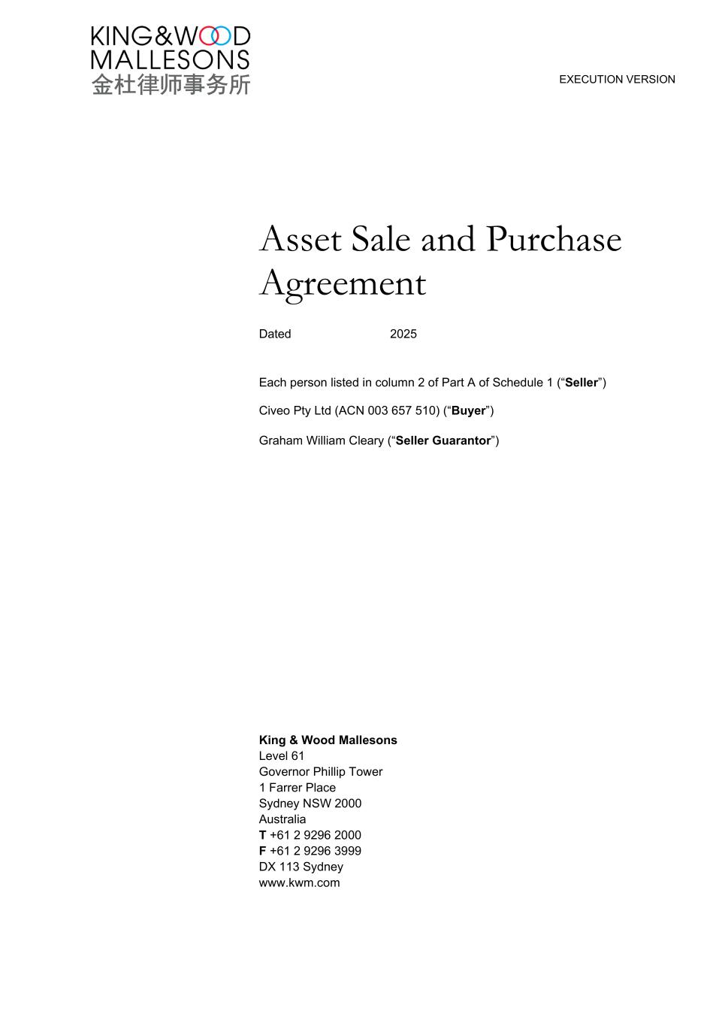
EXECUTION VERSION Asset Sale and Purchase Agreement Dated 2025 Each person listed in column 2 of Part A of Schedule 1 (“Seller”) Civeo Pty Ltd (ACN 003 657 510) (“Buyer”) Graham William Cleary (“Seller Guarantor”) King & Wood Mallesons Level 61 Governor Phillip Tower 1 Farrer Place Sydney NSW 2000 Australia T +61 2 9296 2000 F +61 2 9296 3999 DX 113 Sydney www.kwm.com

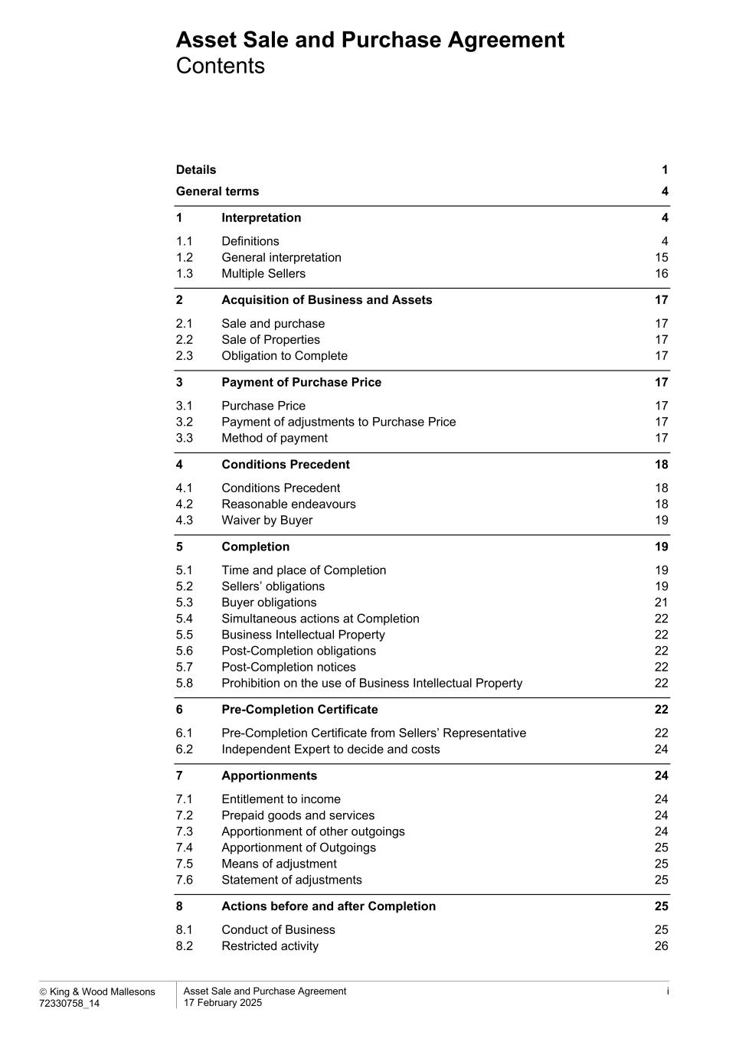
Asset Sale and Purchase Agreement Contents  King & Wood Mallesons 72330758_14 Asset Sale and Purchase Agreement 17 February 2025 i Details 1 General terms 4 1 Interpretation 4 1.1 Definitions 4 1.2 General interpretation 15 1.3 Multiple Sellers 16 2 Acquisition of Business and Assets 17 2.1 Sale and purchase 17 2.2 Sale of Properties 17 2.3 Obligation to Complete 17 3 Payment of Purchase Price 17 3.1 Purchase Price 17 3.2 Payment of adjustments to Purchase Price 17 3.3 Method of payment 17 4 Conditions Precedent 18 4.1 Conditions Precedent 18 4.2 Reasonable endeavours 18 4.3 Waiver by Buyer 19 5 Completion 19 5.1 Time and place of Completion 19 5.2 Sellers’ obligations 19 5.3 Buyer obligations 21 5.4 Simultaneous actions at Completion 22 5.5 Business Intellectual Property 22 5.6 Post-Completion obligations 22 5.7 Post-Completion notices 22 5.8 Prohibition on the use of Business Intellectual Property 22 6 Pre-Completion Certificate 22 6.1 Pre-Completion Certificate from Sellers’ Representative 22 6.2 Independent Expert to decide and costs 24 7 Apportionments 24 7.1 Entitlement to income 24 7.2 Prepaid goods and services 24 7.3 Apportionment of other outgoings 24 7.4 Apportionment of Outgoings 25 7.5 Means of adjustment 25 7.6 Statement of adjustments 25 8 Actions before and after Completion 25 8.1 Conduct of Business 25 8.2 Restricted activity 26

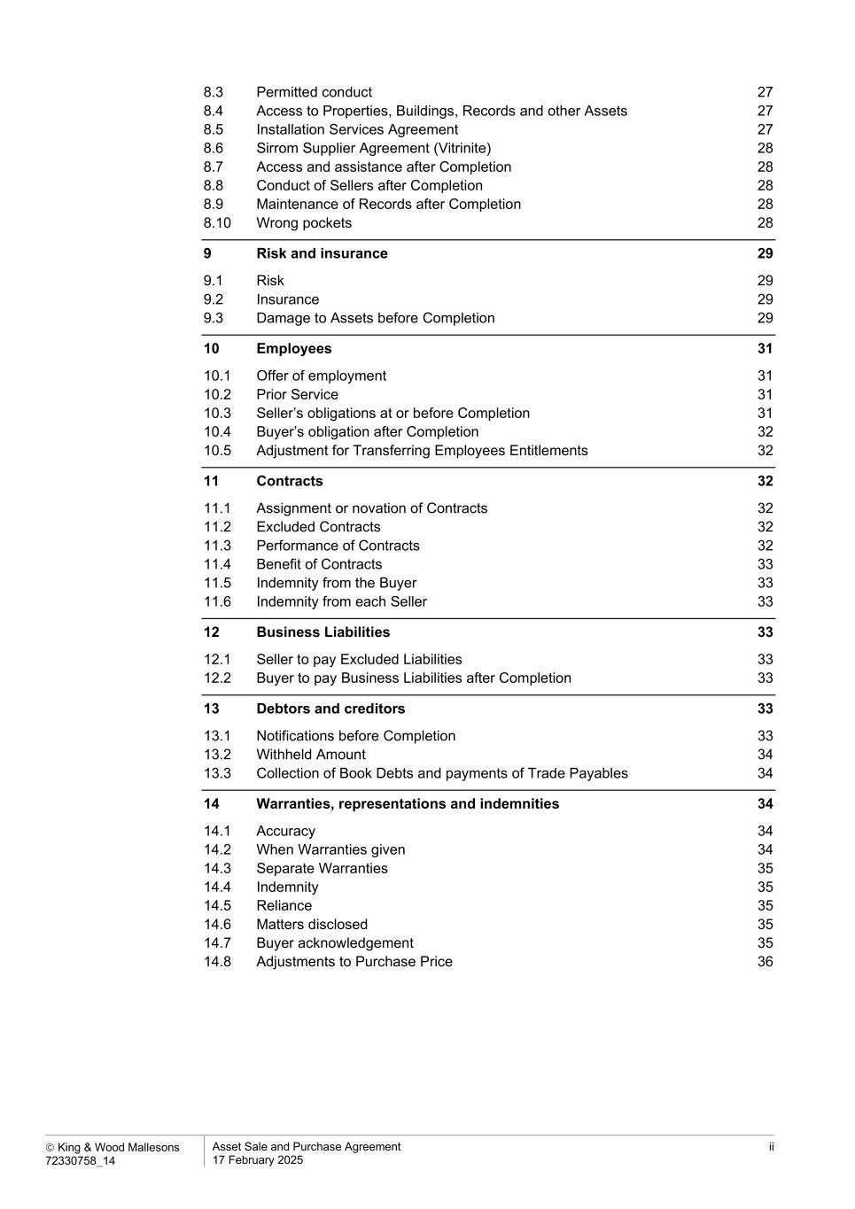
 King & Wood Mallesons 72330758_14 Asset Sale and Purchase Agreement 17 February 2025 ii 8.3 Permitted conduct 27 8.4 Access to Properties, Buildings, Records and other Assets 27 8.5 Installation Services Agreement 27 8.6 Sirrom Supplier Agreement (Vitrinite) 28 8.7 Access and assistance after Completion 28 8.8 Conduct of Sellers after Completion 28 8.9 Maintenance of Records after Completion 28 8.10 Wrong pockets 28 9 Risk and insurance 29 9.1 Risk 29 9.2 Insurance 29 9.3 Damage to Assets before Completion 29 10 Employees 31 10.1 Offer of employment 31 10.2 Prior Service 31 10.3 Seller’s obligations at or before Completion 31 10.4 Buyer’s obligation after Completion 32 10.5 Adjustment for Transferring Employees Entitlements 32 11 Contracts 32 11.1 Assignment or novation of Contracts 32 11.2 Excluded Contracts 32 11.3 Performance of Contracts 32 11.4 Benefit of Contracts 33 11.5 Indemnity from the Buyer 33 11.6 Indemnity from each Seller 33 12 Business Liabilities 33 12.1 Seller to pay Excluded Liabilities 33 12.2 Buyer to pay Business Liabilities after Completion 33 13 Debtors and creditors 33 13.1 Notifications before Completion 33 13.2 Withheld Amount 34 13.3 Collection of Book Debts and payments of Trade Payables 34 14 Warranties, representations and indemnities 34 14.1 Accuracy 34 14.2 When Warranties given 34 14.3 Separate Warranties 35 14.4 Indemnity 35 14.5 Reliance 35 14.6 Matters disclosed 35 14.7 Buyer acknowledgement 35 14.8 Adjustments to Purchase Price 36

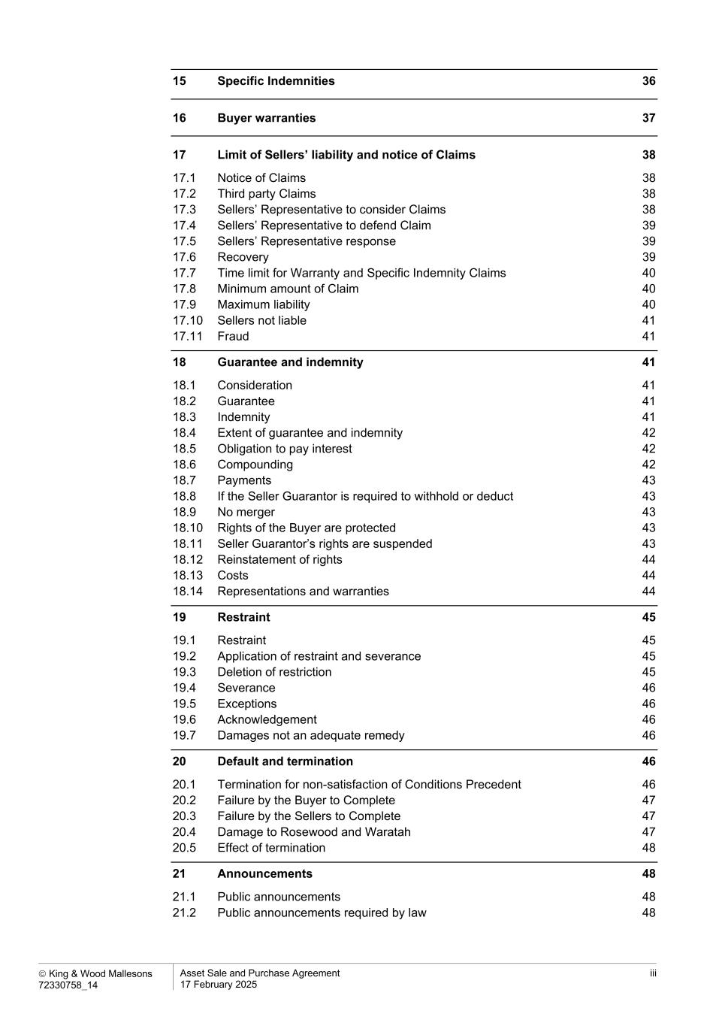
 King & Wood Mallesons 72330758_14 Asset Sale and Purchase Agreement 17 February 2025 iii 15 Specific Indemnities 36 16 Buyer warranties 37 17 Limit of Sellers’ liability and notice of Claims 38 17.1 Notice of Claims 38 17.2 Third party Claims 38 17.3 Sellers’ Representative to consider Claims 38 17.4 Sellers’ Representative to defend Claim 39 17.5 Sellers’ Representative response 39 17.6 Recovery 39 17.7 Time limit for Warranty and Specific Indemnity Claims 40 17.8 Minimum amount of Claim 40 17.9 Maximum liability 40 17.10 Sellers not liable 41 17.11 Fraud 41 18 Guarantee and indemnity 41 18.1 Consideration 41 18.2 Guarantee 41 18.3 Indemnity 41 18.4 Extent of guarantee and indemnity 42 18.5 Obligation to pay interest 42 18.6 Compounding 42 18.7 Payments 43 18.8 If the Seller Guarantor is required to withhold or deduct 43 18.9 No merger 43 18.10 Rights of the Buyer are protected 43 18.11 Seller Guarantor’s rights are suspended 43 18.12 Reinstatement of rights 44 18.13 Costs 44 18.14 Representations and warranties 44 19 Restraint 45 19.1 Restraint 45 19.2 Application of restraint and severance 45 19.3 Deletion of restriction 45 19.4 Severance 46 19.5 Exceptions 46 19.6 Acknowledgement 46 19.7 Damages not an adequate remedy 46 20 Default and termination 46 20.1 Termination for non-satisfaction of Conditions Precedent 46 20.2 Failure by the Buyer to Complete 47 20.3 Failure by the Sellers to Complete 47 20.4 Damage to Rosewood and Waratah 47 20.5 Effect of termination 48 21 Announcements 48 21.1 Public announcements 48 21.2 Public announcements required by law 48

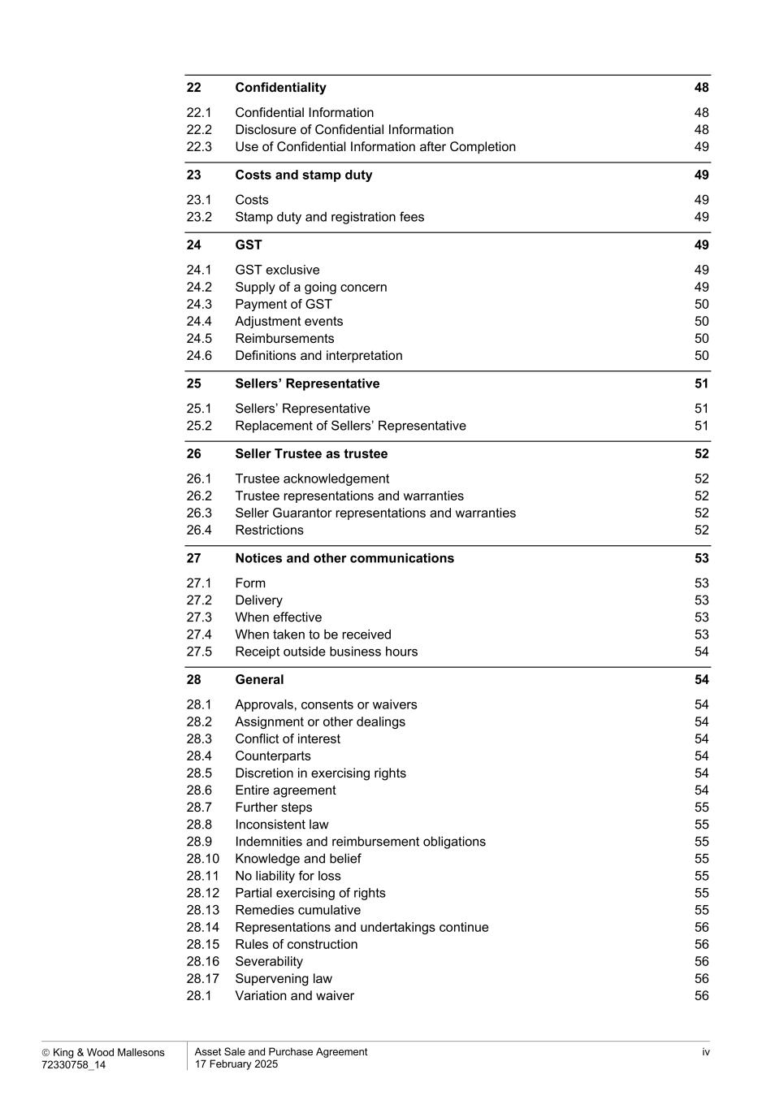
 King & Wood Mallesons 72330758_14 Asset Sale and Purchase Agreement 17 February 2025 iv 22 Confidentiality 48 22.1 Confidential Information 48 22.2 Disclosure of Confidential Information 48 22.3 Use of Confidential Information after Completion 49 23 Costs and stamp duty 49 23.1 Costs 49 23.2 Stamp duty and registration fees 49 24 GST 49 24.1 GST exclusive 49 24.2 Supply of a going concern 49 24.3 Payment of GST 50 24.4 Adjustment events 50 24.5 Reimbursements 50 24.6 Definitions and interpretation 50 25 Sellers’ Representative 51 25.1 Sellers’ Representative 51 25.2 Replacement of Sellers’ Representative 51 26 Seller Trustee as trustee 52 26.1 Trustee acknowledgement 52 26.2 Trustee representations and warranties 52 26.3 Seller Guarantor representations and warranties 52 26.4 Restrictions 52 27 Notices and other communications 53 27.1 Form 53 27.2 Delivery 53 27.3 When effective 53 27.4 When taken to be received 53 27.5 Receipt outside business hours 54 28 General 54 28.1 Approvals, consents or waivers 54 28.2 Assignment or other dealings 54 28.3 Conflict of interest 54 28.4 Counterparts 54 28.5 Discretion in exercising rights 54 28.6 Entire agreement 54 28.7 Further steps 55 28.8 Inconsistent law 55 28.9 Indemnities and reimbursement obligations 55 28.10 Knowledge and belief 55 28.11 No liability for loss 55 28.12 Partial exercising of rights 55 28.13 Remedies cumulative 55 28.14 Representations and undertakings continue 56 28.15 Rules of construction 56 28.16 Severability 56 28.17 Supervening law 56 28.1 Variation and waiver 56

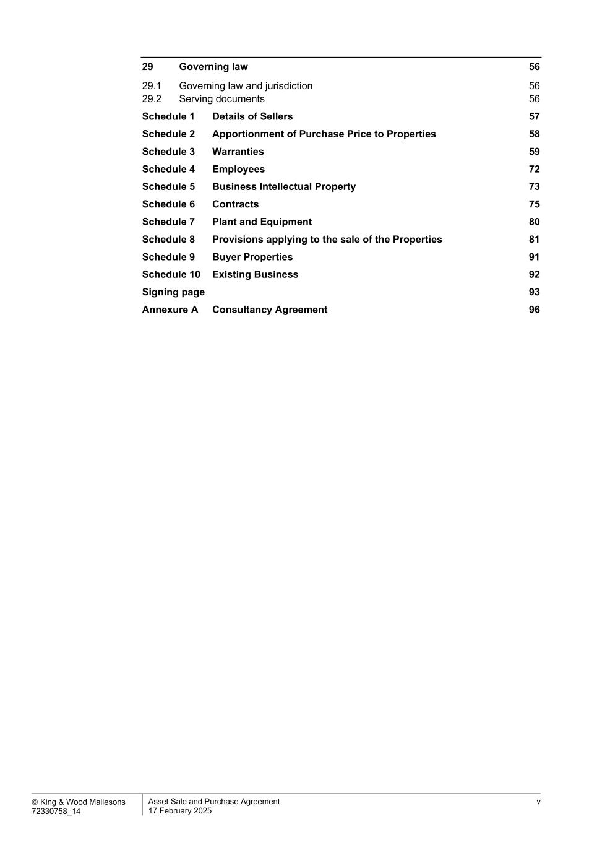
 King & Wood Mallesons 72330758_14 Asset Sale and Purchase Agreement 17 February 2025 v 29 Governing law 56 29.1 Governing law and jurisdiction 56 29.2 Serving documents 56 Schedule 1 Details of Sellers 57 Schedule 2 Apportionment of Purchase Price to Properties 58 Schedule 3 Warranties 59 Schedule 4 Employees 72 Schedule 5 Business Intellectual Property 73 Schedule 6 Contracts 75 Schedule 7 Plant and Equipment 80 Schedule 8 Provisions applying to the sale of the Properties 81 Schedule 9 Buyer Properties 91 Schedule 10 Existing Business 92 Signing page 93 Annexure A Consultancy Agreement 96

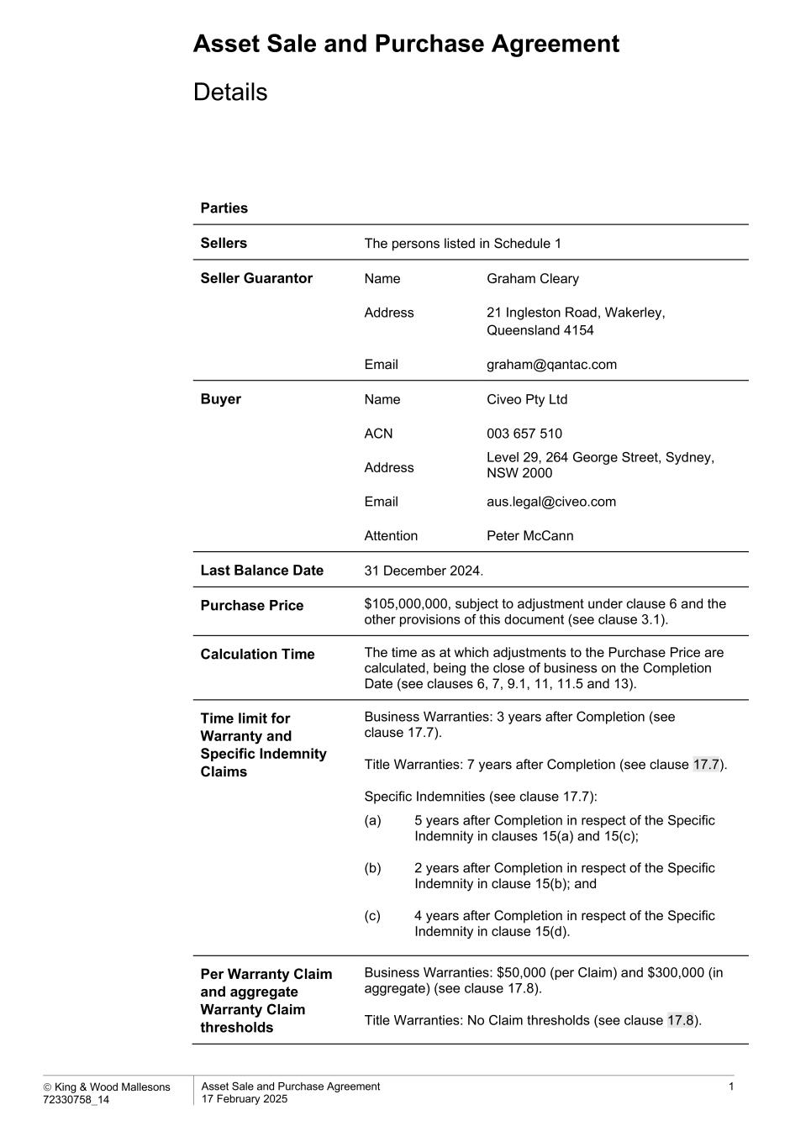
Asset Sale and Purchase Agreement  King & Wood Mallesons 72330758_14 Asset Sale and Purchase Agreement 17 February 2025 1 Details Parties Sellers The persons listed in Schedule 1 Seller Guarantor Name Graham Cleary Address 21 Ingleston Road, Wakerley, Queensland 4154 Email graham@qantac.com Buyer Name Civeo Pty Ltd ACN 003 657 510 Address Level 29, 264 George Street, Sydney, NSW 2000 Email aus.legal@civeo.com Attention Peter McCann Last Balance Date 31 December 2024. Purchase Price $105,000,000, subject to adjustment under clause 6 and the other provisions of this document (see clause 3.1). Calculation Time The time as at which adjustments to the Purchase Price are calculated, being the close of business on the Completion Date (see clauses 6, 7, 9.1, 11, 11.5 and 13). Time limit for Warranty and Specific Indemnity Claims Business Warranties: 3 years after Completion (see clause 17.7). Title Warranties: 7 years after Completion (see clause 17.7). Specific Indemnities (see clause 17.7): (a) 5 years after Completion in respect of the Specific Indemnity in clauses 15(a) and 15(c); (b) 2 years after Completion in respect of the Specific Indemnity in clause 15(b); and (c) 4 years after Completion in respect of the Specific Indemnity in clause 15(d). Per Warranty Claim and aggregate Warranty Claim thresholds Business Warranties: $50,000 (per Claim) and $300,000 (in aggregate) (see clause 17.8). Title Warranties: No Claim thresholds (see clause 17.8).

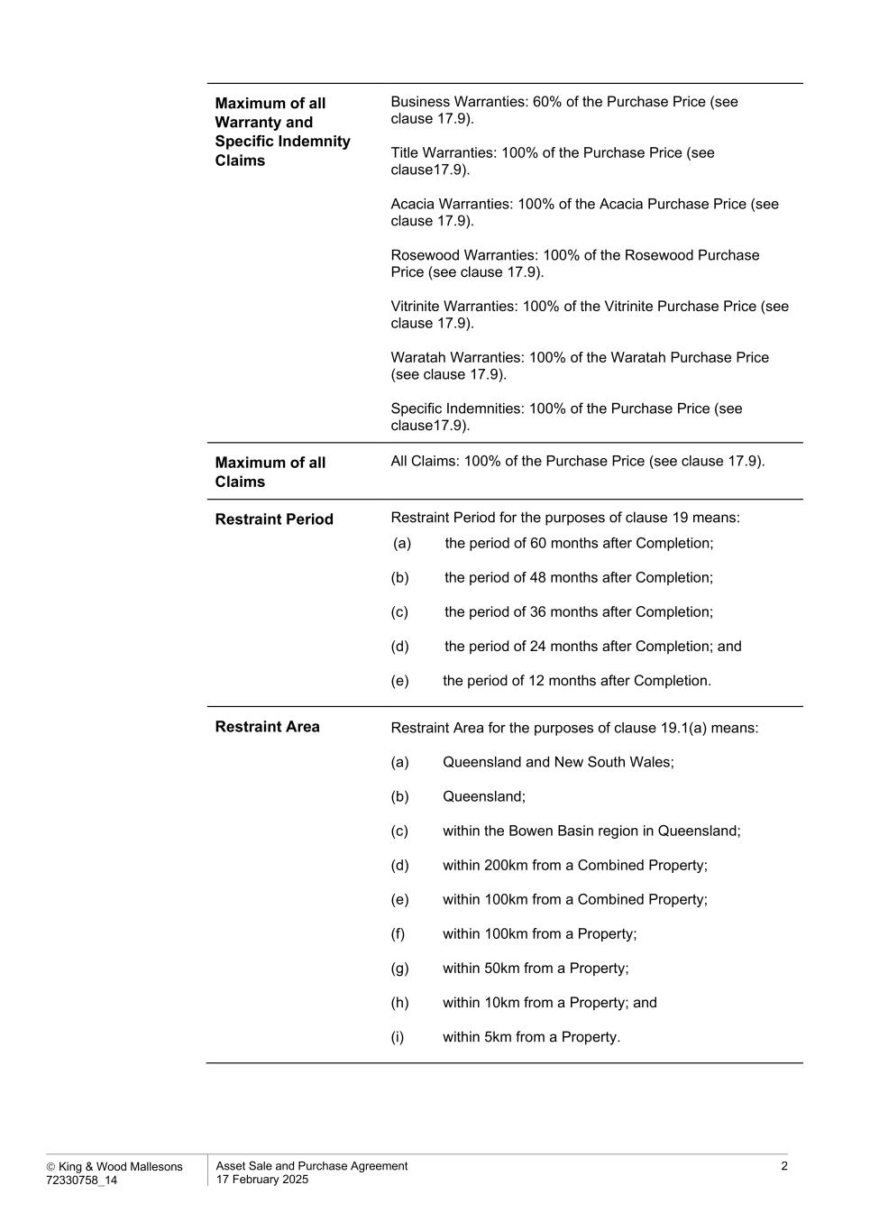
 King & Wood Mallesons 72330758_14 Asset Sale and Purchase Agreement 17 February 2025 2 Maximum of all Warranty and Specific Indemnity Claims Business Warranties: 60% of the Purchase Price (see clause 17.9). Title Warranties: 100% of the Purchase Price (see clause17.9). Acacia Warranties: 100% of the Acacia Purchase Price (see clause 17.9). Rosewood Warranties: 100% of the Rosewood Purchase Price (see clause 17.9). Vitrinite Warranties: 100% of the Vitrinite Purchase Price (see clause 17.9). Waratah Warranties: 100% of the Waratah Purchase Price (see clause 17.9). Specific Indemnities: 100% of the Purchase Price (see clause17.9). Maximum of all Claims All Claims: 100% of the Purchase Price (see clause 17.9). Restraint Period Restraint Period for the purposes of clause 19 means: (a) the period of 60 months after Completion; (b) the period of 48 months after Completion; (c) the period of 36 months after Completion; (d) the period of 24 months after Completion; and (e) the period of 12 months after Completion. Restraint Area Restraint Area for the purposes of clause 19.1(a) means: (a) Queensland and New South Wales; (b) Queensland; (c) within the Bowen Basin region in Queensland; (d) within 200km from a Combined Property; (e) within 100km from a Combined Property; (f) within 100km from a Property; (g) within 50km from a Property; (h) within 10km from a Property; and (i) within 5km from a Property.

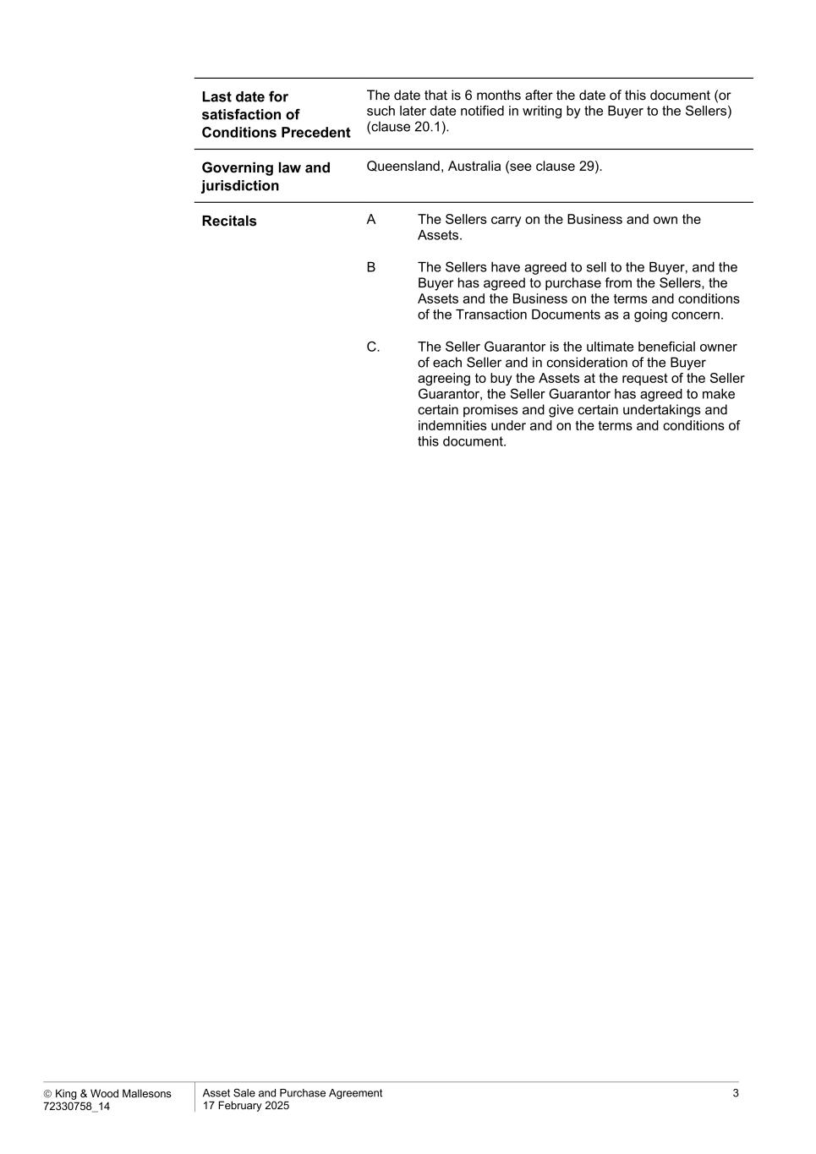
 King & Wood Mallesons 72330758_14 Asset Sale and Purchase Agreement 17 February 2025 3 Last date for satisfaction of Conditions Precedent The date that is 6 months after the date of this document (or such later date notified in writing by the Buyer to the Sellers) (clause 20.1). Governing law and jurisdiction Queensland, Australia (see clause 29). Recitals A The Sellers carry on the Business and own the Assets. B The Sellers have agreed to sell to the Buyer, and the Buyer has agreed to purchase from the Sellers, the Assets and the Business on the terms and conditions of the Transaction Documents as a going concern. C. The Seller Guarantor is the ultimate beneficial owner of each Seller and in consideration of the Buyer agreeing to buy the Assets at the request of the Seller Guarantor, the Seller Guarantor has agreed to make certain promises and give certain undertakings and indemnities under and on the terms and conditions of this document.

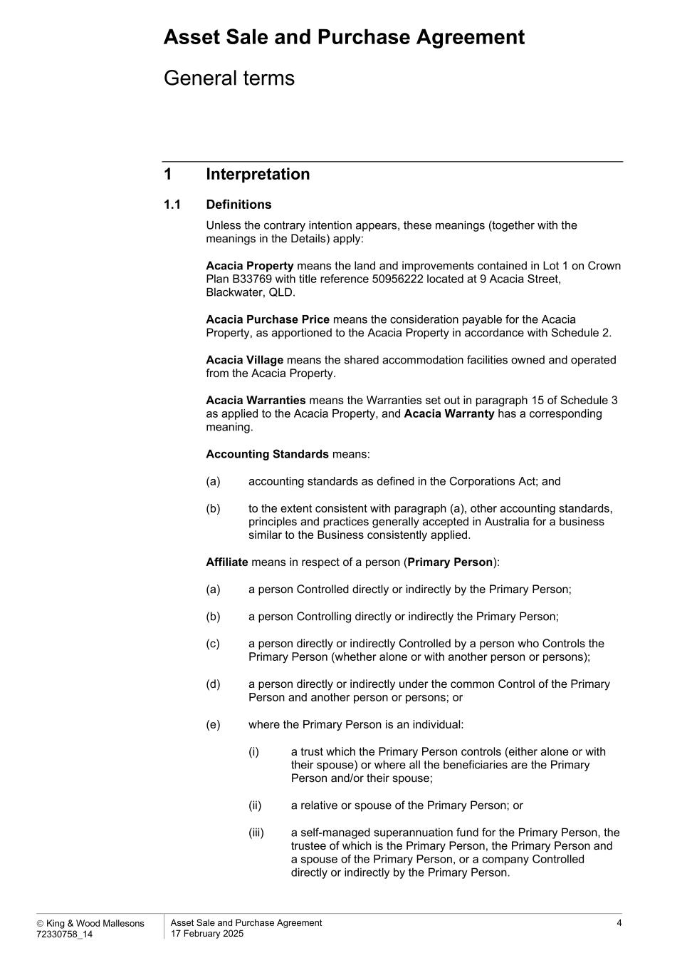
Asset Sale and Purchase Agreement  King & Wood Mallesons 72330758_14 Asset Sale and Purchase Agreement 17 February 2025 4 General terms 1 Interpretation 1.1 Definitions Unless the contrary intention appears, these meanings (together with the meanings in the Details) apply: Acacia Property means the land and improvements contained in Lot 1 on Crown Plan B33769 with title reference 50956222 located at 9 Acacia Street, Blackwater, QLD. Acacia Purchase Price means the consideration payable for the Acacia Property, as apportioned to the Acacia Property in accordance with Schedule 2. Acacia Village means the shared accommodation facilities owned and operated from the Acacia Property. Acacia Warranties means the Warranties set out in paragraph 15 of Schedule 3 as applied to the Acacia Property, and Acacia Warranty has a corresponding meaning. Accounting Standards means: (a) accounting standards as defined in the Corporations Act; and (b) to the extent consistent with paragraph (a), other accounting standards, principles and practices generally accepted in Australia for a business similar to the Business consistently applied. Affiliate means in respect of a person (Primary Person): (a) a person Controlled directly or indirectly by the Primary Person; (b) a person Controlling directly or indirectly the Primary Person; (c) a person directly or indirectly Controlled by a person who Controls the Primary Person (whether alone or with another person or persons); (d) a person directly or indirectly under the common Control of the Primary Person and another person or persons; or (e) where the Primary Person is an individual: (i) a trust which the Primary Person controls (either alone or with their spouse) or where all the beneficiaries are the Primary Person and/or their spouse; (ii) a relative or spouse of the Primary Person; or (iii) a self-managed superannuation fund for the Primary Person, the trustee of which is the Primary Person, the Primary Person and a spouse of the Primary Person, or a company Controlled directly or indirectly by the Primary Person.

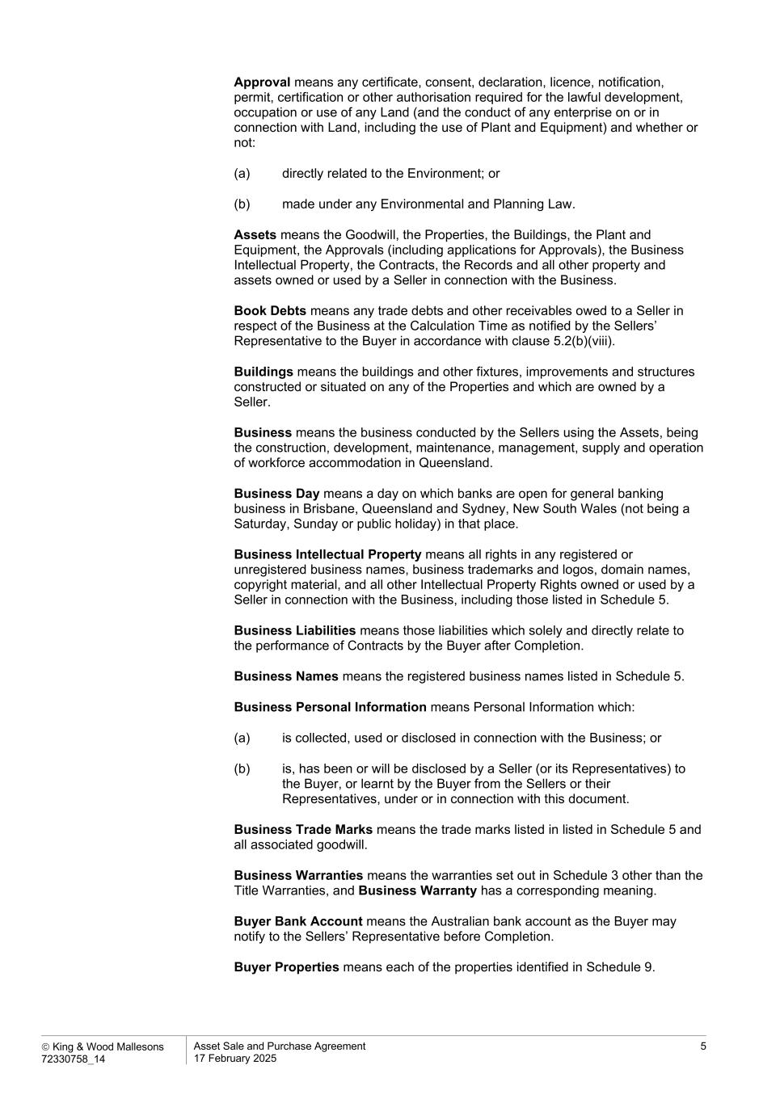
 King & Wood Mallesons 72330758_14 Asset Sale and Purchase Agreement 17 February 2025 5 Approval means any certificate, consent, declaration, licence, notification, permit, certification or other authorisation required for the lawful development, occupation or use of any Land (and the conduct of any enterprise on or in connection with Land, including the use of Plant and Equipment) and whether or not: (a) directly related to the Environment; or (b) made under any Environmental and Planning Law. Assets means the Goodwill, the Properties, the Buildings, the Plant and Equipment, the Approvals (including applications for Approvals), the Business Intellectual Property, the Contracts, the Records and all other property and assets owned or used by a Seller in connection with the Business. Book Debts means any trade debts and other receivables owed to a Seller in respect of the Business at the Calculation Time as notified by the Sellers’ Representative to the Buyer in accordance with clause 5.2(b)(viii). Buildings means the buildings and other fixtures, improvements and structures constructed or situated on any of the Properties and which are owned by a Seller. Business means the business conducted by the Sellers using the Assets, being the construction, development, maintenance, management, supply and operation of workforce accommodation in Queensland. Business Day means a day on which banks are open for general banking business in Brisbane, Queensland and Sydney, New South Wales (not being a Saturday, Sunday or public holiday) in that place. Business Intellectual Property means all rights in any registered or unregistered business names, business trademarks and logos, domain names, copyright material, and all other Intellectual Property Rights owned or used by a Seller in connection with the Business, including those listed in Schedule 5. Business Liabilities means those liabilities which solely and directly relate to the performance of Contracts by the Buyer after Completion. Business Names means the registered business names listed in Schedule 5. Business Personal Information means Personal Information which: (a) is collected, used or disclosed in connection with the Business; or (b) is, has been or will be disclosed by a Seller (or its Representatives) to the Buyer, or learnt by the Buyer from the Sellers or their Representatives, under or in connection with this document. Business Trade Marks means the trade marks listed in listed in Schedule 5 and all associated goodwill. Business Warranties means the warranties set out in Schedule 3 other than the Title Warranties, and Business Warranty has a corresponding meaning. Buyer Bank Account means the Australian bank account as the Buyer may notify to the Sellers’ Representative before Completion. Buyer Properties means each of the properties identified in Schedule 9.

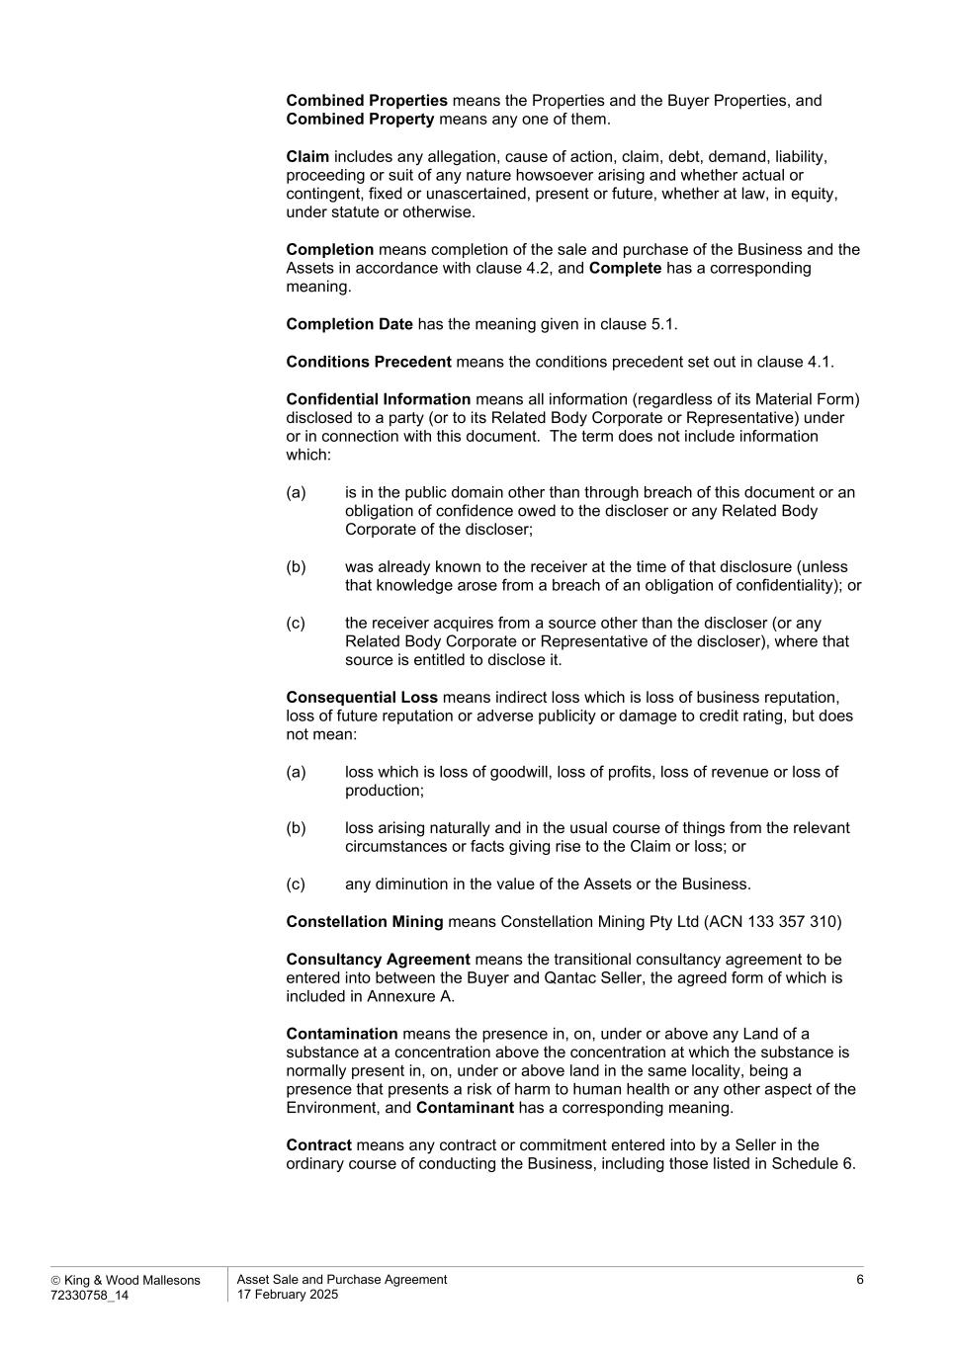
 King & Wood Mallesons 72330758_14 Asset Sale and Purchase Agreement 17 February 2025 6 Combined Properties means the Properties and the Buyer Properties, and Combined Property means any one of them. Claim includes any allegation, cause of action, claim, debt, demand, liability, proceeding or suit of any nature howsoever arising and whether actual or contingent, fixed or unascertained, present or future, whether at law, in equity, under statute or otherwise. Completion means completion of the sale and purchase of the Business and the Assets in accordance with clause 4.2, and Complete has a corresponding meaning. Completion Date has the meaning given in clause 5.1. Conditions Precedent means the conditions precedent set out in clause 4.1. Confidential Information means all information (regardless of its Material Form) disclosed to a party (or to its Related Body Corporate or Representative) under or in connection with this document. The term does not include information which: (a) is in the public domain other than through breach of this document or an obligation of confidence owed to the discloser or any Related Body Corporate of the discloser; (b) was already known to the receiver at the time of that disclosure (unless that knowledge arose from a breach of an obligation of confidentiality); or (c) the receiver acquires from a source other than the discloser (or any Related Body Corporate or Representative of the discloser), where that source is entitled to disclose it. Consequential Loss means indirect loss which is loss of business reputation, loss of future reputation or adverse publicity or damage to credit rating, but does not mean: (a) loss which is loss of goodwill, loss of profits, loss of revenue or loss of production; (b) loss arising naturally and in the usual course of things from the relevant circumstances or facts giving rise to the Claim or loss; or (c) any diminution in the value of the Assets or the Business. Constellation Mining means Constellation Mining Pty Ltd (ACN 133 357 310) Consultancy Agreement means the transitional consultancy agreement to be entered into between the Buyer and Qantac Seller, the agreed form of which is included in Annexure A. Contamination means the presence in, on, under or above any Land of a substance at a concentration above the concentration at which the substance is normally present in, on, under or above land in the same locality, being a presence that presents a risk of harm to human health or any other aspect of the Environment, and Contaminant has a corresponding meaning. Contract means any contract or commitment entered into by a Seller in the ordinary course of conducting the Business, including those listed in Schedule 6.

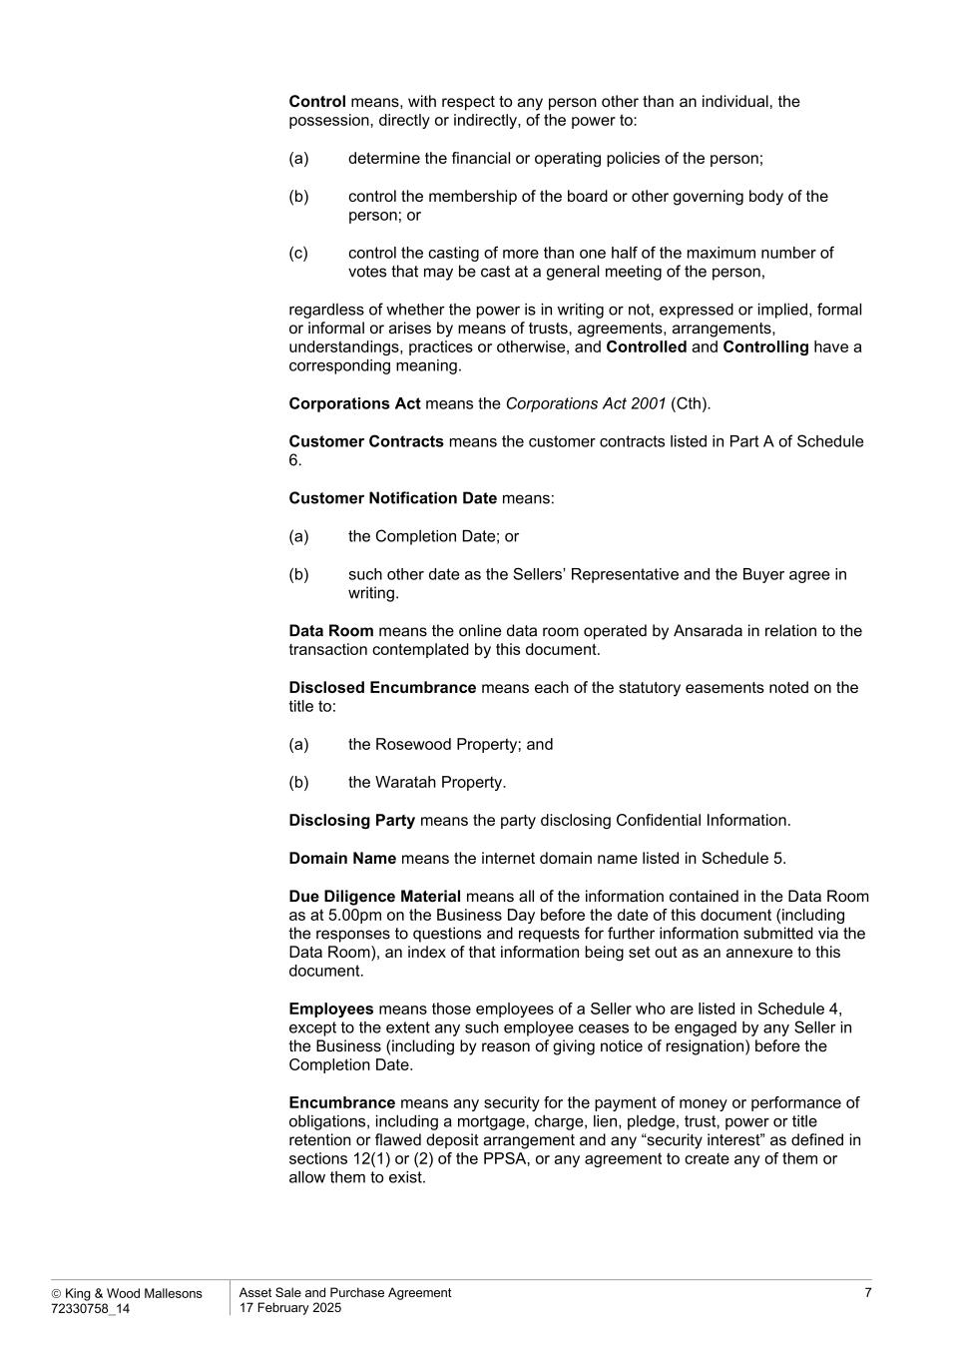
 King & Wood Mallesons 72330758_14 Asset Sale and Purchase Agreement 17 February 2025 7 Control means, with respect to any person other than an individual, the possession, directly or indirectly, of the power to: (a) determine the financial or operating policies of the person; (b) control the membership of the board or other governing body of the person; or (c) control the casting of more than one half of the maximum number of votes that may be cast at a general meeting of the person, regardless of whether the power is in writing or not, expressed or implied, formal or informal or arises by means of trusts, agreements, arrangements, understandings, practices or otherwise, and Controlled and Controlling have a corresponding meaning. Corporations Act means the Corporations Act 2001 (Cth). Customer Contracts means the customer contracts listed in Part A of Schedule 6. Customer Notification Date means: (a) the Completion Date; or (b) such other date as the Sellers’ Representative and the Buyer agree in writing. Data Room means the online data room operated by Ansarada in relation to the transaction contemplated by this document. Disclosed Encumbrance means each of the statutory easements noted on the title to: (a) the Rosewood Property; and (b) the Waratah Property. Disclosing Party means the party disclosing Confidential Information. Domain Name means the internet domain name listed in Schedule 5. Due Diligence Material means all of the information contained in the Data Room as at 5.00pm on the Business Day before the date of this document (including the responses to questions and requests for further information submitted via the Data Room), an index of that information being set out as an annexure to this document. Employees means those employees of a Seller who are listed in Schedule 4, except to the extent any such employee ceases to be engaged by any Seller in the Business (including by reason of giving notice of resignation) before the Completion Date. Encumbrance means any security for the payment of money or performance of obligations, including a mortgage, charge, lien, pledge, trust, power or title retention or flawed deposit arrangement and any “security interest” as defined in sections 12(1) or (2) of the PPSA, or any agreement to create any of them or allow them to exist.

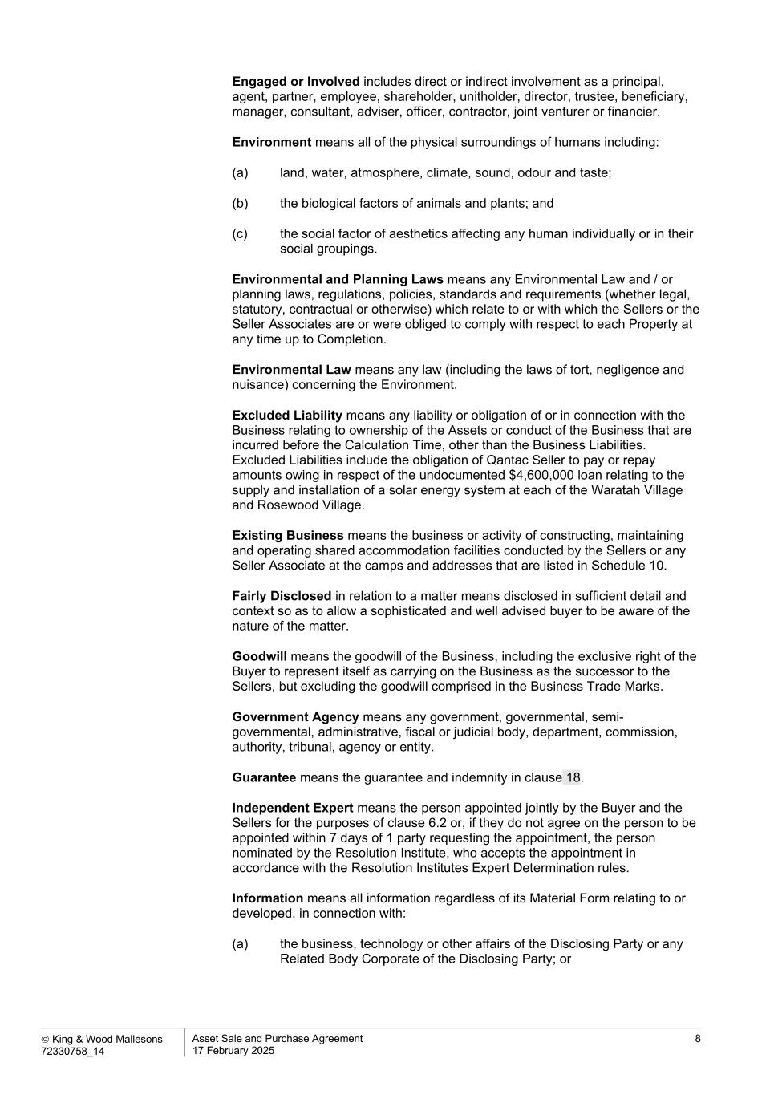
 King & Wood Mallesons 72330758_14 Asset Sale and Purchase Agreement 17 February 2025 8 Engaged or Involved includes direct or indirect involvement as a principal, agent, partner, employee, shareholder, unitholder, director, trustee, beneficiary, manager, consultant, adviser, officer, contractor, joint venturer or financier. Environment means all of the physical surroundings of humans including: (a) land, water, atmosphere, climate, sound, odour and taste; (b) the biological factors of animals and plants; and (c) the social factor of aesthetics affecting any human individually or in their social groupings. Environmental and Planning Laws means any Environmental Law and / or planning laws, regulations, policies, standards and requirements (whether legal, statutory, contractual or otherwise) which relate to or with which the Sellers or the Seller Associates are or were obliged to comply with respect to each Property at any time up to Completion. Environmental Law means any law (including the laws of tort, negligence and nuisance) concerning the Environment. Excluded Liability means any liability or obligation of or in connection with the Business relating to ownership of the Assets or conduct of the Business that are incurred before the Calculation Time, other than the Business Liabilities. Excluded Liabilities include the obligation of Qantac Seller to pay or repay amounts owing in respect of the undocumented $4,600,000 loan relating to the supply and installation of a solar energy system at each of the Waratah Village and Rosewood Village. Existing Business means the business or activity of constructing, maintaining and operating shared accommodation facilities conducted by the Sellers or any Seller Associate at the camps and addresses that are listed in Schedule 10. Fairly Disclosed in relation to a matter means disclosed in sufficient detail and context so as to allow a sophisticated and well advised buyer to be aware of the nature of the matter. Goodwill means the goodwill of the Business, including the exclusive right of the Buyer to represent itself as carrying on the Business as the successor to the Sellers, but excluding the goodwill comprised in the Business Trade Marks. Government Agency means any government, governmental, semi- governmental, administrative, fiscal or judicial body, department, commission, authority, tribunal, agency or entity. Guarantee means the guarantee and indemnity in clause 18. Independent Expert means the person appointed jointly by the Buyer and the Sellers for the purposes of clause 6.2 or, if they do not agree on the person to be appointed within 7 days of 1 party requesting the appointment, the person nominated by the Resolution Institute, who accepts the appointment in accordance with the Resolution Institutes Expert Determination rules. Information means all information regardless of its Material Form relating to or developed, in connection with: (a) the business, technology or other affairs of the Disclosing Party or any Related Body Corporate of the Disclosing Party; or

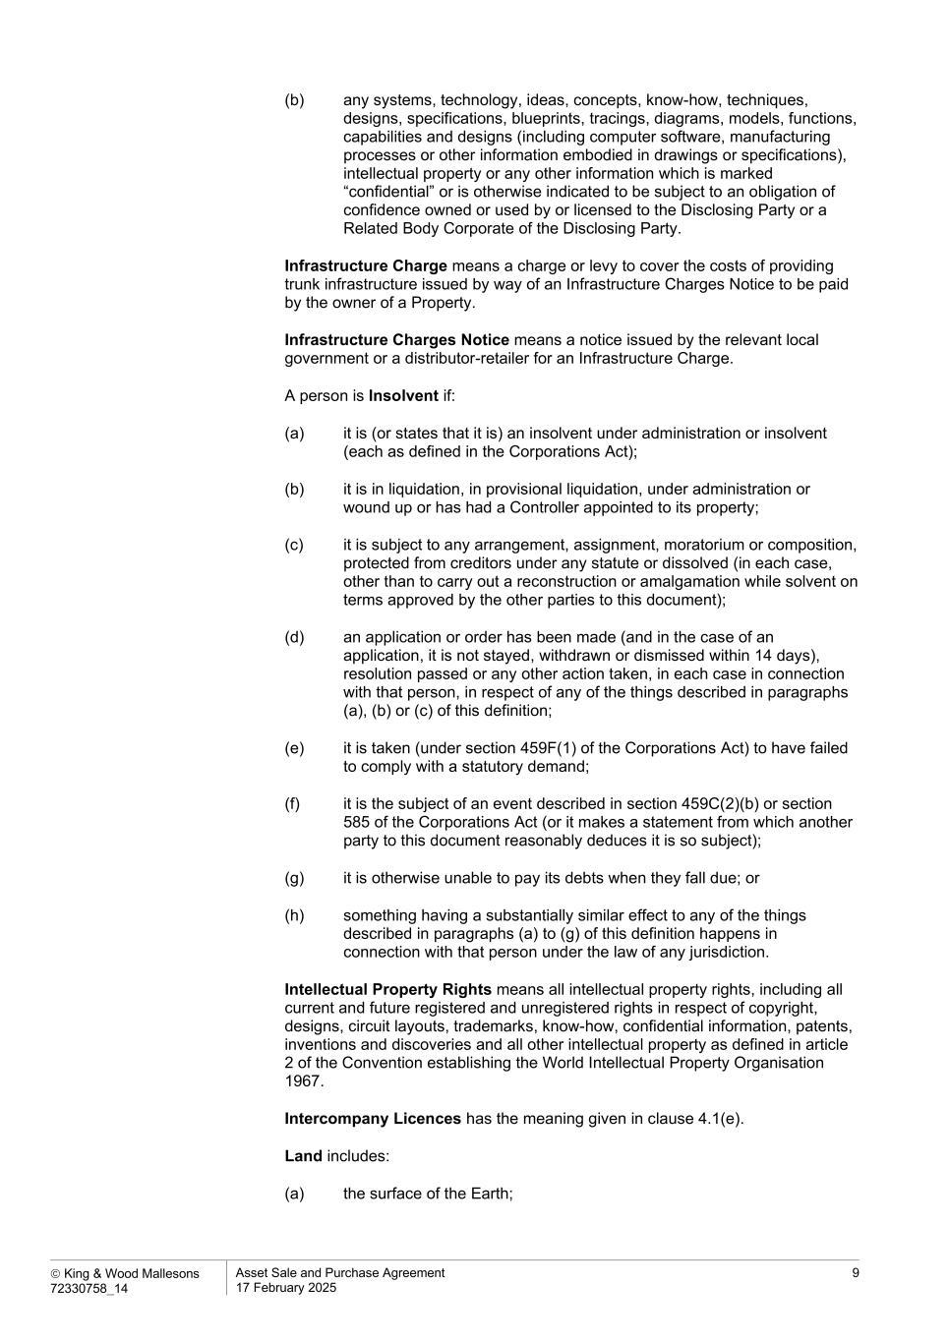
 King & Wood Mallesons 72330758_14 Asset Sale and Purchase Agreement 17 February 2025 9 (b) any systems, technology, ideas, concepts, know-how, techniques, designs, specifications, blueprints, tracings, diagrams, models, functions, capabilities and designs (including computer software, manufacturing processes or other information embodied in drawings or specifications), intellectual property or any other information which is marked “confidential” or is otherwise indicated to be subject to an obligation of confidence owned or used by or licensed to the Disclosing Party or a Related Body Corporate of the Disclosing Party. Infrastructure Charge means a charge or levy to cover the costs of providing trunk infrastructure issued by way of an Infrastructure Charges Notice to be paid by the owner of a Property. Infrastructure Charges Notice means a notice issued by the relevant local government or a distributor-retailer for an Infrastructure Charge. A person is Insolvent if: (a) it is (or states that it is) an insolvent under administration or insolvent (each as defined in the Corporations Act); (b) it is in liquidation, in provisional liquidation, under administration or wound up or has had a Controller appointed to its property; (c) it is subject to any arrangement, assignment, moratorium or composition, protected from creditors under any statute or dissolved (in each case, other than to carry out a reconstruction or amalgamation while solvent on terms approved by the other parties to this document); (d) an application or order has been made (and in the case of an application, it is not stayed, withdrawn or dismissed within 14 days), resolution passed or any other action taken, in each case in connection with that person, in respect of any of the things described in paragraphs (a), (b) or (c) of this definition; (e) it is taken (under section 459F(1) of the Corporations Act) to have failed to comply with a statutory demand; (f) it is the subject of an event described in section 459C(2)(b) or section 585 of the Corporations Act (or it makes a statement from which another party to this document reasonably deduces it is so subject); (g) it is otherwise unable to pay its debts when they fall due; or (h) something having a substantially similar effect to any of the things described in paragraphs (a) to (g) of this definition happens in connection with that person under the law of any jurisdiction. Intellectual Property Rights means all intellectual property rights, including all current and future registered and unregistered rights in respect of copyright, designs, circuit layouts, trademarks, know-how, confidential information, patents, inventions and discoveries and all other intellectual property as defined in article 2 of the Convention establishing the World Intellectual Property Organisation 1967. Intercompany Licences has the meaning given in clause 4.1(e). Land includes: (a) the surface of the Earth;

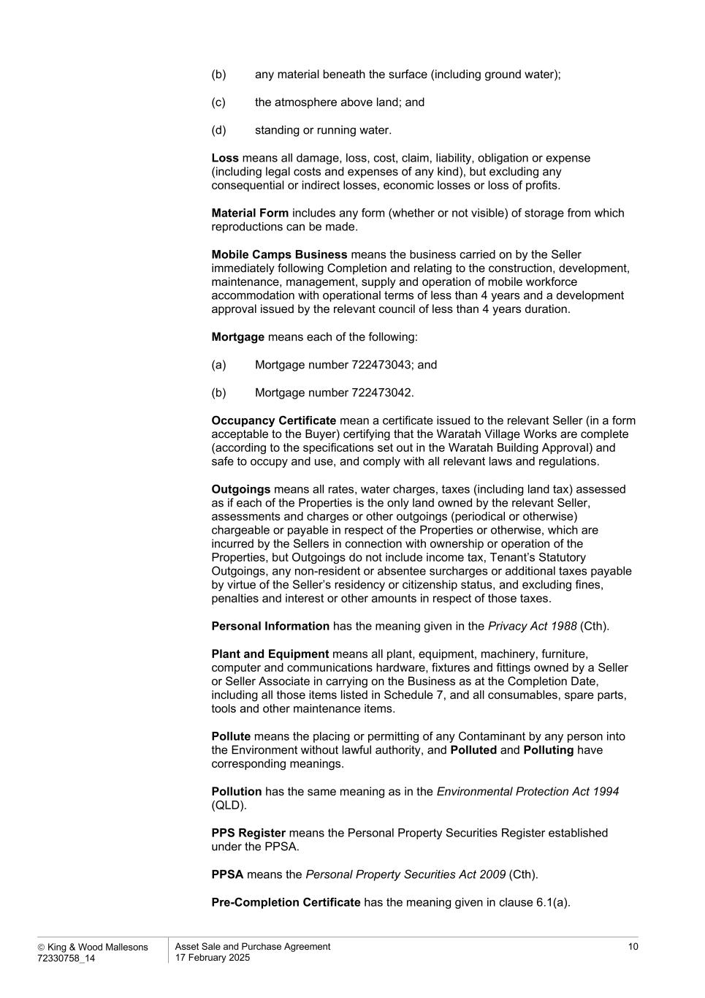
 King & Wood Mallesons 72330758_14 Asset Sale and Purchase Agreement 17 February 2025 10 (b) any material beneath the surface (including ground water); (c) the atmosphere above land; and (d) standing or running water. Loss means all damage, loss, cost, claim, liability, obligation or expense (including legal costs and expenses of any kind), but excluding any consequential or indirect losses, economic losses or loss of profits. Material Form includes any form (whether or not visible) of storage from which reproductions can be made. Mobile Camps Business means the business carried on by the Seller immediately following Completion and relating to the construction, development, maintenance, management, supply and operation of mobile workforce accommodation with operational terms of less than 4 years and a development approval issued by the relevant council of less than 4 years duration. Mortgage means each of the following: (a) Mortgage number 722473043; and (b) Mortgage number 722473042. Occupancy Certificate mean a certificate issued to the relevant Seller (in a form acceptable to the Buyer) certifying that the Waratah Village Works are complete (according to the specifications set out in the Waratah Building Approval) and safe to occupy and use, and comply with all relevant laws and regulations. Outgoings means all rates, water charges, taxes (including land tax) assessed as if each of the Properties is the only land owned by the relevant Seller, assessments and charges or other outgoings (periodical or otherwise) chargeable or payable in respect of the Properties or otherwise, which are incurred by the Sellers in connection with ownership or operation of the Properties, but Outgoings do not include income tax, Tenant’s Statutory Outgoings, any non-resident or absentee surcharges or additional taxes payable by virtue of the Seller’s residency or citizenship status, and excluding fines, penalties and interest or other amounts in respect of those taxes. Personal Information has the meaning given in the Privacy Act 1988 (Cth). Plant and Equipment means all plant, equipment, machinery, furniture, computer and communications hardware, fixtures and fittings owned by a Seller or Seller Associate in carrying on the Business as at the Completion Date, including all those items listed in Schedule 7, and all consumables, spare parts, tools and other maintenance items. Pollute means the placing or permitting of any Contaminant by any person into the Environment without lawful authority, and Polluted and Polluting have corresponding meanings. Pollution has the same meaning as in the Environmental Protection Act 1994 (QLD). PPS Register means the Personal Property Securities Register established under the PPSA. PPSA means the Personal Property Securities Act 2009 (Cth). Pre-Completion Certificate has the meaning given in clause 6.1(a).

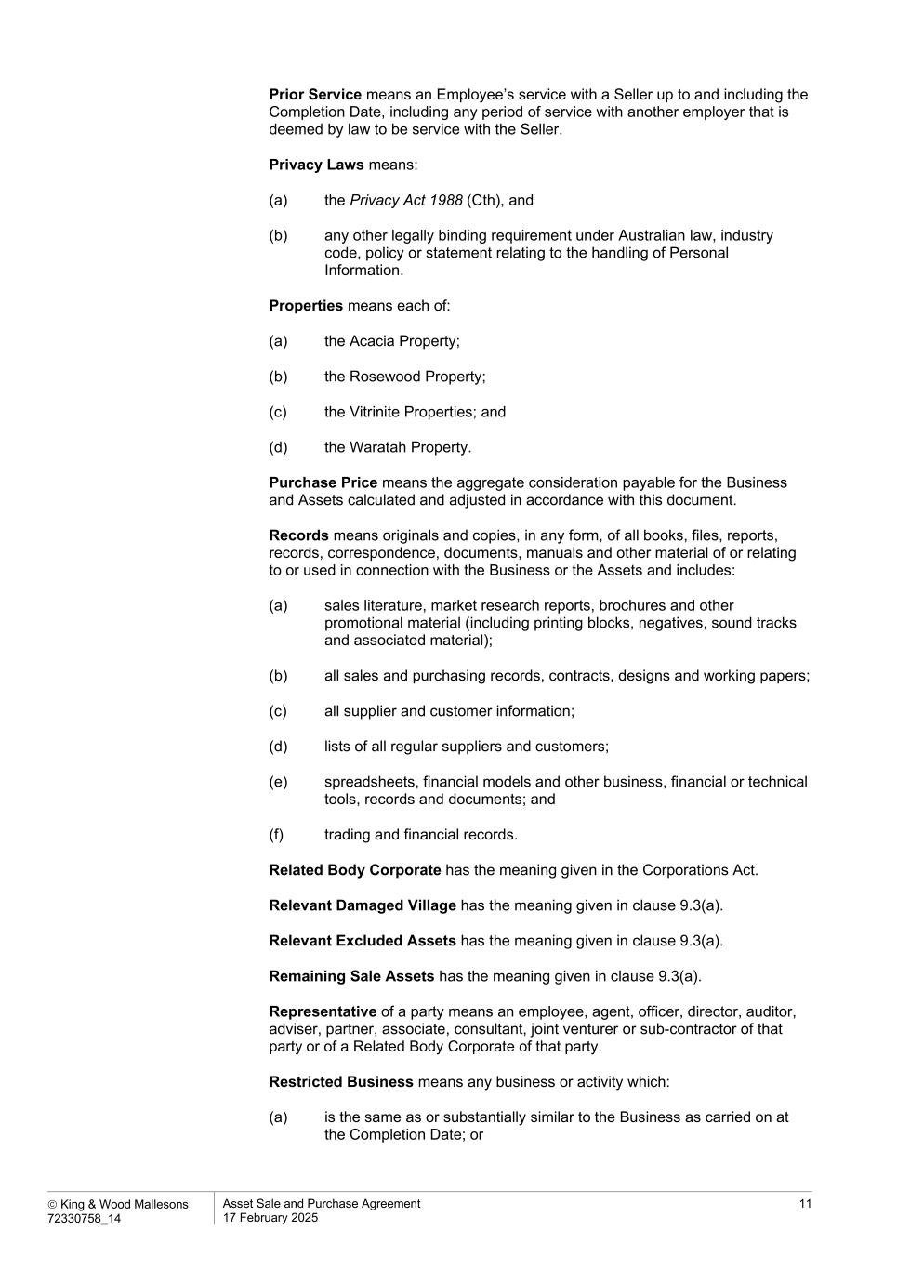
 King & Wood Mallesons 72330758_14 Asset Sale and Purchase Agreement 17 February 2025 11 Prior Service means an Employee’s service with a Seller up to and including the Completion Date, including any period of service with another employer that is deemed by law to be service with the Seller. Privacy Laws means: (a) the Privacy Act 1988 (Cth), and (b) any other legally binding requirement under Australian law, industry code, policy or statement relating to the handling of Personal Information. Properties means each of: (a) the Acacia Property; (b) the Rosewood Property; (c) the Vitrinite Properties; and (d) the Waratah Property. Purchase Price means the aggregate consideration payable for the Business and Assets calculated and adjusted in accordance with this document. Records means originals and copies, in any form, of all books, files, reports, records, correspondence, documents, manuals and other material of or relating to or used in connection with the Business or the Assets and includes: (a) sales literature, market research reports, brochures and other promotional material (including printing blocks, negatives, sound tracks and associated material); (b) all sales and purchasing records, contracts, designs and working papers; (c) all supplier and customer information; (d) lists of all regular suppliers and customers; (e) spreadsheets, financial models and other business, financial or technical tools, records and documents; and (f) trading and financial records. Related Body Corporate has the meaning given in the Corporations Act. Relevant Damaged Village has the meaning given in clause 9.3(a). Relevant Excluded Assets has the meaning given in clause 9.3(a). Remaining Sale Assets has the meaning given in clause 9.3(a). Representative of a party means an employee, agent, officer, director, auditor, adviser, partner, associate, consultant, joint venturer or sub-contractor of that party or of a Related Body Corporate of that party. Restricted Business means any business or activity which: (a) is the same as or substantially similar to the Business as carried on at the Completion Date; or

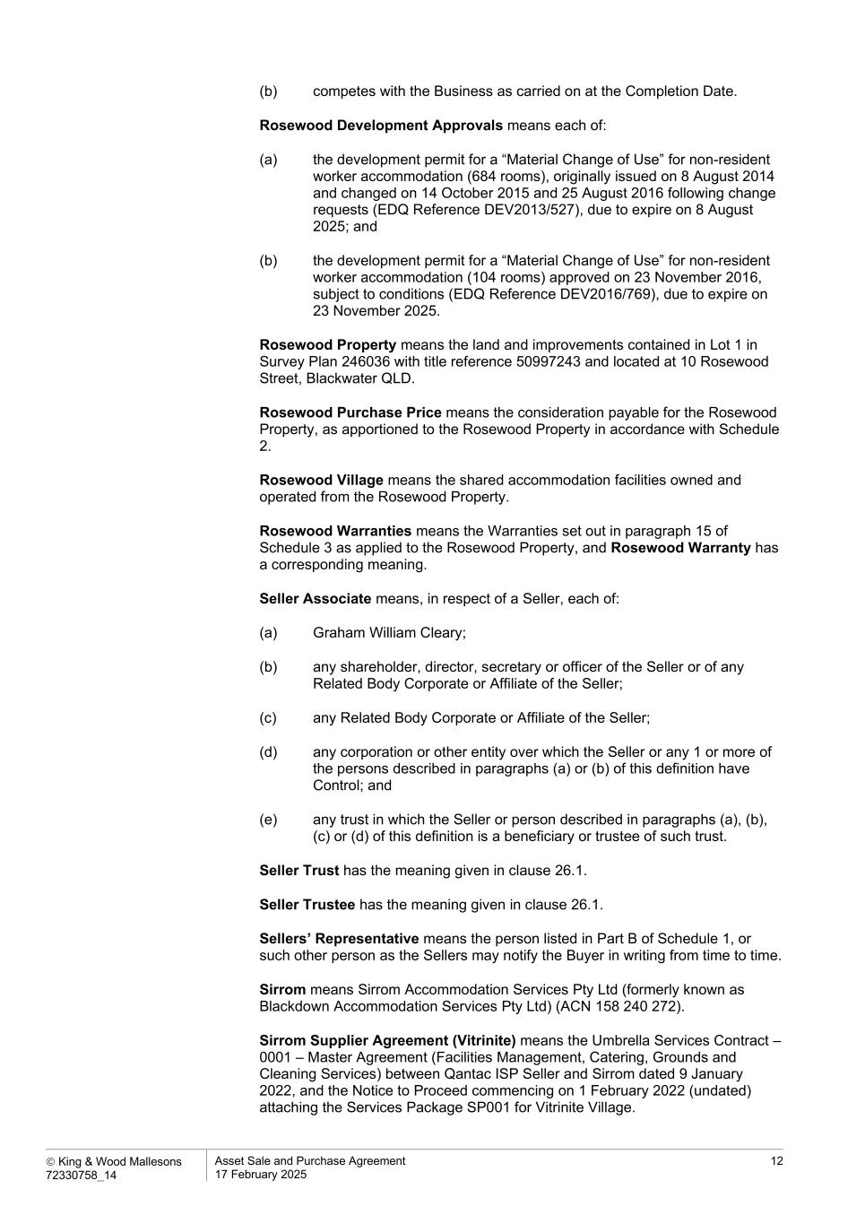
 King & Wood Mallesons 72330758_14 Asset Sale and Purchase Agreement 17 February 2025 12 (b) competes with the Business as carried on at the Completion Date. Rosewood Development Approvals means each of: (a) the development permit for a “Material Change of Use” for non-resident worker accommodation (684 rooms), originally issued on 8 August 2014 and changed on 14 October 2015 and 25 August 2016 following change requests (EDQ Reference DEV2013/527), due to expire on 8 August 2025; and (b) the development permit for a “Material Change of Use” for non-resident worker accommodation (104 rooms) approved on 23 November 2016, subject to conditions (EDQ Reference DEV2016/769), due to expire on 23 November 2025. Rosewood Property means the land and improvements contained in Lot 1 in Survey Plan 246036 with title reference 50997243 and located at 10 Rosewood Street, Blackwater QLD. Rosewood Purchase Price means the consideration payable for the Rosewood Property, as apportioned to the Rosewood Property in accordance with Schedule 2. Rosewood Village means the shared accommodation facilities owned and operated from the Rosewood Property. Rosewood Warranties means the Warranties set out in paragraph 15 of Schedule 3 as applied to the Rosewood Property, and Rosewood Warranty has a corresponding meaning. Seller Associate means, in respect of a Seller, each of: (a) Graham William Cleary; (b) any shareholder, director, secretary or officer of the Seller or of any Related Body Corporate or Affiliate of the Seller; (c) any Related Body Corporate or Affiliate of the Seller; (d) any corporation or other entity over which the Seller or any 1 or more of the persons described in paragraphs (a) or (b) of this definition have Control; and (e) any trust in which the Seller or person described in paragraphs (a), (b), (c) or (d) of this definition is a beneficiary or trustee of such trust. Seller Trust has the meaning given in clause 26.1. Seller Trustee has the meaning given in clause 26.1. Sellers’ Representative means the person listed in Part B of Schedule 1, or such other person as the Sellers may notify the Buyer in writing from time to time. Sirrom means Sirrom Accommodation Services Pty Ltd (formerly known as Blackdown Accommodation Services Pty Ltd) (ACN 158 240 272). Sirrom Supplier Agreement (Vitrinite) means the Umbrella Services Contract – 0001 – Master Agreement (Facilities Management, Catering, Grounds and Cleaning Services) between Qantac ISP Seller and Sirrom dated 9 January 2022, and the Notice to Proceed commencing on 1 February 2022 (undated) attaching the Services Package SP001 for Vitrinite Village.

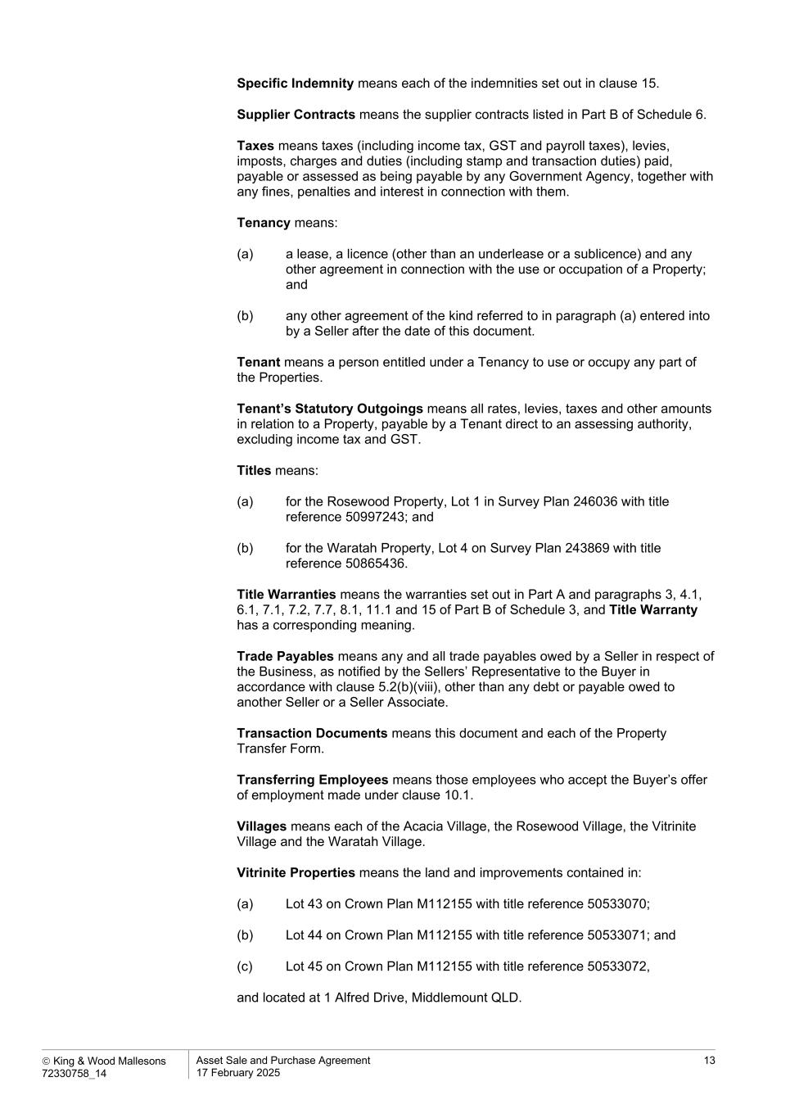
 King & Wood Mallesons 72330758_14 Asset Sale and Purchase Agreement 17 February 2025 13 Specific Indemnity means each of the indemnities set out in clause 15. Supplier Contracts means the supplier contracts listed in Part B of Schedule 6. Taxes means taxes (including income tax, GST and payroll taxes), levies, imposts, charges and duties (including stamp and transaction duties) paid, payable or assessed as being payable by any Government Agency, together with any fines, penalties and interest in connection with them. Tenancy means: (a) a lease, a licence (other than an underlease or a sublicence) and any other agreement in connection with the use or occupation of a Property; and (b) any other agreement of the kind referred to in paragraph (a) entered into by a Seller after the date of this document. Tenant means a person entitled under a Tenancy to use or occupy any part of the Properties. Tenant’s Statutory Outgoings means all rates, levies, taxes and other amounts in relation to a Property, payable by a Tenant direct to an assessing authority, excluding income tax and GST. Titles means: (a) for the Rosewood Property, Lot 1 in Survey Plan 246036 with title reference 50997243; and (b) for the Waratah Property, Lot 4 on Survey Plan 243869 with title reference 50865436. Title Warranties means the warranties set out in Part A and paragraphs 3, 4.1, 6.1, 7.1, 7.2, 7.7, 8.1, 11.1 and 15 of Part B of Schedule 3, and Title Warranty has a corresponding meaning. Trade Payables means any and all trade payables owed by a Seller in respect of the Business, as notified by the Sellers’ Representative to the Buyer in accordance with clause 5.2(b)(viii), other than any debt or payable owed to another Seller or a Seller Associate. Transaction Documents means this document and each of the Property Transfer Form. Transferring Employees means those employees who accept the Buyer’s offer of employment made under clause 10.1. Villages means each of the Acacia Village, the Rosewood Village, the Vitrinite Village and the Waratah Village. Vitrinite Properties means the land and improvements contained in: (a) Lot 43 on Crown Plan M112155 with title reference 50533070; (b) Lot 44 on Crown Plan M112155 with title reference 50533071; and (c) Lot 45 on Crown Plan M112155 with title reference 50533072, and located at 1 Alfred Drive, Middlemount QLD.

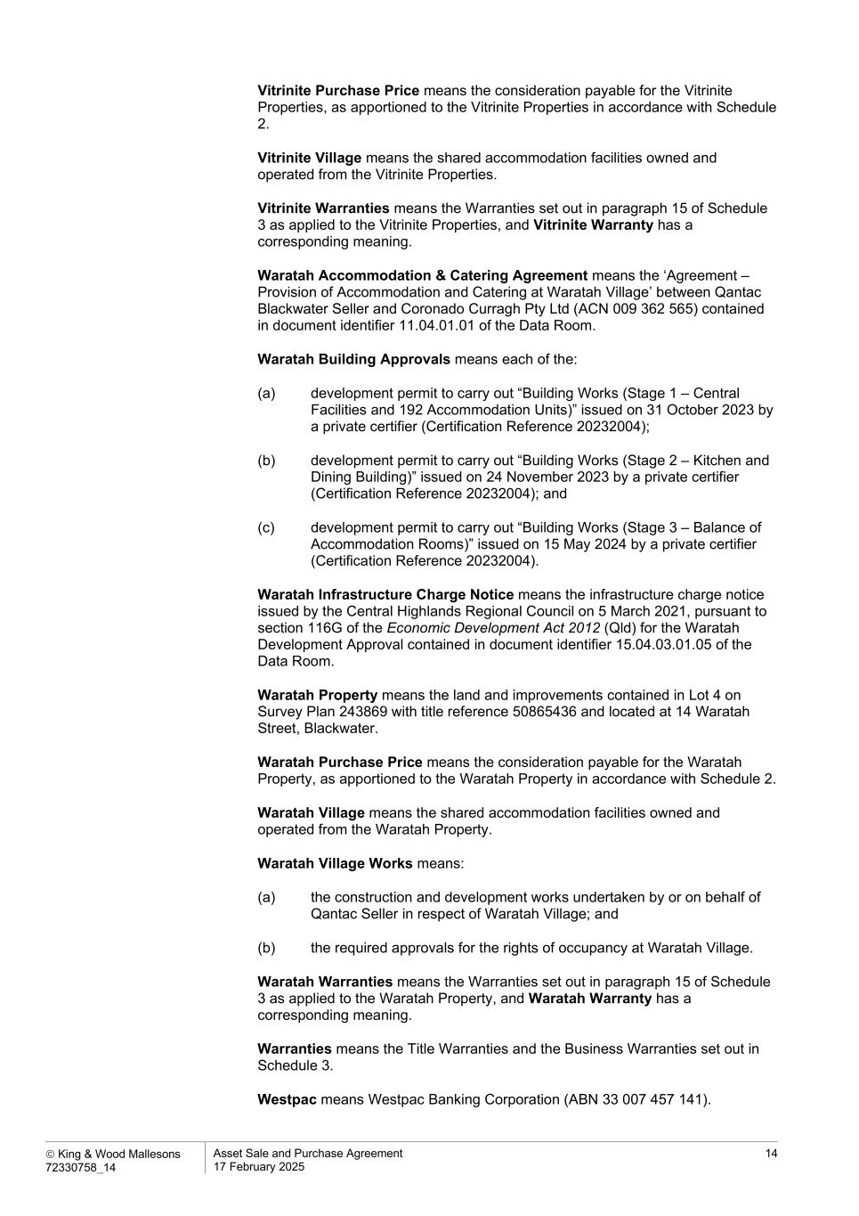
 King & Wood Mallesons 72330758_14 Asset Sale and Purchase Agreement 17 February 2025 14 Vitrinite Purchase Price means the consideration payable for the Vitrinite Properties, as apportioned to the Vitrinite Properties in accordance with Schedule 2. Vitrinite Village means the shared accommodation facilities owned and operated from the Vitrinite Properties. Vitrinite Warranties means the Warranties set out in paragraph 15 of Schedule 3 as applied to the Vitrinite Properties, and Vitrinite Warranty has a corresponding meaning. Waratah Accommodation & Catering Agreement means the ‘Agreement – Provision of Accommodation and Catering at Waratah Village’ between Qantac Blackwater Seller and Coronado Curragh Pty Ltd (ACN 009 362 565) contained in document identifier 11.04.01.01 of the Data Room. Waratah Building Approvals means each of the: (a) development permit to carry out “Building Works (Stage 1 – Central Facilities and 192 Accommodation Units)” issued on 31 October 2023 by a private certifier (Certification Reference 20232004); (b) development permit to carry out “Building Works (Stage 2 – Kitchen and Dining Building)” issued on 24 November 2023 by a private certifier (Certification Reference 20232004); and (c) development permit to carry out “Building Works (Stage 3 – Balance of Accommodation Rooms)” issued on 15 May 2024 by a private certifier (Certification Reference 20232004). Waratah Infrastructure Charge Notice means the infrastructure charge notice issued by the Central Highlands Regional Council on 5 March 2021, pursuant to section 116G of the Economic Development Act 2012 (Qld) for the Waratah Development Approval contained in document identifier 15.04.03.01.05 of the Data Room. Waratah Property means the land and improvements contained in Lot 4 on Survey Plan 243869 with title reference 50865436 and located at 14 Waratah Street, Blackwater. Waratah Purchase Price means the consideration payable for the Waratah Property, as apportioned to the Waratah Property in accordance with Schedule 2. Waratah Village means the shared accommodation facilities owned and operated from the Waratah Property. Waratah Village Works means: (a) the construction and development works undertaken by or on behalf of Qantac Seller in respect of Waratah Village; and (b) the required approvals for the rights of occupancy at Waratah Village. Waratah Warranties means the Warranties set out in paragraph 15 of Schedule 3 as applied to the Waratah Property, and Waratah Warranty has a corresponding meaning. Warranties means the Title Warranties and the Business Warranties set out in Schedule 3. Westpac means Westpac Banking Corporation (ABN 33 007 457 141).

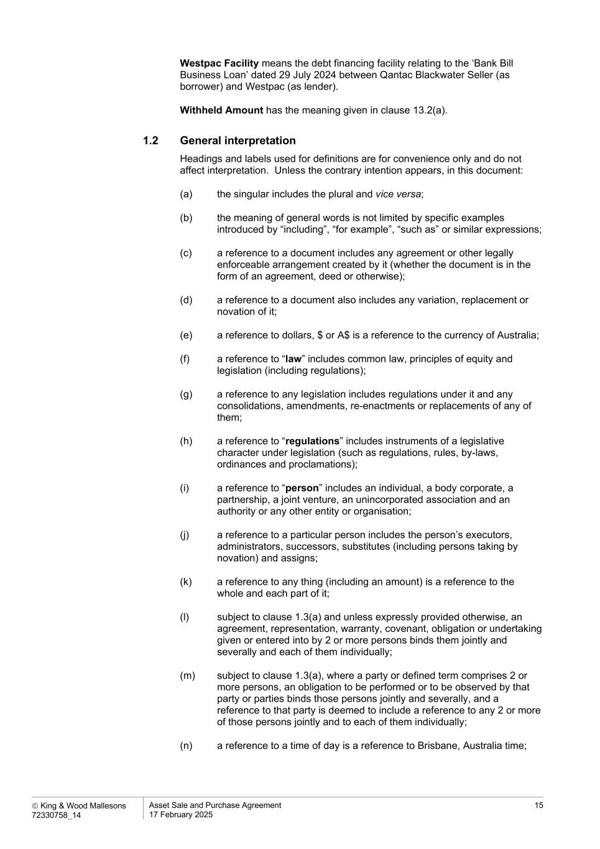
 King & Wood Mallesons 72330758_14 Asset Sale and Purchase Agreement 17 February 2025 15 Westpac Facility means the debt financing facility relating to the ‘Bank Bill Business Loan’ dated 29 July 2024 between Qantac Blackwater Seller (as borrower) and Westpac (as lender). Withheld Amount has the meaning given in clause 13.2(a). 1.2 General interpretation Headings and labels used for definitions are for convenience only and do not affect interpretation. Unless the contrary intention appears, in this document: (a) the singular includes the plural and vice versa; (b) the meaning of general words is not limited by specific examples introduced by “including”, “for example”, “such as” or similar expressions; (c) a reference to a document includes any agreement or other legally enforceable arrangement created by it (whether the document is in the form of an agreement, deed or otherwise); (d) a reference to a document also includes any variation, replacement or novation of it; (e) a reference to dollars, $ or A$ is a reference to the currency of Australia; (f) a reference to “law” includes common law, principles of equity and legislation (including regulations); (g) a reference to any legislation includes regulations under it and any consolidations, amendments, re-enactments or replacements of any of them; (h) a reference to “regulations” includes instruments of a legislative character under legislation (such as regulations, rules, by-laws, ordinances and proclamations); (i) a reference to “person” includes an individual, a body corporate, a partnership, a joint venture, an unincorporated association and an authority or any other entity or organisation; (j) a reference to a particular person includes the person’s executors, administrators, successors, substitutes (including persons taking by novation) and assigns; (k) a reference to any thing (including an amount) is a reference to the whole and each part of it; (l) subject to clause 1.3(a) and unless expressly provided otherwise, an agreement, representation, warranty, covenant, obligation or undertaking given or entered into by 2 or more persons binds them jointly and severally and each of them individually; (m) subject to clause 1.3(a), where a party or defined term comprises 2 or more persons, an obligation to be performed or to be observed by that party or parties binds those persons jointly and severally, and a reference to that party is deemed to include a reference to any 2 or more of those persons jointly and to each of them individually; (n) a reference to a time of day is a reference to Brisbane, Australia time;

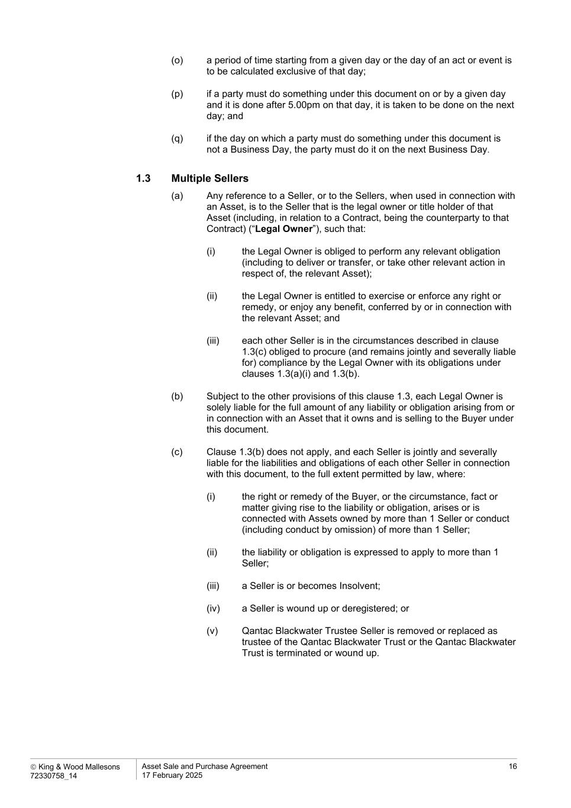
 King & Wood Mallesons 72330758_14 Asset Sale and Purchase Agreement 17 February 2025 16 (o) a period of time starting from a given day or the day of an act or event is to be calculated exclusive of that day; (p) if a party must do something under this document on or by a given day and it is done after 5.00pm on that day, it is taken to be done on the next day; and (q) if the day on which a party must do something under this document is not a Business Day, the party must do it on the next Business Day. 1.3 Multiple Sellers (a) Any reference to a Seller, or to the Sellers, when used in connection with an Asset, is to the Seller that is the legal owner or title holder of that Asset (including, in relation to a Contract, being the counterparty to that Contract) (“Legal Owner”), such that: (i) the Legal Owner is obliged to perform any relevant obligation (including to deliver or transfer, or take other relevant action in respect of, the relevant Asset); (ii) the Legal Owner is entitled to exercise or enforce any right or remedy, or enjoy any benefit, conferred by or in connection with the relevant Asset; and (iii) each other Seller is in the circumstances described in clause 1.3(c) obliged to procure (and remains jointly and severally liable for) compliance by the Legal Owner with its obligations under clauses 1.3(a)(i) and 1.3(b). (b) Subject to the other provisions of this clause 1.3, each Legal Owner is solely liable for the full amount of any liability or obligation arising from or in connection with an Asset that it owns and is selling to the Buyer under this document. (c) Clause 1.3(b) does not apply, and each Seller is jointly and severally liable for the liabilities and obligations of each other Seller in connection with this document, to the full extent permitted by law, where: (i) the right or remedy of the Buyer, or the circumstance, fact or matter giving rise to the liability or obligation, arises or is connected with Assets owned by more than 1 Seller or conduct (including conduct by omission) of more than 1 Seller; (ii) the liability or obligation is expressed to apply to more than 1 Seller; (iii) a Seller is or becomes Insolvent; (iv) a Seller is wound up or deregistered; or (v) Qantac Blackwater Trustee Seller is removed or replaced as trustee of the Qantac Blackwater Trust or the Qantac Blackwater Trust is terminated or wound up.

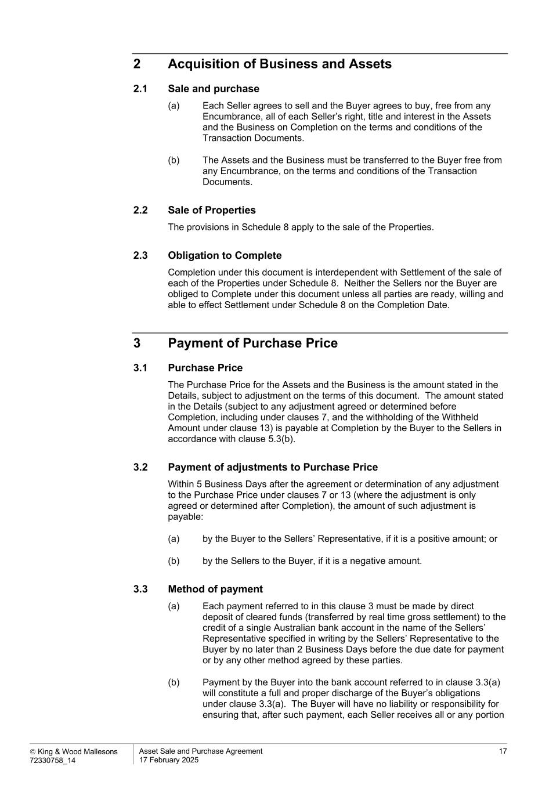
 King & Wood Mallesons 72330758_14 Asset Sale and Purchase Agreement 17 February 2025 17 2 Acquisition of Business and Assets 2.1 Sale and purchase (a) Each Seller agrees to sell and the Buyer agrees to buy, free from any Encumbrance, all of each Seller’s right, title and interest in the Assets and the Business on Completion on the terms and conditions of the Transaction Documents. (b) The Assets and the Business must be transferred to the Buyer free from any Encumbrance, on the terms and conditions of the Transaction Documents. 2.2 Sale of Properties The provisions in Schedule 8 apply to the sale of the Properties. 2.3 Obligation to Complete Completion under this document is interdependent with Settlement of the sale of each of the Properties under Schedule 8. Neither the Sellers nor the Buyer are obliged to Complete under this document unless all parties are ready, willing and able to effect Settlement under Schedule 8 on the Completion Date. 3 Payment of Purchase Price 3.1 Purchase Price The Purchase Price for the Assets and the Business is the amount stated in the Details, subject to adjustment on the terms of this document. The amount stated in the Details (subject to any adjustment agreed or determined before Completion, including under clauses 7, and the withholding of the Withheld Amount under clause 13) is payable at Completion by the Buyer to the Sellers in accordance with clause 5.3(b). 3.2 Payment of adjustments to Purchase Price Within 5 Business Days after the agreement or determination of any adjustment to the Purchase Price under clauses 7 or 13 (where the adjustment is only agreed or determined after Completion), the amount of such adjustment is payable: (a) by the Buyer to the Sellers’ Representative, if it is a positive amount; or (b) by the Sellers to the Buyer, if it is a negative amount. 3.3 Method of payment (a) Each payment referred to in this clause 3 must be made by direct deposit of cleared funds (transferred by real time gross settlement) to the credit of a single Australian bank account in the name of the Sellers’ Representative specified in writing by the Sellers’ Representative to the Buyer by no later than 2 Business Days before the due date for payment or by any other method agreed by these parties. (b) Payment by the Buyer into the bank account referred to in clause 3.3(a) will constitute a full and proper discharge of the Buyer’s obligations under clause 3.3(a). The Buyer will have no liability or responsibility for ensuring that, after such payment, each Seller receives all or any portion

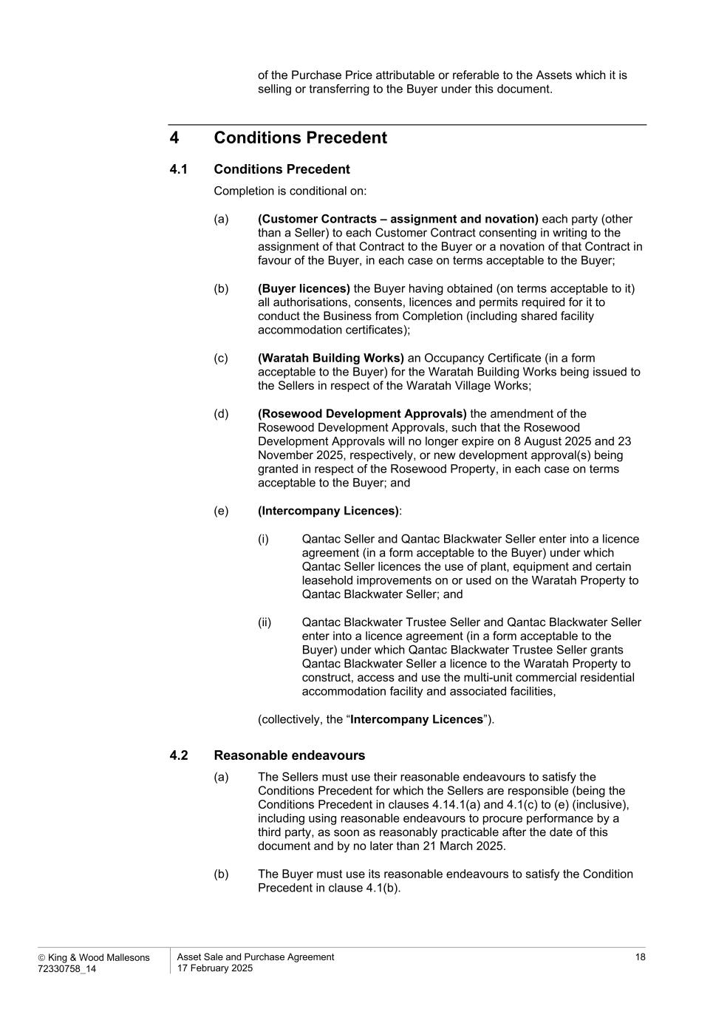
 King & Wood Mallesons 72330758_14 Asset Sale and Purchase Agreement 17 February 2025 18 of the Purchase Price attributable or referable to the Assets which it is selling or transferring to the Buyer under this document. 4 Conditions Precedent 4.1 Conditions Precedent Completion is conditional on: (a) (Customer Contracts – assignment and novation) each party (other than a Seller) to each Customer Contract consenting in writing to the assignment of that Contract to the Buyer or a novation of that Contract in favour of the Buyer, in each case on terms acceptable to the Buyer; (b) (Buyer licences) the Buyer having obtained (on terms acceptable to it) all authorisations, consents, licences and permits required for it to conduct the Business from Completion (including shared facility accommodation certificates); (c) (Waratah Building Works) an Occupancy Certificate (in a form acceptable to the Buyer) for the Waratah Building Works being issued to the Sellers in respect of the Waratah Village Works; (d) (Rosewood Development Approvals) the amendment of the Rosewood Development Approvals, such that the Rosewood Development Approvals will no longer expire on 8 August 2025 and 23 November 2025, respectively, or new development approval(s) being granted in respect of the Rosewood Property, in each case on terms acceptable to the Buyer; and (e) (Intercompany Licences): (i) Qantac Seller and Qantac Blackwater Seller enter into a licence agreement (in a form acceptable to the Buyer) under which Qantac Seller licences the use of plant, equipment and certain leasehold improvements on or used on the Waratah Property to Qantac Blackwater Seller; and (ii) Qantac Blackwater Trustee Seller and Qantac Blackwater Seller enter into a licence agreement (in a form acceptable to the Buyer) under which Qantac Blackwater Trustee Seller grants Qantac Blackwater Seller a licence to the Waratah Property to construct, access and use the multi-unit commercial residential accommodation facility and associated facilities, (collectively, the “Intercompany Licences”). 4.2 Reasonable endeavours (a) The Sellers must use their reasonable endeavours to satisfy the Conditions Precedent for which the Sellers are responsible (being the Conditions Precedent in clauses 4.14.1(a) and 4.1(c) to (e) (inclusive), including using reasonable endeavours to procure performance by a third party, as soon as reasonably practicable after the date of this document and by no later than 21 March 2025. (b) The Buyer must use its reasonable endeavours to satisfy the Condition Precedent in clause 4.1(b).

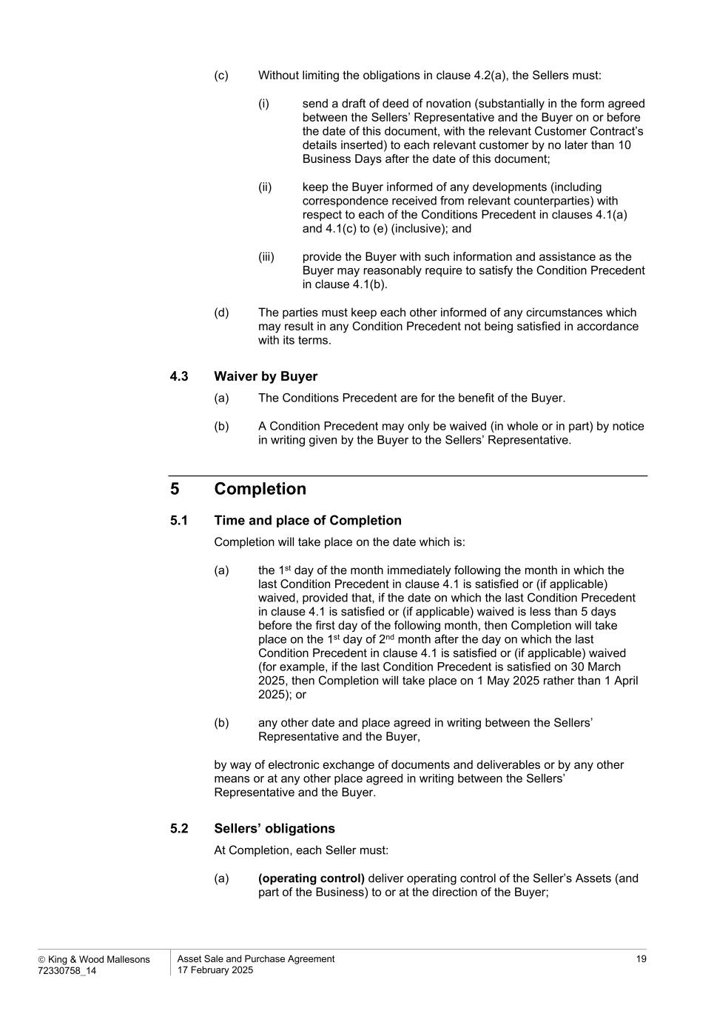
 King & Wood Mallesons 72330758_14 Asset Sale and Purchase Agreement 17 February 2025 19 (c) Without limiting the obligations in clause 4.2(a), the Sellers must: (i) send a draft of deed of novation (substantially in the form agreed between the Sellers’ Representative and the Buyer on or before the date of this document, with the relevant Customer Contract’s details inserted) to each relevant customer by no later than 10 Business Days after the date of this document; (ii) keep the Buyer informed of any developments (including correspondence received from relevant counterparties) with respect to each of the Conditions Precedent in clauses 4.1(a) and 4.1(c) to (e) (inclusive); and (iii) provide the Buyer with such information and assistance as the Buyer may reasonably require to satisfy the Condition Precedent in clause 4.1(b). (d) The parties must keep each other informed of any circumstances which may result in any Condition Precedent not being satisfied in accordance with its terms. 4.3 Waiver by Buyer (a) The Conditions Precedent are for the benefit of the Buyer. (b) A Condition Precedent may only be waived (in whole or in part) by notice in writing given by the Buyer to the Sellers’ Representative. 5 Completion 5.1 Time and place of Completion Completion will take place on the date which is: (a) the 1st day of the month immediately following the month in which the last Condition Precedent in clause 4.1 is satisfied or (if applicable) waived, provided that, if the date on which the last Condition Precedent in clause 4.1 is satisfied or (if applicable) waived is less than 5 days before the first day of the following month, then Completion will take place on the 1st day of 2nd month after the day on which the last Condition Precedent in clause 4.1 is satisfied or (if applicable) waived (for example, if the last Condition Precedent is satisfied on 30 March 2025, then Completion will take place on 1 May 2025 rather than 1 April 2025); or (b) any other date and place agreed in writing between the Sellers’ Representative and the Buyer, by way of electronic exchange of documents and deliverables or by any other means or at any other place agreed in writing between the Sellers’ Representative and the Buyer. 5.2 Sellers’ obligations At Completion, each Seller must: (a) (operating control) deliver operating control of the Seller’s Assets (and part of the Business) to or at the direction of the Buyer;

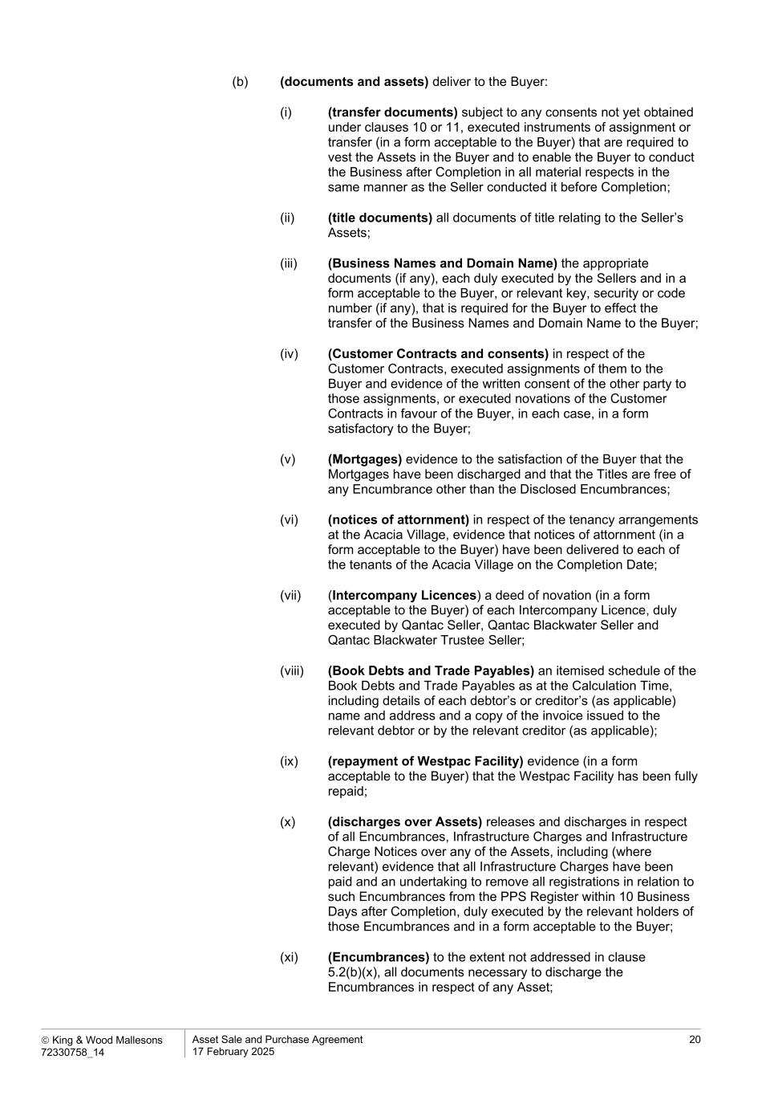
 King & Wood Mallesons 72330758_14 Asset Sale and Purchase Agreement 17 February 2025 20 (b) (documents and assets) deliver to the Buyer: (i) (transfer documents) subject to any consents not yet obtained under clauses 10 or 11, executed instruments of assignment or transfer (in a form acceptable to the Buyer) that are required to vest the Assets in the Buyer and to enable the Buyer to conduct the Business after Completion in all material respects in the same manner as the Seller conducted it before Completion; (ii) (title documents) all documents of title relating to the Seller’s Assets; (iii) (Business Names and Domain Name) the appropriate documents (if any), each duly executed by the Sellers and in a form acceptable to the Buyer, or relevant key, security or code number (if any), that is required for the Buyer to effect the transfer of the Business Names and Domain Name to the Buyer; (iv) (Customer Contracts and consents) in respect of the Customer Contracts, executed assignments of them to the Buyer and evidence of the written consent of the other party to those assignments, or executed novations of the Customer Contracts in favour of the Buyer, in each case, in a form satisfactory to the Buyer; (v) (Mortgages) evidence to the satisfaction of the Buyer that the Mortgages have been discharged and that the Titles are free of any Encumbrance other than the Disclosed Encumbrances; (vi) (notices of attornment) in respect of the tenancy arrangements at the Acacia Village, evidence that notices of attornment (in a form acceptable to the Buyer) have been delivered to each of the tenants of the Acacia Village on the Completion Date; (vii) (Intercompany Licences) a deed of novation (in a form acceptable to the Buyer) of each Intercompany Licence, duly executed by Qantac Seller, Qantac Blackwater Seller and Qantac Blackwater Trustee Seller; (viii) (Book Debts and Trade Payables) an itemised schedule of the Book Debts and Trade Payables as at the Calculation Time, including details of each debtor’s or creditor’s (as applicable) name and address and a copy of the invoice issued to the relevant debtor or by the relevant creditor (as applicable); (ix) (repayment of Westpac Facility) evidence (in a form acceptable to the Buyer) that the Westpac Facility has been fully repaid; (x) (discharges over Assets) releases and discharges in respect of all Encumbrances, Infrastructure Charges and Infrastructure Charge Notices over any of the Assets, including (where relevant) evidence that all Infrastructure Charges have been paid and an undertaking to remove all registrations in relation to such Encumbrances from the PPS Register within 10 Business Days after Completion, duly executed by the relevant holders of those Encumbrances and in a form acceptable to the Buyer; (xi) (Encumbrances) to the extent not addressed in clause 5.2(b)(x), all documents necessary to discharge the Encumbrances in respect of any Asset;

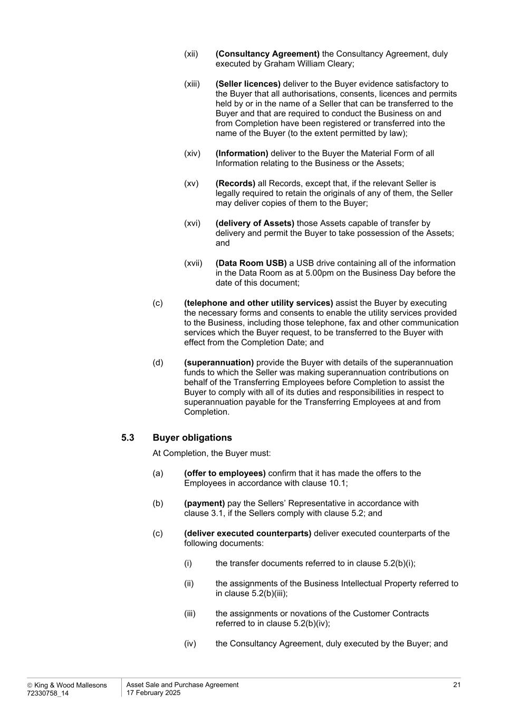
 King & Wood Mallesons 72330758_14 Asset Sale and Purchase Agreement 17 February 2025 21 (xii) (Consultancy Agreement) the Consultancy Agreement, duly executed by Graham William Cleary; (xiii) (Seller licences) deliver to the Buyer evidence satisfactory to the Buyer that all authorisations, consents, licences and permits held by or in the name of a Seller that can be transferred to the Buyer and that are required to conduct the Business on and from Completion have been registered or transferred into the name of the Buyer (to the extent permitted by law); (xiv) (Information) deliver to the Buyer the Material Form of all Information relating to the Business or the Assets; (xv) (Records) all Records, except that, if the relevant Seller is legally required to retain the originals of any of them, the Seller may deliver copies of them to the Buyer; (xvi) (delivery of Assets) those Assets capable of transfer by delivery and permit the Buyer to take possession of the Assets; and (xvii) (Data Room USB) a USB drive containing all of the information in the Data Room as at 5.00pm on the Business Day before the date of this document; (c) (telephone and other utility services) assist the Buyer by executing the necessary forms and consents to enable the utility services provided to the Business, including those telephone, fax and other communication services which the Buyer request, to be transferred to the Buyer with effect from the Completion Date; and (d) (superannuation) provide the Buyer with details of the superannuation funds to which the Seller was making superannuation contributions on behalf of the Transferring Employees before Completion to assist the Buyer to comply with all of its duties and responsibilities in respect to superannuation payable for the Transferring Employees at and from Completion. 5.3 Buyer obligations At Completion, the Buyer must: (a) (offer to employees) confirm that it has made the offers to the Employees in accordance with clause 10.1; (b) (payment) pay the Sellers’ Representative in accordance with clause 3.1, if the Sellers comply with clause 5.2; and (c) (deliver executed counterparts) deliver executed counterparts of the following documents: (i) the transfer documents referred to in clause 5.2(b)(i); (ii) the assignments of the Business Intellectual Property referred to in clause 5.2(b)(iii); (iii) the assignments or novations of the Customer Contracts referred to in clause 5.2(b)(iv); (iv) the Consultancy Agreement, duly executed by the Buyer; and

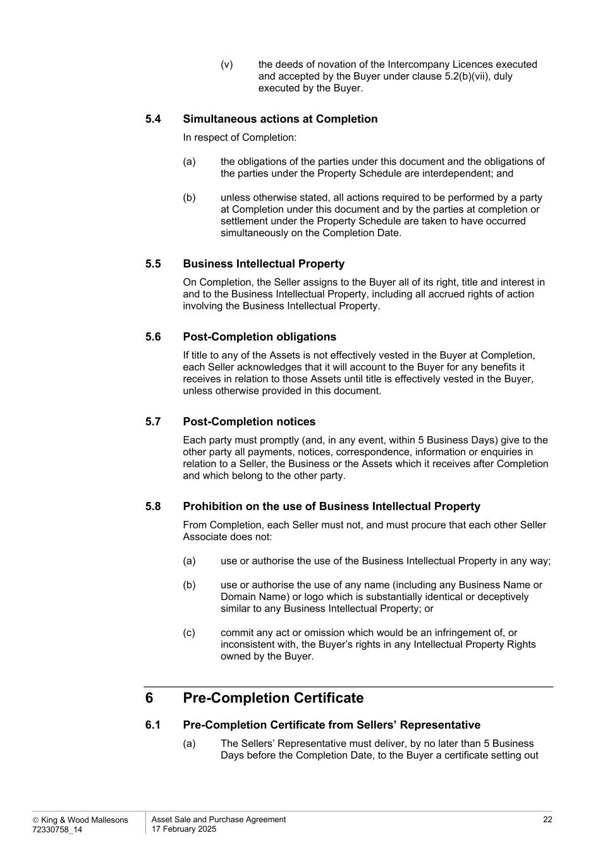
 King & Wood Mallesons 72330758_14 Asset Sale and Purchase Agreement 17 February 2025 22 (v) the deeds of novation of the Intercompany Licences executed and accepted by the Buyer under clause 5.2(b)(vii), duly executed by the Buyer. 5.4 Simultaneous actions at Completion In respect of Completion: (a) the obligations of the parties under this document and the obligations of the parties under the Property Schedule are interdependent; and (b) unless otherwise stated, all actions required to be performed by a party at Completion under this document and by the parties at completion or settlement under the Property Schedule are taken to have occurred simultaneously on the Completion Date. 5.5 Business Intellectual Property On Completion, the Seller assigns to the Buyer all of its right, title and interest in and to the Business Intellectual Property, including all accrued rights of action involving the Business Intellectual Property. 5.6 Post-Completion obligations If title to any of the Assets is not effectively vested in the Buyer at Completion, each Seller acknowledges that it will account to the Buyer for any benefits it receives in relation to those Assets until title is effectively vested in the Buyer, unless otherwise provided in this document. 5.7 Post-Completion notices Each party must promptly (and, in any event, within 5 Business Days) give to the other party all payments, notices, correspondence, information or enquiries in relation to a Seller, the Business or the Assets which it receives after Completion and which belong to the other party. 5.8 Prohibition on the use of Business Intellectual Property From Completion, each Seller must not, and must procure that each other Seller Associate does not: (a) use or authorise the use of the Business Intellectual Property in any way; (b) use or authorise the use of any name (including any Business Name or Domain Name) or logo which is substantially identical or deceptively similar to any Business Intellectual Property; or (c) commit any act or omission which would be an infringement of, or inconsistent with, the Buyer’s rights in any Intellectual Property Rights owned by the Buyer. 6 Pre-Completion Certificate 6.1 Pre-Completion Certificate from Sellers’ Representative (a) The Sellers’ Representative must deliver, by no later than 5 Business Days before the Completion Date, to the Buyer a certificate setting out

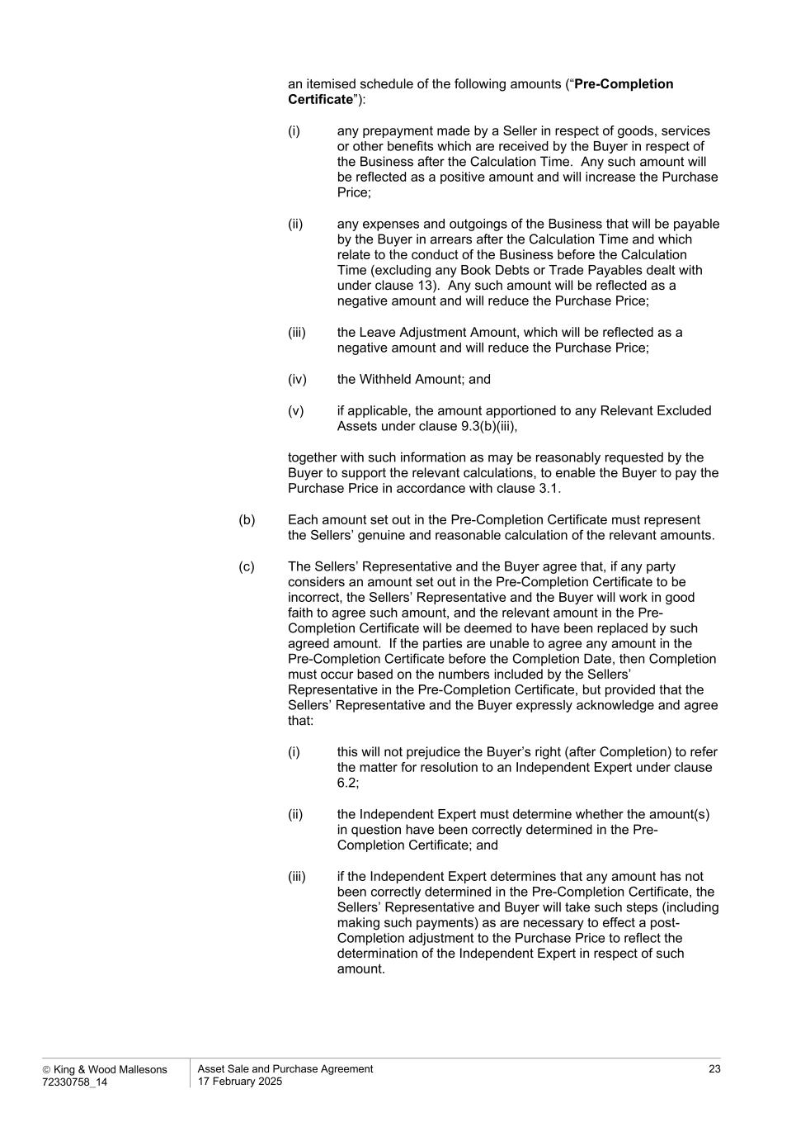
 King & Wood Mallesons 72330758_14 Asset Sale and Purchase Agreement 17 February 2025 23 an itemised schedule of the following amounts (“Pre-Completion Certificate”): (i) any prepayment made by a Seller in respect of goods, services or other benefits which are received by the Buyer in respect of the Business after the Calculation Time. Any such amount will be reflected as a positive amount and will increase the Purchase Price; (ii) any expenses and outgoings of the Business that will be payable by the Buyer in arrears after the Calculation Time and which relate to the conduct of the Business before the Calculation Time (excluding any Book Debts or Trade Payables dealt with under clause 13). Any such amount will be reflected as a negative amount and will reduce the Purchase Price; (iii) the Leave Adjustment Amount, which will be reflected as a negative amount and will reduce the Purchase Price; (iv) the Withheld Amount; and (v) if applicable, the amount apportioned to any Relevant Excluded Assets under clause 9.3(b)(iii), together with such information as may be reasonably requested by the Buyer to support the relevant calculations, to enable the Buyer to pay the Purchase Price in accordance with clause 3.1. (b) Each amount set out in the Pre-Completion Certificate must represent the Sellers’ genuine and reasonable calculation of the relevant amounts. (c) The Sellers’ Representative and the Buyer agree that, if any party considers an amount set out in the Pre-Completion Certificate to be incorrect, the Sellers’ Representative and the Buyer will work in good faith to agree such amount, and the relevant amount in the Pre- Completion Certificate will be deemed to have been replaced by such agreed amount. If the parties are unable to agree any amount in the Pre-Completion Certificate before the Completion Date, then Completion must occur based on the numbers included by the Sellers’ Representative in the Pre-Completion Certificate, but provided that the Sellers’ Representative and the Buyer expressly acknowledge and agree that: (i) this will not prejudice the Buyer’s right (after Completion) to refer the matter for resolution to an Independent Expert under clause 6.2; (ii) the Independent Expert must determine whether the amount(s) in question have been correctly determined in the Pre- Completion Certificate; and (iii) if the Independent Expert determines that any amount has not been correctly determined in the Pre-Completion Certificate, the Sellers’ Representative and Buyer will take such steps (including making such payments) as are necessary to effect a post- Completion adjustment to the Purchase Price to reflect the determination of the Independent Expert in respect of such amount.

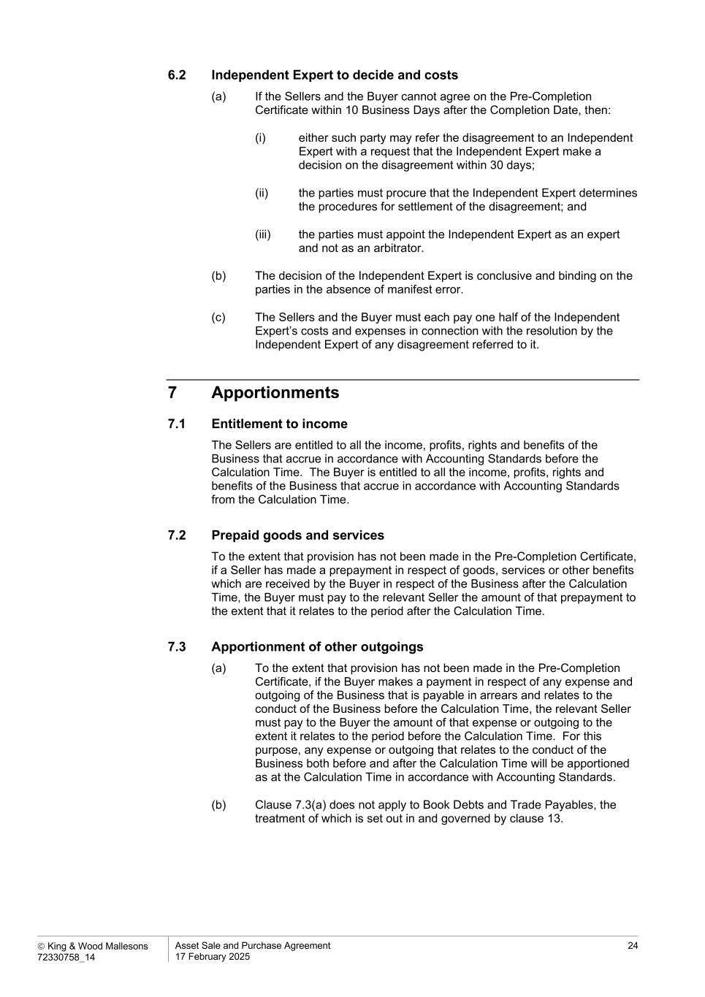
 King & Wood Mallesons 72330758_14 Asset Sale and Purchase Agreement 17 February 2025 24 6.2 Independent Expert to decide and costs (a) If the Sellers and the Buyer cannot agree on the Pre-Completion Certificate within 10 Business Days after the Completion Date, then: (i) either such party may refer the disagreement to an Independent Expert with a request that the Independent Expert make a decision on the disagreement within 30 days; (ii) the parties must procure that the Independent Expert determines the procedures for settlement of the disagreement; and (iii) the parties must appoint the Independent Expert as an expert and not as an arbitrator. (b) The decision of the Independent Expert is conclusive and binding on the parties in the absence of manifest error. (c) The Sellers and the Buyer must each pay one half of the Independent Expert’s costs and expenses in connection with the resolution by the Independent Expert of any disagreement referred to it. 7 Apportionments 7.1 Entitlement to income The Sellers are entitled to all the income, profits, rights and benefits of the Business that accrue in accordance with Accounting Standards before the Calculation Time. The Buyer is entitled to all the income, profits, rights and benefits of the Business that accrue in accordance with Accounting Standards from the Calculation Time. 7.2 Prepaid goods and services To the extent that provision has not been made in the Pre-Completion Certificate, if a Seller has made a prepayment in respect of goods, services or other benefits which are received by the Buyer in respect of the Business after the Calculation Time, the Buyer must pay to the relevant Seller the amount of that prepayment to the extent that it relates to the period after the Calculation Time. 7.3 Apportionment of other outgoings (a) To the extent that provision has not been made in the Pre-Completion Certificate, if the Buyer makes a payment in respect of any expense and outgoing of the Business that is payable in arrears and relates to the conduct of the Business before the Calculation Time, the relevant Seller must pay to the Buyer the amount of that expense or outgoing to the extent it relates to the period before the Calculation Time. For this purpose, any expense or outgoing that relates to the conduct of the Business both before and after the Calculation Time will be apportioned as at the Calculation Time in accordance with Accounting Standards. (b) Clause 7.3(a) does not apply to Book Debts and Trade Payables, the treatment of which is set out in and governed by clause 13.

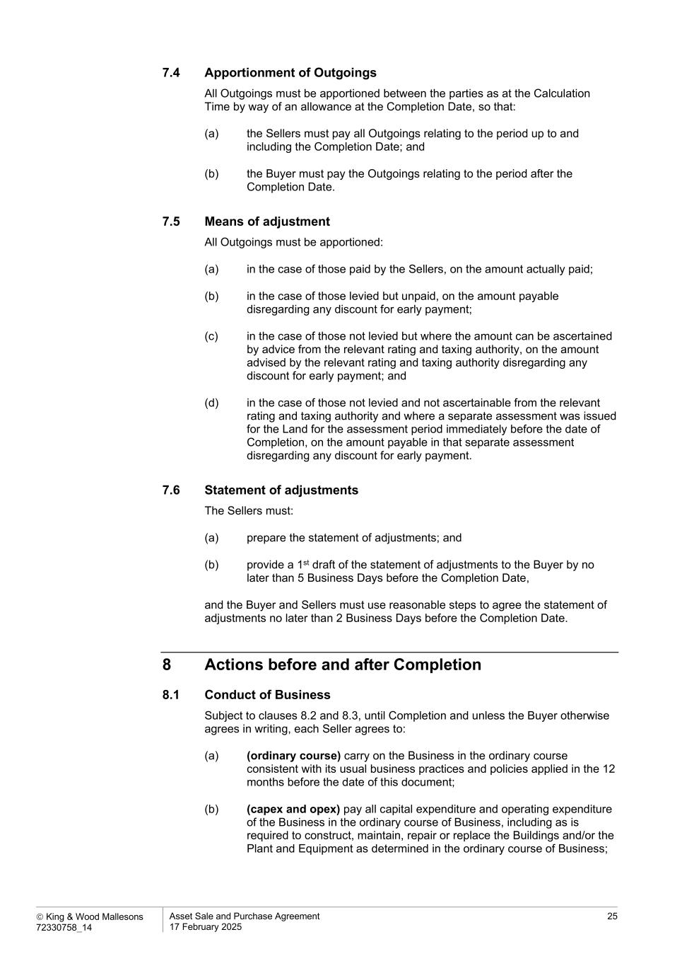
 King & Wood Mallesons 72330758_14 Asset Sale and Purchase Agreement 17 February 2025 25 7.4 Apportionment of Outgoings All Outgoings must be apportioned between the parties as at the Calculation Time by way of an allowance at the Completion Date, so that: (a) the Sellers must pay all Outgoings relating to the period up to and including the Completion Date; and (b) the Buyer must pay the Outgoings relating to the period after the Completion Date. 7.5 Means of adjustment All Outgoings must be apportioned: (a) in the case of those paid by the Sellers, on the amount actually paid; (b) in the case of those levied but unpaid, on the amount payable disregarding any discount for early payment; (c) in the case of those not levied but where the amount can be ascertained by advice from the relevant rating and taxing authority, on the amount advised by the relevant rating and taxing authority disregarding any discount for early payment; and (d) in the case of those not levied and not ascertainable from the relevant rating and taxing authority and where a separate assessment was issued for the Land for the assessment period immediately before the date of Completion, on the amount payable in that separate assessment disregarding any discount for early payment. 7.6 Statement of adjustments The Sellers must: (a) prepare the statement of adjustments; and (b) provide a 1st draft of the statement of adjustments to the Buyer by no later than 5 Business Days before the Completion Date, and the Buyer and Sellers must use reasonable steps to agree the statement of adjustments no later than 2 Business Days before the Completion Date. 8 Actions before and after Completion 8.1 Conduct of Business Subject to clauses 8.2 and 8.3, until Completion and unless the Buyer otherwise agrees in writing, each Seller agrees to: (a) (ordinary course) carry on the Business in the ordinary course consistent with its usual business practices and policies applied in the 12 months before the date of this document; (b) (capex and opex) pay all capital expenditure and operating expenditure of the Business in the ordinary course of Business, including as is required to construct, maintain, repair or replace the Buildings and/or the Plant and Equipment as determined in the ordinary course of Business;

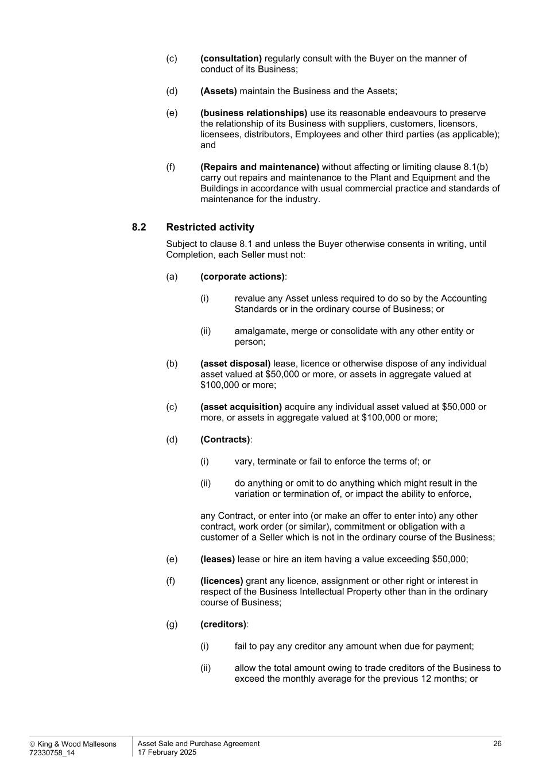
 King & Wood Mallesons 72330758_14 Asset Sale and Purchase Agreement 17 February 2025 26 (c) (consultation) regularly consult with the Buyer on the manner of conduct of its Business; (d) (Assets) maintain the Business and the Assets; (e) (business relationships) use its reasonable endeavours to preserve the relationship of its Business with suppliers, customers, licensors, licensees, distributors, Employees and other third parties (as applicable); and (f) (Repairs and maintenance) without affecting or limiting clause 8.1(b) carry out repairs and maintenance to the Plant and Equipment and the Buildings in accordance with usual commercial practice and standards of maintenance for the industry. 8.2 Restricted activity Subject to clause 8.1 and unless the Buyer otherwise consents in writing, until Completion, each Seller must not: (a) (corporate actions): (i) revalue any Asset unless required to do so by the Accounting Standards or in the ordinary course of Business; or (ii) amalgamate, merge or consolidate with any other entity or person; (b) (asset disposal) lease, licence or otherwise dispose of any individual asset valued at $50,000 or more, or assets in aggregate valued at $100,000 or more; (c) (asset acquisition) acquire any individual asset valued at $50,000 or more, or assets in aggregate valued at $100,000 or more; (d) (Contracts): (i) vary, terminate or fail to enforce the terms of; or (ii) do anything or omit to do anything which might result in the variation or termination of, or impact the ability to enforce, any Contract, or enter into (or make an offer to enter into) any other contract, work order (or similar), commitment or obligation with a customer of a Seller which is not in the ordinary course of the Business; (e) (leases) lease or hire an item having a value exceeding $50,000; (f) (licences) grant any licence, assignment or other right or interest in respect of the Business Intellectual Property other than in the ordinary course of Business; (g) (creditors): (i) fail to pay any creditor any amount when due for payment; (ii) allow the total amount owing to trade creditors of the Business to exceed the monthly average for the previous 12 months; or

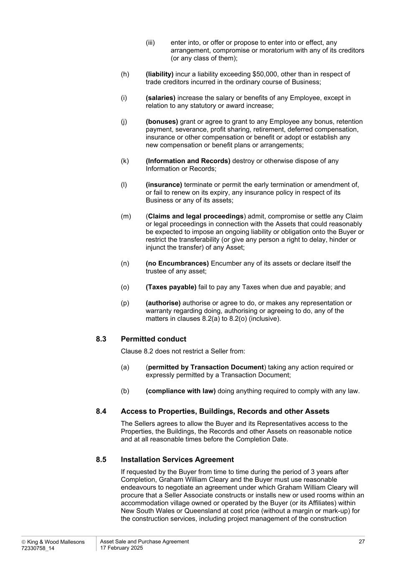
 King & Wood Mallesons 72330758_14 Asset Sale and Purchase Agreement 17 February 2025 27 (iii) enter into, or offer or propose to enter into or effect, any arrangement, compromise or moratorium with any of its creditors (or any class of them); (h) (liability) incur a liability exceeding $50,000, other than in respect of trade creditors incurred in the ordinary course of Business; (i) (salaries) increase the salary or benefits of any Employee, except in relation to any statutory or award increase; (j) (bonuses) grant or agree to grant to any Employee any bonus, retention payment, severance, profit sharing, retirement, deferred compensation, insurance or other compensation or benefit or adopt or establish any new compensation or benefit plans or arrangements; (k) (Information and Records) destroy or otherwise dispose of any Information or Records; (l) (insurance) terminate or permit the early termination or amendment of, or fail to renew on its expiry, any insurance policy in respect of its Business or any of its assets; (m) (Claims and legal proceedings) admit, compromise or settle any Claim or legal proceedings in connection with the Assets that could reasonably be expected to impose an ongoing liability or obligation onto the Buyer or restrict the transferability (or give any person a right to delay, hinder or injunct the transfer) of any Asset; (n) (no Encumbrances) Encumber any of its assets or declare itself the trustee of any asset; (o) (Taxes payable) fail to pay any Taxes when due and payable; and (p) (authorise) authorise or agree to do, or makes any representation or warranty regarding doing, authorising or agreeing to do, any of the matters in clauses 8.2(a) to 8.2(o) (inclusive). 8.3 Permitted conduct Clause 8.2 does not restrict a Seller from: (a) (permitted by Transaction Document) taking any action required or expressly permitted by a Transaction Document; (b) (compliance with law) doing anything required to comply with any law. 8.4 Access to Properties, Buildings, Records and other Assets The Sellers agrees to allow the Buyer and its Representatives access to the Properties, the Buildings, the Records and other Assets on reasonable notice and at all reasonable times before the Completion Date. 8.5 Installation Services Agreement If requested by the Buyer from time to time during the period of 3 years after Completion, Graham William Cleary and the Buyer must use reasonable endeavours to negotiate an agreement under which Graham William Cleary will procure that a Seller Associate constructs or installs new or used rooms within an accommodation village owned or operated by the Buyer (or its Affiliates) within New South Wales or Queensland at cost price (without a margin or mark-up) for the construction services, including project management of the construction

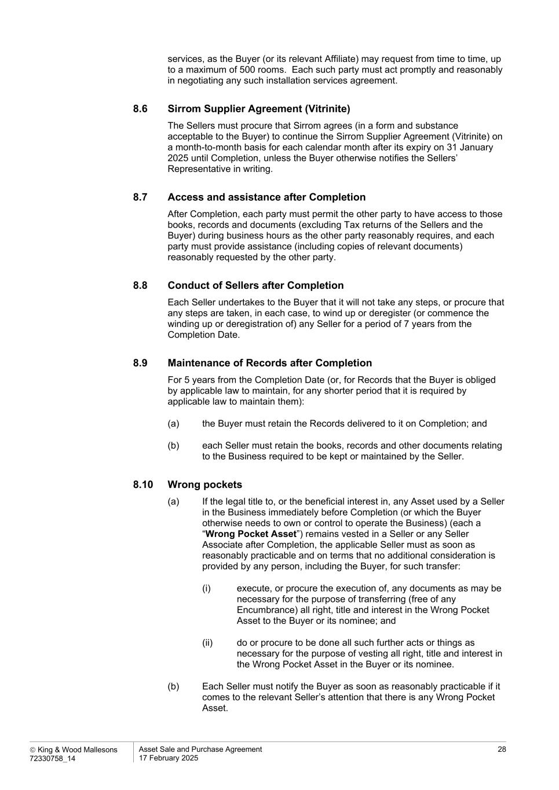
 King & Wood Mallesons 72330758_14 Asset Sale and Purchase Agreement 17 February 2025 28 services, as the Buyer (or its relevant Affiliate) may request from time to time, up to a maximum of 500 rooms. Each such party must act promptly and reasonably in negotiating any such installation services agreement. 8.6 Sirrom Supplier Agreement (Vitrinite) The Sellers must procure that Sirrom agrees (in a form and substance acceptable to the Buyer) to continue the Sirrom Supplier Agreement (Vitrinite) on a month-to-month basis for each calendar month after its expiry on 31 January 2025 until Completion, unless the Buyer otherwise notifies the Sellers’ Representative in writing. 8.7 Access and assistance after Completion After Completion, each party must permit the other party to have access to those books, records and documents (excluding Tax returns of the Sellers and the Buyer) during business hours as the other party reasonably requires, and each party must provide assistance (including copies of relevant documents) reasonably requested by the other party. 8.8 Conduct of Sellers after Completion Each Seller undertakes to the Buyer that it will not take any steps, or procure that any steps are taken, in each case, to wind up or deregister (or commence the winding up or deregistration of) any Seller for a period of 7 years from the Completion Date. 8.9 Maintenance of Records after Completion For 5 years from the Completion Date (or, for Records that the Buyer is obliged by applicable law to maintain, for any shorter period that it is required by applicable law to maintain them): (a) the Buyer must retain the Records delivered to it on Completion; and (b) each Seller must retain the books, records and other documents relating to the Business required to be kept or maintained by the Seller. 8.10 Wrong pockets (a) If the legal title to, or the beneficial interest in, any Asset used by a Seller in the Business immediately before Completion (or which the Buyer otherwise needs to own or control to operate the Business) (each a “Wrong Pocket Asset”) remains vested in a Seller or any Seller Associate after Completion, the applicable Seller must as soon as reasonably practicable and on terms that no additional consideration is provided by any person, including the Buyer, for such transfer: (i) execute, or procure the execution of, any documents as may be necessary for the purpose of transferring (free of any Encumbrance) all right, title and interest in the Wrong Pocket Asset to the Buyer or its nominee; and (ii) do or procure to be done all such further acts or things as necessary for the purpose of vesting all right, title and interest in the Wrong Pocket Asset in the Buyer or its nominee. (b) Each Seller must notify the Buyer as soon as reasonably practicable if it comes to the relevant Seller’s attention that there is any Wrong Pocket Asset.

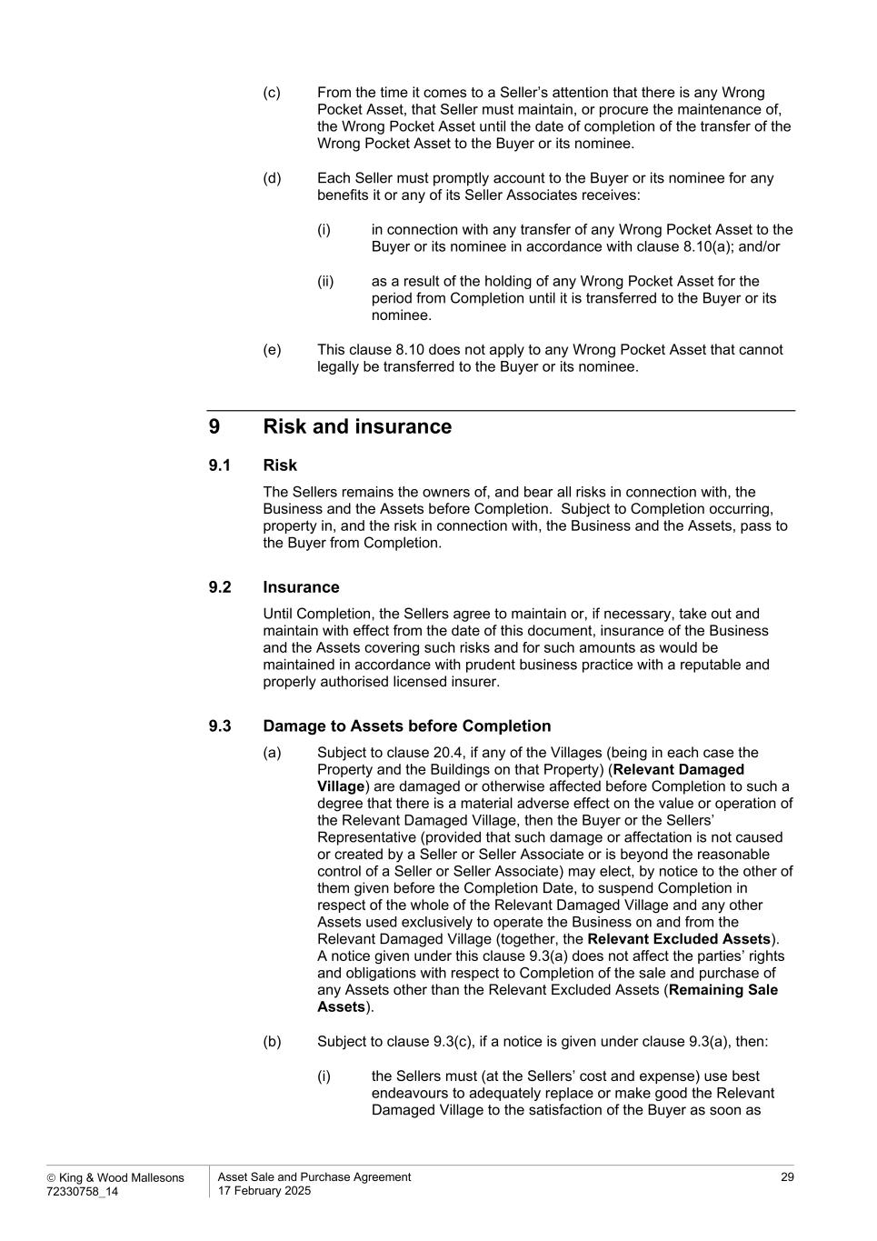
 King & Wood Mallesons 72330758_14 Asset Sale and Purchase Agreement 17 February 2025 29 (c) From the time it comes to a Seller’s attention that there is any Wrong Pocket Asset, that Seller must maintain, or procure the maintenance of, the Wrong Pocket Asset until the date of completion of the transfer of the Wrong Pocket Asset to the Buyer or its nominee. (d) Each Seller must promptly account to the Buyer or its nominee for any benefits it or any of its Seller Associates receives: (i) in connection with any transfer of any Wrong Pocket Asset to the Buyer or its nominee in accordance with clause 8.10(a); and/or (ii) as a result of the holding of any Wrong Pocket Asset for the period from Completion until it is transferred to the Buyer or its nominee. (e) This clause 8.10 does not apply to any Wrong Pocket Asset that cannot legally be transferred to the Buyer or its nominee. 9 Risk and insurance 9.1 Risk The Sellers remains the owners of, and bear all risks in connection with, the Business and the Assets before Completion. Subject to Completion occurring, property in, and the risk in connection with, the Business and the Assets, pass to the Buyer from Completion. 9.2 Insurance Until Completion, the Sellers agree to maintain or, if necessary, take out and maintain with effect from the date of this document, insurance of the Business and the Assets covering such risks and for such amounts as would be maintained in accordance with prudent business practice with a reputable and properly authorised licensed insurer. 9.3 Damage to Assets before Completion (a) Subject to clause 20.4, if any of the Villages (being in each case the Property and the Buildings on that Property) (Relevant Damaged Village) are damaged or otherwise affected before Completion to such a degree that there is a material adverse effect on the value or operation of the Relevant Damaged Village, then the Buyer or the Sellers’ Representative (provided that such damage or affectation is not caused or created by a Seller or Seller Associate or is beyond the reasonable control of a Seller or Seller Associate) may elect, by notice to the other of them given before the Completion Date, to suspend Completion in respect of the whole of the Relevant Damaged Village and any other Assets used exclusively to operate the Business on and from the Relevant Damaged Village (together, the Relevant Excluded Assets). A notice given under this clause 9.3(a) does not affect the parties’ rights and obligations with respect to Completion of the sale and purchase of any Assets other than the Relevant Excluded Assets (Remaining Sale Assets). (b) Subject to clause 9.3(c), if a notice is given under clause 9.3(a), then: (i) the Sellers must (at the Sellers’ cost and expense) use best endeavours to adequately replace or make good the Relevant Damaged Village to the satisfaction of the Buyer as soon as

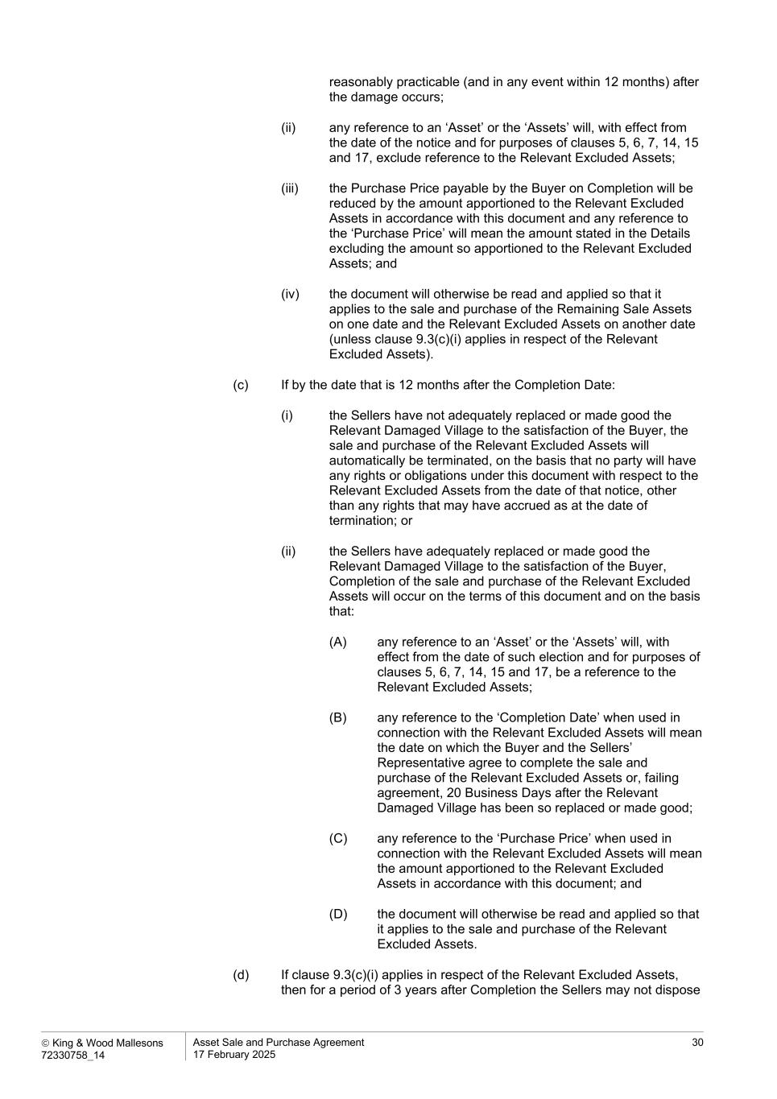
 King & Wood Mallesons 72330758_14 Asset Sale and Purchase Agreement 17 February 2025 30 reasonably practicable (and in any event within 12 months) after the damage occurs; (ii) any reference to an ‘Asset’ or the ‘Assets’ will, with effect from the date of the notice and for purposes of clauses 5, 6, 7, 14, 15 and 17, exclude reference to the Relevant Excluded Assets; (iii) the Purchase Price payable by the Buyer on Completion will be reduced by the amount apportioned to the Relevant Excluded Assets in accordance with this document and any reference to the ‘Purchase Price’ will mean the amount stated in the Details excluding the amount so apportioned to the Relevant Excluded Assets; and (iv) the document will otherwise be read and applied so that it applies to the sale and purchase of the Remaining Sale Assets on one date and the Relevant Excluded Assets on another date (unless clause 9.3(c)(i) applies in respect of the Relevant Excluded Assets). (c) If by the date that is 12 months after the Completion Date: (i) the Sellers have not adequately replaced or made good the Relevant Damaged Village to the satisfaction of the Buyer, the sale and purchase of the Relevant Excluded Assets will automatically be terminated, on the basis that no party will have any rights or obligations under this document with respect to the Relevant Excluded Assets from the date of that notice, other than any rights that may have accrued as at the date of termination; or (ii) the Sellers have adequately replaced or made good the Relevant Damaged Village to the satisfaction of the Buyer, Completion of the sale and purchase of the Relevant Excluded Assets will occur on the terms of this document and on the basis that: (A) any reference to an ‘Asset’ or the ‘Assets’ will, with effect from the date of such election and for purposes of clauses 5, 6, 7, 14, 15 and 17, be a reference to the Relevant Excluded Assets; (B) any reference to the ‘Completion Date’ when used in connection with the Relevant Excluded Assets will mean the date on which the Buyer and the Sellers’ Representative agree to complete the sale and purchase of the Relevant Excluded Assets or, failing agreement, 20 Business Days after the Relevant Damaged Village has been so replaced or made good; (C) any reference to the ‘Purchase Price’ when used in connection with the Relevant Excluded Assets will mean the amount apportioned to the Relevant Excluded Assets in accordance with this document; and (D) the document will otherwise be read and applied so that it applies to the sale and purchase of the Relevant Excluded Assets. (d) If clause 9.3(c)(i) applies in respect of the Relevant Excluded Assets, then for a period of 3 years after Completion the Sellers may not dispose

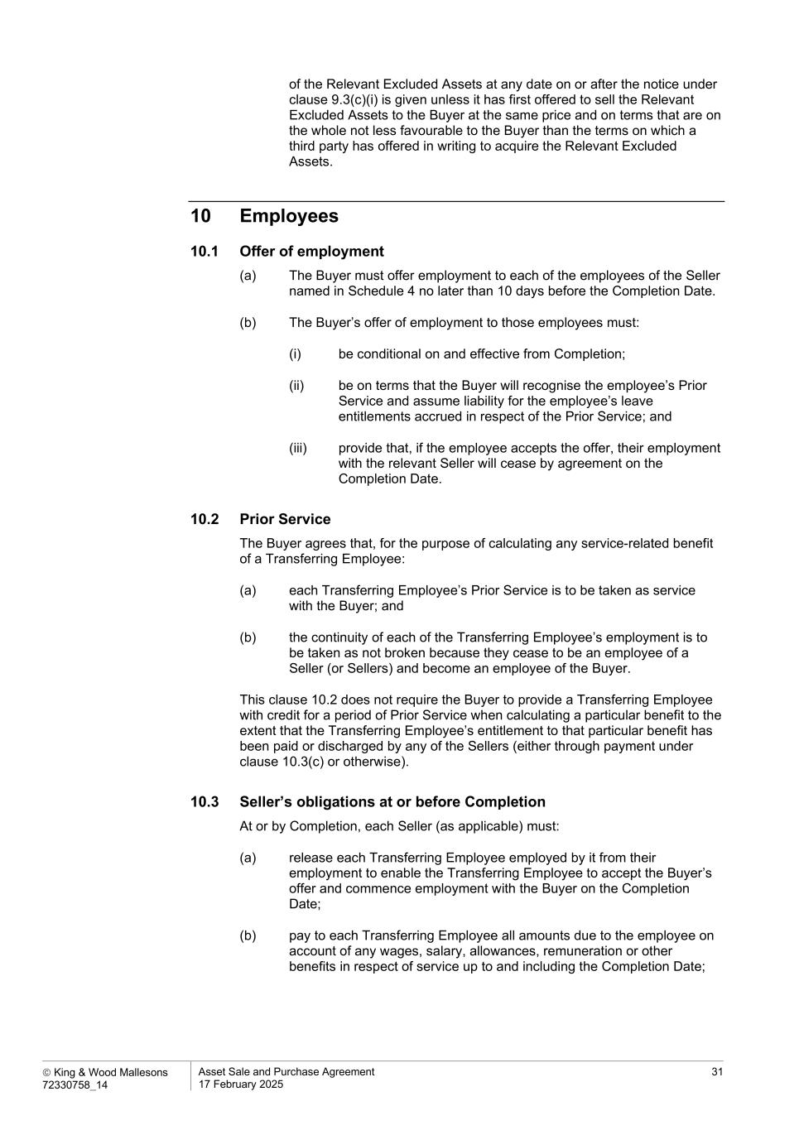
 King & Wood Mallesons 72330758_14 Asset Sale and Purchase Agreement 17 February 2025 31 of the Relevant Excluded Assets at any date on or after the notice under clause 9.3(c)(i) is given unless it has first offered to sell the Relevant Excluded Assets to the Buyer at the same price and on terms that are on the whole not less favourable to the Buyer than the terms on which a third party has offered in writing to acquire the Relevant Excluded Assets. 10 Employees 10.1 Offer of employment (a) The Buyer must offer employment to each of the employees of the Seller named in Schedule 4 no later than 10 days before the Completion Date. (b) The Buyer’s offer of employment to those employees must: (i) be conditional on and effective from Completion; (ii) be on terms that the Buyer will recognise the employee’s Prior Service and assume liability for the employee’s leave entitlements accrued in respect of the Prior Service; and (iii) provide that, if the employee accepts the offer, their employment with the relevant Seller will cease by agreement on the Completion Date. 10.2 Prior Service The Buyer agrees that, for the purpose of calculating any service-related benefit of a Transferring Employee: (a) each Transferring Employee’s Prior Service is to be taken as service with the Buyer; and (b) the continuity of each of the Transferring Employee’s employment is to be taken as not broken because they cease to be an employee of a Seller (or Sellers) and become an employee of the Buyer. This clause 10.2 does not require the Buyer to provide a Transferring Employee with credit for a period of Prior Service when calculating a particular benefit to the extent that the Transferring Employee’s entitlement to that particular benefit has been paid or discharged by any of the Sellers (either through payment under clause 10.3(c) or otherwise). 10.3 Seller’s obligations at or before Completion At or by Completion, each Seller (as applicable) must: (a) release each Transferring Employee employed by it from their employment to enable the Transferring Employee to accept the Buyer’s offer and commence employment with the Buyer on the Completion Date; (b) pay to each Transferring Employee all amounts due to the employee on account of any wages, salary, allowances, remuneration or other benefits in respect of service up to and including the Completion Date;

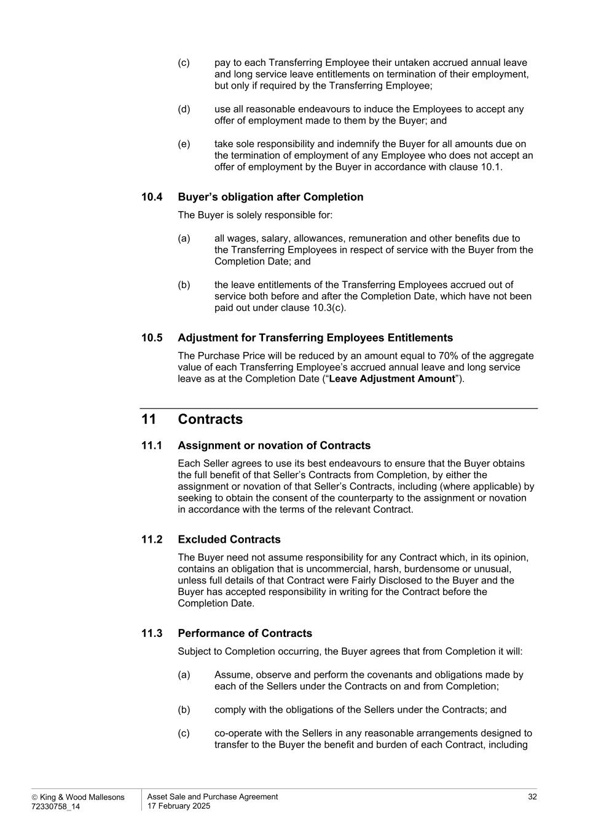
 King & Wood Mallesons 72330758_14 Asset Sale and Purchase Agreement 17 February 2025 32 (c) pay to each Transferring Employee their untaken accrued annual leave and long service leave entitlements on termination of their employment, but only if required by the Transferring Employee; (d) use all reasonable endeavours to induce the Employees to accept any offer of employment made to them by the Buyer; and (e) take sole responsibility and indemnify the Buyer for all amounts due on the termination of employment of any Employee who does not accept an offer of employment by the Buyer in accordance with clause 10.1. 10.4 Buyer’s obligation after Completion The Buyer is solely responsible for: (a) all wages, salary, allowances, remuneration and other benefits due to the Transferring Employees in respect of service with the Buyer from the Completion Date; and (b) the leave entitlements of the Transferring Employees accrued out of service both before and after the Completion Date, which have not been paid out under clause 10.3(c). 10.5 Adjustment for Transferring Employees Entitlements The Purchase Price will be reduced by an amount equal to 70% of the aggregate value of each Transferring Employee’s accrued annual leave and long service leave as at the Completion Date (“Leave Adjustment Amount”). 11 Contracts 11.1 Assignment or novation of Contracts Each Seller agrees to use its best endeavours to ensure that the Buyer obtains the full benefit of that Seller’s Contracts from Completion, by either the assignment or novation of that Seller’s Contracts, including (where applicable) by seeking to obtain the consent of the counterparty to the assignment or novation in accordance with the terms of the relevant Contract. 11.2 Excluded Contracts The Buyer need not assume responsibility for any Contract which, in its opinion, contains an obligation that is uncommercial, harsh, burdensome or unusual, unless full details of that Contract were Fairly Disclosed to the Buyer and the Buyer has accepted responsibility in writing for the Contract before the Completion Date. 11.3 Performance of Contracts Subject to Completion occurring, the Buyer agrees that from Completion it will: (a) Assume, observe and perform the covenants and obligations made by each of the Sellers under the Contracts on and from Completion; (b) comply with the obligations of the Sellers under the Contracts; and (c) co-operate with the Sellers in any reasonable arrangements designed to transfer to the Buyer the benefit and burden of each Contract, including

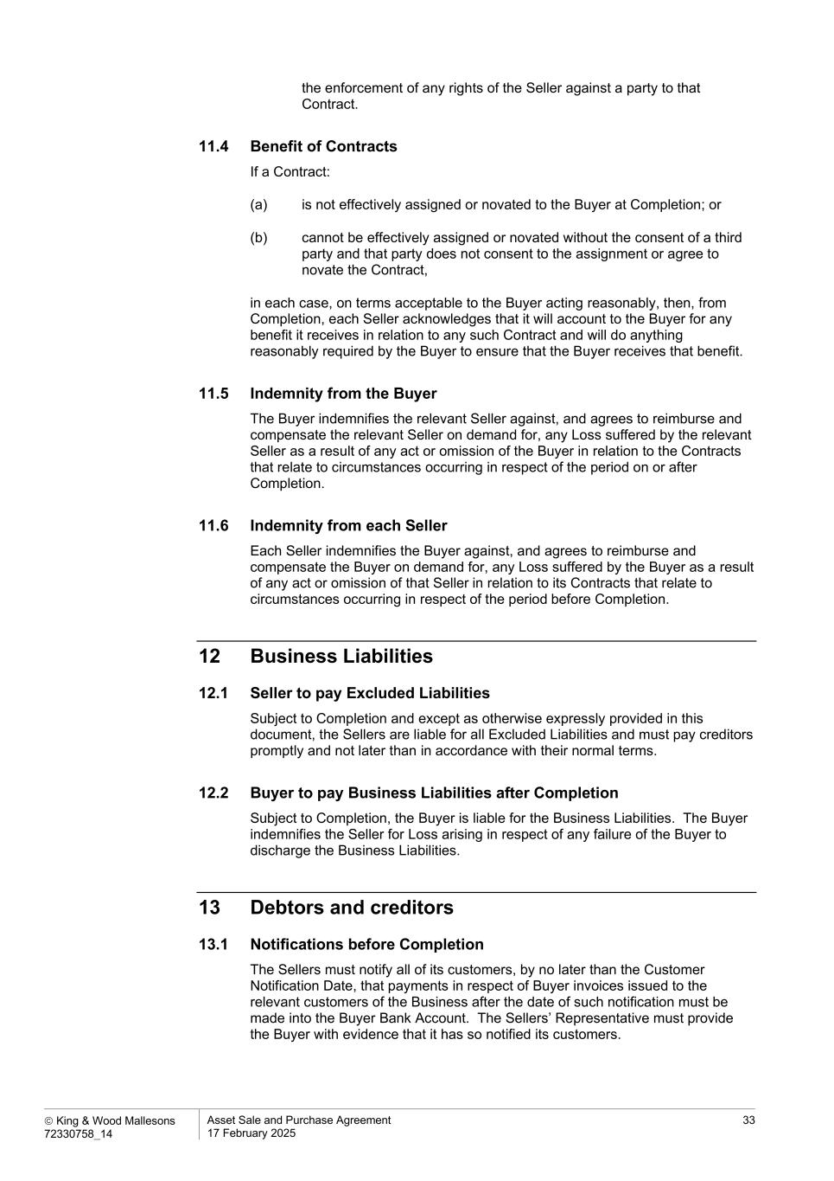
 King & Wood Mallesons 72330758_14 Asset Sale and Purchase Agreement 17 February 2025 33 the enforcement of any rights of the Seller against a party to that Contract. 11.4 Benefit of Contracts If a Contract: (a) is not effectively assigned or novated to the Buyer at Completion; or (b) cannot be effectively assigned or novated without the consent of a third party and that party does not consent to the assignment or agree to novate the Contract, in each case, on terms acceptable to the Buyer acting reasonably, then, from Completion, each Seller acknowledges that it will account to the Buyer for any benefit it receives in relation to any such Contract and will do anything reasonably required by the Buyer to ensure that the Buyer receives that benefit. 11.5 Indemnity from the Buyer The Buyer indemnifies the relevant Seller against, and agrees to reimburse and compensate the relevant Seller on demand for, any Loss suffered by the relevant Seller as a result of any act or omission of the Buyer in relation to the Contracts that relate to circumstances occurring in respect of the period on or after Completion. 11.6 Indemnity from each Seller Each Seller indemnifies the Buyer against, and agrees to reimburse and compensate the Buyer on demand for, any Loss suffered by the Buyer as a result of any act or omission of that Seller in relation to its Contracts that relate to circumstances occurring in respect of the period before Completion. 12 Business Liabilities 12.1 Seller to pay Excluded Liabilities Subject to Completion and except as otherwise expressly provided in this document, the Sellers are liable for all Excluded Liabilities and must pay creditors promptly and not later than in accordance with their normal terms. 12.2 Buyer to pay Business Liabilities after Completion Subject to Completion, the Buyer is liable for the Business Liabilities. The Buyer indemnifies the Seller for Loss arising in respect of any failure of the Buyer to discharge the Business Liabilities. 13 Debtors and creditors 13.1 Notifications before Completion The Sellers must notify all of its customers, by no later than the Customer Notification Date, that payments in respect of Buyer invoices issued to the relevant customers of the Business after the date of such notification must be made into the Buyer Bank Account. The Sellers’ Representative must provide the Buyer with evidence that it has so notified its customers.

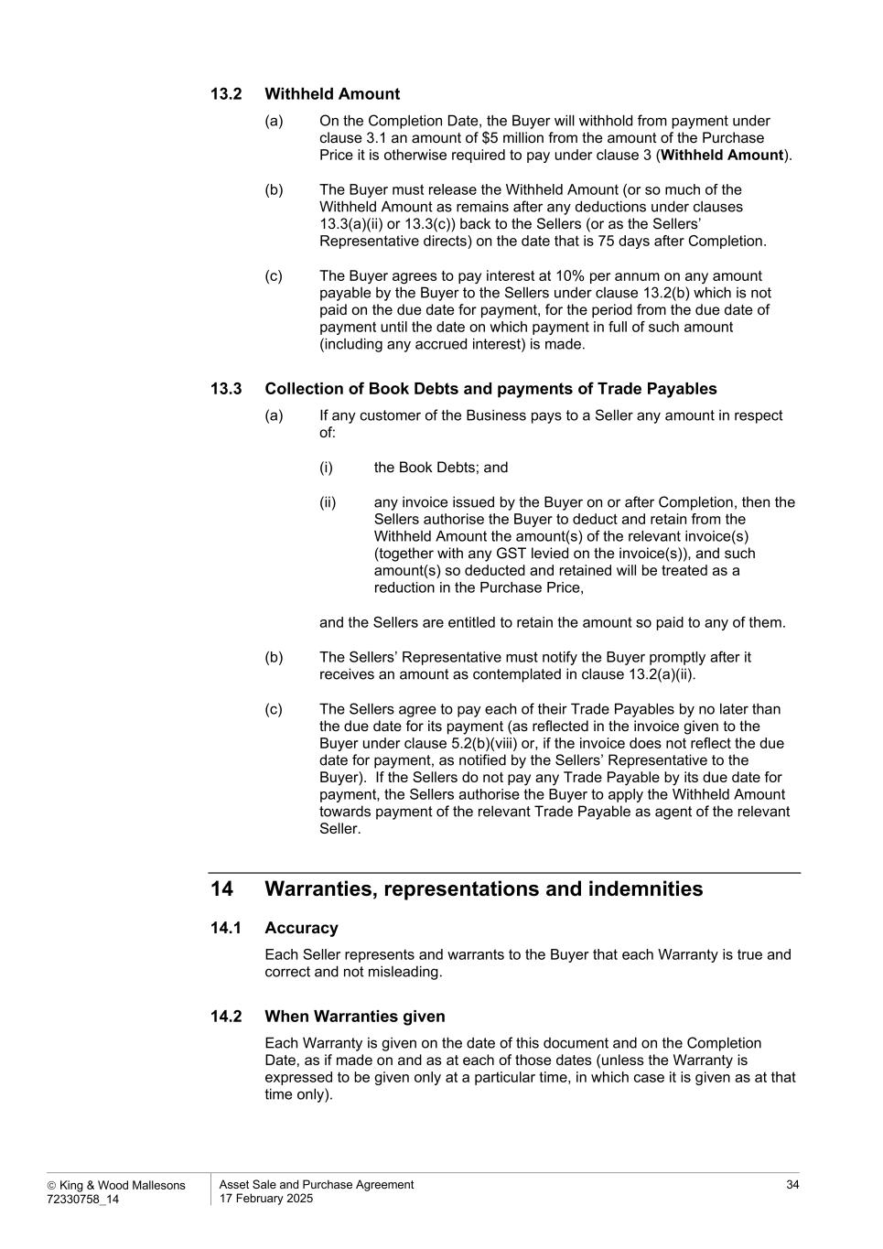
 King & Wood Mallesons 72330758_14 Asset Sale and Purchase Agreement 17 February 2025 34 13.2 Withheld Amount (a) On the Completion Date, the Buyer will withhold from payment under clause 3.1 an amount of $5 million from the amount of the Purchase Price it is otherwise required to pay under clause 3 (Withheld Amount). (b) The Buyer must release the Withheld Amount (or so much of the Withheld Amount as remains after any deductions under clauses 13.3(a)(ii) or 13.3(c)) back to the Sellers (or as the Sellers’ Representative directs) on the date that is 75 days after Completion. (c) The Buyer agrees to pay interest at 10% per annum on any amount payable by the Buyer to the Sellers under clause 13.2(b) which is not paid on the due date for payment, for the period from the due date of payment until the date on which payment in full of such amount (including any accrued interest) is made. 13.3 Collection of Book Debts and payments of Trade Payables (a) If any customer of the Business pays to a Seller any amount in respect of: (i) the Book Debts; and (ii) any invoice issued by the Buyer on or after Completion, then the Sellers authorise the Buyer to deduct and retain from the Withheld Amount the amount(s) of the relevant invoice(s) (together with any GST levied on the invoice(s)), and such amount(s) so deducted and retained will be treated as a reduction in the Purchase Price, and the Sellers are entitled to retain the amount so paid to any of them. (b) The Sellers’ Representative must notify the Buyer promptly after it receives an amount as contemplated in clause 13.2(a)(ii). (c) The Sellers agree to pay each of their Trade Payables by no later than the due date for its payment (as reflected in the invoice given to the Buyer under clause 5.2(b)(viii) or, if the invoice does not reflect the due date for payment, as notified by the Sellers’ Representative to the Buyer). If the Sellers do not pay any Trade Payable by its due date for payment, the Sellers authorise the Buyer to apply the Withheld Amount towards payment of the relevant Trade Payable as agent of the relevant Seller. 14 Warranties, representations and indemnities 14.1 Accuracy Each Seller represents and warrants to the Buyer that each Warranty is true and correct and not misleading. 14.2 When Warranties given Each Warranty is given on the date of this document and on the Completion Date, as if made on and as at each of those dates (unless the Warranty is expressed to be given only at a particular time, in which case it is given as at that time only).

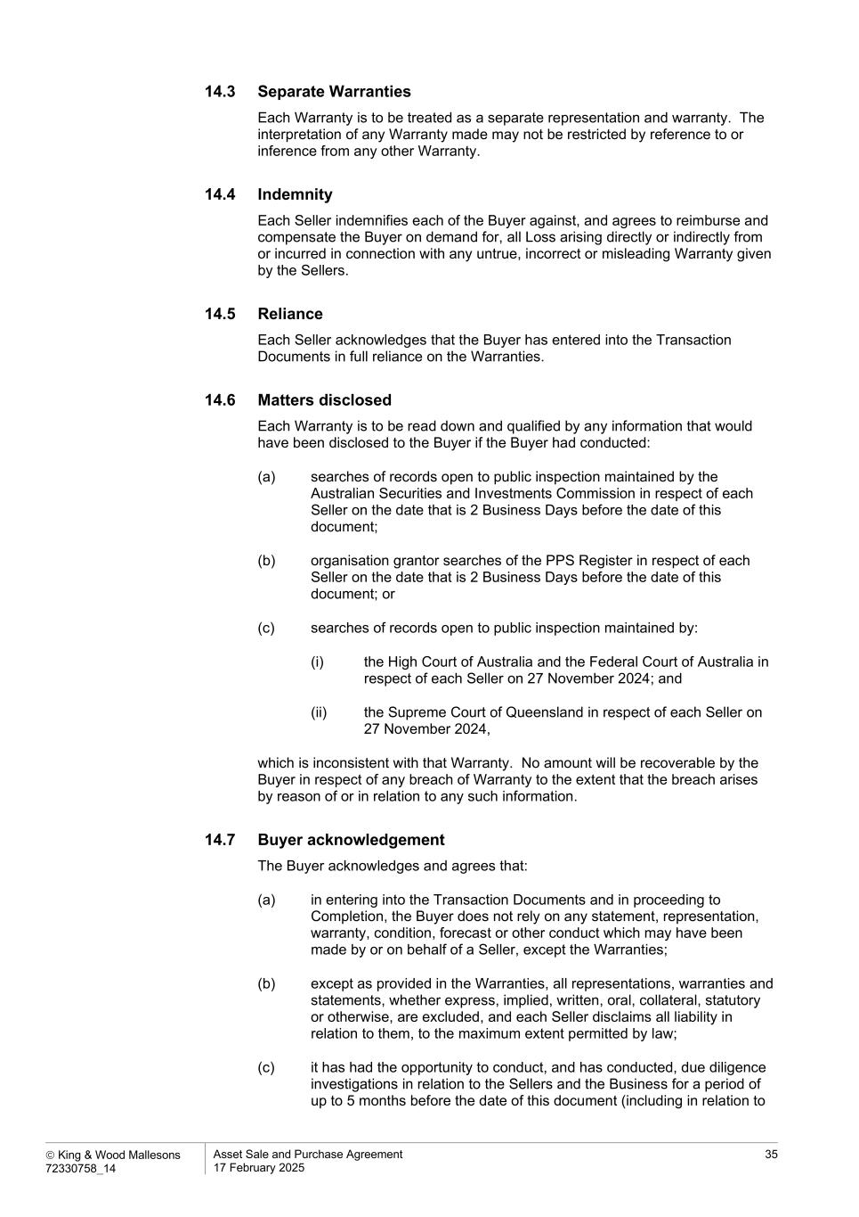
 King & Wood Mallesons 72330758_14 Asset Sale and Purchase Agreement 17 February 2025 35 14.3 Separate Warranties Each Warranty is to be treated as a separate representation and warranty. The interpretation of any Warranty made may not be restricted by reference to or inference from any other Warranty. 14.4 Indemnity Each Seller indemnifies each of the Buyer against, and agrees to reimburse and compensate the Buyer on demand for, all Loss arising directly or indirectly from or incurred in connection with any untrue, incorrect or misleading Warranty given by the Sellers. 14.5 Reliance Each Seller acknowledges that the Buyer has entered into the Transaction Documents in full reliance on the Warranties. 14.6 Matters disclosed Each Warranty is to be read down and qualified by any information that would have been disclosed to the Buyer if the Buyer had conducted: (a) searches of records open to public inspection maintained by the Australian Securities and Investments Commission in respect of each Seller on the date that is 2 Business Days before the date of this document; (b) organisation grantor searches of the PPS Register in respect of each Seller on the date that is 2 Business Days before the date of this document; or (c) searches of records open to public inspection maintained by: (i) the High Court of Australia and the Federal Court of Australia in respect of each Seller on 27 November 2024; and (ii) the Supreme Court of Queensland in respect of each Seller on 27 November 2024, which is inconsistent with that Warranty. No amount will be recoverable by the Buyer in respect of any breach of Warranty to the extent that the breach arises by reason of or in relation to any such information. 14.7 Buyer acknowledgement The Buyer acknowledges and agrees that: (a) in entering into the Transaction Documents and in proceeding to Completion, the Buyer does not rely on any statement, representation, warranty, condition, forecast or other conduct which may have been made by or on behalf of a Seller, except the Warranties; (b) except as provided in the Warranties, all representations, warranties and statements, whether express, implied, written, oral, collateral, statutory or otherwise, are excluded, and each Seller disclaims all liability in relation to them, to the maximum extent permitted by law; (c) it has had the opportunity to conduct, and has conducted, due diligence investigations in relation to the Sellers and the Business for a period of up to 5 months before the date of this document (including in relation to

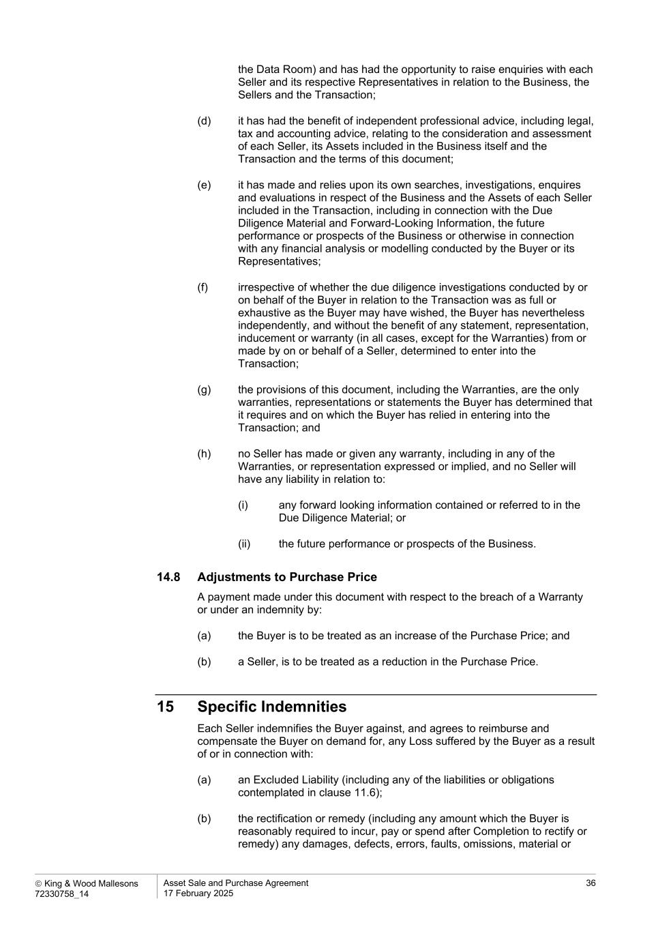
 King & Wood Mallesons 72330758_14 Asset Sale and Purchase Agreement 17 February 2025 36 the Data Room) and has had the opportunity to raise enquiries with each Seller and its respective Representatives in relation to the Business, the Sellers and the Transaction; (d) it has had the benefit of independent professional advice, including legal, tax and accounting advice, relating to the consideration and assessment of each Seller, its Assets included in the Business itself and the Transaction and the terms of this document; (e) it has made and relies upon its own searches, investigations, enquires and evaluations in respect of the Business and the Assets of each Seller included in the Transaction, including in connection with the Due Diligence Material and Forward-Looking Information, the future performance or prospects of the Business or otherwise in connection with any financial analysis or modelling conducted by the Buyer or its Representatives; (f) irrespective of whether the due diligence investigations conducted by or on behalf of the Buyer in relation to the Transaction was as full or exhaustive as the Buyer may have wished, the Buyer has nevertheless independently, and without the benefit of any statement, representation, inducement or warranty (in all cases, except for the Warranties) from or made by on or behalf of a Seller, determined to enter into the Transaction; (g) the provisions of this document, including the Warranties, are the only warranties, representations or statements the Buyer has determined that it requires and on which the Buyer has relied in entering into the Transaction; and (h) no Seller has made or given any warranty, including in any of the Warranties, or representation expressed or implied, and no Seller will have any liability in relation to: (i) any forward looking information contained or referred to in the Due Diligence Material; or (ii) the future performance or prospects of the Business. 14.8 Adjustments to Purchase Price A payment made under this document with respect to the breach of a Warranty or under an indemnity by: (a) the Buyer is to be treated as an increase of the Purchase Price; and (b) a Seller, is to be treated as a reduction in the Purchase Price. 15 Specific Indemnities Each Seller indemnifies the Buyer against, and agrees to reimburse and compensate the Buyer on demand for, any Loss suffered by the Buyer as a result of or in connection with: (a) an Excluded Liability (including any of the liabilities or obligations contemplated in clause 11.6); (b) the rectification or remedy (including any amount which the Buyer is reasonably required to incur, pay or spend after Completion to rectify or remedy) any damages, defects, errors, faults, omissions, material or

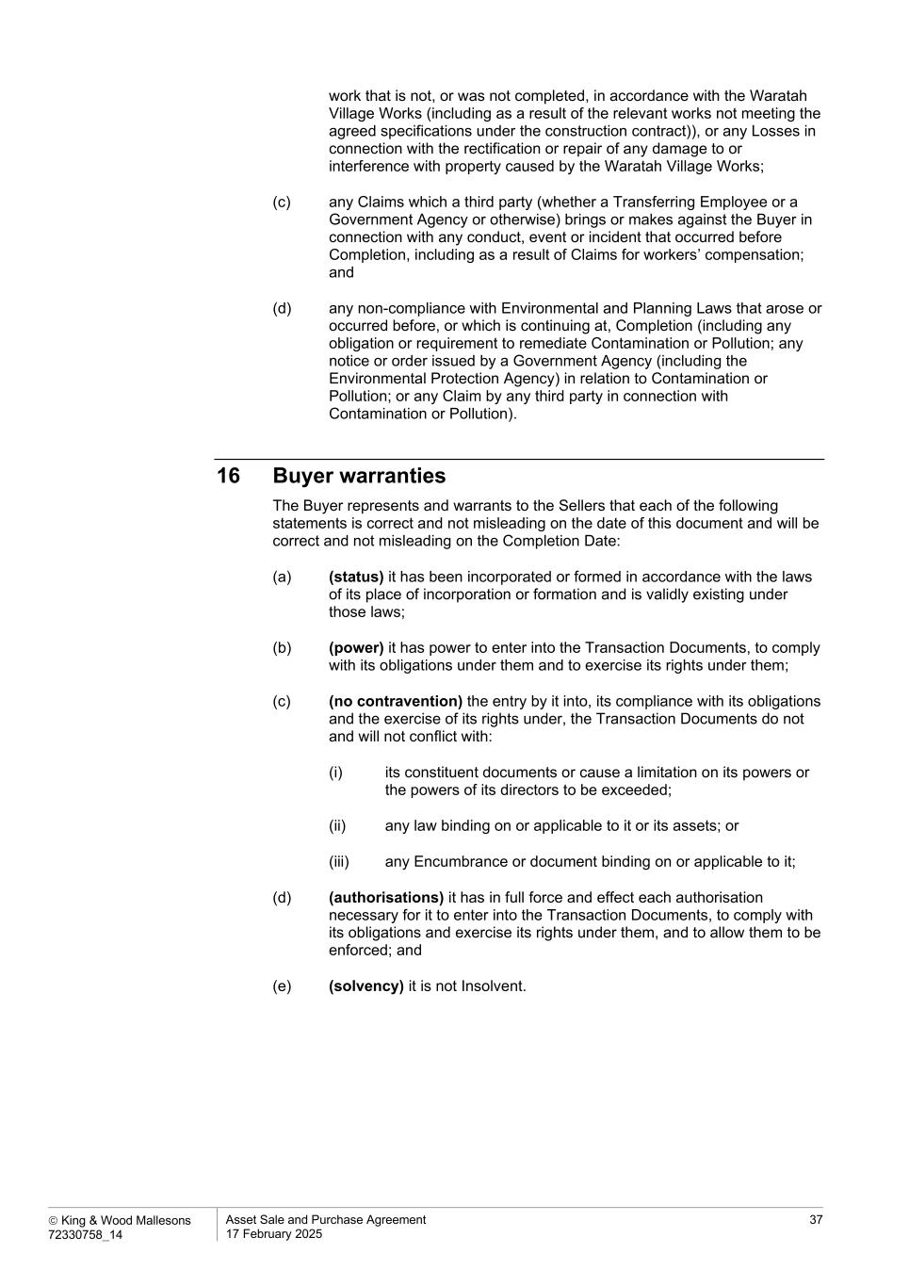
 King & Wood Mallesons 72330758_14 Asset Sale and Purchase Agreement 17 February 2025 37 work that is not, or was not completed, in accordance with the Waratah Village Works (including as a result of the relevant works not meeting the agreed specifications under the construction contract)), or any Losses in connection with the rectification or repair of any damage to or interference with property caused by the Waratah Village Works; (c) any Claims which a third party (whether a Transferring Employee or a Government Agency or otherwise) brings or makes against the Buyer in connection with any conduct, event or incident that occurred before Completion, including as a result of Claims for workers’ compensation; and (d) any non-compliance with Environmental and Planning Laws that arose or occurred before, or which is continuing at, Completion (including any obligation or requirement to remediate Contamination or Pollution; any notice or order issued by a Government Agency (including the Environmental Protection Agency) in relation to Contamination or Pollution; or any Claim by any third party in connection with Contamination or Pollution). 16 Buyer warranties The Buyer represents and warrants to the Sellers that each of the following statements is correct and not misleading on the date of this document and will be correct and not misleading on the Completion Date: (a) (status) it has been incorporated or formed in accordance with the laws of its place of incorporation or formation and is validly existing under those laws; (b) (power) it has power to enter into the Transaction Documents, to comply with its obligations under them and to exercise its rights under them; (c) (no contravention) the entry by it into, its compliance with its obligations and the exercise of its rights under, the Transaction Documents do not and will not conflict with: (i) its constituent documents or cause a limitation on its powers or the powers of its directors to be exceeded; (ii) any law binding on or applicable to it or its assets; or (iii) any Encumbrance or document binding on or applicable to it; (d) (authorisations) it has in full force and effect each authorisation necessary for it to enter into the Transaction Documents, to comply with its obligations and exercise its rights under them, and to allow them to be enforced; and (e) (solvency) it is not Insolvent.

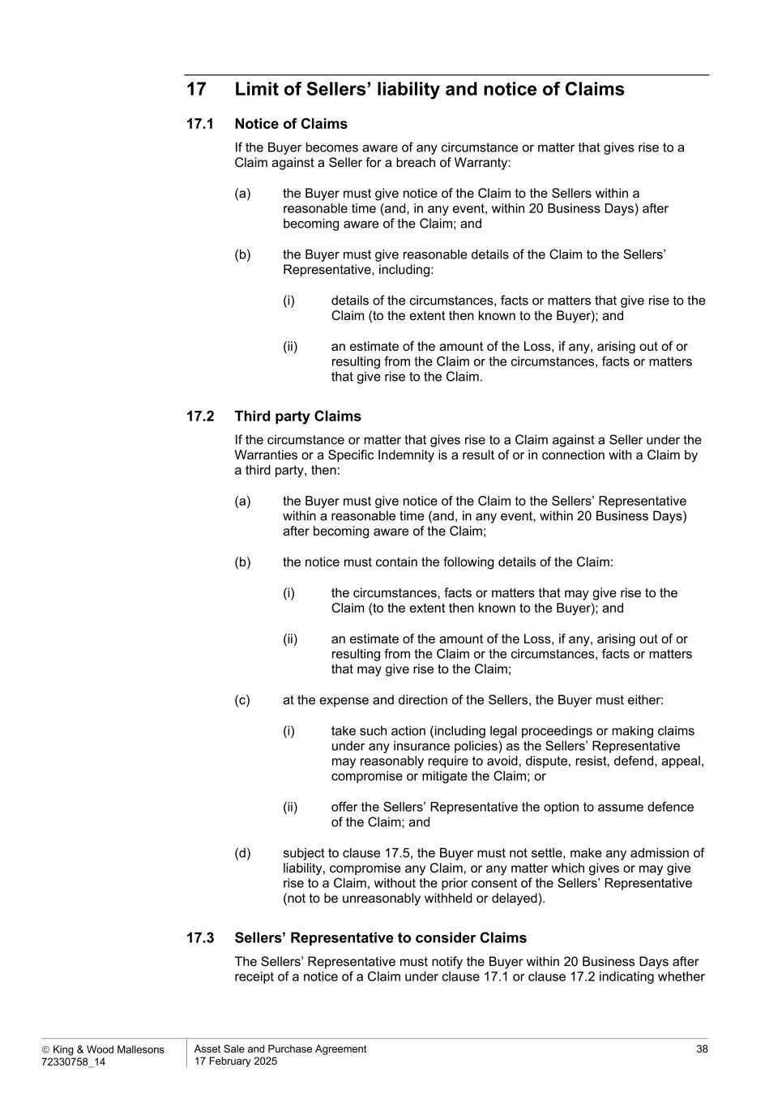
 King & Wood Mallesons 72330758_14 Asset Sale and Purchase Agreement 17 February 2025 38 17 Limit of Sellers’ liability and notice of Claims 17.1 Notice of Claims If the Buyer becomes aware of any circumstance or matter that gives rise to a Claim against a Seller for a breach of Warranty: (a) the Buyer must give notice of the Claim to the Sellers within a reasonable time (and, in any event, within 20 Business Days) after becoming aware of the Claim; and (b) the Buyer must give reasonable details of the Claim to the Sellers’ Representative, including: (i) details of the circumstances, facts or matters that give rise to the Claim (to the extent then known to the Buyer); and (ii) an estimate of the amount of the Loss, if any, arising out of or resulting from the Claim or the circumstances, facts or matters that give rise to the Claim. 17.2 Third party Claims If the circumstance or matter that gives rise to a Claim against a Seller under the Warranties or a Specific Indemnity is a result of or in connection with a Claim by a third party, then: (a) the Buyer must give notice of the Claim to the Sellers’ Representative within a reasonable time (and, in any event, within 20 Business Days) after becoming aware of the Claim; (b) the notice must contain the following details of the Claim: (i) the circumstances, facts or matters that may give rise to the Claim (to the extent then known to the Buyer); and (ii) an estimate of the amount of the Loss, if any, arising out of or resulting from the Claim or the circumstances, facts or matters that may give rise to the Claim; (c) at the expense and direction of the Sellers, the Buyer must either: (i) take such action (including legal proceedings or making claims under any insurance policies) as the Sellers’ Representative may reasonably require to avoid, dispute, resist, defend, appeal, compromise or mitigate the Claim; or (ii) offer the Sellers’ Representative the option to assume defence of the Claim; and (d) subject to clause 17.5, the Buyer must not settle, make any admission of liability, compromise any Claim, or any matter which gives or may give rise to a Claim, without the prior consent of the Sellers’ Representative (not to be unreasonably withheld or delayed). 17.3 Sellers’ Representative to consider Claims The Sellers’ Representative must notify the Buyer within 20 Business Days after receipt of a notice of a Claim under clause 17.1 or clause 17.2 indicating whether

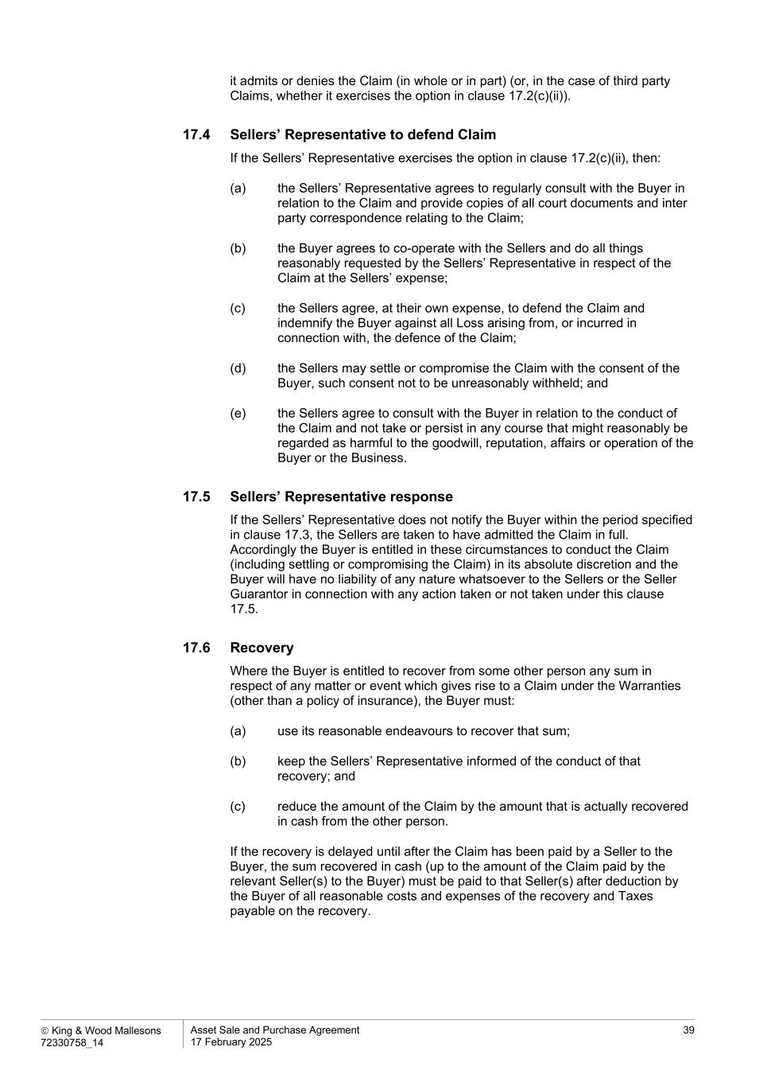
 King & Wood Mallesons 72330758_14 Asset Sale and Purchase Agreement 17 February 2025 39 it admits or denies the Claim (in whole or in part) (or, in the case of third party Claims, whether it exercises the option in clause 17.2(c)(ii)). 17.4 Sellers’ Representative to defend Claim If the Sellers’ Representative exercises the option in clause 17.2(c)(ii), then: (a) the Sellers’ Representative agrees to regularly consult with the Buyer in relation to the Claim and provide copies of all court documents and inter party correspondence relating to the Claim; (b) the Buyer agrees to co-operate with the Sellers and do all things reasonably requested by the Sellers’ Representative in respect of the Claim at the Sellers’ expense; (c) the Sellers agree, at their own expense, to defend the Claim and indemnify the Buyer against all Loss arising from, or incurred in connection with, the defence of the Claim; (d) the Sellers may settle or compromise the Claim with the consent of the Buyer, such consent not to be unreasonably withheld; and (e) the Sellers agree to consult with the Buyer in relation to the conduct of the Claim and not take or persist in any course that might reasonably be regarded as harmful to the goodwill, reputation, affairs or operation of the Buyer or the Business. 17.5 Sellers’ Representative response If the Sellers’ Representative does not notify the Buyer within the period specified in clause 17.3, the Sellers are taken to have admitted the Claim in full. Accordingly the Buyer is entitled in these circumstances to conduct the Claim (including settling or compromising the Claim) in its absolute discretion and the Buyer will have no liability of any nature whatsoever to the Sellers or the Seller Guarantor in connection with any action taken or not taken under this clause 17.5. 17.6 Recovery Where the Buyer is entitled to recover from some other person any sum in respect of any matter or event which gives rise to a Claim under the Warranties (other than a policy of insurance), the Buyer must: (a) use its reasonable endeavours to recover that sum; (b) keep the Sellers’ Representative informed of the conduct of that recovery; and (c) reduce the amount of the Claim by the amount that is actually recovered in cash from the other person. If the recovery is delayed until after the Claim has been paid by a Seller to the Buyer, the sum recovered in cash (up to the amount of the Claim paid by the relevant Seller(s) to the Buyer) must be paid to that Seller(s) after deduction by the Buyer of all reasonable costs and expenses of the recovery and Taxes payable on the recovery.

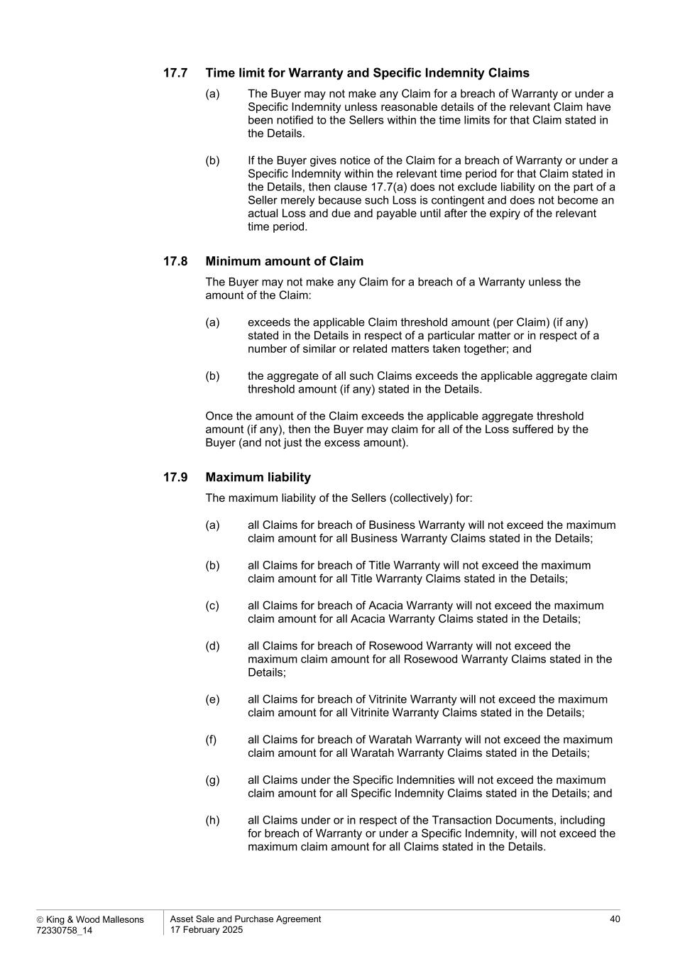
 King & Wood Mallesons 72330758_14 Asset Sale and Purchase Agreement 17 February 2025 40 17.7 Time limit for Warranty and Specific Indemnity Claims (a) The Buyer may not make any Claim for a breach of Warranty or under a Specific Indemnity unless reasonable details of the relevant Claim have been notified to the Sellers within the time limits for that Claim stated in the Details. (b) If the Buyer gives notice of the Claim for a breach of Warranty or under a Specific Indemnity within the relevant time period for that Claim stated in the Details, then clause 17.7(a) does not exclude liability on the part of a Seller merely because such Loss is contingent and does not become an actual Loss and due and payable until after the expiry of the relevant time period. 17.8 Minimum amount of Claim The Buyer may not make any Claim for a breach of a Warranty unless the amount of the Claim: (a) exceeds the applicable Claim threshold amount (per Claim) (if any) stated in the Details in respect of a particular matter or in respect of a number of similar or related matters taken together; and (b) the aggregate of all such Claims exceeds the applicable aggregate claim threshold amount (if any) stated in the Details. Once the amount of the Claim exceeds the applicable aggregate threshold amount (if any), then the Buyer may claim for all of the Loss suffered by the Buyer (and not just the excess amount). 17.9 Maximum liability The maximum liability of the Sellers (collectively) for: (a) all Claims for breach of Business Warranty will not exceed the maximum claim amount for all Business Warranty Claims stated in the Details; (b) all Claims for breach of Title Warranty will not exceed the maximum claim amount for all Title Warranty Claims stated in the Details; (c) all Claims for breach of Acacia Warranty will not exceed the maximum claim amount for all Acacia Warranty Claims stated in the Details; (d) all Claims for breach of Rosewood Warranty will not exceed the maximum claim amount for all Rosewood Warranty Claims stated in the Details; (e) all Claims for breach of Vitrinite Warranty will not exceed the maximum claim amount for all Vitrinite Warranty Claims stated in the Details; (f) all Claims for breach of Waratah Warranty will not exceed the maximum claim amount for all Waratah Warranty Claims stated in the Details; (g) all Claims under the Specific Indemnities will not exceed the maximum claim amount for all Specific Indemnity Claims stated in the Details; and (h) all Claims under or in respect of the Transaction Documents, including for breach of Warranty or under a Specific Indemnity, will not exceed the maximum claim amount for all Claims stated in the Details.

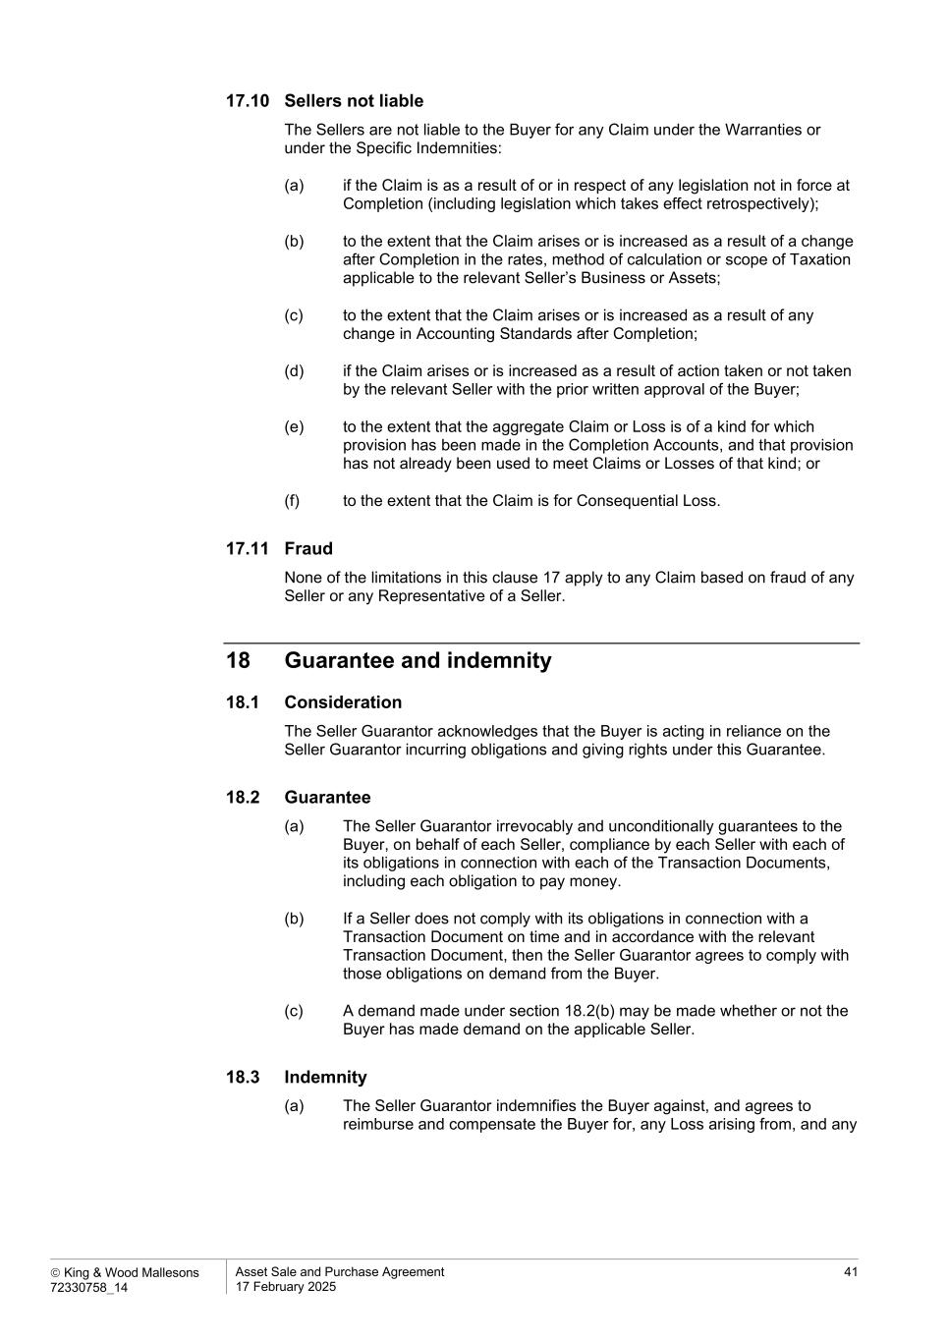
 King & Wood Mallesons 72330758_14 Asset Sale and Purchase Agreement 17 February 2025 41 17.10 Sellers not liable The Sellers are not liable to the Buyer for any Claim under the Warranties or under the Specific Indemnities: (a) if the Claim is as a result of or in respect of any legislation not in force at Completion (including legislation which takes effect retrospectively); (b) to the extent that the Claim arises or is increased as a result of a change after Completion in the rates, method of calculation or scope of Taxation applicable to the relevant Seller’s Business or Assets; (c) to the extent that the Claim arises or is increased as a result of any change in Accounting Standards after Completion; (d) if the Claim arises or is increased as a result of action taken or not taken by the relevant Seller with the prior written approval of the Buyer; (e) to the extent that the aggregate Claim or Loss is of a kind for which provision has been made in the Completion Accounts, and that provision has not already been used to meet Claims or Losses of that kind; or (f) to the extent that the Claim is for Consequential Loss. 17.11 Fraud None of the limitations in this clause 17 apply to any Claim based on fraud of any Seller or any Representative of a Seller. 18 Guarantee and indemnity 18.1 Consideration The Seller Guarantor acknowledges that the Buyer is acting in reliance on the Seller Guarantor incurring obligations and giving rights under this Guarantee. 18.2 Guarantee (a) The Seller Guarantor irrevocably and unconditionally guarantees to the Buyer, on behalf of each Seller, compliance by each Seller with each of its obligations in connection with each of the Transaction Documents, including each obligation to pay money. (b) If a Seller does not comply with its obligations in connection with a Transaction Document on time and in accordance with the relevant Transaction Document, then the Seller Guarantor agrees to comply with those obligations on demand from the Buyer. (c) A demand made under section 18.2(b) may be made whether or not the Buyer has made demand on the applicable Seller. 18.3 Indemnity (a) The Seller Guarantor indemnifies the Buyer against, and agrees to reimburse and compensate the Buyer for, any Loss arising from, and any

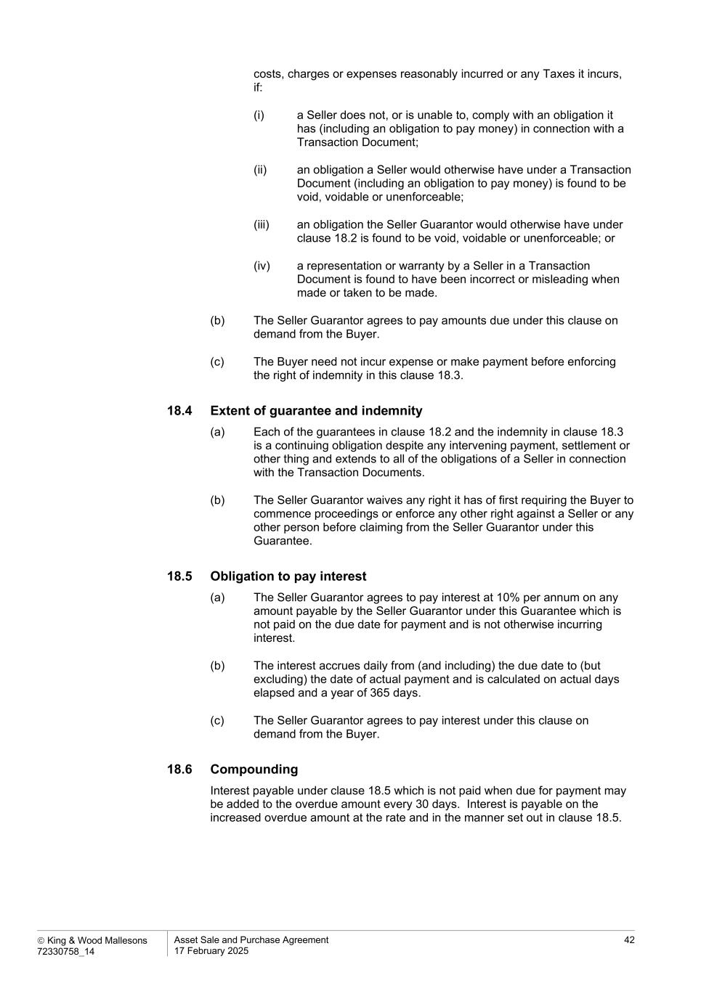
 King & Wood Mallesons 72330758_14 Asset Sale and Purchase Agreement 17 February 2025 42 costs, charges or expenses reasonably incurred or any Taxes it incurs, if: (i) a Seller does not, or is unable to, comply with an obligation it has (including an obligation to pay money) in connection with a Transaction Document; (ii) an obligation a Seller would otherwise have under a Transaction Document (including an obligation to pay money) is found to be void, voidable or unenforceable; (iii) an obligation the Seller Guarantor would otherwise have under clause 18.2 is found to be void, voidable or unenforceable; or (iv) a representation or warranty by a Seller in a Transaction Document is found to have been incorrect or misleading when made or taken to be made. (b) The Seller Guarantor agrees to pay amounts due under this clause on demand from the Buyer. (c) The Buyer need not incur expense or make payment before enforcing the right of indemnity in this clause 18.3. 18.4 Extent of guarantee and indemnity (a) Each of the guarantees in clause 18.2 and the indemnity in clause 18.3 is a continuing obligation despite any intervening payment, settlement or other thing and extends to all of the obligations of a Seller in connection with the Transaction Documents. (b) The Seller Guarantor waives any right it has of first requiring the Buyer to commence proceedings or enforce any other right against a Seller or any other person before claiming from the Seller Guarantor under this Guarantee. 18.5 Obligation to pay interest (a) The Seller Guarantor agrees to pay interest at 10% per annum on any amount payable by the Seller Guarantor under this Guarantee which is not paid on the due date for payment and is not otherwise incurring interest. (b) The interest accrues daily from (and including) the due date to (but excluding) the date of actual payment and is calculated on actual days elapsed and a year of 365 days. (c) The Seller Guarantor agrees to pay interest under this clause on demand from the Buyer. 18.6 Compounding Interest payable under clause 18.5 which is not paid when due for payment may be added to the overdue amount every 30 days. Interest is payable on the increased overdue amount at the rate and in the manner set out in clause 18.5.

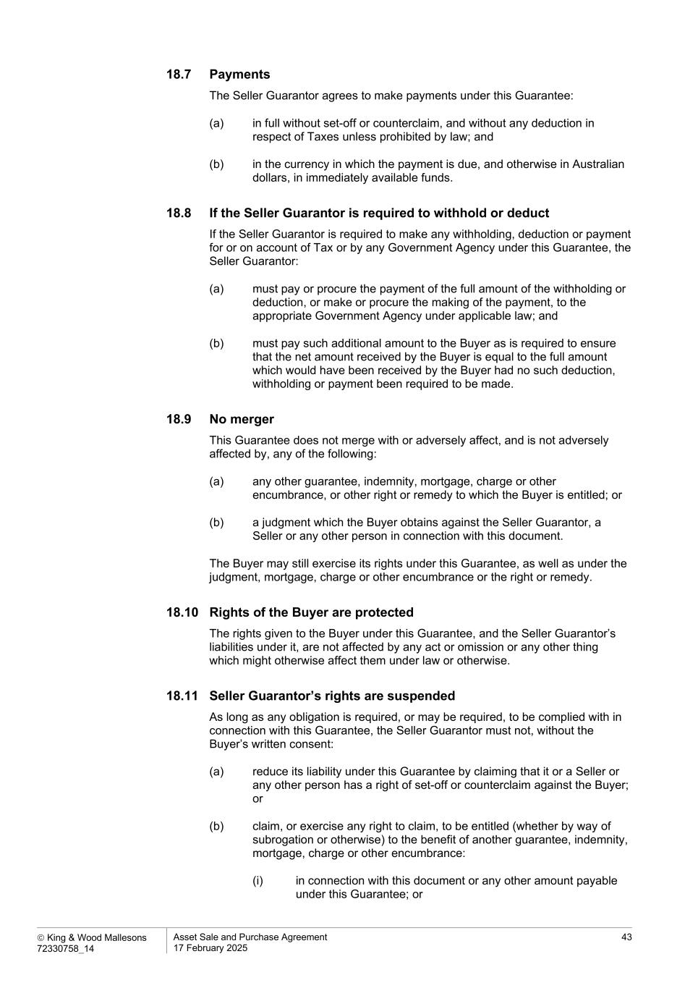
 King & Wood Mallesons 72330758_14 Asset Sale and Purchase Agreement 17 February 2025 43 18.7 Payments The Seller Guarantor agrees to make payments under this Guarantee: (a) in full without set-off or counterclaim, and without any deduction in respect of Taxes unless prohibited by law; and (b) in the currency in which the payment is due, and otherwise in Australian dollars, in immediately available funds. 18.8 If the Seller Guarantor is required to withhold or deduct If the Seller Guarantor is required to make any withholding, deduction or payment for or on account of Tax or by any Government Agency under this Guarantee, the Seller Guarantor: (a) must pay or procure the payment of the full amount of the withholding or deduction, or make or procure the making of the payment, to the appropriate Government Agency under applicable law; and (b) must pay such additional amount to the Buyer as is required to ensure that the net amount received by the Buyer is equal to the full amount which would have been received by the Buyer had no such deduction, withholding or payment been required to be made. 18.9 No merger This Guarantee does not merge with or adversely affect, and is not adversely affected by, any of the following: (a) any other guarantee, indemnity, mortgage, charge or other encumbrance, or other right or remedy to which the Buyer is entitled; or (b) a judgment which the Buyer obtains against the Seller Guarantor, a Seller or any other person in connection with this document. The Buyer may still exercise its rights under this Guarantee, as well as under the judgment, mortgage, charge or other encumbrance or the right or remedy. 18.10 Rights of the Buyer are protected The rights given to the Buyer under this Guarantee, and the Seller Guarantor’s liabilities under it, are not affected by any act or omission or any other thing which might otherwise affect them under law or otherwise. 18.11 Seller Guarantor’s rights are suspended As long as any obligation is required, or may be required, to be complied with in connection with this Guarantee, the Seller Guarantor must not, without the Buyer’s written consent: (a) reduce its liability under this Guarantee by claiming that it or a Seller or any other person has a right of set-off or counterclaim against the Buyer; or (b) claim, or exercise any right to claim, to be entitled (whether by way of subrogation or otherwise) to the benefit of another guarantee, indemnity, mortgage, charge or other encumbrance: (i) in connection with this document or any other amount payable under this Guarantee; or

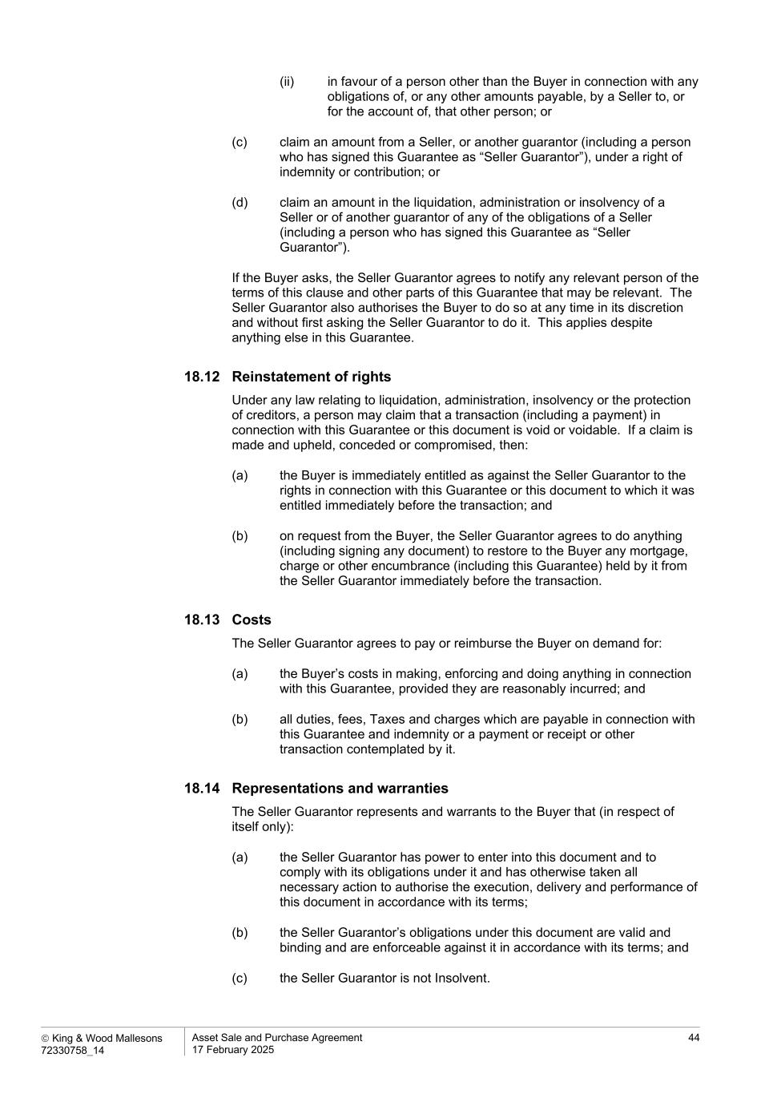
 King & Wood Mallesons 72330758_14 Asset Sale and Purchase Agreement 17 February 2025 44 (ii) in favour of a person other than the Buyer in connection with any obligations of, or any other amounts payable, by a Seller to, or for the account of, that other person; or (c) claim an amount from a Seller, or another guarantor (including a person who has signed this Guarantee as “Seller Guarantor”), under a right of indemnity or contribution; or (d) claim an amount in the liquidation, administration or insolvency of a Seller or of another guarantor of any of the obligations of a Seller (including a person who has signed this Guarantee as “Seller Guarantor”). If the Buyer asks, the Seller Guarantor agrees to notify any relevant person of the terms of this clause and other parts of this Guarantee that may be relevant. The Seller Guarantor also authorises the Buyer to do so at any time in its discretion and without first asking the Seller Guarantor to do it. This applies despite anything else in this Guarantee. 18.12 Reinstatement of rights Under any law relating to liquidation, administration, insolvency or the protection of creditors, a person may claim that a transaction (including a payment) in connection with this Guarantee or this document is void or voidable. If a claim is made and upheld, conceded or compromised, then: (a) the Buyer is immediately entitled as against the Seller Guarantor to the rights in connection with this Guarantee or this document to which it was entitled immediately before the transaction; and (b) on request from the Buyer, the Seller Guarantor agrees to do anything (including signing any document) to restore to the Buyer any mortgage, charge or other encumbrance (including this Guarantee) held by it from the Seller Guarantor immediately before the transaction. 18.13 Costs The Seller Guarantor agrees to pay or reimburse the Buyer on demand for: (a) the Buyer’s costs in making, enforcing and doing anything in connection with this Guarantee, provided they are reasonably incurred; and (b) all duties, fees, Taxes and charges which are payable in connection with this Guarantee and indemnity or a payment or receipt or other transaction contemplated by it. 18.14 Representations and warranties The Seller Guarantor represents and warrants to the Buyer that (in respect of itself only): (a) the Seller Guarantor has power to enter into this document and to comply with its obligations under it and has otherwise taken all necessary action to authorise the execution, delivery and performance of this document in accordance with its terms; (b) the Seller Guarantor’s obligations under this document are valid and binding and are enforceable against it in accordance with its terms; and (c) the Seller Guarantor is not Insolvent.

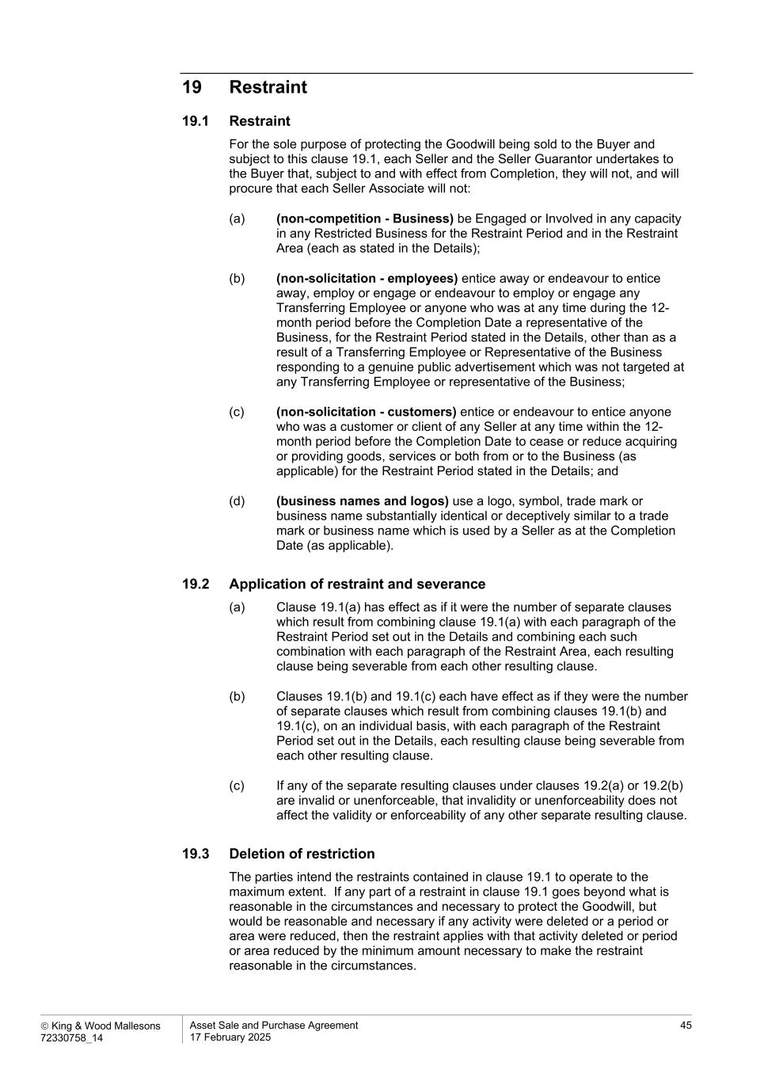
 King & Wood Mallesons 72330758_14 Asset Sale and Purchase Agreement 17 February 2025 45 19 Restraint 19.1 Restraint For the sole purpose of protecting the Goodwill being sold to the Buyer and subject to this clause 19.1, each Seller and the Seller Guarantor undertakes to the Buyer that, subject to and with effect from Completion, they will not, and will procure that each Seller Associate will not: (a) (non-competition - Business) be Engaged or Involved in any capacity in any Restricted Business for the Restraint Period and in the Restraint Area (each as stated in the Details); (b) (non-solicitation - employees) entice away or endeavour to entice away, employ or engage or endeavour to employ or engage any Transferring Employee or anyone who was at any time during the 12- month period before the Completion Date a representative of the Business, for the Restraint Period stated in the Details, other than as a result of a Transferring Employee or Representative of the Business responding to a genuine public advertisement which was not targeted at any Transferring Employee or representative of the Business; (c) (non-solicitation - customers) entice or endeavour to entice anyone who was a customer or client of any Seller at any time within the 12- month period before the Completion Date to cease or reduce acquiring or providing goods, services or both from or to the Business (as applicable) for the Restraint Period stated in the Details; and (d) (business names and logos) use a logo, symbol, trade mark or business name substantially identical or deceptively similar to a trade mark or business name which is used by a Seller as at the Completion Date (as applicable). 19.2 Application of restraint and severance (a) Clause 19.1(a) has effect as if it were the number of separate clauses which result from combining clause 19.1(a) with each paragraph of the Restraint Period set out in the Details and combining each such combination with each paragraph of the Restraint Area, each resulting clause being severable from each other resulting clause. (b) Clauses 19.1(b) and 19.1(c) each have effect as if they were the number of separate clauses which result from combining clauses 19.1(b) and 19.1(c), on an individual basis, with each paragraph of the Restraint Period set out in the Details, each resulting clause being severable from each other resulting clause. (c) If any of the separate resulting clauses under clauses 19.2(a) or 19.2(b) are invalid or unenforceable, that invalidity or unenforceability does not affect the validity or enforceability of any other separate resulting clause. 19.3 Deletion of restriction The parties intend the restraints contained in clause 19.1 to operate to the maximum extent. If any part of a restraint in clause 19.1 goes beyond what is reasonable in the circumstances and necessary to protect the Goodwill, but would be reasonable and necessary if any activity were deleted or a period or area were reduced, then the restraint applies with that activity deleted or period or area reduced by the minimum amount necessary to make the restraint reasonable in the circumstances.

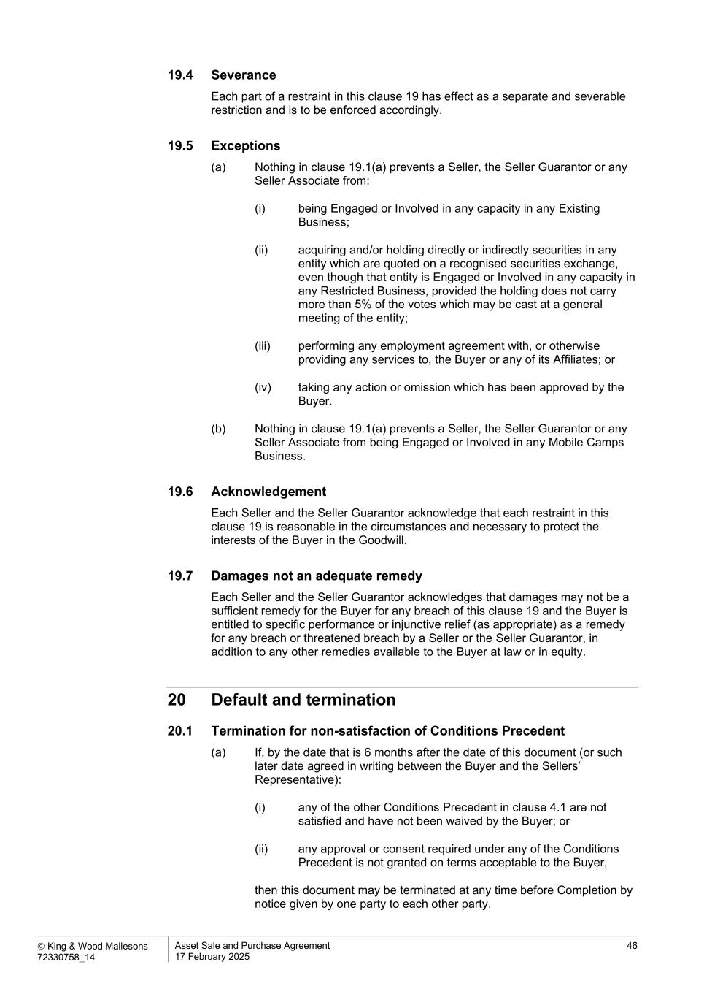
 King & Wood Mallesons 72330758_14 Asset Sale and Purchase Agreement 17 February 2025 46 19.4 Severance Each part of a restraint in this clause 19 has effect as a separate and severable restriction and is to be enforced accordingly. 19.5 Exceptions (a) Nothing in clause 19.1(a) prevents a Seller, the Seller Guarantor or any Seller Associate from: (i) being Engaged or Involved in any capacity in any Existing Business; (ii) acquiring and/or holding directly or indirectly securities in any entity which are quoted on a recognised securities exchange, even though that entity is Engaged or Involved in any capacity in any Restricted Business, provided the holding does not carry more than 5% of the votes which may be cast at a general meeting of the entity; (iii) performing any employment agreement with, or otherwise providing any services to, the Buyer or any of its Affiliates; or (iv) taking any action or omission which has been approved by the Buyer. (b) Nothing in clause 19.1(a) prevents a Seller, the Seller Guarantor or any Seller Associate from being Engaged or Involved in any Mobile Camps Business. 19.6 Acknowledgement Each Seller and the Seller Guarantor acknowledge that each restraint in this clause 19 is reasonable in the circumstances and necessary to protect the interests of the Buyer in the Goodwill. 19.7 Damages not an adequate remedy Each Seller and the Seller Guarantor acknowledges that damages may not be a sufficient remedy for the Buyer for any breach of this clause 19 and the Buyer is entitled to specific performance or injunctive relief (as appropriate) as a remedy for any breach or threatened breach by a Seller or the Seller Guarantor, in addition to any other remedies available to the Buyer at law or in equity. 20 Default and termination 20.1 Termination for non-satisfaction of Conditions Precedent (a) If, by the date that is 6 months after the date of this document (or such later date agreed in writing between the Buyer and the Sellers’ Representative): (i) any of the other Conditions Precedent in clause 4.1 are not satisfied and have not been waived by the Buyer; or (ii) any approval or consent required under any of the Conditions Precedent is not granted on terms acceptable to the Buyer, then this document may be terminated at any time before Completion by notice given by one party to each other party.

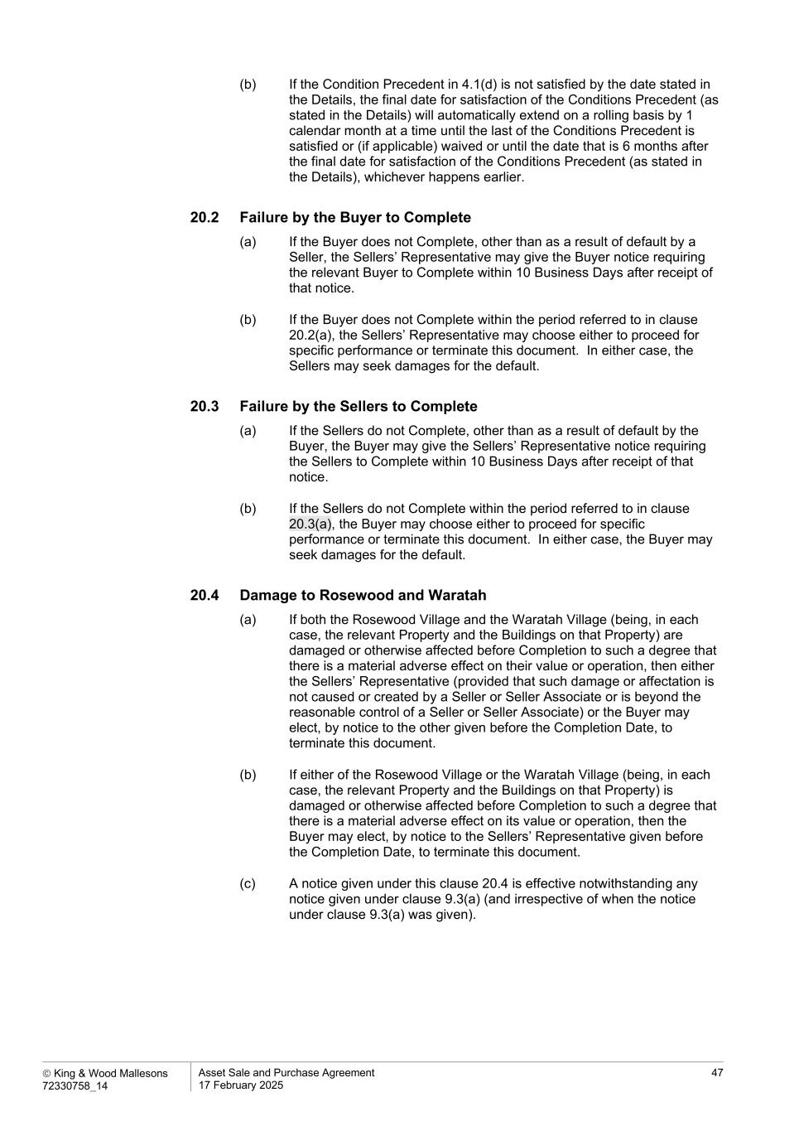
 King & Wood Mallesons 72330758_14 Asset Sale and Purchase Agreement 17 February 2025 47 (b) If the Condition Precedent in 4.1(d) is not satisfied by the date stated in the Details, the final date for satisfaction of the Conditions Precedent (as stated in the Details) will automatically extend on a rolling basis by 1 calendar month at a time until the last of the Conditions Precedent is satisfied or (if applicable) waived or until the date that is 6 months after the final date for satisfaction of the Conditions Precedent (as stated in the Details), whichever happens earlier. 20.2 Failure by the Buyer to Complete (a) If the Buyer does not Complete, other than as a result of default by a Seller, the Sellers’ Representative may give the Buyer notice requiring the relevant Buyer to Complete within 10 Business Days after receipt of that notice. (b) If the Buyer does not Complete within the period referred to in clause 20.2(a), the Sellers’ Representative may choose either to proceed for specific performance or terminate this document. In either case, the Sellers may seek damages for the default. 20.3 Failure by the Sellers to Complete (a) If the Sellers do not Complete, other than as a result of default by the Buyer, the Buyer may give the Sellers’ Representative notice requiring the Sellers to Complete within 10 Business Days after receipt of that notice. (b) If the Sellers do not Complete within the period referred to in clause 20.3(a), the Buyer may choose either to proceed for specific performance or terminate this document. In either case, the Buyer may seek damages for the default. 20.4 Damage to Rosewood and Waratah (a) If both the Rosewood Village and the Waratah Village (being, in each case, the relevant Property and the Buildings on that Property) are damaged or otherwise affected before Completion to such a degree that there is a material adverse effect on their value or operation, then either the Sellers’ Representative (provided that such damage or affectation is not caused or created by a Seller or Seller Associate or is beyond the reasonable control of a Seller or Seller Associate) or the Buyer may elect, by notice to the other given before the Completion Date, to terminate this document. (b) If either of the Rosewood Village or the Waratah Village (being, in each case, the relevant Property and the Buildings on that Property) is damaged or otherwise affected before Completion to such a degree that there is a material adverse effect on its value or operation, then the Buyer may elect, by notice to the Sellers’ Representative given before the Completion Date, to terminate this document. (c) A notice given under this clause 20.4 is effective notwithstanding any notice given under clause 9.3(a) (and irrespective of when the notice under clause 9.3(a) was given).

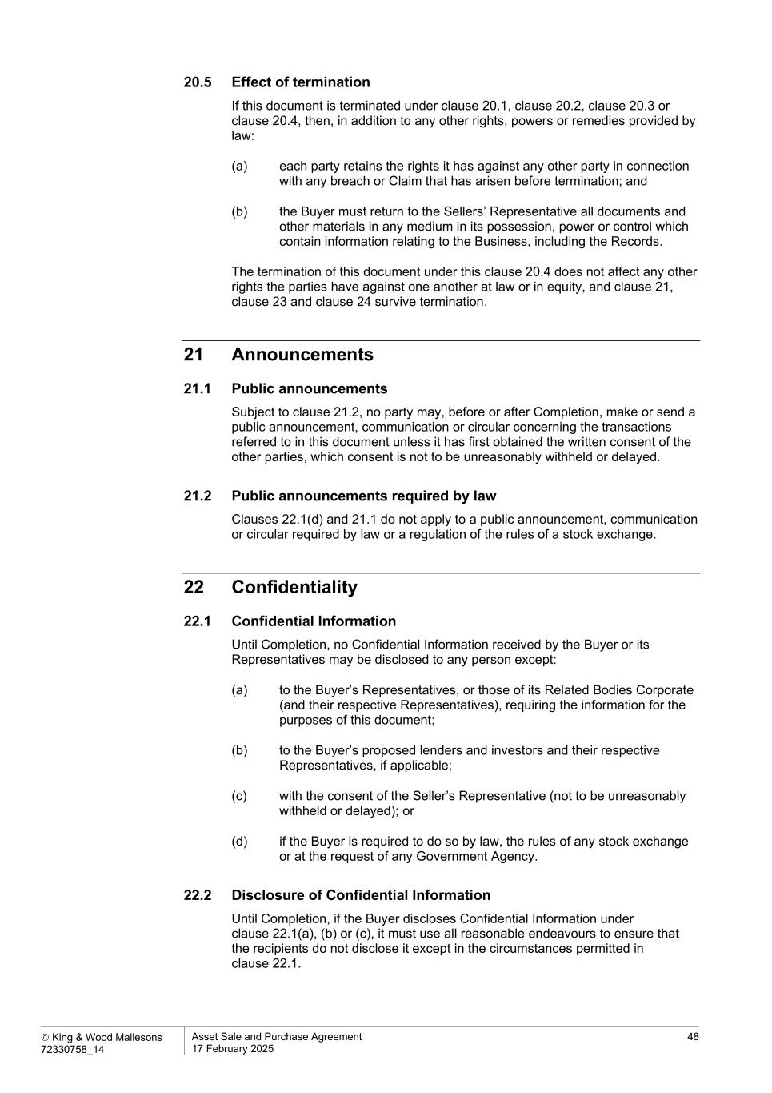
 King & Wood Mallesons 72330758_14 Asset Sale and Purchase Agreement 17 February 2025 48 20.5 Effect of termination If this document is terminated under clause 20.1, clause 20.2, clause 20.3 or clause 20.4, then, in addition to any other rights, powers or remedies provided by law: (a) each party retains the rights it has against any other party in connection with any breach or Claim that has arisen before termination; and (b) the Buyer must return to the Sellers’ Representative all documents and other materials in any medium in its possession, power or control which contain information relating to the Business, including the Records. The termination of this document under this clause 20.4 does not affect any other rights the parties have against one another at law or in equity, and clause 21, clause 23 and clause 24 survive termination. 21 Announcements 21.1 Public announcements Subject to clause 21.2, no party may, before or after Completion, make or send a public announcement, communication or circular concerning the transactions referred to in this document unless it has first obtained the written consent of the other parties, which consent is not to be unreasonably withheld or delayed. 21.2 Public announcements required by law Clauses 22.1(d) and 21.1 do not apply to a public announcement, communication or circular required by law or a regulation of the rules of a stock exchange. 22 Confidentiality 22.1 Confidential Information Until Completion, no Confidential Information received by the Buyer or its Representatives may be disclosed to any person except: (a) to the Buyer’s Representatives, or those of its Related Bodies Corporate (and their respective Representatives), requiring the information for the purposes of this document; (b) to the Buyer’s proposed lenders and investors and their respective Representatives, if applicable; (c) with the consent of the Seller’s Representative (not to be unreasonably withheld or delayed); or (d) if the Buyer is required to do so by law, the rules of any stock exchange or at the request of any Government Agency. 22.2 Disclosure of Confidential Information Until Completion, if the Buyer discloses Confidential Information under clause 22.1(a), (b) or (c), it must use all reasonable endeavours to ensure that the recipients do not disclose it except in the circumstances permitted in clause 22.1.

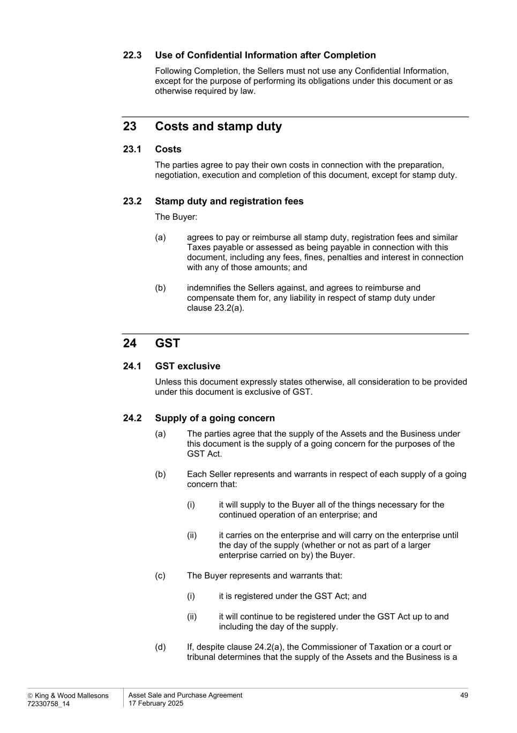
 King & Wood Mallesons 72330758_14 Asset Sale and Purchase Agreement 17 February 2025 49 22.3 Use of Confidential Information after Completion Following Completion, the Sellers must not use any Confidential Information, except for the purpose of performing its obligations under this document or as otherwise required by law. 23 Costs and stamp duty 23.1 Costs The parties agree to pay their own costs in connection with the preparation, negotiation, execution and completion of this document, except for stamp duty. 23.2 Stamp duty and registration fees The Buyer: (a) agrees to pay or reimburse all stamp duty, registration fees and similar Taxes payable or assessed as being payable in connection with this document, including any fees, fines, penalties and interest in connection with any of those amounts; and (b) indemnifies the Sellers against, and agrees to reimburse and compensate them for, any liability in respect of stamp duty under clause 23.2(a). 24 GST 24.1 GST exclusive Unless this document expressly states otherwise, all consideration to be provided under this document is exclusive of GST. 24.2 Supply of a going concern (a) The parties agree that the supply of the Assets and the Business under this document is the supply of a going concern for the purposes of the GST Act. (b) Each Seller represents and warrants in respect of each supply of a going concern that: (i) it will supply to the Buyer all of the things necessary for the continued operation of an enterprise; and (ii) it carries on the enterprise and will carry on the enterprise until the day of the supply (whether or not as part of a larger enterprise carried on by) the Buyer. (c) The Buyer represents and warrants that: (i) it is registered under the GST Act; and (ii) it will continue to be registered under the GST Act up to and including the day of the supply. (d) If, despite clause 24.2(a), the Commissioner of Taxation or a court or tribunal determines that the supply of the Assets and the Business is a

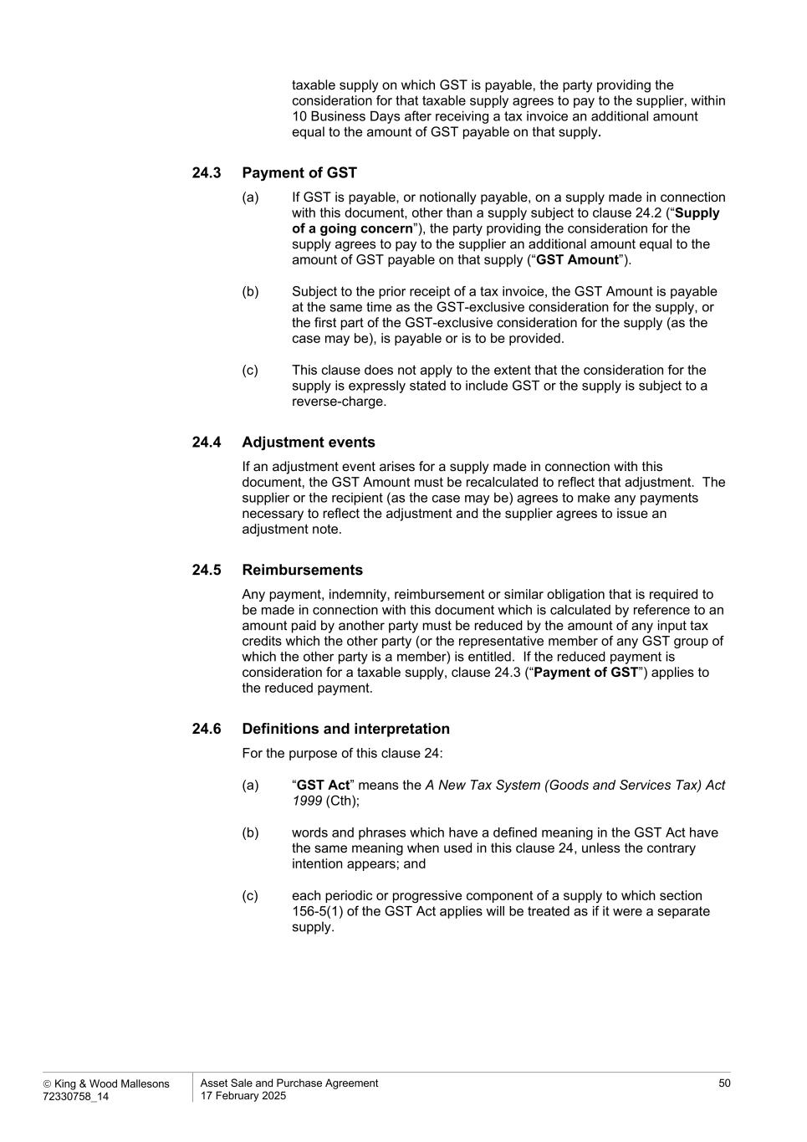
 King & Wood Mallesons 72330758_14 Asset Sale and Purchase Agreement 17 February 2025 50 taxable supply on which GST is payable, the party providing the consideration for that taxable supply agrees to pay to the supplier, within 10 Business Days after receiving a tax invoice an additional amount equal to the amount of GST payable on that supply. 24.3 Payment of GST (a) If GST is payable, or notionally payable, on a supply made in connection with this document, other than a supply subject to clause 24.2 (“Supply of a going concern”), the party providing the consideration for the supply agrees to pay to the supplier an additional amount equal to the amount of GST payable on that supply (“GST Amount”). (b) Subject to the prior receipt of a tax invoice, the GST Amount is payable at the same time as the GST-exclusive consideration for the supply, or the first part of the GST-exclusive consideration for the supply (as the case may be), is payable or is to be provided. (c) This clause does not apply to the extent that the consideration for the supply is expressly stated to include GST or the supply is subject to a reverse-charge. 24.4 Adjustment events If an adjustment event arises for a supply made in connection with this document, the GST Amount must be recalculated to reflect that adjustment. The supplier or the recipient (as the case may be) agrees to make any payments necessary to reflect the adjustment and the supplier agrees to issue an adjustment note. 24.5 Reimbursements Any payment, indemnity, reimbursement or similar obligation that is required to be made in connection with this document which is calculated by reference to an amount paid by another party must be reduced by the amount of any input tax credits which the other party (or the representative member of any GST group of which the other party is a member) is entitled. If the reduced payment is consideration for a taxable supply, clause 24.3 (“Payment of GST”) applies to the reduced payment. 24.6 Definitions and interpretation For the purpose of this clause 24: (a) “GST Act” means the A New Tax System (Goods and Services Tax) Act 1999 (Cth); (b) words and phrases which have a defined meaning in the GST Act have the same meaning when used in this clause 24, unless the contrary intention appears; and (c) each periodic or progressive component of a supply to which section 156-5(1) of the GST Act applies will be treated as if it were a separate supply.

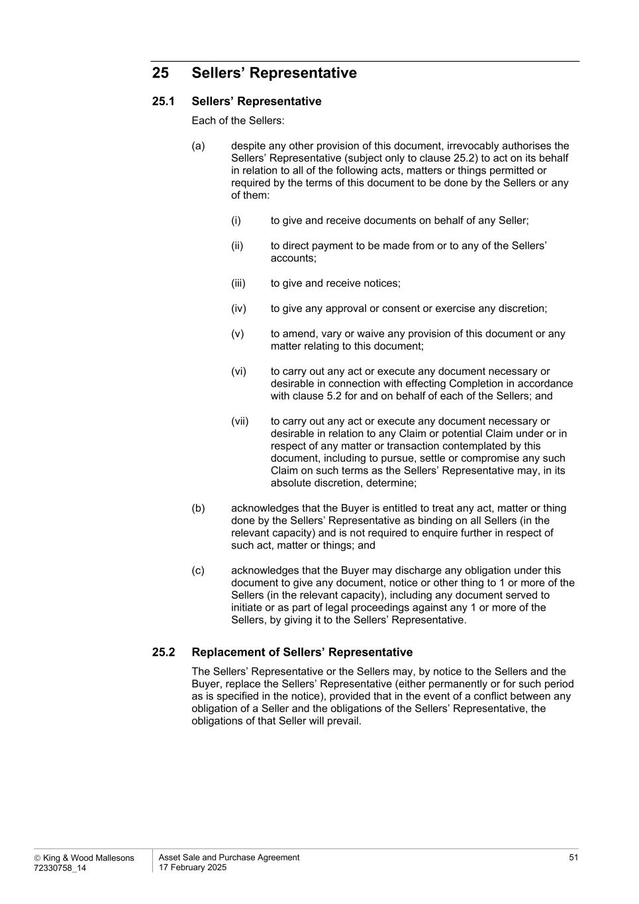
 King & Wood Mallesons 72330758_14 Asset Sale and Purchase Agreement 17 February 2025 51 25 Sellers’ Representative 25.1 Sellers’ Representative Each of the Sellers: (a) despite any other provision of this document, irrevocably authorises the Sellers’ Representative (subject only to clause 25.2) to act on its behalf in relation to all of the following acts, matters or things permitted or required by the terms of this document to be done by the Sellers or any of them: (i) to give and receive documents on behalf of any Seller; (ii) to direct payment to be made from or to any of the Sellers’ accounts; (iii) to give and receive notices; (iv) to give any approval or consent or exercise any discretion; (v) to amend, vary or waive any provision of this document or any matter relating to this document; (vi) to carry out any act or execute any document necessary or desirable in connection with effecting Completion in accordance with clause 5.2 for and on behalf of each of the Sellers; and (vii) to carry out any act or execute any document necessary or desirable in relation to any Claim or potential Claim under or in respect of any matter or transaction contemplated by this document, including to pursue, settle or compromise any such Claim on such terms as the Sellers’ Representative may, in its absolute discretion, determine; (b) acknowledges that the Buyer is entitled to treat any act, matter or thing done by the Sellers’ Representative as binding on all Sellers (in the relevant capacity) and is not required to enquire further in respect of such act, matter or things; and (c) acknowledges that the Buyer may discharge any obligation under this document to give any document, notice or other thing to 1 or more of the Sellers (in the relevant capacity), including any document served to initiate or as part of legal proceedings against any 1 or more of the Sellers, by giving it to the Sellers’ Representative. 25.2 Replacement of Sellers’ Representative The Sellers’ Representative or the Sellers may, by notice to the Sellers and the Buyer, replace the Sellers’ Representative (either permanently or for such period as is specified in the notice), provided that in the event of a conflict between any obligation of a Seller and the obligations of the Sellers’ Representative, the obligations of that Seller will prevail.

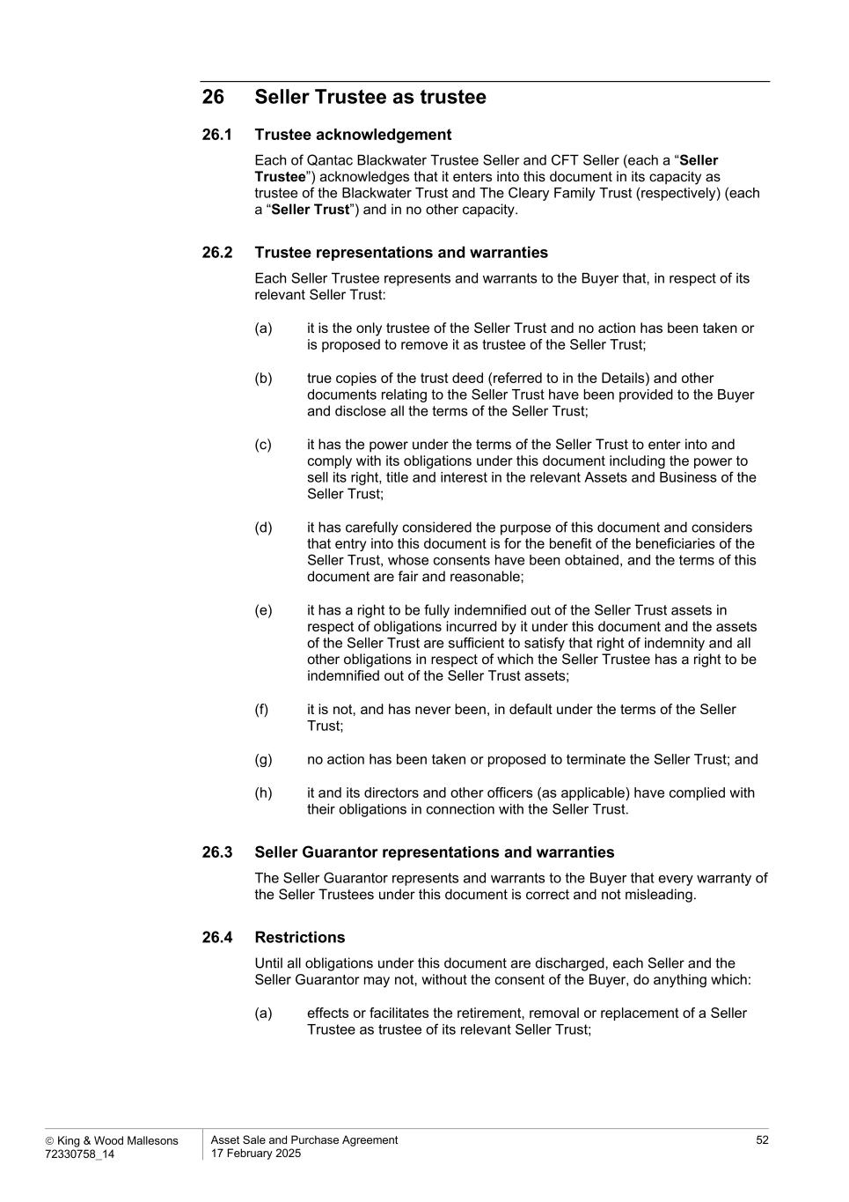
 King & Wood Mallesons 72330758_14 Asset Sale and Purchase Agreement 17 February 2025 52 26 Seller Trustee as trustee 26.1 Trustee acknowledgement Each of Qantac Blackwater Trustee Seller and CFT Seller (each a “Seller Trustee”) acknowledges that it enters into this document in its capacity as trustee of the Blackwater Trust and The Cleary Family Trust (respectively) (each a “Seller Trust”) and in no other capacity. 26.2 Trustee representations and warranties Each Seller Trustee represents and warrants to the Buyer that, in respect of its relevant Seller Trust: (a) it is the only trustee of the Seller Trust and no action has been taken or is proposed to remove it as trustee of the Seller Trust; (b) true copies of the trust deed (referred to in the Details) and other documents relating to the Seller Trust have been provided to the Buyer and disclose all the terms of the Seller Trust; (c) it has the power under the terms of the Seller Trust to enter into and comply with its obligations under this document including the power to sell its right, title and interest in the relevant Assets and Business of the Seller Trust; (d) it has carefully considered the purpose of this document and considers that entry into this document is for the benefit of the beneficiaries of the Seller Trust, whose consents have been obtained, and the terms of this document are fair and reasonable; (e) it has a right to be fully indemnified out of the Seller Trust assets in respect of obligations incurred by it under this document and the assets of the Seller Trust are sufficient to satisfy that right of indemnity and all other obligations in respect of which the Seller Trustee has a right to be indemnified out of the Seller Trust assets; (f) it is not, and has never been, in default under the terms of the Seller Trust; (g) no action has been taken or proposed to terminate the Seller Trust; and (h) it and its directors and other officers (as applicable) have complied with their obligations in connection with the Seller Trust. 26.3 Seller Guarantor representations and warranties The Seller Guarantor represents and warrants to the Buyer that every warranty of the Seller Trustees under this document is correct and not misleading. 26.4 Restrictions Until all obligations under this document are discharged, each Seller and the Seller Guarantor may not, without the consent of the Buyer, do anything which: (a) effects or facilitates the retirement, removal or replacement of a Seller Trustee as trustee of its relevant Seller Trust;

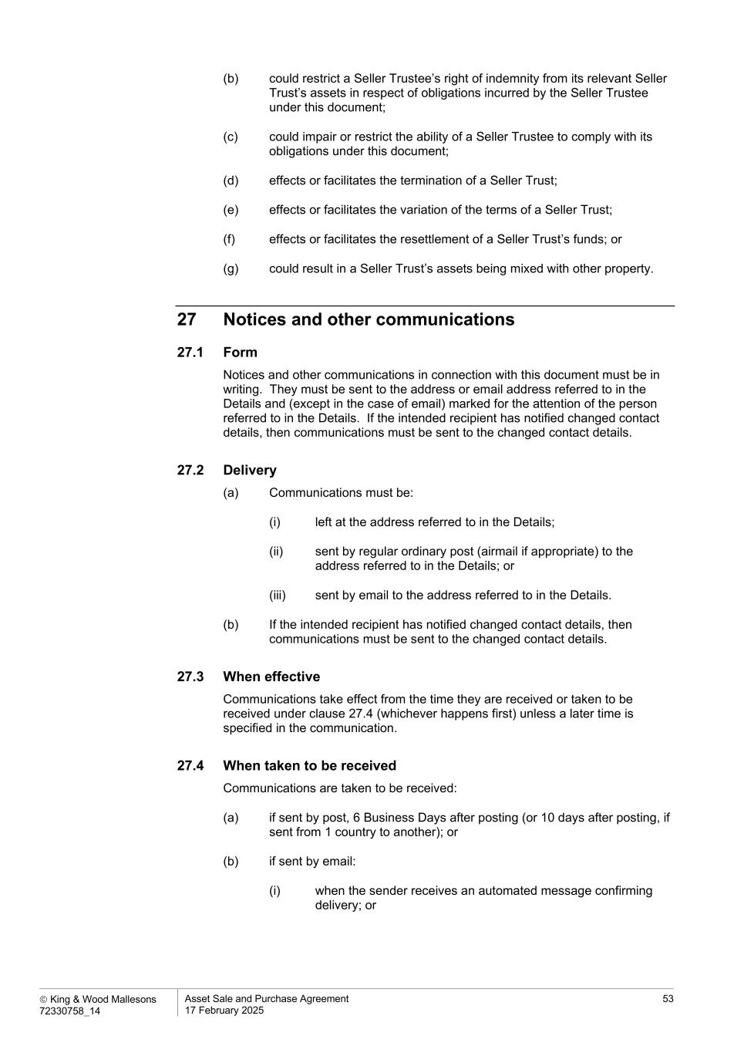
 King & Wood Mallesons 72330758_14 Asset Sale and Purchase Agreement 17 February 2025 53 (b) could restrict a Seller Trustee’s right of indemnity from its relevant Seller Trust’s assets in respect of obligations incurred by the Seller Trustee under this document; (c) could impair or restrict the ability of a Seller Trustee to comply with its obligations under this document; (d) effects or facilitates the termination of a Seller Trust; (e) effects or facilitates the variation of the terms of a Seller Trust; (f) effects or facilitates the resettlement of a Seller Trust’s funds; or (g) could result in a Seller Trust’s assets being mixed with other property. 27 Notices and other communications 27.1 Form Notices and other communications in connection with this document must be in writing. They must be sent to the address or email address referred to in the Details and (except in the case of email) marked for the attention of the person referred to in the Details. If the intended recipient has notified changed contact details, then communications must be sent to the changed contact details. 27.2 Delivery (a) Communications must be: (i) left at the address referred to in the Details; (ii) sent by regular ordinary post (airmail if appropriate) to the address referred to in the Details; or (iii) sent by email to the address referred to in the Details. (b) If the intended recipient has notified changed contact details, then communications must be sent to the changed contact details. 27.3 When effective Communications take effect from the time they are received or taken to be received under clause 27.4 (whichever happens first) unless a later time is specified in the communication. 27.4 When taken to be received Communications are taken to be received: (a) if sent by post, 6 Business Days after posting (or 10 days after posting, if sent from 1 country to another); or (b) if sent by email: (i) when the sender receives an automated message confirming delivery; or

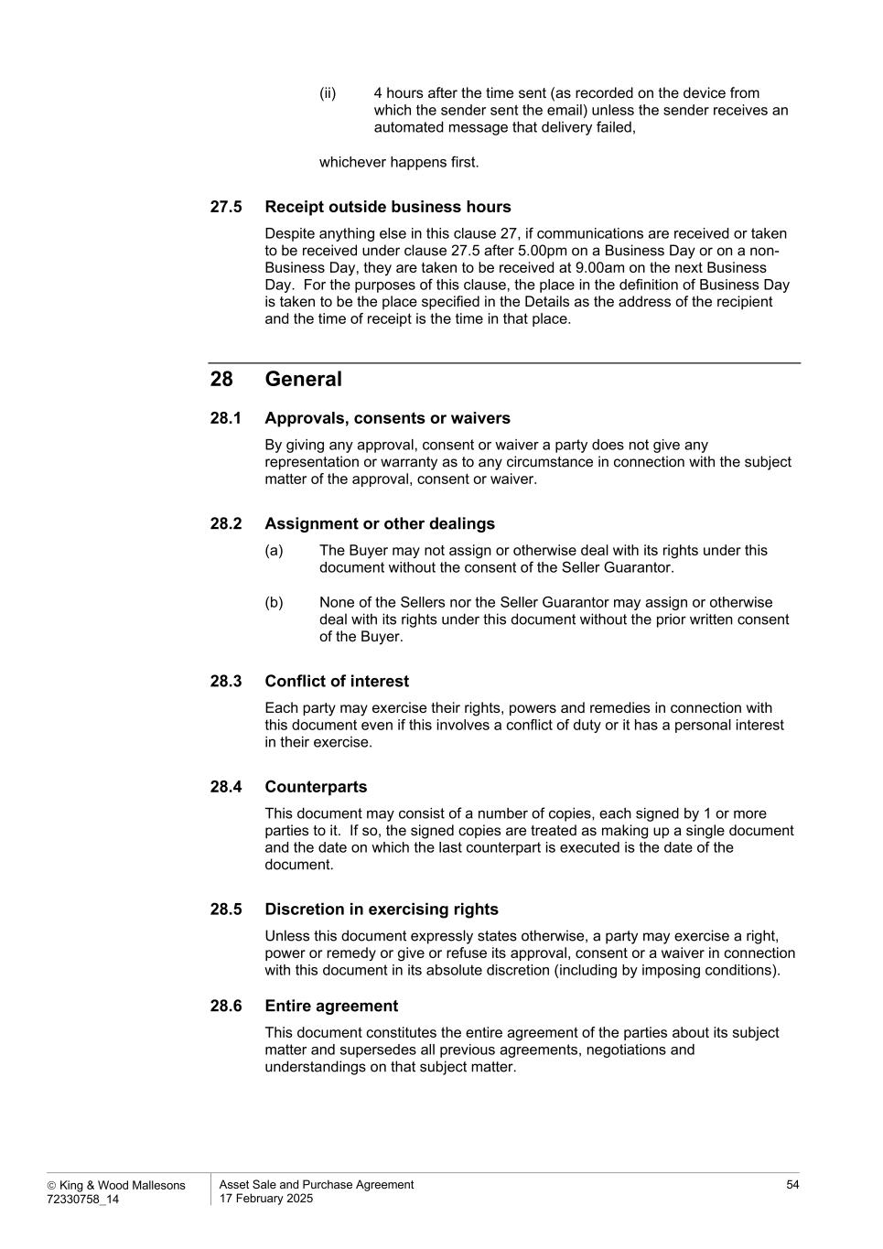
 King & Wood Mallesons 72330758_14 Asset Sale and Purchase Agreement 17 February 2025 54 (ii) 4 hours after the time sent (as recorded on the device from which the sender sent the email) unless the sender receives an automated message that delivery failed, whichever happens first. 27.5 Receipt outside business hours Despite anything else in this clause 27, if communications are received or taken to be received under clause 27.5 after 5.00pm on a Business Day or on a non- Business Day, they are taken to be received at 9.00am on the next Business Day. For the purposes of this clause, the place in the definition of Business Day is taken to be the place specified in the Details as the address of the recipient and the time of receipt is the time in that place. 28 General 28.1 Approvals, consents or waivers By giving any approval, consent or waiver a party does not give any representation or warranty as to any circumstance in connection with the subject matter of the approval, consent or waiver. 28.2 Assignment or other dealings (a) The Buyer may not assign or otherwise deal with its rights under this document without the consent of the Seller Guarantor. (b) None of the Sellers nor the Seller Guarantor may assign or otherwise deal with its rights under this document without the prior written consent of the Buyer. 28.3 Conflict of interest Each party may exercise their rights, powers and remedies in connection with this document even if this involves a conflict of duty or it has a personal interest in their exercise. 28.4 Counterparts This document may consist of a number of copies, each signed by 1 or more parties to it. If so, the signed copies are treated as making up a single document and the date on which the last counterpart is executed is the date of the document. 28.5 Discretion in exercising rights Unless this document expressly states otherwise, a party may exercise a right, power or remedy or give or refuse its approval, consent or a waiver in connection with this document in its absolute discretion (including by imposing conditions). 28.6 Entire agreement This document constitutes the entire agreement of the parties about its subject matter and supersedes all previous agreements, negotiations and understandings on that subject matter.

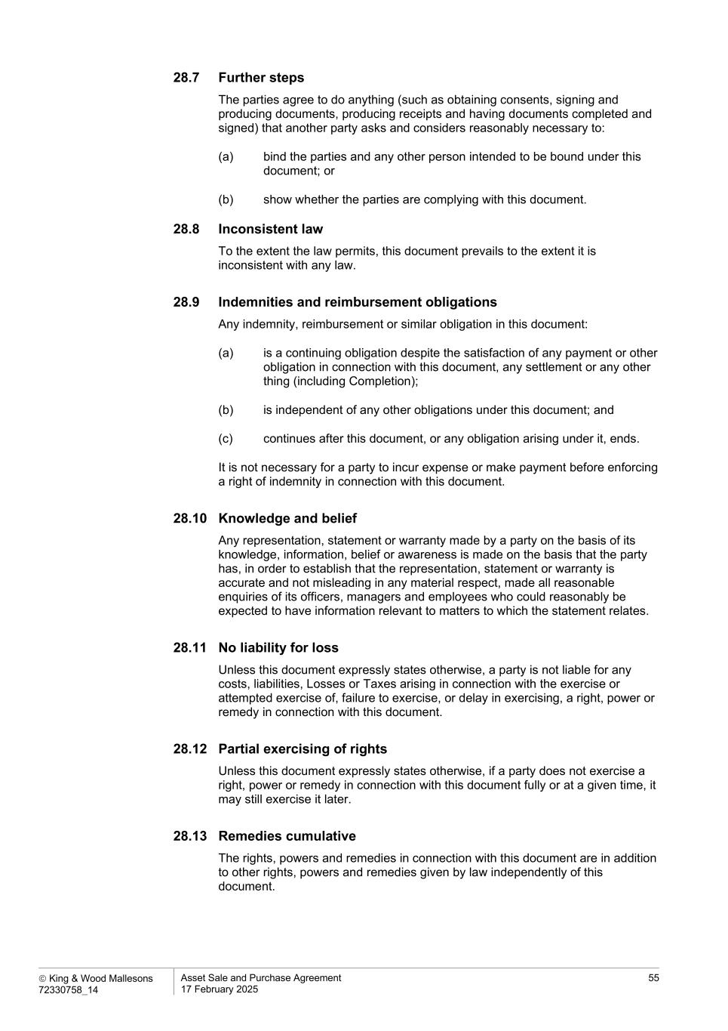
 King & Wood Mallesons 72330758_14 Asset Sale and Purchase Agreement 17 February 2025 55 28.7 Further steps The parties agree to do anything (such as obtaining consents, signing and producing documents, producing receipts and having documents completed and signed) that another party asks and considers reasonably necessary to: (a) bind the parties and any other person intended to be bound under this document; or (b) show whether the parties are complying with this document. 28.8 Inconsistent law To the extent the law permits, this document prevails to the extent it is inconsistent with any law. 28.9 Indemnities and reimbursement obligations Any indemnity, reimbursement or similar obligation in this document: (a) is a continuing obligation despite the satisfaction of any payment or other obligation in connection with this document, any settlement or any other thing (including Completion); (b) is independent of any other obligations under this document; and (c) continues after this document, or any obligation arising under it, ends. It is not necessary for a party to incur expense or make payment before enforcing a right of indemnity in connection with this document. 28.10 Knowledge and belief Any representation, statement or warranty made by a party on the basis of its knowledge, information, belief or awareness is made on the basis that the party has, in order to establish that the representation, statement or warranty is accurate and not misleading in any material respect, made all reasonable enquiries of its officers, managers and employees who could reasonably be expected to have information relevant to matters to which the statement relates. 28.11 No liability for loss Unless this document expressly states otherwise, a party is not liable for any costs, liabilities, Losses or Taxes arising in connection with the exercise or attempted exercise of, failure to exercise, or delay in exercising, a right, power or remedy in connection with this document. 28.12 Partial exercising of rights Unless this document expressly states otherwise, if a party does not exercise a right, power or remedy in connection with this document fully or at a given time, it may still exercise it later. 28.13 Remedies cumulative The rights, powers and remedies in connection with this document are in addition to other rights, powers and remedies given by law independently of this document.

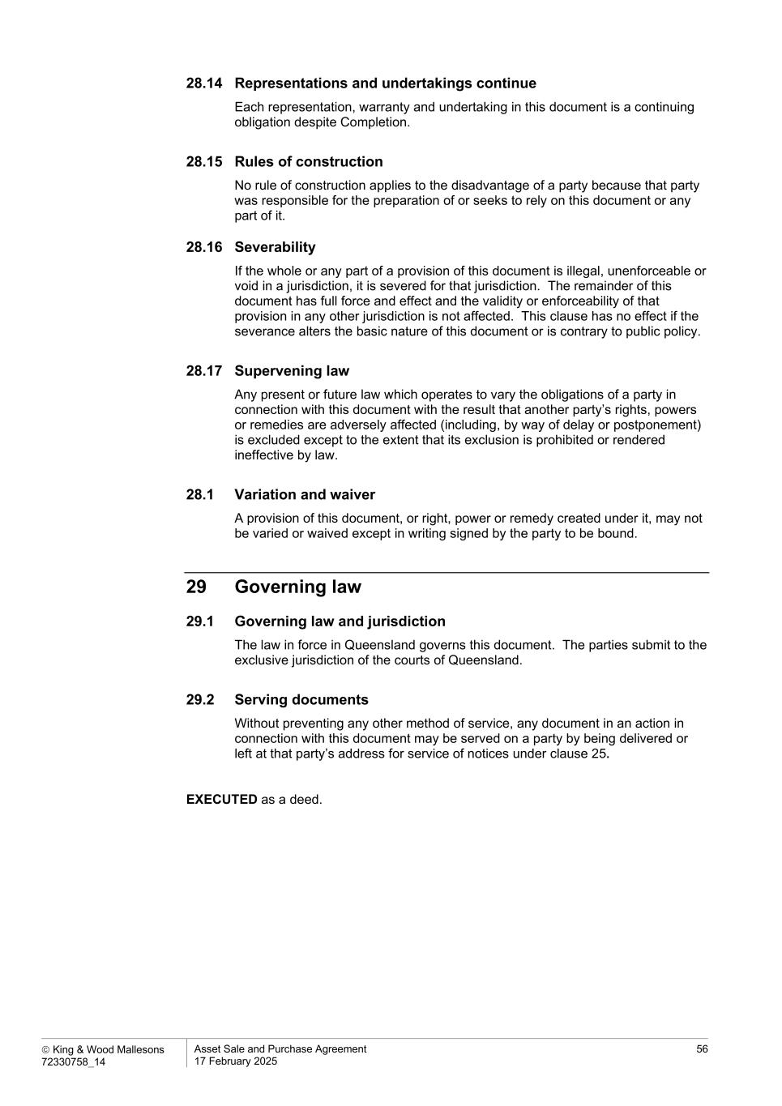
 King & Wood Mallesons 72330758_14 Asset Sale and Purchase Agreement 17 February 2025 56 28.14 Representations and undertakings continue Each representation, warranty and undertaking in this document is a continuing obligation despite Completion. 28.15 Rules of construction No rule of construction applies to the disadvantage of a party because that party was responsible for the preparation of or seeks to rely on this document or any part of it. 28.16 Severability If the whole or any part of a provision of this document is illegal, unenforceable or void in a jurisdiction, it is severed for that jurisdiction. The remainder of this document has full force and effect and the validity or enforceability of that provision in any other jurisdiction is not affected. This clause has no effect if the severance alters the basic nature of this document or is contrary to public policy. 28.17 Supervening law Any present or future law which operates to vary the obligations of a party in connection with this document with the result that another party’s rights, powers or remedies are adversely affected (including, by way of delay or postponement) is excluded except to the extent that its exclusion is prohibited or rendered ineffective by law. 28.1 Variation and waiver A provision of this document, or right, power or remedy created under it, may not be varied or waived except in writing signed by the party to be bound. 29 Governing law 29.1 Governing law and jurisdiction The law in force in Queensland governs this document. The parties submit to the exclusive jurisdiction of the courts of Queensland. 29.2 Serving documents Without preventing any other method of service, any document in an action in connection with this document may be served on a party by being delivered or left at that party’s address for service of notices under clause 25. EXECUTED as a deed.

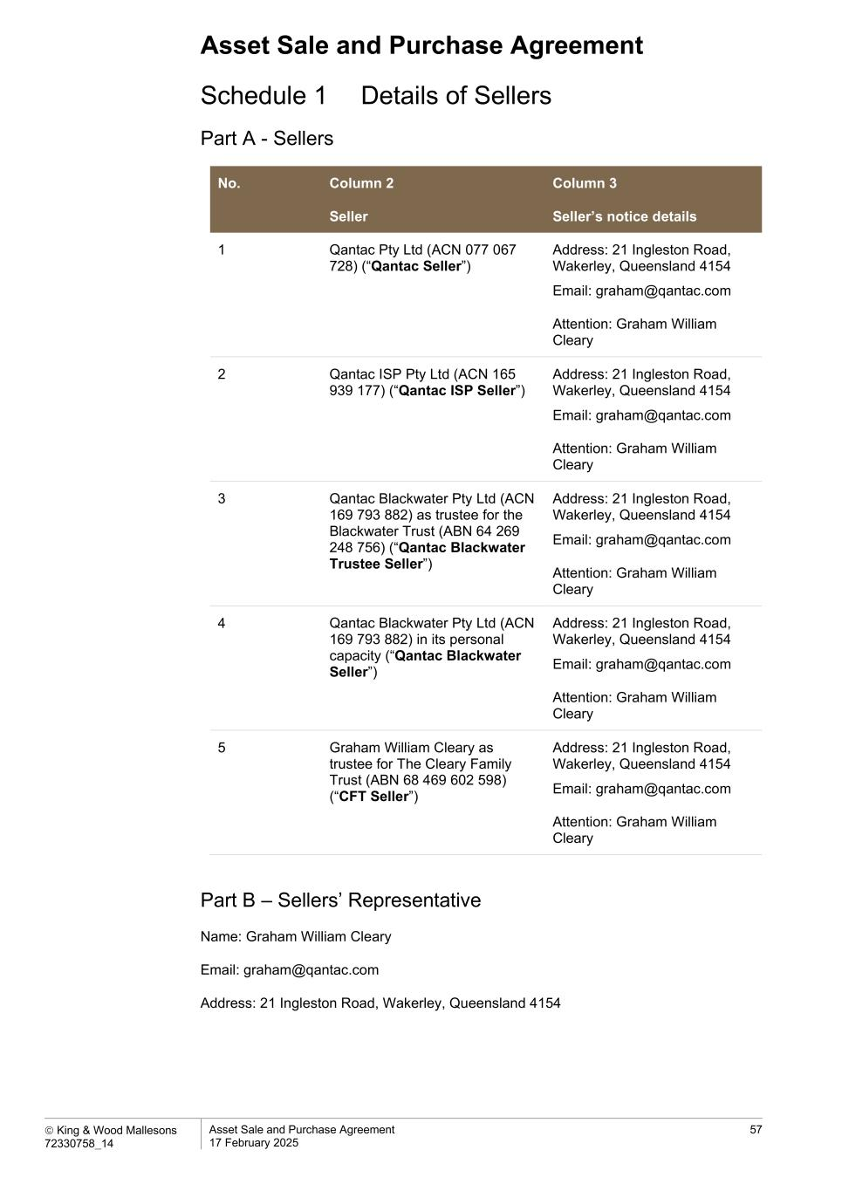
Asset Sale and Purchase Agreement  King & Wood Mallesons 72330758_14 Asset Sale and Purchase Agreement 17 February 2025 57 Schedule 1 Details of Sellers Part A - Sellers No. Column 2 Seller Column 3 Seller’s notice details 1 Qantac Pty Ltd (ACN 077 067 728) (“Qantac Seller”) Address: 21 Ingleston Road, Wakerley, Queensland 4154 Email: graham@qantac.com Attention: Graham William Cleary 2 Qantac ISP Pty Ltd (ACN 165 939 177) (“Qantac ISP Seller”) Address: 21 Ingleston Road, Wakerley, Queensland 4154 Email: graham@qantac.com Attention: Graham William Cleary 3 Qantac Blackwater Pty Ltd (ACN 169 793 882) as trustee for the Blackwater Trust (ABN 64 269 248 756) (“Qantac Blackwater Trustee Seller”) Address: 21 Ingleston Road, Wakerley, Queensland 4154 Email: graham@qantac.com Attention: Graham William Cleary 4 Qantac Blackwater Pty Ltd (ACN 169 793 882) in its personal capacity (“Qantac Blackwater Seller”) Address: 21 Ingleston Road, Wakerley, Queensland 4154 Email: graham@qantac.com Attention: Graham William Cleary 5 Graham William Cleary as trustee for The Cleary Family Trust (ABN 68 469 602 598) (“CFT Seller”) Address: 21 Ingleston Road, Wakerley, Queensland 4154 Email: graham@qantac.com Attention: Graham William Cleary Part B – Sellers’ Representative Name: Graham William Cleary Email: graham@qantac.com Address: 21 Ingleston Road, Wakerley, Queensland 4154

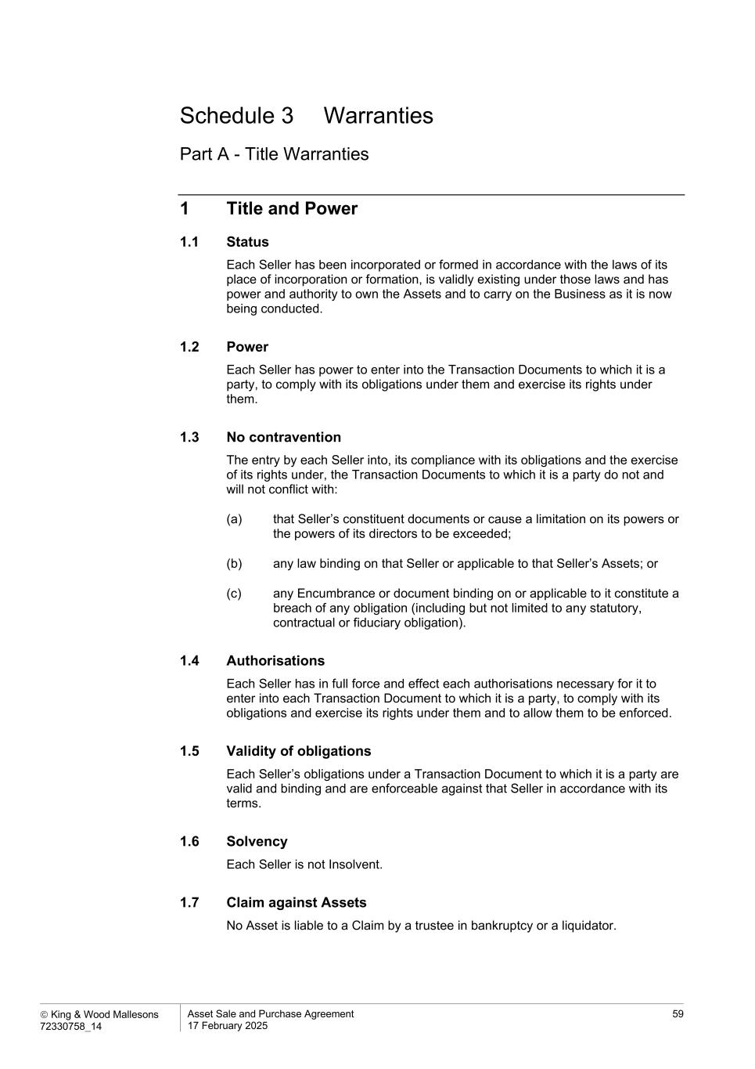
 King & Wood Mallesons 72330758_14 Asset Sale and Purchase Agreement 17 February 2025 59 Schedule 3 Warranties Part A - Title Warranties 1 Title and Power 1.1 Status Each Seller has been incorporated or formed in accordance with the laws of its place of incorporation or formation, is validly existing under those laws and has power and authority to own the Assets and to carry on the Business as it is now being conducted. 1.2 Power Each Seller has power to enter into the Transaction Documents to which it is a party, to comply with its obligations under them and exercise its rights under them. 1.3 No contravention The entry by each Seller into, its compliance with its obligations and the exercise of its rights under, the Transaction Documents to which it is a party do not and will not conflict with: (a) that Seller’s constituent documents or cause a limitation on its powers or the powers of its directors to be exceeded; (b) any law binding on that Seller or applicable to that Seller’s Assets; or (c) any Encumbrance or document binding on or applicable to it constitute a breach of any obligation (including but not limited to any statutory, contractual or fiduciary obligation). 1.4 Authorisations Each Seller has in full force and effect each authorisations necessary for it to enter into each Transaction Document to which it is a party, to comply with its obligations and exercise its rights under them and to allow them to be enforced. 1.5 Validity of obligations Each Seller’s obligations under a Transaction Document to which it is a party are valid and binding and are enforceable against that Seller in accordance with its terms. 1.6 Solvency Each Seller is not Insolvent. 1.7 Claim against Assets No Asset is liable to a Claim by a trustee in bankruptcy or a liquidator.

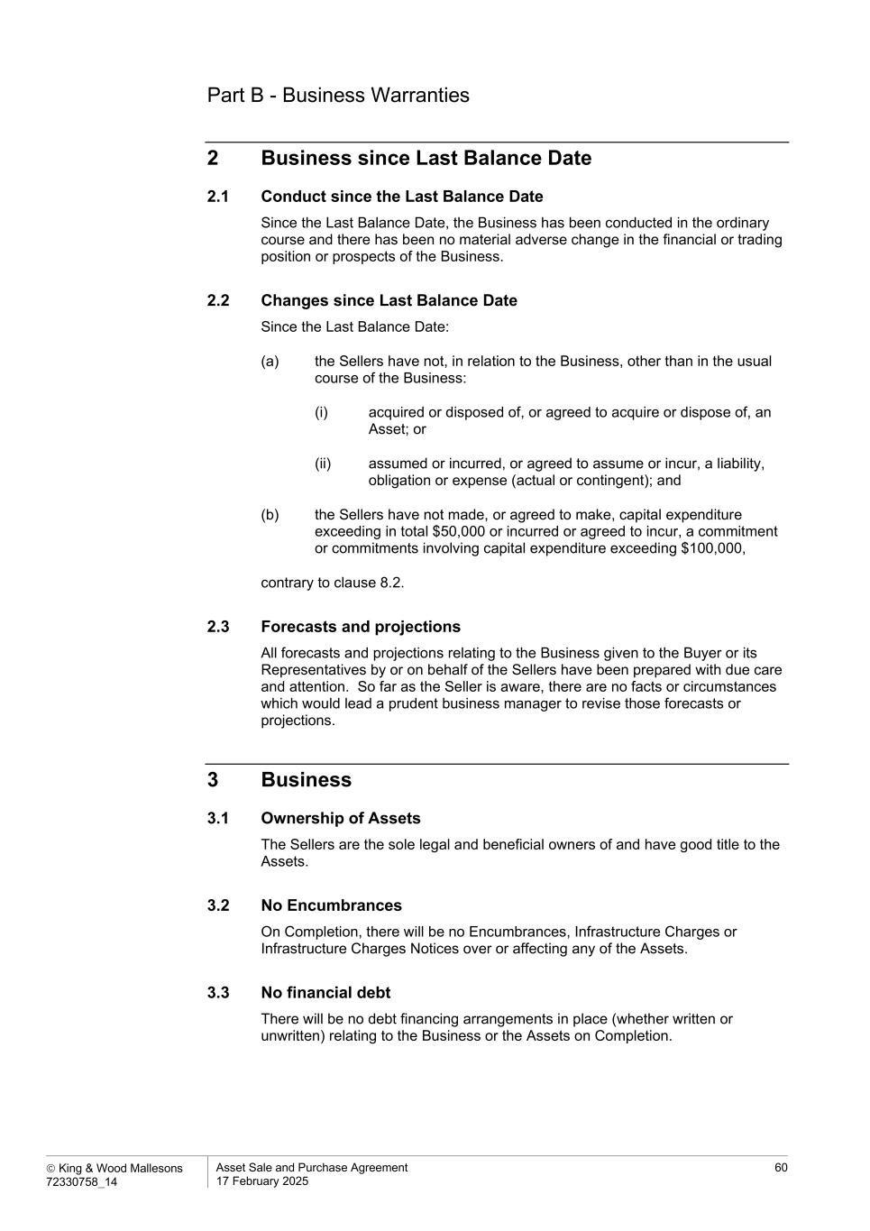
 King & Wood Mallesons 72330758_14 Asset Sale and Purchase Agreement 17 February 2025 60 Part B - Business Warranties 2 Business since Last Balance Date 2.1 Conduct since the Last Balance Date Since the Last Balance Date, the Business has been conducted in the ordinary course and there has been no material adverse change in the financial or trading position or prospects of the Business. 2.2 Changes since Last Balance Date Since the Last Balance Date: (a) the Sellers have not, in relation to the Business, other than in the usual course of the Business: (i) acquired or disposed of, or agreed to acquire or dispose of, an Asset; or (ii) assumed or incurred, or agreed to assume or incur, a liability, obligation or expense (actual or contingent); and (b) the Sellers have not made, or agreed to make, capital expenditure exceeding in total $50,000 or incurred or agreed to incur, a commitment or commitments involving capital expenditure exceeding $100,000, contrary to clause 8.2. 2.3 Forecasts and projections All forecasts and projections relating to the Business given to the Buyer or its Representatives by or on behalf of the Sellers have been prepared with due care and attention. So far as the Seller is aware, there are no facts or circumstances which would lead a prudent business manager to revise those forecasts or projections. 3 Business 3.1 Ownership of Assets The Sellers are the sole legal and beneficial owners of and have good title to the Assets. 3.2 No Encumbrances On Completion, there will be no Encumbrances, Infrastructure Charges or Infrastructure Charges Notices over or affecting any of the Assets. 3.3 No financial debt There will be no debt financing arrangements in place (whether written or unwritten) relating to the Business or the Assets on Completion.

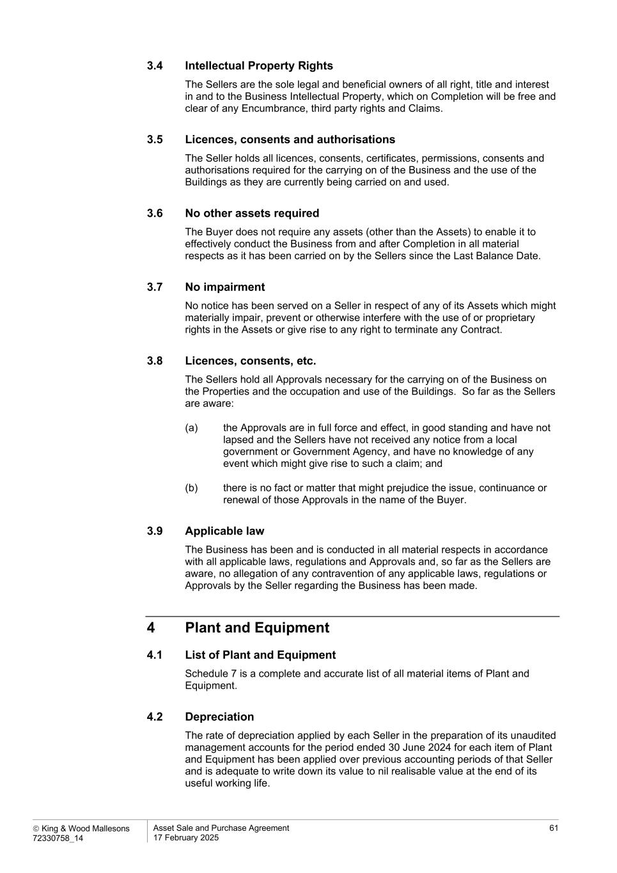
 King & Wood Mallesons 72330758_14 Asset Sale and Purchase Agreement 17 February 2025 61 3.4 Intellectual Property Rights The Sellers are the sole legal and beneficial owners of all right, title and interest in and to the Business Intellectual Property, which on Completion will be free and clear of any Encumbrance, third party rights and Claims. 3.5 Licences, consents and authorisations The Seller holds all licences, consents, certificates, permissions, consents and authorisations required for the carrying on of the Business and the use of the Buildings as they are currently being carried on and used. 3.6 No other assets required The Buyer does not require any assets (other than the Assets) to enable it to effectively conduct the Business from and after Completion in all material respects as it has been carried on by the Sellers since the Last Balance Date. 3.7 No impairment No notice has been served on a Seller in respect of any of its Assets which might materially impair, prevent or otherwise interfere with the use of or proprietary rights in the Assets or give rise to any right to terminate any Contract. 3.8 Licences, consents, etc. The Sellers hold all Approvals necessary for the carrying on of the Business on the Properties and the occupation and use of the Buildings. So far as the Sellers are aware: (a) the Approvals are in full force and effect, in good standing and have not lapsed and the Sellers have not received any notice from a local government or Government Agency, and have no knowledge of any event which might give rise to such a claim; and (b) there is no fact or matter that might prejudice the issue, continuance or renewal of those Approvals in the name of the Buyer. 3.9 Applicable law The Business has been and is conducted in all material respects in accordance with all applicable laws, regulations and Approvals and, so far as the Sellers are aware, no allegation of any contravention of any applicable laws, regulations or Approvals by the Seller regarding the Business has been made. 4 Plant and Equipment 4.1 List of Plant and Equipment Schedule 7 is a complete and accurate list of all material items of Plant and Equipment. 4.2 Depreciation The rate of depreciation applied by each Seller in the preparation of its unaudited management accounts for the period ended 30 June 2024 for each item of Plant and Equipment has been applied over previous accounting periods of that Seller and is adequate to write down its value to nil realisable value at the end of its useful working life.

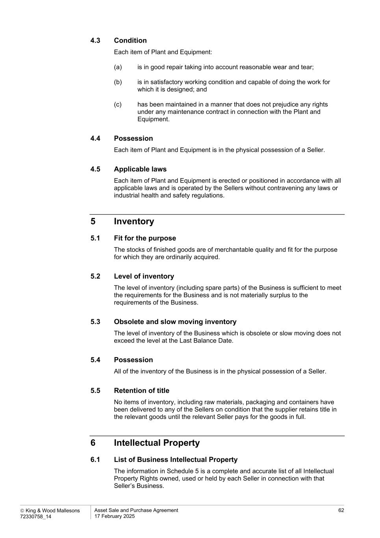
 King & Wood Mallesons 72330758_14 Asset Sale and Purchase Agreement 17 February 2025 62 4.3 Condition Each item of Plant and Equipment: (a) is in good repair taking into account reasonable wear and tear; (b) is in satisfactory working condition and capable of doing the work for which it is designed; and (c) has been maintained in a manner that does not prejudice any rights under any maintenance contract in connection with the Plant and Equipment. 4.4 Possession Each item of Plant and Equipment is in the physical possession of a Seller. 4.5 Applicable laws Each item of Plant and Equipment is erected or positioned in accordance with all applicable laws and is operated by the Sellers without contravening any laws or industrial health and safety regulations. 5 Inventory 5.1 Fit for the purpose The stocks of finished goods are of merchantable quality and fit for the purpose for which they are ordinarily acquired. 5.2 Level of inventory The level of inventory (including spare parts) of the Business is sufficient to meet the requirements for the Business and is not materially surplus to the requirements of the Business. 5.3 Obsolete and slow moving inventory The level of inventory of the Business which is obsolete or slow moving does not exceed the level at the Last Balance Date. 5.4 Possession All of the inventory of the Business is in the physical possession of a Seller. 5.5 Retention of title No items of inventory, including raw materials, packaging and containers have been delivered to any of the Sellers on condition that the supplier retains title in the relevant goods until the relevant Seller pays for the goods in full. 6 Intellectual Property 6.1 List of Business Intellectual Property The information in Schedule 5 is a complete and accurate list of all Intellectual Property Rights owned, used or held by each Seller in connection with that Seller’s Business.

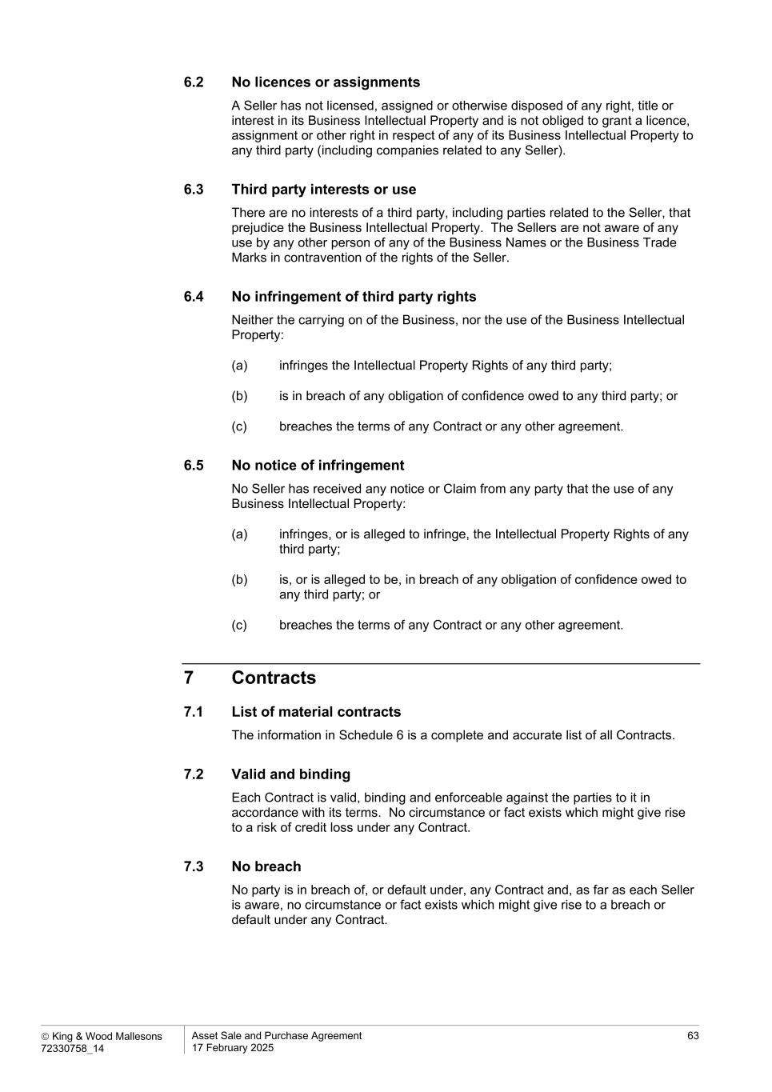
 King & Wood Mallesons 72330758_14 Asset Sale and Purchase Agreement 17 February 2025 63 6.2 No licences or assignments A Seller has not licensed, assigned or otherwise disposed of any right, title or interest in its Business Intellectual Property and is not obliged to grant a licence, assignment or other right in respect of any of its Business Intellectual Property to any third party (including companies related to any Seller). 6.3 Third party interests or use There are no interests of a third party, including parties related to the Seller, that prejudice the Business Intellectual Property. The Sellers are not aware of any use by any other person of any of the Business Names or the Business Trade Marks in contravention of the rights of the Seller. 6.4 No infringement of third party rights Neither the carrying on of the Business, nor the use of the Business Intellectual Property: (a) infringes the Intellectual Property Rights of any third party; (b) is in breach of any obligation of confidence owed to any third party; or (c) breaches the terms of any Contract or any other agreement. 6.5 No notice of infringement No Seller has received any notice or Claim from any party that the use of any Business Intellectual Property: (a) infringes, or is alleged to infringe, the Intellectual Property Rights of any third party; (b) is, or is alleged to be, in breach of any obligation of confidence owed to any third party; or (c) breaches the terms of any Contract or any other agreement. 7 Contracts 7.1 List of material contracts The information in Schedule 6 is a complete and accurate list of all Contracts. 7.2 Valid and binding Each Contract is valid, binding and enforceable against the parties to it in accordance with its terms. No circumstance or fact exists which might give rise to a risk of credit loss under any Contract. 7.3 No breach No party is in breach of, or default under, any Contract and, as far as each Seller is aware, no circumstance or fact exists which might give rise to a breach or default under any Contract.

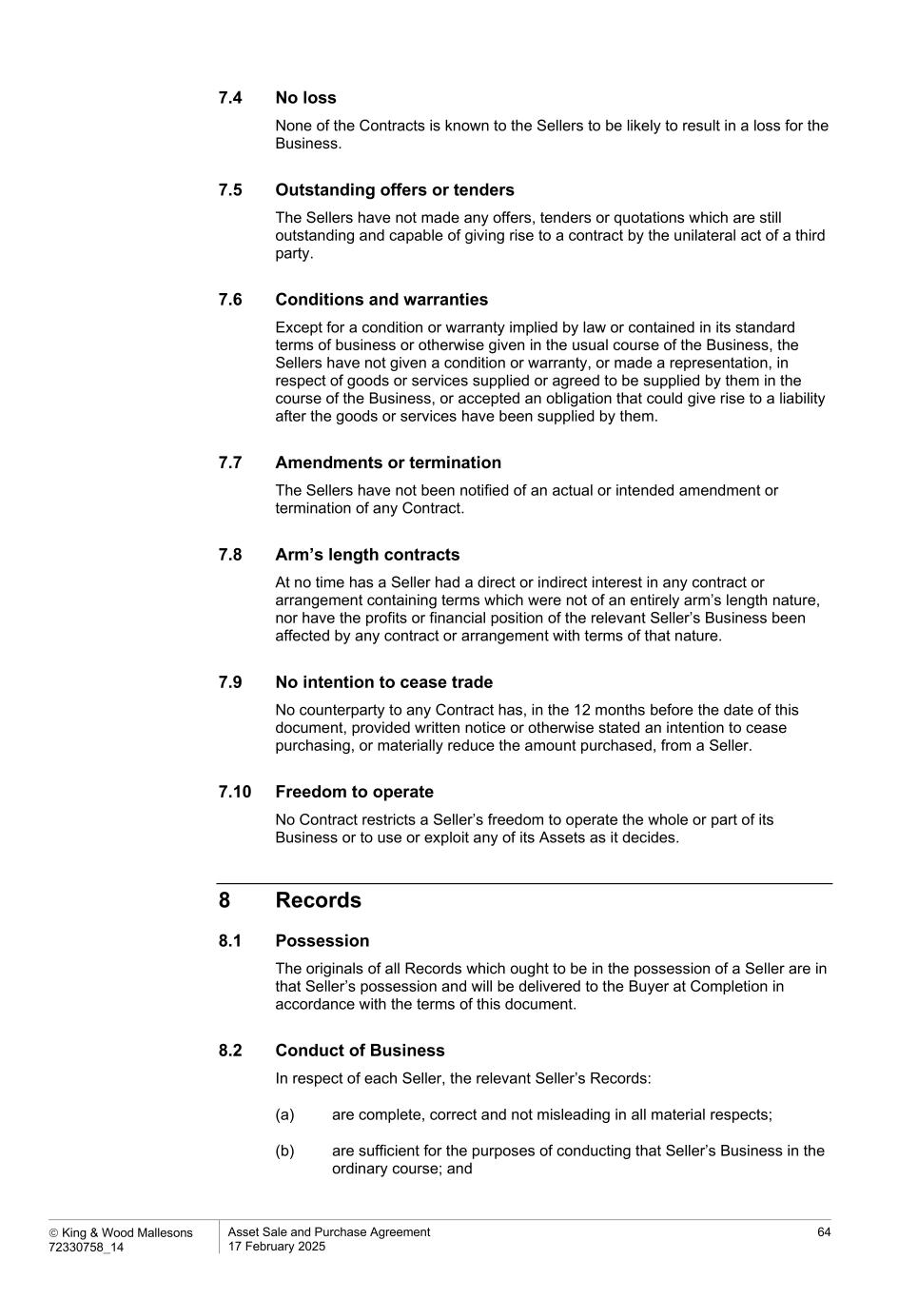
 King & Wood Mallesons 72330758_14 Asset Sale and Purchase Agreement 17 February 2025 64 7.4 No loss None of the Contracts is known to the Sellers to be likely to result in a loss for the Business. 7.5 Outstanding offers or tenders The Sellers have not made any offers, tenders or quotations which are still outstanding and capable of giving rise to a contract by the unilateral act of a third party. 7.6 Conditions and warranties Except for a condition or warranty implied by law or contained in its standard terms of business or otherwise given in the usual course of the Business, the Sellers have not given a condition or warranty, or made a representation, in respect of goods or services supplied or agreed to be supplied by them in the course of the Business, or accepted an obligation that could give rise to a liability after the goods or services have been supplied by them. 7.7 Amendments or termination The Sellers have not been notified of an actual or intended amendment or termination of any Contract. 7.8 Arm’s length contracts At no time has a Seller had a direct or indirect interest in any contract or arrangement containing terms which were not of an entirely arm’s length nature, nor have the profits or financial position of the relevant Seller’s Business been affected by any contract or arrangement with terms of that nature. 7.9 No intention to cease trade No counterparty to any Contract has, in the 12 months before the date of this document, provided written notice or otherwise stated an intention to cease purchasing, or materially reduce the amount purchased, from a Seller. 7.10 Freedom to operate No Contract restricts a Seller’s freedom to operate the whole or part of its Business or to use or exploit any of its Assets as it decides. 8 Records 8.1 Possession The originals of all Records which ought to be in the possession of a Seller are in that Seller’s possession and will be delivered to the Buyer at Completion in accordance with the terms of this document. 8.2 Conduct of Business In respect of each Seller, the relevant Seller’s Records: (a) are complete, correct and not misleading in all material respects; (b) are sufficient for the purposes of conducting that Seller’s Business in the ordinary course; and

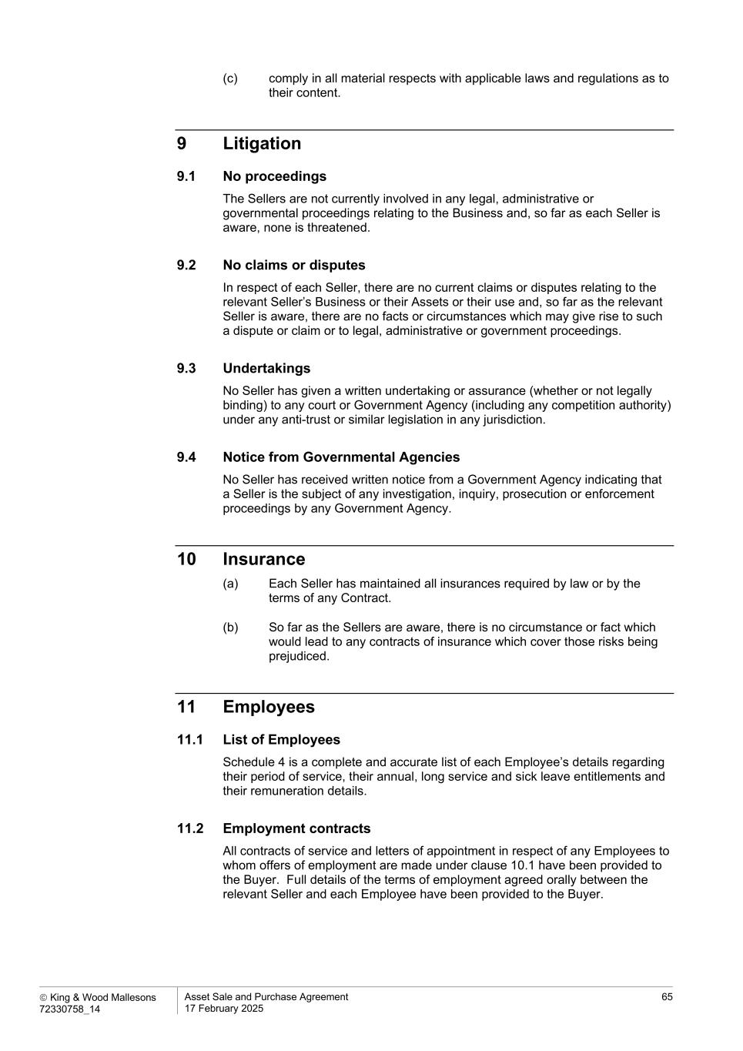
 King & Wood Mallesons 72330758_14 Asset Sale and Purchase Agreement 17 February 2025 65 (c) comply in all material respects with applicable laws and regulations as to their content. 9 Litigation 9.1 No proceedings The Sellers are not currently involved in any legal, administrative or governmental proceedings relating to the Business and, so far as each Seller is aware, none is threatened. 9.2 No claims or disputes In respect of each Seller, there are no current claims or disputes relating to the relevant Seller’s Business or their Assets or their use and, so far as the relevant Seller is aware, there are no facts or circumstances which may give rise to such a dispute or claim or to legal, administrative or government proceedings. 9.3 Undertakings No Seller has given a written undertaking or assurance (whether or not legally binding) to any court or Government Agency (including any competition authority) under any anti-trust or similar legislation in any jurisdiction. 9.4 Notice from Governmental Agencies No Seller has received written notice from a Government Agency indicating that a Seller is the subject of any investigation, inquiry, prosecution or enforcement proceedings by any Government Agency. 10 Insurance (a) Each Seller has maintained all insurances required by law or by the terms of any Contract. (b) So far as the Sellers are aware, there is no circumstance or fact which would lead to any contracts of insurance which cover those risks being prejudiced. 11 Employees 11.1 List of Employees Schedule 4 is a complete and accurate list of each Employee’s details regarding their period of service, their annual, long service and sick leave entitlements and their remuneration details. 11.2 Employment contracts All contracts of service and letters of appointment in respect of any Employees to whom offers of employment are made under clause 10.1 have been provided to the Buyer. Full details of the terms of employment agreed orally between the relevant Seller and each Employee have been provided to the Buyer.

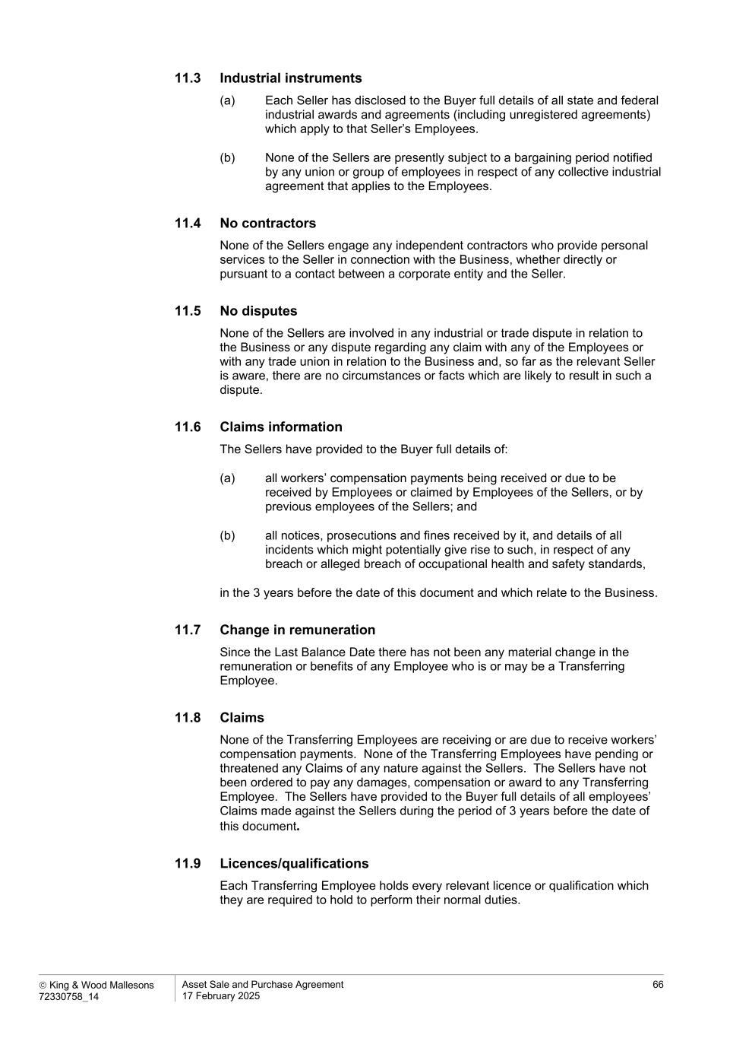
 King & Wood Mallesons 72330758_14 Asset Sale and Purchase Agreement 17 February 2025 66 11.3 Industrial instruments (a) Each Seller has disclosed to the Buyer full details of all state and federal industrial awards and agreements (including unregistered agreements) which apply to that Seller’s Employees. (b) None of the Sellers are presently subject to a bargaining period notified by any union or group of employees in respect of any collective industrial agreement that applies to the Employees. 11.4 No contractors None of the Sellers engage any independent contractors who provide personal services to the Seller in connection with the Business, whether directly or pursuant to a contact between a corporate entity and the Seller. 11.5 No disputes None of the Sellers are involved in any industrial or trade dispute in relation to the Business or any dispute regarding any claim with any of the Employees or with any trade union in relation to the Business and, so far as the relevant Seller is aware, there are no circumstances or facts which are likely to result in such a dispute. 11.6 Claims information The Sellers have provided to the Buyer full details of: (a) all workers’ compensation payments being received or due to be received by Employees or claimed by Employees of the Sellers, or by previous employees of the Sellers; and (b) all notices, prosecutions and fines received by it, and details of all incidents which might potentially give rise to such, in respect of any breach or alleged breach of occupational health and safety standards, in the 3 years before the date of this document and which relate to the Business. 11.7 Change in remuneration Since the Last Balance Date there has not been any material change in the remuneration or benefits of any Employee who is or may be a Transferring Employee. 11.8 Claims None of the Transferring Employees are receiving or are due to receive workers’ compensation payments. None of the Transferring Employees have pending or threatened any Claims of any nature against the Sellers. The Sellers have not been ordered to pay any damages, compensation or award to any Transferring Employee. The Sellers have provided to the Buyer full details of all employees’ Claims made against the Sellers during the period of 3 years before the date of this document. 11.9 Licences/qualifications Each Transferring Employee holds every relevant licence or qualification which they are required to hold to perform their normal duties.

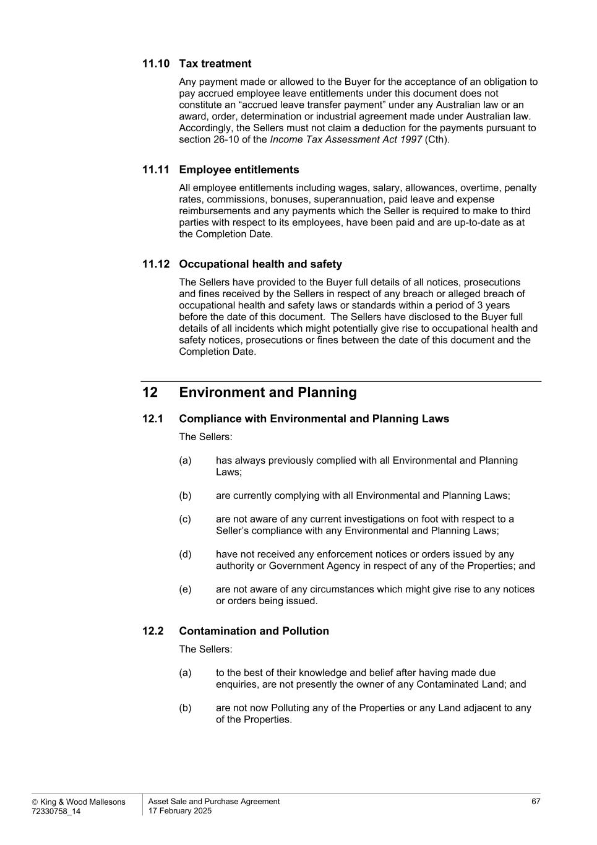
 King & Wood Mallesons 72330758_14 Asset Sale and Purchase Agreement 17 February 2025 67 11.10 Tax treatment Any payment made or allowed to the Buyer for the acceptance of an obligation to pay accrued employee leave entitlements under this document does not constitute an “accrued leave transfer payment” under any Australian law or an award, order, determination or industrial agreement made under Australian law. Accordingly, the Sellers must not claim a deduction for the payments pursuant to section 26-10 of the Income Tax Assessment Act 1997 (Cth). 11.11 Employee entitlements All employee entitlements including wages, salary, allowances, overtime, penalty rates, commissions, bonuses, superannuation, paid leave and expense reimbursements and any payments which the Seller is required to make to third parties with respect to its employees, have been paid and are up-to-date as at the Completion Date. 11.12 Occupational health and safety The Sellers have provided to the Buyer full details of all notices, prosecutions and fines received by the Sellers in respect of any breach or alleged breach of occupational health and safety laws or standards within a period of 3 years before the date of this document. The Sellers have disclosed to the Buyer full details of all incidents which might potentially give rise to occupational health and safety notices, prosecutions or fines between the date of this document and the Completion Date. 12 Environment and Planning 12.1 Compliance with Environmental and Planning Laws The Sellers: (a) has always previously complied with all Environmental and Planning Laws; (b) are currently complying with all Environmental and Planning Laws; (c) are not aware of any current investigations on foot with respect to a Seller’s compliance with any Environmental and Planning Laws; (d) have not received any enforcement notices or orders issued by any authority or Government Agency in respect of any of the Properties; and (e) are not aware of any circumstances which might give rise to any notices or orders being issued. 12.2 Contamination and Pollution The Sellers: (a) to the best of their knowledge and belief after having made due enquiries, are not presently the owner of any Contaminated Land; and (b) are not now Polluting any of the Properties or any Land adjacent to any of the Properties.

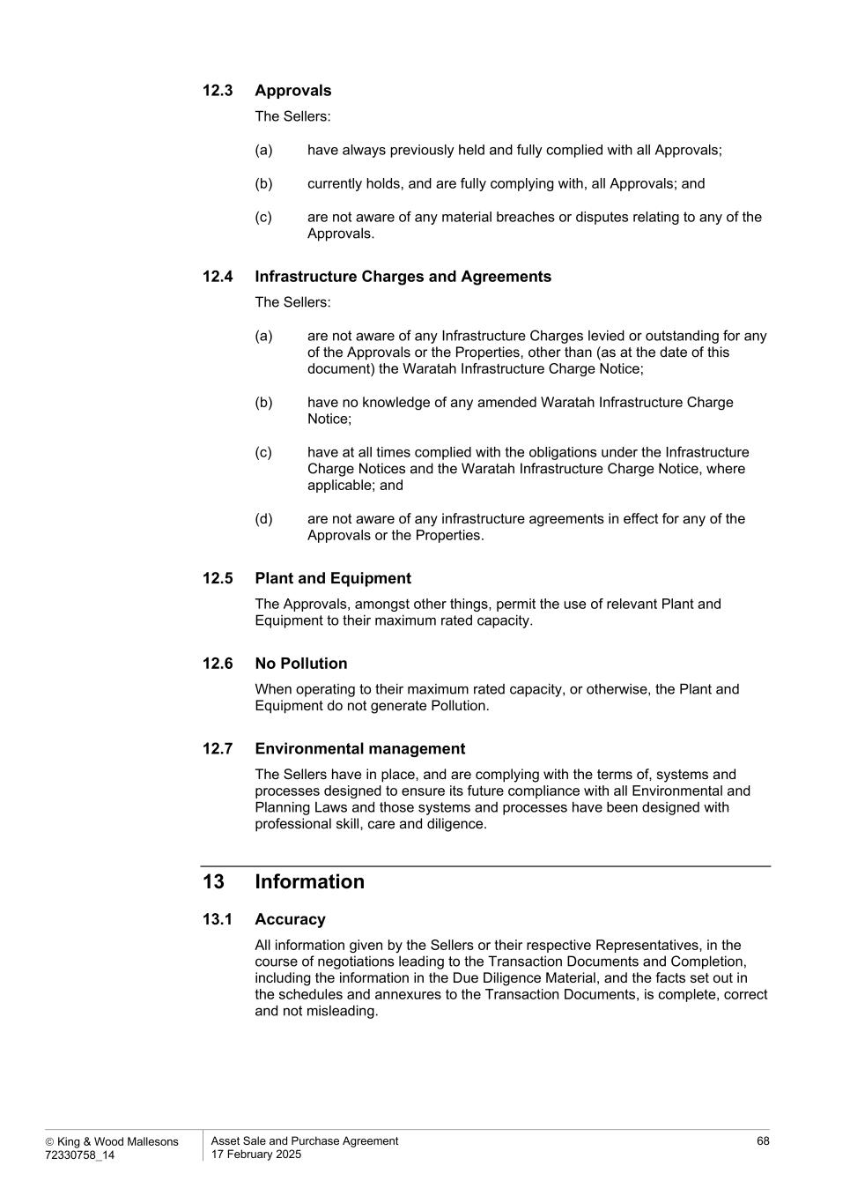
 King & Wood Mallesons 72330758_14 Asset Sale and Purchase Agreement 17 February 2025 68 12.3 Approvals The Sellers: (a) have always previously held and fully complied with all Approvals; (b) currently holds, and are fully complying with, all Approvals; and (c) are not aware of any material breaches or disputes relating to any of the Approvals. 12.4 Infrastructure Charges and Agreements The Sellers: (a) are not aware of any Infrastructure Charges levied or outstanding for any of the Approvals or the Properties, other than (as at the date of this document) the Waratah Infrastructure Charge Notice; (b) have no knowledge of any amended Waratah Infrastructure Charge Notice; (c) have at all times complied with the obligations under the Infrastructure Charge Notices and the Waratah Infrastructure Charge Notice, where applicable; and (d) are not aware of any infrastructure agreements in effect for any of the Approvals or the Properties. 12.5 Plant and Equipment The Approvals, amongst other things, permit the use of relevant Plant and Equipment to their maximum rated capacity. 12.6 No Pollution When operating to their maximum rated capacity, or otherwise, the Plant and Equipment do not generate Pollution. 12.7 Environmental management The Sellers have in place, and are complying with the terms of, systems and processes designed to ensure its future compliance with all Environmental and Planning Laws and those systems and processes have been designed with professional skill, care and diligence. 13 Information 13.1 Accuracy All information given by the Sellers or their respective Representatives, in the course of negotiations leading to the Transaction Documents and Completion, including the information in the Due Diligence Material, and the facts set out in the schedules and annexures to the Transaction Documents, is complete, correct and not misleading.

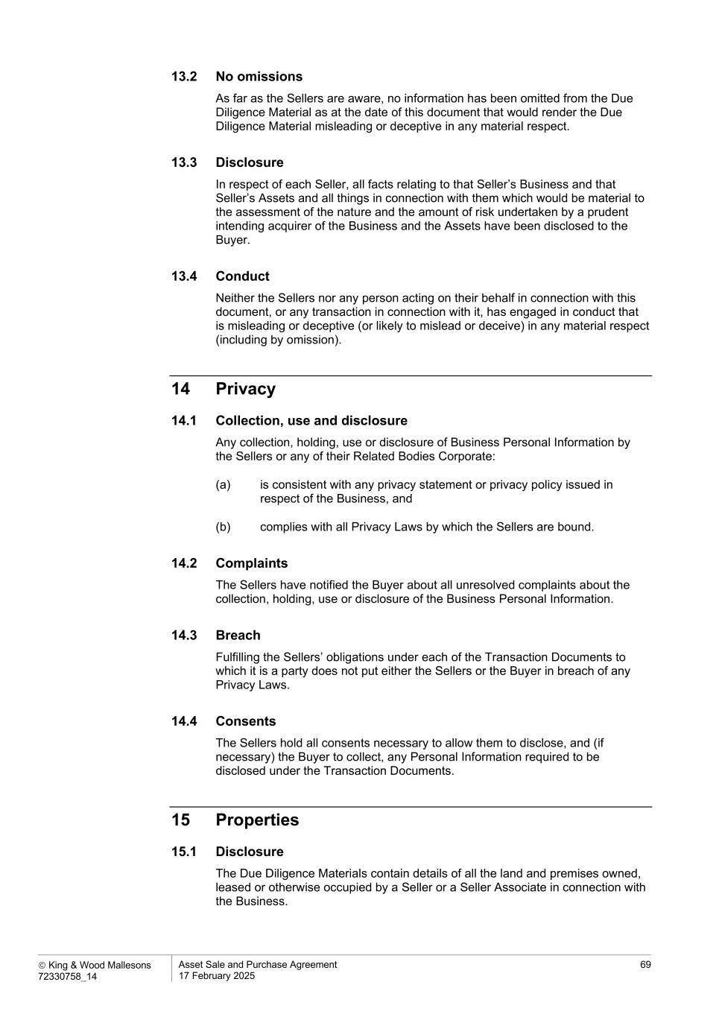
 King & Wood Mallesons 72330758_14 Asset Sale and Purchase Agreement 17 February 2025 69 13.2 No omissions As far as the Sellers are aware, no information has been omitted from the Due Diligence Material as at the date of this document that would render the Due Diligence Material misleading or deceptive in any material respect. 13.3 Disclosure In respect of each Seller, all facts relating to that Seller’s Business and that Seller’s Assets and all things in connection with them which would be material to the assessment of the nature and the amount of risk undertaken by a prudent intending acquirer of the Business and the Assets have been disclosed to the Buyer. 13.4 Conduct Neither the Sellers nor any person acting on their behalf in connection with this document, or any transaction in connection with it, has engaged in conduct that is misleading or deceptive (or likely to mislead or deceive) in any material respect (including by omission). 14 Privacy 14.1 Collection, use and disclosure Any collection, holding, use or disclosure of Business Personal Information by the Sellers or any of their Related Bodies Corporate: (a) is consistent with any privacy statement or privacy policy issued in respect of the Business, and (b) complies with all Privacy Laws by which the Sellers are bound. 14.2 Complaints The Sellers have notified the Buyer about all unresolved complaints about the collection, holding, use or disclosure of the Business Personal Information. 14.3 Breach Fulfilling the Sellers’ obligations under each of the Transaction Documents to which it is a party does not put either the Sellers or the Buyer in breach of any Privacy Laws. 14.4 Consents The Sellers hold all consents necessary to allow them to disclose, and (if necessary) the Buyer to collect, any Personal Information required to be disclosed under the Transaction Documents. 15 Properties 15.1 Disclosure The Due Diligence Materials contain details of all the land and premises owned, leased or otherwise occupied by a Seller or a Seller Associate in connection with the Business.

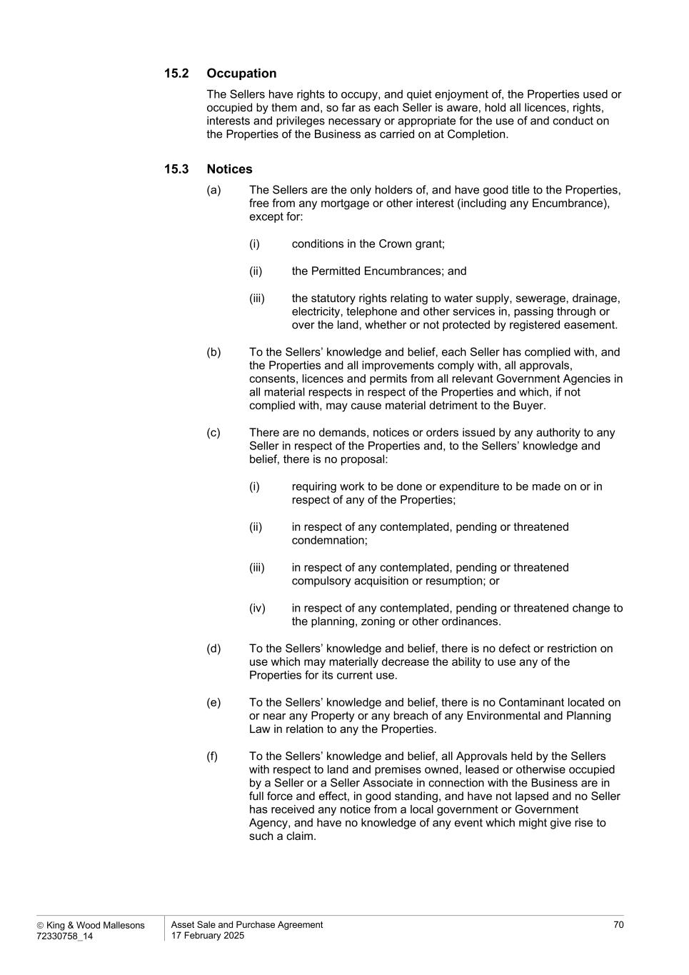
 King & Wood Mallesons 72330758_14 Asset Sale and Purchase Agreement 17 February 2025 70 15.2 Occupation The Sellers have rights to occupy, and quiet enjoyment of, the Properties used or occupied by them and, so far as each Seller is aware, hold all licences, rights, interests and privileges necessary or appropriate for the use of and conduct on the Properties of the Business as carried on at Completion. 15.3 Notices (a) The Sellers are the only holders of, and have good title to the Properties, free from any mortgage or other interest (including any Encumbrance), except for: (i) conditions in the Crown grant; (ii) the Permitted Encumbrances; and (iii) the statutory rights relating to water supply, sewerage, drainage, electricity, telephone and other services in, passing through or over the land, whether or not protected by registered easement. (b) To the Sellers’ knowledge and belief, each Seller has complied with, and the Properties and all improvements comply with, all approvals, consents, licences and permits from all relevant Government Agencies in all material respects in respect of the Properties and which, if not complied with, may cause material detriment to the Buyer. (c) There are no demands, notices or orders issued by any authority to any Seller in respect of the Properties and, to the Sellers’ knowledge and belief, there is no proposal: (i) requiring work to be done or expenditure to be made on or in respect of any of the Properties; (ii) in respect of any contemplated, pending or threatened condemnation; (iii) in respect of any contemplated, pending or threatened compulsory acquisition or resumption; or (iv) in respect of any contemplated, pending or threatened change to the planning, zoning or other ordinances. (d) To the Sellers’ knowledge and belief, there is no defect or restriction on use which may materially decrease the ability to use any of the Properties for its current use. (e) To the Sellers’ knowledge and belief, there is no Contaminant located on or near any Property or any breach of any Environmental and Planning Law in relation to any the Properties. (f) To the Sellers’ knowledge and belief, all Approvals held by the Sellers with respect to land and premises owned, leased or otherwise occupied by a Seller or a Seller Associate in connection with the Business are in full force and effect, in good standing, and have not lapsed and no Seller has received any notice from a local government or Government Agency, and have no knowledge of any event which might give rise to such a claim.


 King & Wood Mallesons 72330758_14 Asset Sale and Purchase Agreement 17 February 2025 71 (g) There are no disputes between a Seller and any owners of the land adjoining the Properties or with Government Agencies or otherwise in relation to any of the Properties. (h) No Seller has disposed of, agreed to dispose of or granted any option to purchase any of the Properties. (i) The Properties are not subject to any unsatisfied judgment or any award, decision or order made by an arbitrator, authority, commission or court. (j) There is no contract under which any Seller has committed to incur capital expenditure in relation to any the Properties which has not been paid or spent.

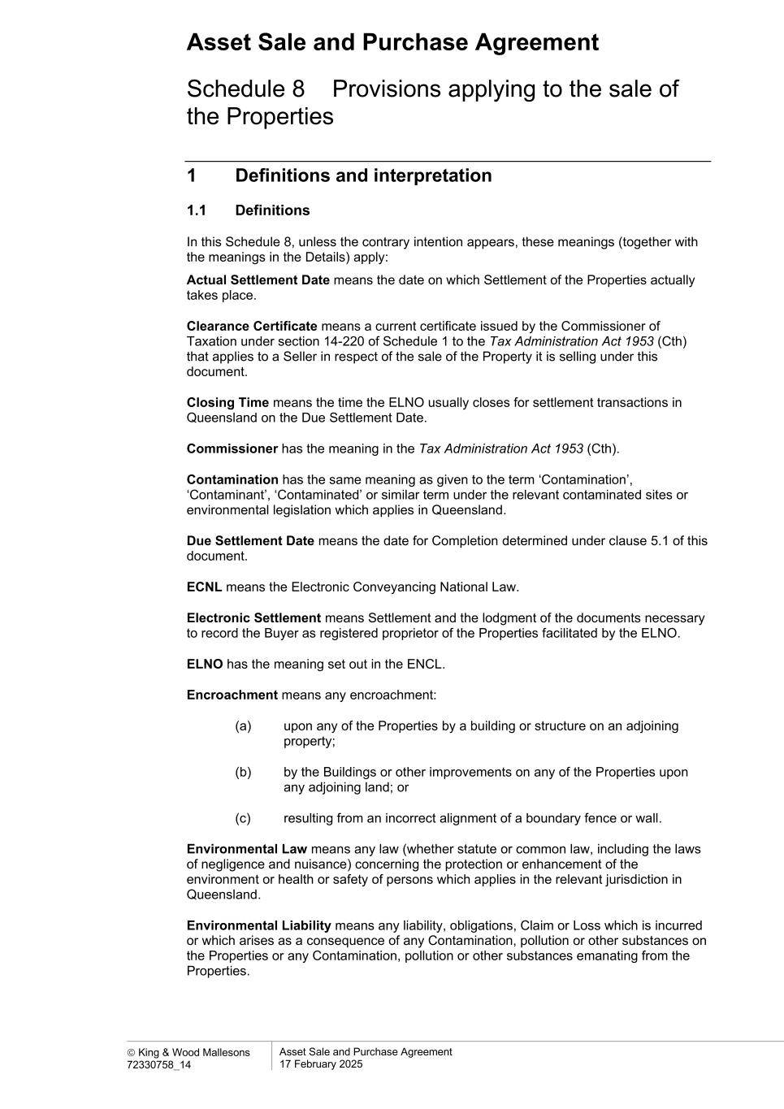
Asset Sale and Purchase Agreement  King & Wood Mallesons 72330758_14 Asset Sale and Purchase Agreement 17 February 2025 Schedule 8 Provisions applying to the sale of the Properties 1 Definitions and interpretation 1.1 Definitions In this Schedule 8, unless the contrary intention appears, these meanings (together with the meanings in the Details) apply: Actual Settlement Date means the date on which Settlement of the Properties actually takes place. Clearance Certificate means a current certificate issued by the Commissioner of Taxation under section 14-220 of Schedule 1 to the Tax Administration Act 1953 (Cth) that applies to a Seller in respect of the sale of the Property it is selling under this document. Closing Time means the time the ELNO usually closes for settlement transactions in Queensland on the Due Settlement Date. Commissioner has the meaning in the Tax Administration Act 1953 (Cth). Contamination has the same meaning as given to the term ‘Contamination’, ‘Contaminant’, ‘Contaminated’ or similar term under the relevant contaminated sites or environmental legislation which applies in Queensland. Due Settlement Date means the date for Completion determined under clause 5.1 of this document. ECNL means the Electronic Conveyancing National Law. Electronic Settlement means Settlement and the lodgment of the documents necessary to record the Buyer as registered proprietor of the Properties facilitated by the ELNO. ELNO has the meaning set out in the ENCL. Encroachment means any encroachment: (a) upon any of the Properties by a building or structure on an adjoining property; (b) by the Buildings or other improvements on any of the Properties upon any adjoining land; or (c) resulting from an incorrect alignment of a boundary fence or wall. Environmental Law means any law (whether statute or common law, including the laws of negligence and nuisance) concerning the protection or enhancement of the environment or health or safety of persons which applies in the relevant jurisdiction in Queensland. Environmental Liability means any liability, obligations, Claim or Loss which is incurred or which arises as a consequence of any Contamination, pollution or other substances on the Properties or any Contamination, pollution or other substances emanating from the Properties.

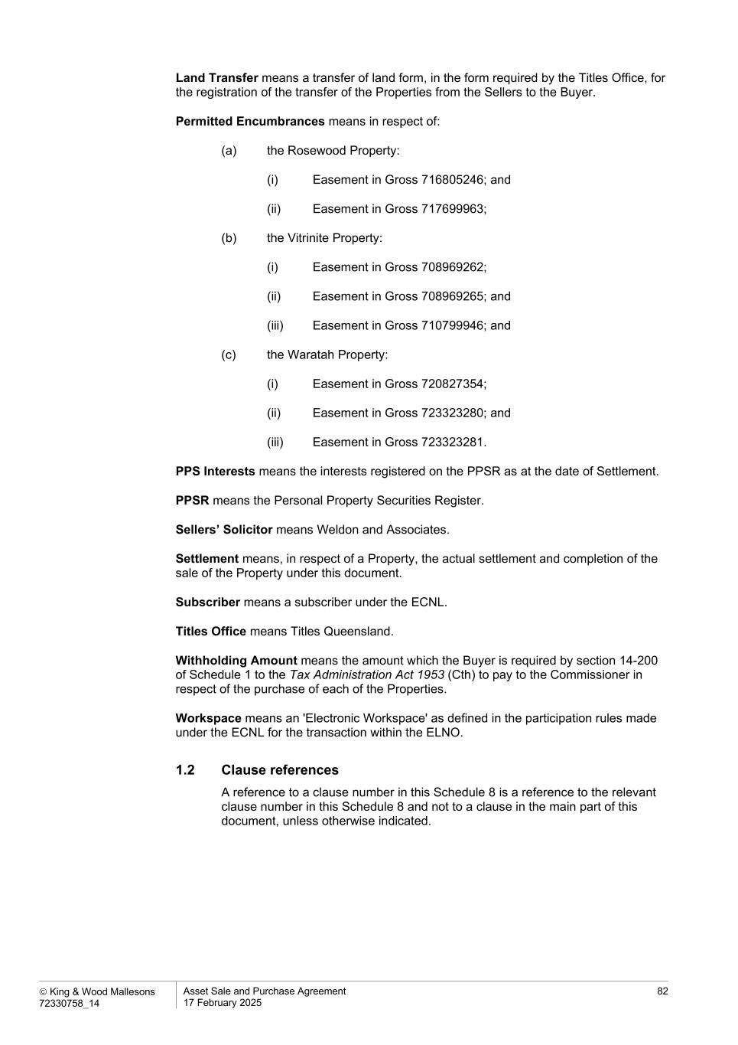
 King & Wood Mallesons 72330758_14 Asset Sale and Purchase Agreement 17 February 2025 82 Land Transfer means a transfer of land form, in the form required by the Titles Office, for the registration of the transfer of the Properties from the Sellers to the Buyer. Permitted Encumbrances means in respect of: (a) the Rosewood Property: (i) Easement in Gross 716805246; and (ii) Easement in Gross 717699963; (b) the Vitrinite Property: (i) Easement in Gross 708969262; (ii) Easement in Gross 708969265; and (iii) Easement in Gross 710799946; and (c) the Waratah Property: (i) Easement in Gross 720827354; (ii) Easement in Gross 723323280; and (iii) Easement in Gross 723323281. PPS Interests means the interests registered on the PPSR as at the date of Settlement. PPSR means the Personal Property Securities Register. Sellers’ Solicitor means Weldon and Associates. Settlement means, in respect of a Property, the actual settlement and completion of the sale of the Property under this document. Subscriber means a subscriber under the ECNL. Titles Office means Titles Queensland. Withholding Amount means the amount which the Buyer is required by section 14-200 of Schedule 1 to the Tax Administration Act 1953 (Cth) to pay to the Commissioner in respect of the purchase of each of the Properties. Workspace means an 'Electronic Workspace' as defined in the participation rules made under the ECNL for the transaction within the ELNO. 1.2 Clause references A reference to a clause number in this Schedule 8 is a reference to the relevant clause number in this Schedule 8 and not to a clause in the main part of this document, unless otherwise indicated.

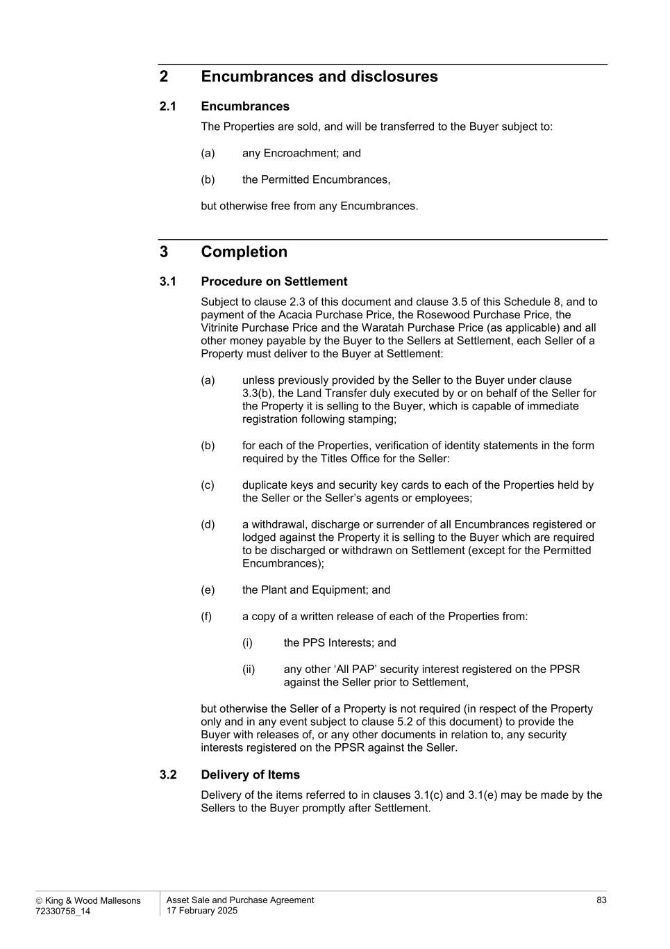
 King & Wood Mallesons 72330758_14 Asset Sale and Purchase Agreement 17 February 2025 83 2 Encumbrances and disclosures 2.1 Encumbrances The Properties are sold, and will be transferred to the Buyer subject to: (a) any Encroachment; and (b) the Permitted Encumbrances, but otherwise free from any Encumbrances. 3 Completion 3.1 Procedure on Settlement Subject to clause 2.3 of this document and clause 3.5 of this Schedule 8, and to payment of the Acacia Purchase Price, the Rosewood Purchase Price, the Vitrinite Purchase Price and the Waratah Purchase Price (as applicable) and all other money payable by the Buyer to the Sellers at Settlement, each Seller of a Property must deliver to the Buyer at Settlement: (a) unless previously provided by the Seller to the Buyer under clause 3.3(b), the Land Transfer duly executed by or on behalf of the Seller for the Property it is selling to the Buyer, which is capable of immediate registration following stamping; (b) for each of the Properties, verification of identity statements in the form required by the Titles Office for the Seller: (c) duplicate keys and security key cards to each of the Properties held by the Seller or the Seller’s agents or employees; (d) a withdrawal, discharge or surrender of all Encumbrances registered or lodged against the Property it is selling to the Buyer which are required to be discharged or withdrawn on Settlement (except for the Permitted Encumbrances); (e) the Plant and Equipment; and (f) a copy of a written release of each of the Properties from: (i) the PPS Interests; and (ii) any other ‘All PAP’ security interest registered on the PPSR against the Seller prior to Settlement, but otherwise the Seller of a Property is not required (in respect of the Property only and in any event subject to clause 5.2 of this document) to provide the Buyer with releases of, or any other documents in relation to, any security interests registered on the PPSR against the Seller. 3.2 Delivery of Items Delivery of the items referred to in clauses 3.1(c) and 3.1(e) may be made by the Sellers to the Buyer promptly after Settlement.

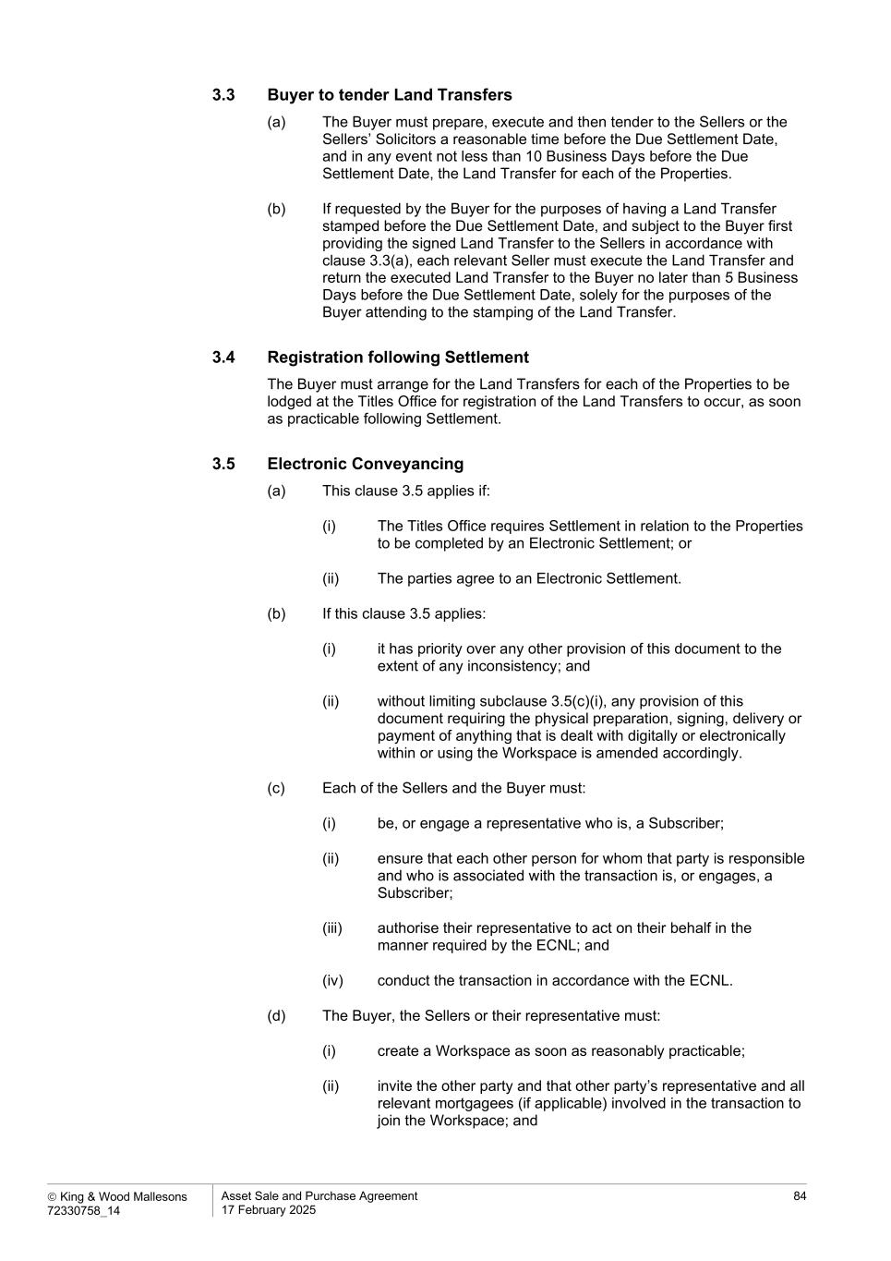
 King & Wood Mallesons 72330758_14 Asset Sale and Purchase Agreement 17 February 2025 84 3.3 Buyer to tender Land Transfers (a) The Buyer must prepare, execute and then tender to the Sellers or the Sellers’ Solicitors a reasonable time before the Due Settlement Date, and in any event not less than 10 Business Days before the Due Settlement Date, the Land Transfer for each of the Properties. (b) If requested by the Buyer for the purposes of having a Land Transfer stamped before the Due Settlement Date, and subject to the Buyer first providing the signed Land Transfer to the Sellers in accordance with clause 3.3(a), each relevant Seller must execute the Land Transfer and return the executed Land Transfer to the Buyer no later than 5 Business Days before the Due Settlement Date, solely for the purposes of the Buyer attending to the stamping of the Land Transfer. 3.4 Registration following Settlement The Buyer must arrange for the Land Transfers for each of the Properties to be lodged at the Titles Office for registration of the Land Transfers to occur, as soon as practicable following Settlement. 3.5 Electronic Conveyancing (a) This clause 3.5 applies if: (i) The Titles Office requires Settlement in relation to the Properties to be completed by an Electronic Settlement; or (ii) The parties agree to an Electronic Settlement. (b) If this clause 3.5 applies: (i) it has priority over any other provision of this document to the extent of any inconsistency; and (ii) without limiting subclause 3.5(c)(i), any provision of this document requiring the physical preparation, signing, delivery or payment of anything that is dealt with digitally or electronically within or using the Workspace is amended accordingly. (c) Each of the Sellers and the Buyer must: (i) be, or engage a representative who is, a Subscriber; (ii) ensure that each other person for whom that party is responsible and who is associated with the transaction is, or engages, a Subscriber; (iii) authorise their representative to act on their behalf in the manner required by the ECNL; and (iv) conduct the transaction in accordance with the ECNL. (d) The Buyer, the Sellers or their representative must: (i) create a Workspace as soon as reasonably practicable; (ii) invite the other party and that other party’s representative and all relevant mortgagees (if applicable) involved in the transaction to join the Workspace; and

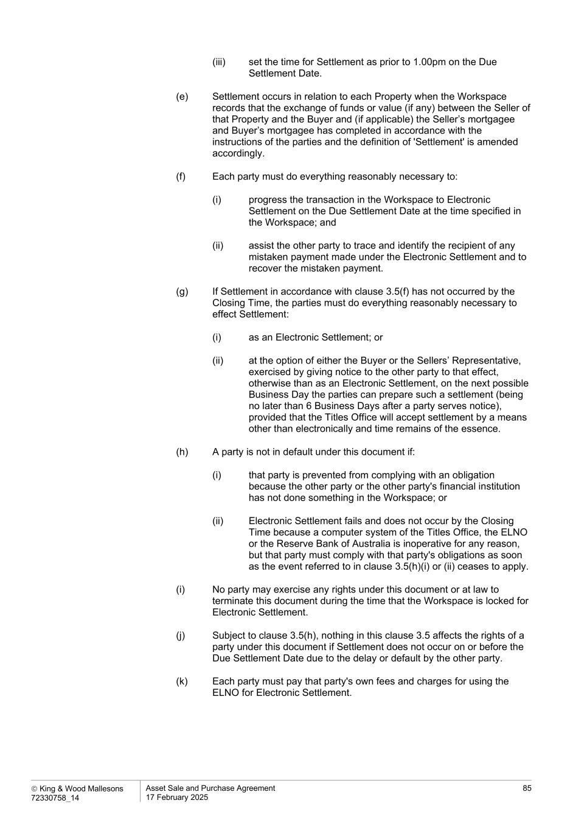
 King & Wood Mallesons 72330758_14 Asset Sale and Purchase Agreement 17 February 2025 85 (iii) set the time for Settlement as prior to 1.00pm on the Due Settlement Date. (e) Settlement occurs in relation to each Property when the Workspace records that the exchange of funds or value (if any) between the Seller of that Property and the Buyer and (if applicable) the Seller’s mortgagee and Buyer’s mortgagee has completed in accordance with the instructions of the parties and the definition of 'Settlement' is amended accordingly. (f) Each party must do everything reasonably necessary to: (i) progress the transaction in the Workspace to Electronic Settlement on the Due Settlement Date at the time specified in the Workspace; and (ii) assist the other party to trace and identify the recipient of any mistaken payment made under the Electronic Settlement and to recover the mistaken payment. (g) If Settlement in accordance with clause 3.5(f) has not occurred by the Closing Time, the parties must do everything reasonably necessary to effect Settlement: (i) as an Electronic Settlement; or (ii) at the option of either the Buyer or the Sellers’ Representative, exercised by giving notice to the other party to that effect, otherwise than as an Electronic Settlement, on the next possible Business Day the parties can prepare such a settlement (being no later than 6 Business Days after a party serves notice), provided that the Titles Office will accept settlement by a means other than electronically and time remains of the essence. (h) A party is not in default under this document if: (i) that party is prevented from complying with an obligation because the other party or the other party's financial institution has not done something in the Workspace; or (ii) Electronic Settlement fails and does not occur by the Closing Time because a computer system of the Titles Office, the ELNO or the Reserve Bank of Australia is inoperative for any reason, but that party must comply with that party's obligations as soon as the event referred to in clause 3.5(h)(i) or (ii) ceases to apply. (i) No party may exercise any rights under this document or at law to terminate this document during the time that the Workspace is locked for Electronic Settlement. (j) Subject to clause 3.5(h), nothing in this clause 3.5 affects the rights of a party under this document if Settlement does not occur on or before the Due Settlement Date due to the delay or default by the other party. (k) Each party must pay that party's own fees and charges for using the ELNO for Electronic Settlement.

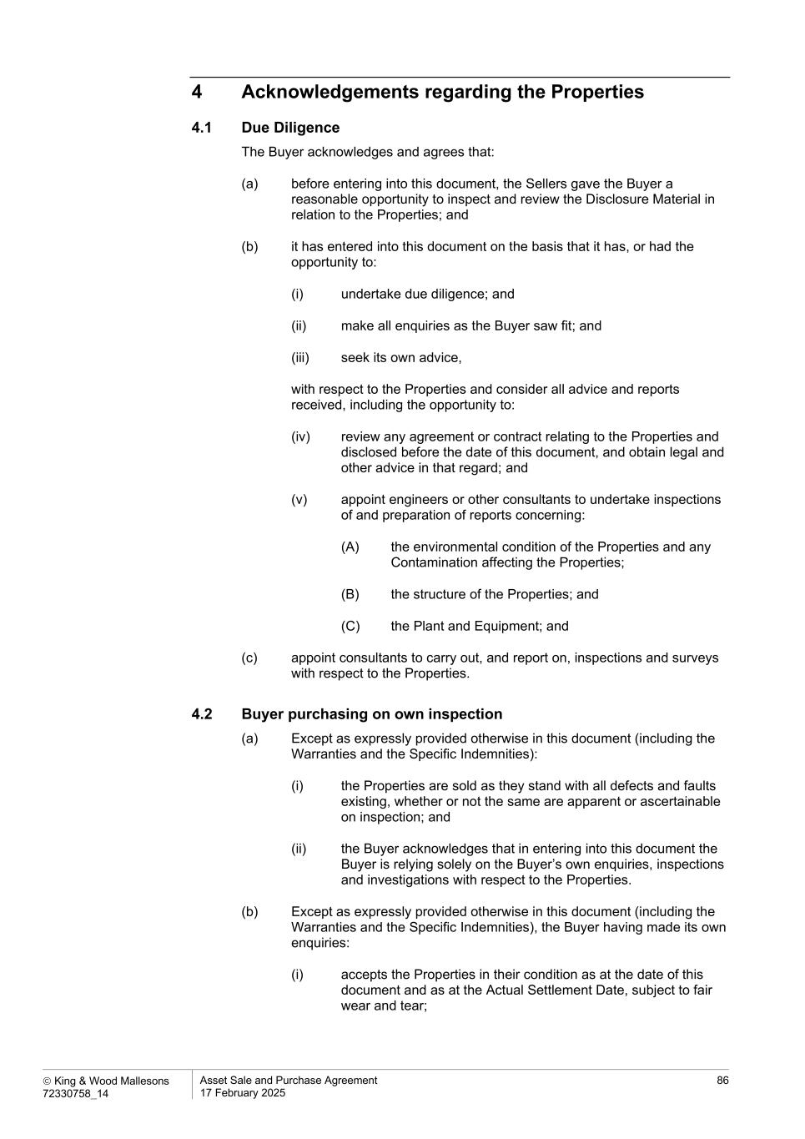
 King & Wood Mallesons 72330758_14 Asset Sale and Purchase Agreement 17 February 2025 86 4 Acknowledgements regarding the Properties 4.1 Due Diligence The Buyer acknowledges and agrees that: (a) before entering into this document, the Sellers gave the Buyer a reasonable opportunity to inspect and review the Disclosure Material in relation to the Properties; and (b) it has entered into this document on the basis that it has, or had the opportunity to: (i) undertake due diligence; and (ii) make all enquiries as the Buyer saw fit; and (iii) seek its own advice, with respect to the Properties and consider all advice and reports received, including the opportunity to: (iv) review any agreement or contract relating to the Properties and disclosed before the date of this document, and obtain legal and other advice in that regard; and (v) appoint engineers or other consultants to undertake inspections of and preparation of reports concerning: (A) the environmental condition of the Properties and any Contamination affecting the Properties; (B) the structure of the Properties; and (C) the Plant and Equipment; and (c) appoint consultants to carry out, and report on, inspections and surveys with respect to the Properties. 4.2 Buyer purchasing on own inspection (a) Except as expressly provided otherwise in this document (including the Warranties and the Specific Indemnities): (i) the Properties are sold as they stand with all defects and faults existing, whether or not the same are apparent or ascertainable on inspection; and (ii) the Buyer acknowledges that in entering into this document the Buyer is relying solely on the Buyer’s own enquiries, inspections and investigations with respect to the Properties. (b) Except as expressly provided otherwise in this document (including the Warranties and the Specific Indemnities), the Buyer having made its own enquiries: (i) accepts the Properties in their condition as at the date of this document and as at the Actual Settlement Date, subject to fair wear and tear;

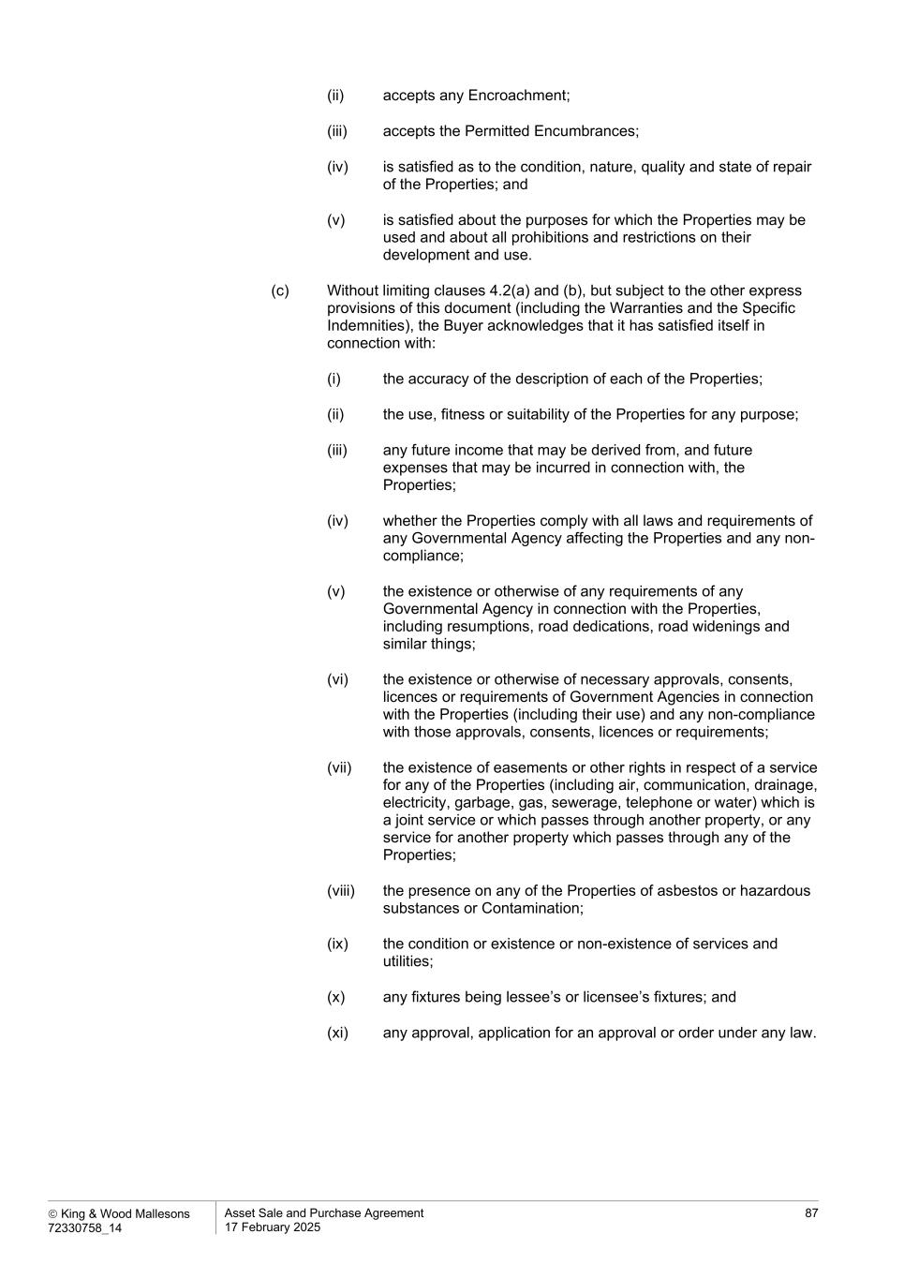
 King & Wood Mallesons 72330758_14 Asset Sale and Purchase Agreement 17 February 2025 87 (ii) accepts any Encroachment; (iii) accepts the Permitted Encumbrances; (iv) is satisfied as to the condition, nature, quality and state of repair of the Properties; and (v) is satisfied about the purposes for which the Properties may be used and about all prohibitions and restrictions on their development and use. (c) Without limiting clauses 4.2(a) and (b), but subject to the other express provisions of this document (including the Warranties and the Specific Indemnities), the Buyer acknowledges that it has satisfied itself in connection with: (i) the accuracy of the description of each of the Properties; (ii) the use, fitness or suitability of the Properties for any purpose; (iii) any future income that may be derived from, and future expenses that may be incurred in connection with, the Properties; (iv) whether the Properties comply with all laws and requirements of any Governmental Agency affecting the Properties and any non- compliance; (v) the existence or otherwise of any requirements of any Governmental Agency in connection with the Properties, including resumptions, road dedications, road widenings and similar things; (vi) the existence or otherwise of necessary approvals, consents, licences or requirements of Government Agencies in connection with the Properties (including their use) and any non-compliance with those approvals, consents, licences or requirements; (vii) the existence of easements or other rights in respect of a service for any of the Properties (including air, communication, drainage, electricity, garbage, gas, sewerage, telephone or water) which is a joint service or which passes through another property, or any service for another property which passes through any of the Properties; (viii) the presence on any of the Properties of asbestos or hazardous substances or Contamination; (ix) the condition or existence or non-existence of services and utilities; (x) any fixtures being lessee’s or licensee’s fixtures; and (xi) any approval, application for an approval or order under any law.

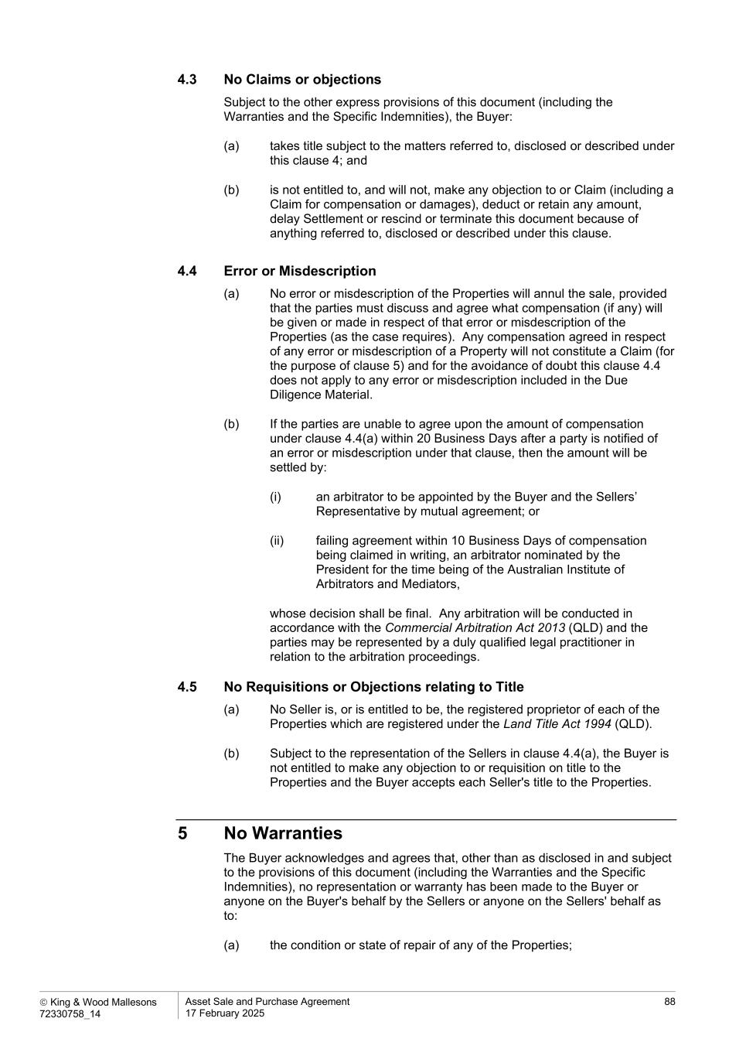
 King & Wood Mallesons 72330758_14 Asset Sale and Purchase Agreement 17 February 2025 88 4.3 No Claims or objections Subject to the other express provisions of this document (including the Warranties and the Specific Indemnities), the Buyer: (a) takes title subject to the matters referred to, disclosed or described under this clause 4; and (b) is not entitled to, and will not, make any objection to or Claim (including a Claim for compensation or damages), deduct or retain any amount, delay Settlement or rescind or terminate this document because of anything referred to, disclosed or described under this clause. 4.4 Error or Misdescription (a) No error or misdescription of the Properties will annul the sale, provided that the parties must discuss and agree what compensation (if any) will be given or made in respect of that error or misdescription of the Properties (as the case requires). Any compensation agreed in respect of any error or misdescription of a Property will not constitute a Claim (for the purpose of clause 5) and for the avoidance of doubt this clause 4.4 does not apply to any error or misdescription included in the Due Diligence Material. (b) If the parties are unable to agree upon the amount of compensation under clause 4.4(a) within 20 Business Days after a party is notified of an error or misdescription under that clause, then the amount will be settled by: (i) an arbitrator to be appointed by the Buyer and the Sellers’ Representative by mutual agreement; or (ii) failing agreement within 10 Business Days of compensation being claimed in writing, an arbitrator nominated by the President for the time being of the Australian Institute of Arbitrators and Mediators, whose decision shall be final. Any arbitration will be conducted in accordance with the Commercial Arbitration Act 2013 (QLD) and the parties may be represented by a duly qualified legal practitioner in relation to the arbitration proceedings. 4.5 No Requisitions or Objections relating to Title (a) No Seller is, or is entitled to be, the registered proprietor of each of the Properties which are registered under the Land Title Act 1994 (QLD). (b) Subject to the representation of the Sellers in clause 4.4(a), the Buyer is not entitled to make any objection to or requisition on title to the Properties and the Buyer accepts each Seller's title to the Properties. 5 No Warranties The Buyer acknowledges and agrees that, other than as disclosed in and subject to the provisions of this document (including the Warranties and the Specific Indemnities), no representation or warranty has been made to the Buyer or anyone on the Buyer's behalf by the Sellers or anyone on the Sellers' behalf as to: (a) the condition or state of repair of any of the Properties;

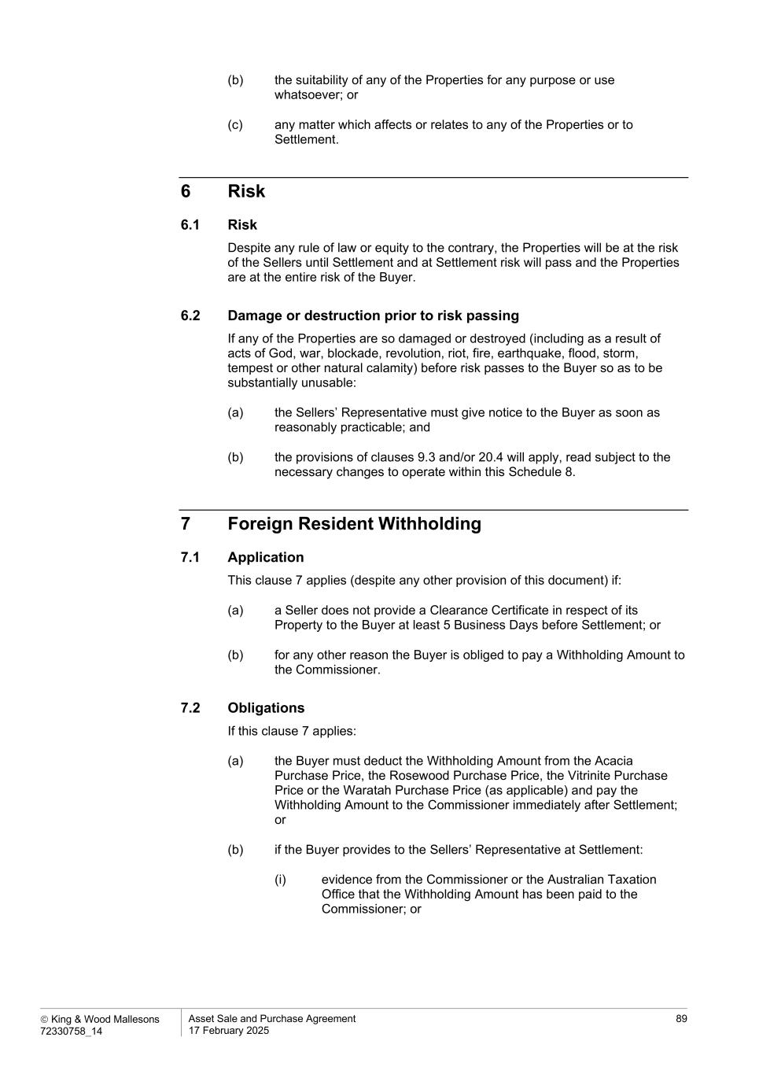
 King & Wood Mallesons 72330758_14 Asset Sale and Purchase Agreement 17 February 2025 89 (b) the suitability of any of the Properties for any purpose or use whatsoever; or (c) any matter which affects or relates to any of the Properties or to Settlement. 6 Risk 6.1 Risk Despite any rule of law or equity to the contrary, the Properties will be at the risk of the Sellers until Settlement and at Settlement risk will pass and the Properties are at the entire risk of the Buyer. 6.2 Damage or destruction prior to risk passing If any of the Properties are so damaged or destroyed (including as a result of acts of God, war, blockade, revolution, riot, fire, earthquake, flood, storm, tempest or other natural calamity) before risk passes to the Buyer so as to be substantially unusable: (a) the Sellers’ Representative must give notice to the Buyer as soon as reasonably practicable; and (b) the provisions of clauses 9.3 and/or 20.4 will apply, read subject to the necessary changes to operate within this Schedule 8. 7 Foreign Resident Withholding 7.1 Application This clause 7 applies (despite any other provision of this document) if: (a) a Seller does not provide a Clearance Certificate in respect of its Property to the Buyer at least 5 Business Days before Settlement; or (b) for any other reason the Buyer is obliged to pay a Withholding Amount to the Commissioner. 7.2 Obligations If this clause 7 applies: (a) the Buyer must deduct the Withholding Amount from the Acacia Purchase Price, the Rosewood Purchase Price, the Vitrinite Purchase Price or the Waratah Purchase Price (as applicable) and pay the Withholding Amount to the Commissioner immediately after Settlement; or (b) if the Buyer provides to the Sellers’ Representative at Settlement: (i) evidence from the Commissioner or the Australian Taxation Office that the Withholding Amount has been paid to the Commissioner; or


 King & Wood Mallesons 72330758_14 Asset Sale and Purchase Agreement 17 February 2025 90 (ii) any other evidence relating to the payment of the Withholding Amount that is acceptable to the Sellers’ Representative acting reasonably, the Buyer is not required to pay that part of the Acacia Purchase Price, the Rosewood Purchase Price, the Vitrinite Purchase Price or the Waratah Purchase Price (as applicable) to any Seller. 7.3 Withholding Amount If clause 7.2 applies, the Buyer will be treated as having given an irrevocable authority and direction to the Buyer’s Representative to pay the Withholding Amount to the Commissioner immediately following Settlement.

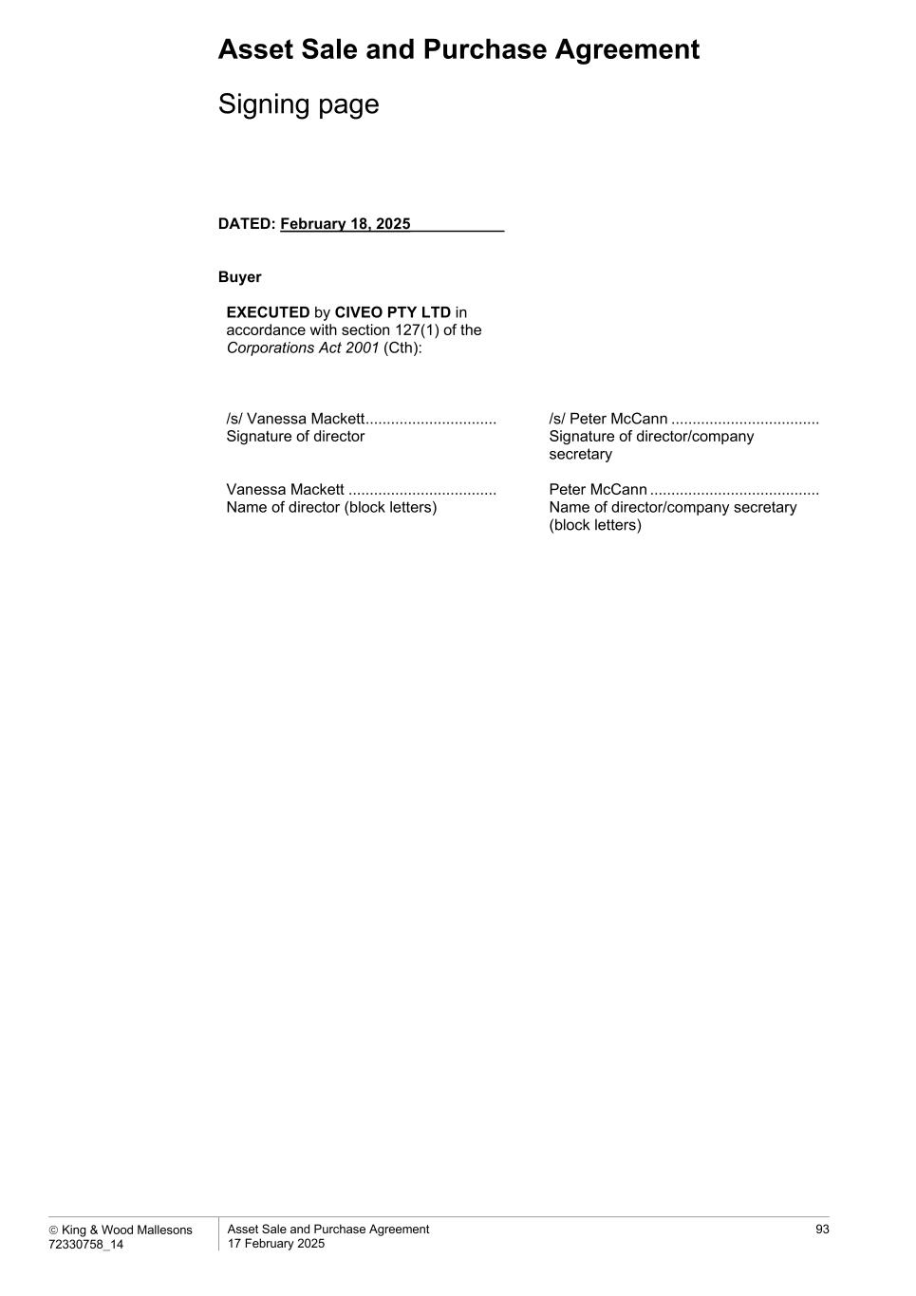
Asset Sale and Purchase Agreement  King & Wood Mallesons 72330758_14 Asset Sale and Purchase Agreement 17 February 2025 93 Signing page DATED: February 18, 2025___________ Buyer EXECUTED by CIVEO PTY LTD in accordance with section 127(1) of the Corporations Act 2001 (Cth): /s/ Vanessa Mackett ............................... Signature of director Vanessa Mackett ................................... Name of director (block letters) /s/ Peter McCann ................................... Signature of director/company secretary Peter McCann ........................................ Name of director/company secretary (block letters)

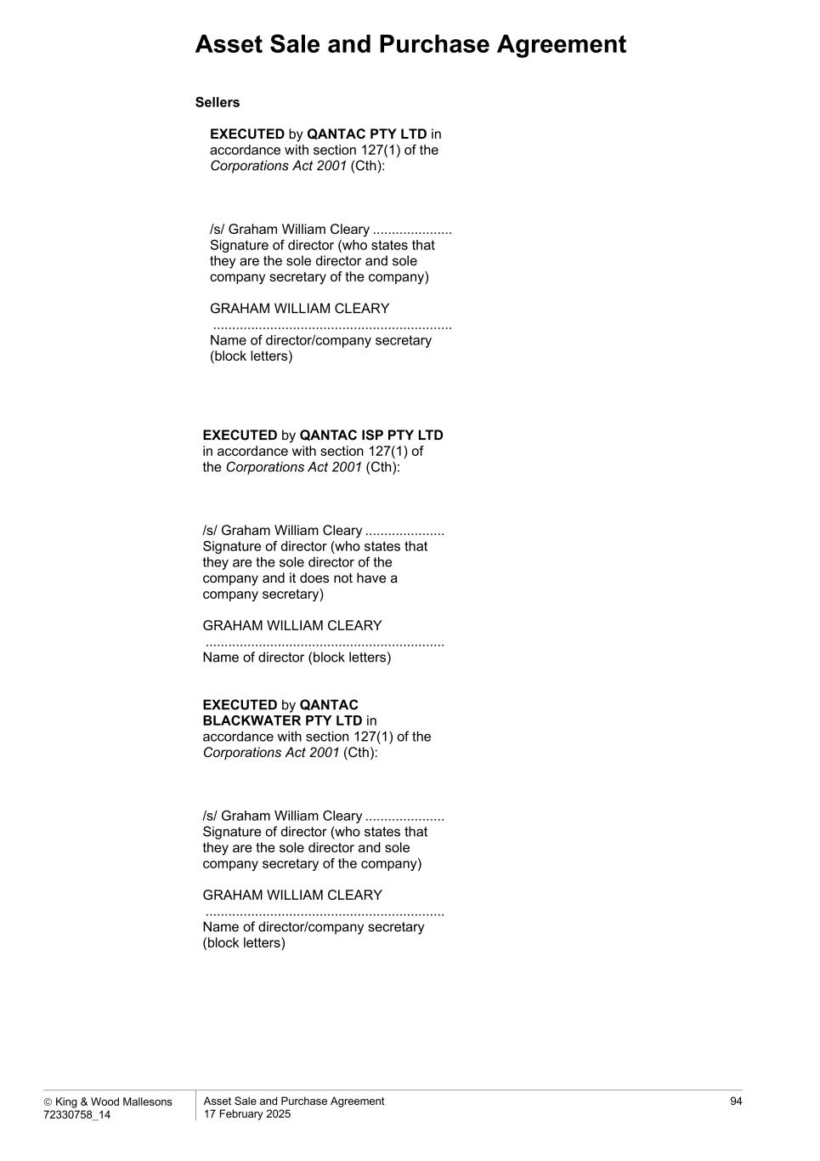
Asset Sale and Purchase Agreement  King & Wood Mallesons 72330758_14 Asset Sale and Purchase Agreement 17 February 2025 94 Sellers EXECUTED by QANTAC PTY LTD in accordance with section 127(1) of the Corporations Act 2001 (Cth): /s/ Graham William Cleary ..................... Signature of director (who states that they are the sole director and sole company secretary of the company) GRAHAM WILLIAM CLEARY ............................................................... Name of director/company secretary (block letters) EXECUTED by QANTAC ISP PTY LTD in accordance with section 127(1) of the Corporations Act 2001 (Cth): /s/ Graham William Cleary ..................... Signature of director (who states that they are the sole director of the company and it does not have a company secretary) GRAHAM WILLIAM CLEARY ............................................................... Name of director (block letters) EXECUTED by QANTAC BLACKWATER PTY LTD in accordance with section 127(1) of the Corporations Act 2001 (Cth): /s/ Graham William Cleary ..................... Signature of director (who states that they are the sole director and sole company secretary of the company) GRAHAM WILLIAM CLEARY ............................................................... Name of director/company secretary (block letters)

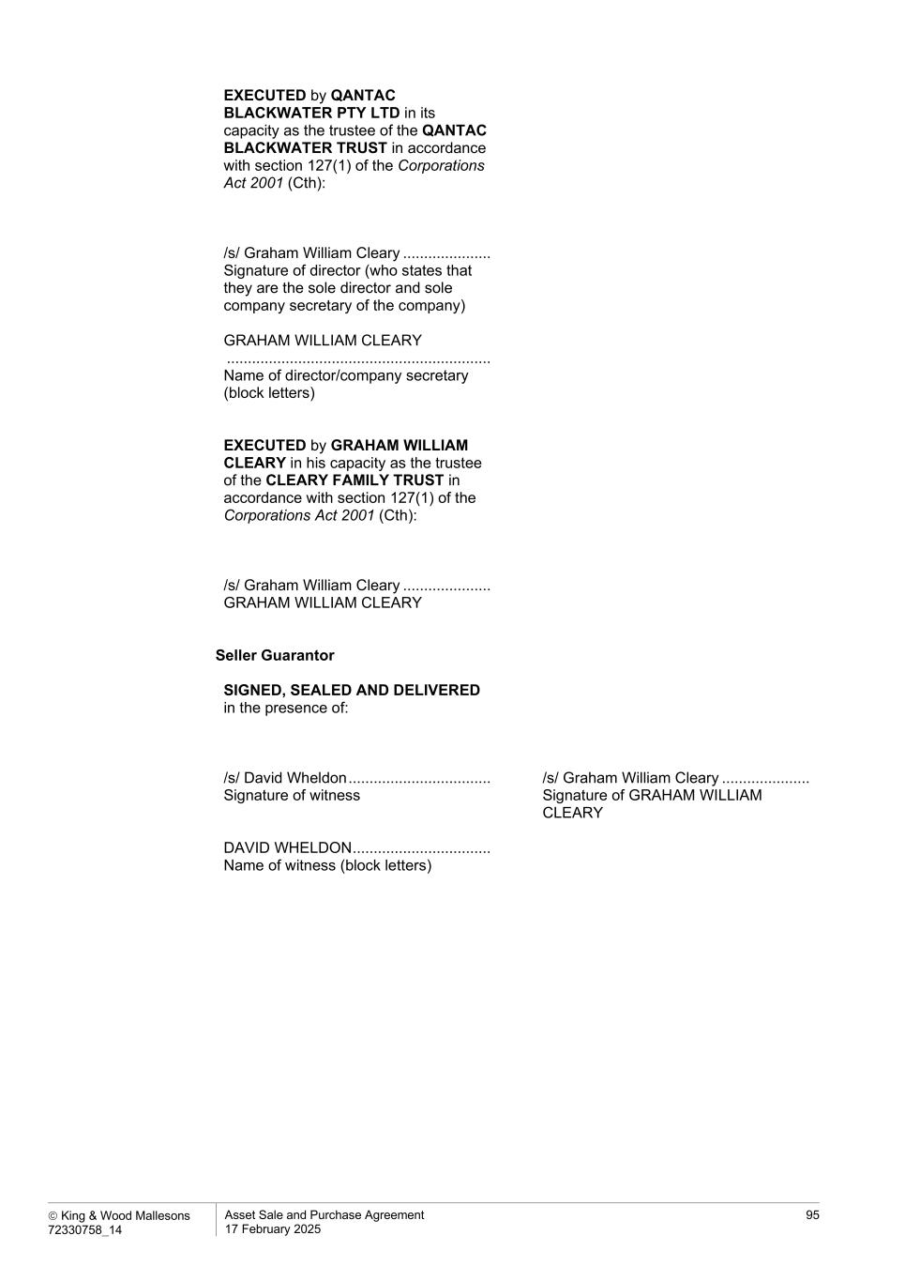
 King & Wood Mallesons 72330758_14 Asset Sale and Purchase Agreement 17 February 2025 95 EXECUTED by QANTAC BLACKWATER PTY LTD in its capacity as the trustee of the QANTAC BLACKWATER TRUST in accordance with section 127(1) of the Corporations Act 2001 (Cth): /s/ Graham William Cleary ..................... Signature of director (who states that they are the sole director and sole company secretary of the company) GRAHAM WILLIAM CLEARY ............................................................... Name of director/company secretary (block letters) EXECUTED by GRAHAM WILLIAM CLEARY in his capacity as the trustee of the CLEARY FAMILY TRUST in accordance with section 127(1) of the Corporations Act 2001 (Cth): /s/ Graham William Cleary ..................... GRAHAM WILLIAM CLEARY Seller Guarantor SIGNED, SEALED AND DELIVERED in the presence of: /s/ David Wheldon .................................. Signature of witness DAVID WHELDON ................................. Name of witness (block letters) /s/ Graham William Cleary ..................... Signature of GRAHAM WILLIAM CLEARY

Exhibit 4.3
DESCRIPTION OF THE REGISTRANT’S SECURITIES
REGISTERED PURSUANT TO SECTION 12 OF THE
SECURITIES ACT OF 1934
General
The authorized shares of Civeo Corporation (“Civeo,” “us,” “our” or “we”) consist of (i) 46,000,000 common shares, no par value, (ii) up to 50,000,000 Class A preferred shares, no par value, to be issued in one or more series, and (iii) up to 50,000,000 Class B preferred shares, no par value, to be issued in one or more series, provided that the authorized limit of the Class A preferred shares and the Class B preferred shares is 50,000,000 shares in the aggregate. The first series of Class A preferred shares are designated as the “Class A Series 1 Preferred Shares” and up to 50,000,000 Class A Series 1 Preferred Shares are authorized for issuance, and the first series of Class B preferred shares are designated as the “Class B Series 1 Preferred Shares” and up to 50,000,000 Class B Series 1 Preferred Shares are authorized for issuance, provided that no more than 50,000,000 Class A Series 1 Preferred Shares and Class B Series 1 Preferred Shares are issued in the aggregate.
We may issue shares subject to the maximum authorized share capital contained in our notice of articles. The maximum number of shares that we are authorized to issue out of any class or series of shares may be increased or decreased by a resolution passed at a general meeting of shareholders by two thirds of the votes cast on such resolution by shareholders voting shares that carry the right to vote at general meetings. Our directors are authorized to issue new common shares, Class A preferred shares or Class B preferred shares without shareholder approval.
The rights and restrictions to which the common shares and Class A Series 1 Preferred Shares are subject as of the date hereof are set out in our amended and restated articles (“articles”). Our notice of articles and articles permit the board of directors, without shareholder approval, to alter and attach special rights and restrictions to the Class B Series 1 Preferred Shares, including the number of shares, dividend rights, liquidation preferences, voting rights, conversion rights, preemptive rights and redemption rights.
Description of Common Shares
The following description sets forth certain material terms and provisions of our common shares, which are registered under Section 12 of the Securities Exchange Act of 1934, as amended. The following description of our common shares is not complete and is qualified in its entirety by reference to our notice of articles and articles, which are filed as exhibits to our Annual Report on Form 10-K.
Voting Rights
Except as provided by law or pursuant to the rights that the directors may attach to any series of preferred shares, holders of common shares are entitled to one vote for each share held of record on all matters submitted to a vote of the shareholders, have the right to vote for the election of directors and do not have cumulative voting rights. Except as otherwise required by law, holders of common shares are not entitled to vote on any amendment to the notice of articles or articles that prejudices or interferes with the rights and special rights of the Class A Series 1 Preferred Shares, Class B Series 1 Preferred Shares or any future outstanding series of preferred shares if the holders of such affected series are entitled, either separately or together with the holders of one or more other such series, to vote thereon pursuant to the notice of articles and articles or pursuant to British Columbia law or the Business Corporations Act (British Columbia) (the “BCA”).
Dividends
Subject to prior rights and preferences applicable to the Class A Series 1 Preferred Shares, the Class B Series 1 Preferred Shares or any future outstanding series of preferred shares, holders of common shares are entitled to receive ratably in proportion to the number of common shares held by them such dividends (payable in cash,

shares or otherwise), if any, as may be declared from time to time by the board of directors out of funds available for dividend payments. Dividends will not be declared where there are reasonable grounds for believing the company is insolvent or the payment of dividends would render the company insolvent. There is not a fixed rate of dividends.
Conversion, Sinking Fund, Redemption, Liquidation and Preemption Rights
The holders of common shares have no preferences or rights of conversion, exchange, pre-emption or other subscription rights. There are no redemption or sinking fund provisions applicable to the common shares. In the event of any voluntary or involuntary liquidation, dissolution or winding-up of our affairs, holders of common shares will be entitled to share ratably in our assets in proportion to the common shares held by them that are remaining after payment or provision for payment of all of our debts and obligations and after distribution in full of preferential amounts to be distributed to holders of outstanding shares of the Class A Series 1 Preferred Shares, the Class B Series 1 Preferred Shares or any other outstanding preferred shares, if any.
Notice of Articles and Articles
Provisions of our notice of articles and articles may delay or discourage transactions involving an actual or potential change in control or change in our management, including transactions in which shareholders might otherwise receive a premium for their shares, or transactions that our shareholders might otherwise deem to be in their best interests. Therefore, these provisions could adversely affect the price of our shares.
These provisions are expected to discourage coercive takeover practices and inadequate takeover bids. These provisions are also designed to encourage persons seeking to acquire control of us to first negotiate with us. We believe that the benefits of increased protection and our potential ability to negotiate with the proponent of an unfriendly or unsolicited proposal to acquire or restructure us outweigh the disadvantages of discouraging these proposals because, among other things, negotiation of these proposals could result in an improvement of their terms.
Among other things, our notice of articles and articles:
•provide that our directors are divided into three classes serving staggered three-year terms, with only one class being elected each year by our shareholders, subject to a phase out of the classification of our board of directors over a three-year period beginning with the 2025 annual meeting such that all directors will be elected on an annual basis beginning with the 2027 annual meeting. Until such time that all directors are elected on an annual basis, this classified board may discourage a third party from making a tender offer or otherwise attempting to obtain control of us because it generally makes it more difficult for shareholders to replace a majority of our directors;
•provide that our directors may only be removed by shareholders passing a resolution with the requisite majority of three-quarters of the votes cast at a meeting of shareholders entitled to vote in the election of directors, voting together as a single class;
•establish advance notice procedures with regard to shareholder proposals relating to the nomination of candidates for election as directors or new business to be brought before meetings of our shareholders. These procedures provide that notice of shareholder proposals must be timely given in writing to our corporate secretary prior to the meeting at which the action is to be taken. Generally, to be timely, notice must be received at our principal executive offices not later than 120 days prior to the first anniversary date of the annual meeting for the preceding year. Our articles specify the requirements as to form and content of all shareholders’ notices. These requirements may preclude shareholders from bringing matters before the shareholders at an annual or special meeting;
•provide our board of directors the ability to issue the Class A Series 1 Preferred Shares and the Class B Series 1 Preferred Shares. This ability makes it possible for our board of directors to issue, without shareholder approval, preferred shares with voting or other rights or preferences that could

impede the success of any attempt to change control of us. These and other provisions may have the effect of deterring hostile takeovers or delaying changes in control or management of our company;
•provide that the authorized number of directors may only be set by the board of directors;
•provide that all vacancies, including newly created directorships, may, except as otherwise required by law or, if applicable, the rights of holders of a series of preferred shares, be filled by the affirmative vote of a majority of directors then in office;
•provide that any action required or permitted to be taken by the shareholders must be effected at a duly called annual or special meeting of shareholders and may not be effected by any consent in writing in lieu of a meeting of such shareholders, subject to the rights of the holders of any series of preferred shares with respect to such series;
•provide that our notice of articles and articles can be amended or repealed at any annual or special meeting of shareholders or amended by the board of directors in certain circumstances, including the requirement that certain amendments by the shareholders to the articles at a meeting be upon a resolution passed by the affirmative vote of the holders of 66 2/3% of the voting power of the issued and outstanding shares entitled to vote on such matters, voting together as a single class; and
•provide that, if a meeting of shareholders has been adjourned one or more times due to insufficient attendance required to pass any resolution, and at such adjourned meeting, less than the number of holders required to pass any resolution requiring 66 2/3% of the voting power of the issued and outstanding shares is present in person or by proxy, with the approval of the board, the holders holding at least 66 2/3% of the shares present in person or by proxy at such adjourned meeting and entitled to vote on the matter, voting together as a single class, may alter the articles.
When interpreting a director’s duties under British Columbia law, Canadian courts have generally interpreted a director’s duty to act in “the best interest of the company” to include a duty to treat all stakeholders affected by corporate actions equitably and fairly, including in the context of a change of control transaction. Accordingly, in determining what is in “the best interests of the company”, it may be legitimate for our directors to consider the interests of not only the company’s shareholders, but other stakeholders, such as employees and creditors, as well.
Limitation of Liability and Indemnification Matters
Our articles allow us to indemnify our directors to the fullest extent authorized by the BCA against all expenses, liabilities and losses (including judgments and fines) which may be reasonably incurred by reason of being or having been a director of the company, except for liability that cannot be indemnified under British Columbia law. British Columbia law provides that a company must not indemnify its directors if any of the following circumstances apply:
•if the indemnity or payment is made under an earlier agreement to indemnify or pay expenses and, at the time that the agreement to indemnify or pay expenses was made, the company was prohibited from giving the indemnity or paying the expenses by its articles;
•if the indemnity or payment is made otherwise than under an earlier agreement to indemnify or pay expenses and, at the time that the indemnity or payment is made, the company is prohibited from giving the indemnity or paying the expenses by its articles;
•if, in relation to the subject matter of the relevant proceeding, the director did not act honestly and in good faith with a view to the best interests of the company or the associated corporation, as the

case may be, with such associated corporation being an affiliate of the company or a partnership, trust, joint venture or other unincorporated entity in which the director served in the capacity as a director or a position equivalent to that thereof, at the request of the company; or
•in the case of the relevant proceeding other than a civil proceeding, if the director did not have reasonable grounds for believing that the director’s conduct in respect of which the proceeding was brought was lawful.
Notwithstanding any of the above prohibitions, the company or a director may apply to court for an order that the company must indemnify the director for any liability or expenses incurred by the director or for any other related obligations of the company.
The articles also provide that we will indemnify our directors and officers to the fullest extent permitted by British Columbia law. The articles also permit us to purchase insurance on behalf of any officer, director, employee or other agent of our company or, at our request, of another entity, for any liability arising out of that person’s actions in such capacity. We have entered into indemnification agreements with each of our current directors and executive officers requiring us to indemnify these individuals to the fullest extent permitted under British Columbia law against liability that may arise by reason of their service to us, and to advance expenses incurred as a result of any proceeding against them as to which they could be indemnified, and have received a written undertaking from each such director and officer as required under British Columbia law.
Dated: February 27, 2025



POLICY ON INSIDER TRADING
PURPOSE
Civeo Corporation (together with its subsidiaries, the “Company”) has adopted this Policy on Insider Trading (this “Policy”), which applies to all directors, officers, employees, contractors and consultants of the Company (“Civeo Personnel” or “insider”), as well as Related Persons (as defined below), with respect to transactions in a company’s securities, including the Company’s securities (as discussed in greater detail below), for the purpose of promoting compliance with applicable securities laws. All insiders and Related Persons must comply with this Policy.
The Company reserves the right to amend or rescind this Policy or any portion of it at any time and to adopt different policies and procedures at any time.
In the event of any conflict or inconsistency between this Policy and any other materials distributed by the Company, this Policy shall govern. If a law conflicts with this Policy, you must comply with the law.
POLICY
1. Definitions and Explanations
A. Material, Non-Public Information
i.What Information is “Material”?
It is not possible to define all categories of material information. However, information should be regarded as material if a reasonable investor would consider it important in deciding whether to buy, sell or hold a security. Information that is likely to affect the price of a company’s securities should be considered material. It is also important to remember that either positive or negative information may be material.
While it may be difficult under this standard to determine whether particular information is material, there are various categories of information that are particularly sensitive and, as a general rule, should always be considered material information. Common examples of material information may include, but are not limited to:
•financial results for the month, quarter or the year;
•financial forecasts and budgets;
•possible mergers, acquisitions, joint ventures and other purchases and sales of companies and investments in companies;
•changes in relationships with significant customers;
•the gain or loss of important contracts;
GLB COR POL 10 REV 27 March 2024 Page 1

•material defaults under agreements or actions by the Company, creditors, customers or suppliers;
•major financing developments;
•proposed or contemplated issuance, redemption or purchase of securities;
•changes in directors, senior management or auditors;
•major personnel changes including material headcount reductions;
•major litigation developments;
•material changes in the carrying values of assets;
•bankruptcy or liquidity concerns or developments;
•changes in dividends; and
•significant actual or potential cybersecurity incidents or events or risks that affect the Company or third-party providers that support the Company’s business operations.
The above list is for illustration purposes only. If securities transactions become the subject of scrutiny, they will be viewed after-the-fact and with the benefit of hindsight. Therefore, before engaging in any securities transaction, you should consider carefully how the Securities and Exchange Commission (“SEC”) and others might view your transaction in hindsight and with all of the facts disclosed. If you have questions regarding specific transactions, please contact the Company’s Chief Financial Officer or Corporate Secretary (“Compliance Officers”).
ii.What Information is “Non-public”?
Information is “non-public” if it has not been previously disclosed to the general public and is otherwise not generally available to the investing public. In order for information to be considered “public,” it must be widely disseminated in a manner making it generally available to the investing public and the investing public has had time to absorb the information fully. Although timing may vary depending upon the circumstance, for purposes of this Policy, information is not considered “public” until after at least two full trading day(s) have elapsed following publication of the information by the Company. Generally, insiders should assume that information has not been widely disseminated unless one or more of the following has occurred:
•it has been carried in a national financial or general news service such as Reuters, Bloomberg or the Associated Press;
•it has been carried by a national television news service; and/or
•it has appeared in a publicly available press release issued by the Company or in a publicly available filing made by the Company with the SEC.
B. Related Person
“Related Person” means, with respect to the Company’s insiders:
GLB COR POL 10 REV 27 March 2024 Page 2

•Any spouse, minor child, minor stepchild and anyone else living in the insider’s household;
•Family members who do not live in the insider’s household but whose transactions in Company securities or another company’s securities are directed by the insider or subject to the insider’s influence or control;
•Partnerships in which the insider or family member (as described in the two bullet points above) is a general partner;
•Any other entities which an insider or family member controls;
•Trusts of which the insider or family member is a trustee; and
•Estates of which the insider or family member is an executor.
Although a person’s parent or sibling may not be considered a Related Person (unless living in the same household), a parent or sibling may be considered a “tippee” for securities law purposes.
As such, Civeo Personnel are responsible for making sure that any transaction in securities covered by this Policy by any Related Person complies with this Policy. Therefore, Civeo Personnel should make any Related Persons aware of the need to confer with you before they trade in the Company’s securities, and Civeo Personnel should treat all such transactions and transactions by any Related Persons for the purposes of this Policy and applicable securities laws as if the transactions were for the covered individual’s own account. For the avoidance of doubt, references to “you” or “insider” in this Policy also pick up Related Persons, unless context indicates otherwise.
2. General Policy
This Policy prohibits insiders and any Related Persons from trading or “tipping” others who may trade in the Company’s securities while aware of Material, Non-Public Information about the Company. Insiders and any Related Persons are also prohibited from trading or tipping others who may trade in the securities of another company if they learn Material, Non-Public Information about the other company in connection with their employment by or relationship with the Company. These illegal activities are commonly referred to as “insider trading.”

The prohibition on engaging in transactions while aware of Material, Non-Public Information covers virtually all transactions in the Company’s securities, including common stock, options to purchase common stock, or any other type of securities that the Company may issue, including (but not limited to) preferred stock, convertible debentures and warrants, as well as derivative securities that are not issued by the Company, such as exchange-traded put or call options or swaps relating to Company securities. Transactions in Company securities include purchases, sales, pledges, hedges, loans and gifts of Company securities, as well as other direct or indirect transfers of Company securities (other than transfers required by law or pursuant to a court order). Special rules may apply to certain of these transactions, which are addressed in more detail below. Additionally, certain types of transactions are always prohibited by this Policy, regardless of whether you are aware of any Material, Non-Public Information.
GLB COR POL 10 REV 27 March 2024 Page 3

All insiders and Related Persons should treat Material, Non-Public Information about the Company’s business partners, such as customers or suppliers, with the same care required with respect to Material, Non-Public Information related directly to the Company.
A. Trading on Material, Non-Public Information
No insider or Related Person shall engage in any transaction involving a purchase or sale of the Company’s securities, including any offer to purchase or offer to sell, during any period commencing with the date that he or she is aware of Material, Non-Public Information concerning the Company, and ending at least two full trading days following the date of public disclosure of the information, or at the time that the information is no longer Material.
B. Tipping Others of Material, Non-Public Information
No insider or Related Person shall disclose or tip Material, Non-Public Information to any other person (including Related Persons), nor shall the insider or the Related Person make recommendations or express opinions on the basis of Material, Non-Public Information as to trading in the Company’s securities. Persons with whom an insider has a history, pattern or practice of sharing confidences—such as family members, close friends and financial and personal counselors—may be presumed to act on the basis of information known to the insider; therefore, special care should be taken so that Material, Non-Public Information is not disclosed to such persons.
Insiders and the Related Persons are not authorized to recommend the purchase or sale of the Company’s securities to any other person regardless of whether the insider is aware of Material, Non-Public Information.
C. Confidentiality of Material, Non-Public Information
Material, Non-Public Information relating to the Company is the Company’s property and the unauthorized disclosure of Material, Non-Public Information is prohibited. No insider or Related Person who receives or has access to Material, Non-Public Information may comment on stock price movements or rumors of other corporate developments that are of possible significance to the investing public unless it is part of the insider’s job (such as Investor Relations) or the insider has been specifically authorized in accordance with the Company’s Policy on Management and Disclosure of Material Non-Public Information. If an insider receives any inquiry from outside the Company (such as a securities analyst) for information (particularly financial results and/or projections), the inquiry should be referred to the Company’s Chief Financial Officer, who is responsible for coordinating and overseeing the release of that information to the investing public, securities analysts and others in compliance with applicable laws and regulations.
D. Gifts and Charitable Donations
For purposes of this Policy, references to “trading” and “transactions” includes gifts and charitable donations. As such, insiders may not gift or donate Company securities while aware
GLB COR POL 10 REV 27 March 2024 Page 4

of Material, Non-Public Information. Further, insiders who are subject to the blackout period restrictions, trading window policy and/or preclearance policy, as described in Section 3 below, may only gift or donate the Company’s securities in compliance with such policies.
E. Short Sales, Publicly Traded Options, Hedging, Pledging and Trading on Margin
i. Short Sales
Short sales of Company securities (i.e., the sale of a security that the seller does not own) may evidence an expectation on the part of the seller that the securities will decline in value. In addition, short sales may reduce a seller’s incentive to seek to improve the Company’s performance. As such, insiders and Related Persons are prohibited from engaging in short sales of the Company’s securities, including “sales against the box” (i.e., when the seller actually owns sufficient securities to make delivery but chooses to borrow securities to cover the sale), whether or not such insider possesses Material, Non-Public Information. In addition, Section 16(c) of the Securities Exchange Act of 1934, as amended (the “Exchange Act”), generally prohibits officers and directors from engaging in short sales.
ii. Publicly Traded Options
Because publicly-traded options (i.e., puts and call options) generally have a short term, transactions in options may create the appearance that an insider is trading based on Material, Nonpublic Information and focus Civeo Personnel’s attention on short-term performance at the expense of the Company’s long-term objectives. As such, insiders and Related Persons are prohibited from trading in put options, call options or other derivative securities, on an exchange or in any other organized market.
iii. Hedging and Monetization Transactions
Hedging or monetization transactions can be accomplished through a number of possible mechanisms, including through the use of financial instruments such as prepaid variable forwards, equity swaps, collars and exchange funds. Because certain forms of hedging transactions, in certain instances involve the establishment of a short position (or an equivalent position) in Company securities and limit or eliminate the ability to profit from an increase in the value of Company securities, insiders and Related Persons are prohibited from engaging in any hedging transactions involving Company securities.
iv. Pledging and Trading on Margin
Because securities held on margin (or margined) or pledged as collateral may be sold without a customer’s consent if a customer fails to meet a margin call or if a customer defaults on a loan, a margin or foreclosure sale may result in unlawful insider trading. Because of this danger, insiders and Related Persons are prohibited from margining Company securities or pledging Company securities as collateral for a loan. This Policy does not prohibit broker-assisted exercise or settlement of equity awards granted by the Company that may involve an
GLB COR POL 10 REV 27 March 2024 Page 5

extension of credit only until the sale is settled, provided that any such transaction complies with the terms of this Policy.
F. Post Termination Transactions
The guidelines set forth in this Section 2 continue to apply to transactions in the Company’s securities even after the insider has terminated employment or other service relationship with the Company as follows:
•if the insider is aware of Material, Non-Public Information when his or her employment or service relationship terminates, the insider may not trade in the Company’s securities until that information has become public or is no longer material;
•If an insider is subject to a Blackout Period (as defined below) at the time of termination, such former insider may not trade in the Company’s securities until that Blackout Period is lifted or the Compliance Officer (as defined below) notifies such former insider is permitted to trade (subject to such insider not having any other Material, Nonpublic Information at the time of the lifting of the blackout period); and
•If an insider’s trades are subject to the trading window and the trading window is closed at the time of termination, such former insider may not trade in the Company’s securities until the next open trading window (subject to such insider not having any Material, Nonpublic Information at the time of the opening of the Window Period).
G. No Hardship Waivers
The guidelines set forth in this Section 2 may not be waived, even if necessary or justifiable for independent reasons, such as the need to raise money for an emergency expenditure.
3. Additional Trading Guidelines and Requirements for Certain Insiders
A. Blackout Periods and Trading Windows
Certain insiders identified by the Company and who have been notified that they have been so identified and Related Persons (the “Window Group”) may trade in the Company’s securities only during four periods each year, called “trading windows,” and then only if the insider or Related Person is not in possession of Material, Non-Public Information at the time of such trades.1 The four trading windows for the securities of the Company consist of the periods that begin two full trading days after the Company issues its press release announcing quarterly or annual earnings and end on the last day of the calendar quarter in which such announcement was made. In other words, the insider or Related Person, as applicable, may not trade in the Company’s
1 For the avoidance of doubt, the so-called “net exercise” of warrants or options or “net delivery” of restricted shares (in which the Company retains a portion of the shares otherwise issuable upon exercise of the warrant or option or otherwise vested in accordance with the terms of a restricted stock agreement, as applicable, to cover the exercise price and/or applicable taxes) shall not be considered trading in the Company’s securities for purposes of this Policy. A broker-assisted cashless exercise (which involves a broker selling some or all of the shares underlying the option or warrant on the open market), on the other hand, is considered trading for purposes of this Policy.
GLB COR POL 10 REV 27 March 2024 Page 6

securities during the period from the end of any calendar quarter until two full trading days have elapsed after the release of the earnings announcement relating to such quarter. For example, if the Company announces its second quarter earnings (i.e., for the quarterly period ending June 30) on July 21, the trading window for securities of the Company would begin two full trading days following the release of the earnings announcement relating to the Company’s second quarter earnings.
The last day to trade in that trading window would be September 30 (the last day of the calendar quarter in which such announcement was made). Trades would not be permitted again until one full trading session following the release of an earnings announcement relating to the Company’s third quarter earnings. The period when trading is prohibited by the Window Group (the “Blackout Period”) is a particularly sensitive period of time for transactions in the Company’s securities from the perspective of compliance with applicable securities laws. This sensitivity is due to the fact that certain insiders identified by the Company will, during the Blackout Period, often be aware of Material, Non-Public Information about the expected financial results for the quarter.
The prohibition against trading during the Blackout Period encompasses the fulfillment of “limit orders” by any broker, and the brokers with whom the limit order is placed must be so instructed at the time it is placed.
The prohibition against trading during the Blackout Period does not apply to transactions involving (1) the exercise of stock options for cash under the Company’s stock option plans (however, any such exercise is subject to the pre-clearance requirements set forth in Section 3(B) below and shares acquired must be held until the Blackout Period has expired), (2) the exercise of a tax withholding right pursuant to which you elect to have the Company withhold shares subject to an option or restricted stock or stock unit award to satisfy tax withholding requirements or (3) the purchase of stock through a Company employee stock purchase plan resulting from your periodic contribution of money to the plan pursuant to the election you made at the time of your enrollment in the plan (however, election is subject to the Policy and any shares so acquired must be held until the Blackout Period has expired) The Blackout Period does apply, however, to any sale of stock as part of a broker-assisted cashless exercise of an option or any other market sale for the purpose of generating the cash needed to pay the exercise price of an option.
From time to time, the Company may also prohibit the Window Group and persons other than the Window Group from trading the Company’s securities because of developments known to the Company and not yet disclosed to the public. In this event, the Window Group and affected persons other than the Window Group may not engage in any transaction involving the purchase or sale of the Company’s securities until the information that may be considered Material, Non-Public Information has been known publicly for at least two full trading days or until that information is no longer considered Material, Non-Public Information. The Window Group and any other affected persons should not disclose to others the fact of the trading suspension.
GLB COR POL 10 REV 27 March 2024 Page 7

It should be noted that even during the trading window, any person aware of Material, Non-Public Information concerning the Company should not engage in any transactions in the Company’s securities until the information has been known publicly for at least two full trading days, whether or not the Company has recommended a suspension of trading to that person. Trading in the Company’s securities during the trading window should not be considered a “safe harbor,” and all insiders should use good judgment at all times.
Insiders who have been identified as being in the Window Group should certify their compliance with this policy in a form set forth as Annex A. Insiders who have not been identified as being in the Window Group should adhere to the general prohibitions set forth in Section 2 of this Policy.
B. Trading Pre-Clearance for Section 16 Persons
The Company has determined that its directors and those officers subject to the reporting requirements of Section 16 of the Exchange Act (collectively, “Section 16 Persons”), and their Related Persons must not trade in the Company’s securities, even during a trading window, without first complying with the Company’s “pre-clearance” process. Each Section 16 Person should contact and obtain approval of the Company’s Compliance Officers2 prior to commencing any trade in the Company’s securities (or prior to having a Related Person trade in the Company’s securities).
The Compliance Officer may refuse to permit any transaction even if it would not violate the federal securities laws or a specific provision of this Policy. The Compliance Officer may consult with the Company’s legal counsel and/or senior management before responding to a pre-clearance request. Requests for pre-clearance should be made at least two business days in advance of the proposed transaction (other than for 10b5-1 plans, which must be submitted for review and pre-approval at least five business days in advance as indicated below). It is extremely important that you comply with the pre-clearance procedures to allow sufficient time to review transactions and 10b5-1 plans and, if applicable, to allow sufficient time to prepare any SEC filings required for the transaction. [Note that special requirements and pre-clearance procedures apply to modifications and /or terminations of 10b5-1 plans. Please consult Annex B, “Guidelines for Rule 10b5-1 Trading Plans,” to this Policy for details.]
If a Section 16 Person is advised that he or she (or his or her Related Person) may not trade, then he or she (or his or her Related Person) may not buy or sell the Company’s securities under any circumstances until the Section 16 Person is advised that trading is allowed and the transaction is specifically approved. In addition, the Section 16 Person may not inform anyone else within or outside the Company that his or her trade was not approved (other than the Compliance Officer or that officer’s substitute, or except as authorized by the Compliance Officer). If a transaction is approved under the pre-clearance process, but subsequent to
2 If a Compliance Officer, his or her spouse or relatives living in his or her house or his or her other Related Person wish to purchase or sell securities of the Company, the Compliance Officer must pre-clear his or her intent to trade with the Company’s Chief Executive Officer. If the Compliance Officer will be absent from the office or unavailable for a significant period of time, he or she will designate another executive officer of the Company to handle trading requests.
GLB COR POL 10 REV 27 March 2024 Page 8

executing the trade, a Section 16 Person or his or her Related Person, as applicable, obtains Material, Non-Public Information concerning the Company, such person must refrain from trading and must re-submit the trade for pre-clearance at a time when he/she/it no longer possesses Material, Nonpublic Information.
The exercise of a warrant or option to purchase securities of the Company requires pre-clearance and the securities acquired through such exercise may not be sold except during a trading window after authorization from the Compliance Officer has been received, and after all other requirements of this Policy have been satisfied. The so-called “cashless exercise” of warrants or options or “same-day sale” of shares through a broker (in which the broker sells shares on the exercise date in the case of warrants or options to cover the exercise price) is covered by this Policy and will require prior pre-clearance. The surrender of shares of vesting restricted stock or stock units to cover taxes does not require pre-clearance. The sale of shares upon receipt of vesting restricted stock or settlement of restricted stock units requires pre-clearance.
Please note that clearance of a proposed trade by a Compliance Officer does not constitute legal advice regarding or otherwise acknowledge that a member of the Section 16 Persons does not possess Material, Non-Public Information. Section 16 Persons must ultimately make their own judgments regarding, and are personally responsible for determining, whether they are in possession of Material, Non-Public Information.
4. Additional Information for Section 16 Persons
Section 16 Persons are required to file Section 16 reports with the SEC when they engage in transactions in the Company’s securities. Although the Company may generally assist its Section 16 Persons in preparing and filing the required reports, Section 16 Persons retain responsibility for the reports.
Section 16 Persons shall comply with the policies and procedures set forth in the Company’s Policy on Compliance with Short-Swing Trading and Reporting Laws (as the same may be amended).
Further, Section 16 Persons may be subject to trading blackouts pursuant to Regulation Blackout Trading Restriction (“Regulation BTR”) under the federal securities laws. In general and with certain limited exemptions, Regulation BTR prohibits any Section 16 Person from engaging in certain transactions involving Company securities during periods when participants are prevented from purchasing, selling or otherwise acquiring or transferring an interest in certain securities held in individual account plans. The rules encompass a variety of pension plans, including Section 401(k) plans, profit-sharing and savings plans, stock bonus plans and money purchase pension plans. Any profits realized from a transaction that violates Regulation BTR are recoverable by the Company, regardless of the intentions of the Section 16 Person effecting the transaction. In addition, Section 16 Persons who engage in such transactions are subject to sanction by the SEC as well as potential criminal liability. The Company will notify Section 16 Persons if they are subject to a blackout trading restriction under Regulation BTR.
GLB COR POL 10 REV 27 March 2024 Page 9

Failure to comply with an applicable trading blackout in accordance with Regulation BTR is a violation of law and this Policy.
GLB COR POL 10 REV 27 March 2024 Page 10

5. Planned Trading Programs
Rule 10b5-1 under the Exchange Act provides an affirmative defense from insider trading liability under Rule 10b-5. In order to be eligible to rely on this defense, a person subject to this Policy must enter into a Rule 10b5-1 plan for transactions in Company securities that meets certain conditions specified in the Rule (a “Rule 10b5-1 Plan”). Rule 10b5-1 Plans are designed to provide flexibility to those who would like to plan securities transactions in advance at a time when they are not aware of Material, Non-Public Information, and then carry out those pre-planned transactions at a later time, even if they later become aware of Material, Non-Public Information after the Rule 10b5-1 Plan is implemented but before the trade is executed.
All Rule 10b5-1 Plans are required to be reviewed and approved by a Compliance Officer for compliance with Rule 10b5-1 and the Company’s policies concerning such programs, prior to implementing any such plan, contract or instruction in accordance with procedures set forth in Annex B, “Guidelines for Rule 10b5-1 Plans.” Similarly, any modification / amendment or termination of a Rule 10b5-1 plan must meet the requirements set forth in Annex B, “Guidelines for Rule 10b5-1 Plans.”

Because the SEC rules on trading plans are complex, you should consult with your own legal and financial advisors and be sure you fully understand the limitations and conditions of the rules before you establish a Rule 10b5-1 plan.
6. Potential Criminal and Civil Liability and/or Disciplinary Action
The adverse consequences of insider trading violations can be staggering and currently include, without limitation, the following:
a. For individuals who trade on Material, Non-Public Information (or tip information to others):
•A civil penalty of up to three times the profit gained or loss avoided resulting from the violation;
•A criminal fine of up to $5 million (no matter how small the profit); and/or
• A jail term of up to 20 years.
b. For a company (as well as possibly any supervisory person) that fails to take appropriate steps to prevent illegal trading:
• A civil penalty of up to the greater of $2.1 million(as may be adjusted for inflation) or three times the profit gained or loss avoided as a result of the insider’s violation;
•A criminal penalty of up to $25 million; and/or
•The civil penalties may extend personal liability to the Company’s directors, officers and other supervisory personnel if they fail to take appropriate steps to prevent insider trading.
GLB COR POL 10 REV 27 March 2024 Page 11

Your failure to observe this Policy could lead to significant legal problems and could have other serious consequences, including the termination of your employment or service with the Company.
7. Reporting Violations
If you know or have reason to believe that this Policy has been or is about to be violated in any way, you should promptly bring the actual or potential violation to the attention of a Compliance Officer. You may also provide such information on a confidential or anonymous basis pursuant to the procedures outlined in the Company’s Policy for Employee Complaint and Reporting Procedures for Accounting and Compliance Matters.
___________________________
This document states a policy of Civeo Corporation and is not intended to be regarded as the rendering of legal advice.
You should read this Policy carefully and promptly sign and return the attached Certification acknowledging receipt hereof to Civeo Corporation, Three Allen Center, 333 Clay Street, Suite 4980, Houston, Texas 77002. If you have any questions, please contact the Chief Financial Officer or Corporate Secretary (“Compliance Officers”).

GLB COR POL 10 REV 27 March 2024 Page 12

ANNEX A
Certification
To Civeo Corporation:
I have received a copy of Civeo Corporation’s Policy on Insider Trading (the “Policy”). I have read and understand the Policy. I will comply with the policies and procedures set forth in the Policy. I understand and agree that, if I am an employee of Civeo Corporation or one of its subsidiaries or other affiliates, my failure to comply in all respects with Civeo Corporation policies, including the Policy, is a legitimate basis for termination for cause of my employment with Civeo Corporation and any subsidiary or other affiliate to which my employment now relates or may in the future relate.
I am aware that this signed Certification will be filed with my personal records in the Human Resources Department of Civeo Corporation.
X______________________________
(Signature)
________________________________
(Type or Print Name)
Date: ___________________________

GLB COR POL 10 REV 27 February 2023 A-1

ANNEX B

Guidelines for Rule 10b5-1 Plans
Rule 10b5-1 (“Rule 10b5-1”) under the Securities Exchange Act of 1934, as amended (the “Exchange Act”), provides an affirmative defense from insider trading liability under Rule 10b-5. In order to be eligible to rely on this defense, a person subject to the Policy must enter into a Rule 10b5-1 trading plan for transactions in Company securities that meets certain conditions specified in the rule (referred to here and in this Policy, as “Rule 10b5-1 Plan”).
As such, the Company permits its directors, officers and employees as well as such persons’ Related Persons to enter into 10b5-1 plans and has adopted the following guidelines regarding the adoption, modification and termination of any such 10b5-1 plans. All references in these guidelines to “you” should be read to include your Related Persons. Capitalized terms used in these guidelines without definition have the meaning set forth in the Policy.
These guidelines are in addition to, and not in lieu of, the requirements and conditions of Rule 10b5-1. The Compliance Officer or the Compliance Officer’s designee will interpret and administer these guidelines for compliance with the Policy and the requirements below. No personal legal or financial advice is being provided by the Compliance Officer regarding any 10b5-1 plan or proposed trades. You remain ultimately responsible for ensuring that your 10b5-1 plan and contemplated transactions fully comply with applicable securities laws. It is recommended that you consult with your own attorney,broker, or other advisors about any contemplated Rule 10b5-1 Plan. Note that if you are a Section 16 Person, the Company is required to disclose the material terms of your 10b5-1 plan, other than with respect to price, in its periodic report for the quarter in which the 10b5-1 plan is adopted or terminated or modified (as described below).
1.Pre-Clearance Requirement. The Rule 10b5-1 Plan must be reviewed and pre-approved in advance by the Compliance Officer or the Compliance Officer’s designee at least five business days prior to the entry into the plan in accordance with the procedures set forth in the Policy and these guidelines.
2.Time of Adoption. Subject to pre-clearance requirements described above, the 10b5-1 plan must be adopted at a time:
●When you are not aware of any Material, Non-Public Information; and
●During a trading window (for anyone in the Window Group).
3.Plan Instructions. Any Rule 10b5-1 Plan you adopt must be in writing, signed and either:

•specify the amount, price and date of the sales (or purchases) of Company securities to be effected;
•provide a formula, algorithm or computer program for determining when to sell (or purchase) Company securities, the quantity to sell (or purchase) and the price; or
GLB COR POL 10 REV 27 February 2023 B-1

•delegate decision-making authority with regard to these transactions to a broker or other agent without any material nonpublic information about the Company or Company securities.
For the avoidance of doubt, you may not subsequently influence how, when, or whether to effect purchases or sales with respect to the securities subject to an approved and adopted Rule 10b5-1 Plan.
4.No Hedging. You may not have entered into or altered a corresponding or hedging transaction or position with respect to the securities subject to the Rule 10b5-1 Plan and must agree not to enter into any such transaction while the Rule 10b5-1 Plan is in effect.
5.Good Faith Requirements. You must enter into the Rule 10b5-1 Plan in good faith and not as part of a plan or scheme to evade the prohibitions of Rule 10b5-1. You must act in good faith with respect to the Rule 10b5-1 Plan for the entirety of its duration.
6.Certifications for Section 16 Persons. If you are a Section 16 Person (including any Related Person), the Rule 10b5-1 Plan must include the following certifications required by Rule 10b5-1(c)(1)(ii)(C): (1) you are not aware of any material nonpublic information about the Company or the Company’s securities; and (2) you are adopting the Rule 10b5-1 Plan in good faith and not as part of a plan or scheme to evade the prohibitions of Rule 10b5-1 under the Exchange Act.
7.Cooling Off Periods. The first trade under the Rule 10b5-1 Plan may not occur until the expiration of a cooling-off period as follows:
●If you are a Section 16 Person (including Related Persons), the later of (a) two business days following the filing of the Form 10-Q or Form 10-K for the completed fiscal quarter in which the 10b5-1 plan was adopted and (b) 90 calendar days after adoption of the 10b5-1 plan; provided, however, that the required cooling-off period shall in no event exceed 120 days.
●If you are not a Section 16 Person, 30 days after adoption of the 10b5-1 plan.
8.No Overlapping 10b5-1 Plans. No more than one Rule 10b5-1 Plan can be effecting trades at a time (except eligible sell-to-cover taxes Rule 10b5-1 Plan (“Eligible STC Rule 10b5-1 Plans”), as discussed in greater detail later in this section). Notwithstanding the foregoing, two separate Rule 10b5-1 Plan can be in effect at the same time (but not trading at the same time) so long as your later-commencing plan meets all the conditions set forth in Rule 10b5-1. Depending on the circumstances, terminating your earlier-commencing plan after entering into your later-commencing plan may cause plan(s) to no longer be eligible for the affirmative defense under Rule 10b5-1. For additional information about terminations, refer to Section 10. Please consult the Compliance Officer or the Compliance Officer’s designee with any questions regarding overlapping plans.
GLB COR POL 10 REV 27 February 2023 B-2

An Eligible STC Rule 10b5-1 Plan is not subject to the limitations set forth in this Section 8. An Eligible STC Rule 10b5-1 Trading is a contract, instruction, or plan that authorizes an agent to sell only such securities as are necessary to satisfy tax withholding obligations arising exclusively from the vesting of a compensatory award, such as restricted stock, restricted stock units or stock appreciation rights (but not options), and you do not otherwise exercise control over the timing of such sales. Prior to adoption, an Eligible STC Rule 10b5-1 Plan must meet all other requirements set forth in these guidelines, other than the limitations set forth in Sections 8 and 9.
9.Single Transaction Plans. Other than an Eligible STC Rule 10b5-1 Plan as described in Section 8 above, you may not enter into more than one Rule 10b5-1 Plan designed to effect the open-market purchase or sale of the total amount of securities as a single transaction during any rolling 12-month period. A single-transaction plan is “designed to effect” the purchase or sale of securities as a single transaction when the terms of the plan would, for practical purposes, directly or indirectly require execution in a single transaction.
10.Modifications and Terminations.
●Modifications/amendments and terminations of an existing Rule 10b5-1 Plan are strongly discouraged due to legal risks, and can affect the validity of trades that have taken place under the plan prior to such modification/amendment or termination. Under Rule 10b5-1 and these guidelines, any modification/amendment to the amount, price, or timing of the purchase or sale of the securities underlying the Rule 10b5-1 Plan will be deemed to be a termination of the current Rule 10b5-1 Plan and creation of a new Rule 10b5-1 Plan. If you are considering administerial changes to your Rule 10b5-1 Plan, such as changing the account information, you should consult with a Compliance Officer or a Compliance Officer’s designee in advance to confirm that any such change does not constitute an effective termination of your plan.
As such, the modification/amendment of an existing Rule 10b5-1 Plan must be reviewed and approved in advance by a Compliance Officer or a Compliance Officer’s designee in accordance with the pre-clearance procedures set forth in the Policy and Section 1 of these guidelines, and will be subject to all the other requirements set forth in Sections 2 - 99 of these guidelines regarding the adoption of a new Rule 10b5-1 Plan.
●The termination (other than through an amendment or modification) of an existing Rule 10b5-1 Plan must be reviewed and approved in advance by a Compliance Officer or a Compliance Officer’s designee in accordance with pre-clearance procedures set forth in the Policy and these guidelines. Except in limited circumstances, the termination of a 10b5-1 plan will not be approved unless:
i.You terminate a Rule 10b5-1 Plan at a time when you are not aware of Material, Non-Public Information; and
GLB COR POL 10 REV 27 February 2023 B-3

ii.A trading window exists (for anyone in the Window Group).

GLB COR POL 10 REV 27 February 2023 B-4

Exhibit 21.1

SIGNIFICANT SUBSIDIARIES OF CIVEO CORPORATION
 |  |  | Name of Entity |  |  |  |  |  | Jurisdiction of Organization
 |  |  | Civeo Canada Limited Partnership |  |  |  |  |  | Alberta, Canada
 |  |  | Civeo Holding Company 1 Pty Ltd |  |  |  |  |  | Australia
 |  |  | Civeo Holding Company 2 Pty Ltd |  |  |  |  |  | Australia
 |  |  | Civeo Management LLC |  |  |  |  |  | Delaware, U.S.
 |  |  | Civeo Pty Ltd |  |  |  |  |  | Australia
 |  |  | Civeo USA LLC |  |  |  |  |  | Delaware, U.S.
 |  |  | Action Industrial Catering Pty Ltd |  |  |  |  |  | Australia
 |  |  | Civeo Property Pty Ltd |  |  |  |  |  | Australia

Exhibit 23.1

CONSENT OF INDEPENDENT REGISTERED PUBLIC ACCOUNTING FIRM

We consent to the incorporation by reference in the following Registration Statements:

(i)the Registration Statement (Form S-8 No. 333-196292, as amended) pertaining to the 2014 Equity Participation Plan of Civeo Corporation,

(ii)the Registration Statement (Form S-8 No. 333-211393) pertaining to the Amended and Restated 2014 Equity Participation Plan of Civeo Corporation,

(iii)the Registration Statement (Form S-8 No. 333-226388) pertaining to the Amended and Restated 2014 Equity Participation Plan of Civeo Corporation,

(iv)the Registration Statement (Form S-8 No. 333-240167) pertaining to the Amended and Restated 2014 Equity Participation Plan of Civeo Corporation,

(v)the Registration Statement (Form S-3 No. 333-267148) pertaining to the registration of common shares, preferred shares, debt securities and warrants, and

(vi)the Registration Statement (Form S-8 No. 333-273503) pertaining to the Amended and Restated 2014 Equity Participation Plan of Civeo Corporation

of our reports dated February 27, 2025, with respect to the consolidated financial statements of Civeo Corporation and the effectiveness of internal control over financial reporting of Civeo Corporation included in this Annual Report (Form 10-K) of Civeo Corporation for the year ended December 31, 2024.

/s/ Ernst & Young LLP

Houston, Texas
February 27, 2025

EXHIBIT 31.1

CERTIFICATION OF
CHIEF EXECUTIVE OFFICER
OF CIVEO CORPORATION
PURSUANT TO RULE 13a–14(a) UNDER THE
SECURITIES EXCHANGE ACT OF 1934

I, Bradley J. Dodson, certify that:

1.I have reviewed this Annual Report on Form 10-K of Civeo Corporation (“Registrant");

2.Based on my knowledge, this report does not contain any untrue statement of a material fact or omit to state a material fact necessary to make the statements made, in light of the circumstances under which such statements were made, not misleading with respect to the period covered by this report;

3.Based on my knowledge, the financial statements, and other financial information included in this report, fairly present in all material respects the financial condition, results of operations and cash flows of the Registrant as of, and for, the periods presented in this report;

4.The Registrant’s other certifying officer and I are responsible for establishing and maintaining disclosure controls and procedures (as defined in Exchange Act Rules 13a-15(e) and 15d-15(e)) and internal control over financial reporting (as defined in Exchange Act Rules 13a-15(f) and 15d-15(f)) for the Registrant and have:

a.designed such disclosure controls and procedures, or caused such disclosure controls and procedures to be designed under our supervision, to ensure that material information relating to the Registrant, including its consolidated subsidiaries, is made known to us by others within those entities, particularly during the period in which this report is being prepared;

b.designed such internal control over financial reporting, or caused such internal control over financial reporting to be designed under our supervision, to provide reasonable assurance regarding the reliability of financial reporting and the preparation of financial statements for external purposes in accordance with generally accepted accounting principles;

c.evaluated the effectiveness of the Registrant’s disclosure controls and procedures and presented in this report our conclusions about the effectiveness of the disclosure controls and procedures, as of the end of the period covered by this report based on such evaluation; and

d.disclosed in this report any change in the Registrant’s internal control over financial reporting that occurred during the Registrant’s most recent fiscal quarter (the Registrant’s fourth fiscal quarter in the case of an annual report) that has materially affected, or is reasonably likely to materially affect, the Registrant’s internal control over financial reporting; and

5.The Registrant’s other certifying officer and I have disclosed, based on our most recent evaluation of internal control over financial reporting, to the Registrant’s auditors and the audit committee of the Registrant’s Board of Directors (or persons performing the equivalent functions):

a.all significant deficiencies and material weaknesses in the design or operation of internal control over financial reporting which are reasonably likely to adversely affect the Registrant’s ability to record, process, summarize and report financial information; and

b.any fraud, whether or not material, that involves management or other employees who have a significant role in the Registrant’s internal control over financial reporting.

Date: February 27, 2025
/s/ Bradley J. Dodson
Bradley J. Dodson
President and Chief Executive Officer

EXHIBIT 31.2

CERTIFICATION OF
CHIEF FINANCIAL OFFICER
OF CIVEO CORPORATION
PURSUANT TO RULE 13a–14(a) UNDER THE
SECURITIES EXCHANGE ACT OF 1934

I, E. Collin Gerry, certify that:

1.I have reviewed this Annual Report on Form 10-K of Civeo Corporation (“Registrant”);

2.Based on my knowledge, this report does not contain any untrue statement of a material fact or omit to state a material fact necessary to make the statements made, in light of the circumstances under which such statements were made, not misleading with respect to the period covered by this report;

3.Based on my knowledge, the financial statements, and other financial information included in this report, fairly present in all material respects the financial condition, results of operations and cash flows of the Registrant as of, and for, the periods presented in this report;

4.The Registrant’s other certifying officer and I are responsible for establishing and maintaining disclosure controls and procedures (as defined in Exchange Act Rules 13a-15(e) and 15d-15(e)) and internal control over financial reporting (as defined in Exchange Act Rules 13a-15(f) and 15d-15(f)) for the Registrant and have:

a.designed such disclosure controls and procedures, or caused such disclosure controls and procedures to be designed under our supervision, to ensure that material information relating to the Registrant, including its consolidated subsidiaries, is made known to us by others within those entities, particularly during the period in which this report is being prepared;

b.designed such internal control over financial reporting, or caused such internal control over financial reporting to be designed under our supervision, to provide reasonable assurance regarding the reliability of financial reporting and the preparation of financial statements for external purposes in accordance with generally accepted accounting principles;

c.evaluated the effectiveness of the Registrant’s disclosure controls and procedures and presented in this report our conclusions about the effectiveness of the disclosure controls and procedures, as of the end of the period covered by this report based on such evaluation; and

d.disclosed in this report any change in the Registrant’s internal control over financial reporting that occurred during the Registrant’s most recent fiscal quarter (the Registrant’s fourth fiscal quarter in the case of an annual report) that has materially affected, or is reasonably likely to materially affect, the Registrant’s internal control over financial reporting; and

5.The Registrant’s other certifying officer and I have disclosed, based on our most recent evaluation of internal control over financial reporting, to the Registrant’s auditors and the audit committee of the Registrant’s Board of Directors (or persons performing the equivalent functions):

a.all significant deficiencies and material weaknesses in the design or operation of internal control over financial reporting which are reasonably likely to adversely affect the Registrant’s ability to record, process, summarize and report financial information; and

b.any fraud, whether or not material, that involves management or other employees who have a significant role in the Registrant’s internal control over financial reporting.

Date: February 27, 2025

/s/ E. Collin Gerry
E. Collin Gerry
Senior Vice President, Chief Financial Officer and Treasurer

EXHIBIT 32.1

CERTIFICATION OF
CHIEF EXECUTIVE OFFICER
OF CIVEO CORPORATION
PURSUANT TO 18 U.S.C. § 1350, AS ADOPTED PURSUANT TO
SECTION 906 OF THE SARBANES-OXLEY ACT OF 2002

In connection with the Annual Report on Form 10-K of Civeo Corporation (the “Company”) for the twelve month period ended December 31, 2024, as filed with the Securities and Exchange Commission on the date hereof (the “Report”), I, Bradley J. Dodson, President and Chief Executive Officer of the Company, hereby certify, pursuant to 18 U.S.C. Section 1350, as adopted pursuant to Section 906 of the Sarbanes-Oxley Act of 2002, to the best of my knowledge, that:

1.The Report fully complies with the requirements of Section 13(a) or 15(d) of the Securities Exchange Act of 1934; and

2.The information contained in the Report fairly presents, in all material respects, the financial condition and results of operations of the Company.

 |  |  |  |  |  |  |  |  | /s/ Bradley J. Dodson
 |  |  |  |  |  | Name: |  |  | Bradley J. Dodson
 |  |  |  |  |  | Date: |  |  | February 27, 2025

EXHIBIT 32.2

CERTIFICATION OF
CHIEF FINANCIAL OFFICER
OF CIVEO CORPORATION
PURSUANT TO 18 U.S.C. § 1350, AS ADOPTED PURSUANT TO
SECTION 906 OF THE SARBANES-OXLEY ACT OF 2002

In connection with the Annual Report on Form 10-K of Civeo Corporation (the “Company”) for the twelve month period ended December 31, 2024, as filed with the Securities and Exchange Commission on the date hereof (the “Report”), I, E. Collin Gerry, Senior Vice President, Chief Financial Officer and Treasurer of the Company, hereby certify, pursuant to 18 U.S.C. Section 1350, as adopted pursuant to Section 906 of the Sarbanes-Oxley Act of 2002, to the best of my knowledge, that:

1.The Report fully complies with the requirements of Section 13(a) or 15(d) of the Securities Exchange Act of 1934; and

2.The information contained in the Report fairly presents, in all material respects, the financial condition and results of operations of the Company.

 |  |  |  |  |  |  |  |  | /s/ E. Collin Gerry
 |  |  |  |  |  | Name: |  |  | E. Collin Gerry
 |  |  |  |  |  | Date: |  |  | February 27, 2025

