UNITED STATES

SECURITIES AND EXCHANGE COMMISSION

Washington, D.C. 20549

FORM 10-Q

(Mark One)

- QUARTERLY REPORT PURSUANT TO SECTION 13 OR 15(d) OF THE SECURITIES EXCHANGE ACT OF 1934

For the quarterly period ended March 31, 2024

OR

- TRANSITION REPORT PURSUANT TO SECTION 13 OR 15(d) OF THE SECURITIES EXCHANGE ACT OF 1934 For the transition period from _________________________ to _________________________
 |  |  |  | Commission file number: 001-36246
 |  |  |  | Civeo Corporation
 |  |  | (Exact name of registrant as specified in its charter)
 | British Columbia, Canada |  | 98-1253716
(State or other jurisdiction of |  |  |  |  |  |  | (I.R.S. Employer
incorporation or organization) |  |  |  |  |  |  | Identification No.)
Three Allen Center, 333 Clay Street, Suite 4980, |  |  | 77002
 | Houston, Texas |  |  |  |  |  |  | (Zip Code)
(Address of principal executive offices)

(713) 510-2400

(Registrant’s telephone number, including area code)

Securities registered pursuant to Section 12(b) of the Act:

Title of Each Class

Common Shares, no par value

Trading Symbol

CVEO

Name of Each Exchange on Which Registered

New York Stock Exchange

Indicate by check mark whether the registrant (1) has filed all reports required to be filed by Section 13 or 15(d) of the Securities Exchange Act of 1934 during the preceding 12 months (or for such shorter period that the registrant was required to file such reports), and (2) has been subject to such filing requirements for the past 90 days.
Yes ☒ No ☐

Indicate by check mark whether the registrant has submitted electronically every Interactive Data File required to be submitted pursuant to Rule 405 of Regulation S-T (§232.405 of this chapter) during the preceding 12 months (or for such shorter period that the registrant was required to submit such files).

Yes ☒ No ☐

Indicate by check mark whether the registrant is a large accelerated filer, an accelerated filer, a non-accelerated filer, a smaller reporting company or an emerging growth company. See the definitions of "accelerated filer," "large accelerated filer," "smaller reporting company” and “emerging growth company” in Rule 12b-2 of the Exchange Act.

Large Accelerated Filer

☐

Accelerated Filer

☒

Emerging Growth Company

☐

Non-Accelerated Filer

☐

Smaller Reporting Company

☐

If an emerging growth company, indicate by check mark if the registrant has elected not to use the extended transition period for complying with any new or revised financial accounting standards provided pursuant to Section 13(a) of the Exchange Act. ☐

Indicate by check mark whether the registrant is a shell company (as defined in Rule 12b-2 of the Exchange Act).

Yes ☐ No ☒

The Registrant had 14,623,717 common shares outstanding as of April 22, 2024.

CIVEO CORPORATION

INDEX

 |  | Page No.
 | Part I -- FINANCIAL INFORMATION
Item 1. Financial Statements:
 | Consolidated Financial Statements
 | Unaudited Consolidated Statements of Operations for the Three Months Ended March 31, 2024 and 2023 | 4
 | Unaudited Consolidated Statements of Comprehensive Income (Loss) for the Three Months Ended March 31, 2024 and 2023 | 5
 | Consolidated Balance Sheets – as of March 31, 2024 (unaudited) and December 31, 2023 | 6
 | Unaudited Consolidated Statements of Changes in Shareholders’ Equity for the Three Months Ended March 31, 2024 and 2023 | 7
 | Unaudited Consolidated Statements of Cash Flows for the Three Months Ended March 31, 2024 and 2023 | 8
 | Notes to Unaudited Consolidated Financial Statements | 9
Cautionary Statement Regarding Forward-Looking Statements |  | 18
Item 2. Management’s Discussion and Analysis of Financial Condition and Results of Operations |  | 18
Item 3. Quantitative and Qualitative Disclosures About Market Risk |  | 29
Item 4. Controls and Procedures |  | 29
 | Part II -- OTHER INFORMATION
Item 1. | Legal Proceedings | 30
Item 1A. | Risk Factors | 30
Item 2. Unregistered Sales of Equity Securities and Use of Proceeds |  | 30
Item 5. | Other Information | 30
Item 6. | Exhibits | 31
 | (a) Index of Exhibits | 31
Signature Page |  | 32

3

PART I -- FINANCIAL INFORMATION

ITEM 1. Financial Statements

CIVEO CORPORATION

UNAUDITED CONSOLIDATED STATEMENTS OF OPERATIONS

(In Thousands, Except Per Share Amounts)

Three Months Ended
March 31,

 |  | 2024 |  |  | 2023
Revenues:
Service and other | $ | 165,530 |  | $ | 167,377
Rental |  | 383 |  |  | 21
Product |  | 207 |  |  | 193
 |  | 166,120 |  |  | 167,591
Costs and expenses:
Service and other costs |  | 130,366 |  |  | 133,392
Rental costs |  | — |  |  | 35
Product costs |  | 79 |  |  | 87
Selling, general and administrative expenses |  | 18,640 |  |  | 16,190
Depreciation and amortization expense |  | 16,770 |  |  | 21,662
Impairment expense |  | 7,823 |  |  | —
Gain on sale of McClelland Lake Lodge assets, net |  | (6,075) |  |  | —
Other operating expense |  | 298 |  |  | 129
 |  | 167,901 |  |  | 171,495
Operating loss |  | (1,781) |  |  | (3,904)
Interest expense |  | (2,360) |  |  | (3,656)
Interest income |  | 43 |  |  | 32
Other income |  | 453 |  |  | 2,450
Loss before income taxes |  | (3,645) |  |  | (5,078)
Income tax expense |  | (1,551) |  |  | (1,233)
Net loss |  | (5,196) |  |  | (6,311)
Less: Net income (loss) attributable to noncontrolling interest |  | (63) |  |  | 42
Net loss attributable to Civeo Corporation | $ | (5,133) |  | $ | (6,353)
Per Share Data (see Note 7)
Basic net loss per share attributable to Civeo Corporation common shareholders | $ | (0.35) |  | $ | (0.42)
Diluted net loss per share attributable to Civeo Corporation common shareholders | $ | (0.35) |  | $ | (0.42)
Weighted average number of common shares outstanding:
Basic |  | 14,655 |  |  | 15,158
Diluted |  | 14,655 |  |  | 15,158
Dividends per common share | $ | 0.25 |  | $ | —

The accompanying notes are an integral part of these financial statements.

4

CIVEO CORPORATION

UNAUDITED CONSOLIDATED STATEMENTS OF COMPREHENSIVE INCOME (LOSS)

(In Thousands)

Three Months Ended
March 31,

 | 2024 |  |  |  | 2023
Net loss | $ | (5,196) |  | $ | (6,311)
Other comprehensive loss, net of taxes:
Foreign currency translation adjustment, net of zero taxes |  | (10,231) |  |  | (2,176)
Total other comprehensive loss, net of taxes |  | (10,231) |  |  | (2,176)
Comprehensive loss |  | (15,427) |  |  | (8,487)
Less: Comprehensive income (loss) attributable to noncontrolling interest |  | (132) |  |  | 40
Comprehensive loss attributable to Civeo Corporation | $ | (15,295) |  | $ | (8,527)

The accompanying notes are an integral part of these financial statements.

5

CIVEO CORPORATION

CONSOLIDATED BALANCE SHEETS

(In Thousands, Excluding Share Amounts)

Current assets:

Cash and cash equivalents

Accounts receivable, net

Inventories

Prepaid expenses

Other current assets

Assets held for sale

Total current assets

Property, plant and equipment, net Goodwill

Other intangible assets, net

Operating lease right-of-use assets

Other noncurrent assets

Total assets

 |  | March 31, 2024 |  |  | December 31, 2023
 |  | (Unaudited)
ASSETS
$ |  | 16,752 |  | $ | 3,323
 |  | 131,478 |  |  | 143,222
 |  | 7,233 |  |  | 6,982
 |  | 6,088 |  |  | 8,439
 |  | 3,521 |  |  | 7,407
 |  | 3,800 |  |  | 5,873
 |  | 168,872 |  |  | 175,246
 |  | 245,840 |  |  | 270,563
 |  | 7,360 |  |  | 7,690
 |  | 74,688 |  |  | 77,999
 |  | 12,738 |  |  | 12,286
 |  | 3,572 |  |  | 4,278
 | $ | 513,070 |  | $ | 548,062

LIABILITIES AND SHAREHOLDERS’ EQUITY

Current liabilities:
Accounts payable | $ | 48,641 |  | $ | 58,699
Accrued liabilities |  | 26,127 |  |  | 40,523
Income taxes |  | 7,426 |  |  | 3,831
Deferred revenue |  | 4,492 |  |  | 4,849
Other current liabilities |  | 6,167 |  |  | 6,334
Total current liabilities |  | 92,853 |  |  | 114,236
Long-term debt |  | 78,597 |  |  | 65,554
Deferred income taxes |  | 9,046 |  |  | 11,803
Operating lease liabilities |  | 9,447 |  |  | 9,264
Other noncurrent liabilities |  | 23,017 |  |  | 24,167
Total liabilities |  | 212,960 |  |  | 225,024
Shareholders’ Equity:
Common shares (no par value; 46,000,000 shares authorized, 15,037,791 shares and 15,046,756 shares issued, respectively, and 14,623,717 shares and 14,680,081 shares |  | — |  |  | —
outstanding, respectively) |  |  |  |  | —
Additional paid-in capital |  | 1,629,521 |  |  | 1,628,972
Accumulated deficit |  | (931,135) |  |  | (919,023)
Common shares held in treasury at cost, 414,074 and 366,675 shares, respectively |  | (10,130) |  |  | (9,063)
Accumulated other comprehensive loss |  | (390,877) |  |  | (380,715)
Total Civeo Corporation shareholders’ equity |  | 297,379 |  |  | 320,171
Noncontrolling interest |  | 2,731 |  |  | 2,867
Total shareholders’ equity |  | 300,110 |  |  | 323,038
Total liabilities and shareholders’ equity | $ | 513,070 |  | $ | 548,062

The accompanying notes are an integral part of these financial statements.

6

CIVEO CORPORATION

UNAUDITED CONSOLIDATED STATEMENTS OF

CHANGES IN SHAREHOLDERS’ EQUITY

(In Thousands)

 |  |  | Attributable to Civeo
 | Common
 | Shares
 |  | Additional |  |  | Accumulated |  | Total
 |  | Additional | Accumulated | Treasury | Other | Noncontrolling | Total
 |  | Paid-in | Accumulated | Treasury | Comprehensive | Noncontrolling | Shareholders’
 | Par Value | Capital | Deficit | Shares | Income (Loss) | Interest | Equity

Balance, December 31, 2022 | $ | — |  |  | $ | 1,624,512 | $
Net income |  | — |  |  |  | —
Currency translation adjustment |  | — |  |  |  | —
Dividends paid |  | — |  |  |  | —
Common shares repurchased |  | — |  |  |  | —
Share-based compensation |  | — |  |  |  | 867
Balance, March 31, 2023 | $ | — |  |  | $ | 1,625,379 | $
Balance, December 31, 2023 | $ | — |  | $ |  | 1,628,972 | $
Net income |  | — |  |  |  | —
Currency translation adjustment |  | — |  |  |  | —
Dividends paid |  | — |  |  |  | —
Common shares repurchased |  | — |  |  |  | —
Excise tax on common shares repurchased |  | — |  |  |  | —
Share-based compensation |  | — |  |  |  | 549
Balance, March 31, 2024 | $ | — |  |  | $ | 1,629,521 | $
 |  | Common
 |  | Shares (in
 |  | thousands)
Balance, December 31, 2023 |  | 14,680
Share-based compensation |  |  |  | 77
Common shares repurchased |  |  |  | (133)
Balance, March 31, 2024 |  | 14,624

(930,123) | $ | (9,063) |  | $ | (385,187) |  | $ | 3,562 |  | $ | 303,701
(6,353) |  | — |  |  | — |  |  | 42 |  |  | (6,311)
— |  | — |  |  | (2,174) |  |  | (2) |  |  | (2,176)
— |  | — |  |  | — |  |  | (133) |  |  | (133)
(3,771) |  | — |  |  | — |  |  | — |  |  | (3,771)
— |  | — |  |  | — |  |  | — |  |  | 867
(940,247) | $ | (9,063) |  | $ | (387,361) |  | $ | 3,469 |  | $ | 292,177
(919,023) | $ | (9,063) |  | $ | (380,715) |  | $ | 2,867 |  | $ | 323,038
(5,133) |  | — |  |  | — |  |  | (63) |  |  | (5,196)
— |  | — |  |  | (10,162) |  |  | (69) |  |  | (10,231)
(3,707) |  | — |  |  | — |  |  | (4) |  |  | (3,711)
(3,208) |  | — |  |  | — |  |  | — |  |  | (3,208)
(64) |  | — |  |  | — |  |  | — |  |  | (64)
— |  | (1,067) |  |  | — |  |  | — |  |  | (518)
(931,135) | $ | (10,130) |  | $ | (390,877) |  | $ | 2,731 |  | $ | 300,110

The accompanying notes are an integral part of these financial statements.

7

CIVEO CORPORATION

UNAUDITED CONSOLIDATED STATEMENTS OF CASH FLOWS

(In Thousands)

Three Months Ended
March 31,

 | 2024 |  |  |  | 2023
Cash flows from operating activities:
Net loss | $ | (5,196) |  | $ | (6,311)
Adjustments to reconcile net loss to net cash provided by operating activities:
Depreciation and amortization |  | 16,770 |  |  | 21,662
Impairment charges |  | 7,823 |  |  | —
Deferred income tax expense (benefit) |  | (2,265) |  |  | 1,189
Non-cash compensation charge |  | 549 |  |  | 867
Gain on disposals of assets |  | (6,065) |  |  | (2,018)
Provision (benefit) for credit losses, net of recoveries |  | 4 |  |  | (68)
Other, net |  | 722 |  |  | 589
Changes in operating assets and liabilities:
Accounts receivable |  | 7,387 |  |  | (4,298)
Inventories |  | (510) |  |  | (535)
Accounts payable and accrued liabilities |  | (21,205) |  |  | (20,075)
Taxes payable |  | 3,791 |  |  | 45
Other current and noncurrent assets and liabilities, net |  | 4,180 |  |  | 9,311
Net cash flows provided by operating activities |  | 5,985 |  |  | 358
Cash flows from investing activities:
Capital expenditures |  | (5,613) |  |  | (4,772)
Proceeds from dispositions of property, plant and equipment |  | 6,778 |  |  | 2,265
Net cash flows provided by (used in) investing activities |  | 1,165 |  |  | (2,507)
Cash flows from financing activities:
Revolving credit borrowings |  | 81,073 |  |  | 48,045
Revolving credit repayments |  | (66,477) |  |  | (30,315)
Term loan repayments |  | — |  |  | (7,389)
Dividends paid |  | (3,707)
Repurchases of common shares |  | (3,208) |  |  | (3,771)
Taxes paid on vested shares |  | (1,067) |  |  | —
Net cash flows provided by financing activities |  | 6,614 |  |  | 6,570
Effect of exchange rate changes on cash |  | (335) |  |  | (9)
Net change in cash and cash equivalents |  | 13,429 |  |  | 4,412
Cash and cash equivalents, beginning of period |  | 3,323 |  |  | 7,954
Cash and cash equivalents, end of period | $ | 16,752 |  | $ | 12,366

The accompanying notes are an integral part of these financial statements.

8

CIVEO CORPORATION

NOTES TO UNAUDITED CONSOLIDATED

FINANCIAL STATEMENTS

- DESCRIPTION OF BUSINESS AND BASIS OF PRESENTATION

Description of the Business

We provide hospitality services to remote workforces in Canada and Australia, including lodging, catering and food service, housekeeping and maintenance at accommodation facilities that we or our customers own. We provide services that support the day-to-day operations of these facilities, such as laundry, facility management and maintenance, water and wastewater treatment, power generation, communication systems, security and logistics. We also manage development activities for workforce accommodation facilities, including site selection, permitting, engineering and design, manufacturing management and site construction, along with providing hospitality services once the facility is constructed. We primarily operate in some of the world’s most active oil, metallurgical (met) coal, liquefied natural gas (LNG) and iron ore producing regions, and our customers include major and independent oil companies, mining companies, engineering companies and oilfield and mining service companies. We operate in two principal reportable business segments – Canada and Australia.

Basis of Presentation

Unless otherwise stated or the context otherwise indicates: (i) all references in these consolidated financial statements to “Civeo,” “us,” “our” or “we” refer to Civeo Corporation and its consolidated subsidiaries; and (ii) all references in this report to “dollars” or “$” are to U.S. dollars.

The accompanying unaudited consolidated financial statements of Civeo have been prepared pursuant to the rules and regulations of the Securities and Exchange Commission (the SEC) pertaining to interim financial information. Certain information in footnote disclosures normally included in financial statements prepared in accordance with U.S. Generally Accepted Accounting Principles (GAAP) has been condensed or omitted pursuant to those rules and regulations. The unaudited consolidated financial statements included in this report reflect all the adjustments, consisting of normal recurring adjustments, which Civeo considers necessary for a fair presentation of the results of operations for the interim periods covered and for the financial condition of Civeo at the date of the interim balance sheet. Results for the interim periods are not necessarily indicative of results for the full year.

The preparation of consolidated financial statements in conformity with GAAP requires the use of estimates and assumptions by management in determining the reported amounts of assets and liabilities and disclosures of contingent assets and liabilities at the date of the consolidated financial statements and the reported amounts of revenues and expenses during the reporting period. If the underlying estimates and assumptions upon which the financial statements are based change in future periods, actual amounts may differ from those included in the accompanying consolidated financial statements.

The unaudited consolidated financial statements included in this report should be read in conjunction with our audited consolidated financial statements and accompanying notes included in our Annual Report on Form 10-K for the year ended December 31, 2023.

9

CIVEO CORPORATION

NOTES TO UNAUDITED CONSOLIDATED

FINANCIAL STATEMENTS

(Continued)

- REVENUE

The following table disaggregates our revenue by our two reportable segments (Canada and Australia) into major categories for the periods indicated (in thousands):

Three Months Ended
March 31,

 | 2024 |  |  |  | 2023
Canada
Accommodation revenues | $ | 59,787 |  | $ | 64,228
Mobile facility rental revenues |  | 994 |  |  | 20,031
Food service and other services revenues |  | 6,379 |  |  | 5,194
Total Canada revenues |  | 67,160 |  |  | 89,453
Australia
Accommodation revenues | $ | 47,107 |  | $ | 40,599
Food service and other services revenues |  | 44,630 |  |  | 36,390
Total Australia revenues |  | 91,737 |  |  | 76,989
Other
Other revenues | $ | 7,223 |  | $ | 1,149
Total other revenues |  | 7,223 |  |  | 1,149
Total revenues | $ | 166,120 |  | $ | 167,591

Our payment terms vary by the type and location of our customer and the services offered. The time between invoicing and when our performance obligations are satisfied is not significant.

Payment terms are generally within 30 days and in most cases do not extend beyond 60 days. We do not have significant financing components or significant payment terms.

As of March 31, 2024, for contracts that are greater than one year, the table below discloses the estimated revenues related to performance obligations that are unsatisfied (or partially unsatisfied) and when we expect to recognize the revenue. The table only includes revenue expected to be recognized from contracts where the quantity of service is certain (in thousands):

 |  |  |  |  | For the years ending December 31,
 |  | 2024 |  |  | 2025 |  |  | 2026 |  |  | Thereafter |  |  | Total
Revenue expected to be recognized as of March 31, 2024 | $ | 130,870 |  | $ | 130,218 |  | $ | 96,661 |  | $ | 298,110 |  | $ | 655,859

We applied the practical expedient and do not disclose consideration for remaining performance obligations with an original expected duration of one year or less. In addition, we do not estimate revenues expected to be recognized related to unsatisfied performance obligations for contracts without minimum room commitments. The table above represents only a portion of our expected future consolidated revenues and it is not necessarily indicative of the expected trend in total revenues.

- IMPAIRMENT CHARGES

The following summarizes pre-tax impairment charges recorded during 2024, which are included in Impairment expense in our consolidated statements of operations (in thousands):

 |  |  |  | Australia |  |  | U.S. |  |  | Total
 | Quarter ended March 31, 2024
 | Long-lived assets | $ |  | 5,749 |  | $ | 2,074 |  | $ | 7,823
 | Total |  | $ | 5,749 |  | $ | 2,074 |  | $ | 7,823
 |  | 10

CIVEO CORPORATION

NOTES TO UNAUDITED CONSOLIDATED

FINANCIAL STATEMENTS

(Continued)

Quarter ended March 31, 2024. During the first quarter of 2024, we recorded impairment expense of $5.7 million related to various undeveloped land positions and related permitting costs in Australia. At March 31, 2024, we identified an impairment trigger related to certain of these properties due to the denial of development permit applications in Australia. Accordingly, the assets were written down to their estimated fair value of $0.6 million.

In addition, during the first quarter of 2024, we recorded impairment expense of $2.1 million, related to land located in the U.S. The land was written down to its estimated fair value (less costs to sell) of $3.8 million.

- FAIR VALUE MEASUREMENTS

Our financial instruments consist of cash and cash equivalents, receivables, payables and debt instruments. We believe that the carrying values of these instruments on the accompanying consolidated balance sheets approximate their fair values.

As of March 31, 2024 and December 31, 2023, we believe the carrying value of our floating-rate debt outstanding under our revolving credit facilities approximates fair value because the terms include short-term interest rates and exclude penalties for prepayment. We estimated the fair value of our floating-rate revolving credit facilities using significant other observable inputs, representative of a Level 2 fair value measurement, including terms and credit spreads for these loans. In addition, the estimated fair value of our assets held for sale is based upon Level 2 fair value measurements, which include appraisals, broker price opinions and negotiations with third parties.

During the first quarter of 2024, we wrote down certain long-lived assets to fair value. Our estimate of the fair value of undeveloped land positions in Australia that were impaired was based on appraisals from third parties.

- DETAILS OF SELECTED BALANCE SHEET ACCOUNTS

Additional information regarding selected balance sheet accounts at March 31, 2024 and December 31, 2023 is presented below (in thousands):

 |  | March 31, 2024 |  |  | December 31, 2023
Accounts receivable, net:
Trade | $ | 87,111 |  | $ | 93,527
Unbilled revenue |  | 41,579 |  |  | 46,331
Other |  | 2,983 |  |  | 3,563
Total accounts receivable |  | 131,673 |  |  | 143,421
Allowance for credit losses |  | (195) |  |  | (199)
Total accounts receivable, net | $ | 131,478 |  | $ | 143,222

 |  | March 31, 2024 |  |  | December 31, 2023
Inventories:
Finished goods and purchased products | $ | 5,906 |  | $ | 5,648
Raw materials |  | 1,327 |  |  | 1,334
Total inventories | $ | 7,233 |  | $ | 6,982

11

CIVEO CORPORATION

NOTES TO UNAUDITED CONSOLIDATED

FINANCIAL STATEMENTS

(Continued)

 |  | Estimated
 |  | Useful Life |  |  |  | March 31, 2024 |  |  | December 31, 2023
 |  | (in years) |  |  |  |  |  |  | December 31, 2023
Property, plant and equipment, net:
Land |  |  |  |  | $ | 25,356 |  | $ | 27,988
Accommodations assets | 3 | — | 15 |  |  | 1,333,543 |  |  | 1,378,408
Buildings and leasehold improvements | 7 | — | 20 |  |  | 13,983 |  |  | 14,603
Machinery and equipment | 4 | — | 7 |  |  | 13,643 |  |  | 13,255
Office furniture and equipment | 3 | — | 7 |  |  | 66,812 |  |  | 67,248
Vehicles | 3 | — | 5 |  |  | 9,693 |  |  | 10,025
Construction in progress |  |  |  |  |  | 14,119 |  |  | 12,087
Total property, plant and equipment |  |  |  |  |  | 1,477,149 |  |  | 1,523,614
Accumulated depreciation |  |  |  |  |  | (1,231,309) |  |  | (1,253,051)
Total property, plant and equipment, net |  |  |  |  | $ | 245,840 |  | $ | 270,563

 |  | March 31, 2024 |  |  | December 31, 2023
Accrued liabilities:
Accrued compensation | $ | 20,392 |  | $ | 33,854
Accrued taxes, other than income taxes |  | 3,403 |  |  | 3,997
Other |  | 2,332 |  |  | 2,672
Total accrued liabilities | $ | 26,127 |  | $ | 40,523

 |  | March 31, 2024 |  |  | December 31, 2023
Contract liabilities (Deferred revenue):
Current contract liabilities ⁽¹⁾ | $ | 4,492 |  | $ | 4,849
Noncurrent contract liabilities ⁽¹⁾ |  | 7,112 |  |  | 8,068
Total contract liabilities (Deferred revenue) | $ | 11,604 |  | $ | 12,917

- Current contract liabilities and Noncurrent contract liabilities are included in "Deferred revenue" and "Other noncurrent liabilities," respectively, in our unaudited consolidated balance sheets.

Deferred revenue typically consists of upfront payments received before we satisfy the associated performance obligation. The decrease in deferred revenue from December 31, 2023 to March 31, 2024 was due to revenue recognized over the contracted terms related to advance payments received from a customer for village enhancements in Australia.

- ASSETS HELD FOR SALE

As of March 31, 2024 and December 31, 2023, assets held for sale included certain assets in the United States (U.S.). These assets were recorded at the estimated fair value less costs to sell, which exceeded or equaled their carry values.

During the third quarter of 2023, we entered into a definitive agreement to sell our McClelland Lake Lodge assets for approximately $36 million. The related assets had no remaining carrying value. During the third and fourth quarters of 2023, we recognized $14.2 million in dismantle costs and received $28.2 million in cash proceeds associated with the sale. During the first quarter of 2024, we recognized the remaining $1.0 million in dismantle costs and received the remaining $7.8 million in cash proceeds.

The following table summarizes the carrying amount as of March 31, 2024 and December 31, 2023 of the assets classified as held for sale (in thousands):

12

CIVEO CORPORATION

NOTES TO UNAUDITED CONSOLIDATED

FINANCIAL STATEMENTS

(Continued)

 |  | March 31, 2024 |  |  | December 31, 2023
Assets held for sale:
Property, plant and equipment, net | $ | 3,800 |  | $ | 5,873
Total assets held for sale | $ | 3,800 |  | $ | 5,873

- EARNINGS PER SHARE

We calculate our basic earnings per share by dividing net loss attributable to Civeo Corporation by the weighted average number of common shares outstanding. For diluted earnings per share, the basic shares outstanding are adjusted by adding all potentially dilutive securities.

The calculation of basic and diluted earnings per share attributable to Civeo common shareholders is presented below for the periods indicated (in thousands, except per share amounts):

 |  | Three Months Ended March 31,
 |  | 2024 |  |  | 2023
Numerator:
Basic net loss attributable to Civeo Corporation | $ | (5,133) |  | $ | (6,353)
Diluted net loss attributable to Civeo Corporation | $ | (5,133) |  | $ | (6,353)
Denominator:
Weighted average shares outstanding - basic |  | 14,655 |  |  | 15,158
Dilutive shares - share-based awards |  | — |  |  | —
Weighted average shares outstanding - diluted |  | 14,655 |  |  | 15,158
Basic net loss per share attributable to Civeo Corporation common shareholders ⁽¹⁾ | $ | (0.35) |  | $ | (0.42)
Diluted net loss per share attributable to Civeo Corporation common shareholders ⁽¹⁾ | $ | (0.35) |  | $ | (0.42)

(1) | Computations may reflect rounding adjustments.

The following common share equivalents have been excluded from the calculation of weighted-average common shares outstanding because the effect is anti-dilutive for the periods presented (in millions of shares):

Three Months Ended March 31,

 | 2024 |  |  | 2023
Share-based awards |  | 0.1 |  | 0.1

13

CIVEO CORPORATION

NOTES TO UNAUDITED CONSOLIDATED

FINANCIAL STATEMENTS

(Continued)

- DEBT

As of March 31, 2024 and December 31, 2023, long-term debt consisted of the following (in thousands):

 |  | March 31, 2024 |  |  | December 31, 2023
U.S. revolving credit facility; weighted average interest rate of 10.5% for the three month period ended March 31, 2024 | $ | — |  | $ | —
Canadian revolving credit facility; weighted average interest rate of 8.9% for the three month period ended March 31, 2024 |  | 78,597 |  |  | 65,554
Australian revolving credit facility; weighted average interest rate of 7.3% for the three month period ended March 31, 2024 |  | — |  |  | —
Total debt | $ | 78,597 |  | $ | 65,554

Credit Agreement

As of March 31, 2024, our Credit Agreement (as then amended to date, the Credit Agreement) provided for a $200.0 million revolving credit facility scheduled to mature on September 8, 2025, allocated as follows: (A) a $10.0 million senior secured revolving credit facility in favor of one of our U.S. subsidiaries, as borrower; (B) a $155.0 million senior secured revolving credit facility in favor of Civeo, as borrower; and (C) a $35.0 million senior secured revolving credit facility in favor of one of our Australian subsidiaries, as borrower. A C$100.0 million term loan facility provided under the Credit Agreement was fully repaid on December 31, 2023.

The Credit Agreement was amended effective March 31, 2023 to, among other things, change the benchmark interest rate for certain U.S. dollar-denominated loans in each of the Australian Revolving Facility, Canadian Revolving Facility, and U.S. Revolving Facility from London Inter-Bank Offered Rate to Term Secured Overnight Financing Rate (SOFR).

U.S. dollar amounts outstanding under the facilities provided by the Credit Agreement bear interest at a variable rate equal to the Term SOFR plus a margin of 3.00% to 4.00%, or a base rate plus 2.00% to 3.00%, in each case based on a ratio of our total net debt to Consolidated EBITDA (as defined in the Credit Agreement). Canadian dollar amounts outstanding bear interest at a variable rate equal to a Bankers’ Acceptance Discount Rate (as defined in the Credit Agreement) based on the Canadian Dollar Offered Rate (CDOR) plus a margin of 3.00% to 4.00%, or a Canadian Prime rate plus a margin of 2.00% to 3.00%, in each case based on a ratio of our total net debt to Consolidated EBITDA. Australian dollar amounts outstanding under the Credit Agreement bear interest at a variable rate equal to the Bank Bill Swap Bid Rate plus a margin of 3.00% to 4.00%, based on a ratio of our total net debt to Consolidated EBITDA. The future transition from CDOR as an interest rate benchmark is addressed in the Credit Agreement and at such time the transition from CDOR takes place, an alternate benchmark will be established based on the first alternative of the following, plus a benchmark replacement adjustment, Term Canadian Overnight Repo Rate Average (CORRA) and Compound CORRA.

The Credit Agreement contains customary affirmative and negative covenants that, among other things, limit or restrict: (i) indebtedness, liens and fundamental changes; (ii) asset sales; (iii) specified acquisitions; (iv) certain restrictive agreements; (v) transactions with affiliates; and (vi) investments and other restricted payments, including dividends and other distributions. In addition, we must maintain a minimum interest coverage ratio, defined as the ratio of consolidated EBITDA to consolidated interest expense, of at least 3.00 to 1.00 and a maximum net leverage ratio, defined as the ratio of total net debt to Consolidated EBITDA, of no greater than 3.00 to 1.00. Following a qualified offering of indebtedness, we will be required to maintain a maximum leverage ratio of no greater than 3.50 to 1.00 and a maximum senior secured ratio less than 2.00 to 1.00. Each of the factors considered in the calculations of these ratios are defined in the Credit Agreement. EBITDA and consolidated interest, as defined, exclude goodwill and asset impairments, debt discount amortization, amortization of intangibles and other non-cash charges. We were in compliance with our covenants as of March 31, 2024.

Borrowings under the Credit Agreement are secured by a pledge of substantially all of our assets and the assets of our subsidiaries subject to customary exceptions. The obligations under the Credit Agreement are guaranteed by our significant subsidiaries. As of March 31, 2024, we had seven lenders that were parties to the Credit Agreement, with total revolving commitments ranging from $13.0 million to $60.6 million. As of March 31, 2024, we had outstanding letters of credit of $0.3

14

CIVEO CORPORATION

NOTES TO UNAUDITED CONSOLIDATED

FINANCIAL STATEMENTS

(Continued)

million under the U.S. facility, zero under the Australian facility and $1.1 million under the Canadian facility. We also had outstanding bank guarantees of A$0.8 million under the Australian facility.

- INCOME TAXES

Our operations are conducted through various subsidiaries in a number of countries throughout the world. We have provided for income taxes based upon the tax laws and rates in the countries in which operations are conducted and income is earned.

We operate in three jurisdictions, Canada, Australia and the U.S., where statutory tax rates range from 15% to 30%. Our effective tax rate will vary from period to period based on changes in earnings mix between these different jurisdictions. On January 1, 2024, the Organization for Economic Cooperation and Development Pillar Two rules became effective and established a minimum 15% tax rate on certain multinational enterprises. The Pillar Two rules have been implemented in Canada and Australia, with the U.S. still uncertain to date. The applicable tax law changes with respect to Pillar Two have been considered for the jurisdictions in which we operate, and we do not anticipate the Pillar Two rules to have a materially adverse impact on our financial results.

We compute our quarterly taxes under the effective tax rate method by applying an anticipated annual effective rate to our year-to-date income, except for significant unusual or extraordinary transactions. Income taxes for any significant and unusual or extraordinary transactions are computed and recorded in the period in which the specific transaction occurs. As of March 31, 2024 and 2023, Canada and the U.S. were considered loss jurisdictions for tax accounting purposes and were removed from the annual effective tax rate computation for purposes of computing the interim tax provision.

Our income tax expense for the three months ended March 31, 2024 totaled $1.6 million, or (42.6)% of pretax loss, compared to income tax expense of $1.2 million, or (24.3)% of pretax loss, for the three months ended March 31, 2023. Our effective tax rate for the three months ended March 31, 2024 and 2023 was impacted by Canada and the U.S. being considered loss jurisdictions that were removed from the annual effective tax rate computation for purposes of computing the interim tax provision.

10. COMMITMENTS AND CONTINGENCIES

We are a party to various pending or threatened claims, lawsuits and administrative proceedings seeking damages or other remedies concerning our commercial operations, products, employees and other matters, including warranty and product liability claims as a result of our products or operations. Although we can give no assurance about the outcome of pending legal and administrative proceedings and the effect such outcomes may have on us, management believes that any ultimate liability resulting from the outcome of such proceedings, to the extent not otherwise provided for or covered by insurance, will not have a material adverse effect on our consolidated financial position, results of operations or liquidity.

11. ACCUMULATED OTHER COMPREHENSIVE LOSS

Our accumulated other comprehensive loss increased $10.2 million from $380.7 million at December 31, 2023 to $390.9 million at March 31, 2024, as a result of foreign currency exchange rate fluctuations. Changes in other comprehensive loss during the three months of 2024 were primarily driven by the Australian dollar and the Canadian dollar decreasing in value compared to the U.S. dollar. Excluding intercompany balances, our Canadian dollar and Australian dollar functional currency net assets totaled approximately C$206 million and A$207 million, respectively, at March 31, 2024.

12. SHARE REPURCHASE PROGRAMS AND DIVIDENDS

Share Repurchase Programs

In August 2023 and 2022, our Board of Directors (Board) authorized common share repurchase programs to repurchase up to 5.0% of our total common shares which were issued and outstanding, or approximately 742,000 and 685,000 common shares, respectively, over a twelve month period.

15

CIVEO CORPORATION

NOTES TO UNAUDITED CONSOLIDATED

FINANCIAL STATEMENTS

(Continued)

The repurchase authorization allows repurchases from time to time in open market transactions, including pursuant to trading plans adopted in accordance with Rule 10b5-1 of the Securities Exchange Act of 1934. We have funded, and intend to continue to fund, repurchases through cash on hand and cash generated from operations. The common shares repurchased under the share repurchase programs are cancelled in the periods they are acquired and the payment is accounted for as an increase to accumulated deficit in our Unaudited Consolidated Statements of Changes in Shareholders’ Equity in the period the payment is made.

The following table summarizes our common share repurchases pursuant to our share repurchase programs (in thousands, except per share data).

 | Three Months Ended March 31,
 | 2024 |  |  | 2023
Dollar-value of shares repurchased | $ | 3,208 |  | $ | 3,771
Shares repurchased |  | 133.1 |  |  | 168.7
Average price paid per share | $ | 24.08 |  | $ | 22.33

Dividends

Our Board declared a quarterly dividend on February 2, 2024 of $0.25 per common share to shareholders of record as of close of business on February 26, 2024. The total cash payment of $3.7 million was paid on March 18, 2024. The dividend is an eligible dividend pursuant to the Income Tax Act (Canada).

13. SHARE-BASED COMPENSATION

Certain key employees and non-employee directors participate in the Amended and Restated 2014 Equity Participation Plan of Civeo Corporation (the Civeo Plan). The Civeo Plan authorizes our Board and the Compensation Committee of our Board to approve and grant awards of options, awards of restricted shares, performance awards, phantom share units and dividend equivalents, awards of deferred shares, and share payments to our employees and non-employee directors. Approximately 3.0 million Civeo common shares are authorized to be issued under the Civeo Plan.

Outstanding Awards

Phantom Share Units. On March 2, 2024, we granted 184,640 phantom share units under the Civeo Plan, which vest in three equal annual installments beginning on March 2, 2025. We also granted 84,408 phantom share units under the Canadian Long-Term Incentive Plan, which vest in three equal annual installments beginning on March 2, 2025. Phantom share units are settled in cash upon vesting.

During the three months ended March 31, 2024 and 2023, we recognized compensation expense associated with phantom share units totaling $1.3 million and $1.8 million, respectively. At March 31, 2024, unrecognized compensation cost related to phantom share units was $12.8 million, as remeasured at March 31, 2024, which is expected to be recognized over a weighted average period of 2.2 years.

Performance Awards. On March 2, 2024, we granted 122,978 performance awards under the Civeo Plan, which cliff vest after three years on March 2, 2027 subject to attainment of applicable performance criteria. These awards will be earned in amounts between 0% and 200% of the participant’s target performance share award, based on (i) the payout percentage associated with Civeo’s relative total shareholder return rank among a peer group of other companies and (ii) the payout percentage associated with Civeo's three year growth in EBITDA over the performance period relative to a preset 2026 EBITDA target. The portion of the performance awards tied to the 2026 EBITDA target includes a performance-based vesting requirement. We evaluate the probability of achieving the performance criteria throughout the performance period and will adjust share-based compensation expense based on the number of shares expected to vest based on our estimate of the most probable performance outcome. No share-based compensation expense is recognized if the performance criteria are not probable of being achieved.

During the three months ended March 31, 2024 and 2023, we recognized compensation expense associated with performance share awards totaling $0.3 million and $0.6 million, respectively. The total fair value of performance share awards that vested during the three months ended March 31, 2024 and 2023 was $2.8 million and zero, respectively. At March 31,

16

CIVEO CORPORATION

NOTES TO UNAUDITED CONSOLIDATED

FINANCIAL STATEMENTS

(Continued)

2024, unrecognized compensation cost related to performance share awards was $3.5 million, which is expected to be recognized over a weighted average period of 1.9 years.

Restricted Share Awards / Restricted Share Units / Deferred Share Awards. Compensation expense associated with restricted share awards, restricted share units and deferred share awards recognized in the three months ended March 31, 2024 and 2023 totaled $0.3 million and $0.3 million, respectively. The total fair value of restricted share awards, restricted share units and deferred share awards that vested during the three months ended March 31, 2024 and 2023 was zero and less than $0.1 million, respectively.

At March 31, 2024, unrecognized compensation cost related to restricted share awards, restricted share units and deferred share awards was $0.1 million, which is expected to be recognized over a weighted average period of 0.1 years.

14. SEGMENT AND RELATED INFORMATION

In accordance with current accounting standards regarding disclosures about segments of an enterprise and related information, we have identified two reportable segments, Canada and Australia, which represent our strategic focus on hospitality services and workforce accommodations.

Financial information by business segment for each of the three months ended March 31, 2024 and 2023 is summarized in the following table (in thousands):

 | Total |  |  |  | Depreciation |  |  | Operating |  |  | Capital
 | Total |  |  |  | and |  |  | income |  |  |  |  |  | Total assets
 | revenues |  |  |  | amortization |  |  | (loss) |  |  | expenditures |  |  | Total assets
Three months ended March 31, 2024
Canada | $ | 67,160 |  | $ | 9,396 |  | $ | 554 |  | $ | 1,095 |  | $ | 744,639
Australia |  | 91,737 |  |  | 7,237 |  |  | 5,967 |  |  | 4,518 |  |  | 199,430
Corporate, other and eliminations |  | 7,223 |  |  | 137 |  |  | (8,302) |  |  | — |  |  | (430,999)
Total | $ | 166,120 |  | $ | 16,770 |  | $ | (1,781) |  | $ | 5,613 |  | $ | 513,070
Three months ended March 31, 2023
Canada | $ | 89,453 |  | $ | 14,139 |  | $ | (4,502) |  | $ | 1,461 |  | $ | 710,884
Australia |  | 76,989 |  |  | 7,547 |  |  | 4,897 |  |  | 3,025 |  |  | 192,432
Corporate, other and eliminations |  | 1,149 |  |  | (24) |  |  | (4,299) |  |  | 286 |  |  | (352,153)
Total | $ | 167,591 |  | $ | 21,662 |  | $ | (3,904) |  | $ | 4,772 |  | $ | 551,163

17

Cautionary Statement Regarding Forward-Looking Statements

This quarterly report on Form 10-Q contains certain “forward-looking statements” within the meaning of Section 27A of the Securities Act of 1933 and Section 21E of the Securities Exchange Act of 1934 (the Exchange Act). The Private Securities Litigation Reform Act of 1995 provides safe harbor provisions for forward-looking information. The forward-looking statements can be identified by the use of forward-looking terminology including “may,” “expect,” “anticipate,” “estimate,” “continue,” “believe” or other similar words. The forward-looking statements in this report include, but are not limited to, the statements in “Management’s Discussion and Analysis of Financial Condition and Results of Operations” relating to our expectations about the macroeconomic environment and industry conditions, including the volatility in the price of and demand for commodities, as well as our expectations about capital expenditures in 2024, beliefs with respect to liquidity needs and expectations with respect to share repurchases and dividends. Actual results could differ materially from those projected in the forward-looking statements as a result of a number of important factors. For a discussion of known material factors that could affect our results, please refer to “Risk Factors,” “Cautionary Statement Regarding Forward-Looking Statements,” and “Management’s Discussion and Analysis of Financial Condition and Results of Operations” included in our Annual Report on Form 10-K for the year ended December 31, 2023 and our subsequent SEC filings. Should one or more of these risks or uncertainties materialize, or should the assumptions prove incorrect, actual results may differ materially from those expected, estimated or projected. Our management believes these forward-looking statements are reasonable. However, you should not place undue reliance on these forward-looking statements, which are based only on our current expectations and are not guarantees of future performance. All subsequent written and oral forward-looking statements attributable to us or to persons acting on our behalf are expressly qualified in their entirety by the foregoing. Forward-looking statements speak only as of the date they are made, and we undertake no obligation to publicly update or revise any of them in light of new information, future events or otherwise, except to the extent required by applicable law.

In addition, in certain places in this quarterly report, we may refer to reports published by third parties that purport to describe trends or developments in the natural resources industry. We do so for the convenience of our shareholders and in an effort to provide information available in the market that will assist our investors in a better understanding of the market environment in which we operate. However, we specifically disclaim any responsibility for the accuracy and completeness of such information and undertake no obligation to update such information.

ITEM 2. Management’s Discussion and Analysis of Financial Condition and Results of Operations

You should read the following discussion and analysis together with our consolidated financial statements and the notes to those statements included elsewhere in this quarterly report on Form

10-Q.

Overview and Macroeconomic Environment

Historically, initial demand for our hospitality services has been driven by our customers’ capital spending programs related to the construction and development of natural resource projects and associated infrastructure, as well as the exploration for oil and natural gas. Long-term demand for our services has been driven by natural resource production, maintenance and operation of those facilities as well as expansion of those sites. In general, industry capital spending programs are based on the outlook for commodity prices, production costs, economic growth, global commodity supply/demand, reserve replacement, estimates of resource production and the expectations of our customers' shareholders. As a result, demand for our hospitality services is largely sensitive to expected commodity prices, principally related to oil, metallurgical (met) coal, liquefied natural gas (LNG) and iron ore, and the resultant impact of these commodity price expectations on our customers' spending. Other factors that can affect our business and financial results include the general global economic environment, including inflationary pressures, supply chain disruptions and labor shortages, volatility affecting the banking system and financial markets, availability of capital to the natural resource industry and regulatory changes in Canada, Australia and other markets, including governmental measures introduced to fight climate change.

Commodity Prices

There is continued uncertainty around commodity price levels, including the impact of inflationary pressures, actions taken by Organization of the Petroleum Exporting Countries Plus (OPEC+) to adjust production levels, geopolitical events such as the ongoing Russia/Ukraine and Middle East conflicts and rising geopolitical risks in the Middle East, United States (U.S.) oil production levels and regulatory implications on such prices. In particular, these items could cause our Canadian oil sands and pipeline customers to reduce production, delay expansionary and maintenance spending and defer additional investments in their oil sands assets.

18

Recent Commodity Prices.

Recent West Texas Intermediate (WTI) crude, Western Canadian Select (WCS) crude, met coal and iron ore pricing trends are as follows:

 |  |  |  |  |  | Average Price ⁽¹⁾
 |  | WTI |  |  | WCS |  |  | Hard |  |  |  | Iron
 |  | WTI |  |  | WCS |  |  | Coking Coal |  |  |  | Iron
Quarter |  | Crude |  |  | Crude |  |  | (Met Coal) |  |  |  | Ore
ended |  | (per bbl) |  |  | (per bbl) |  |  | (per tonne) |  |  |  | (per tonne)
Second Quarter through April 22, 2024 |  | $ | 84.91 |  | $ | 70.89 |  | $ | 234.56 |  | $ | 104.55
3/31/2024 |  |  | 77.01 |  |  | 59.48 |  |  | 307.68 |  |  | 118.54
12/31/2023 |  |  | 78.60 |  |  | 55.31 |  |  | 332.24 |  |  | 122.24
9/30/2023 |  |  | 82.50 |  |  | 66.20 |  |  | 260.12 |  |  | 111.04
6/30/2023 |  |  | 73.54 |  |  | 60.25 |  |  | 243.54 |  |  | 106.98
3/31/2023 |  |  | 75.96 |  |  | 56.61 |  |  | 341.08 |  |  | 117.08
12/31/2022 |  |  | 82.82 |  |  | 54.72 |  |  | 276.19 |  |  | 94.93
9/30/2022 |  |  | 91.63 |  |  | 70.70 |  |  | 252.63 |  |  | 99.21
6/30/2022 |  |  | 108.77 |  |  | 92.89 |  |  | 464.61 |  |  | 128.80
3/31/2022 |  |  | 95.17 |  |  | 82.04 |  |  | 474.83 |  |  | 129.46

- Source: WTI crude prices are from U.S. Energy Information Administration, WCS crude prices and iron ore prices are from Bloomberg and hard coking coal prices are from IHS Markit.

WTI Crude. After reaching historic lows in early 2020 during the start of the COVID-19 pandemic, global oil prices increased to above $100 per barrel in the second quarter 2022. In the second half of 2022 and throughout 2023, oil prices declined due to (i) rising fears of a recession resulting from severe inflation and rising interest rates, (ii) resulting lower demand growth for oil and

- increasing U.S. oil production. In an effort to support the price of oil amidst demand concerns, OPEC+ countries have extended their 2023 oil production cuts through the first half of 2024. These production cuts, coupled with the rising geopolitical risks in the Middle East, resulted in rising oil prices during the first quarter of 2024 following a decline in prices in the latter part of the fourth quarter of 2023.

WCS Crude. In Canada, WCS crude is the benchmark price for our oil sands customers. Pricing for WCS is driven by several factors, including the underlying price for WTI crude, the availability of transportation infrastructure (consisting of pipelines and crude by railcar), refinery blending requirements and governmental regulation. Historically, WCS has traded at a discount to WTI, creating a “WCS Differential,” due to transportation costs and capacity restrictions to move Canadian heavy oil production to refineries, primarily along the U.S. Gulf Coast. The WCS Differential has varied depending on the extent of transportation capacity availability.

Certain expansionary oil pipeline projects have the potential to both drive incremental demand for mobile assets and to improve take-away capacity for Canadian oil sands producers over the longer term, most notably the Trans Mountain Pipeline expansion, which is expected to commence commercial operation by May 1, 2024.

WCS prices in the first quarter of 2024 averaged $59.48 per barrel compared to an average of $56.61 in the first quarter of 2023. The WCS Differential decreased from $19.35 per barrel at the end of the fourth quarter of 2023 to $13.29 at the end of the first quarter of 2024. As of April 22, 2024, the WTI price was $82.85 and the WCS price was $68.88, resulting in a WCS Differential of $13.97.

Met Coal. In Australia, 84% of our rooms are located in the Bowen Basin of Queensland, Australia and primarily serve met coal mines in that region. Met coal pricing and production growth in the Bowen Basin region is predominantly influenced by the level of global steel production, which decreased by 0.1% in the first quarter of 2024 compared to the first quarter of 2023. Production stability was the result of strong production from key producers in China and India particularly in the month of February 2024, which offset weaker production in the U.S., Russia and Europe. As of April 22, 2024, met coal spot prices were $250.20 per tonne. Steel demand is expected to increase by 1.2% in 2024 compared to 2023, with continued improvements in demand from India.

Met coal prices remained over $300 per tonne into early March 2024 before weakening in the second half of March 2024 as a result of a recovery in met coal supply when compared to 2023. Prices for 2024 have remained over $200 per tonne and continue to support existing production. With supply side pressures easing and China's gross domestic product target of +5%

19

year-on-year, analysts anticipate met coal prices will increase to over $230 per tonne in the second quarter of 2024, with a 2024 average of $245 per tonne.

Iron Ore. Iron ore prices remained consistently over $100 per tonne despite recent weakness in prices during March 2024 through April 2024 and have averaged $118.54 per tonne in the first quarter of 2024. Analysts are expecting iron ore prices to remain over $100 per tonne during 2024 as supply stabilizes.

Other

Inflationary Pressures. During 2023 and through the first quarter of 2024, inflationary pressures and supply chain disruptions have been, and are being, experienced worldwide. Price increases resulting from inflation and supply chain concerns have, and are expected to continue to have, a negative impact on our labor and food costs, as well as consumable costs such as fuel. We are managing inflation risk with negotiated service scope changes and contractual protections.

Labor Shortages. In addition to the macro inflationary impacts on labor costs noted above, we continue to be impacted by increased staff costs as a result of hospitality labor shortages in Australia due to lingering government-imposed and voluntary social distancing and quarantining during the COVID-19 pandemic. This labor shortage has been exacerbated by significantly reduced migration in and around Australia affecting labor availability, which has subsequently led to an increased reliance on more expensive temporary labor resources.

LNG. Our Sitka Lodge supports the LNG Canada project and related pipeline projects. From a macroeconomic standpoint, LNG demand has continued to grow, reinforcing the need for the global LNG industry to expand access to natural gas. Evolving government energy policies around the world have amplified support for cleaner energy supply, creating more opportunities for natural gas and LNG. The conflicts between Russia/Ukraine and in the Middle East have further highlighted the need for secure natural gas supply globally, particularly in Europe. Accordingly, additional investment in LNG supply will be needed to meet the resulting expected long-term LNG demand growth.

Currently, Western Canada does not have any operational LNG export facilities. LNG Canada (LNGC), a joint venture among Shell Canada Energy, an affiliate of Shell plc (40 percent), and affiliates of PETRONAS, through its wholly-owned entity, North Montney LNG Limited Partnership (25 percent), PetroChina (15 percent), Mitsubishi Corporation (15 percent) and Korea Gas Corporation (5 percent), is currently constructing a liquefaction and export facility in Kitimat, British Columbia (Kitimat LNG Facility). The Kitimat LNG Facility is nearing completion and expected to be operational in 2024. British Columbia LNG activity and related pipeline projects are a material driver of activity for our Sitka Lodge, as well as for our mobile assets, which were contracted to serve designated portions of the related pipeline construction activity. The majority of our contracted commitments associated with the Coastal GasLink Pipeline, the pipeline constructed to transport natural gas feedstock to LNGC, were completed in the fourth quarter of 2023.

McClelland Lake Lodge. We did not renew our expiring land lease associated with our McClelland Lake Lodge in Alberta, Canada, which expired in June 2023, in order to support our customer’s intent to mine the land where the lodge was located. In addition, the accompanying hospitality services contract at McClelland Lake Lodge expired in July 2023; however, we continued to provide hospitality services to the customer at our other owned lodges through January 31, 2024 under a short-term take-or-pay commitment. Subsequent to this date, we have continued to provide such services at our other lodges; however, not pursuant to a take-or-pay commitment. During the third quarter of 2023, we entered into a definitive agreement to sell our McClelland Lake Lodge assets to a U.S.-based mining project for approximately C$49 million, or US$36 million. Our McClelland Lake Lodge assets were dismantled and completely removed from the existing site in January 2024. During the third and fourth quarters of 2023, we recognized $14.2 million in dismantle costs and received $28.2 million in cash proceeds associated with the sale. During the first quarter of 2024, the transaction was completed, and we recognized the remaining $1.0 million in dismantle costs and received the remaining $7.8 million in cash proceeds.

U.S. Business. In the first quarter of 2023, we sold our accommodation assets in Louisiana. Our U.S. business supports completion activity in the Bakken. U.S. oil completion activity will continue to be impacted by oil prices, pipeline capacity, federal energy policies and availability of capital to support exploration and production completion plans.

Foreign Currency Exchange Rates. Exchange rates between the U.S. dollar and each of the Canadian dollar and the Australian dollar influence our U.S. dollar reported financial results. Our business has historically derived the vast majority of its revenues and operating income (loss) in Canada and Australia. These revenues and profits/losses are translated into U.S. dollars for financial reporting purposes under U.S. Generally Accepted Accounting Principles. The following tables summarize the fluctuations in the exchange rates between the U.S. dollar and each of the Canadian dollar and the Australian dollar:

20

 |  |  | Three Months Ended
 |  |  | March 31,
 | 2024 |  | 2023 |  | Change |  | Percentage
Average Canadian dollar to U.S. dollar | $0.741 |  | $0.740 |  | $0.002 |  | 0.2%
Average Australian dollar to U.S. dollar | $0.657 |  | $0.684 |  | ($0.027) |  | (3.9)%

 |  |  |  | As of
 | March 31, 2024 |  |  | December 31, 2023 |  | Change |  | Percentage
Canadian dollar to U.S. dollar |  | $0.738 |  | $0.756 |  | ($0.02) |  | (2.4)%
Australian dollar to U.S. dollar |  | $0.651 |  | $0.681 |  | ($0.03) |  | (4.3)%

These fluctuations of the Canadian and Australian dollars have had and will continue to have an impact on the translation of earnings generated from our Canadian and Australian subsidiaries and, therefore, our financial results.

Capital Expenditures. We continue to monitor the global economy, commodity prices, demand for crude oil, met coal, LNG and iron ore, inflation and the resultant impact on the capital spending plans of our customers in order to plan our business activities. We currently expect that our 2024 capital expenditures will be in the range of approximately $30 million to $35 million, compared to 2023 capital expenditures of $31.6 million. We may adjust our capital expenditure plans in the future as we continue to monitor customer activity.

See “Liquidity and Capital Resources” below for further discussion of our 2024 capital expenditures.

21

Results of Operations

Unless otherwise indicated, discussion of results for the three months ended March 31, 2024, is based on a comparison to the corresponding period of 2023.

Results of Operations – Three Months Ended March 31, 2024 Compared to Three Months Ended March 31, 2023

 |  |  |  | Three Months Ended
 |  |  |  |  | March 31,
 |  | 2024 |  |  | 2023 |  |  | Change
 |  |  |  | ($ | in thousands)
Revenues:
Canada | $ | 67,160 |  | $ | 89,453 |  | $ | (22,293)
Australia |  | 91,737 |  |  | 76,989 |  |  | 14,748
Other |  | 7,223 |  |  | 1,149 |  |  | 6,074
Total revenues |  | 166,120 |  |  | 167,591 |  |  | (1,471)
Costs and expenses:
Cost of sales and services
Canada |  | 57,257 |  |  | 73,905 |  |  | (16,648)
Australia |  | 66,113 |  |  | 58,308 |  |  | 7,805
Other |  | 7,075 |  |  | 1,301 |  |  | 5,774
Total cost of sales and services |  | 130,445 |  |  | 133,514 |  |  | (3,069)
Selling, general and administrative expenses |  | 18,640 |  |  | 16,190 |  |  | 2,450
Depreciation and amortization expense |  | 16,770 |  |  | 21,662 |  |  | (4,892)
Impairment expense |  | 7,823 |  |  | — |  |  | 7,823
Gain on sale of McClelland Lake Lodge assets, net |  | (6,075) |  |  | — |  |  | (6,075)
Other operating expense |  | 298 |  |  | 129 |  |  | 169
Total costs and expenses |  | 167,901 |  |  | 171,495 |  |  | (3,594)
Operating loss |  | (1,781) |  |  | (3,904) |  |  | 2,123
Interest expense, net |  | (2,317) |  |  | (3,624) |  |  | 1,307
Other income |  | 453 |  |  | 2,450 |  |  | (1,997)
Loss before income taxes |  | (3,645) |  |  | (5,078) |  |  | 1,433
Income tax expense |  | (1,551) |  |  | (1,233) |  |  | (318)
Less: Net loss attributable to noncontrolling interest |  | (5,196) |  |  | (6,311) |  |  | 1,115
Less: Net income (loss) attributable to noncontrolling interest |  | (63) |  |  | 42 |  |  | (105)
Net loss attributable to Civeo Corporation | $ | (5,133) |  | $ | (6,353) |  | $ | 1,220

We reported net loss attributable to Civeo for the quarter ended March 31, 2024 of $5.1 million, or $0.35 per diluted share. As further discussed below, net loss included (i) $6.1 million of net gains associated with the sale of the McClelland Lake Lodge in Canada and (ii) a $7.8 million pre-tax loss resulting from the impairment of fixed assets included in Impairment expense.

We reported net loss attributable to Civeo for the quarter ended March 31, 2023 of $6.4 million, or $0.42 per diluted share.

Revenues. Consolidated revenues decreased $1.5 million, or 1%, in the first quarter of 2024 compared to the first quarter of 2023. This decrease was primarily due to (i) decreased mobile asset activity from pipeline projects in Canada which were largely completed in 2023, (ii) lower billed rooms at our lodges in Canada and (iii) a weaker Australian dollar relative to the U.S. dollar in the first quarter of 2024 compared to the first quarter of 2023. These items were partially offset by (i) increased activity at our Civeo owned villages in the Australian Bowen Basin, (ii) increased activity at our integrated services villages in Western Australia and (iii) higher other revenue related to the transportation contract for the McClelland Lake Lodge assets. See the discussion of segment results of operations below for further information.

Cost of Sales and Services. Our consolidated cost of sales and services decreased $3.1 million, or 2%, in the first quarter of 2024 compared to the first quarter of 2023. This decrease was primarily due to (i) reduced mobile asset activity from pipeline projects in Canada which were largely completed in 2023, (ii) reduced activity at certain lodges in Canada and (iii) a

22

weaker Australian dollar relative to the U.S. dollar in the first quarter of 2024 compared to the first quarter of 2023. These items were partially offset by the increase in cost of sales and services largely driven by (i) increased occupancy at our Bowen Basin Civeo owned villages in Australia, (ii) increased activity at our integrated services villages in Western Australia and (iii) higher other costs related to the transportation contract for the McClelland Lake Lodge assets. See the discussion of segment results of operations below for further information.

Selling, General and Administrative Expenses. SG&A expenses increased $2.5 million, or 15%, in the first quarter of 2024 compared to the first quarter of 2023. This increase was primarily due to higher compensation expense of $1.7 million, higher incentive compensation costs of $0.6 million and higher professional fees of $0.6 million. The increase in compensation expense was primarily due to $1.1 million in severance costs related to the departure of our former Chief Financial Officer (CFO) and increased staff and associated recruitment costs. These items were partially offset by lower share-based compensation expense of $0.9 million and a weaker Australian dollar relative to the U.S. dollar in the first quarter of 2024 compared to the first quarter of 2023. The decrease in share-based compensation expense was due to the changes in our share price during 2024 compared to 2023 and forfeitures related to the departure of our former CFO.

Depreciation and Amortization Expense. Depreciation and amortization expense decreased $4.9 million, or 23%, in the first quarter of 2024 compared to the first quarter of 2023. The decrease was primarily due to certain assets becoming fully depreciated in Canada, including the McClelland Lake Lodge, in the second quarter of 2023 and lower depreciation and amortization expense due to a weaker Australian dollar relative to the U.S. dollar in the first quarter of 2024 compared to the first quarter of 2023.

Impairment Expense. We recorded pre-tax impairment expense of $7.8 million in 2024 associated with long-lived assets in Australia and the U.S. See Note 3 - Impairment Charges to the notes to the unaudited consolidated financial statements included in Item 1 of this quarterly report for further discussion.

Gain on Sale of McClelland Lake Lodge Assets, net. We recorded $6.1 million in the first quarter of 2024 related to net gains associated with the sale of the McClelland Lake Lodge.

Operating Loss. Consolidated operating loss decreased $2.1 million, or 54%, in the first quarter of 2024 compared to the first quarter of 2023, primarily due to a net gain on sale of McClelland Lake Lodge assets, higher activity levels in Australia and lower depreciation and amortization expense in the first quarter of 2024 compared to the first quarter of 2023. These items were partially offset by reduced mobile asset activity in Canada and impairment expenses in the first quarter of 2024 compared to the first quarter of 2023.

Interest Expense, net. Net interest expense decreased by $1.3 million, or 36%, in the first quarter of 2024 compared to the first quarter of 2023, primarily related to lower average debt levels during 2024 compared to 2023, partially offset by higher interest rates on credit facility borrowings.

Other Income. Consolidated other income decreased $2.0 million in the first quarter of 2024 compared to the first quarter of 2023, primarily due to higher gain on the sale of assets related to the sale of our Acadian Acres accommodation assets in the U.S. in the first quarter of 2023 compared to the first quarter of 2024.

Income Tax Expense. Our income tax expense for the three months ended March 31, 2024 totaled $1.6 million, or (42.6)% of pretax loss, compared to an income tax expense of $1.2 million, or (24.3)% of pretax loss, for the three months ended March 31, 2023. Our effective tax rate for each of the three months ended March 31, 2024 and 2023 was impacted by Canada and the U.S. being considered loss jurisdictions that were removed from the annual effective tax rate computation for purposes of computing the interim tax provision.

Other Comprehensive (Loss) Income. Other comprehensive loss increased $8.1 million in the first quarter of 2024 compared to the first quarter of 2023, primarily as a result of foreign currency translation adjustments due to changes in the Canadian and Australian dollar exchange rates compared to the U.S. dollar. The Canadian dollar exchange rate compared to the U.S. dollar decreased 2% in the first quarter of 2024 and remained constant in the first quarter of 2023. The Australian dollar exchange rate compared to the U.S. dollar decreased 4% in the first quarter of 2024 compared to a 1% decrease in the first quarter of 2023.

23

Segment Results of Operations – Canadian Segment

 |  |  |  |  | Three Months Ended
 |  |  |  |  | March 31,
 | 2024 |  |  |  | 2023 |  |  | Change
Revenues ($ in thousands)
Accommodation revenue (1) | $ | 59,787 |  | $ | 64,228 |  | $ | (4,441)
Mobile facility rental revenue (2) |  | 994 |  |  | 20,031 |  |  | (19,037)
Food service and other services revenue (3) |  | 6,379 |  |  | 5,194 |  |  | 1,185
Total revenues | $ | 67,160 |  | $ | 89,453 |  | $ | (22,293)
Cost of sales and services ($ in thousands)
Accommodation cost | $ | 45,720 |  | $ | 52,098 |  | $ | (6,378)
Mobile facility rental cost |  | 2,651 |  |  | 14,502 |  |  | (11,851)
Food service and other services cost |  | 6,140 |  |  | 4,774 |  |  | 1,366
Indirect other costs |  | 2,746 |  |  | 2,531 |  |  | 215
Total cost of sales and services | $ | 57,257 |  | $ | 73,905 |  | $ | (16,648)
Gross margin as a % of revenues |  | 14.7 % |  |  | 17.4 % |  |  | (2.6)%
Average daily rate for lodges (4) | $ | 98 |  | $ | 96 |  | $ | 2
Total billed rooms for lodges (5) |  | 610,032 |  |  | 642,796 |  |  | (32,764)
Average Canadian dollar to U.S. dollar | $ | 0.741 |  | $ | 0.740 |  | $ | 0.002

- Includes revenues related to lodge rooms and hospitality services for owned rooms for the periods presented.

- Includes revenues related to mobile assets for the periods presented.

- Includes revenues related to food services, laundry and water and wastewater treatment services for the periods presented.

- Average daily rate is based on billed rooms and accommodation revenue.

- Billed rooms represents total billed days for owned assets for the periods presented.

Our Canadian segment reported revenues in the first quarter of 2024 that were $22.3 million, or 25%, lower than the first quarter of 2023. The revenue decrease was driven by reduced mobile asset activity from pipeline projects which were largely completed in 2023 and lower billed rooms at our lodges.

Our Canadian segment cost of sales and services decreased $16.6 million, or 23%, in the first quarter of 2024 compared to the first quarter of 2023. The decrease in cost of sales and services was driven by lower costs related to reduced mobile asset activity from pipeline projects which were largely completed in 2023 and reduced activity at certain lodges.

Our Canadian segment gross margin as a percentage of revenues decreased from 17.4% in the first quarter of 2023 to 14.7% in the first quarter of 2024. This was primarily driven by reduced mobile asset activity from pipeline projects which were largely completed in 2023 and mobile camp demobilization costs of approximately $1.8 million which were incurred in the first quarter of 2024, partially offset by improved margins at our lodges due to improved efficiencies.

24

Segment Results of Operations – Australian Segment

 |  |  |  |  | Three Months Ended
 |  |  |  |  | March 31,
 | 2024 |  |  |  | 2023 |  |  | Change
Revenues ($ in thousands)
Accommodation revenue ⁽¹⁾ | $ | 47,107 |  | $ | 40,599 |  | $ | 6,508
Food service and other services revenue ⁽²⁾ |  | 44,630 |  |  | 36,390 |  |  | 8,240
Total revenues | $ | 91,737 |  | $ | 76,989 |  | $ | 14,748
Cost of sales and services ($ in thousands)
Accommodation cost | $ | 22,594 |  | $ | 20,318 |  | $ | 2,276
Food service and other services cost |  | 40,904 |  |  | 35,862 |  |  | 5,042
Indirect other cost |  | 2,615 |  |  | 2,128 |  |  | 487
Total cost of sales and services | $ | 66,113 |  | $ | 58,308 |  | $ | 7,805
Gross margin as a % of revenues |  | 27.9 % |  |  | 24.3 % |  |  | 3.7 %
Average daily rate for villages ⁽³⁾ | $ | 77 |  | $ | 78 |  | $ | (1)
Total billed rooms for villages ⁽⁴⁾ |  | 613,936 |  |  | 522,713 |  |  | 91,223
Average Australian dollar to U.S. dollar | $ | 0.657 |  | $ | 0.684 |  | $ | (0.027)

- Includes revenues related to village rooms and hospitality services for owned rooms for the periods presented.

- Includes revenues related to food services and other services, including facilities management for the periods presented.

- Average daily rate is based on billed rooms and accommodation revenue.

- Billed rooms represent total billed days for owned assets for the periods presented.

Our Australian segment reported revenues in the first quarter of 2024 that were $14.7 million, or 19%, higher than the first quarter of 2023. The weakening of the average exchange rate for Australian dollars relative to the U.S. dollar by 3.9% in the first quarter of 2024 compared to the first quarter of 2023 resulted in a $3.7 million period-over-period decrease in revenues. On a constant currency basis, the Australian segment experienced a 24% period-over-period increase in revenues. Excluding the impact of the weaker Australian exchange rate, the increase in the Australian segment was driven by increased activity at our Civeo owned villages in the Bowen Basin and our integrated services villages in Western Australia.

Our Australian segment cost of sales and services increased $7.8 million, or 13%, in the first quarter of 2024 compared to the first quarter of 2023. The weakening of the average exchange rate for Australian dollars relative to the U.S. dollar by 3.9% in the first quarter of 2024 compared to the first quarter of 2023 resulted in a $2.6 million period-over-period decrease in cost of sales and services. Excluding the impact of the weaker Australian exchange rate, the increase in cost of sales and services was largely driven by increased occupancy at our Bowen Basin owned villages and integrated services villages in Western Australia.

Our Australian segment gross margin as a percentage of revenues increased to 27.9% in the first quarter of 2024 from 24.3% in the first quarter of 2023. This was primarily driven by an increased relative gross margin contribution from our Bowen Basin accommodation business which generates higher overall gross margins than our integrated services business, which has a service-only business model.

25

Liquidity and Capital Resources

Our primary liquidity needs are to fund capital expenditures, which in the past have included expanding and improving our hospitality services, developing new lodges and villages and purchasing or leasing land, to pay dividends, to repurchase common shares and for general working capital needs. In addition, capital has been used to repay debt and fund strategic business acquisitions. Historically, our primary sources of funds have been available cash, cash flow from operations, borrowings under our Credit Agreement and proceeds from equity issuances. In the future, capital may be required to move lodges from one site to another, and we may seek to access the debt and equity capital markets from time to time to raise additional capital, increase liquidity, fund acquisitions or refinance debt.

The following table summarizes our consolidated liquidity position as of March 31, 2024 and December 31, 2023 (in thousands):

 | March 31, 2024 |  |  |  | December 31, 2023
Lender commitments | $ | 200,000 |  | $ | 200,000
Borrowings against revolving credit capacity |  | (78,597) |  |  | (65,554)
Outstanding letters of credit |  | (1,328) |  |  | (1,353)
Unused availability |  | 120,075 |  |  | 133,093
Cash and cash equivalents |  | 16,752 |  |  | 3,323
Total available liquidity | $ | 136,827 |  | $ | 136,416

Cash totaling $6.0 million was provided by operations during the three months ended March 31, 2024, compared to $0.4 million provided by operations during the three months ended March 31, 2023. During the three months ended March 31, 2024 and 2023, $6.4 million and $15.6 million was used in working capital, respectively. The year-over-year decrease in cash used in working capital in 2024 compared to 2023 is largely due to the timing of collections of accounts receivable and the timing of payments and accrued liabilities during the three months ended March 31, 2024 compared to the three months ended March 31, 2023.

Cash was provided by investing activities during the three months ended March 31, 2024 in the amount of $1.2 million, compared to cash used in investing activities during the three months ended March 31, 2023 in the amount of $2.5 million. The increase in cash provided by investing activities was primarily due to higher proceeds from the sale of property, plant and equipment. We received net proceeds from the sale of property, plant and equipment of $6.8 million during the three months ended March 31, 2024 related to the sale of our McClelland Lake Lodge accommodation assets in Canada, compared to $2.3 million during the three months ended March 31, 2023 primarily related to the sale of our Acadian Acres accommodation assets in the U.S. Capital expenditures totaled $5.6 million and $4.8 million during the three months ended March 31, 2024 and 2023, respectively. Capital expenditures in both periods were primarily related to maintenance. In addition, our 2024 capital expenditures included approximately $2.4 million related to customer-funded infrastructure upgrades in Australia.

We expect our capital expenditures for 2024 to be in the range of $30 million to $35 million, which excludes any unannounced and uncommitted projects, the spending for which is contingent on obtaining customer contracts or commitments. Whether planned expenditures will actually be spent in 2024 depends on industry conditions, project approvals and schedules, customer room commitments and project and construction timing. We expect to fund these capital expenditures with available cash, cash flow from operations and revolving credit borrowings under our Credit Agreement. The foregoing capital expenditure forecast does not include any funds for strategic acquisitions, which we could pursue should the transaction economics be attractive enough to us compared to the current capital allocation priorities of debt reduction and return of capital to shareholders. We continue to monitor the global economy, commodity prices, demand for crude oil, met coal, LNG and iron ore, inflation and the resultant impact on the capital spending plans of our customers in order to plan our business activities, and we may adjust our capital expenditure plans in the future.

Net cash of $6.6 million was provided by financing activities during the three months ended March 31, 2024 primarily due to net borrowings under our revolving credit facilities of $14.6 million, partially offset by dividend payments of $3.7 million, repurchases of our common shares of $3.2 million and payments to settle tax obligations on vested shares under our share-based compensation plans of $1.1 million. Net cash of $6.6 million was provided by financing activities during the three months ended March 31, 2023 primarily due to net borrowings under our revolving credit facilities of $17.7 million, partially offset by term loan repayments of $7.4 million and repurchases of our common shares of $3.8 million.

26

The following table summarizes the changes in debt outstanding during the three months ended March 31, 2024 (in thousands):

Balance at December 31, 2023

Borrowings under revolving credit facilities

Repayments of borrowings under revolving credit facilities

Translation

Balance at March 31, 2024

- 65,554

81,073

(66,477)

(1,553)

- 78,597

We believe that cash on hand and cash flow from operations will be sufficient to meet our anticipated liquidity needs for the next 12 months. If our plans or assumptions change, including as a result of changes in our customers' capital spending or changes in the price of and demand for natural resources, or are inaccurate, or if we make acquisitions, we may need to raise additional capital. Acquisitions have been, and our management believes acquisitions will continue to be, an element of our long-term business strategy. The timing, size or success of any acquisition effort and the associated potential capital commitments are unpredictable and uncertain. We may seek to fund all or part of any such efforts with proceeds from debt and/or equity issuances or may issue equity directly to the sellers. Our ability to obtain capital for additional projects to implement our growth strategy over the longer term will depend on our future operating performance, financial condition and, more broadly, on the availability of equity and debt financing. Capital availability will be affected by prevailing conditions in our industry, the global economy, the global financial markets and other factors, many of which are beyond our control. In addition, any additional debt service requirements we take on could be based on higher interest rates and shorter maturities and could impose a significant burden on our results of operations and financial condition, and the issuance of additional equity securities could result in significant dilution to shareholders.

In August 2023, our Board of Directors (Board) authorized a common share repurchase program to repurchase up to 5.0% of our total common shares which are issued and outstanding, or 742,134 common shares, over a twelve month period. In addition, our Board declared a quarterly dividend on February 2, 2024 of $0.25 per common share to shareholders of record as of close of business on February 26, 2024. The total cash payment of $3.7 million was paid on March 18, 2024. The dividend is an eligible dividend pursuant to the Income Tax Act (Canada). See Note 12 – Share Repurchase Programs and Dividends to the notes to the unaudited consolidated financial statements included in Item 1 of this quarterly report for further discussion.

Credit Agreement

As of March 31, 2024, our Credit Agreement (as then amended to date, the Credit Agreement) provided for a $200.0 million revolving credit facility scheduled to mature on September 8, 2025, allocated as follows: (A) a $10.0 million senior secured revolving credit facility in favor of one of our U.S. subsidiaries, as borrower; (B) a $155.0 million senior secured revolving credit facility in favor of Civeo, as borrower; and (C) a $35.0 million senior secured revolving credit facility in favor of one of our Australian subsidiaries, as borrower. A C$100.0 million term loan facility provided under the Credit Agreement was fully repaid on December 31, 2023.

As of March 31, 2024, we had outstanding letters of credit of $0.3 million under the U.S. facility, zero under the Australian facility and $1.1 million under the Canadian facility. We also had outstanding bank guarantees of A$0.8 million under the Australian facility.

See Note 8 – Debt to the notes to the unaudited consolidated financial statements included in Item 1 of this quarterly report for further discussion.

27

Dividends

We intend to pay regular quarterly dividends on our common shares, with all future dividend payments subject to quarterly review and approval by our Board. The declaration and amount of all potential future dividends will be at the discretion of our Board and will depend upon many factors, including our financial condition, results of operations, cash flows, prospects, industry conditions, capital requirements of our business, covenants associated with certain debt obligations, legal requirements, regulatory constraints, industry practice and other factors the Board deems relevant. In addition, our ability to pay cash dividends on common shares is limited by covenants in the Credit Agreement. Future agreements may also limit our ability to pay dividends, and we may incur incremental taxes if we are required to repatriate foreign earnings to pay such dividends. The amount per share of our dividend payments may be changed, or dividends may be suspended, without advance notice. The likelihood that dividends will be reduced or suspended is increased during periods of market weakness. There can be no assurance that we will continue to pay a dividend in the future.

Critical Accounting Policies

For a discussion of the critical accounting policies and estimates that we use in the preparation of our consolidated financial statements, see “Management’s Discussion and Analysis of Financial Condition and Results of Operations” in our Annual Report on Form 10-K for the year ended December 31, 2023. These estimates require significant judgments, assumptions and estimates. We have discussed the development, selection and disclosure of these critical accounting policies and estimates with the audit committee of our Board. There have been no material changes to the judgments, assumptions and estimates upon which our critical accounting estimates are based.

28

ITEM 3. Quantitative and Qualitative Disclosures about Market Risk

Our principal market risks are our exposure to changes in interest rates and foreign currency exchange rates.

Interest Rate Risk

We have credit facilities that are subject to the risk of higher interest charges associated with increases in interest rates. As of March 31, 2024, we had $78.6 million of outstanding floating-rate obligations under our credit facilities. These floating-rate obligations expose us to the risk of increased interest expense in the event of increases in short-term interest rates. If floating interest rates increased by 100 basis points, our consolidated interest expense would increase by approximately $0.8 million annually, based on our floating-rate debt obligations and interest rates in effect as of March 31, 2024.

Foreign Currency Exchange Rate Risk

Our operations are conducted in various countries around the world, and we receive revenue and pay expenses from these operations in a number of different currencies. As such, our earnings are subject to movements in foreign currency exchange rates when transactions are denominated in (i) currencies other than the U.S. dollar, which is our reporting currency, or (ii) the functional currency of our subsidiaries, which is not necessarily the U.S. dollar. Excluding intercompany balances, our Canadian dollar and Australian dollar functional currency net assets total approximately C$206 million and A$207 million, respectively, at March 31, 2024. We use a sensitivity analysis model to measure the impact of a 10% adverse movement of foreign currency exchange rates against the U.S. dollar. A hypothetical 10% adverse change in the value of the Canadian dollar and Australian dollar relative to the U.S. dollar as of March 31, 2024 would result in translation adjustments of approximately $21 million and $21 million, respectively, recorded in other comprehensive loss. Although we do not currently have any foreign exchange agreements outstanding, in order to reduce our exposure to fluctuations in currency exchange rates, we may enter into foreign exchange agreements with financial institutions in the future.

ITEM 4. Controls and Procedures

Evaluation of Disclosure Controls and Procedures

As of the end of the period covered by this report, we carried out an evaluation, under the supervision and with the participation of our management, including our Chief Executive Officer and Interim Chief Financial Officer, of the effectiveness of the design and operation of our disclosure controls and procedures (as defined in Rules 13a-15(e) and 15d-15(e) under the Exchange Act). Our disclosure controls and procedures are designed to provide reasonable assurance that the information required to be disclosed by us in reports that we file under the Exchange Act is accumulated and communicated to our management, including our Chief Executive Officer and Interim Chief Financial Officer, as appropriate, to allow timely decisions regarding required disclosure and is recorded, processed, summarized and reported within the time periods specified in the rules and forms of the SEC. Based upon that evaluation, our Chief Executive Officer and Interim Chief Financial Officer concluded that our disclosure controls and procedures were effective as of March 31, 2024, at the reasonable assurance level.

Changes in Internal Control over Financial Reporting

During the three months ended March 31, 2024, there were no changes in our internal control over financial reporting (as defined in Rules 13a-15(f) and 15d-15(f) of the Exchange Act) which have materially affected, or are reasonably likely to materially affect, our internal control over financial reporting.

29

PART II -- OTHER INFORMATION

ITEM 1. Legal Proceedings

We are a party to various pending or threatened claims, lawsuits and administrative proceedings seeking damages or other remedies concerning our commercial operations, products, employees and other matters, including occasional claims by individuals alleging exposure to hazardous materials as a result of our products or operations. Some of these claims relate to matters occurring prior to our acquisition of businesses, and some relate to businesses we have sold. In certain cases, we are entitled to indemnification from the sellers of businesses, and in other cases, we have indemnified the buyers of businesses from us. Although we can give no assurance about the outcome of pending legal and administrative proceedings and the effect such outcomes may have on us, we believe that any ultimate liability resulting from the outcome of such proceedings, to the extent not otherwise provided for or covered by indemnity or insurance, will not have a material adverse effect on our consolidated financial position, results of operations or liquidity.

ITEM 1A. Risk Factors

For additional information about our risk factors, you should carefully read the section entitled "Risk Factors” included in our Annual Report on Form 10-K for the year ended December 31,

2023.

ITEM 2. Unregistered Sales of Equity Securities and Use of Proceeds

The following table provides information about purchases of our common shares during the three months ended March 31, 2024.

 | Total Number of |  |  | Average Price Paid per |  | Total number of shares | Maximum number of shares
 | Total Number of |  |  | Average Price Paid per |  | purchased as part of publicly | that may be purchased under
 | Shares Purchased |  |  | Share |  | announced plans or programs | the plans or programs
January 1, 2024 - January 31, 2024 | 10,314 | (1) | $ | 21.50 |  | 10,314 | 569,223
February 1, 2024 - February 29, 2024 | 47,399 | (2) | $ | 22.51 | (3) | — | —
March 1, 2024 - March 31, 2024 | 122,750 | (1) | $ | 24.30 |  | 122,750 | 446,473
Total | 180,463 |  | $ | 23.67 |  | 133,064 | 446,473

- In August 2023, our Board of Directors authorized a common share repurchase program, which expires in August 2024, to repurchase up to 5.0% of our total common shares which were issued and outstanding at the time of approval, or 742,134 common shares, over a twelve month period. We repurchased an aggregate of 133,064 of our common shares outstanding for approximately $3.2 million during the three months ended March 31, 2024.

- Consists of shares surrendered to us by participants in our 2014 Equity Participation Plan to settle the participants' personal tax liabilities that resulted from the lapsing of restrictions on shares awarded to the participants under the plan.
- The price paid per share was based on the closing price of our common shares on February 22, 2024, the respective date as of which the restrictions lapsed on such shares.

ITEM 5. Other Information

None.

30

ITEM 6. Exhibits

- INDEX OF EXHIBITS

 | Exhibit No. |  |  |  |  |  |  |  | Description
10.1*† |  |  | — Separation, Waiver and Release Agreement dated as of March 11, 2024 by and between Civeo Corporation and Carolyn Stone.
31.1* |  |  | — Certification of Chief Executive Officer of Civeo Corporation pursuant to Rules 13a-14(a) or 15d-14(a) under the Securities Exchange Act of
 |  |  |  | 1934.
31.2* |  |  | — Certification of Interim Chief Financial Officer of Civeo Corporation pursuant to Rules 13a-14(a) or 15d-14(a) under the Securities Exchange
 |  |  |  | Act of 1934.
32.1** |  |  | — Certification of Chief Executive Officer of Civeo Corporation pursuant to Rules 13a-14(b) or 15d-14(b) under the Securities Exchange Act of
 |  |  |  | 1934 and 18 U.S.C. Section 1350.
32.2** |  |  | — Certification of Interim Chief Financial Officer of Civeo Corporation pursuant to Rules 13a-14(b) or 15d-14(b) under the Securities Exchange
 |  |  |  | Act of 1934 and 18 U.S.C. Section 1350.
101.INS* |  |  | — Inline XBRL Instance Document - the instance document does not appear in the Interactive Data File because its XBRL tags are embedded
 |  |  |  | within the Inline XBRL document
101.SCH* |  |  | — Inline XBRL Taxonomy Extension Schema Document
101.CAL* |  |  | — Inline XBRL Taxonomy Extension Calculation Linkbase Document
101.DEF* |  |  | — Inline Taxonomy Extension Definition Linkbase Document
101.LAB* |  |  | — Inline XBRL Taxonomy Extension Label Linkbase Document
101.PRE* |  |  | — Inline XBRL Taxonomy Extension Presentation Linkbase Document

  - — Cover Page Interactive Data File (formatted as Inline XBRL and contained in Exhibit 101)

---------

*Filed herewith.

- Furnished herewith.

- Management contracts and compensatory plans and arrangements.

PLEASE NOTE: Pursuant to the rules and regulations of the Securities and Exchange Commission, we have filed or incorporated by reference the agreements referenced above as exhibits to this Quarterly Report on Form 10-Q. The agreements have been filed to provide investors with information regarding their respective terms. The agreements are not intended to provide any other factual information about Civeo or its business or operations. In particular, the assertions embodied in any representations, warranties and covenants contained in the agreements may be subject to qualifications with respect to knowledge and materiality different from those applicable to investors and may be qualified by information in confidential disclosure schedules not included with the exhibits. These disclosure schedules may contain information that modifies, qualifies and creates exceptions to the representations, warranties and covenants set forth in the agreements. Moreover, certain representations, warranties and covenants in the agreements may have been used for the purpose of allocating risk between the parties, rather than establishing matters as facts. In addition, information concerning the subject matter of the representations, warranties and covenants may have changed after the date of the respective agreement, which subsequent information may or may not be fully reflected in our public disclosures. Accordingly, investors should not rely on the representations, warranties and covenants in the agreements as characterizations of the actual state of facts about Civeo or its business or operations on the date hereof.

31

SIGNATURES

Pursuant to the requirements of the Securities Exchange Act of 1934, the registrant has duly caused this report to be signed on its behalf by the undersigned thereunto duly authorized.

 |  | CIVEO CORPORATION
Date: April 26, 2024 |  | By /s/ Barclay Brewer
 |  |  | Barclay Brewer
 |  | Interim Chief Financial Officer (Duly Authorized Officer and Principal Financial Officer)

32

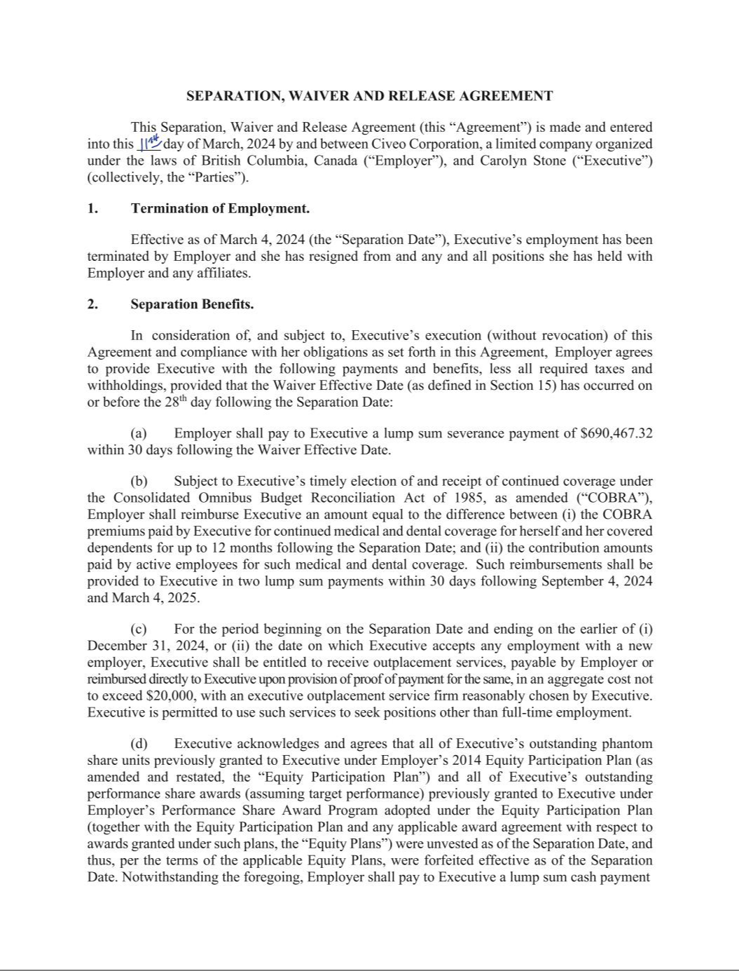

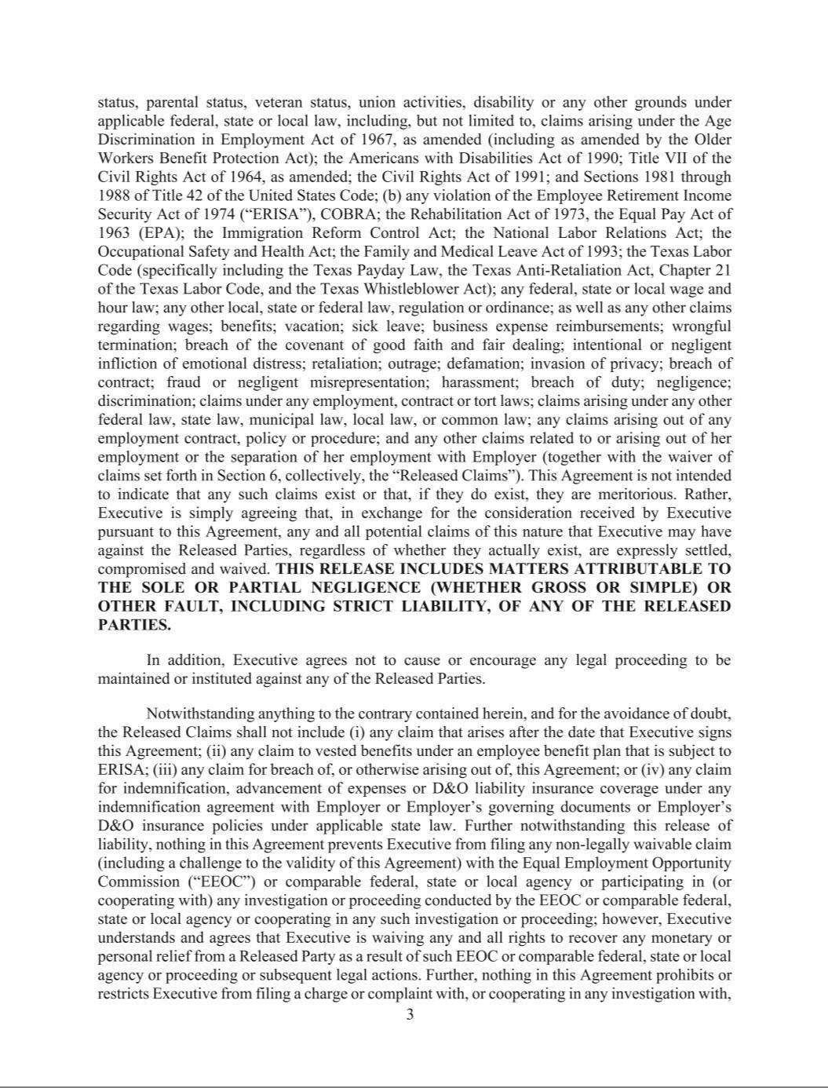

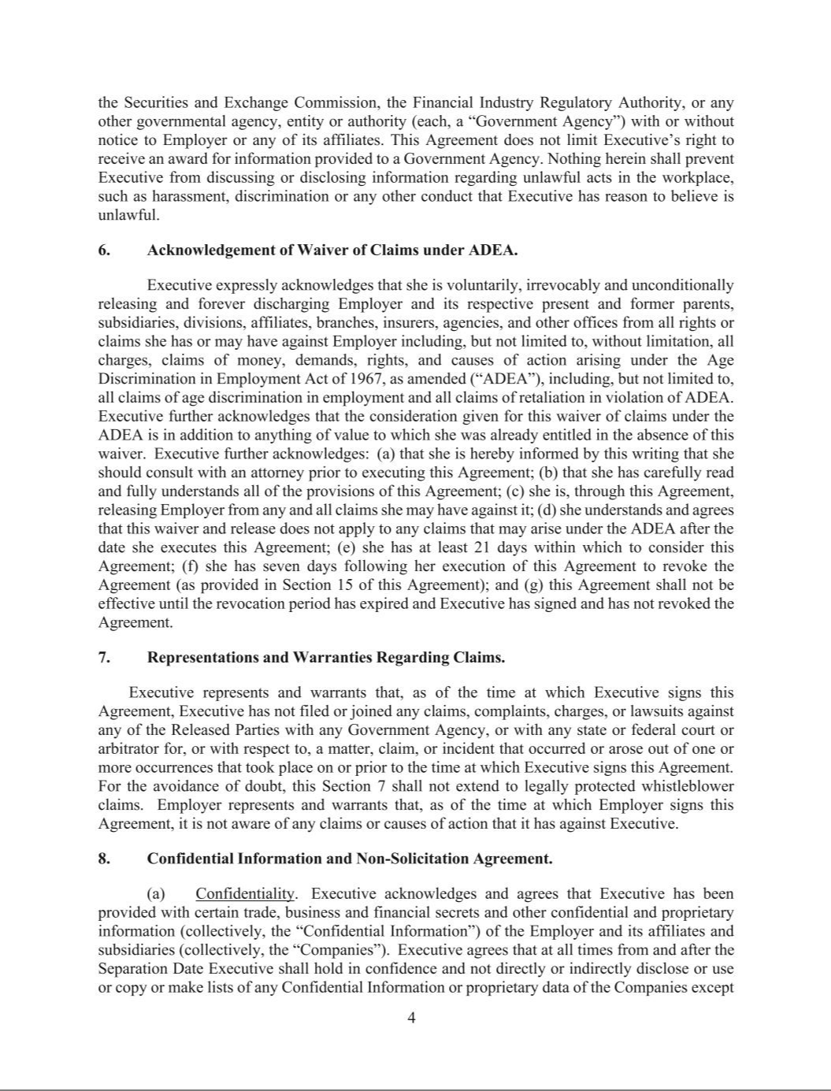

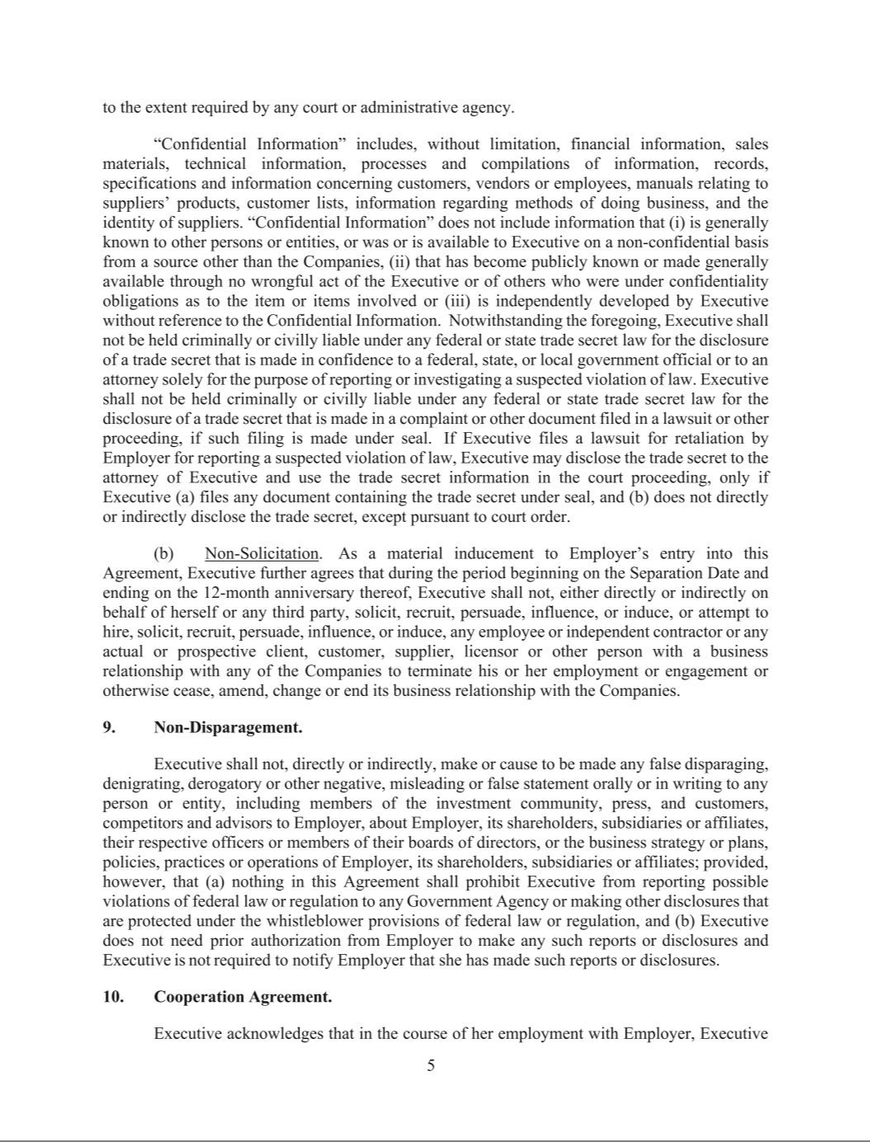

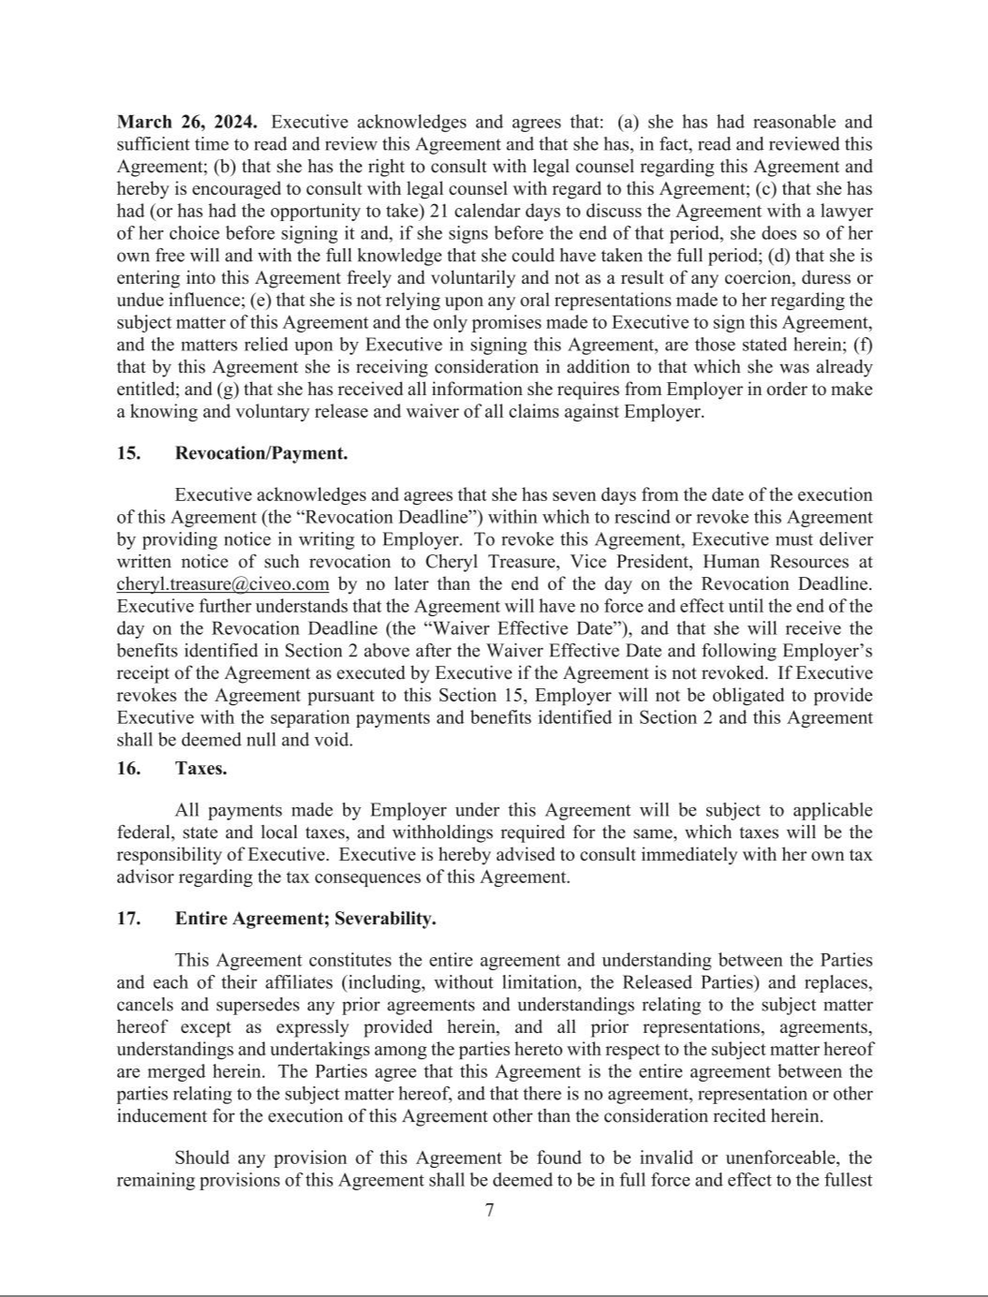

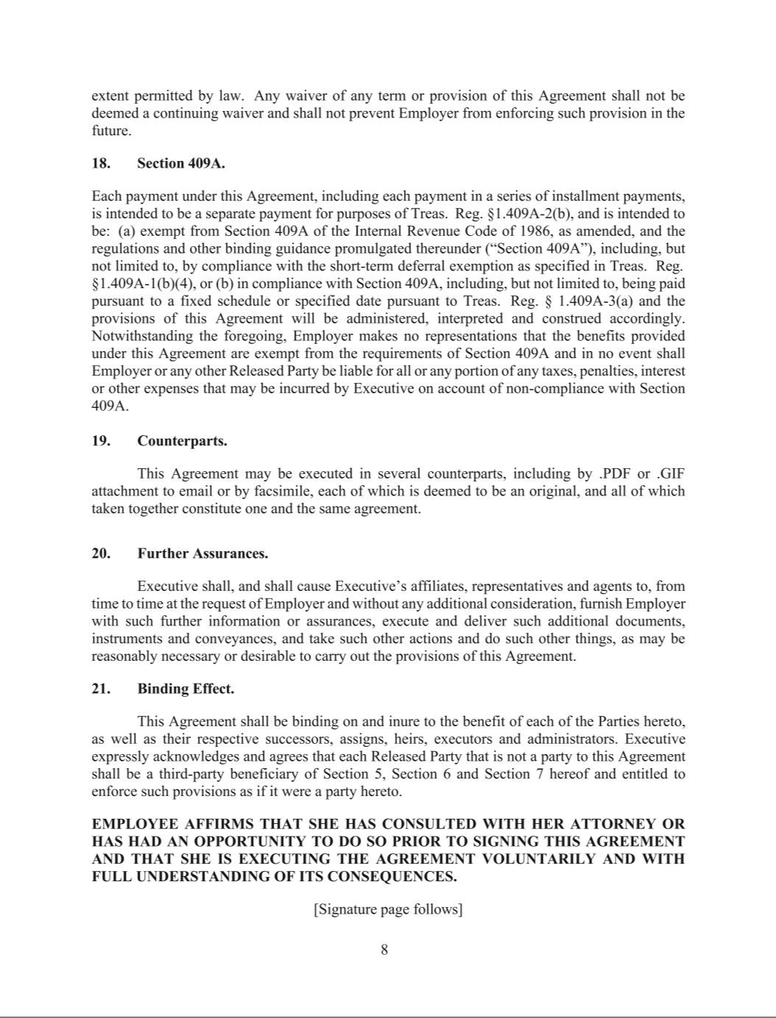

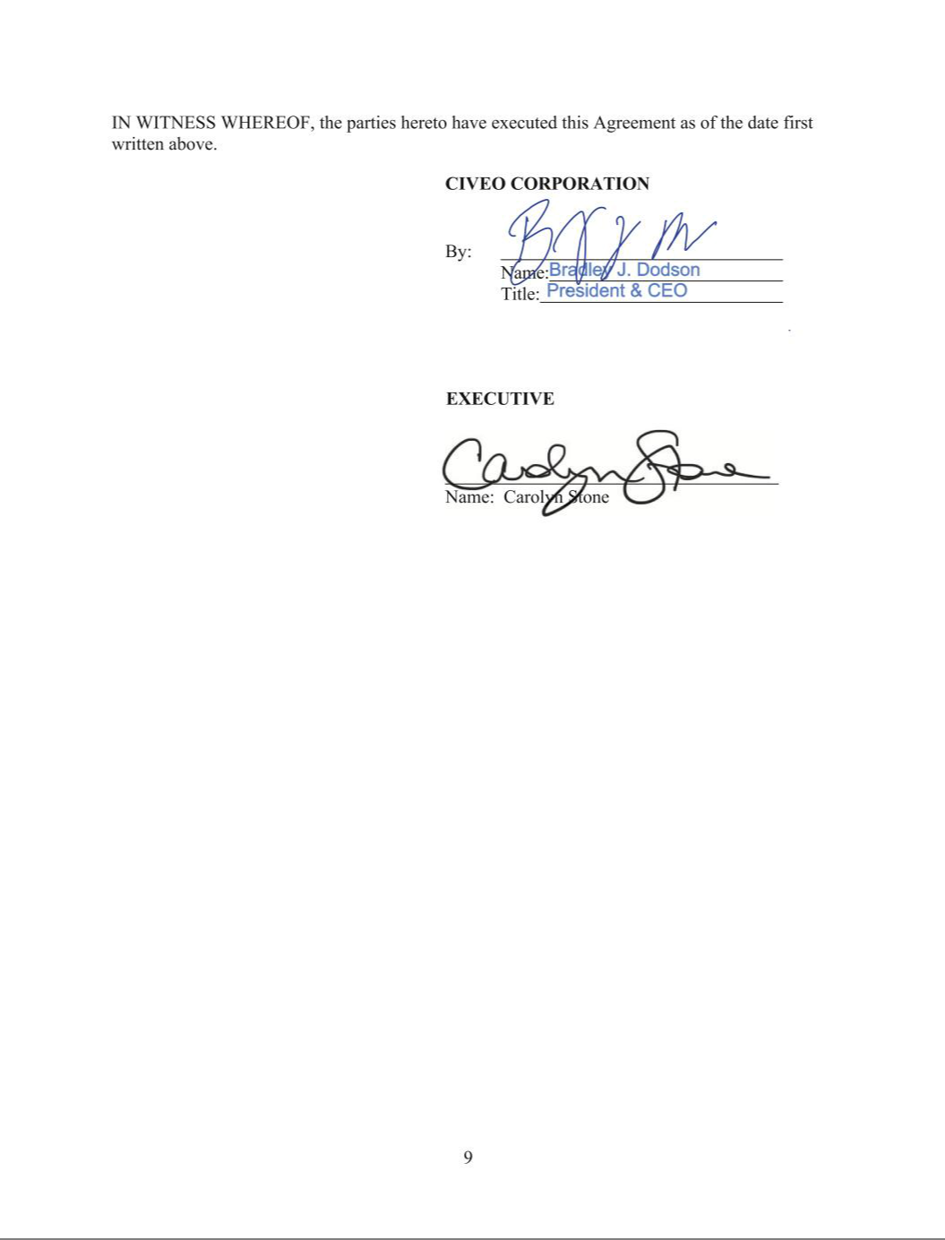

EXHIBIT 31.1

CERTIFICATION OF

CHIEF EXECUTIVE OFFICER

OF CIVEO CORPORATION

PURSUANT TO RULE 13a–14(a) UNDER THE

SECURITIES EXCHANGE ACT OF 1934

I, Bradley J. Dodson, certify that:

- I have reviewed this Quarterly Report on Form 10-Q of Civeo Corporation (Registrant);

- Based on my knowledge, this report does not contain any untrue statement of a material fact or omit to state a material fact necessary to make the statements made, in light of the circumstances under which such statements were made, not misleading with respect to the period covered by this report;

- Based on my knowledge, the financial statements, and other financial information included in this report, fairly present in all material respects the financial condition, results of operations and cash flows of the Registrant as of, and for, the periods presented in this report;

- The Registrant’s other certifying officer and I are responsible for establishing and maintaining disclosure controls and procedures (as defined in Exchange Act Rules 13a-15(e) and 15d-15(e)) and internal control over financial reporting (as defined in Exchange Act Rules 13a-15(f) and 15d-15(f)) for the Registrant and have:

a designed such disclosure controls and procedures, or caused such disclosure controls and procedures to be designed under our supervision, to ensure that material information relating to the Registrant, including its consolidated subsidiaries, is made known to us by others within those entities, particularly during the period in which this report is being prepared;

b designed such internal control over financial reporting, or caused such internal control over financial reporting to be designed under our supervision, to provide reasonable assurance regarding the reliability of financial reporting and the preparation of financial statements for external purposes in accordance with generally accepted accounting principles;

c evaluated the effectiveness of the Registrant’s disclosure controls and procedures and presented in this report our conclusions about the effectiveness of the disclosure controls and procedures, as of the end of the period covered by this report based on such evaluation; and

- disclosed in this report any change in the Registrant’s internal control over financial reporting that occurred during the Registrant’s most recent fiscal quarter (the Registrant’s fourth fiscal quarter in the case of an annual report) that has materially affected, or is reasonably likely to materially affect, the Registrant’s internal control over financial reporting; and

- The Registrant’s other certifying officer and I have disclosed, based on our most recent evaluation of internal control over financial reporting, to the Registrant’s auditors and the audit committee of the Registrant’s Board of Directors (or persons performing the equivalent functions):

a all significant deficiencies and material weaknesses in the design or operation of internal control over financial reporting which are reasonably likely to adversely affect the Registrant’s ability to record, process, summarize and report financial information; and

b any fraud, whether or not material, that involves management or other employees who have a significant role in the Registrant’s internal control over financial reporting.

Date: April 26, 2024

/s/ Bradley J. Dodson

Bradley J. Dodson

President and Chief Executive Officer

EXHIBIT 31.2

CERTIFICATION OF

INTERIM CHIEF FINANCIAL OFFICER

OF CIVEO CORPORATION

PURSUANT TO RULE 13a–14(a) UNDER THE

SECURITIES EXCHANGE ACT OF 1934

I, Barclay Brewer, certify that:

- I have reviewed this Quarterly Report on Form 10-Q of Civeo Corporation (Registrant);

- Based on my knowledge, this report does not contain any untrue statement of a material fact or omit to state a material fact necessary to make the statements made, in light of the circumstances under which such statements were made, not misleading with respect to the period covered by this report;

- Based on my knowledge, the financial statements, and other financial information included in this report, fairly present in all material respects the financial condition, results of operations and cash flows of the Registrant as of, and for, the periods presented in this report;

- The Registrant’s other certifying officer and I are responsible for establishing and maintaining disclosure controls and procedures (as defined in Exchange Act Rules 13a-15(e) and 15d-15(e)) and internal control over financial reporting (as defined in Exchange Act Rules 13a-15(f) and 15d-15(f)) for the Registrant and have:

a designed such disclosure controls and procedures, or caused such disclosure controls and procedures to be designed under our supervision, to ensure that material information relating to the Registrant, including its consolidated subsidiaries, is made known to us by others within those entities, particularly during the period in which this report is being prepared;

b designed such internal control over financial reporting, or caused such internal control over financial reporting to be designed under our supervision, to provide reasonable assurance regarding the reliability of financial reporting and the preparation of financial statements for external purposes in accordance with generally accepted accounting principles;

c evaluated the effectiveness of the Registrant’s disclosure controls and procedures and presented in this report our conclusions about the effectiveness of the disclosure controls and procedures, as of the end of the period covered by this report based on such evaluation; and

d disclosed in this report any change in the Registrant’s internal control over financial reporting that occurred during the Registrant’s most recent fiscal quarter (the Registrant’s fourth fiscal quarter in the case of an annual report) that has materially affected, or is reasonably likely to materially affect, the Registrant’s internal control over financial reporting; and

- The Registrant’s other certifying officer and I have disclosed, based on our most recent evaluation of internal control over financial reporting, to the Registrant’s auditors and the audit committee of the Registrant’s Board of Directors (or persons performing the equivalent functions):

a all significant deficiencies and material weaknesses in the design or operation of internal control over financial reporting which are reasonably likely to adversely affect the Registrant’s ability to record, process, summarize and report financial information; and

b any fraud, whether or not material, that involves management or other employees who have a significant role in the Registrant’s internal control over financial reporting.

Date: April 26, 2024

/s/ Barclay Brewer

Barclay Brewer

Interim Chief Financial Officer

EXHIBIT 32.1

CERTIFICATION OF

CHIEF EXECUTIVE OFFICER

OF CIVEO CORPORATION

PURSUANT TO 18 U.S.C. § 1350, AS ADOPTED PURSUANT TO

SECTION 906 OF THE SARBANES-OXLEY ACT OF 2002

In connection with the Quarterly Report on Form 10-Q of Civeo Corporation (the “Company”) for the quarterly period ended March 31, 2024, as filed with the Securities and Exchange Commission on the date hereof (the “Report”), I, Bradley J. Dodson, President and Chief Executive Officer of the Company, hereby certify, pursuant to 18 U.S.C. Section 1350, as adopted pursuant to Section 906 of the Sarbanes-Oxley Act of 2002, to the best of my knowledge, that:

1 The Report fully complies with the requirements of Section 13(a) or 15(d) of the Securities Exchange Act of 1934; and

- The information contained in the Report fairly presents, in all material respects, the financial condition and results of operations of the Company.

/s/ Bradley J. Dodson

Name: | Bradley J. Dodson
Date: | April 26, 2024

EXHIBIT 32.2

CERTIFICATION OF

INTERIM CHIEF FINANCIAL OFFICER

OF CIVEO CORPORATION

PURSUANT TO 18 U.S.C. § 1350, AS ADOPTED PURSUANT TO

SECTION 906 OF THE SARBANES-OXLEY ACT OF 2002

In connection with the Quarterly Report on Form 10-Q of Civeo Corporation (the “Company”) for the quarterly period ended March 31, 2024, as filed with the Securities and Exchange Commission on the date hereof (the “Report”), I, Barclay Brewer, Interim Chief Financial Officer of the Company, hereby certify, pursuant to 18 U.S.C. Section 1350, as adopted pursuant to Section 906 of the Sarbanes-Oxley Act of 2002, to the best of my knowledge, that:

1 The Report fully complies with the requirements of Section 13(a) or 15(d) of the Securities Exchange Act of 1934; and

- The information contained in the Report fairly presents, in all material respects, the financial condition and results of operations of the Company.

/s/ Barclay Brewer

Name: | Barclay Brewer
Date: | April 26, 2024

